README now is documentation for using DragAndDroid:

The DragAndDroid Program - Overview:

The DragAndDroid program is designed to personally create and edit your own GUI (Graphical User Interface) for the Andriod environment. This guide will explain how to run this program, as well as how to upload the results of this program to the Android Phone. This is a developer tool and should be treated as such.

How to use the GUI EDITOR interface:

The "File" panel option contains the "Generate" and "New" options. "New" will clear any existing work done to the editor, while "Generate" will create the xml file with your custom changes to the GUI environment. In order to make these changes there are various tools you can use to edit your own personal interface. To add these element to your draggable editor click the corresponding name of the element you wish to add then click the location on the black screen where you wish to put
this element.

Your canvas for the DragandDroid Application upon opening:
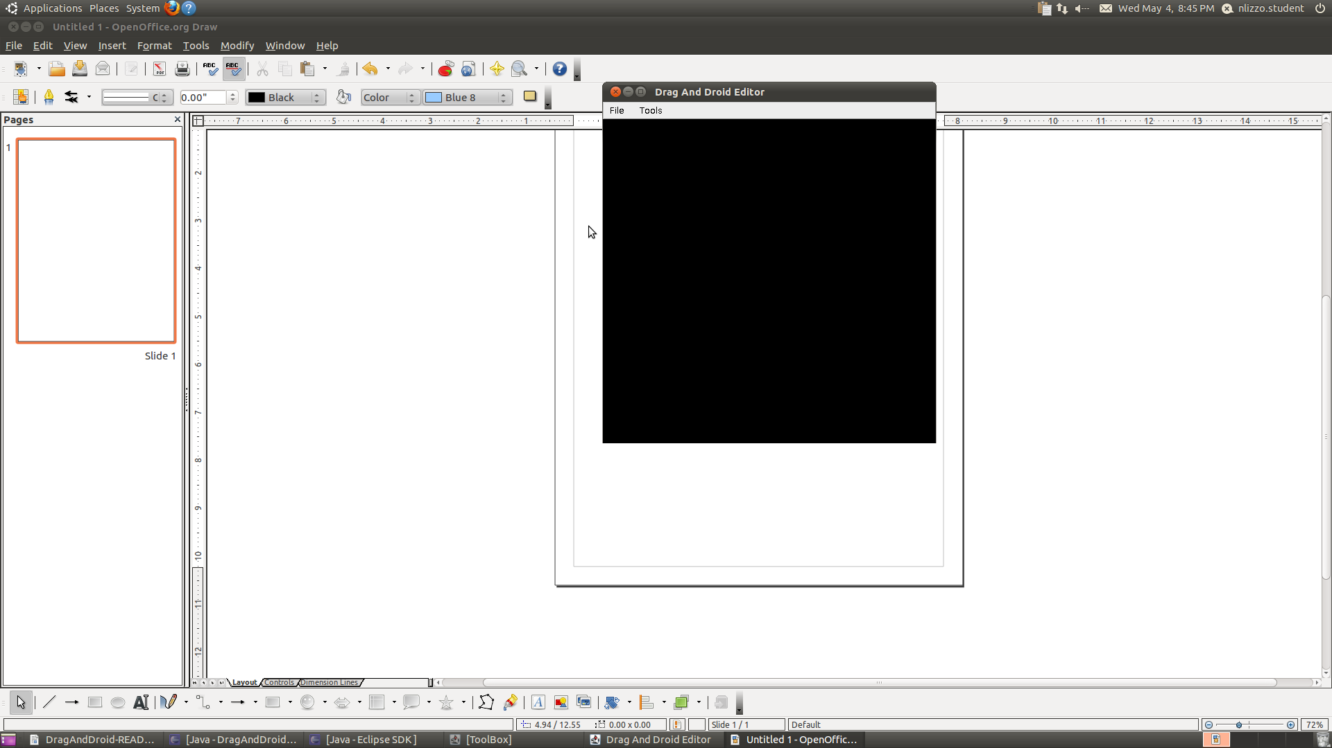
The editor toolbox:

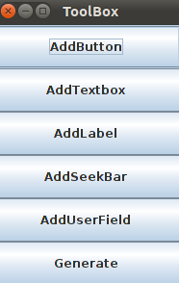

The following describes the elements you can add to the draggable editor environment
using the editor ToolBox:

    - AddButton: Creates a button in the Android environment. It's properties can be edited via the Tools panel option. Buttons can be given various properties and can interact via an OnClick interaction or a LongPress interaction (more on this is be under the "Editing Buttons" section). All elements can be dragged to a relative location on screen which will correspond to their relative location in the Android environment. However under the Tools panel option you can fine tune the location of the button/element via the X and Y coordinates as well as change the name of the button under this Tools "Element Properties" option.

    - AddTextBox: Creates a text area in which the user can interactively add his or her text. Again, it's name and location can be edited under the Tools -> Element Properties panel option.

    - AddLabel: Adds non-editable text within the Android environment. Again, it can be edited in the Drag And Droid Editor under the Tools -> Element Properties panel option. It is important to note that once the xml file is generated the properties CANNOT be edited in the Android environment unless a new xml is generated from the Drag And Droid Editor.

    - AddSeekBar: Creates a seek bar within the GUI. Users can actively click and drag the bar to scroll through the current progress level or use the arrow keys to interact with the seekbar.

    - AddUserField: Adds a User Field. This field is designed specifically for storing user entered data. Like the textfield it can be interactively edited to comprise of user entered text.

    - Generate: Clicking generate (whether under File -> Generate or clicking "Generate" in the "Toolbox" Window Pane) will create the physical xml file that you can use in the Android environment.

Example of a custom canvas containing all elements:

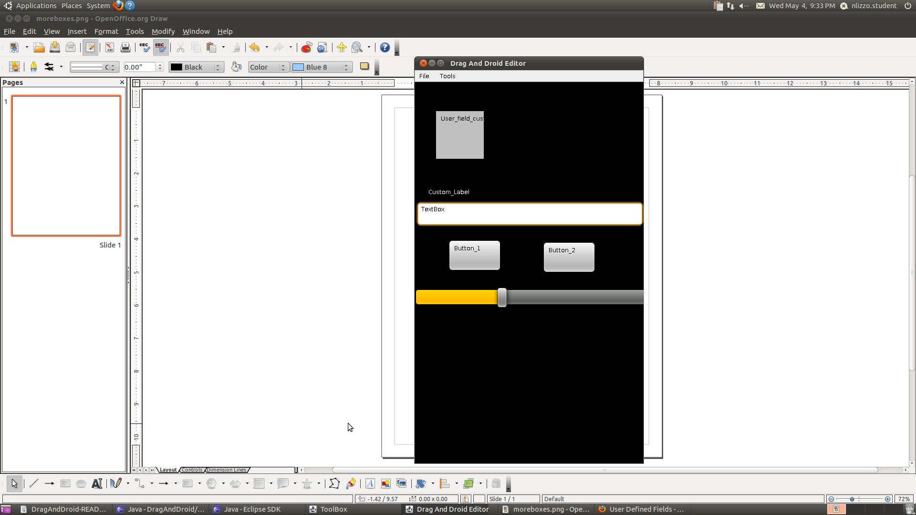

The created xml will correspond using the relative layout in the android environment and align elements accordingly.

Interacting with your GUI interface:

The DragAndDroid application is designed so that your custom GUI can serve as the interactive
medium between your program/external application and the Android Environment. Once you've decided what your interface will look like you'll want to add some functionality to it. The following properties can be utilized in the Element Editor portion of the interface so that your GUI can respond to elements. The developer may parse his or her code through the AndroidGenerator class to interact in the following ways:

Buttons:
Buttons can respond by either the OnClick command or LongPress command. Developers can utilize these functions as users respond to their interaction. The OnClick commad responds to a user immediately pressing and releasing any created button in the Android GUI. The LongPress command requires users to hold down the selected button for a time before release. Here they can add functionality such as OnClick or LongPress to their own linked code.

SeekBar:
The seekbar can be edited in the seekBarMethods of the AndroidGenerator. Here the can interact with the seekbar and customizing it's functionality depending on preference and user interaction.

Label:
Labels are static and act simply as displayed text.

Userfields:
Here users can insert data that can be stored and interacted with the developers inherit changes to the userfield. Text can be inserted in this field and stored on the developer backend.

Textfields:
Allows users to enter text in the android environment. Developers may interact with the dynamic text as needed.

These elements can be used multiple times and depending on the developer's additions to the xml parsed file can interact as needed. It is important to remember the interface is designed around the Android Environment and will therefore be operable on any platform supporting that interface.

The Android DragandDroid development tool can be configured as an editable GUI interface. Working buttons can simulate real time responses within its environment. The goal of the application is to provide developers with an easily accessible program that after creation will give all Front End users a useful interaction tool that enables them to access Back End commands and changes made by the developer.

The application is an interface with customizable infrastructure. It is designed so that developers can use that interface for their own personal use. All developer changes should be made in the aforementioned classes. The DragAndDroid application is designed as a dynamic tool that gives editors the ability to create GUI interfaces in the Android environment. As such it can be used in any device that supports the Android operating system. Simply install your customized program into the Android OS and your interactive program should run in its fully customized capacity.

NOTE: The DragAndDroid application is styled with the current custom defaults:

    - SeekBar is set to 100
    - The layout configuration is set to relevant, thus all elements will be lined up accordingly
    - Textboxes, Seekbars and User fields are fitted to screen width
    - Labels are static

