ASSIGNMENT
JavaScript and the Document Object Model (DOM)
Selecting, Styling, Attributes, Manipulation and Navigation
Item | Details
Course / Module | Web Development - Client-Side JavaScript
Student Name | Lorenzo, Mhel Pablo
Student ID / Section | 22-UR-1115T / BSIT 3rd Year
Date Issued | October 30, 2026
Total Marks | 100

This document contains my written answers (theory, code reading and explanations). The code is in separate files, as the instructions say. Here is how the submission is organised:
File / folder | What it contains
practice/index.html | The starter HTML from Appendix A, exactly as given (not edited)
practice/script.js | All practical tasks for Sections A to E
task-manager/index.html, style.css, script.js | Section F mini project (Interactive Task Manager) with the three bonus challenges
screenshots/ | Screenshots of the practice page and the Task Manager
This Word document | Theory answers, code reading answers, task notes, reflection

All the code reading answers in this document were also checked by running the code in a browser, so they are the real results and not only my prediction. Every practical task was tested in Chromium and no errors appeared in the console.

Section A - Selecting DOM Elements

A.1 Theory
1. The five main methods for selecting elements
Method | When there is a match | When there is no match
getElementById(id) | Returns the one element with that id. | Returns null.
getElementsByClassName(name) | Returns a live HTMLCollection of all elements with that class. | Returns an empty HTMLCollection (length 0), not null.
getElementsByTagName(tag) | Returns a live HTMLCollection of all elements with that tag. | Returns an empty HTMLCollection (length 0).
querySelector(selector) | Returns the first element that matches the CSS selector. | Returns null.
querySelectorAll(selector) | Returns a static NodeList of all matching elements. | Returns an empty NodeList (length 0).

2. HTMLCollection vs NodeList, and live collections
An HTMLCollection is what the getElementsBy... methods return. It only holds elements, it is always live, and it has no forEach method, so I have to use a normal for loop or convert it with Array.from(). A NodeList is what querySelectorAll returns. It is static, which means it is a snapshot taken at the moment of the call, and it has forEach. (Note: some NodeLists such as childNodes are live too, so the type of object does not decide it, the method that created it does.)
"Live" means the collection updates by itself when the page changes. For example, if I write const items = document.getElementsByClassName("menu-item"), then items.length is 3. If I add another li with the class menu-item, items.length becomes 4 without selecting again. With querySelectorAll(".menu-item") it would stay 3. This matters in loops: if I loop over a live collection and remove elements inside the loop, the collection shrinks while I loop, so some elements get skipped. Converting to an array first, or using a static NodeList, avoids this.
3. querySelector vs getElementById
querySelector is more flexible because it accepts any CSS selector (classes, ids, attributes, descendants, :nth-child and so on), so one method can replace most of the others. It can also be called on any element to search only inside that element. getElementById only works with ids. Still, getElementById is a better choice when I already know the exact id: it is simple, a bit faster, and I do not need to write the # sign or escape special characters (an id such as "user:name" would need escaping inside a selector).

A.2 Code Reading
Expression | Result
1. document.getElementById("menu") | The <ul id="menu"> element (it contains the three <li> items).
2. document.getElementsByClassName("menu-item").length | 3
3. document.querySelector(".menu-item.active a").textContent | "About"
4. document.querySelectorAll("#products .card").length | 3
5. document.querySelector("input[name='email']").placeholder | "Email"
6. document.getElementById("footer") | null (there is no element with id footer)
7. document.querySelectorAll("li:nth-child(odd)").length | 2 (Home is the 1st li and Contact is the 3rd li; About is the 2nd)
8. document.querySelector("[data-id='2'] .price").textContent | "$500" (the Phone card)

A.3 Practical Tasks (practice/script.js, Section A)
Task 1. I selected the h1 with getElementById, querySelector and getElementsByTagName("h1")[0]. The three === comparisons all log true, so they are the same element.
Task 2. querySelectorAll(".card") with forEach. Inside the loop I use card.querySelector to get the h3 and the p.price and log them.
Task 3. getElementsByTagName("a") gives a live HTMLCollection. I used Array.from() to make a real array and then map() to get the href of every link.
Task 4. A NodeList does not have filter(), so I converted it with Array.from() first and filtered with Number(card.dataset.id) > 1. This gives the Phone and Tablet cards.
Task 5. safeSelect(selector) uses querySelector. If the result is null it logs console.warn with a helpful message and returns null. I also put it in try/catch so an invalid selector like "##bad" does not crash the script.
Console output of Section A:
A1 same element (id vs querySelector): true
A1 same element (id vs tag name): true
A1 all three the same: true
A2 card -> name: Laptop, price: $900
A2 card -> name: Phone, price: $500
A2 card -> name: Tablet, price: $300
A3 hrefs: ["#home", "#about", "#contact"]
A4 cards with data-id > 1: ["Phone", "Tablet"]
A5 found: <section id="products" data-category="store">
A5 not found: null (warning: nothing matches "#footer")
A5 invalid: null (warning: "##bad" is not a valid selector)

Section B - Styling DOM Elements

B.1 Theory
1. element.style vs classList vs className
Way | Advantage | Disadvantage
element.style | Good for one-time values that are calculated in JavaScript (for example a colour from a number). It is applied directly and is easy to understand. | It writes inline styles, which mixes design into the script, is hard to override from CSS, and cannot do hover, media queries or pseudo-classes.
classList | The design stays in the CSS file. I can add, remove, toggle or check one class without touching the other classes. | The class must already exist in the CSS. It cannot set a new custom value, only switch between prepared styles.
className | Simple. I can read or replace the whole class attribute in one line. | It is just a string, so assigning to it overwrites every existing class, and adding or removing one class means string handling that is easy to get wrong.

2. CSS property names in JavaScript
background-color becomes style.backgroundColor (camelCase, hyphen removed and the next letter capitalised). Two more examples: font-size becomes style.fontSize, and border-radius becomes style.borderRadius (also margin-top becomes style.marginTop). The hyphenated name can still be used with the bracket form style["background-color"] or with style.setProperty("background-color", ...).
3. Why style.color returns an empty string
element.style only reads the inline style (the style="..." attribute or values set through the style property). If the red colour comes from an external stylesheet, the inline style is empty, so style.color returns "". The method that gives the real applied value is getComputedStyle(element), for example getComputedStyle(element).color returns "rgb(255, 0, 0)".

B.2 Code Reading
The code selects the h1 with id main-title. Then, line by line:
- style.cssText = ... replaces the whole inline style of the h1 (any older inline styles are lost). The text becomes white, the background becomes dark blue (#1F3A5F) and there is 12px padding on all sides.
- classList.add("highlight") adds the class highlight, so the class attribute is "highlight".
- classList.toggle("highlight") switches it. The class was there, so it is removed. The class attribute is now empty.
- classList.toggle("large", true) the second argument true forces the class to be added, so the class attribute is now "large".
- console.log(title.classList.contains("highlight")) prints false, because highlight was removed by the toggle.
- console.log(getComputedStyle(title).paddingTop) prints "12px", the final computed top padding.
What the user sees: the title appears as white text on a dark blue block with 12px of space around the text. The class large is on the element but the starter page has no CSS for .large or .highlight, so those two classes do not change anything visible. (I ran this code in the browser and it gave false and 12px.)

B.3 Practical Tasks (practice/script.js, Section B)
Task 1. A function styleCard(card) sets border, padding, borderRadius, backgroundColor and margin through the style property. It is applied to every .card (and later to new cards).
Task 2. The .active-card class is in a <style> block that my script creates (the HTML file must not be edited). One click listener on the products section uses event.target.closest(".card"), then card.classList.toggle("active-card", card === clicked) for every card, so only the clicked card keeps the class. The class uses outline, box-shadow and transform because the inline styles from Task 1 would beat a class for background and border.
Task 3. colourPrice(card) removes everything except digits and the dot from the price text, uses parseFloat, and sets style.color to green if the number is below 400, otherwise red. Result: Laptop $900 red, Phone $500 red, Tablet $300 green (and Headphones $150 green).
Task 4. A "Dark Mode" button (created in JavaScript) runs document.body.classList.toggle("dark"). The CSS rule body.dark changes the background, text and heading colours.
Task 5. The CSS uses var(--main-color) for headings, buttons and the menu. I set it with document.documentElement.style.setProperty("--main-color", "#1F3A5F"), and a "Change Theme Colour" button cycles through other colours with the same method.
Task 6. getComputedStyle(h1) logs font-size 32px and display block. I used getComputedStyle because h1.style.fontSize is just an empty string: those values are not written inline, they come from the browser's default stylesheet (h1 is 2em of the 16px base size and is a block element). getComputedStyle gives the final value after all CSS rules, defaults and inheritance are applied.
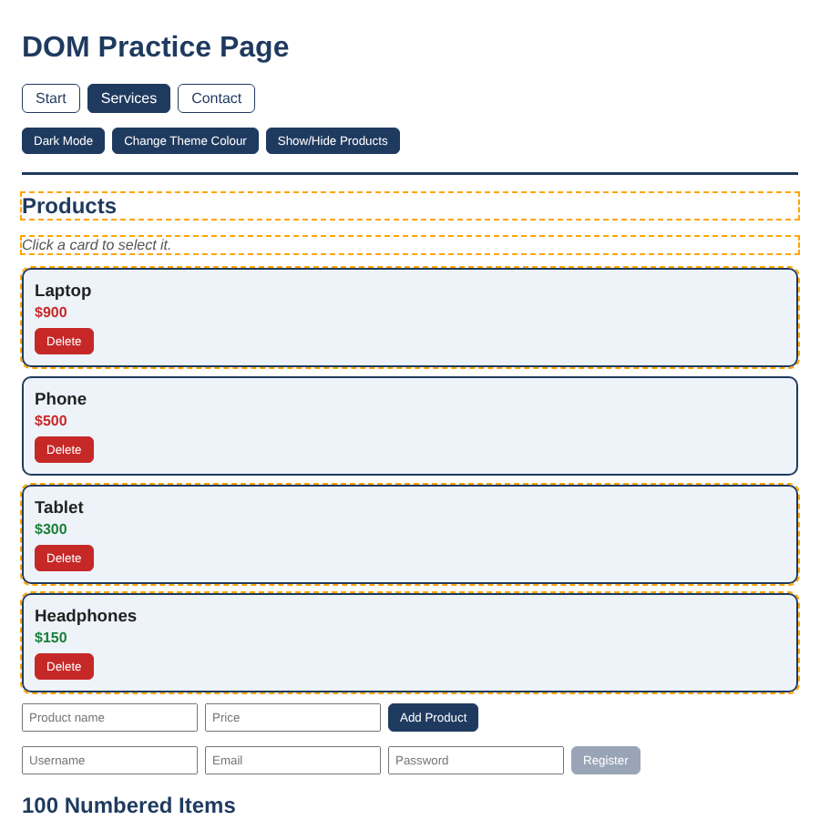
Figure 1. Practice page after loading (Section E highlight still visible for 3 seconds)
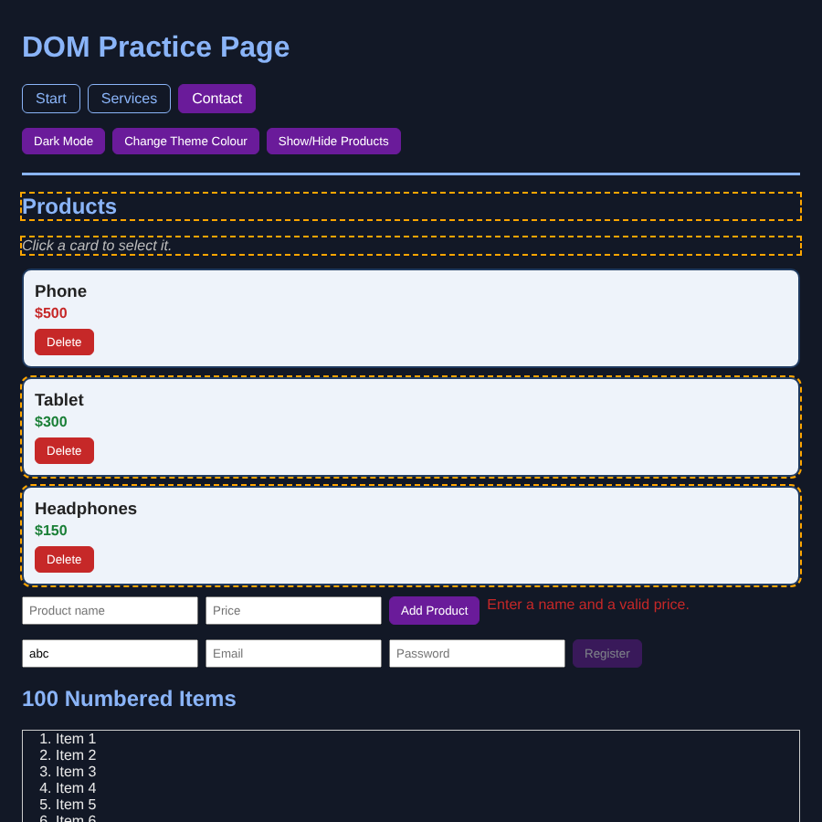
Figure 2. Dark mode on, a different theme colour set with setProperty(), and a card removed

Section C - Setting and Removing DOM Attributes

C.1 Theory
1. Attribute methods
- getAttribute(name) returns the value of the attribute as a string, or null if the element does not have it.
- setAttribute(name, value) adds the attribute or changes its value (the value is turned into a string).
- hasAttribute(name) returns true or false depending on whether the attribute exists, even when its value is empty.
- removeAttribute(name) deletes the attribute from the element (nothing happens if it is missing).
- toggleAttribute(name, force) adds the attribute (with an empty value) if it is missing and removes it if it is there; it returns true when the attribute is present afterwards. The optional second argument forces add (true) or remove (false).
2. HTML attribute vs DOM property
An attribute is what is written in the HTML (or set with setAttribute). It is always a string and it holds the starting value. A property is a value on the JavaScript object of the element, and it shows the current state. They are often linked but not always. Example: with <input value="Hello">, both input.value and getAttribute("value") start as "Hello". After the user types "World", input.value (the property) is "World", but getAttribute("value") is still "Hello", because typing does not change the attribute. So the attribute is the default and the property is the live value.
3. Boolean attributes
For boolean attributes like disabled, checked and hidden, only the presence of the attribute matters. If it is there, the value is true, no matter what is written. So disabled="false" still disables the button. The correct way to enable a disabled button is button.disabled = false or button.removeAttribute("disabled"), not setAttribute("disabled", "false").
4. data-* attributes and dataset
data-* attributes are custom attributes that I can write on any element to store extra information, for example data-id="2". The dataset property gives access to them as an object where the data- prefix is removed, so data-id is read as element.dataset.id (always a string). Names with hyphens are converted to camelCase, so data-product-id is dataset.productId. Writing element.dataset.productId = "5" creates data-product-id="5" in the HTML.

C.2 Code Reading
Line | Output | Explanation
(a) | true | setAttribute("disabled", "") adds the attribute, so hasAttribute returns true (an empty value still counts as present).
(b) | false | removeAttribute("disabled") took the attribute away, so the property btn.disabled is false.
(c) | "1" | The first card is <div class="card" data-id="1">, so getAttribute returns the string "1".
(d) | "1" | dataset.id reads the same data-id attribute. It is the string "1", not the number 1.
(e) | "900" | card.dataset.price = "900" created a new attribute data-price="900" on the card, and getAttribute("data-price") reads it.

C.3 Practical Tasks (practice/script.js, Section C)
Task 1. For every #menu a I use setAttribute("title", Go to ${link.textContent}), giving "Go to Home", "Go to About" and "Go to Contact" as tooltips.
Task 2. updateRegisterButton() runs on page load (button starts disabled) and on every input event of the form. If both the username and email have text (trim() is not empty) it uses removeAttribute("disabled"), otherwise setAttribute("disabled", ""). I tested: empty = disabled, only username = disabled, both filled = enabled, clearing one = disabled again. The submit handler uses preventDefault() so the practice page does not reload.
Task 3. The username input gets setAttribute("required", "") and setAttribute("minlength", "3"). A new input is created with createElement and its type is set to "password" with setAttribute; it is placed after the email input.
Task 4. Every card gets setAttribute("id", card-${card.dataset.id}), so the ids are card-1, card-2 and card-3.
Task 5. The "Show/Hide Products" button calls productsSection.toggleAttribute("hidden"). I added a CSS rule [hidden] { display: none !important; } so the attribute always works, even if another rule sets display.
Task 6. removeAllDataAttributes(element) makes a copy of the attributes with Array.from(element.attributes) and removes every one whose name starts with "data-". It is safe to remove inside the loop because I loop over the copy. I tested it on a clone of the first card: before = class, data-id, style, id; after = class, style, id.

Section D - Manipulating DOM Elements

D.1 Theory
1. textContent, innerText and innerHTML
textContent gets or sets all the text inside an element and its children, as plain text. It ignores CSS (hidden text is still included) and does not read HTML tags, so it is fast. innerText gets the text as it is rendered on screen. It follows CSS, so hidden elements are not included, and it needs the browser to calculate the layout, which is slower. innerHTML gets or sets the HTML markup inside the element as a string, so when I set it the browser parses the string and creates real elements.
textContent is the safest for showing user input, because whatever the user types is always treated as plain text and never as HTML. innerHTML is risky because of XSS (cross-site scripting). If a page puts user input into innerHTML, an attacker can type something like <img src=x onerror="alert(document.cookie)">. The browser creates the image, the image fails to load, and the onerror code runs on the page. That code can steal cookies or login tokens or change the page. So innerHTML should not be used with user input unless it has been properly cleaned.
2. Insert methods
- appendChild(node) adds one node at the end of the parent. It only accepts nodes (not plain strings) and returns the node.
- append(...) also adds at the end, but it accepts many nodes and strings at once and returns nothing.
- prepend(...) is like append but puts the content at the start of the parent.
- insertBefore(newNode, referenceNode) inserts the new node in the parent, just before the given child (if the reference is null it goes to the end).
- insertAdjacentElement(position, element) inserts an element at a position relative to the element it is called on, and insertAdjacentHTML(position, htmlString) does the same with an HTML string that is parsed.
The four positions are "beforebegin" (before the element itself), "afterbegin" (inside, at the start), "beforeend" (inside, at the end) and "afterend" (after the element).
3. cloneNode(true) vs cloneNode(false)
cloneNode(true) is a deep clone: it copies the element with all its attributes and all its children and text. cloneNode(false) is a shallow clone: it only copies the element and its attributes, with no children, so any text inside is not copied. Event listeners added with addEventListener are NOT copied. (Inline handlers written as attributes, like onclick="...", are copied because they are attributes.) Also, if the original has an id, the clone has the same id, so it should be changed to avoid duplicates.
4. DocumentFragment
A DocumentFragment is a lightweight, invisible container that is not part of the page. I can create many elements and put them in the fragment, and then add the fragment to the page with one call. When it is inserted, its children move into the page and the fragment becomes empty. It is useful because the page is updated only once, so the browser does one reflow and repaint instead of one per element, which is faster for large lists.

D.2 Code Reading
The menu starts as Home, About, Contact. Order after each key line:
Line | Menu order | Children
list.append(li) | Home, About, Contact, Blog | 4
list.prepend(list.lastElementChild.cloneNode(true)) | Blog, Home, About, Contact, Blog | 5
list.firstElementChild.remove() | Home, About, Contact, Blog | 4

The final number logged is 4. The menu shows Home, About, Contact, Blog. The clone of Blog that was put at the front was removed again by the last line, so the final result is the same as only adding Blog at the end. (Checked in the browser.)

D.3 Practical Tasks (practice/script.js, Section D)
Task 1. The Headphones card is built by hand: createElement("div") with class card and dataset.id = "4", an h3 and a p.price created with createElement and textContent, then appended to the products section with append().
Task 2. The page gets a text input, a number input and an "Add Product" button (created with JavaScript, because the HTML cannot be edited). On click, the function createCard(name, price) builds the card (with textContent only) and appends it. It rejects an empty name or a bad price and shows a message. New cards get the next data-id (5, 6, ...), an id, the Task 1 styles of Section B and a Delete button.
Task 3. Every card gets a Delete button. There is one click listener on the products section (event delegation) that does event.target.closest(".delete-btn") and then .closest(".card").remove(). It also works for cards that are added later (I tested deleting an original card and a new one).
Task 4. The text of the first link is changed with textContent = "Start". The second menu item (About) is replaced with a new li (link "Services") using menu.children[1].replaceWith(newItem). I gave the new li the active class because the old second item was the active one.
Task 5. h2.insertAdjacentHTML("afterend", '<p class="note">Click a card to select it.</p>'). I used the position "afterend", which puts the new paragraph after the closing tag of the h2, outside of it, so it becomes the next sibling of the heading, directly under the heading and above the first card. ("beforebegin" would put it above the heading, "afterbegin" and "beforeend" would put it inside the h2.) Using insertAdjacentHTML is fine here because the HTML is fixed text, not user input.
Task 6. A loop from 1 to 100 creates li elements ("Item 1" ... "Item 100") and adds them to a DocumentFragment. The fragment is appended to an ol with a single append() call, so the page is updated only once. The console shows 100 items.

Section E - Navigating Between DOM Nodes

E.1 Theory
1. DOM tree of the <nav> section
header#site-header
|-- h1#main-title (previous sibling of nav)
`-- nav (parent: header)
`-- ul#menu (only child of nav; parent: nav)
|-- li.menu-item
| `-- a[href="#home"]
| `-- "Home" (text node)
|-- li.menu-item.active
| `-- a[href="#about"]
| `-- "About" (text node)
`-- li.menu-item
`-- a[href="#contact"]
`-- "Contact" (text node)

Relationships: header is the parent of h1 and nav, which are siblings (h1 is the previous sibling of nav). nav has one child, the ul#menu. The ul is the parent of three li elements, which are siblings of each other (About has Home as previous sibling and Contact as next sibling). Each li has one child, the a element, and each a has one text node child. The ancestors of every link are li, ul, nav, header, body and html. In the real DOM there are also whitespace text nodes between these elements, because of the line breaks and indentation in the source code.
2. childNodes vs children, and the sibling properties
childNodes is a NodeList with all child nodes: elements, text nodes (including whitespace) and comments. children is an HTMLCollection with element children only. In the same way, firstChild returns the first node of any type, while firstElementChild returns the first element; nextSibling returns the next node of any type, while nextElementSibling returns the next element.
Whitespace text nodes cause confusion because the spaces and line breaks used to format the HTML are also part of the DOM. For <ul id="menu"> followed by a new line and an indented <li>, the firstChild of the ul is not the li but a text node containing the line break and spaces. So firstChild, nextSibling and childNodes give unexpected results (and their textContent looks empty), while the Element versions skip these text nodes.
3. Main nodeType values
nodeType | Constant | Represents
1 | ELEMENT_NODE | An HTML element such as <div> or <li>
3 | TEXT_NODE | Text inside an element (including whitespace)
8 | COMMENT_NODE | An HTML comment <!-- ... -->
9 | DOCUMENT_NODE | The document object itself

4. parentNode, parentElement, closest() and contains()
parentNode returns the parent of a node, whatever type it is (element, document or fragment). parentElement returns the parent only if it is an element, otherwise null. closest(selector) starts at the element itself and goes up through its ancestors, and returns the first one that matches the selector (or null). contains(node) returns true if the node is the element itself or one of its descendants. parentElement can be null while parentNode is not for the <html> element: document.documentElement.parentNode is the document object, but its parentElement is null because the document is not an element.

E.2 Code Reading
active is the About li (class "menu-item active").
Expression | Result | Reason
1. active.previousElementSibling.textContent | "Home" | The li before About
2. active.nextElementSibling.textContent | "Contact" | The li after About
3. active.parentElement.id | "menu" | Parent is ul#menu
4. active.parentElement.children.length | 3 | Three li elements
5. active.firstElementChild.tagName | "A" | tagName is uppercase in HTML
6. document.getElementById("menu").firstChild.nodeType | 3 | A whitespace text node (line break + indent before the first li), see note below
7. document.querySelector(".card h3").closest("section").id | "products" | First h3 is in the Laptop card, whose section is #products
8. document.getElementById("products").lastElementChild.dataset.id | "3" | The last element in the section is the Tablet card

Note for number 6: this is 3 because the HTML in Appendix A has the <li> elements on new lines with indentation. If the whole list were written on one line without spaces, the answer would be 1 (the li element itself). I checked it in the browser with the starter HTML and got 3.

E.3 Practical Tasks (practice/script.js, Section E)
Task 1. I find the Phone card, then log previousElementSibling (Laptop card), nextElementSibling (Tablet card), parentElement (the products section), and the section's firstElementChild (the h2) and lastElementChild (the last card in the section, which is the Headphones card because it was added in Section D).
Task 2. highlightSiblings(element) loops over element.parentElement.children and adds the class sibling-highlight to every child that is not the element itself. I called it on the Phone card: 5 siblings are highlighted (h2, note, Laptop, Tablet, Headphones). The highlight is removed after 3 seconds so it does not stay on the page.
Task 3. walkDOM(node, depth) logs the tag name with two spaces of indent per depth level and then calls itself for each element in node.children with depth + 1. Called on document.documentElement it prints the full element tree (html, head, meta, title, style, body, header, h1, nav, ...). I used console.groupCollapsed so the long output does not fill the console.
Task 4. One click listener on the menu: event.target.closest("a") finds the link, link.closest("li") (the same element as link.parentElement, which I also compare in the log) gets the li. The active class is removed from the old active item (found with menu.querySelector(".active")) and added to the new li.
Task 5. getAncestors(element) starts at element.parentElement and loops with a while loop, pushing each parent into an array until parentElement is null (after html). For the first h3 it returns: div, section, main, body, html.
Console output of Section E (first lines):
E2 highlighted siblings: 5
E3 walkDOM output (collapsed)
html
head
meta
title
style
body
header
h1
nav
ul
li
a
...
E5 ancestors of first h3: ["div", "section", "main", "body", "html"]

Section F - Integrated Mini Project: Interactive Task Manager
The project is in the folder task-manager (index.html, style.css, script.js). index.html only has the skeleton (heading, input area, filter buttons, an empty ul, and a footer with the counter). All the behaviour is created in script.js. To use it, open index.html in a browser.

How each required feature is done
Feature | Implementation
1. Add a task | Text input + Add button, and the Enter key. An empty or spaces-only input is rejected: the message element gets new textContent ("Please type a task first.") and a red colour through the style property. The Add button also has the disabled attribute while the input is empty.
2. Task item | createTaskItem() builds an li with createElement: a span with the text, and two buttons (Done and Delete) inside a div.
3. Done | classList.toggle("completed") gives the strikethrough and grey text, and dataset.status is set to "done" or "pending".
4. Delete | One click listener on the ul (event delegation). It uses event.target.closest("button") and button.closest("li").remove().
5. Filters | All / Active / Completed buttons keep a currentFilter value (from data-filter). applyFilter() sets the hidden property of each li, and the filter is applied again after every change.
6. Counter | updateCounter() uses taskList.querySelectorAll("li:not(.completed)").length and writes "X tasks remaining" ("1 task remaining" for one). It runs after every change.
7. Clear Completed | Selects all li.completed with querySelectorAll and removes each one.
8. Edit (bonus) | Double-click on the task text replaces the span with an input (replaceWith). Enter saves, Escape cancels, and leaving the field saves. A flag makes sure it only saves once.

Technical requirements
Topic | Where it appears in the project
Selecting | getElementById (input, list, counter), querySelector (filter bar), querySelectorAll (counter, clear completed, filters)
Styling | classList.toggle for completed and selected filter; style.color on the message element
Attributes | dataset.status (done/pending); setAttribute/removeAttribute for disabled on the Add button; the hidden property for filters; the data-filter attributes
Manipulating | createElement, append, remove, replaceWith, textContent. innerHTML is never used, so there is no unsafe user input. (I tested a task named <b>groceries</b> and it shows as plain text.)
Navigating | closest("li"), closest("button"), button.parentElement, previousElementSibling (to find the task text from the button), firstElementChild (to read the text when saving)

Bonus challenges (all three done)
- Helper library: $(selector), $$(selector) and create(tag, attrs, ...children) wrap querySelector, querySelectorAll and createElement. I rebuilt the task item creation with create() and used $$ for filtering. create() uses textContent and text nodes only.
- MutationObserver: observes the task list with childList: true and logs in the console when a task is added or removed.
- localStorage: the tasks (text and done state) are saved after every change and the list is rebuilt from the saved data when the page loads, wrapped in try/catch.

Screenshots
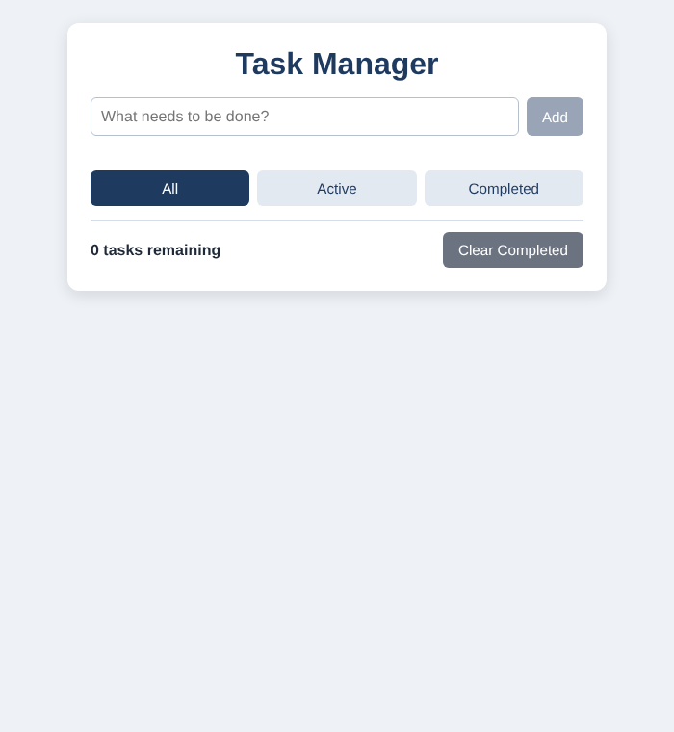
Figure 3. Empty state (Add button disabled, counter 0 tasks remaining)
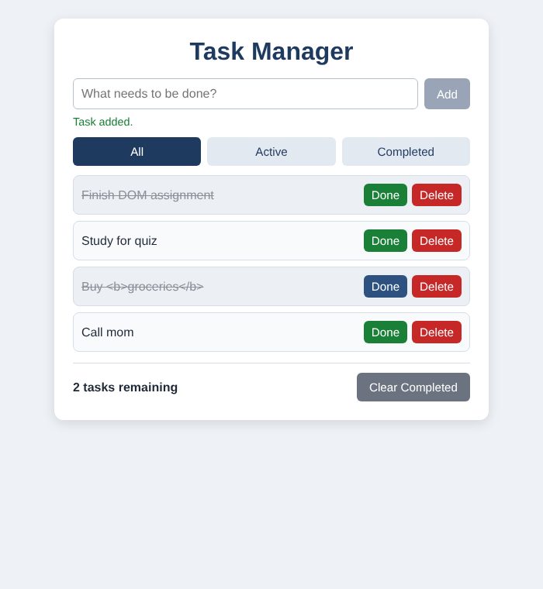
Figure 4. Several tasks, two of them marked done
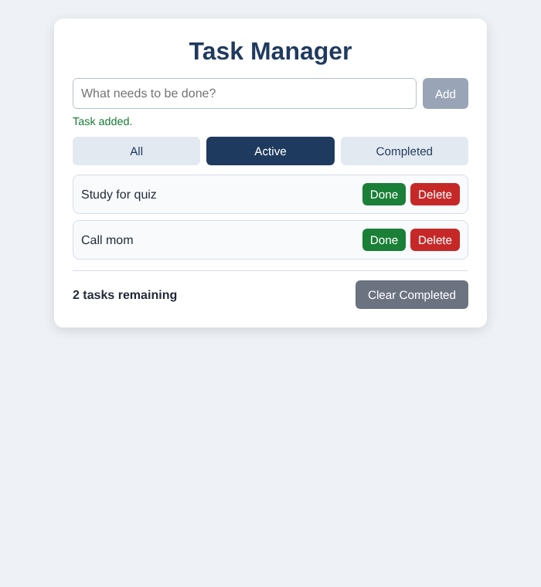
Figure 5. Filtered view: Active only
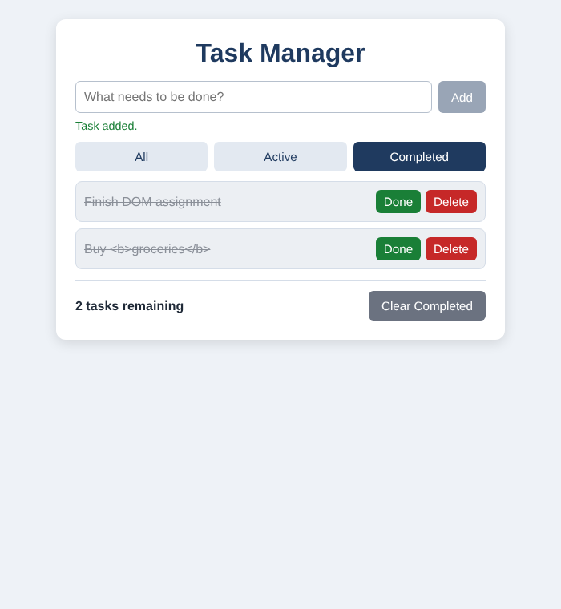
Figure 6. Filtered view: Completed only

Reflection
For me the hardest DOM concept was event delegation together with closest(). At first I thought I needed a click listener on every Delete and Done button, but the tasks are created later by JavaScript, so that would mean adding listeners again for each new task. I learned that one listener on the ul is enough, because clicks bubble up from the button to the list.
The tricky part is that event.target is not always the thing I expect. It can be the button, or something inside it, or the empty space of the list. I solved it by using event.target.closest("button") and returning early when the result is null, and then button.closest("li") to get the right task. After that, one listener handled Done and Delete for all tasks, even new ones.
Another part I had to be careful about was the edit feature. When Enter is pressed the input is replaced, and the blur event can fire too, so I added a flag to make sure the text is saved only once. I also learned that the hidden attribute does not work if the CSS sets display: flex on the same element, so I added a rule for [hidden]. Logging values in the console while testing helped me check each step.
(Word count: 211)

References
- MDN Web Docs - Document Object Model: developer.mozilla.org/en-US/docs/Web/API/Document_Object_Model
- MDN - Document.querySelector, Element.classList, Element.setAttribute, Node.appendChild
- javascript.info - Document section

