NUST SEECS
CS 236: Advanced Database Management Systems

Smart Student Mental Fatigue &
Adaptive Workload Tracker
Complete Project Documentation

Project | Smart Student Mental Fatigue & Adaptive Workload Tracker
Course | CS 236 — Advanced Database Management Systems
Instructor | Dr. Ayesha Hakim
Team | Zaina Zia (501113) • Hiba Rafique (501846)
Semester | Spring 2026
Document Type | Working Reference — Features, Logic & Database Schema

1. System Overview

The Smart Student Mental Fatigue & Adaptive Workload Tracker is a dual-purpose academic project combining an Advanced Database Management System (ADBMS) with a web application. The system is designed to monitor student mental fatigue, track academic and extracurricular workload, and surface timely recommendations and alerts — helping students, counselors, faculty, and administrators respond to burnout risk proactively.

1.1 Motivation
Student burnout is a growing problem in academic institutions. Most systems treat mental health monitoring reactively — only responding after a student reaches crisis. This system takes a data-driven, proactive approach: collecting daily self-reported stress and workload data, computing a Burnout Risk Index, and escalating alerts before a student hits breaking point.

1.2 What Makes This System Unique
- Burnout Risk Index (BRI): a composite computed score, not just a raw stress number
- Adaptive recommendations that unlock only after consistent logging behavior
- Tiered alert escalation (WATCH → WARNING → CRITICAL) with deduplication logic
- Behavioral pattern detection after 30 days of data
- Two student types: General students and 14C students — 14C students get peer benchmarking and their aggregated data is visible to faculty
- Role-based access across 5 distinct user types

1.3 System Type
Aspect | Detail
Project Type | ADBMS + Web Application (dual deliverable)
Database | Oracle SQL (relational) — triggers, stored procedures, PL/SQL
Users | 5 roles: General Student, 14C Student, Counselor, Faculty, Admin
Core Output | BRI score, stress trend, tiered alerts, adaptive recommendations
Special Feature | 14C cohort stress aggregation visible to Faculty; peer benchmarking for 14C students

2. Roles & Features

The system has five distinct roles. Every role has its own dashboard and access level. All roles share a single login system (USERS table); role-specific data lives in sub-tables.

5 Roles | Role 1 — General Student: personal dashboard, logging, BRI, recommendations, counselor request  Role 2 — 14C Student: everything General gets + peer benchmarking + feeds faculty view  Role 3 — Counselor: assigned student monitoring, alert management, manual recommendations  Role 4 — Faculty: section-level 14C aggregated stress view only  Role 5 — Admin: full system control, config, analytics, audit logs

2.1 General Student
Registration: Signs up with any email and password. No department, section, or semester required. If the email matches the 14C whitelist, the account is automatically upgraded to 14C type — otherwise it stays General.

Features
- Log daily stress (1–10) with optional notes and an emotion tag (Anxious, Tired, Motivated, Overwhelmed, Calm)
  - Multiple stress logs per day are allowed; the first is marked is_primary = 1, secondary check-ins are 0
- Log academic tasks: title, course name (plain text), deadline, estimated effort hours, task type, status
- Log extracurricular activities: name, category, duration in hours, energy cost (1–5)
- View personal stress timeline and workload overview on dashboard
- View their own Burnout Risk Index (BRI) score and stress trend label
- Receive adaptive recommendations — unlocks after 7 consecutive log days, 1 missed day forgiven, locks again on 2+ missed days
- Voluntarily request a counselor from their dashboard (sets a flag; admin/system then assigns one)
- View their assigned counselor's name once assigned
- Receive email notifications: alert raised, counselor assigned, new recommendation, weekly summary

2.2 14C Student
A 14C student is a verified NUST CS 14C class student. During registration, if the student uses their school email and it matches the EMAIL_WHITELIST, their account is automatically set to student_type = 14C. No extra steps required from the student — the system handles it silently.

Everything a General Student gets, PLUS:
- Peer benchmarking: can see where their stress and workload stands vs. the 14C cohort anonymously (percentile view)
- Their stress data (anonymized, averaged weekly) is included in the Faculty view

NOTE | 14C students never see individual peer data — only their own percentile rank vs. the cohort average.  Faculty never see individual 14C student data — only the weekly section aggregate.

2.3 Counselor
Counselors are assigned to students either automatically (triggered by an alert or student request) or manually by Admin. They see student data anonymously — no names, only student IDs and data.

- Log in to counselor dashboard
- See list of assigned students (ID + data only, no names)
- For each assigned student: view stress history, BRI score, trend label, task load, activity load
- View behavioral patterns detected for each student (after 30 days of their data)
- See tiered alerts (WATCH / WARNING / CRITICAL) for assigned students
- Acknowledge and resolve alerts
- Manually add or override recommendations for a student
- Receive email notification when a new alert is raised for one of their assigned students

2.4 Faculty
Faculty have the most restricted access in the system. They exist solely to monitor their 14C section's overall stress health — they cannot drill down into any individual student's data.

- Log in to faculty dashboard
- View weekly average stress level for the 14C cohort (aggregated, anonymized)
- View trend direction for the cohort: Increasing / Stable / Decreasing
- No access to any individual student data whatsoever

2.5 Admin
- Manage all user accounts: activate and deactivate
- Upload and manage the 14C verified email whitelist
- Configure max caseload per counselor
- Configure BRI alert thresholds (what score triggers WATCH / WARNING / CRITICAL)
- Configure recommendation unlock rules (default: 7 consecutive days)
- View system-wide analytics: stress distribution, high-risk student counts, counselor caseload overview
- View full audit logs of all system actions

3. Core Logic & Background Systems

All of these systems run in the background. Students and counselors interact with the outputs — they never manually trigger these calculations. Everything is driven by database triggers and scheduled jobs.

3.1 Burnout Risk Index (BRI)
BRI | Score range: 0 – 100. Higher = higher burnout risk.  Formula inputs: 7-day rolling stress average + weighted pending task workload score + activity energy drain total + consecutive high-stress days bonus  Recomputed after every stress log, task log, and activity log via database trigger.  Stored in STUDENT_METRICS.bri_score

How it works:
- After each student log entry, a trigger fires and pulls the latest data
- stress_avg: average of last 7 stress_level values from STRESS_LOG (primary logs only)
- workload_score: weighted sum of effort_hours for all PENDING tasks, multiplied by priority_weight, normalized by days until deadline
- activity_score: sum of energy_cost values from ACTIVITY_LOG in the last 7 days
- consecutive_high_days: count of consecutive days where stress_level >= 7
- All four factors are combined into the 0–100 BRI score and written to STUDENT_METRICS

3.2 Stress Trend Classifier
After every stress log, the trend classifier looks at the student's last 7 primary stress entries and assigns a label to STUDENT_METRICS.trend_label:

Label | Condition
IMPROVING | Stress values show a consistent downward direction over the last 7 entries
STABLE | Stress values remain roughly flat with low variance
DETERIORATING | Stress values show a consistent upward direction over the last 7 entries
VOLATILE | Stress values swing up and down with high variance — no clear direction

3.3 Alert Escalation Engine
When the BRI score is updated, a trigger checks it against the thresholds stored in SYSTEM_CONFIG. If a threshold is crossed and no OPEN alert currently exists for that student, a new alert is inserted into the ALERT table.

Alert Level | Behaviour
WATCH | BRI exceeds bri_watch threshold. Counselor notified. Student continues normally.
WARNING | BRI exceeds bri_warning threshold. Counselor notified with higher urgency.
CRITICAL | BRI exceeds bri_critical threshold. Counselor notified immediately. If no counselor is assigned, the assignment engine fires automatically.

Deduplication logic:
- A new alert is only created if no OPEN alert already exists for that student
- Full alert history is preserved — all past RESOLVED alerts remain in the table
- Counselor resolves an alert by acknowledging it on their dashboard; status flips to RESOLVED and resolved_at is stamped

3.4 Counselor Assignment Engine
Triggered by two events: a student voluntarily requesting a counselor, or a CRITICAL alert firing with no counselor currently assigned.

Assignment logic (in order):
- Check if the student has had a counselor before (look for INACTIVE rows in COUNSELOR_STUDENT)
- If yes — check if that previous counselor is under max_caseload. If yes, reassign them.
- If no previous counselor, or previous counselor is at capacity — find the counselor with the lowest current active caseload who is still under max_caseload.
- Insert a new ACTIVE row in COUNSELOR_STUDENT. Any existing ACTIVE row for the student is flipped to INACTIVE first.
- Notification is sent to both student and counselor confirming the assignment.

3.5 Adaptive Recommendation Engine
Recommendations are generated by the system (rule-based) or manually added by a counselor. However, students only see them when their recommendation_status in STUDENT_METRICS is UNLOCKED.

State | Condition
LOCKED (default) | New student; has not yet built a 7-day streak
UNLOCKED | Student has logged stress on 7 consecutive days (1 missed day is forgiven)
Re-LOCKED | Student misses 2 or more consecutive days — recommendations lock again

Recommendation types:
- REST — student is showing high stress and low activity recovery time; suggest rest
- DEFER_TASK — upcoming deadline cluster detected; suggest deferring a lower-priority task
- CONTACT_COUNSELOR — BRI rising, recommend student proactively reach out
- RESOURCE — link to a wellness resource, breathing exercise, or academic support page

3.6 Behavioral Pattern Detection
Activates at 30 days | This feature only activates once a student has 30+ days of logged data.  A weekly scheduled database job re-runs pattern detection for all eligible students.  Results are written to PATTERN_PROFILE.

The pattern detection job correlates STRESS_LOG, TASK_LOG, and ACTIVITY_LOG across the rolling 30-day window to identify recurring triggers. For example: does stress spike consistently during exam weeks? Does high social activity correlate with stress the following day?

- trigger_category: what type of event correlates with high stress (e.g. EXAM_WEEK, SOCIAL_OVERLOAD, DEADLINE_CLUSTER)
- frequency_count: how many times this pattern has appeared in the window
- avg_severity: average stress level during detected pattern occurrences
- pattern_summary: a human-readable description written for counselor display

3.7 Peer Benchmarking (14C Only)
14C students can view their stress and workload percentile compared to the rest of the 14C cohort. This is computed from STUDENT_METRICS across all 14C students. No individual peer data is ever exposed — only the student's own rank within the anonymized cohort average.

3.8 Faculty Aggregation
A weekly scheduled job computes the average stress level across all 14C students and writes it to WEEKLY_SECTION_STATS. Faculty members can only see this table — they have no access to any other student data. The stat includes: week start/end, average stress, student count (anonymized), and trend direction vs. the previous week.

3.9 Email Notification System
Trigger Event | Who Gets Notified
New ALERT created | Assigned counselor (email) + student (in-app)
Counselor assigned to student | Student (email confirmation) + counselor (new assignment email)
New RECOMMENDATION unlocked | Student (in-app notification)
Weekly summary | Student (weekly digest of their BRI, streak, upcoming tasks)

4. Application Workflow

4.1 Registration Flow
- User visits signup page and enters: name, email, password
- System checks if email exists in EMAIL_WHITELIST
- If yes → student_type set to 14C, EMAIL_WHITELIST.is_used flipped to 1, student_id back-reference saved
- If no → student_type set to GENERAL
- Row inserted into USERS, then into STUDENT
- Row inserted into STUDENT_METRICS with default values (BRI = 0, streak = 0, status = LOCKED)
- Student lands on their dashboard

Hint shown on signup | The signup page shows a small hint: 'NUST 14C CS student? Use your school email to unlock extra features.'  No extra field required — the system detects automatically.

4.2 Daily Student Workflow
- Student logs in and sees their dashboard: BRI score, trend, log streak, upcoming tasks
- Student logs their stress for the day (level + optional note + emotion tag)
- Trigger fires: STUDENT_METRICS updated — stress_avg, log_streak, last_log_date, consecutive_high_days, trend_label, bri_score all recomputed
- If BRI crosses a threshold → ALERT created → counselor notified
- Student logs any academic tasks or activities (optional, same session or any time)
- If tasks logged → workload_score and bri_score recomputed
- If streak hits 7 → recommendation_status flipped to UNLOCKED → student can now see recommendations

4.3 Counselor Workflow
- Counselor logs in to their dashboard
- Dashboard shows list of assigned students (by ID, anonymous) with BRI scores and trend labels
- Counselor clicks a student to see full history: stress logs, task load, activity load, pattern profile
- Any open alerts are shown with severity level
- Counselor resolves an alert (clicks acknowledge) → ALERT.status = RESOLVED, resolved_at stamped
- Counselor can manually add a recommendation for the student
- Counselor receives email when a new alert fires for any of their assigned students

4.4 Admin Workflow
- Admin logs in to admin panel
- Can upload a CSV of 14C student emails to populate EMAIL_WHITELIST
- Can activate or deactivate any user account
- Can configure BRI thresholds and recommendation unlock rules in SYSTEM_CONFIG
- Can view system-wide analytics: how many students are at each alert level, counselor caseload distribution
- Can view the full AUDIT_LOG of all system actions

4.5 Faculty Workflow
- Faculty logs in to faculty dashboard
- Sees only: this week's 14C cohort average stress, trend direction, student count
- Can scroll back to view previous weeks from WEEKLY_SECTION_STATS
- No drilldown, no individual data

5. Complete Database Schema

18 tables across 4 groups. Every column is listed with its type, constraints, and purpose. This is the single source of truth for the database.

Grp | Name | Tables
1 | Users & Roles | USERS, STUDENT, COUNSELOR, FACULTY, ADMIN, EMAIL_WHITELIST
2 | Core Activity Data | STRESS_LOG, TASK_LOG, ACTIVITY_LOG
3 | Intelligence & Alerts | STUDENT_METRICS, ALERT, RECOMMENDATION, PATTERN_PROFILE
4 | Supporting & System | COUNSELOR_STUDENT, NOTIFICATION_LOG, AUDIT_LOG, WEEKLY_SECTION_STATS, SYSTEM_CONFIG

Group 1 — Users & Roles
All roles share the USERS table. Role-specific data is in sub-tables. student_id, counselor_id, faculty_id, and admin_id are all foreign keys to USERS.user_id — same ID, no duplication.

USERS
Central identity table. One row per person regardless of role.
Column | Type / Constraint | Notes
user_id | NUMBER PK | Surrogate primary key
name | VARCHAR2(100) NOT NULL | Full name
email | VARCHAR2(100) UNIQUE NOT NULL | Login email
password_hash | VARCHAR2(255) NOT NULL | Bcrypt hashed password
role | VARCHAR2(20) CHECK (STUDENT|COUNSELOR|FACULTY|ADMIN) | Determines dashboard and access
created_at | TIMESTAMP DEFAULT CURRENT_TIMESTAMP | Account creation time
is_active | NUMBER(1) DEFAULT 1 | Soft delete; Admin can deactivate

STUDENT
Extends USERS. student_id = USERS.user_id. student_type is auto-set at registration.
Column | Type / Constraint | Notes
student_id | NUMBER PK, FK → USERS(user_id) | Same ID as USERS row
student_type | VARCHAR2(20) CHECK (GENERAL|14C) | Auto-set: 14C if email in whitelist, else GENERAL
counselor_requested | NUMBER(1) DEFAULT 0 | Set to 1 when student clicks Request Counselor on dashboard
request_date | DATE | Date of voluntary counselor request; NULL if none

COUNSELOR
Extends USERS for counselors.
Column | Type / Constraint | Notes
counselor_id | NUMBER PK, FK → USERS(user_id) | Same ID as USERS row
specialization | VARCHAR2(100) | e.g. Anxiety, Academic Stress
max_caseload | NUMBER | Admin-configurable cap on assigned students

FACULTY
Extends USERS. Faculty only see aggregated 14C cohort stress data.
Column | Type / Constraint | Notes
faculty_id | NUMBER PK, FK → USERS(user_id) | Same ID as USERS row
department | VARCHAR2(50) | Faculty department (informational only)

ADMIN
Extends USERS. Full system access.
Column | Type / Constraint | Notes
admin_id | NUMBER PK, FK → USERS(user_id) | Same ID as USERS row
permissions | VARCHAR2(200) | Optional granular permission string

EMAIL_WHITELIST
Pre-approved 14C emails uploaded by Admin. Checked at registration to auto-assign student_type = 14C.
Column | Type / Constraint | Notes
email | VARCHAR2(100) PK | The whitelisted school email
is_used | NUMBER(1) DEFAULT 0 | Flipped to 1 when the student registers
student_id | NUMBER FK → STUDENT(student_id) | Back-reference set at registration for audit trail

Group 2 — Core Activity Data
What students log every day. These three tables are the primary inputs to all scoring, trend analysis, and recommendations.

STRESS_LOG
Daily stress entries. Multiple logs per day allowed. is_primary = 1 for the main daily entry.
Column | Type / Constraint | Notes
stress_id | NUMBER PK | Surrogate key
student_id | NUMBER NOT NULL, FK → STUDENT | Which student
stress_level | NUMBER CHECK (1–10) | Self-reported stress rating
note | VARCHAR2(300) | Optional free-text note
emotion_tag | VARCHAR2(30) CHECK (ANXIOUS|TIRED|MOTIVATED|OVERWHELMED|CALM) | Emotional state
is_primary | NUMBER(1) DEFAULT 1 | 1 = main daily log; 0 = secondary check-in
log_date | DATE DEFAULT SYSDATE | Date of entry
log_time | TIMESTAMP DEFAULT CURRENT_TIMESTAMP | Exact time; orders multiple daily logs

TASK_LOG
Academic tasks. course_name is plain text — no COURSE table or FK. Status drives workload scoring.
Column | Type / Constraint | Notes
task_id | NUMBER PK | Surrogate key
student_id | NUMBER NOT NULL, FK → STUDENT | Which student
title | VARCHAR2(150) | Task title
course_name | VARCHAR2(100) | Plain text course name (student-typed, no FK)
deadline | DATE | Due date
effort_hours | NUMBER | Estimated hours to complete
task_type | VARCHAR2(30) CHECK (ASSIGNMENT|QUIZ|PROJECT|EXAM|OTHER) | Task category
status | VARCHAR2(20) CHECK (PENDING|COMPLETED|DEFERRED) | Only PENDING tasks feed workload score
priority_weight | NUMBER DEFAULT 1 | Multiplier for workload scoring; higher = more urgent
created_at | DATE DEFAULT SYSDATE | When the task was logged

ACTIVITY_LOG
Extracurricular activities. energy_cost feeds the activity_score component of BRI.
Column | Type / Constraint | Notes
activity_id | NUMBER PK | Surrogate key
student_id | NUMBER NOT NULL, FK → STUDENT | Which student
activity_name | VARCHAR2(100) | Name of activity
category | VARCHAR2(30) CHECK (SPORTS|FITNESS|ENTERTAINMENT|SOCIAL|OTHER) | Activity type
duration_hours | NUMBER | Time spent
energy_cost | NUMBER CHECK (1–5) | Self-rated energy drain; feeds BRI
log_date | DATE DEFAULT SYSDATE | Date of activity

Group 3 — Intelligence & Alerts
Computed and derived data. All fields in this group are written by triggers or scheduled jobs — never directly by users.

STUDENT_METRICS
One row per student. The live computed state. Updated after every log entry.
Column | Type / Constraint | Notes
metric_id | NUMBER PK | Surrogate key
student_id | NUMBER NOT NULL, FK → STUDENT | One row per student
bri_score | NUMBER CHECK (0–100) | Burnout Risk Index — composite score
stress_avg | NUMBER | Rolling 7-day average of primary stress logs
workload_score | NUMBER | Weighted PENDING task effort, normalized by deadline proximity
activity_score | NUMBER | Sum of recent energy_cost values from ACTIVITY_LOG
consecutive_high_days | NUMBER DEFAULT 0 | Consecutive days with stress_level >= 7; feeds BRI + alerts
log_streak | NUMBER DEFAULT 0 | Consecutive days student has logged; drives recommendation unlock
last_log_date | DATE | Date of most recent stress log; used to detect missed days
trend_label | VARCHAR2(20) CHECK (IMPROVING|STABLE|DETERIORATING|VOLATILE) | Based on last 7 primary stress entries
recommendation_status | VARCHAR2(10) CHECK (LOCKED|UNLOCKED) | UNLOCKED after 7-day streak; re-LOCKED on 2+ misses
calculated_at | TIMESTAMP DEFAULT CURRENT_TIMESTAMP | Last recomputation time

ALERT
Full alert history. No unique constraint on status — all past alerts preserved.
Column | Type / Constraint | Notes
alert_id | NUMBER PK | Surrogate key
student_id | NUMBER NOT NULL, FK → STUDENT | Which student
counselor_id | NUMBER FK → COUNSELOR | Auto-assigned counselor; NULL until assignment fires
alert_level | VARCHAR2(10) CHECK (WATCH|WARNING|CRITICAL) | Severity tier
bri_value | NUMBER | BRI score at time of alert creation
status | VARCHAR2(10) CHECK (OPEN|RESOLVED) | OPEN = active; RESOLVED = counselor acknowledged
created_at | TIMESTAMP DEFAULT CURRENT_TIMESTAMP | When alert was raised
resolved_at | TIMESTAMP | When counselor resolved; NULL if still open

RECOMMENDATION
System or counselor-generated. Only visible to student when STUDENT_METRICS.recommendation_status = UNLOCKED.
Column | Type / Constraint | Notes
recommendation_id | NUMBER PK | Surrogate key
student_id | NUMBER NOT NULL, FK → STUDENT | Which student
type | VARCHAR2(30) CHECK (REST|DEFER_TASK|CONTACT_COUNSELOR|RESOURCE) | Recommendation category
message | VARCHAR2(300) | Human-readable text shown to student
generated_by | VARCHAR2(20) CHECK (SYSTEM|COUNSELOR) | Source of recommendation
created_at | TIMESTAMP DEFAULT CURRENT_TIMESTAMP | Creation time
unlocked_at | TIMESTAMP | When it became visible to the student
expires_at | TIMESTAMP | NULL if no expiry; set when re-locking logic fires
is_active | NUMBER(1) DEFAULT 1 | 0 = superseded or expired

PATTERN_PROFILE
One row per student. Populated after 30 days of data by weekly scheduled job.
Column | Type / Constraint | Notes
profile_id | NUMBER PK | Surrogate key
student_id | NUMBER UNIQUE, FK → STUDENT | One profile per student
trigger_category | VARCHAR2(50) | What triggers high stress e.g. EXAM_WEEK, SOCIAL_OVERLOAD
frequency_count | NUMBER | How often this pattern appears in the rolling window
avg_severity | NUMBER | Average stress level during detected pattern occurrences
pattern_summary | VARCHAR2(500) | Human-readable description for counselor display
last_updated | DATE | When pattern was last recomputed

Group 4 — Supporting & System Tables

COUNSELOR_STUDENT
Full assignment history. Active assignment queried by WHERE status = 'ACTIVE'. Previous counselor checked here for reassignment logic.
Column | Type / Constraint | Notes
assignment_id | NUMBER PK | Surrogate key
counselor_id | NUMBER NOT NULL, FK → COUNSELOR | Assigned counselor
student_id | NUMBER NOT NULL, FK → STUDENT | Assigned student
assigned_date | DATE DEFAULT SYSDATE | When assignment was made
status | VARCHAR2(10) CHECK (ACTIVE|INACTIVE) | One ACTIVE row per student at a time (enforced in trigger)
assigned_by | VARCHAR2(20) CHECK (SYSTEM|ADMIN) | Auto-triggered or manually set by Admin

NOTIFICATION_LOG
Record of all emails and in-app notifications sent.
Column | Type / Constraint | Notes
notification_id | NUMBER PK | Surrogate key
user_id | NUMBER NOT NULL, FK → USERS | Recipient
message | VARCHAR2(300) | Notification body
type | VARCHAR2(30) CHECK (ALERT|RECOMMENDATION|ASSIGNMENT|SUMMARY) | Event type
sent_at | TIMESTAMP DEFAULT CURRENT_TIMESTAMP | Delivery timestamp

AUDIT_LOG
Immutable log of all significant system actions for Admin review.
Column | Type / Constraint | Notes
audit_id | NUMBER PK | Surrogate key
user_id | NUMBER FK → USERS | Who performed the action
action | VARCHAR2(200) | Description of what happened
target_table | VARCHAR2(50) | Which table was affected
target_id | NUMBER | PK of the affected row
timestamp | TIMESTAMP DEFAULT CURRENT_TIMESTAMP | When it happened

WEEKLY_SECTION_STATS
Pre-aggregated weekly stress data for the 14C cohort. Populated by weekly scheduled job. Exposed to Faculty role only.
Column | Type / Constraint | Notes
stat_id | NUMBER PK | Surrogate key
week_start | DATE | Monday of the week
week_end | DATE | Sunday of the week
avg_stress | NUMBER | Average stress across all 14C students that week
student_count | NUMBER | Number of students whose data was included
trend_label | VARCHAR2(20) CHECK (INCREASING|STABLE|DECREASING) | Direction vs. previous week
computed_at | TIMESTAMP DEFAULT CURRENT_TIMESTAMP | When this row was calculated

SYSTEM_CONFIG
Admin-controlled global settings. Single configuration row.
Column | Type / Constraint | Notes
config_id | NUMBER PK | Surrogate key
max_caseload | NUMBER | Default max students per counselor
bri_watch | NUMBER | BRI threshold for WATCH alert
bri_warning | NUMBER | BRI threshold for WARNING alert
bri_critical | NUMBER | BRI threshold for CRITICAL alert
unlock_days | NUMBER DEFAULT 7 | Consecutive log days required to unlock recommendations
allowed_misses | NUMBER DEFAULT 1 | Missed days forgiven before recommendations lock
pattern_window_days | NUMBER DEFAULT 30 | Days of history before pattern detection activates

6. Foreign Key Relationships

Child Column (FK) | References
STUDENT.student_id | USERS.user_id
COUNSELOR.counselor_id | USERS.user_id
FACULTY.faculty_id | USERS.user_id
ADMIN.admin_id | USERS.user_id
EMAIL_WHITELIST.student_id | STUDENT.student_id
STRESS_LOG.student_id | STUDENT.student_id
TASK_LOG.student_id | STUDENT.student_id
ACTIVITY_LOG.student_id | STUDENT.student_id
STUDENT_METRICS.student_id | STUDENT.student_id
ALERT.student_id | STUDENT.student_id
ALERT.counselor_id | COUNSELOR.counselor_id
RECOMMENDATION.student_id | STUDENT.student_id
PATTERN_PROFILE.student_id | STUDENT.student_id
COUNSELOR_STUDENT.counselor_id | COUNSELOR.counselor_id
COUNSELOR_STUDENT.student_id | STUDENT.student_id
NOTIFICATION_LOG.user_id | USERS.user_id
AUDIT_LOG.user_id | USERS.user_id

7. Triggers & Scheduled Jobs

All computed fields are maintained automatically. No manual recalculation needed.

7.1 Database Triggers
Event | Action
After INSERT on STRESS_LOG | Update STUDENT_METRICS: recompute stress_avg, log_streak, last_log_date, consecutive_high_days, trend_label, recommendation_status, bri_score
After INSERT on TASK_LOG | Recompute workload_score and bri_score in STUDENT_METRICS
After UPDATE on TASK_LOG (status) | Recompute workload_score when a task is marked COMPLETED or DEFERRED
After INSERT on ACTIVITY_LOG | Recompute activity_score and bri_score in STUDENT_METRICS
After UPDATE on STUDENT_METRICS (bri_score) | Check BRI vs SYSTEM_CONFIG thresholds; if threshold crossed and no OPEN alert exists, insert ALERT row
After INSERT on ALERT | Fire counselor assignment engine if CRITICAL; insert NOTIFICATION_LOG for student and counselor
After INSERT on COUNSELOR_STUDENT | Flip previous ACTIVE row to INACTIVE; insert NOTIFICATION_LOG confirmation for student and counselor
After UPDATE on STUDENT (counselor_requested = 1) | Trigger counselor assignment engine

7.2 Scheduled Jobs (Weekly)
- Aggregate 14C cohort stress data into WEEKLY_SECTION_STATS every Monday
- Re-run pattern detection for all students with 30+ days of data; update PATTERN_PROFILE
- Send weekly summary notifications to all active students

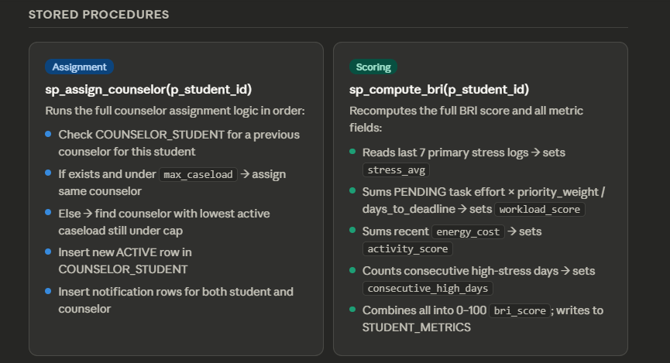

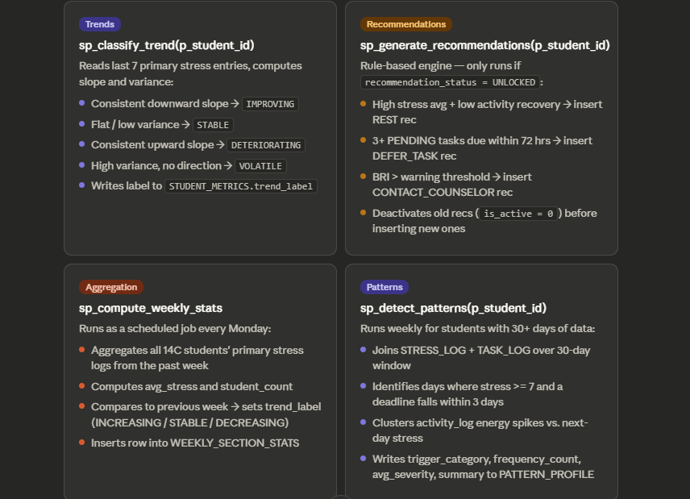

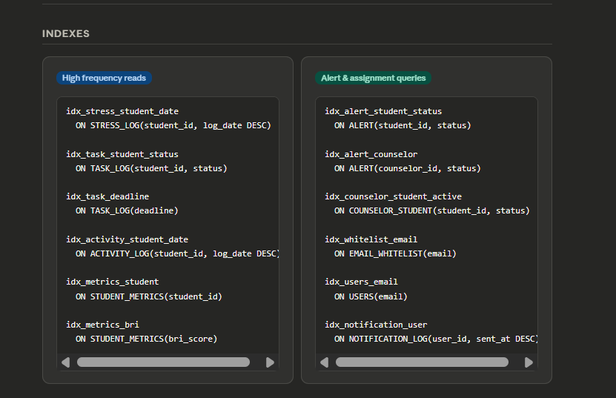

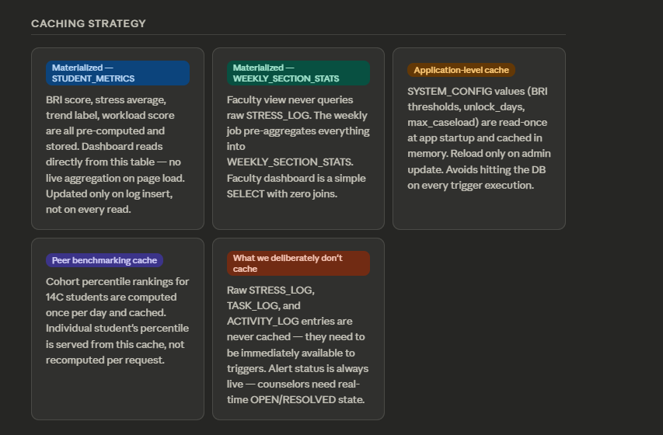

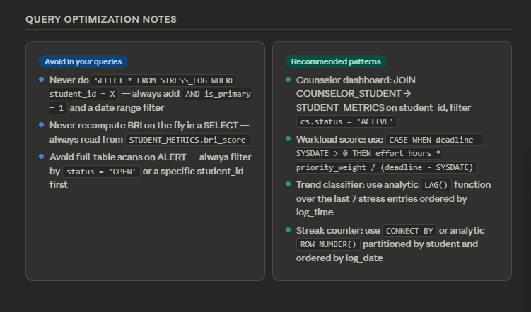

Smart Fatigue Tracker • CS 236 ADBMS • NUST SEECS • Spring 2026

