Cybersecurity & Ethical Hacking Internship
Task 2 — Network Security & Scanning Report
Reconnaissance, Scanning & Traffic Analysis (Days 13–24)
Intern Name | Shaik Hiba Tharunnum
Offer Letter ID | APSPL2645050
Internship Domain | Cybersecurity & Ethical Hacking
Organization | ApexPlanet Software Pvt. Ltd.
Task | Task 2 — Network Security & Scanning

1. Objective
The goal of this task was to learn reconnaissance, port and service scanning, vulnerability assessment, network traffic analysis, and basic firewall configuration — building directly on the isolated lab environment (Kali Linux attacker machine and Metasploitable2 target machine) established in Task 1.

2. Reconnaissance

2.1 Passive Reconnaissance
Passive recon gathers information without directly contacting the target, using public records instead. whois and nslookup were run against a public domain to demonstrate this technique safely.
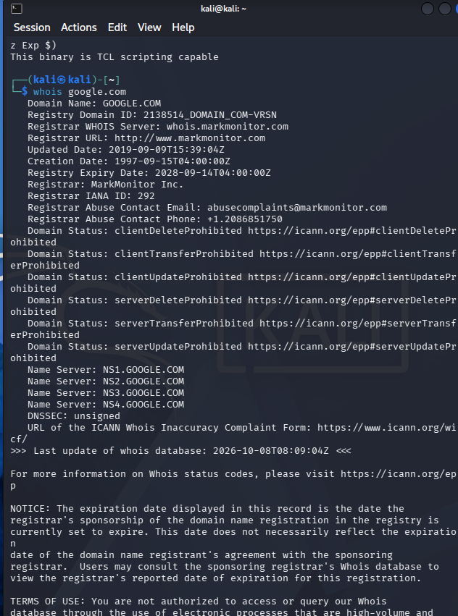
Figure 1: whois lookup showing domain registration details.
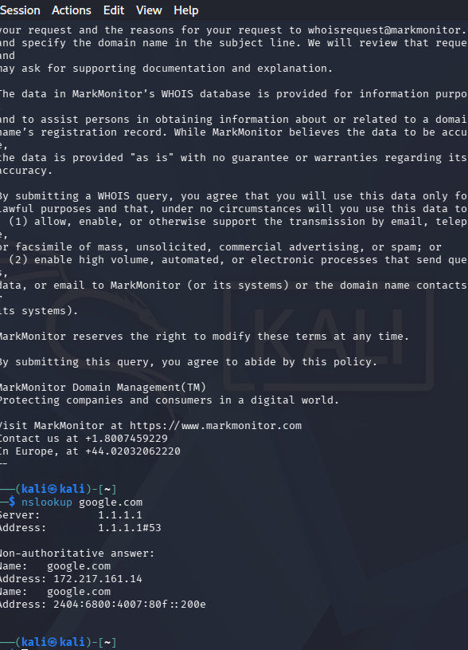
Figure 2: nslookup resolving a domain name to its IP address.
A Google dork (site:google.com filetype:pdf) was also used to demonstrate advanced search-operator-based reconnaissance, a technique used to locate indexed but potentially sensitive documents.

Figure 3: Google dorking search results using the filetype: and site: operators.
A general web search for exposed "apache" services was also performed to demonstrate the kind of open-source intelligence (OSINT) gathering techniques used in the reconnaissance phase, in the spirit of tools like Shodan.

Figure 4: OSINT-style search demonstrating service/technology discovery techniques.

2.2 Active Reconnaissance
Active recon directly contacts the target, performed here only against the lab's own Metasploitable2 machine. A ping sweep (nmap -sn 192.168.56.0/24) identified all live hosts on the lab subnet, and a banner grab against port 21 (FTP) using Netcat revealed the exact service version running.
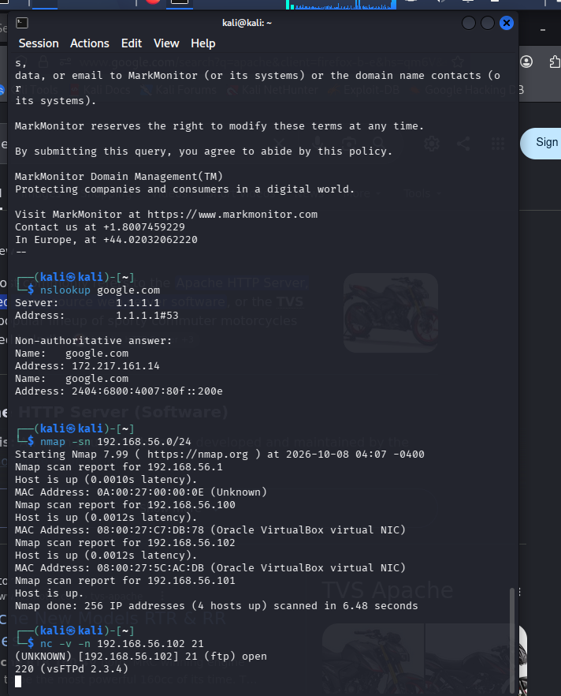
Figure 5: Ping sweep identifying live hosts on the lab network, followed by a banner grab revealing vsFTPd 2.3.4 on Metasploitable2 — a version later confirmed to carry a known critical vulnerability.

3. Port & Service Scanning
A TCP SYN scan (nmap -sS -Pn) was run against Metasploitable2, identifying 20+ open ports and their associated services.
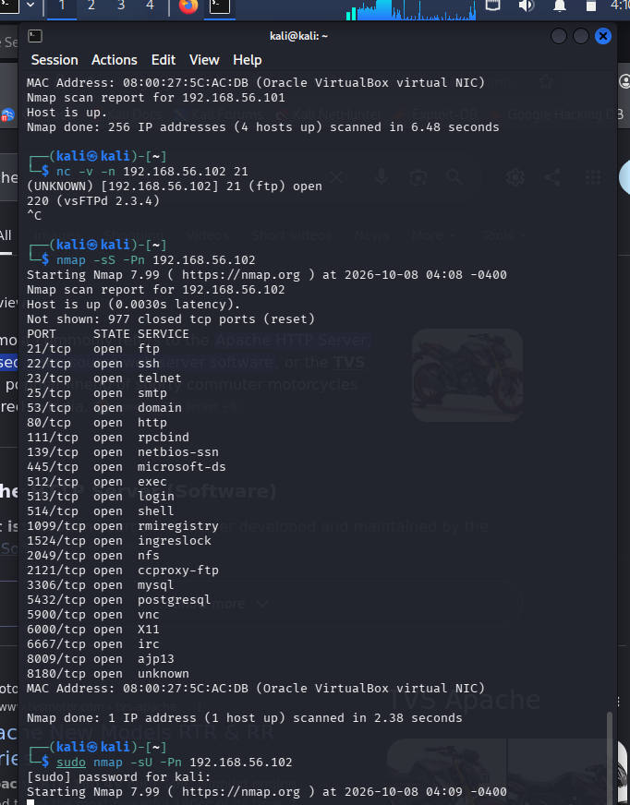
Figure 6: TCP SYN scan results against Metasploitable2, showing a wide range of open ports and services.
A combined scan with service version detection and OS fingerprinting (nmap -sV -O -Pn) was then run and saved to a report file (nmap_scan_report.txt), providing exact version numbers for every detected service and identifying the target's operating system as Linux 2.6.x.
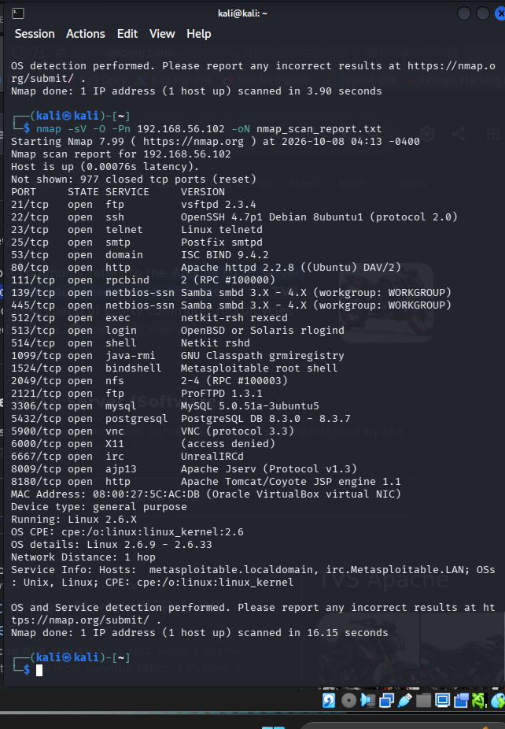
Figure 7: Combined Nmap service-version and OS-detection scan, saved as the formal scan report deliverable.

4. Vulnerability Assessment
Rather than relying solely on an automated vulnerability scanner, the exact service versions identified in the Nmap scan above were manually cross-referenced against publicly known CVEs. This produced a precise, evidence-based vulnerability report categorized by severity, as required by the task deliverables.
Service | Version | Severity | Known Issue
vsFTPd | 2.3.4 | Critical | Contains an intentional backdoor (CVE-2011-2523) allowing remote root access via a crafted username
Samba | 3.X | Critical | Multiple known remote code execution vulnerabilities (e.g., CVE-2007-2447 "usermap script")
UnrealIRCd | (detected) | Critical | Linked to a known 2010 trojaned source code backdoor incident
Apache httpd | 2.2.8 | High | Multiple known CVEs for this old, unsupported branch
OpenSSH | 4.7p1 | Medium | Older version with several known lower-severity vulnerabilities

These findings show that Metasploitable2 is running multiple outdated, critically vulnerable services by design, consistent with its purpose as a safe penetration-testing practice target. The vsFTPd finding in particular was corroborated directly by the banner grab performed during the reconnaissance phase.

5. Packet Analysis with Wireshark

5.1 Capturing Unencrypted FTP Credentials
An FTP session was initiated from Kali to Metasploitable2 while Wireshark captured traffic on eth0, filtered to ftp. The capture confirms that FTP transmits login credentials in plain text, fully readable to anyone able to observe network traffic.
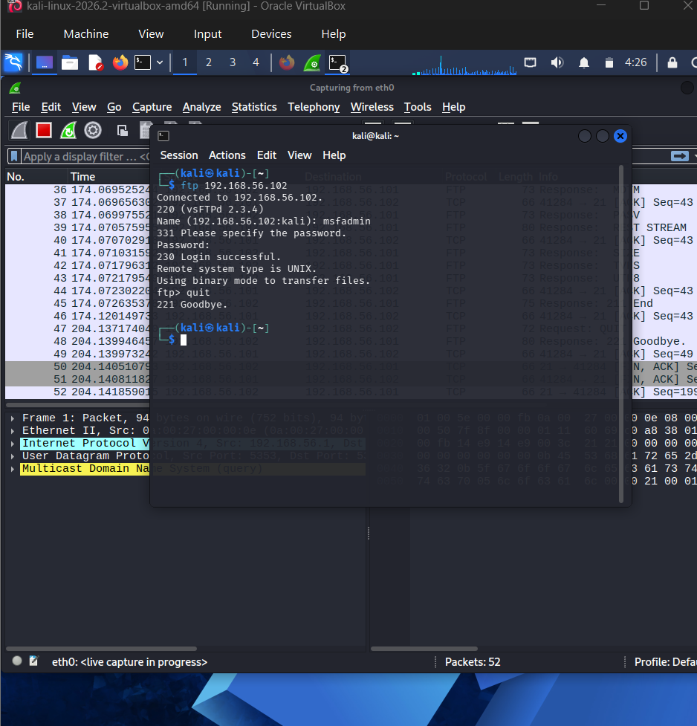
Figure 8: FTP login session, demonstrating the protocol's lack of encryption for credentials.

5.2 SYN Flood Analysis
A SYN flood was simulated against Metasploitable2 using hping3 in flood mode, while Wireshark captured traffic filtered to tcp.flags.syn==1 and tcp.flags.ack==0. The capture shows well over 100,000 SYN packets sent in a matter of seconds, visually demonstrating the packet pattern characteristic of a denial-of-service SYN flood attack.
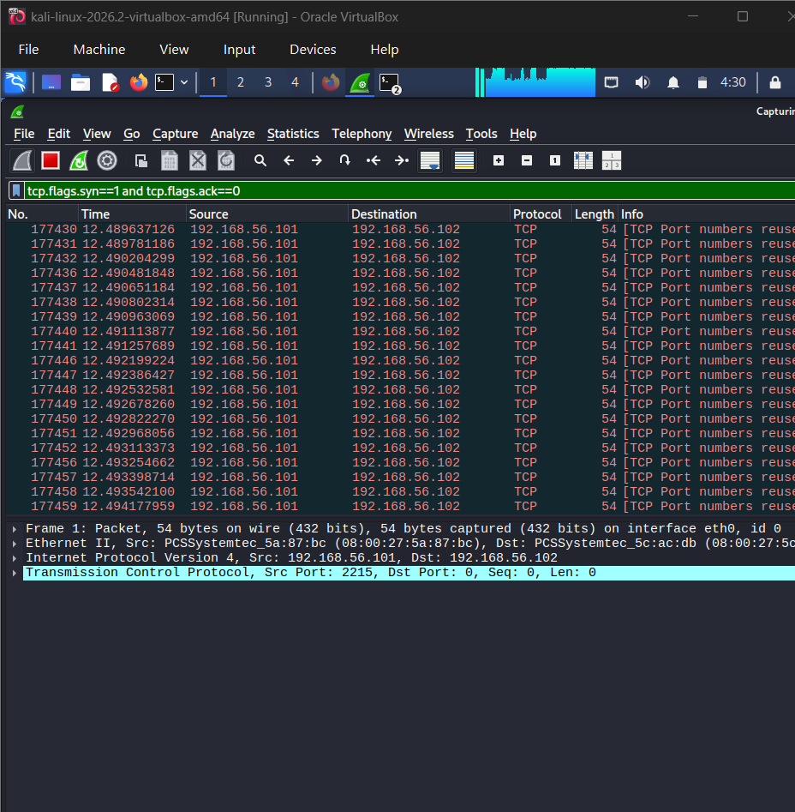
Figure 9: Wireshark capture of a simulated SYN flood, showing a massive burst of SYN packets with no corresponding ACK replies.

6. Firewall Basics (iptables)
A simple iptables rule was created to demonstrate basic firewall control. An initial rule blocking INPUT traffic on port 21 was tested but did not affect an outgoing Netcat connection, since INPUT rules govern incoming traffic only. This was corrected by adding an OUTPUT rule instead, which successfully blocked Kali's own outgoing connection attempts to port 21 — directly demonstrating firewall enforcement.
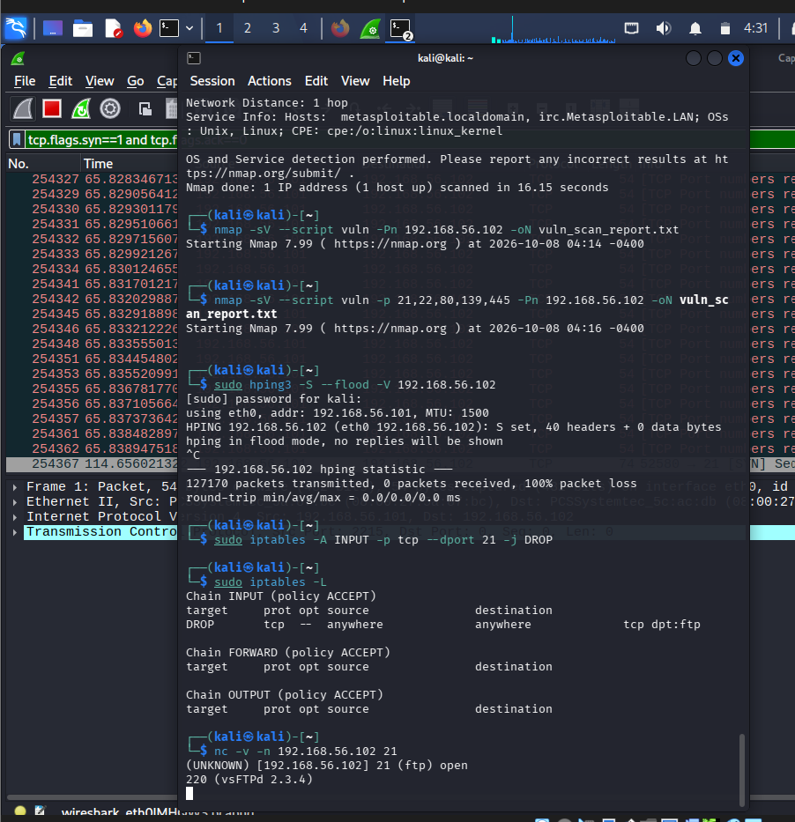
Figure 10: Initial INPUT rule added and verified with iptables -L; the outgoing Netcat test still succeeds, correctly showing that INPUT rules do not govern outbound traffic.
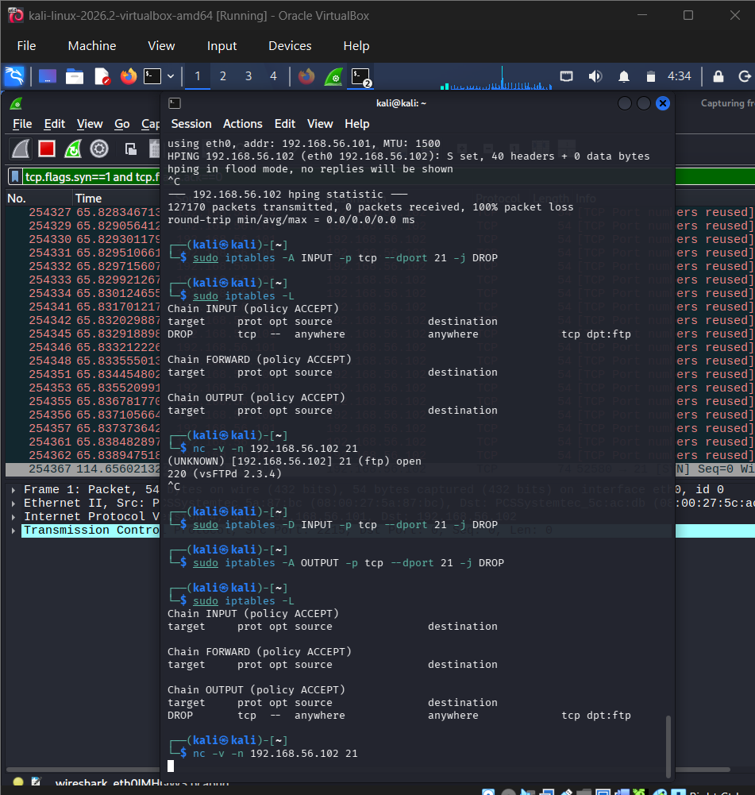
Figure 11: Corrected OUTPUT rule blocking port 21 — the subsequent Netcat connection attempt hangs with no response, confirming the firewall rule is actively blocking outbound traffic on that port. The rule was removed afterward to restore normal connectivity.

7. Key Concepts Covered
- Passive vs. active reconnaissance techniques (whois, nslookup, Google dorking, OSINT search, ping sweep, banner grabbing)
- Nmap scanning techniques: TCP SYN scans, service version detection, OS fingerprinting
- Manual vulnerability assessment using version-matched CVE research, categorized by severity
- Packet-level analysis of unencrypted credential exposure (FTP) using Wireshark
- Recognizing SYN flood attack patterns at the packet level
- Basic firewall rule creation and verification using iptables (INPUT vs. OUTPUT chains)

8. Conclusion
Task 2 is complete. Building on the lab established in Task 1, this task covered the full reconnaissance-to-firewall workflow: gathering information passively and actively, scanning for open ports and services, assessing vulnerabilities with severity ratings, analyzing live traffic for both credential exposure and attack patterns, and applying basic firewall rules to control network access. These skills form the core toolkit for the web application security testing and exploitation work in the tasks that follow.

