ApexPlanet Cybersecurity & Ethical Hacking Internship
Task 3: Web Application Security
Days 25–36 | DVWA on Metasploitable2
Intern Name | Shaik Hiba Tharunnum
Offer Letter ID | APSPL2645050
Email | hibagun007@gmail.com
Organization | ApexPlanet Software Pvt. Ltd.
Internship Domain | Cybersecurity & Ethical Hacking
GitHub Username | HibaShaik13
Task | Task 3 — Web Application Security (Days 25–36)

1. Objective
This task covers hands-on identification and exploitation of common web application vulnerabilities in the OWASP Top 10 category, performed entirely against Damn Vulnerable Web Application (DVWA) hosted on the Metasploitable2 target machine (192.168.56.102) from the Kali Linux attacker machine (192.168.56.101). Vulnerabilities covered: SQL Injection, Stored and Reflected Cross-Site Scripting (XSS), Cross-Site Request Forgery (CSRF), Local and Remote File Inclusion (LFI/RFI), Burp Suite request interception and fuzzing setup, and a web security headers review.

2. SQL Injection

2.1 Low Security — Authentication Bypass Pattern
Using the DVWA SQL Injection module at security level Low, the payload ' OR '1'='1 was submitted in the User ID field. Because the backend query concatenates user input directly into the SQL statement (SELECT first_name, last_name FROM users WHERE user_id = '$id'), the injected OR '1'='1 condition is always true, causing the query to return every row in the users table instead of a single match.
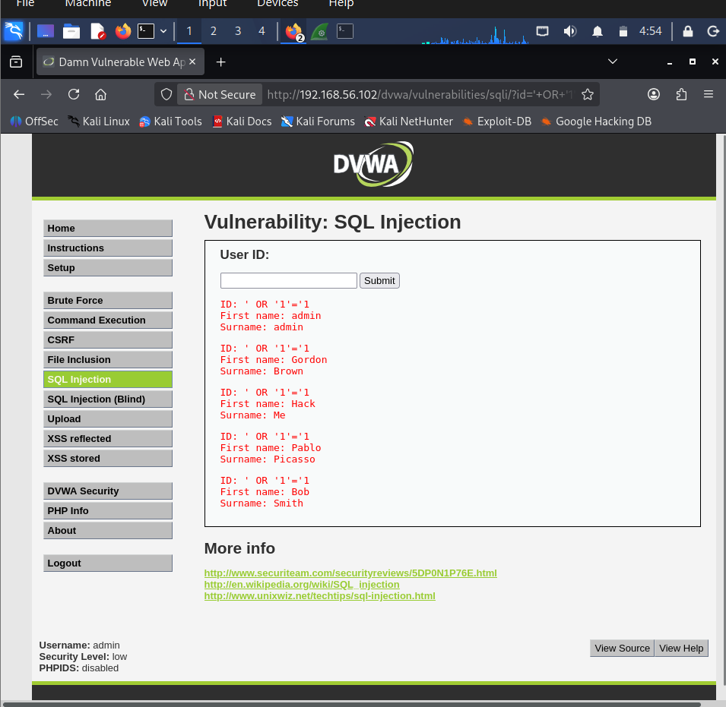
Figure 1: ' OR '1'='1 payload returning all 5 DVWA users.
Building on this, a UNION-based payload — ' UNION SELECT user, password FROM users -- - — was used to pull data from the users table directly, extracting every username alongside its MD5 password hash in a single request.
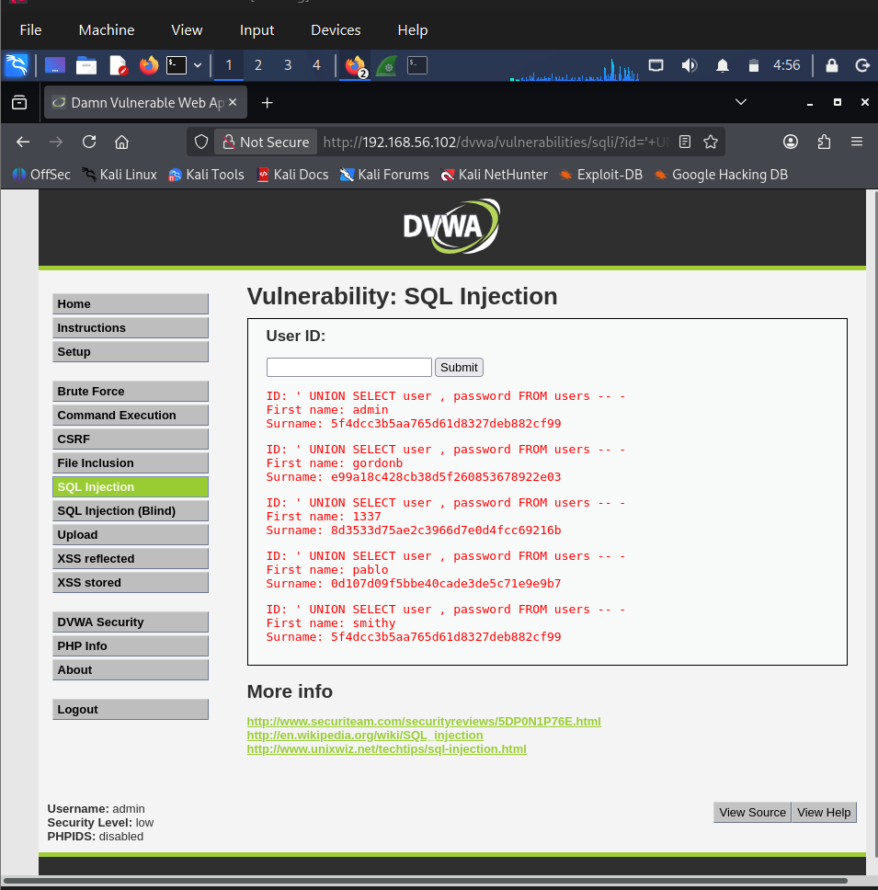
Figure 2: UNION SELECT payload extracting usernames and MD5 password hashes.
Extracted hashes (reused for Task 4 password cracking):
admin / smithy : 5f4dcc3b5aa765d61d8327deb882cf99 (= "password")
gordonb : e99a18c428cb38d5f260853678922e03
1337 : 8d3533d75ae2c3966d7e0d4fcc69216b
pablo : 0d107d09f5bbe40cade3de5c71e9e9b7

2.2 Low vs. High Security — Source Code Comparison
Viewing the Low-security source confirms the raw, unsanitized concatenation shown above — no escaping, no type checking.
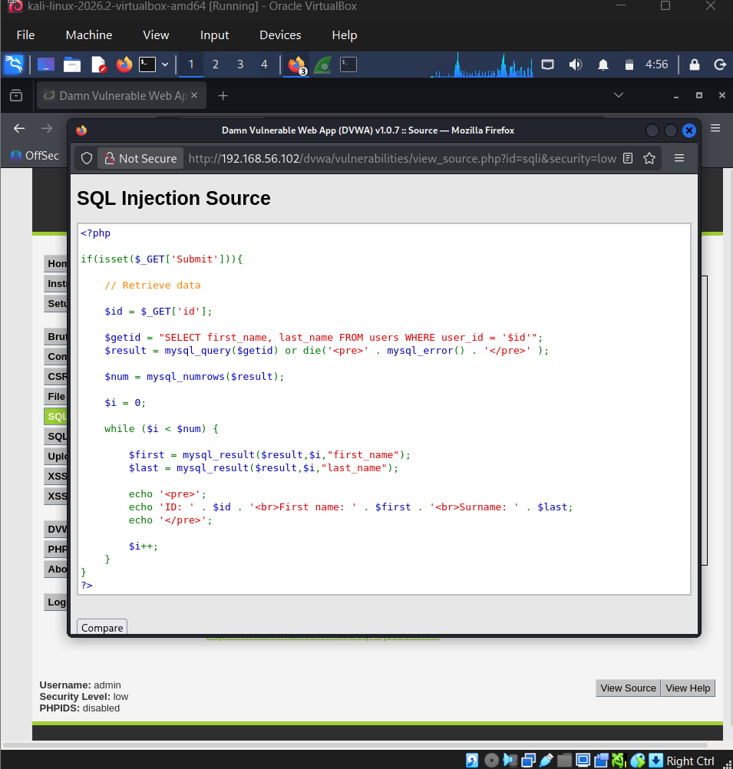
Figure 3: Low-security SQLi source — raw string concatenation into the SQL query.
At High security, DVWA applies stripslashes(), mysql_real_escape_string(), and an is_numeric() check before the query runs. This blocks the classic string-based payloads used above, but it is still escaping and input validation, not a parameterized query — an honest and important distinction worth noting rather than treating High as "fixed."
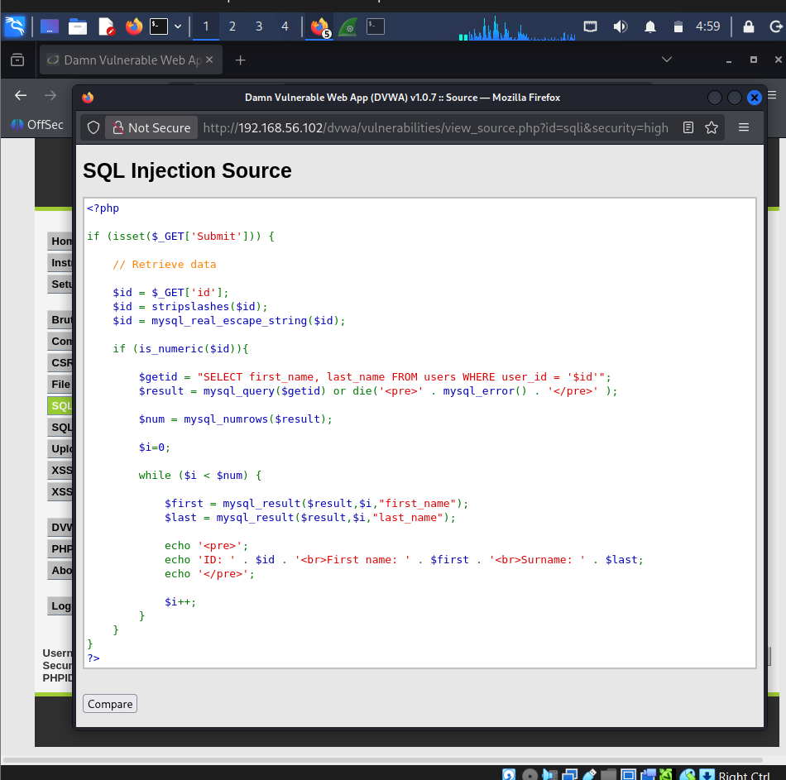
Figure 4: High-security SQLi source — escaping + is_numeric() validation, not prepared statements.

3. Cross-Site Scripting (XSS)

3.1 Stored XSS
The payload <script>alert('Stored XSS')</script> was submitted into the guestbook Message field at Low security. The script executed immediately on submission and again on every page reload, confirming the payload was persisted server-side rather than just reflected once — the defining trait of stored XSS.
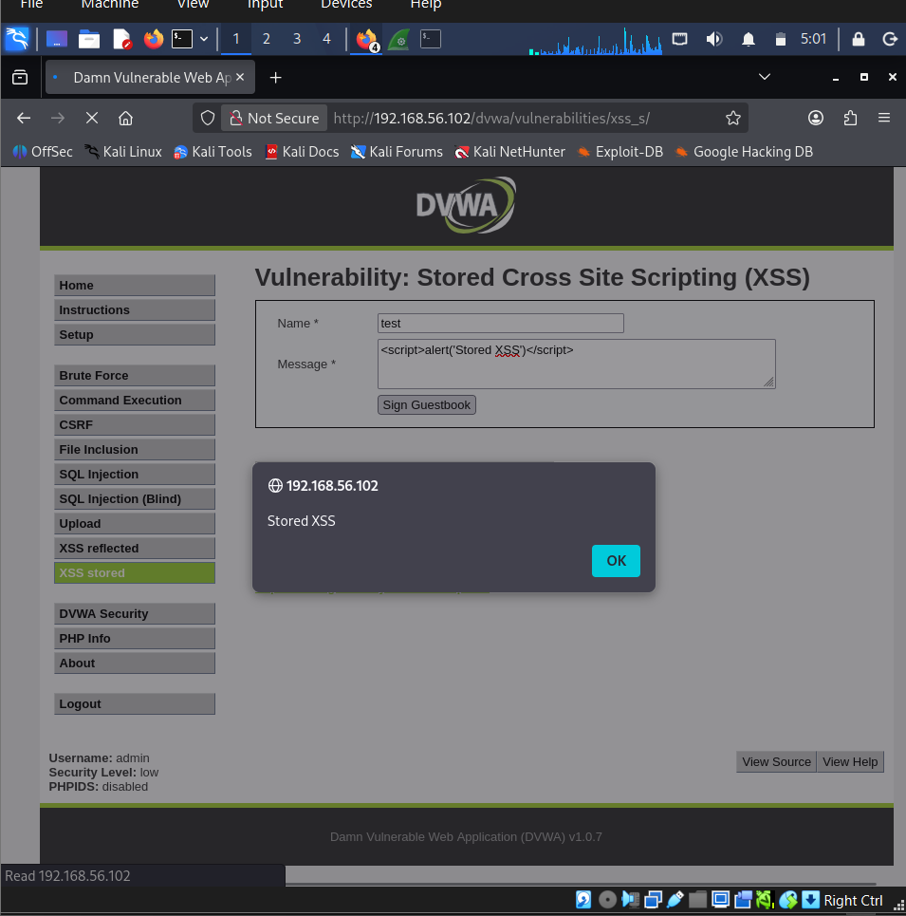
Figure 5: Stored XSS payload executing and persisting in the DVWA guestbook.

3.2 Reflected XSS
The payload <script>alert('Reflected XSS')</script> was submitted in the Name field. The script fired immediately, and the URL's name query parameter visibly carried the raw payload — showing the input is reflected back into the page without being stored or encoded.
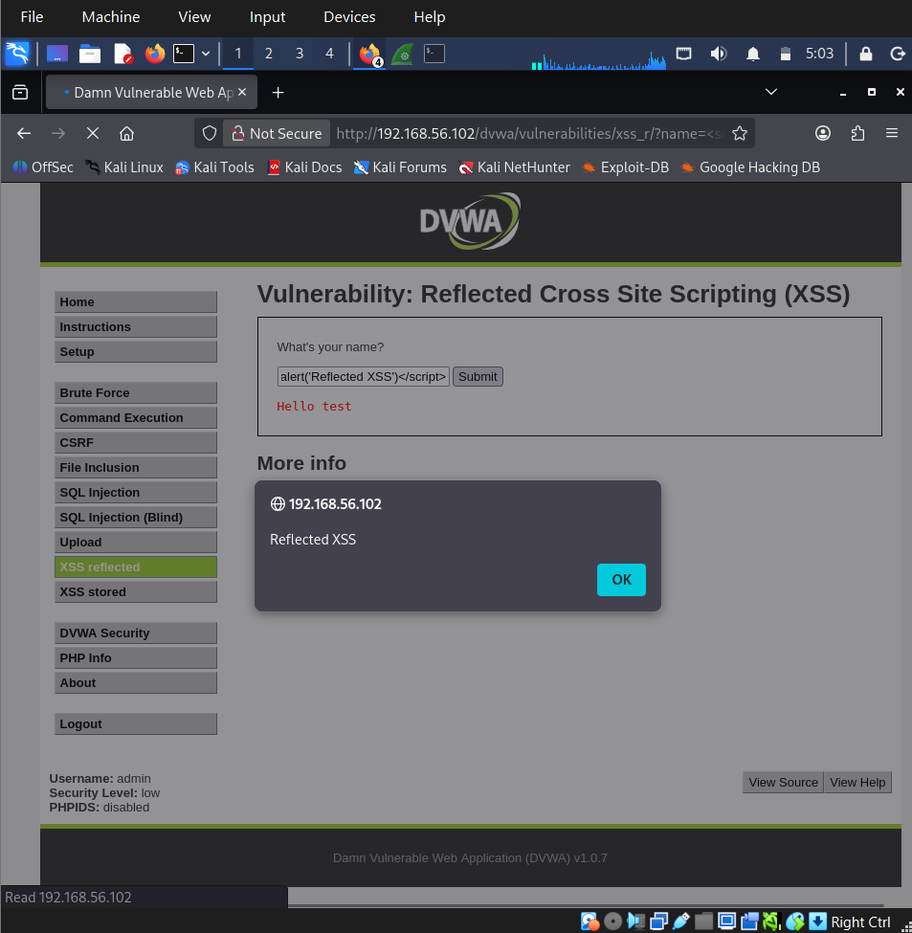
Figure 6: Reflected XSS firing, with the payload visible in the URL parameter.

4. Cross-Site Request Forgery (CSRF)
DVWA's CSRF module changes the logged-in admin's password through a simple GET request with no anti-CSRF token. A crafted URL was submitted directly in the browser:
http://192.168.56.102/dvwa/vulnerabilities/csrf/?password_new=hacked123&password_conf=hacked123&Change=Change#
The request succeeded and the password was changed to "hacked123" with no confirmation step — demonstrating that an attacker could embed this URL in a malicious page or image tag and silently change a logged-in victim's password.
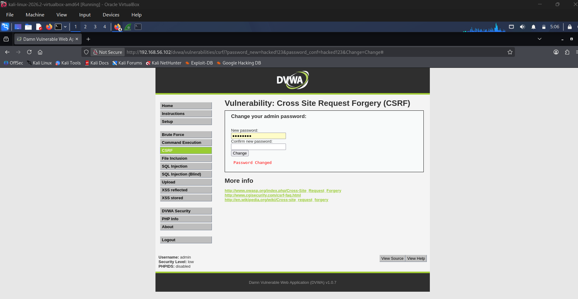
Figure 7: Crafted CSRF URL successfully changing the admin password (no token required).
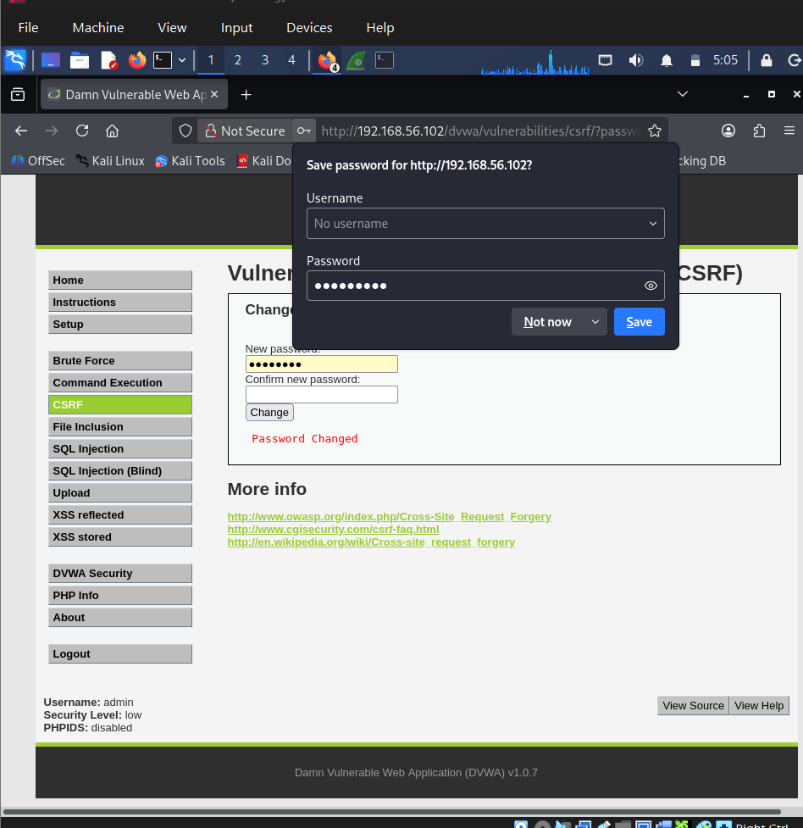
Figure 8: Browser's password-save prompt confirming the password change went through.
The password was reset back to "password" immediately after, to keep the lab environment consistent for later testing.
Viewing the High-security source shows the mitigation used in this DVWA build: it re-checks the current password (password_current) before allowing the change, rather than issuing a dedicated anti-CSRF token. This stops a blind CSRF attack (the attacker doesn't know the current password) but is not the standard token-based defense — another honest finding rather than treating High as fully remediated.
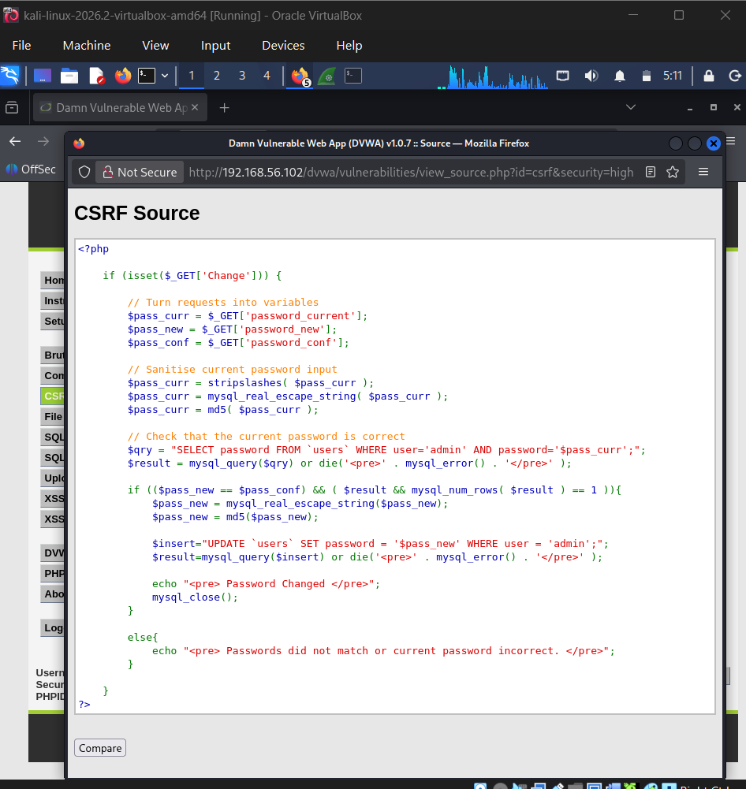
Figure 9: High-security CSRF source — current-password re-verification used instead of a CSRF token.

5. File Inclusion

5.1 Local File Inclusion (LFI)
The File Inclusion module's page parameter was manipulated with a directory traversal payload:
http://192.168.56.102/dvwa/vulnerabilities/fi/?page=../../../../../../etc/passwd
The server returned the full contents of /etc/passwd, confirming the application passes user input directly into a file-include function with no path sanitization or allow-listing — a critical vulnerability, since on a misconfigured host this can be escalated to remote code execution (e.g., via log poisoning).
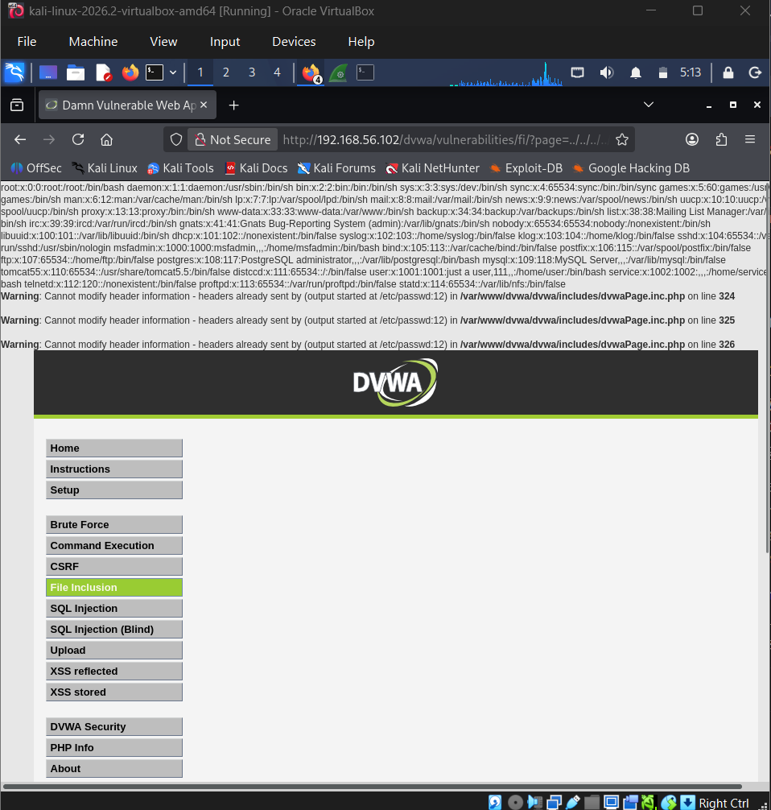
Figure 10: LFI payload returning the full contents of /etc/passwd.

5.2 Remote File Inclusion (RFI)
The same parameter was tested with a remote URL:
http://192.168.56.102/dvwa/vulnerabilities/fi/?page=http://example.com
The server responded with "URL file-access is disabled in the server configuration" instead of fetching and including the remote URL. This confirms the underlying include() call is just as unsanitized as in the LFI case above, but the attack is blocked at the PHP configuration level because allow_url_include is set to Off — a server hardening setting doing the job the application code does not.
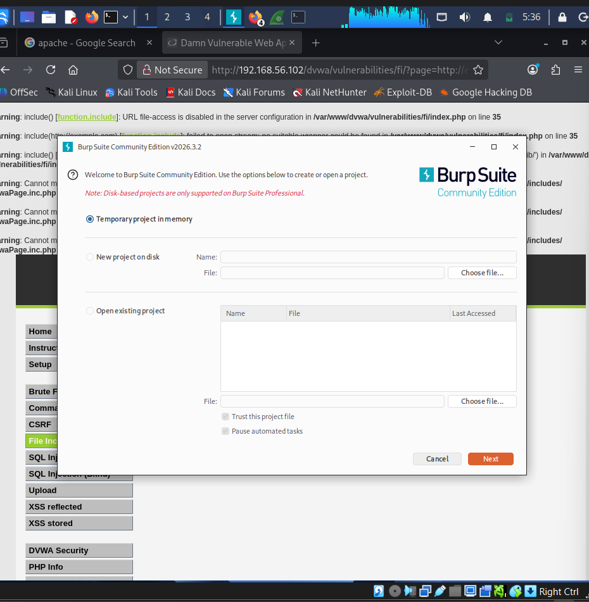
Figure 11: RFI attempt blocked by the server's allow_url_include=Off configuration.

6. Burp Suite — Intercept, Tamper, and Fuzzing Setup
Firefox was configured to proxy through 127.0.0.1:8080 and Burp Suite's Proxy → Intercept was enabled. A DVWA login POST request was captured live in Burp before it reached the server.
The intercepted request's username field was edited from its original value to admintest, demonstrating that Burp can tamper with a request in-flight before it is forwarded to the target — a core technique for testing how an application handles unexpected or malicious input.
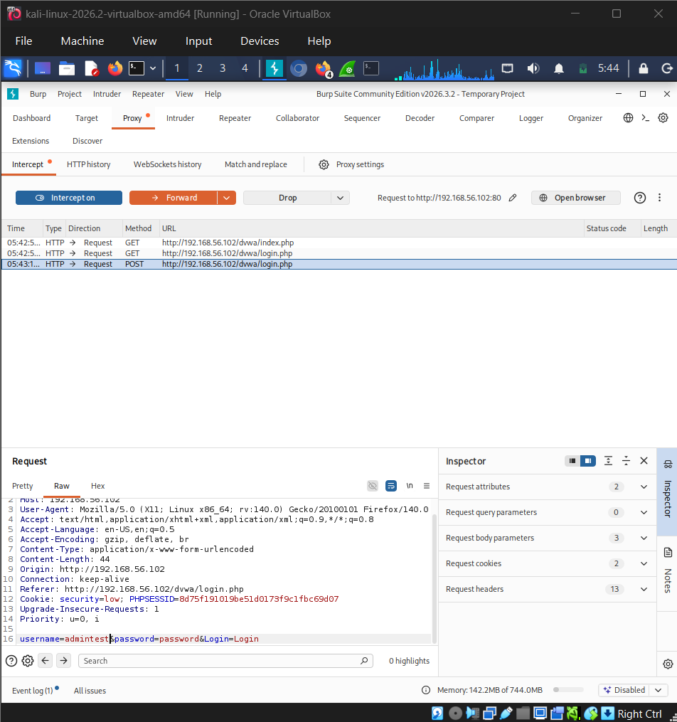
Figure 12: DVWA login POST request intercepted in Burp, with the username field edited to "admintest".
The edited request was forwarded, then re-sent from Proxy → HTTP History into Intruder. In Intruder's Positions tab, the username and password values were marked as payload (fuzzing) positions, shown wrapped in § markers — the configuration Burp uses to know which parts of a request to substitute during an automated attack. The attack itself was not launched; only the Positions configuration was required for this step.
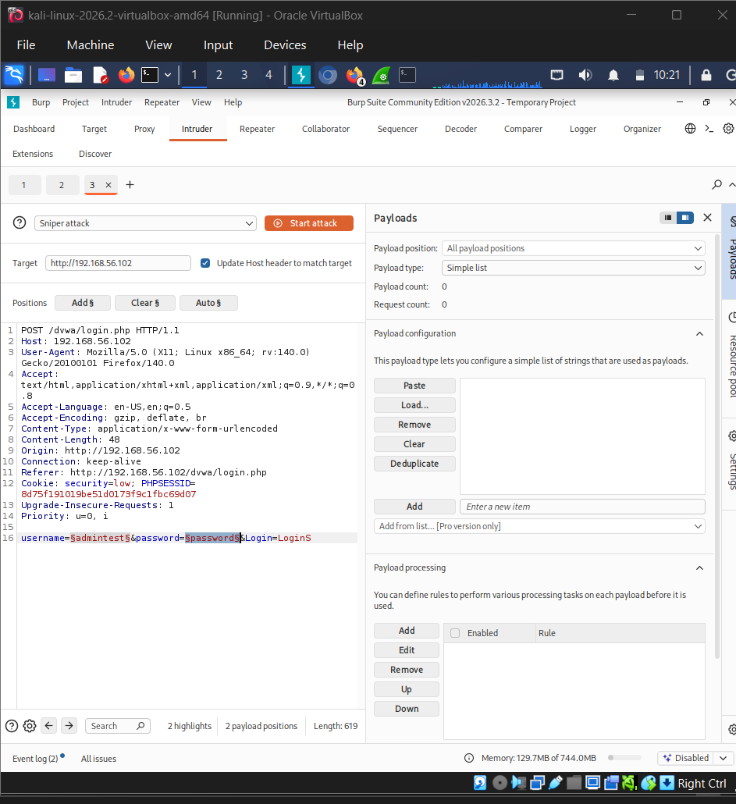
Figure 13: Intruder Positions tab with username and password marked as fuzzing payload positions.
After this step, Intercept was turned back off and Firefox's proxy setting was reverted to normal, restoring regular browsing.

7. Web Security Headers Review
securityheaders.com cannot reach a private/internal IP, so response headers were inspected directly from Kali using:
curl -I http://192.168.56.102/dvwa/
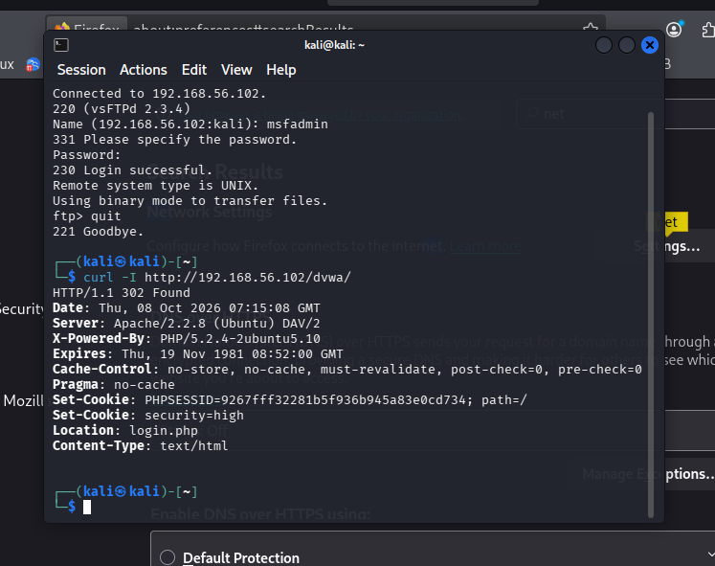
Figure 14: curl -I output showing DVWA's raw HTTP response headers.
Headers found vs. missing:
Header | Present? | Notes
X-Frame-Options | Missing | Site can be framed by any origin — clickjacking risk
Content-Security-Policy | Missing | No restriction on script sources — compounds the XSS findings above
X-Content-Type-Options | Missing | Browsers may MIME-sniff responses
Strict-Transport-Security | Missing | Served over plain HTTP in the lab; no HSTS to enforce HTTPS in production
X-Powered-By | Present | Discloses PHP/5.2.4-2ubuntu5.10 — an outdated, vulnerable version; should be suppressed
Server | Present | Discloses Apache/2.2.8 (Ubuntu) DAV/2 — version disclosure, should be minimized

Recommended fix (documented here as a configuration example rather than applied to the lab target, given the project timeline — Metasploitable2's Apache instance was left unmodified so it remains intentionally vulnerable for any later task):
Header set X-Frame-Options "SAMEORIGIN"
Header set Content-Security-Policy "default-src 'self'"
Header set X-Content-Type-Options "nosniff"
Header set Strict-Transport-Security "max-age=31536000; includeSubDomains"

8. Vulnerability Summary Table
Vulnerability | Severity | Root Cause | Recommended Fix
SQL Injection | Critical | Unsanitized input concatenated into SQL query (Low); High level uses escaping + is_numeric() rather than true prepared statements | Use parameterized queries / prepared statements everywhere, not escaping alone
Stored XSS | High | User input rendered into page without output encoding, persisted in guestbook | Encode output (htmlspecialchars); apply a strict Content-Security-Policy
Reflected XSS | High | Name parameter echoed back into the page unsanitized | Encode output; validate/allow-list input; add CSP header
CSRF | High | Password change accepted via GET with no anti-CSRF token (Low); High level checks current password but still no token | Implement per-session anti-CSRF tokens on all state-changing requests
Local File Inclusion (LFI) | Critical | page parameter passed directly to an include() with no path sanitization | Allow-list permitted filenames; never pass user input directly to include/require
Remote File Inclusion (RFI) | Medium | Same unsanitized include(), but mitigated at the PHP config level (allow_url_include disabled) | Keep allow_url_include Off; still fix the underlying include() logic as above
Missing Security Headers | Medium | Apache/DVWA serve no X-Frame-Options, CSP, X-Content-Type-Options, or HSTS headers | Add headers via httpd.conf, e.g. Header set X-Frame-Options "SAMEORIGIN"

9. Key Concepts Covered
- SQL Injection: authentication-bypass and UNION-based data extraction, and the practical difference between input escaping and true parameterized queries
- Stored vs. Reflected XSS: persistence vs. one-time reflection, and why output encoding (not just input filtering) is the real fix
- CSRF: how state-changing GET requests without anti-CSRF tokens can be triggered by a third-party page, and the limits of current-password re-verification as a mitigation
- Local and Remote File Inclusion: directory traversal into sensitive files, and how a single server configuration flag (allow_url_include) can block one attack vector while the underlying code flaw remains
- Burp Suite as an intercepting proxy: capturing, editing, and forwarding live HTTP requests, and configuring Intruder payload positions for automated fuzzing
- HTTP security headers: identifying missing browser-enforced protections (X-Frame-Options, CSP, X-Content-Type-Options, HSTS) via curl, independent of external scanning tools

10. Conclusion
Task 3 covered six distinct web application vulnerability classes against DVWA, each demonstrated end-to-end: triggering the vulnerability, capturing evidence, and — where DVWA's "High" security setting applied — comparing the mitigation actually used against the ideal fix. A consistent theme across SQL Injection, XSS, and CSRF was that DVWA's High security level often applies a partial or situational mitigation (escaping instead of parameterization, current-password checks instead of CSRF tokens) rather than a complete fix, which is itself a useful real-world lesson: a security control passing one specific test does not mean the underlying weakness is resolved. The File Inclusion and security headers findings reinforced that application-level flaws and server/configuration-level hardening are separate layers of defense, each capable of masking or exposing the other. The vsFTPd backdoor and MD5 password hashes identified here and in Task 2 carry directly into Task 4's exploitation work.

