Cybersecurity & Ethical Hacking Internship
Task 1 — Lab Setup Report
Foundation & Environment Setup (Days 1–12)
Intern Name | Shaik Hiba Tharunnum
Offer Letter ID | APSPL2645050
Internship Domain | Cybersecurity & Ethical Hacking
Organization | ApexPlanet Software Pvt. Ltd.
Task | Task 1 — Foundation & Environment Setup

1. Objective
The goal of this task was to build strong cybersecurity fundamentals — networking, Linux, and cryptography basics — and to set up a professional, isolated penetration testing lab using VirtualBox. The lab consists of a Kali Linux attacker machine and a Metasploitable2 target machine, connected on a private Host-only network so that all testing stays fully isolated from the real internet.

2. Lab Environment Overview
- Hypervisor: Oracle VirtualBox 7.2.14
- Attacker machine: Kali Linux 2026.2 (2048 MB RAM, 2 vCPUs)
- Target machine: Metasploitable2 (1024 MB RAM, deliberately vulnerable Ubuntu-based VM)
- Networking: Both VMs configured on a VirtualBox Host-only Adapter, isolating the lab from the host's real network and the internet
- Verified connectivity between attacker and target using ICMP (ping), and confirmed traffic visibility using Wireshark

3. Kali Linux — Attacker Machine
Kali Linux was imported into VirtualBox and configured with a Host-only network adapter. The screenshot below confirms the VM is running and the desktop environment has loaded successfully.
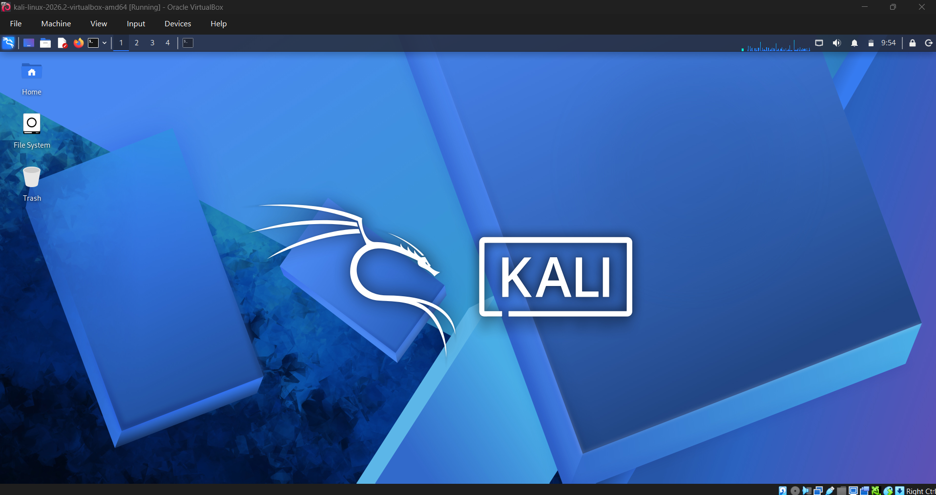
Figure 1: Kali Linux desktop running inside VirtualBox, confirming a successful VM import and boot.

4. Metasploitable2 — Target Machine
Metasploitable2 was added to VirtualBox using its existing .vmdk disk image and placed on the same Host-only network as Kali. It was then booted and logged into using the default credentials (msfadmin / msfadmin), confirming the target machine is reachable and operational.
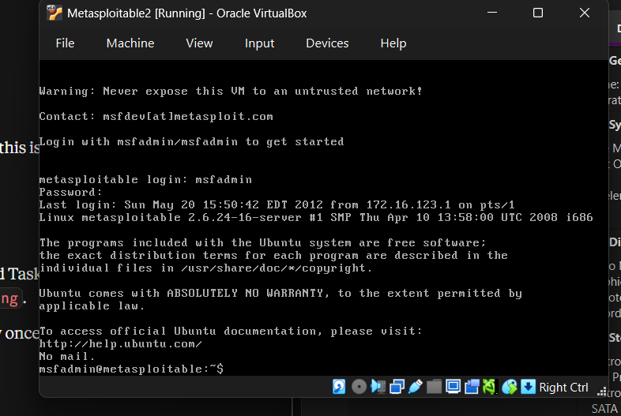
Figure 2: Successful login to the Metasploitable2 target VM.

5. Network Connectivity Test
With both VMs configured on the same Host-only Adapter, connectivity was verified from Kali by pinging Metasploitable2's IP address (192.168.56.102). The result below shows 33 packets transmitted with 0% packet loss, confirming the isolated lab network is functioning correctly.
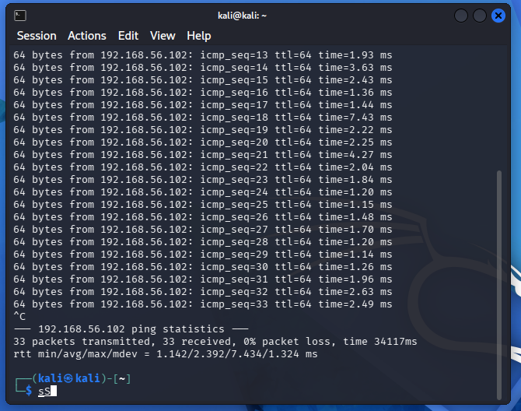
Figure 3: Successful ping test from Kali Linux to Metasploitable2 (0% packet loss).

6. Packet Analysis with Wireshark
Wireshark was used on Kali to capture live traffic on the eth0 interface while the ping test was running. Applying an icmp display filter isolates the ping request/reply packets, and the packet detail pane confirms the Ethernet, IP, and ICMP protocol layers involved in the exchange.
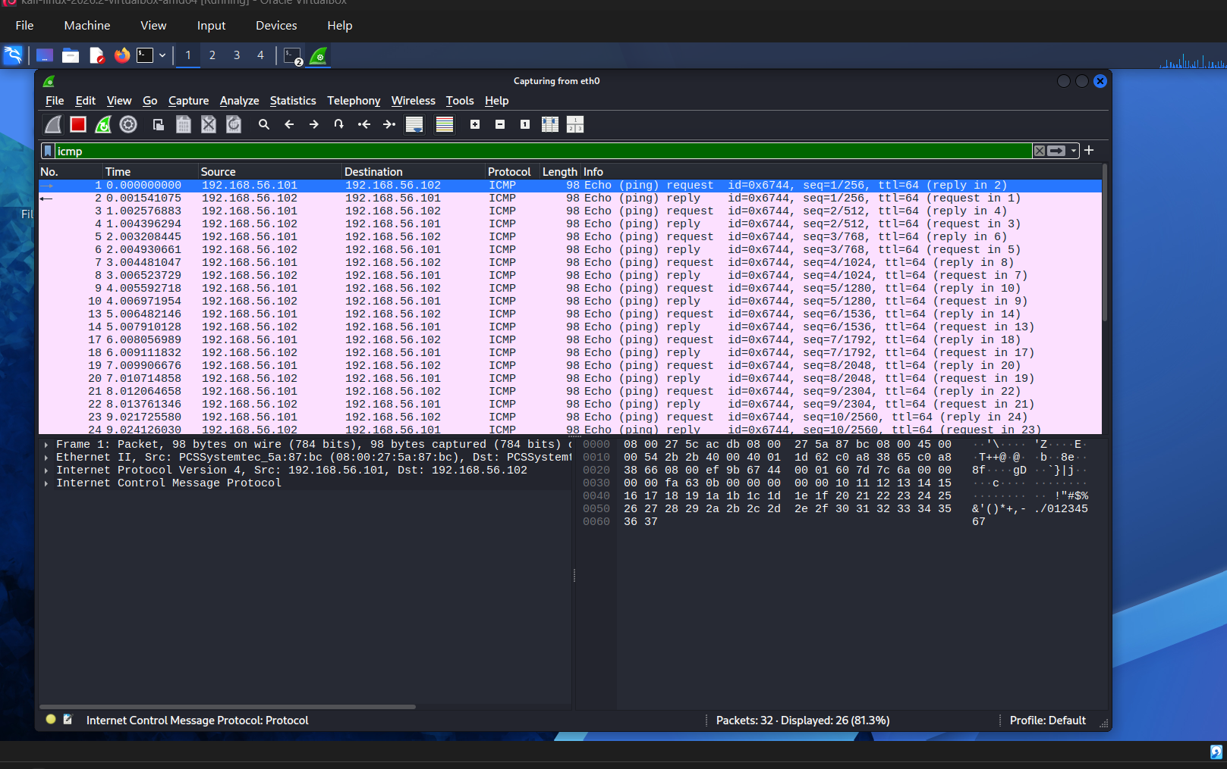
Figure 4: Wireshark capture on eth0, filtered to ICMP traffic, showing ping request/reply pairs between 192.168.56.101 (Kali) and 192.168.56.102 (Metasploitable2).

7. Key Concepts Covered
- CIA Triad (Confidentiality, Integrity, Availability) and common threat types
- Linux fundamentals: file navigation, permissions (chmod/chown), package management (apt), and networking commands (ifconfig, ping)
- Networking fundamentals: OSI model, TCP/IP suite, IP addressing and subnetting, DNS/HTTP basics
- Cryptography basics: symmetric vs asymmetric encryption, hashing, and SSL/TLS certificates
- Tool familiarization: VirtualBox, Kali Linux, Wireshark, and the Host-only networking model used for safe, isolated lab testing

8. Conclusion
Task 1 is complete. A fully isolated penetration testing lab has been built with a working Kali Linux attacker VM and a Metasploitable2 target VM, both verified to communicate over a private Host-only network. This environment forms the foundation for all subsequent tasks, including network scanning, web application security testing, exploitation, and the final capstone project.

