Department: Computer Science Program: BS (CS)
WPL (Theory)
Announced date: 15-Jan-2026 |  |  | Due Date: 22-Jan-2026 |  | Total Marks = 10
 | Complex Computing Problem (CCP)
 | Mapped CLO | SDG |  | Complex Problem Solving Mapped
 | CLO3, GA4, C5 | 9 |  | WP3 (Depth of knowledge required)  WP1 (Range of conflicting requirements required)  WP2 (Depth of analysis required)

Title
Secure Design and Analysis of a Database-Driven Web Application Using SQL Injection Prevention Techniques

Problem Statement
A web-based system is being developed to manage user records through a relational database using MySQL. The system supports Create, Read, Update, and Delete (CRUD) operations through web forms.
However, such systems are highly vulnerable to SQL Injection attacks if user input is not properly validated and handled. Attackers can manipulate form inputs to execute unauthorized SQL commands, leading to data leakage, data corruption, or complete system compromise.
To ensure application security, the system must implement:
- Client-side input validation
- Server-side input validation
- Secure database interaction using prepared statements
Students are required to analyze, design, and justify a secure web-application workflow that prevents SQL injection while supporting complete CRUD functionality.

Constraints / Assumptions
- MySQL must be used as the database engine
- PHP must be used for server-side processing
- HTML, CSS, JavaScript, or jQuery may be used for frontend validation
- CRUD operations must be supported on at least one database table
- Prepared statements must be used for all database queries
- Input validation must be applied on both frontend and backend
- Focus is on security, design decisions, and analysis, not UI complexity

Expected Outcomes
Students must design, explain, and analyze a secure CRUD-based web system by completing the following tasks:

A. Threat Analysis and Problem Identification (2 Marks)
- Explain what SQL Injection is and how it occurs in web applications
- Identify vulnerable points in a typical form-based CRUD system

B. Frontend Validation Strategy (2 Marks)
- Propose suitable client-side validation techniques
- Explain how frontend validation improves usability and reduces invalid requests
- Discuss limitations of relying only on frontend validation

C. Backend Validation and Secure Query Design (3 Marks)
- Explain the role of server-side validation in security
- Describe how prepared statements prevent SQL injection
- Analyze how placeholders and parameter binding improve query safety

D. Secure CRUD Workflow Design (2 Marks)
- Design a logical flow for secure:
  - Insert
  - Select
  - Update
  - Delete
- Highlight where validation and prepared statements are applied in each operation

E. Security Evaluation and Best Practices (1 Mark)
- Identify one additional security measure (e.g., least privilege, error handling, input sanitization)
- Justify how it strengthens the system

Real-World Applicability
This CCP reflects real-world secure web systems such as:
- User registration and login systems
- Student management systems
- Online portals handling sensitive user data
- Database-driven enterprise web applications
- Secure CRUD-based administrative dashboards

Metric | Description
Conceptual Understanding | Understanding of SQL Injection and its risks
Technical Accuracy | Correct explanation of validation and prepared statements
Analytical Depth | Ability to analyze security flaws and countermeasures
Design Quality | Secure CRUD workflow design
Problem-Solving Efficiency | Handling conflicting requirements of usability and security

Deliverable:
Category | Deliverables
Conceptual | Explanation of SQL Injection and validation strategies
Design | Secure CRUD workflow diagrams / descriptions
Report | Written analysis of frontend validation, backend validation, and prepared statements

CCP Attributes mapped
Attributes of Complex Problem Solving |  |  |  | Justification
WP |  |  | Description | Theory of automata CCP Mapping
 | WP3 | Depth of Knowledge |  | Requires understanding of SQL Injection, prepared statements, and validation mechanisms
 | WP1 | Range of Conflicting Requirements |  | Balancing security, usability, and performance
 | WP2 | Depth of Analysis |  | Analysis of vulnerabilities, secure query design, and validation layers

CODE:
Form and create
<!DOCTYPE html>
<html lang="en">
<head>
<meta charset="UTF-8">
<meta name="viewport" content="width=device-width, initial-scale=1.0">
<title>Document</title>
<link rel="stylesheet" href="bootstrap/css/bootstrap.min.css">
<script src="bootstrap/js/bootstrap.bundle.min.js"></script>
</head>
<body>

<div class="container">
<div class="row ">
<div class="col-6">
<div class="card ">
<div class="card-body">
<center> <h1>product form</h1></center>
<form action="create.php" method="post">
<div class="form-group">
<label>product name</label>

<input type="text" name="product_name" id="product_name" class="form-control" >
</div>
<div class="form-group">
<label>product category</label>

<input type="text" name="product_category" id="product_category" class="form-control" >
</div>
<div class="form-group">
<label>product quantity</label>

<input type="number" name="product_quantity" id="product_quantity" class="form-control" >
</div>
<div class="form-group">
<label>product price</label>

<input type="text" name="product_price" id="product_price" class="form-control" >
</div>
<div class="d-flex justify-content-center">
<input type="submit" class="btn btn-primary " value="submit">
</div>
</form>
</div>
</div>
</div>
</div>
</div>
</body>
</html>

<?php
$product_name = $_POST['product_name'];
$product_category = $_POST['product_category'];
$product_quantity = $_POST['product_quantity'];
$product_price = $_POST['product_price'];

$connection = mysqli_connect('localhost', 'root', '', 'products');

$query = "INSERT INTO product (product_name, product_category, product_quantity, product_price)
VALUES (?, ?, ?, ?)";

$stmt = mysqli_prepare($connection, $query);
mysqli_stmt_bind_param($stmt, "ssss", $product_name, $product_category, $product_quantity, $product_price);
mysqli_stmt_execute($stmt);

header('Location: ' . 'table.php');
?>
Edit form and update:
<?php
$id = $_GET["product_id"];
$connection= mysqli_connect('localhost','root','','products');
$query= "select * from product where product_id=$id";
$result = mysqli_query($connection,$query);
$data = mysqli_fetch_all($result,MYSQLI_ASSOC);
?>

<!DOCTYPE html>
<html lang="en">
<head>
<meta charset="UTF-8">
<meta name="viewport" content="width=device-width, initial-scale=1.0">
<title>Document</title>
<link rel="stylesheet" href="bootstrap/css/bootstrap.min.css">
<script src="bootstrap/js/bootstrap.bundle.min.js"></script>
</head>
<body>

<div class="container ">
<div class="row">
<div class="col-6">
<div class="card ">
<div class="card-body">
<h1>product form</h1>

<form action="editsubmit.php" method="post">

<div class="form-group">
<label>product id</label>
<input type="hidden"
value="<?php echo $data[0]['product_id']?>"
name="product_id"
id="product_id"
class="form-control">
</div>

<div class="form-group">
<label>product name</label>
<input type="text"
value="<?php echo $data[0]['product_name']?>"
name="product_name"
id="product_name"
class="form-control">
</div>

<div class="form-group">
<label>product category</label>
<input type="text"
value="<?php echo $data[0]['product_category']?>"
name="product_category"
id="product_category"
class="form-control">
</div>

<div class="form-group">
<label>product quantity</label>
<input type="number"
value="<?php echo $data[0]['product_quantity']?>"
name="product_quantity"
id="product_quantity"
class="form-control">
</div>

<div class="form-group">
<label>product price</label>
<input type="text"
value="<?php echo $data[0]['product_price']?>"
name="product_price"
id="product_price"
class="form-control">
</div>

<div class="d-flex justify-content-center">
<input type="submit"
class="btn btn-primary"
value="submit">
</div>

</form>

</div>
</div>
</div>
</div>
</div>

</body>
</html>

<?php
$id = $_POST['product_id'];
$product_name = $_POST['product_name'];
$product_category = $_POST['product_category'];
$product_quantity = $_POST['product_quantity'];
$product_price = $_POST['product_price'];

$connection = mysqli_connect('localhost', 'root', '', 'products');

$query = "UPDATE product SET
product_name = ?,
product_category = ?,
product_quantity = ?,
product_price = ?
WHERE product_id = ?";

$stmt = mysqli_prepare($connection, $query);
mysqli_stmt_bind_param(
$stmt,
"ssssi",
$product_name,
$product_category,
$product_quantity,
$product_price,
$id
);
mysqli_stmt_execute($stmt);

header('Location: ' . 'table.php');
?>
Table:
<?php
$connection = mysqli_connect('localhost','root','','products');
$query = "select * from Product";
$result = mysqli_query($connection,$query);
$data = mysqli_fetch_all($result,MYSQLI_ASSOC);
?>

<!DOCTYPE html>
<html lang="en">
<head>
<meta charset="UTF-8">
<meta http-equiv="X-UA-Compatible" content="IE=edge">
<meta name="viewport" content="width=device-width, initial-scale=1.0">
<title>Document</title>
<script src="bootstrap/js/bootstrap.bundle.min.js"></script>
<link rel="stylesheet" href="bootstrap/css/bootstrap.min.css">
</head>

<body>

<div class="container mt-5">

<div class="d-flex justify-content-end mb-3">
<a href="form.php" class="btn btn-dark">ADD</a>
</div>

<div class="card shadow">
<div class="card-body">

<table class="table table-bordered table-hover table-striped text-center align-middle">
<thead class="table-dark">
<tr>
<th>Sr</th>
<th>Product Category</th>
<th>Product Name</th>
<th>Product Price</th>
<th>Product Quantity</th>
<th>Action</th>
</tr>
</thead>

<tbody>
<?php
for($i = 0; $i < count($data); $i++){
?>
<tr>
<td><?php echo $data[$i]['product_id']; ?></td>
<td><?php echo $data[$i]['product_name']; ?></td>
<td><?php echo $data[$i]['product_category']; ?></td>
<td><?php echo $data[$i]['product_quantity']; ?></td>
<td><?php echo $data[$i]['product_price']; ?></td>
<td>
<a href="editform.php?product_id=<?php echo $data[$i]['product_id']; ?>"
class="btn btn-warning btn-sm">Edit</a>

<a href="delete.php?product_id=<?php echo $data[$i]['product_id']; ?>"
class="btn btn-danger btn-sm">Delete</a>
</td>
</tr>
<?php } ?>
</tbody>

</table>

</div>
</div>

</div>

</body>
</html>
Screenshots:
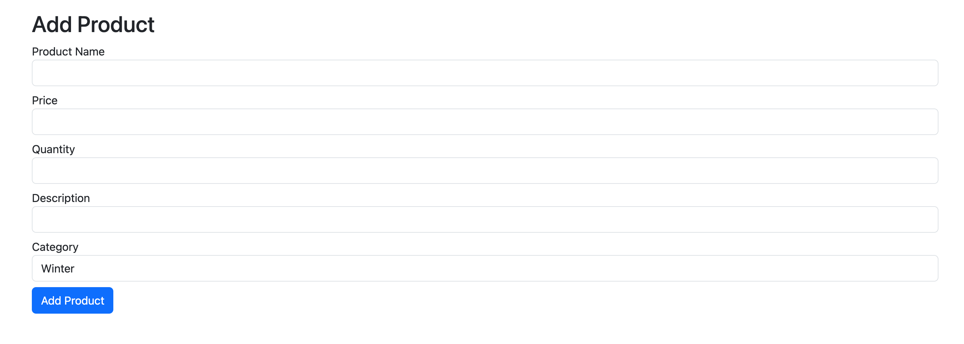
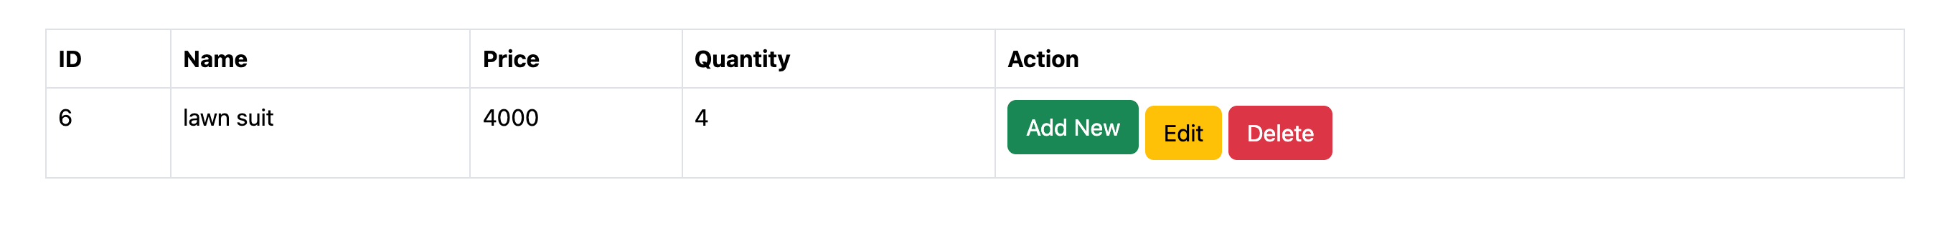
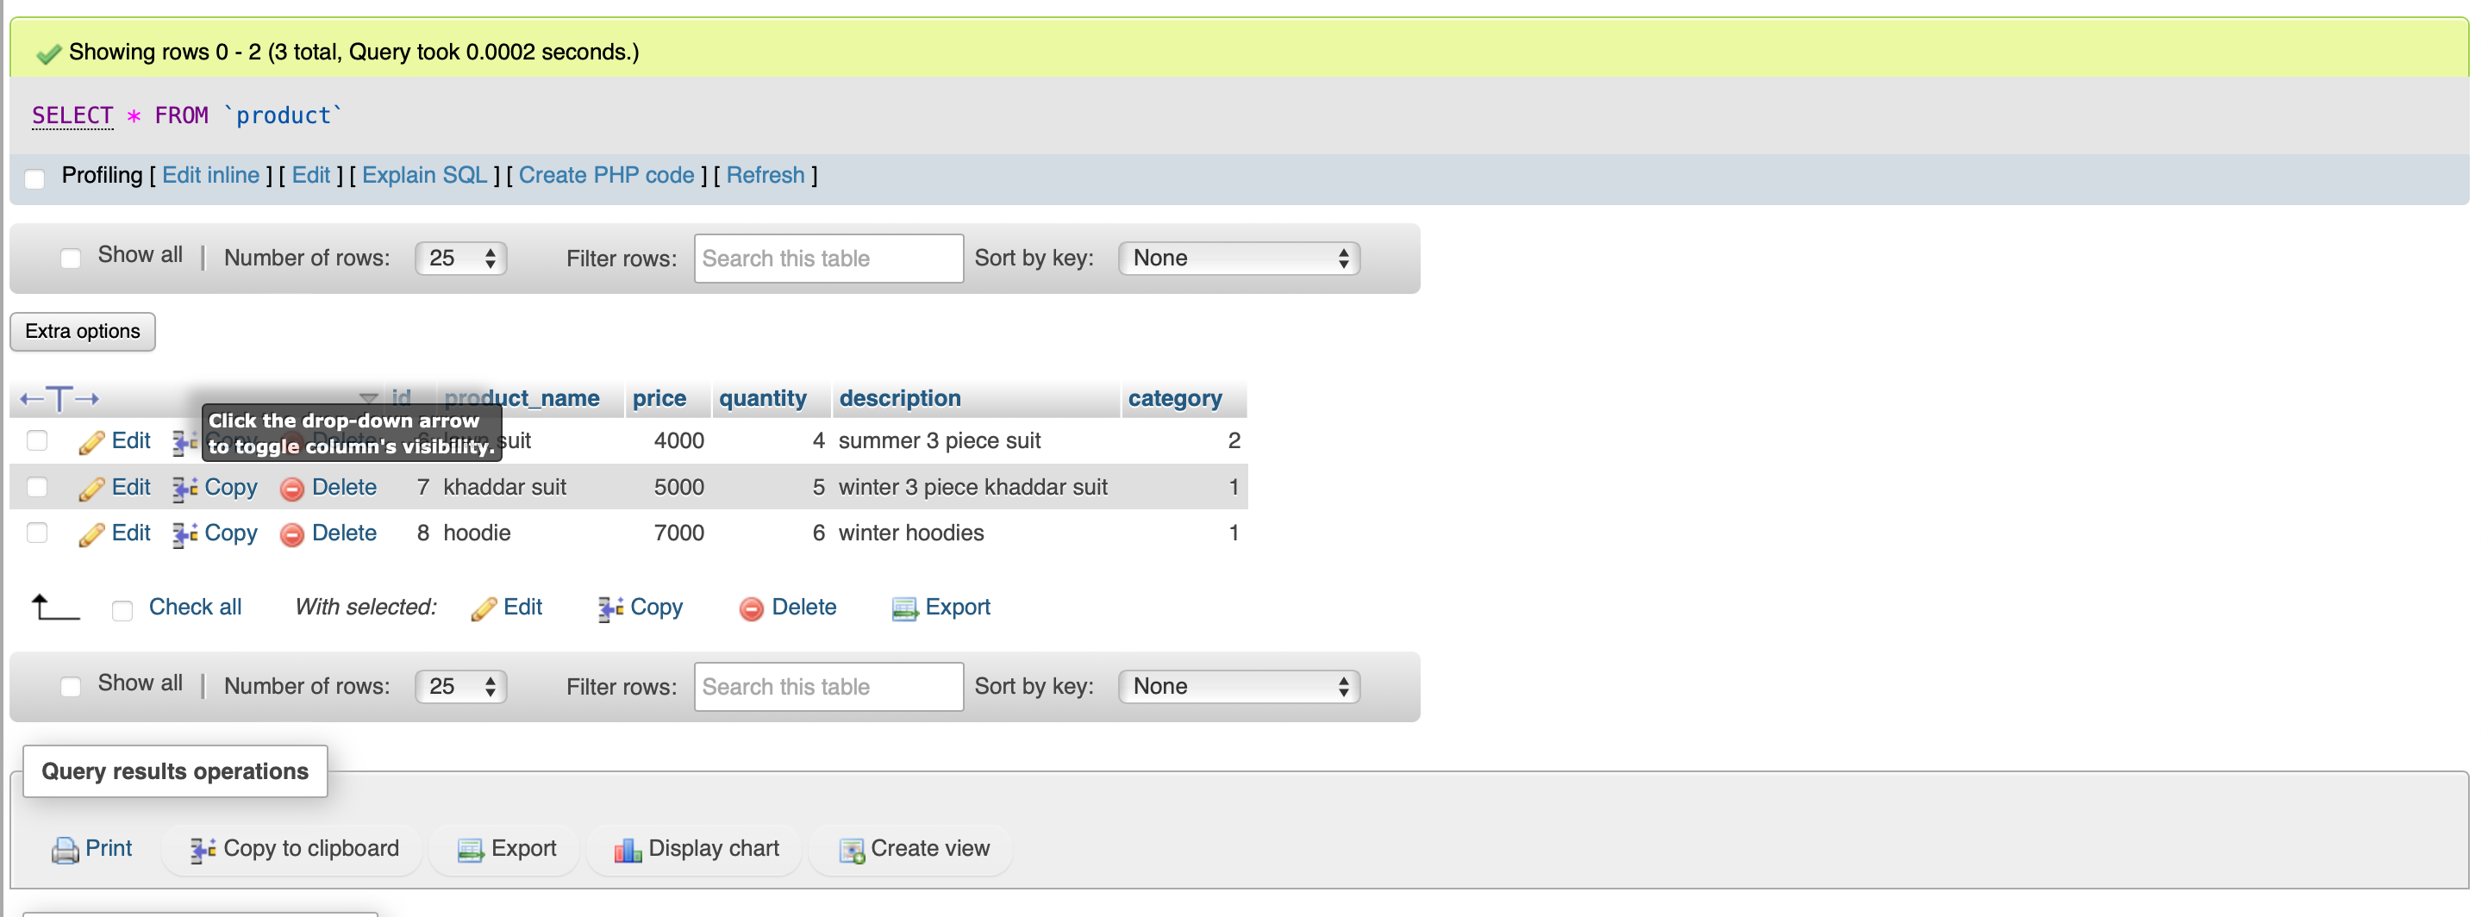
Add New
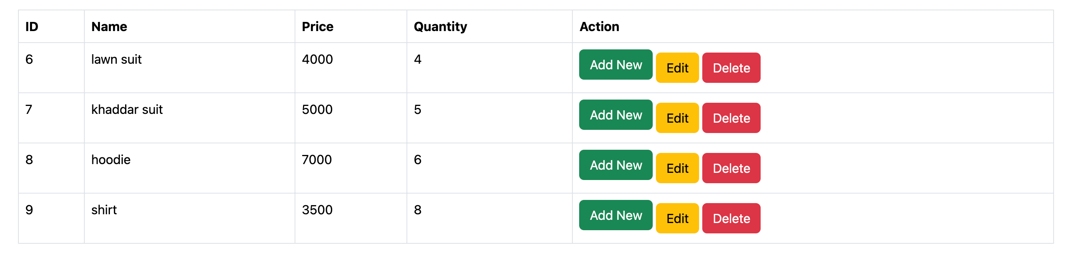

Edit

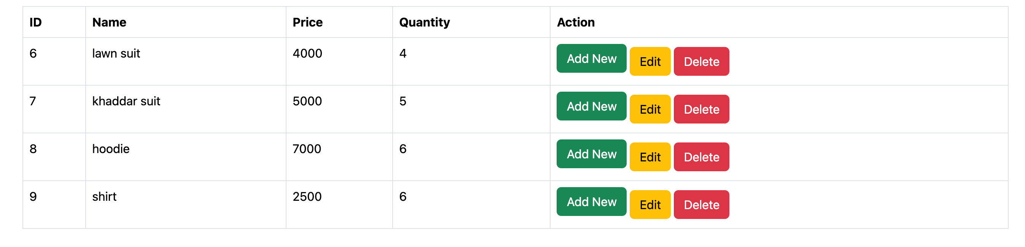
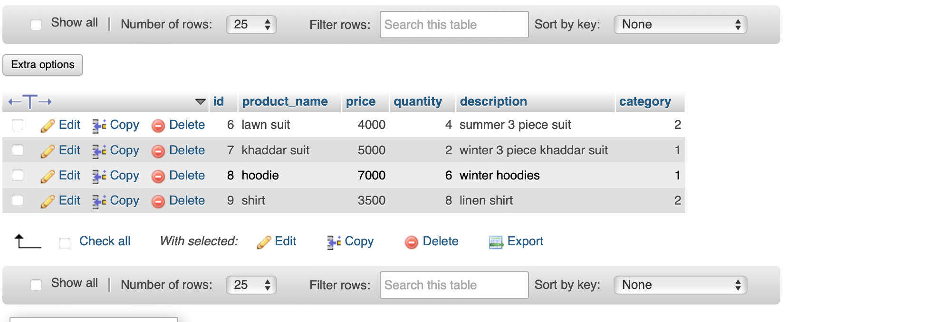
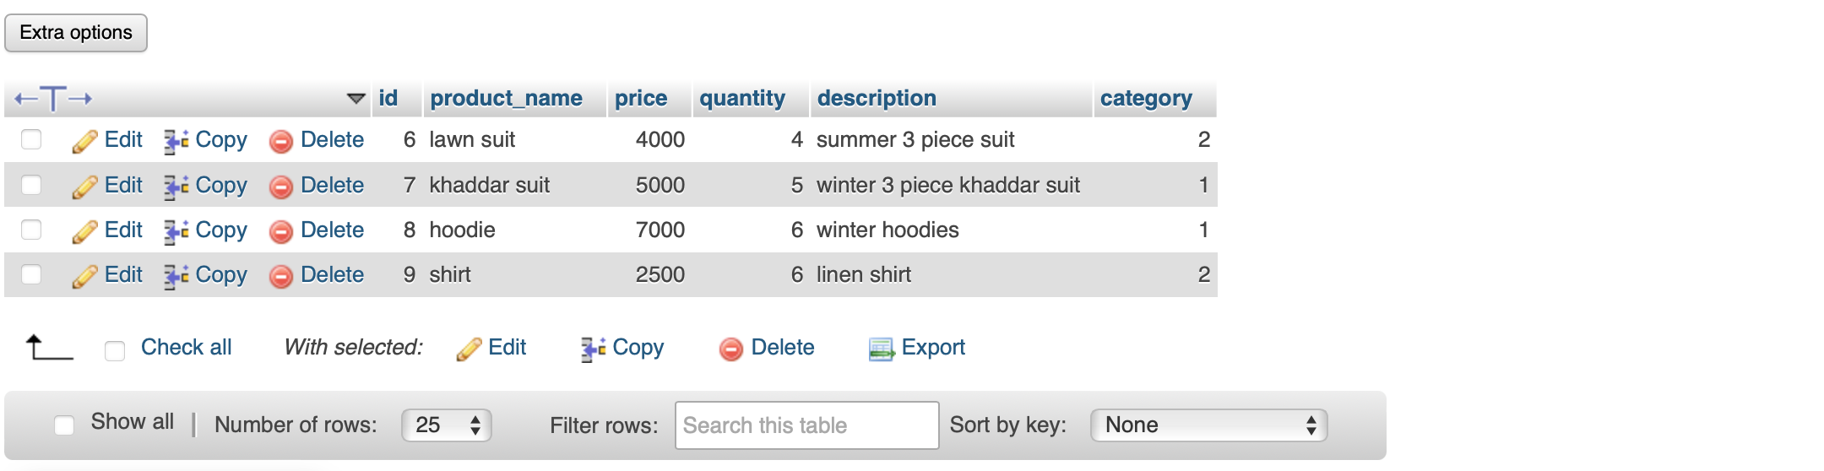

Delete
