# A Closer Look at the WA8LMF TNC Test CD

John Langner, WB2OSZ

Rough Draft 1, January 2016

|  |
| --- |
| C:\Users\John\AppData\Local\Microsoft\Windows\Temporary Internet Files\Content.IE5\NWYZ2AR3\warning-general-2_1_[1].gif  WARNING!  This document contains images  of really ugly APRS radio signals  that some will find disturbing. |

In the earlier document, [A-Better-APRS-Packet-Demodulator-Part-1-1200-baud.pdf](https://github.com/wb2osz/direwolf/blob/master/doc/A-Better-APRS-Packet-Demodulator-Part-1-1200-baud.pdf), we briefly described the most common type of modulation used for VHF FM APRS / Packet Radio and how you might build a demodulator. We also discussed how the mismatch between pre-emphasis (on transmit) and de-emphasis (on receive) makes it more difficult. Finally, we saw a technique that can be used to compensate for this mismatch and obtain more than 1000 error-free frames from the WA8LMF TNC Test CD.

Here, we take a closer look at some of the frames on the TNC Test CD in hopes of gaining some insights into why some are easily decoded and others are more difficult.

## The Good, the Bad, and the Ugly

We will be looking at Track 1 of the TNC Test CD because it doesn’t have low pass filtering and is a more accurate picture of what is on the air. Screen shots, from Audacity ( <http://audacityteam.org/> ), will be correlated with the output from the Dire Wolf “atest” utility.

Let’s start off with a good looking signal. It looks like a sine wave with a nice rounded shape and you can see how it is shifting between two different tones. Notice how “atest” prints a timestamp from the end of the frame so we can match it up with the audio waveform plot.

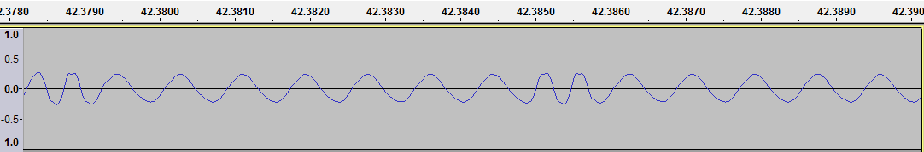

DECODED[37] 0:42.3903 Digipeater N6EX-1 audio level = 53(24/28) ||||||\_\_\_

[0] WA8LMF>APU25N,N6EX-1\*:>202337zhttp://wa8lmf.com<0x0d>

Both tones have about the same amplitude so there seems to be no pre-emphasis on the transmitting side. Notice how the amplitudes 24 & 28 are not that much different.

Here you can see how the higher frequency has significantly larger amplitude and looks pointier rather than rounded. This is probably due to pre-emphasis in the transmitter.

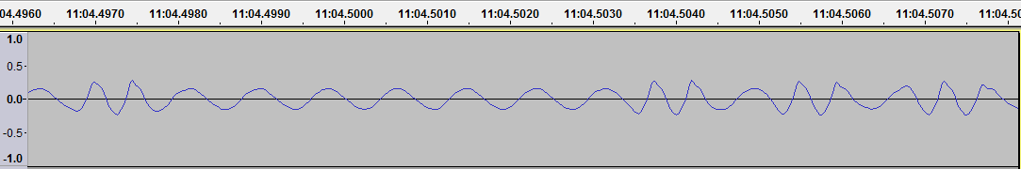

DECODED[459] 11:04.5089 Digipeater N6EX-4 audio level = 51(17/24) |||||\_\_\_\_

[0] KB6CUS-1>S3URPP,N6EX-1,N6EX-4\*:'.\_0l <0x1c>-/]Ted@Home in Lakewood,CA.USA<0x0d>

There is a larger difference between 17 & 24 here indicating that the higher tone has significantly larger amplitude.

This one was surprising. I would expect to see either constant amplitude or larger amplitude for the higher tone due to pre-emphasis. Instead we see that the higher audio tone is significantly weaker.

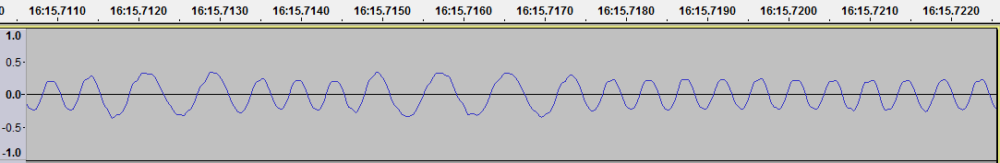

DECODED[651] 16:15.7285 KE6RYZ audio level = 68(33/26) \_||||||\_|

[0] KE6RYZ>S3UUXT,RELAY,WIDE:`.[Jl!h>/]"4>}<0x0d>

Notice how the decoder bars are shifted to the right because we have more success when boosting the higher tone.

Maybe the TNC has overly aggressive low pass filtering on the audio output.

This signal has deviation set a little too high. The peaks are flattened or jagged.

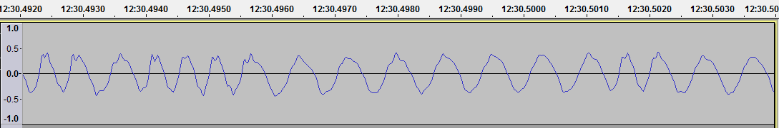

DECODED[514] 12:31.9037 Digipeater WB6JAR-10 audio level = 82(36/34) ||||||\_\_\_

[0] KF6YVS-6>APT202,WB6JAR-10\*,WIDE3-2:!0000.000/00000.000>000/000/kf6yvs, Mike

Notice how the audio level is around 80 when the others were around 50.

Here are some more extreme cases of over deviation. Notice how the reported level is around 100 or more.

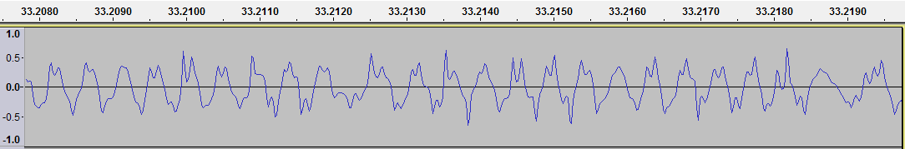

DECODED[27] 0:33.1973 KD6EDM audio level = 116(26/37) \_|||\_\_\_\_\_

[0] KD6EDM>APW275,RELAY,WIDE2-2:=3340.25N/11754.88WKPHG2100/WinAPRS 2.7.5 -CAORACOSTA ME-275-<530><0x0d>

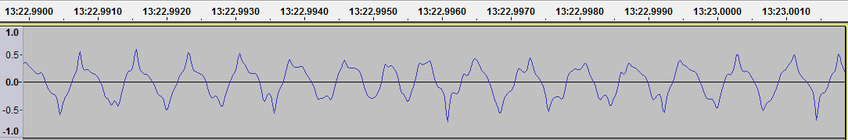

DECODED[548] 13:23.0003 Digipeater WIDE2 audio level = 121(37/38) |||||||\_\_

[0] WB6BSA>APZ036,WB6WLV-11,WB6JAR-10,WIDE2\*:=3244.34N/11709.26W; Camp Balboa wb6bsa@cox.net<0x0d>

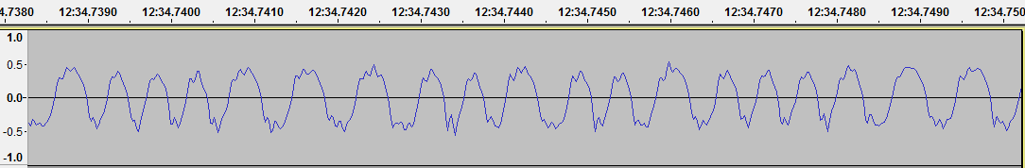

DECODED[516] 12:34.7718 Digipeater RELAY audio level = 96(45/38) |||||||\_\_

[0] KE6RYZ>S3UUXT,RELAY\*,WIDE:`.[Kl!h>/]"49}<0x0d>

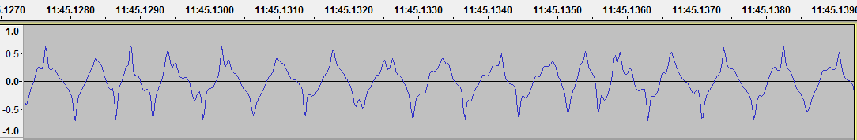

DECODED[491] 11:45.1337 Digipeater WB6JAR-10 audio level = 130(37/38) |||||||\_\_

[0] N6VNI-14>APRS,WB6JAR-10\*,WIDE,WIDE:!3356.06N/11758.01Wk Geo & Kris LaHabra,CA

Not sure what’s happening here. A small region has larger amplitude than the rest. Remarkably we extract something from it. Barely, as indicated by the one bar.

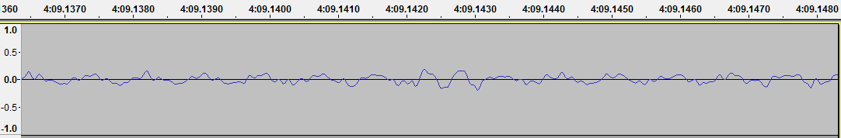

DECODED[189] 4:09.1476 W6OFR audio level = 61(15/18) |\_\_\_\_\_\_\_\_

[0] W6OFR>SSTXPX,WIDE2-2:`./\_lr[v>

Other signals, from the same station, look very strange. With dips in many of the peaks even though it is not over deviated.

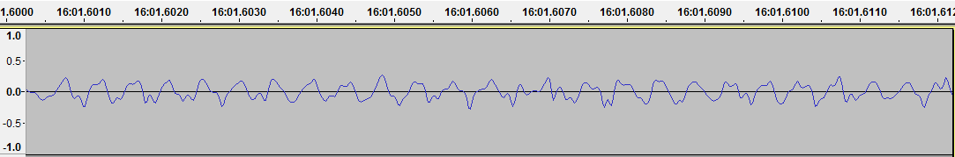

DECODED[646] 16:01.6117 W6OFR audio level = 60(15/18) ||||\_\_\_\_\_

[0] W6OFR>SSTWUP,WIDE2-2:`./ql!zv>

This has ripple with a very interesting pattern. It’s not jagged peaks due to over deviation.

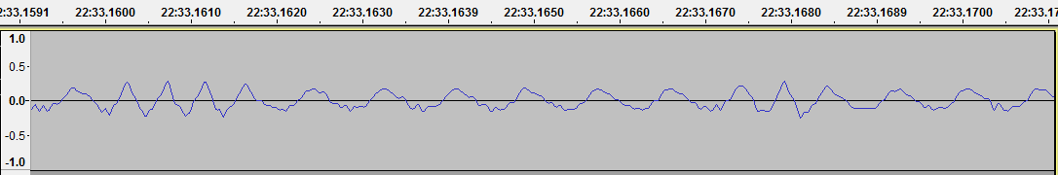

DECODED[889] 22:33.1728 Digipeater W6SCE-10 audio level = 53(15/21) \_\_\_\_|\_\_\_\_

[0] K6NE>APW251,KF6RAL,W6SCE-10\*:=3415.70N/11911.81W\_PHG1100/WinAPRS 2.5.1 -CAVENVENTURA -251-<530><0x0d><0x0a>

It looks like a higher frequency component in there. It’s not symmetrical but rather mostly on one half of the lower tone. It’s not an ephemeral anomaly; we see the same thing in other frames from the same station.

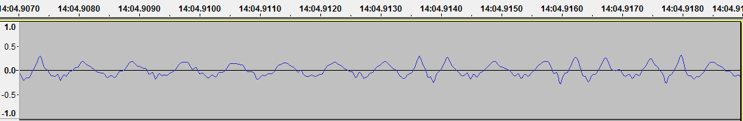

DECODED[576] 14:04.9187 W6SCE-10 audio level = 54(15/22) |||||\_\_\_\_

[0] W6SCE-10>APN382:!3419.82N111836.06W#PHG6860/W1 on Oat Mtn./A=003747/k6ccc@amsat.org for info<0x0d>

This looks like a more extreme case of the same thing. Dire Wolf 1.2 was not able to decode it.

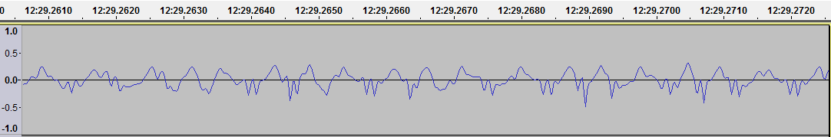

With experimental improvements in Dire Wolf version 1.3, we get this:

DECODED[527] 12:29.3449 Digipeater W6SCE-10 audio level = 96(21/24) [NONE] \_\_\_\_\_\_\_\_\_|\_\_\_\_\_\_\_\_\_\_\_\_\_\_\_\_\_

[0] KD6UZM-15>S3UWTS,WB6JAR-10,W6SCE-10\*:`-)<0x1d>l <0x1c>v\":o}

This is interesting, and not in a good way.

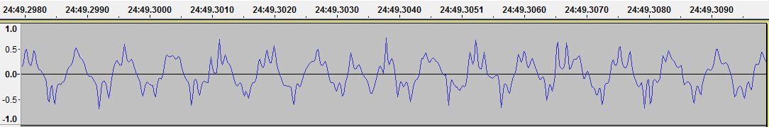

DECODED[979] 24:49.3084 KF6KOI audio level = 129(37/32) \_||||\_\_\_\_

[0] KF6KOI>GPSMV,WIDE2-2:$GPRMC,021718,A,3347.6433,N,11805.4993,W,000.0,111.4,231105,013.4,E\*65<0x0d><0x0a>

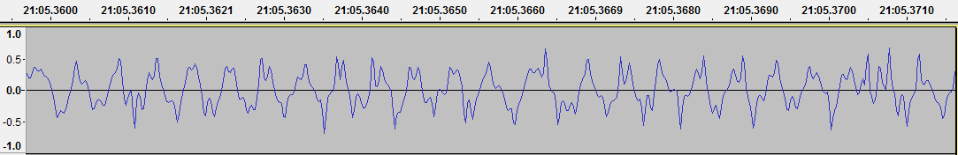

DECODED[835] 21:05.3712 KF6KOI audio level = 129(38/33) \_\_\_||\_\_\_\_

[0] KF6KOI>GPSMV,WIDE2-2:$GPRMC,021118,A,3347.6429,N,11805.5007,W,000.0,111.4,231105,013.4,E\*6D<0x0d><0x0a>

The deviation is too high but there is something else interesting going on there even when we are not near the jagged peaks. I’m wondering if the waveform was generated by pulse width modulation and inadequate filtering.

This is what we get from a frequency analysis. Contrast it with the very first example.

|  |  |
| --- | --- |
|  |  |

Unfortunately, the automatic vertical scaling is not adjustable and the two plots have different scales. After making screen captures, and pasting them here, the images have been shifted and stretched in an attempt to make the scales line up.

On right side (good signal):

We expect to find peaks around 1200 and 2200 Hz. It should fall off pretty quickly outside of that range. The next major peak is around 6.4 kHz, down about 21 dB from the desired signal.

On left side (splatter):

In the most recent example we see many higher frequencies. Here we have multiple spurs out to 9 kHz only 12 dB down from the peak at 2200 Hz.

## Summary

Based on what we’ve observed here, a beauty competition for good looking APRS frames would have trouble finding very many eligible contestants.

There are a lot of ugly signals out there. Many can be improved by decreasing the transmit volume. Others are just plain weird and you have to wonder how they are being generated.