

Walchand College of Engineering, Sangli

(Government aided Autonomous Institute)

Department of Computer Science and Engineering
TY CSE Mini Project 1
Report on

Investigating the Impact of Unsupervised Methods on Supervised Learning Performance

Submitted by

Krishna Dhumal | 23510057
Amit Rane | 23510064
Pranav Oak | 23510115

Under the guidance of

Prof. Shailesh Patil

Department of Computer Science and Engineering,
Walchand College of Engineering, Sangli
2025 - 2026



Walchand College of Engineering, Sangli
(Government aided Autonomous Institute)

Department of Computer Science and Engineering

CERTIFICATE

This is to certify that the Project Report entitled, INVESTIGATING THE IMPACT OF UNSUPERVISED METHODS ON SUPERVISED LEARNING ALGORITHMS submitted by Mr. Krishna Dhumal, Mr. Amit Rane and Mr. Pranav Oak, to Walchand College of Engineering Sangli, India, is a record of bonafide project work of course Mini Project 1 (7CS345) carried out by them under my supervision and guidance and is worthy of consideration for the award of the degree of Bachelor of Technology in Computer Science & Engineering of the Institute.

Prof. Shailesh Patil | Dr. B.F. Momin |  | Dr. A. R. Surve
Guide | Mini project  coordinator | External examiner | Head Of Department
Department of Computer Science and Engineering, | Department of Computer Science and Engineering, |  | Department of Computer Science and Engineering,
Walchand College of Engineering, Sangli | Walchand College of Engineering, Sangli |  | Walchand College of Engineering, Sangli

Acknowledgement

It gives us immense pleasure to present this mini project report as a part of the curriculum of the Btech program. The successful completion of this project would not have been possible without the guidance, support, and encouragement of several individuals.
We would like to express our profound gratitude to Dr. A. R. Surve, Head of the Department of Computer Engineering, for providing us with the necessary resources, valuable advice, and constant encouragement throughout the course of this project
We are also sincerely thankful to our Mini Project Coordinator, Dr. B. F. Momin, for his keen interest, insightful suggestions, and timely assistance at every stage of this work. His valuable inputs have helped us improve the quality and scope of our project significantly.
Our heartfelt appreciation goes to our Project Guide, Prof. Shailesh Patil, for his dedicated supervision, continuous guidance, and patience throughout the development of this project. His valuable insights, technical expertise, and constructive feedback helped us in refining our ideas and overcoming various challenges encountered during the implementation.
Last but not least, we express our deep sense of gratitude to our parents, classmates, and friends for their constant moral support, motivation, and understanding, which served as a source of strength and inspiration throughout the completion of this mini project.
We are truly thankful to everyone who contributed directly or indirectly to the successful completion of this project.

Declaration

I hereby declare that work presented in this project report titled INVESTIGATING THE IMPACT OF UNSUPERVISED METHODS ON SUPERVISED LEARNING ALGORITHMS submitted by me in the partial fulfillment of the requirement of the award of the degree of Bachelor of Technology (B. Tech) in the Department of Computer Science & Engineering, Walchand College of Engineering, Sangli is an authentic record of my project work carried out under the guidance of Prof. Shailesh Patil.

Date:
Place: Sangli

Krishna Dhumal, 23510057
Amit Rane, 23510064
Pranav Oak, 23510115

Table of Contents

Abstract
- Introduction and Related work
- Problem statement
- Objectives
- Methodology
- Project Diagrams (UML diagrams, Flow chart etc.)
- Test plan
- Results
- Conclusion
- Limitations of proposed solution
- Future scope/possible extension to proposed project
- References

Abstract
Supervised learning models rely on labeled data to make predictions, but they often struggle to capture complex or hidden structures in high-dimensional datasets. Unsupervised learning methods, such as clustering and dimensionality reduction techniques, can reveal latent patterns without labels. This project investigates whether these patterns can be leveraged to improve supervised learning outcomes.
The methodology involves applying various unsupervised methods including SVD, PCA, PLS, LDA, OPLS, and clustering algorithms to a dataset and analyzing how the outputs of these methods could potentially aid supervised learning. Techniques such as permutation feature importance and Shapley values will be used to measure the relevance of features or patterns derived from unsupervised methods. The study is to determine whether the additional information from unsupervised analyses can improve the predictive performance of supervised models.
Expected outcomes include insights into which unsupervised methods provide meaningful contributions, under what conditions they are most effective, and whether their integration could be a viable direction for enhancing supervised learning models.

Introduction and Related work
Supervised learning is widely used for predictive modeling but often overlooks hidden patterns in data. Unsupervised learning, especially clustering, can uncover these latent structures, which, when integrated into supervised models, may enhance generalization, interpretability, and robustness.
This project develops a hybrid workflow combining supervised and unsupervised methods. The process involves: (1) establishing baseline supervised performance; (2) applying clustering to detect latent groups; (3) converting cluster outputs (IDs, distances, probabilities) into new features; and (4) retraining and evaluating models for performance gains. The study also assesses stability, effect sizes, and feature importance to determine when clustering-based features are beneficial.
Feature engineering strongly influences model success on tabular data. Prior studies show that adding cluster-derived features-via methods like K-Means, DBSCAN can improve predictive accuracy, especially when classes overlap or contain substructure. Best practices include careful cluster-number selection, using soft or distance features for fuzzy boundaries, consistent data splits, and paired statistical testing to validate gains.

Problem statement
This project investigates the effectiveness of integrating unsupervised clustering information as additional features to improve supervised learning model performance. The research explores whether cluster assignments generated from unsupervised algorithms can serve as meaningful features that enhance the predictive accuracy of various supervised learning models. The project aims to empirically validate the hypothesis that clustering-derived features capture hidden data structures that complement original features, leading to improved classification or regression performance.

Objectives
1. Baseline Performance Establishment
Implement and evaluate multiple supervised learning algorithms (Random Forest, SVM, Logistic Regression, Decision Trees) on the selected dataset to establish comprehensive baseline performance metrics including accuracy, precision, recall, F1-score, and computational efficiency measures.
2. Clustering Algorithm Evaluation
Apply various unsupervised clustering algorithms (K-Means, Hierarchical Clustering, DBSCAN, Gaussian Mixture Models) to the dataset, evaluate cluster quality using metrics such as silhouette score and adjusted rand index, and determine optimal clustering parameters for each algorithm.
3. Feature Engineering Integration
Develop a systematic methodology for incorporating cluster assignments as additional features, including techniques for handling categorical cluster IDs, distance-based features, and cluster membership probabilities to create an enhanced feature space.
4. Performance Comparison and Analysis
Conduct comprehensive statistical analysis comparing the performance of supervised learning models before and after incorporating clustering features, including significance testing, confidence intervals, and analysis of improvement patterns across different algorithms and datasets.
5. Methodology Generalization
Validate the approach across multiple datasets from different domains to establish the generalizability of the methodology and identify the conditions under which clustering-based feature enhancement provides maximum benefit.

Methodology
Tech Stack
Programming Language: Python 3.9+
Core Libraries:
• Data Manipulation: pandas, numpy
• Machine Learning: scikit-learn, scipy
• Deep Learning: TensorFlow, PyTorch (for advanced clustering)
• Visualization: matplotlib, seaborn, plotly
• Statistical Analysis: statsmodels, scipy.stats
Development Environment:
• IDE: Jupyter Notebook, PyCharm, VS Code
• Version Control: Git
• Experiment Tracking: MLflow, Weights & Biases

Algorithms and Techniques

Supervised Learning Algorithms:
These models are used to establish baseline predictive performance on the dataset:

Random Forest Classifier/Regressor - ensemble tree-based method for robust predictions.
Support Vector Machines (SVM) - finds optimal separating hyperplanes in feature space.
Logistic Regression - interpretable linear model for classification tasks.
Decision Trees - simple tree-based model capturing feature interactions.
Gradient Boosting Machines (GBM) - ensemble boosting approach to improve predictive accuracy.
Neural Networks - flexible model for capturing complex, non-linear relationships.

Unsupervised / Semi-Supervised Methods for Investigation:
These techniques are applied to explore latent structures in the dataset and their potential relevance to supervised learning:

SVD (Singular Value Decomposition) - identifies dominant patterns in the data matrix.
PCA (Principal Component Analysis) - reduces dimensionality while preserving variance.
PLS (Partial Least Squares) - finds latent variables maximizing covariance with the target.
OPLS (Orthogonal Partial Least Squares) - separates predictive vs. orthogonal variation in features.
LDA (Linear Discriminant Analysis) - explores separability of classes in feature space.
Clustering Algorithms:
K-Means - partitions data into k clusters based on distance.
Hierarchical Clustering - builds nested cluster hierarchies (agglomerative/divisive).
DBSCAN – identifies dense regions and noise points.
Gaussian Mixture Models (GMM) - probabilistic clustering using Gaussian components.
Spectral Clustering - uses graph Laplacians to identify complex cluster structures.

Evaluation / Analysis Methods

Since the focus is research-oriented, the unsupervised outputs are analyzed rather than directly used for feature engineering:

Permutation Feature Importance - assess the potential relevance of latent components or cluster assignments.
Shapley Values - quantify contributions of unsupervised-derived components to predictions.
Cross-validation - evaluate baseline supervised model performance (k-fold, stratified).
Statistical Significance Testing - t-tests or Wilcoxon tests to compare performance changes.
Performance Metrics - Accuracy, Precision, Recall, F1-score, AUC-ROC.

Implementation Pipeline (Research-Focused)
1. Data Acquisition and Preprocessing
Load dataset, handle missing values, normalize/standardize features.
2. Baseline Supervised Model Training and Evaluation
Train multiple supervised models.
Record baseline performance metrics (accuracy, F1-score, etc.).
3. Unsupervised / Semi-Supervised Analysis
Apply SVD, PCA, PLS, OPLS, LDA, and clustering algorithms.
Analyze outputs for latent structures, potential predictive patterns, and cluster separation.
4. Relevance and Contribution Assessment
Use permutation feature importance and Shapley values to assess whether unsupervised outputs could aid supervised learning.
Compare unsupervised patterns with baseline model performance to identify promising directions.
5. Comparative Performance Analysis
Statistically evaluate potential performance improvements suggested by unsupervised patterns.
Determine whether any patterns consistently align with target variable structure.
6. Reporting and Documentation
Summarize findings, highlighting which unsupervised methods show promise for supervised learning.
Generate visualizations of latent structures, clusters, and component contributions.

Project diagrams

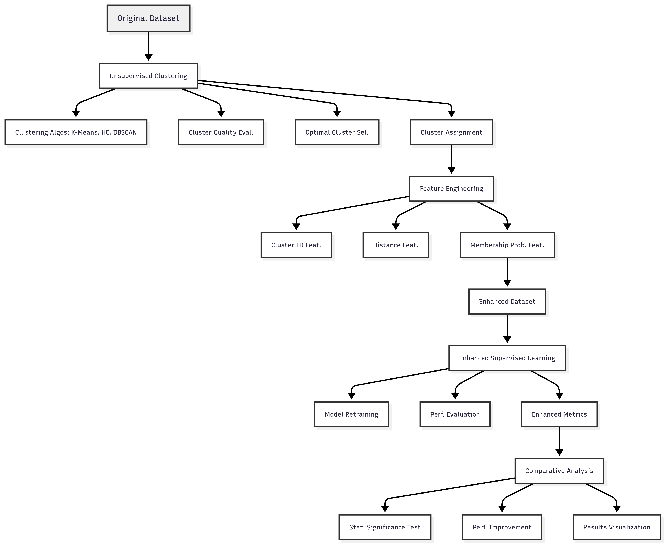

Test plan

To thoroughly evaluate the performance, generalization capability, and robustness of the proposed machine learning models, an extensive testing plan was designed using multiple publicly available and synthetically generated datasets. Separate testing strategies were adopted for regression and classification tasks to ensure a comprehensive analysis across different data types and complexities.

Regression Datasets
For regression, we used a combination of real-world and synthetic datasets: Workers Compensation, BNG Libras Move, Safe Driver Prediction, and Superconductivity. In addition to these, five synthetic datasets were generated with 50 features each and varying instance sizes of 10,000, 25,000, 50,000, 75,000, and 100,000. Among these, 10–15 features were informative, ensuring meaningful patterns for model learning. The datasets were designed to include five clusters, a standard deviation of 2, and a controlled noise factor of 0.2 (ranging between 0 and 1). This setup was intended to simulate diverse real-world data behaviors, including linear, non-linear, and manifold structures.
The regression models were trained and tested on an 80:20 data split, ensuring sufficient data for both learning and validation. Key performance metrics included Mean Absolute Error (MAE), Root Mean Squared Error (RMSE), and R² Score. Each dataset underwent multiple iterations to ensure consistency and statistical significance in results. The combination of real-world and synthetic data helped assess the scalability and stability of models under different noise levels and feature interdependencies.

Classification Datasets
For classification, we utilized nine benchmark datasets: Winequality-Red, Winequality-White, Beed_Data, Letter Recognition, Magic04, Spambase, Credit Card Default, Dry Bean, and Diabetes. These datasets vary widely in terms of the number of instances, attributes, and class distributions. The variety ensures that models are tested across both binary and multi-class scenarios, including imbalanced data conditions.
Each dataset was preprocessed to handle missing values, normalize numerical features, and encode categorical attributes. The data was split into training and testing sets in an 80:20 ratio, and model performance was evaluated using metrics such as Accuracy, Precision, Recall, F1 Score, and ROC-AUC. Cross-validation techniques were also employed to minimize bias and ensure that the results are not dependent on a single random split.

Evaluation and Validation
The test plan emphasizes not only model accuracy but also generalization and robustness. Experiments were conducted under controlled hyperparameter settings, with results averaged over multiple runs to avoid overfitting biases. Comparative evaluations across datasets provide insights into how different models behave on distinct data types, structured vs. unstructured, balanced vs. imbalanced, and small vs. large scale.
Overall, this testing framework ensures a comprehensive evaluation of model performance across regression and classification domains, validating the adaptability and efficiency of the proposed methodologies under varying real-world data conditions.

Results

Model Performance for the dataset California housing

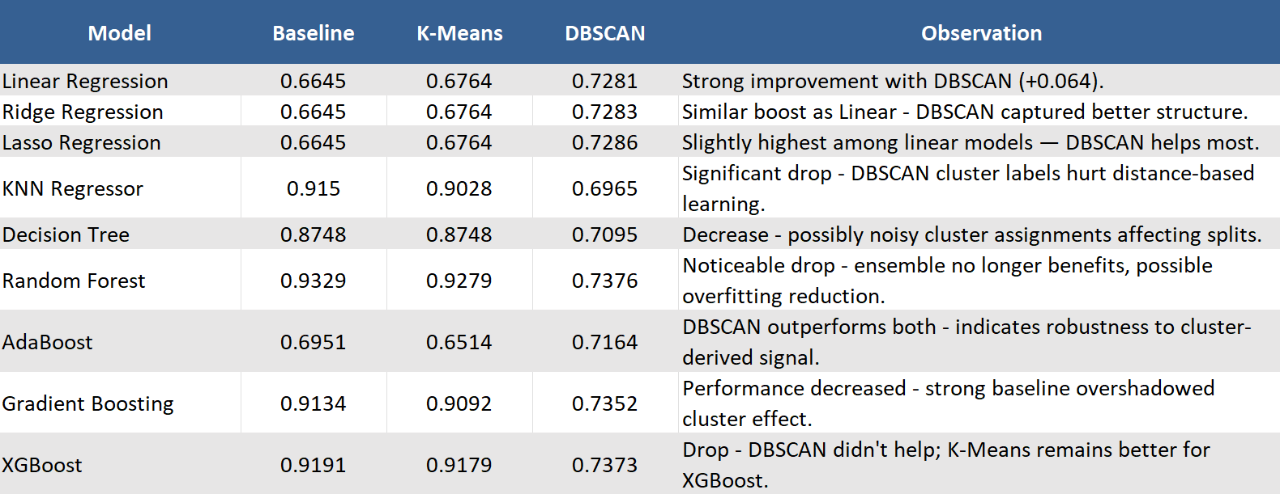

Model Performance for the dataset Gas Turbine (5 years data merged)

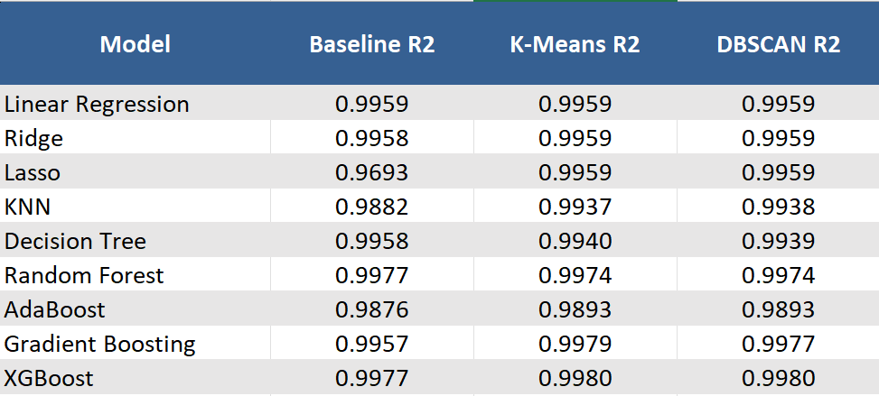

Model Performance for the dataset Diabetes

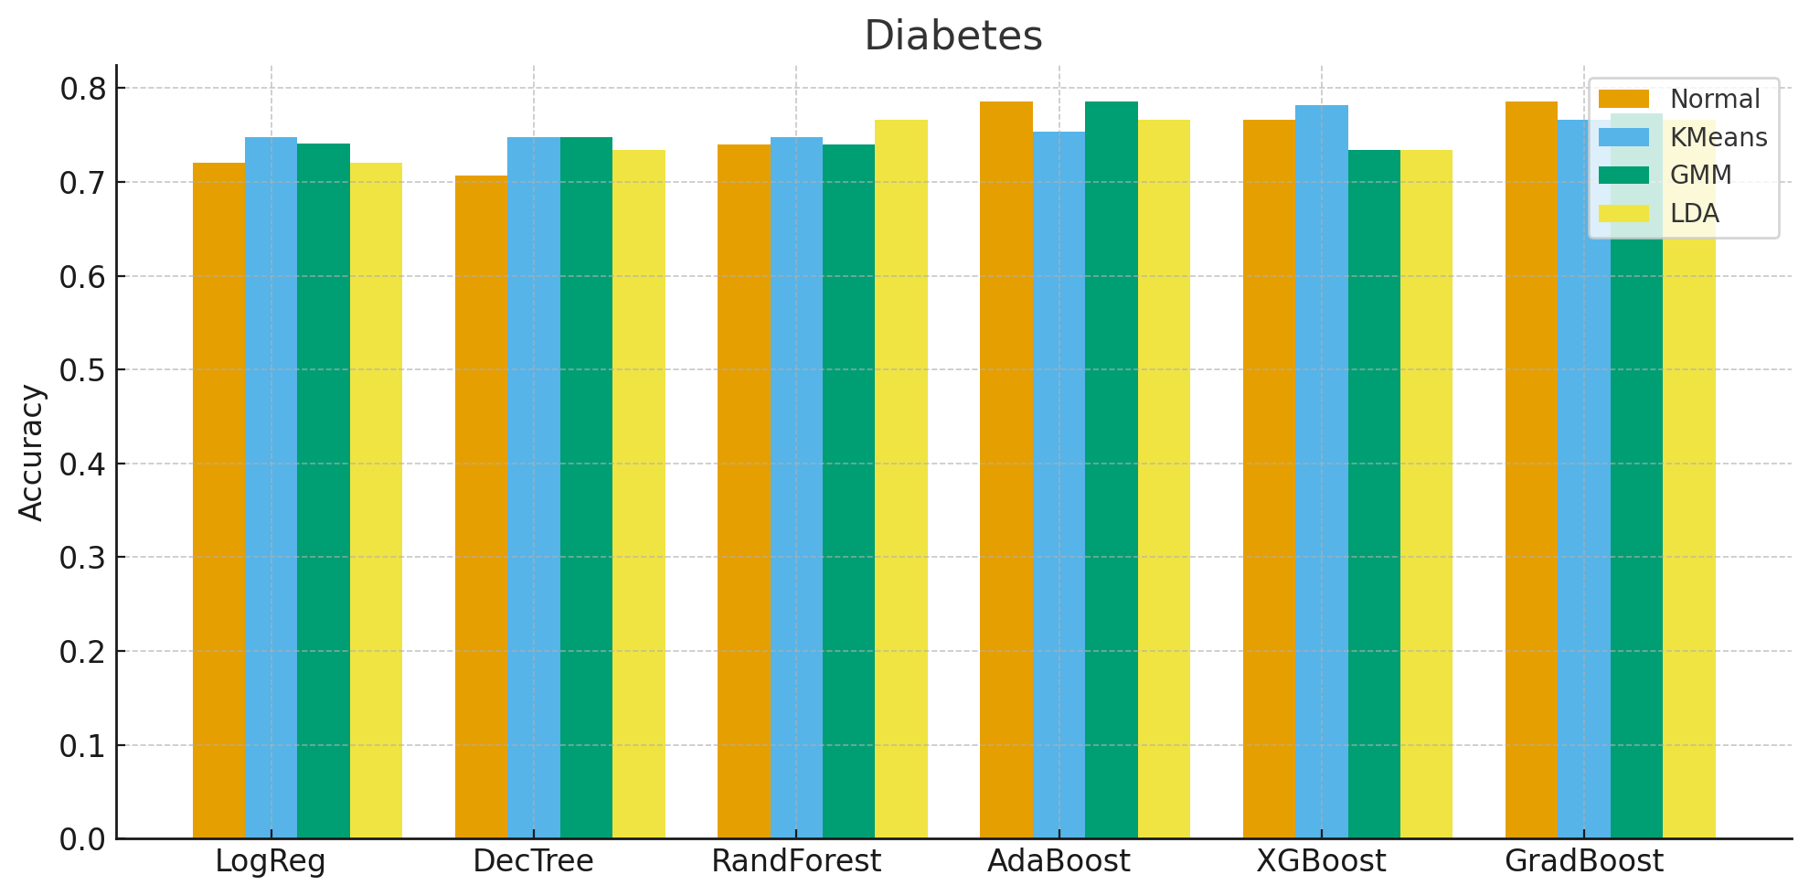

Model Performance for the dataset BEED_Data

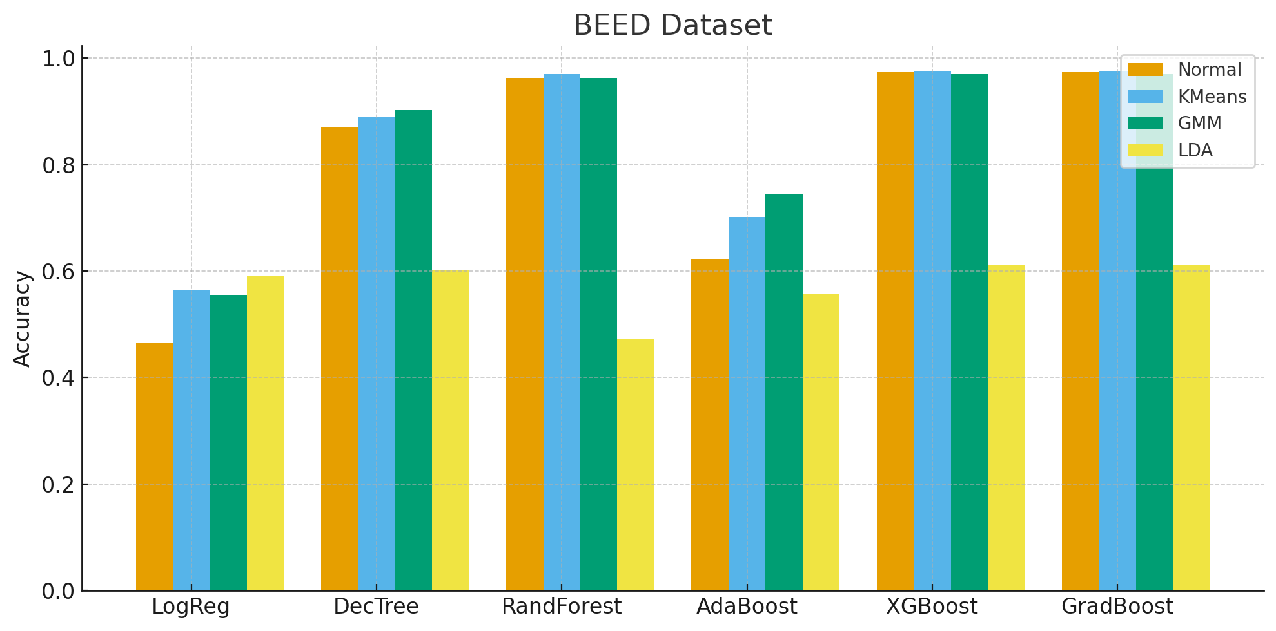

Model Performance for the dataset Spambase

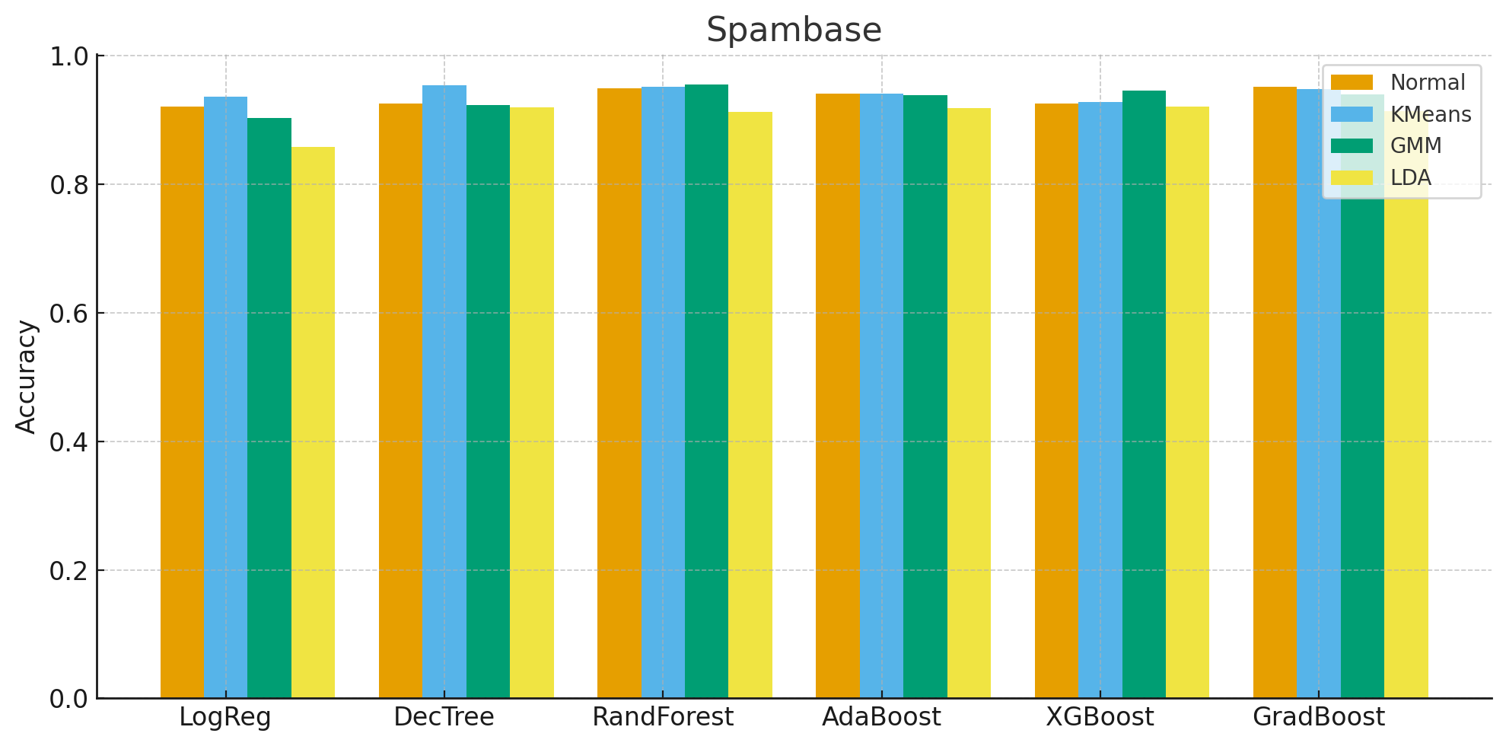

Model Performance for the dataset Magic04

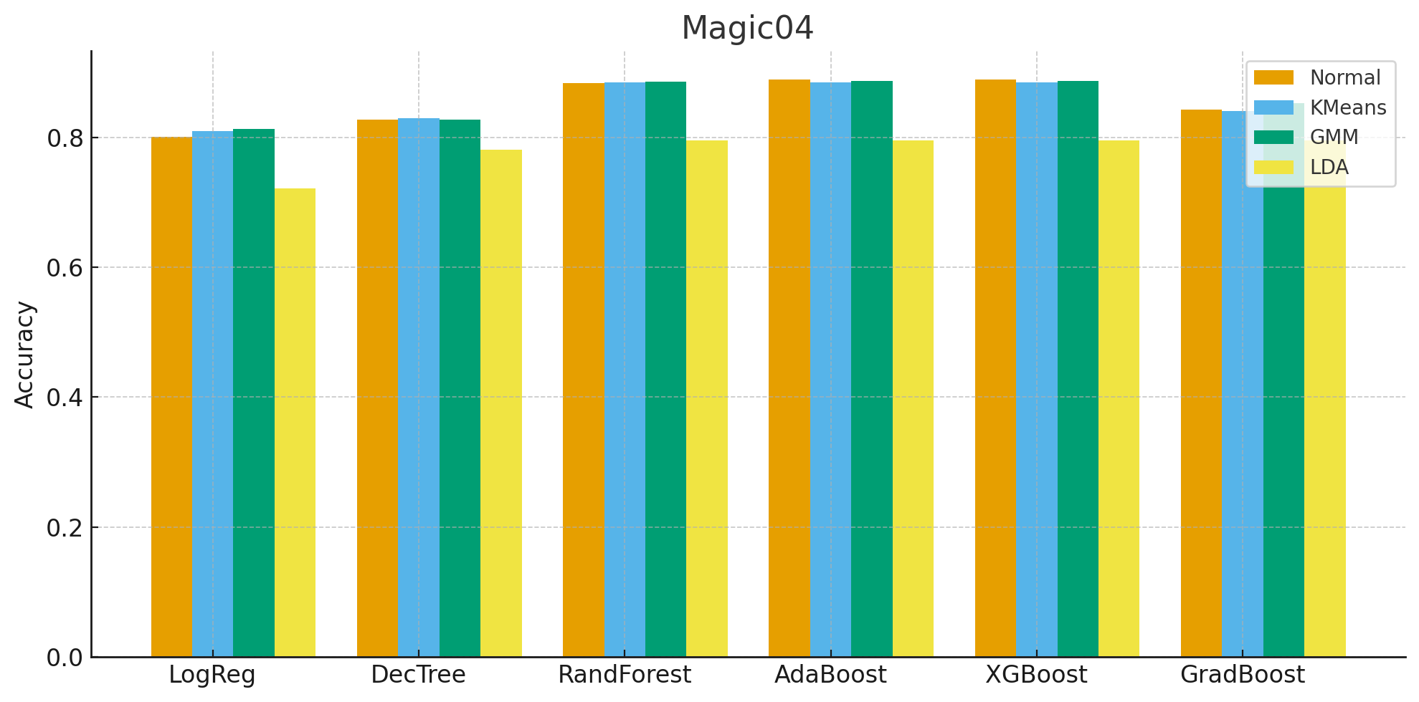

Conclusion
The study demonstrates the impact of integrating unsupervised clustering techniques, K-Means and DBSCAN-with multiple regression algorithms to enhance predictive modeling performance. Experimental results indicate that the inclusion of cluster labels as additional features provides minor but consistent improvements in certain models, particularly K-Nearest Neighbors (KNN) and Gradient Boosting Regressor, while high-performing ensemble methods such as Random Forest and XGBoost showed negligible changes. This suggests that clustering features may add value mainly for models that rely heavily on data structure and proximity information.
Despite these findings, the overall improvement remains modest. One limitation of the approach is that a single discrete cluster label may not capture the full structural complexity of the data, especially when clusters overlap or have irregular densities. Additionally, DBSCAN’s performance is sensitive to the choice of parameters (eps and min_samples), and improper tuning can lead to noise points or uneven cluster distribution, affecting model performance.
For future work, this approach can be extended by introducing richer clustering representations, such as distance-based or soft-cluster probabilities (e.g., using Gaussian Mixture Models). Incorporating dimensionality reduction techniques like PCA before clustering may also yield more meaningful clusters. Another possible extension involves developing an automated hybrid pipeline that optimizes both clustering and regression hyperparameters jointly, potentially improving robustness and interpretability.
Overall, the results affirm that while clustering features may not drastically alter performance in strong ensemble models, they offer interpretive and performance benefits in simpler or distance-based regressors-making this hybrid strategy a useful and flexible addition to the regression modeling toolkit.

References
- The Singular Value Decomposition, Applications and Beyond [Zhihua Zhang, Shanghai Jiao Tong University]
- A Tutorial on Principal Component Analysis [Jonathon Shlens, Google Research Mountain View, CA 94043]
- A Rapid Review of Clustering Algorithms [Hui Yin, Amir Aryani , Stephen Petrie, Aishwarya Nambissan, Aland Astudillo, Shengyuan Cao, Swinburne University of Technology, Victoria, Australia.]
- An Empirical Analysis of Feature Engineering for Predictive Modeling [Jeff Heaton, McKelvey School of Engineering Washington University in St. Louis]
- UCI Datasets
- OpenML datasets

