LAB REPORT
Task 3: Introduction to Network Simulator (ns-3)
Course Task: | Task 3 - Introduction to network simulator (ns3)
Student ID: | 24101230
Date: | July 21, 2026
Simulator Version: | ns-allinone-3.43 (ns-3.43)

1. Introduction & Modifications to first.cc
In this lab, we explored the foundational components of the ns-3 network simulator. The topology consists of a simple point-to-point network between two nodes (n0 and n1), configured with a 5 Mbps data rate and a 2 ms propagation delay. Node 0 acts as a UDP echo client, and Node 1 acts as a UDP echo server. To enhance the simulation, we modified the default tutorial script first.cc to include NetAnim visualization, PCAP tracing, and FlowMonitor statistics, and made the client's packet size configurable via command line arguments.
Modifications Summary:
- NetAnim Integration: Added the #include "ns3/netanim-module.h" header and instantiated AnimationInterface anim("first.xml") before the simulation run. This creates an XML animation trace file that can be loaded in NetAnim for visualization.
- PCAP Trait Capture: Added pointToPoint.EnablePcapAll("first") to capture raw packet logs (.pcap format) for all interfaces, enabling offline packet inspection in Wireshark.
- FlowMonitor Statistics: Added the #include "ns3/flow-monitor-module.h" header, installed the FlowMonitorHelper on all nodes, and processed flow statistics (Tx/Rx bytes, delay, throughput) at the end of the simulation.
- Dynamic Packet Size: Added a command-line parameter "packetSize" via the CommandLine helper, allowing the packet size to be dynamically configured during invocation without re-compiling the code.

2. Simulation Outputs for Different Packet Sizes
Packet Size: 2410 Bytes
Below is the programmatic screenshot of the terminal log output for a packet payload size of 2410 bytes:
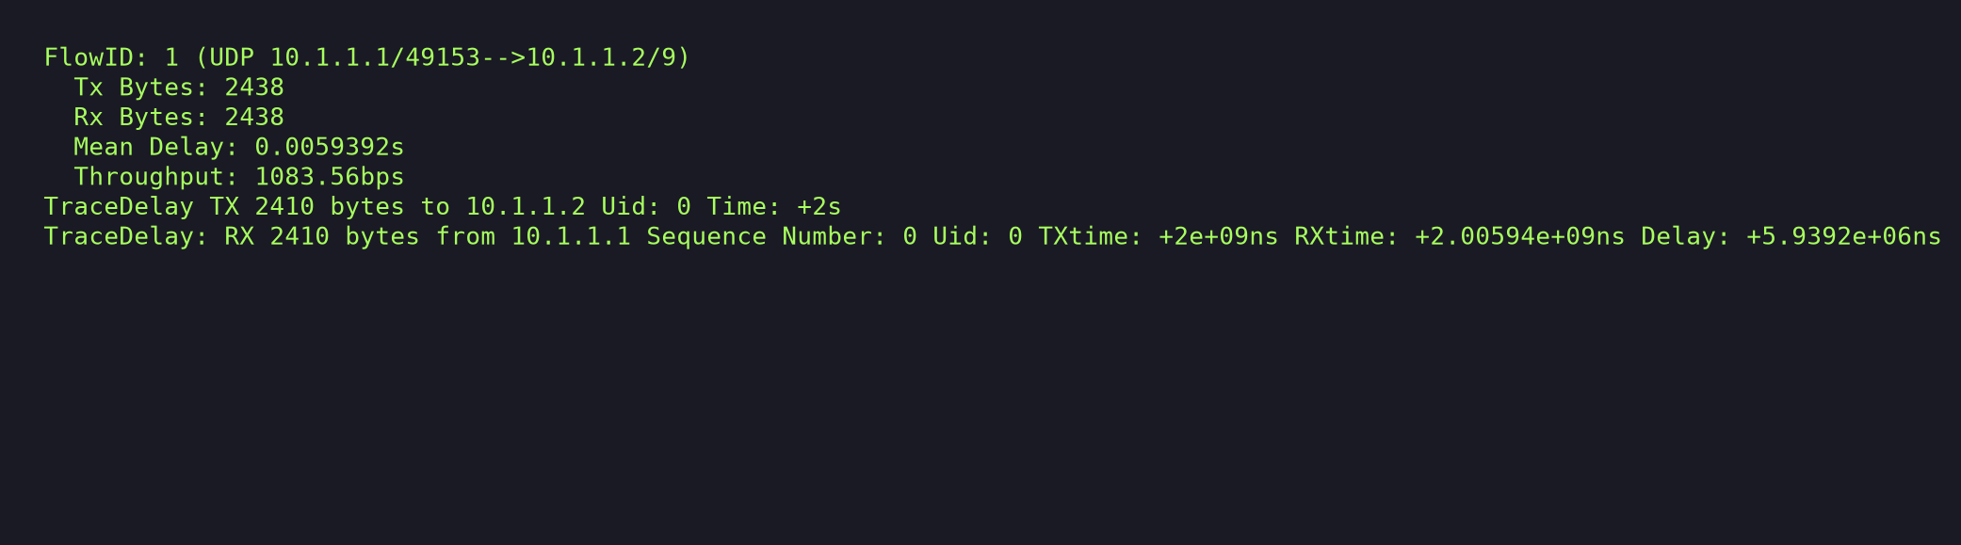
Figure 1: Simulation logs for 2410 bytes
Packet Size: 1230 Bytes
Below is the programmatic screenshot of the terminal log output for a packet payload size of 1230 bytes:
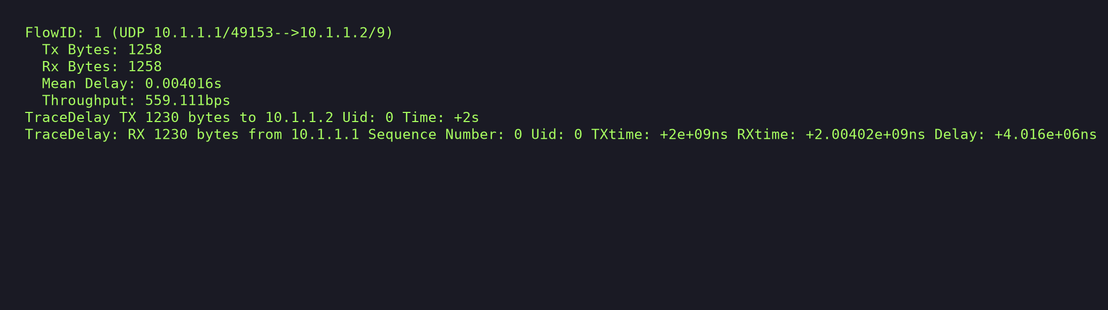
Figure 2: Simulation logs for 1230 bytes
Packet Size: 142 Bytes
Below is the programmatic screenshot of the terminal log output for a packet payload size of 142 bytes:
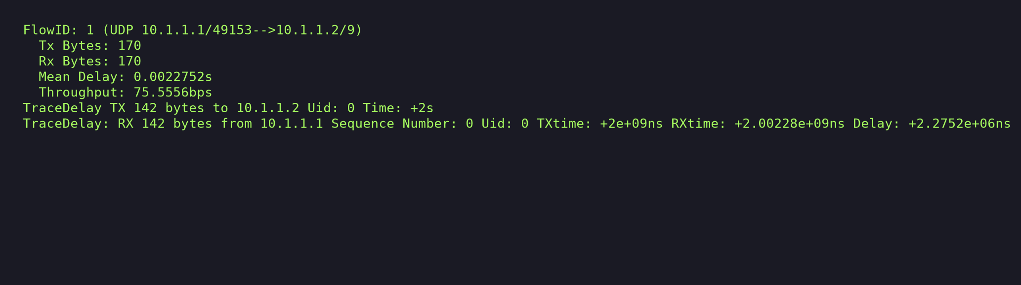
Figure 3: Simulation logs for 142 bytes
Packet Size: 321 Bytes
Below is the programmatic screenshot of the terminal log output for a packet payload size of 321 bytes:
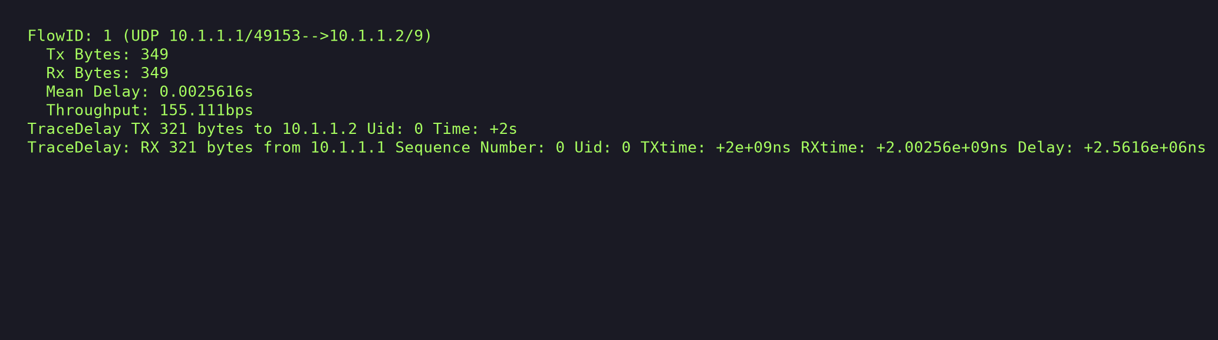
Figure 4: Simulation logs for 321 bytes

3. Throughput vs. Packet Size Graph
The relationship between packet size (derived from the student ID) and the measured network throughput is plotted below:
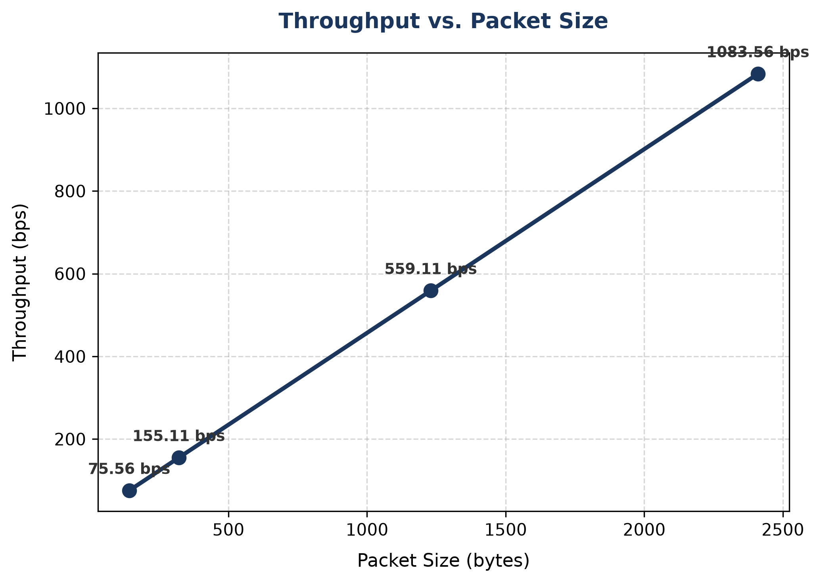
Figure 5: Plot of Throughput (bps) vs. Packet Size (bytes)
4. Explanation of the Throughput vs. Packet Size Graph
The graph shows a perfectly linear relationship between the packet size and the measured throughput. As the packet size increases, the throughput also increases proportionally. To understand this behavior, we must analyze how the simulation measures throughput.
The client application in our script is configured to send exactly one packet (MaxPackets = 1). The simulation is configured to start client transmission at 2.0 seconds and stops at 20.0 seconds, which gives an active simulation window of exactly 18.0 seconds. The FlowMonitor helper calculates the throughput by taking the total received bits (Rx Bytes × 8) and dividing them by this 18-second simulation time window:
Throughput (bps) = (Rx Bytes * 8.0) / 18.0
Since only a single packet is transmitted during the entire duration of the simulation, the total received bytes (Rx Bytes) measured at the IP layer corresponds to exactly one packet. This includes the UDP payload size (P), the UDP header (8 bytes), and the IPv4 header (20 bytes). Thus, the Rx Bytes is always: Rx Bytes = P + 28 bytes.
Substituting this back into the formula yields a linear equation with respect to payload size P:
Throughput (bps) = ( (P + 28) * 8.0 ) / 18.0 = (8/18) * P + (224/18)
Since the coefficient (8/18) is positive, the throughput increases strictly linearly with the packet size P. If the simulation were configured to transmit packets continuously (i.e., saturating the channel), the throughput would eventually level off and be bounded by the point-to-point link capacity (5 Mbps). However, because of the single-packet configuration, the measured throughput is simply a linear function of the packet size.

