

Department of Computer Science and Engineering

CSE422: Artificial Intelligence

Lab Project Report: Career Switch Prediction

Submitted by:
Sadman Rahman - 24101331
Hibrul Anam Prantik – 24101230
Group no: 17

Date of Submission: 03/09/2026

Table of Contents
- Introduction 3
- Dataset Description 3
- Dataset Pre-processing 4
  - Missing / Null Values 4
  - Categorical Values 4
  - Feature Scaling 4
- Dataset Splitting 4
- Model Training & Testing (Supervised and Unsupervised) 4
  - Unsupervised Learning: K-Means 4
  - Supervised Learning 4
- Model Selection & Comparison Analysis 4
- Conclusion 6
- References 6

Career Switch Prediction: A Machine Learning Approach to Identify Potential Employee Turnover

Abstract -- Employee turnover and career switching pose significant challenges and costs to organizations worldwide. This project presents a machine learning approach to predict whether an individual is likely to change their career based on demographic, educational, and professional data. We rigorously process an imbalanced dataset of 5,000 records, addressing missing values, categorical encoding, and feature scaling without data leakage. Six supervised learning algorithms (K-Nearest Neighbors, Decision Tree, Logistic Regression, Linear Regression, Naive Bayes, Neural Network) and one unsupervised algorithm (K-Means) are trained, evaluated, and compared. The results indicate that the Logistic Regression and Linear Regression yield the strongest predictive performance, achieving ROC-AUC scores of
~0.71.
Index Terms -- Machine Learning, Career Switch Prediction, Classification, Pre-processing, Neural Networks.

Introduction
The modern job market is highly dynamic, with professionals frequently transitioning between different career paths. For human resource (HR) departments, anticipating whether a candidate or employee is looking to switch careers is critical for tailoring recruitment, training, and retention strategies.
The objective of this project is to build robust predictive models capable of determining whether an individual will change their career. We treat this as a binary classification problem, where the target variable will_change_career denotes whether a switch will occur (1) or not (0). The motivation behind this project is to automate and optimize HR screening processes by uncovering hidden patterns in candidate profiles.

Dataset Description
The analysis is based on the Career_Switch_Prediction_Dataset.csv. A thorough Exploratory Data Analysis (EDA) was
performed to understand the structure and properties of the data.
Data Points and Features: The dataset consists of 5,000 instances and 14 features (13 predictors
and 1 target).
Problem Type: This is distinctly a classification problem because the objective is to predict a discrete binary label (will_change_career).
Feature Types: The dataset contains a mix of quantitative (3 features) and categorical features (11 features).
Class Imbalance: The target variable is significantly imbalanced. There are 3,738 instances belonging to Class 0 (No Career Switch) and 1,262 instances belonging to Class 1 (Will Switch Career).
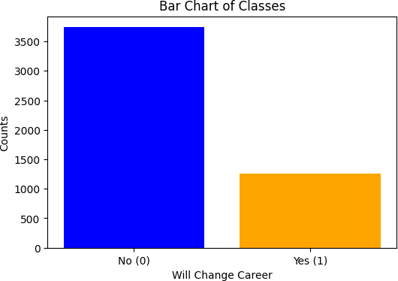
Fig. 1. Bar Chart of Target Classes.
Correlation: A correlation heatmap revealed the internal relationships among numerical variables. It was observed that enrollee_id possessed negligible correlation with the target and functioned merely as a unique identifier; hence, it was dropped.

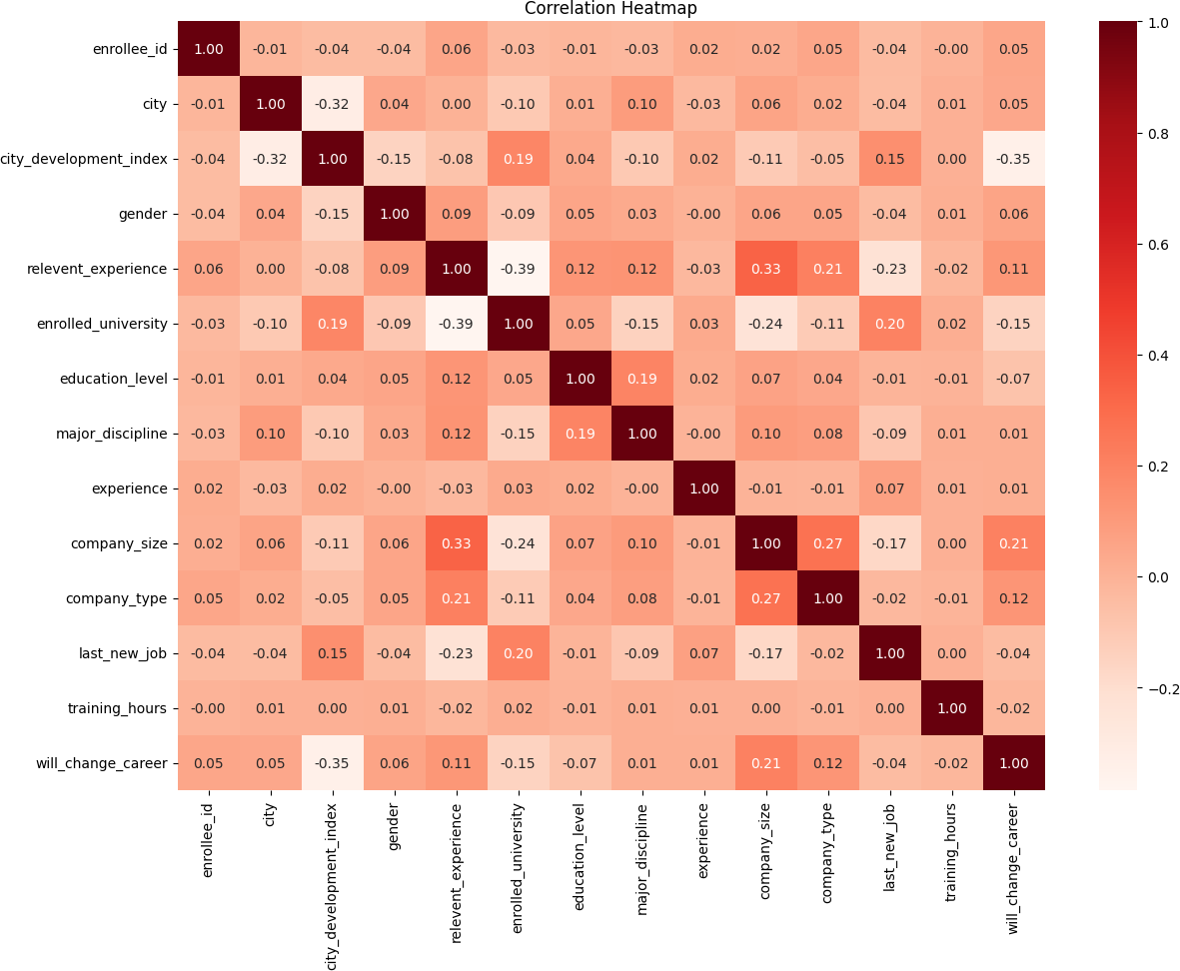
Fig. 2. Feature Correlation Heatmap.

Dataset Pre-processing
To ensure model validity and prevent data leakage, all imputation and scaling parameters were learned exclusively from the training data after the dataset was split.

Missing / Null Values
Problem: A high volume of missing values was detected in critical categorical features such as gender, major_discipline, and company_size.
Solution: We applied targeted imputation. For numerical columns, missing values were replaced with the Median of the respective column in the training set. For categorical columns, we utilized the Mode (most frequent value) of the training set.

Categorical Values
Problem: Standard machine learning algorithms require strictly numerical input, yet the majority of our predictors were categorical strings.
Solution: We applied LabelEncoder to systematically map string labels into integer representations.

Feature Scaling
Problem: Variance analysis showed features had drastically different scales, which heavily biases distance-based algorithms like KNN.
Solution: We applied standard scaling (StandardScaler) to transform the features to a mean of 0 and standard deviation of 1.

Dataset Splitting
To evaluate the models authentically, the dataset was partitioned into an 80% Training set and a 20%
Testing set using stratified sampling to preserve the target class ratios.
To combat class imbalance, random under-sampling was applied strictly to the training set. The majority class was reduced to match the minority class size. The test set was left untouched to ensure evaluations reflect real-world, imbalanced conditions.

- Model Training & Testing

Unsupervised Learning: K-Means
We applied the K-Means clustering algorithm (K=2) to the training features. Principal Component Analysis (PCA) was used to project the multi-dimensional data into a 2D scatter plot.
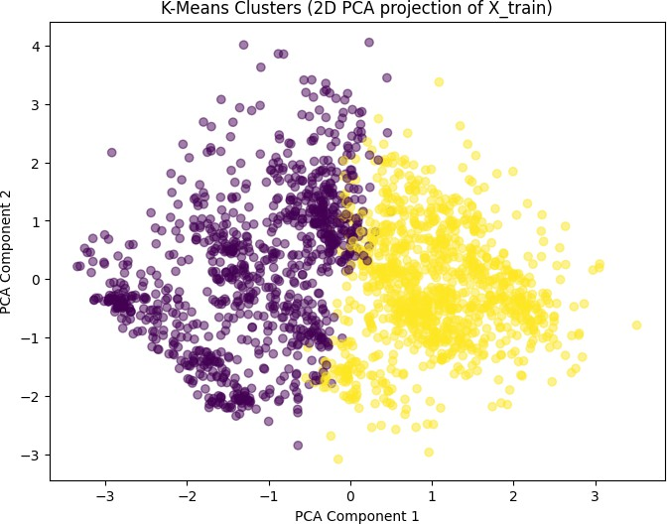
Fig. 3. K-Means Clusters visualized using a 2D PCA projection.

Supervised Learning
The following six models were trained on the balanced training set and tested on the unseen test set: K-Nearest Neighbors (KNN), Decision Tree, Logistic Regression, Linear Regression, Naive Bayes, and Neural Network (MLP).

Model Selection & Comparison Analysis
The models were compared utilizing the test set across multiple metrics. Linear Regression was evaluated utilizing regression metrics (R-squared and Loss), and subsequently thresholder at 0.5 to allow comparison via classification metrics.

KNN | 62.20% | 36.30% | 66.27% | 0.6752
Decision Tree | 62.10% | 35.40% | 61.11% | 0.6175
Logistic Regression | 70.90% | 44.31% | 60.32% | 0.7126
Linear Regression | 71.50% | 45.02% | 59.13% | 0.7130
Naive Bayes | 69.70% | 43.38% | 66.27% | 0.7023
Neural Network | 65.30% | 38.88% | 65.87% | 0.7062

Model | Accuracy | Precision | Recall | AUC

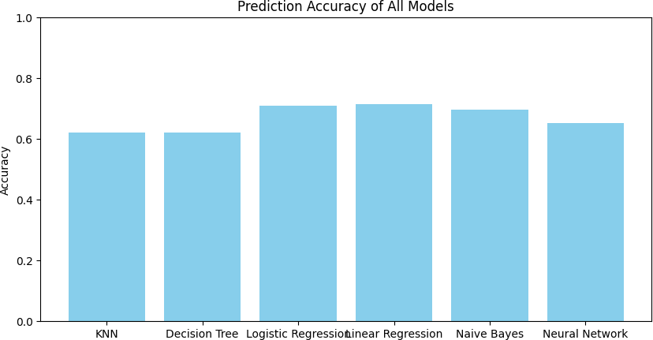

Fig. 4. Prediction accuracy comparison across the six models.

For Linear Regression, the R-squared Score was
-0.1185 and Loss (MSE) was 0.2108.

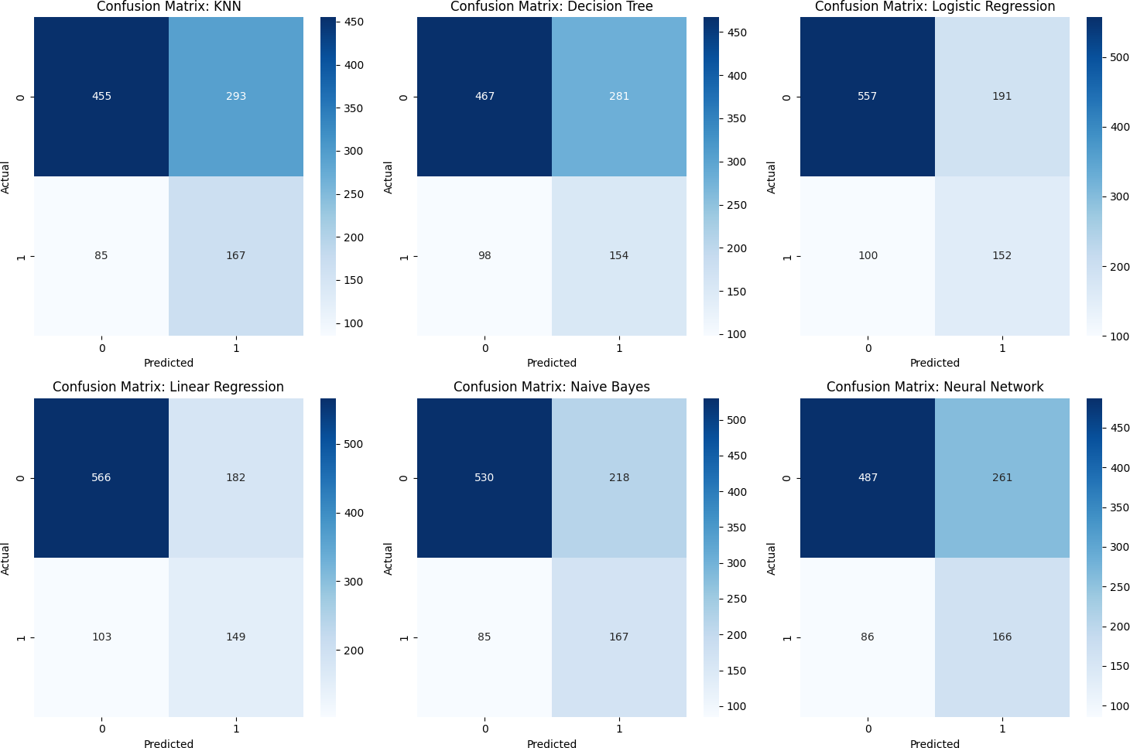
Fig. 5. Confusion matrices for all six supervised models.

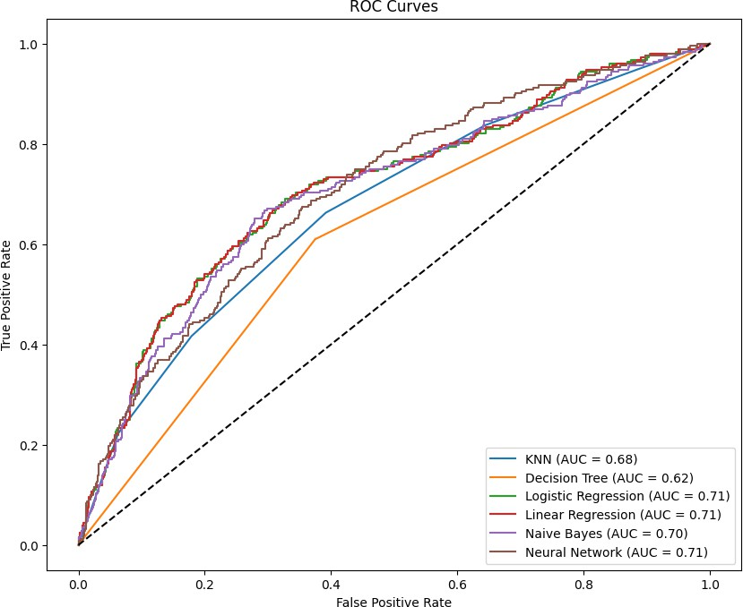

Fig. 6. ROC Curves mapping the True Positive Rate against the False Positive Rate.

Conclusion
Understanding from Results: Generalized linear models (Logistic Regression, Linear Regression) are most capable of deciphering the feature interactions. Linear Regression achieved the peak accuracy (71.50%) after thresholding, while Logistic Regression maintained an excellent balance of Recall and AUC (0.7126).
Performance Comments: Randomly under-sampling the training data was highly effective. It forced the models to prioritize the minority class, resulting in meaningful Recall scores. This is fundamentally more useful for HR practitioners who specifically need to identify career switchers.
Reasons for Results: Strictly preventing data leakage by fitting the imputers and scalers exclusively on the training data ensured the test metrics were highly authentic. Linear Regression performed sub-optimally as a fundamental classifier due to its continuous nature, although its thresholded metrics were adequate.

References
- “career-switch-prediction.ipynb”, Cell 9.
- “career-switch-prediction.ipynb”, Cell 11.
- “career-switch-prediction.ipynb”, Cell 23.
- “career-switch-prediction.ipynb”, Cell 27, 28.

