Extension Functional Specification Design document

Theme
FSD: EFS_P2P_087- Promotional Items - Goods Receipt Replication interface from S4 to eBuy Coupa

PROCESS
Stream: | Purchase to Pay
Process L1 impacted: | Purchase sequence for PR/PO/GR
Process L2 impacted: | Purchasing within Plant (COGS & NCOGS)
Process L3 impacted: | P2P_02_01-NCOGS Purchasing
Process L3 impacted: | P2P_02_02-NCOGS Goods Receipt Creation / Cancellation
Process L3 impacted: | P2P_04_02-MM Invoice with existing NCOGS PO

VALIDATION MATRIX
JIRA Status | Validated version | Date | Status | Owner | Signature
ISHNAP-5479 | V1.0 | 20/08/2023 |  | Anna Chirinos
ISHNAP-5479 | V2.0 | 05/10/2023 |  | Anna Chirinos
ISHCHCMP-22890 | V3.0 | 05/09/2025 |  | El Mouksit Badre
ROISHGSA-28232 / ISHRPM-285 | V4.0 | 15/10/2026 | Updated | El Mouksit Badre

HISTORY
Version | Date | Modified by | Modified Sections | Description of main changes
V1.0 | 20/08/2023 | Anna Chirinos | Newly created | - ISHNAP-5479 - Document Initialization
V2.0 | 05/10/2023 | Anna Chirinos | 3.3. SAP function to enhance | - ISHNAP-5479 - To include the modification of FM ZPTP_AC_GR_SEGMNT_DATA and CAT01 table
V3.0 | 05/09/2025 | El Mouksit Badre | 3.3. SAP function to enhance | - ISHCHCMP-22890 - To include the modification of FM ZPTP_AC_GR_SEGMNT_DATA and CAT01 table
V4.0 | 15/10/2026 | El Mouksit Badre | 3.3. SAP function to enhance | - ROISHGSA-28232 / ISHRPM-285 - IDoc settings (Typinfo, Partner, Address) for IFS_P2P_143 (INVOIC02 / ZINVOIC02_EXT) and IFS_P2P_144 (ACC_DOCUMENT04): message variant HRS, SADR sender HRS.

Related Documents
Document Name | Description | Document Location
IFS_P2P_143 | Citibank HRS incoming invoices (INVOIC02 / ZINVOIC02_EXT) | JIRA ROISHGSA-23607
IFS_P2P_144 | Citibank HRS reclassification document (ACC_DOCUMENT04) | JIRA ROISHGSA-23616
EFS_P2P_207 | Citibank HRS reclassification – iShift configuration and new program | JIRA ROISHGSA-28223

Table of Contents
1. Introduction 3
1.1. Purpose of the document 3
1.2. Audience 3
1.3. Glossary 3
2. Functional specifications 4
2.1. Overview / Scope 5
2.2. Business Prerequisites 5
2.3. Assumptions / Constraints / Limits 6
2.4. Process Flow 6
2.5. Detailed Functional Description 7
2.5.1 Custom tables 7
3. Extension Detailed Specification 8
3.1. Usage 8
3.2. Business logic & Filtering Conditions 8
3.3. SAP function to enhance 8
3.4. Expected results 12
3.5. Reuse considerations 12
3.6. Transaction 12
3.7. Customizing & Configuration prerequisites 12
4. Solution Integration Considerations 13
5. Authority Checks and Controls Requirements 13
6. Error Handling 13
7. Tools and Monitoring 13
8. Testing 13

Introduction

Purpose of the document

The Purpose of this document is to capture the scope of the requirements, mappings, solutions and describing the proposed functionality to be delivered.

Sanofi will implement SAP EBUY/COUPA to have only one single standard platform with harmonized business processes, covering end-to-end process for Pharma companies. To have fast and reliable interchange between Sanofi Shift ERP system and EBUY/COUPA, a set of core automatic interfaces (see scheme below) were defined and will be designed to manage the articulation.

This Functional Specifications (IFS) document defines the core model design, with all required functional details and business rules, for Promotional Items Good Receipts creation and Good Receipt cancellation from SHIFT ERP to EBUY/COUPA.

Audience

This interface is relevant for the parties using Shift and eBuy Coupa (from Pharma companies).
This enhancement/interface allows to send the GRs creation/cancellation from Shift to eBuy.

Glossary

Term or acronym | Definition
IDOC | For Intermediate DOCument  IDoc is a standard data structure for electronic data interchange EDI between application programs written for the popular SAP business system or between an SAP application and an external program.
ALE | For Application Link Enabling  IDocs serve as the vehicle for data transfer in SAP's Application Link Enabling (ALE) system
SHIFT | Back Office  Sales and distribution system.  Financial system.
EBUY/COUPA | Procurement and Invoicing system
FG | Finish Goods
GPDD | General Process Design Document
PO | Purchase Order
COGS | Stockable Stocks
NCOGS | Non Stockable Stocks
MM | Material Management (SAP module)
P2P / PTP | Purchase to Pay
Qty | Quantity
RICEFW | Reports, Interfaces, Conversions, Enhancements, Forms, Workflow
GR | Goods Receipt
GI | Goods Issue
KBR | Key Business Rule
KPI | Key Performance Indicator
MDM | Master Data Management
AIF | Application Integration Framework

Functional specifications

Overview / Scope

The enhancement purpose is to send the Promotional Items Good receipts from SHIFT and replicate in EBUY/COUPA as GR movement for the scenarios of:
- 3rd Party Purchase of NCOGS
This covers both Good receipt and Good receipt cancellation (Return).

Business Prerequisites

PO should exist in Shift, GR creation/cancellation to be replicated to eBuy. Master data should be aligned between systems.

Assumptions / Constraints / Limits

Assumptions
- SHIFT is the sender system.
- EBUY/COUPA is the receiver system.
- eBuy iPaas is the middleware to be used for transformations.
- The iDoc will pass through iShift Tibco as well.
- SHIFT is responsible for sending the valid data while creating the Good receipt.
- eBuy iPaas is responsible for the value mappings and transformation to the target format.
- All master data must be aligned for both systems respectively (eBuy/Coupa and Shift). This is covered via master data propagation done by other interfaces (Not covered in the current document).
- The document numbers (FI & MM) will be allocated internally by SAP
- The order quantities base unit of measure will come from SHIFT.
- GR for these POs should not be initiated in eBuy Coupa.
- Any GRs performed in eBuy should be blocked and will not be interfaced to SHIFT.
- Interface will not apply for any CHANGED GRs. It only applies to NEW and CANCEL GRs.
- If two idocs have been sent for the same GR number, the second one will be ignored by eBuy Coupa.

Limits
- This IFS only concerns the GR for the Promotional Items, with SAP Material type = ZPRO. This interface should not allow any other GRs to flow from S4 to eBuy Coupa.
- EBUY/COUPA Purchase order replication is not covered in the interface. They will be replicated through Purchase order interface, with respect to the Good Receipts which are replicated in Shift already from eBuy/Coupa.

Process Flow

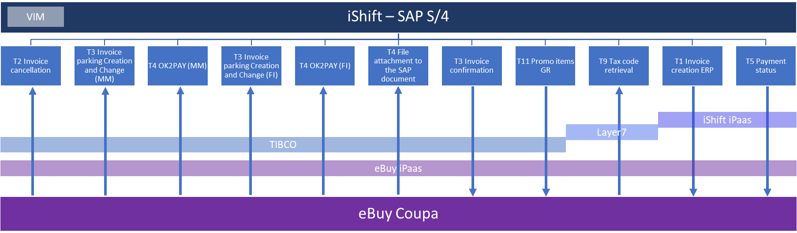

End to End flow

Detailed Functional Description

The enhancement purpose is to create a new Partner profile specific for eBuy to send the GRs creation/cancellation from Shift to eBuy.
The GR creation/cancellation will be sent by iShift, passing through Tibco and then eBuy iPaas until being received in eBuy Coupa.
The Partner profile should be similar to the one existing for Leo for the interface: IFS_P2P_072- Promo Items - Goods Receipt Replication interface from S4 to COUPA LEO

2.5.1 Custom tables

ZUT_T_CAT01 entries to be maintained, details in the section 3.3. SAP Function to enhance

Extension Detailed Specification

Usage

Short Description | Good receipt (Promo items) replication interface - from S4HANA to eBuy/Coupa
Volume of data: | 1 IDOC to be created for each execution (300 per day)
Mode:  <Indicate by 'X'> | (-) Online (X) Background
Frequency:  <Indicate by 'X'> | (-) Daily (-) Weekly (-) Monthly (-) Biweekly (X) others, please specify: at every GR creation / cancellation

Business logic & Filtering Conditions

From iShift, the GRs creation/cancellation information will be sent to eBuy Coupa (when the SAP material group is ZPRO for Promo items).

SAP function to enhance

In shift, an enhancement to be done to populate below values in the iDoc:
- Idoc type: MBGMCR04
- Message Variant: EBY
- Message function: STM
- SADR recipient: EBY
- SADR sender: System client (Ex: PHS 100)
Start of the Change V2.0
To Action Functional Module ZPTP_AC_GR_SEGMNT_DATA from Leo should be reused, a logic to modify the Control Record Mescod (control_record_out-mescod) should be included.
First the logic should take the PO number (MATDOC-EBELN) and pass it in the PO header table (EKKO-EBELN) to get the PO type (EKKO-BSART). If PO type BSART = 'ZNBE' then make Message Variant MESCOD = 'EBY'
And, to inform EBY as SENDER, add specific entries for EBUY in the Object ZPTP_AC_GR_SEGMNT_DATA, similar to LEO ones:
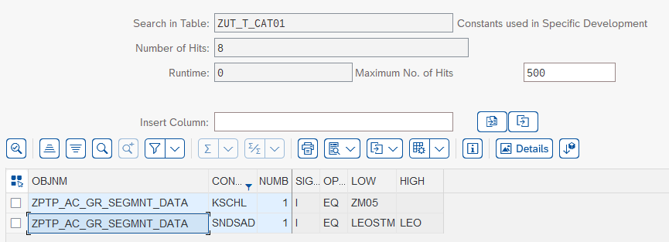
EBUY entries:
Program Name | Constant | Number | INCL/EXCL | Option | Selection value | Selection value
ZPTP_AC_GR_SEGMNT_DATA | SNDSAD | 2 | I | EQ | EBYSTM | EBY
ZPTP_AC_GR_SEGMNT_DATA | BSART | 1 | I | EQ | ZNBE | EBY

End of the Change V2.0

BEGIN OF CHANGE- ISHCHCMP-22890: add Citibank reconciliation file in idoc ACC_DOCUMENT04

For the new interface IFS_P2P_115 Monthly statement file from the bank, we need to add Message type & iDoc type during the idoc posting in iShift:
- Idoc type: ACC_DOCUMENT04
- Message type: ACC_DOCUMENT
- Message variant: CTI
- Message type: INV
- Sender: Citibank

Below is the entry maintained in CAT01 Table

Program Name | Constant | Number | Selection Value | Selection value
ZPTP_AC_FI_INVOICE_PST | CITIBANK | 1 | INV | CTI

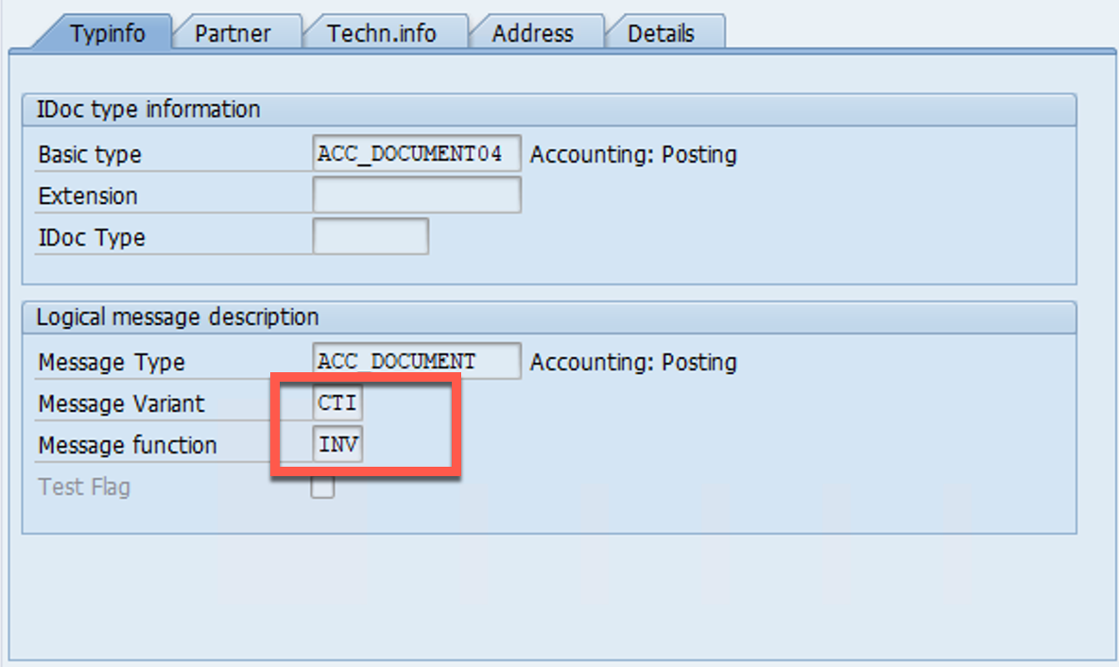

Sender (SNDSAD) = CITIBANK
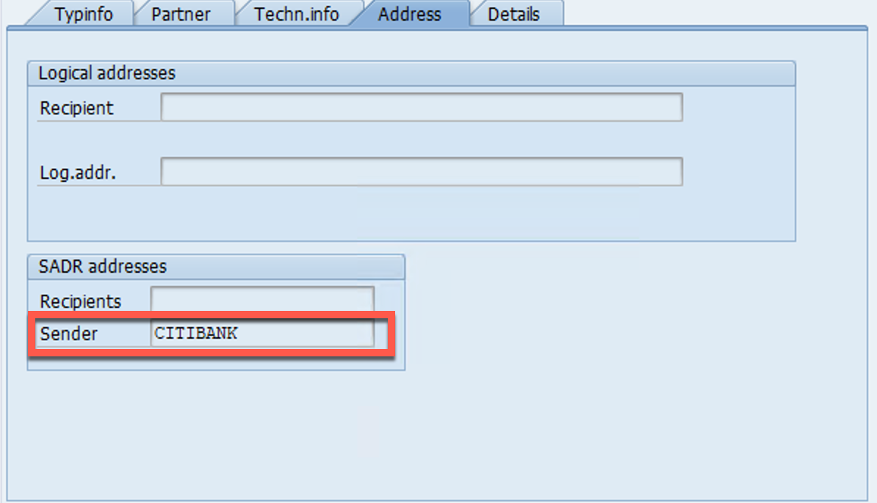

New Sender system value 'CITIBANK' must be added in the domain ZSYSTEM , for the field ZUT_T_CAT02-SYS_SRC

END OF CHANGE- ISHCHCMP-22890: add Citibank reconciliation file in idoc ACC_DOCUMENT04

BEGIN OF CHANGE- ISHRPM-285: IDoc settings (Typinfo, Partner, Address) for HRS – IFS_P2P_143 incoming invoice (INVOIC02 / ZINVOIC02_EXT) and IFS_P2P_144 reclassification (ACC_DOCUMENT04)
For the new interfaces IFS_P2P_143 (Citibank HRS incoming invoices) and IFS_P2P_144 (Citibank HRS reclassification document), the message type, IDoc type, message variant and sender must be maintained for the IDocs posted in iShift. The existing settings used for partner applications passing through VIM are reused (same IDoc format as the Tungsten invoices); the screenshot of the IDoc display taken on the Tungsten example (message variant and SADR sender TUN) applies with HRS instead of TUN.
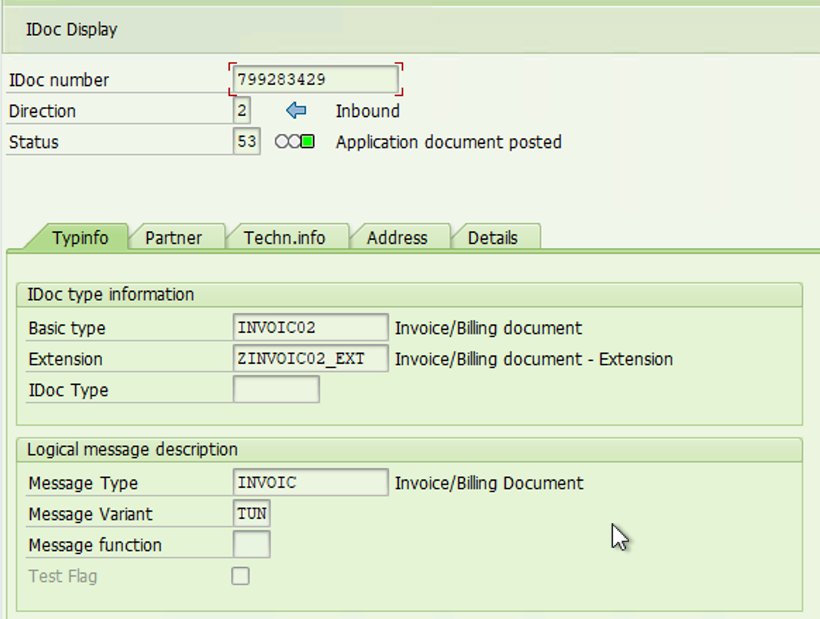
1. IFS_P2P_143 – Citibank HRS incoming invoices
Typinfo tab
Field | Value | Comment
Direction | 2 – Inbound
Basic type | INVOIC02 | Invoice/Billing document
Extension | ZINVOIC02_EXT | Invoice/Billing document – Extension
IDoc Type | Empty
Message Type | INVOIC | Invoice/Billing Document
Message Variant | HRS | Tungsten example: TUN

Partner and Address tabs
Field | Value | Comment
Partner – Sender (port, partner number) | TIBCO port and logical system (partner type LS, role LS) | Tungsten example: UTIBGBO / UTIBGBO_T1 – TBC with the TIBCO team
Partner – Recipient (port, partner number) | iShift port and logical system of the client (partner type LS) | Tungsten example: SAPUHV / UHVCLNT100
Address – SADR sender (SNDSAD) | HRS | Tungsten example: TUN

2. IFS_P2P_144 – Citibank HRS reclassification document
Field | Value | Comment
Direction | 2 – Inbound
Basic type | ACC_DOCUMENT04
Extension | Empty | Standard basic type, no extension (see IFS_P2P_144)
Message Type | ACC_DOCUMENT
Message Variant | HRS
SADR sender (SNDSAD) | HRS | Address tab. Tungsten example: TUN

Below is the entry maintained in CAT01 Table for the HRS reclassification IDoc (IFS_P2P_144):
Program Name | Constant | Number | Selection Value | Selection value
ZPTP_AC_FI_INVOICE_PST | CITIBANK | 1 | INV | HRS

END OF CHANGE- ISHRPM-285: IDoc settings (Typinfo, Partner, Address) for HRS – IFS_P2P_143 incoming invoice (INVOIC02 / ZINVOIC02_EXT) and IFS_P2P_144 reclassification (ACC_DOCUMENT04)

Expected results

Receive the GR creation/cancellation information for the Promotional items sent from iShift to eBuy, this iDoc will pass through Shift Tibco and eBuy iPaas.

Reuse considerations

This interface should be similar to Leo interface: IFS_P2P_072- Promo Items - Goods Receipt Replication interface from S4 to COUPA LEO. iDoc type and Message type already exists and will be reused (MBGMCR04 & MBGMCR)

Transaction

N/A

Customizing & Configuration prerequisites

The interface should be monitored via AIF monitor, using a new node in P2P folder:
SC_DIS OB_STM_PTN Stock Movement from S4 to Partner
Inside, a new hierarchy will be created for each partner, in this case for eBuy considering the partner info from the iDoc.
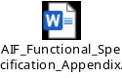

Solution Integration Considerations

GR creation/cancellation will be sent from iShift via iDoc, that will pass through Tibco iShift and eBuy iPaas, then replicated to eBuy Coupa.

Authority Checks and Controls Requirements

N/A

Error Handling

Enhancement/Interface is created using SAP AIF component which can be used to handle errors. Processing the messages are also done in AIF based on the roles assigned.
New AIF node to be created: SC_DIS OB_STM_PTN Stock Movement from S4 to Partner

Tools and Monitoring

The IDoc monitoring will be handled through the AIF Tool.

Tool Specification | Description
AIF | SAP Application Interface Framework

Testing

Test conditions and expected results (for GR creation (NCOGS)

Test # | Test Condition | Test Condition type (normal / exception / error) | Test Data | Expected Result
1 | Simulation of successful IDoc. | Normal | To be done on AIF Tool. Simulation (Good receipt process) of a Good receipt IDoc with all the segments correctly maintained. | IDoc finished with successful status (AIF Tool) and document posted. ALEAUD idoc sent back to middleware
2 | Simulation of a wrong IDoc. | Error | AIF Tool. Simulation of a good receipt IDoc with at least, one of its field wrongly maintained. | Idoc file failed. Good receipt not posted and acknowledgment file sent back to IPAAS with error message.  IDoc processed with error status (transaction AIF Tool)

Test conditions and expected results (for GR cancellation (NCOGS)

Test # | Test Condition | Test Condition type (normal / exception / error) | Test Data | Expected Result
1 | Simulation of successful IDoc. | Normal | To be done on AIF Tool. Simulation (Good receipt process) of a Good receipt IDoc with all the segments correctly maintained. | IDoc finished with successful status (AIF Tool) and document posted. ALEAUD idoc sent back to middleware
2 | Simulation of a wrong IDoc. | Error | AIF Tool. Simulation of a good receipt IDoc with at least, one of its field wrongly maintained (or PO wrongly maintained) | Idoc file failed. Good receipt not posted and acknowledgment file sent back to IPAAS with error message.  IDoc processed with error status (transaction AIF Tool)
Beginning of change ISHCHCMP-22890
Test conditions and expected results (for Reconciliation file from Citibank)

Test # | Test Condition | Test Condition type (normal / exception / error) | Test Data | Expected Result
1 | Simulation of successful IDoc. | Normal | To be done on AIF Tool. Simulation (Good receipt process) of a Good receipt IDoc with all the segments correctly maintained. | IDoc finished with successful status (AIF Tool) and document posted.
2 | Simulation of a wrong IDoc. | Error | AIF Tool. Simulation of an IDoc with at least, one of its field wrongly maintained | Idoc file failed.  IDoc processed with error status (transaction AIF Tool)
End of change ISHCHCMP-22890

Beginning of change ISHRPM-285 – Test conditions and expected results (for HRS: IFS_P2P_143 incoming invoice and IFS_P2P_144 reclassification)
Test # | Test Condition | Type (normal / exception / error) | Test Data | Expected Result
1 | IDoc INVOIC02 / ZINVOIC02_EXT with message variant HRS and SADR sender HRS | Normal | IDoc generated by TIBCO from an HRS CDF3 file; partner profile maintained | IDoc accepted (Typinfo: INVOIC02, ZINVOIC02_EXT, INVOIC, variant HRS; Address sender HRS), routed to SAP VIM and document posted.
2 | IDoc ACC_DOCUMENT04 with message variant HRS and SADR sender HRS | Normal | Reclassification IDoc (IFS_P2P_144) | IDoc finished with successful status (AIF Tool) and document posted.
3 | Wrong IDoc (unknown message variant or sender) | Error | IDoc with variant or SADR sender different from HRS | IDoc processed with error status (AIF Tool); document not posted.
End of change ISHRPM-285

