ADA assignment 2

## Question 1:

#### How to use:

1: Import the project to your IED, the program is code in eclipse (version: photon), other IDEs may not work

2: Select ‘SpiderLeg.java’ in Project Explorer

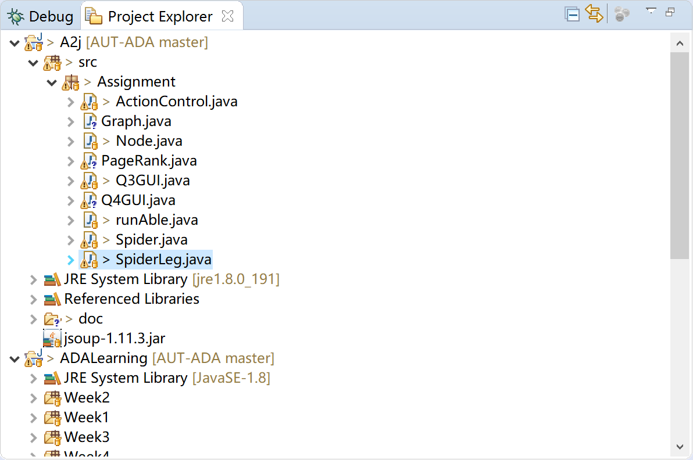

3: Run the ‘SpiderLeg.java’ as java application

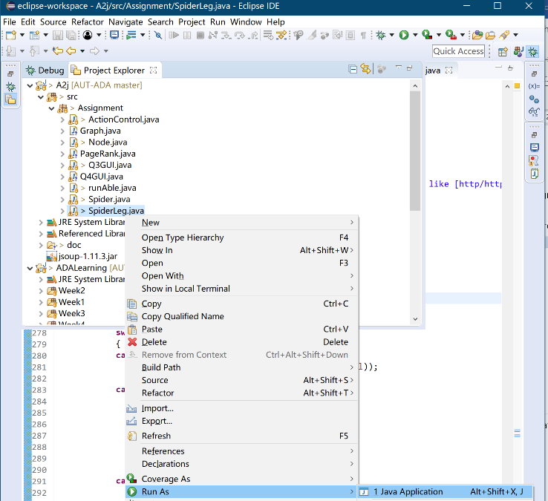

4: Follow the console to run the function

4.1: recommended website :

New egg: a hardware online shop, its website is written in a stand way, it is good for testing

URL: <https://www.newegg.com>

Ashuyun.tk/WP: My personal blog, which is used WordPress to build, it is most likely use stand PHP to code, and my server is stable, no robot test, so that it is good for test

URL: <https://ashuyun.tk/WP>

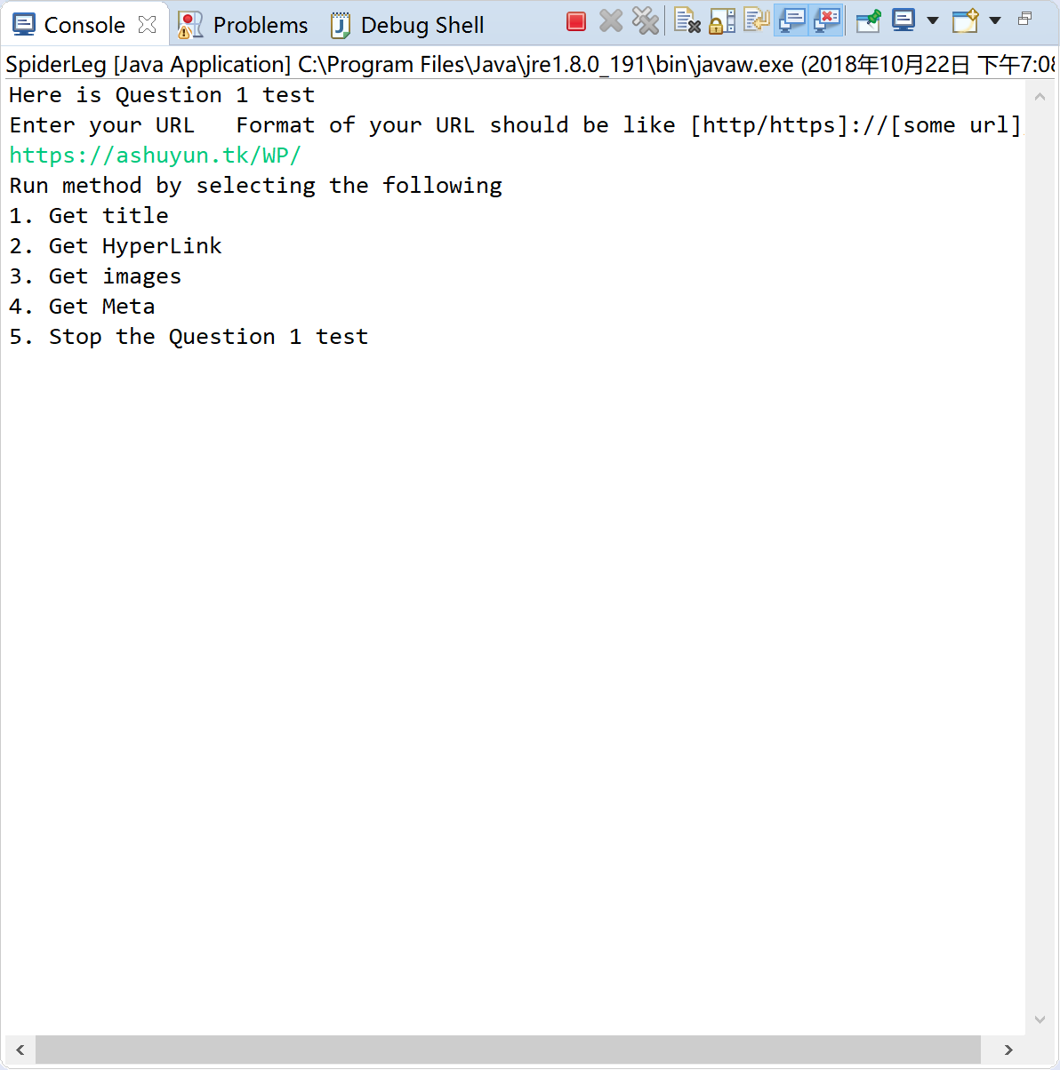

For question 1, Javadoc also available on: [https:ashuyun.tk/ADA/](https://ashuyun.tk/ADA/)

## Question2

#### How to use

1: Import the project to your IED, the program is code in eclipse (version: photon), other IDEs may not work

2: Select ‘Spider.java’ in Project Explorer

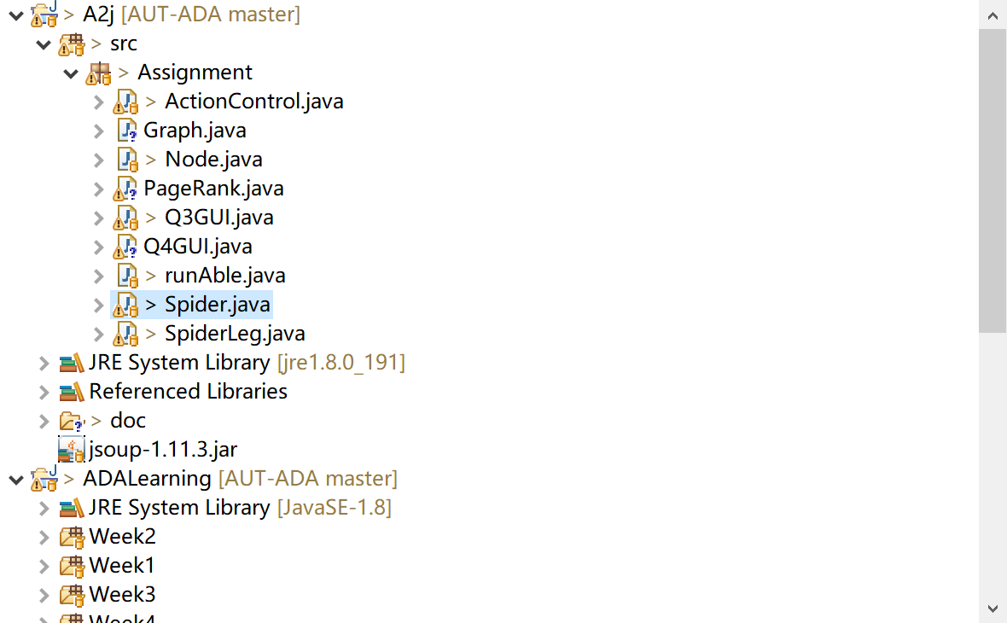

3: Run the ‘SpiderLeg.java’ as java application

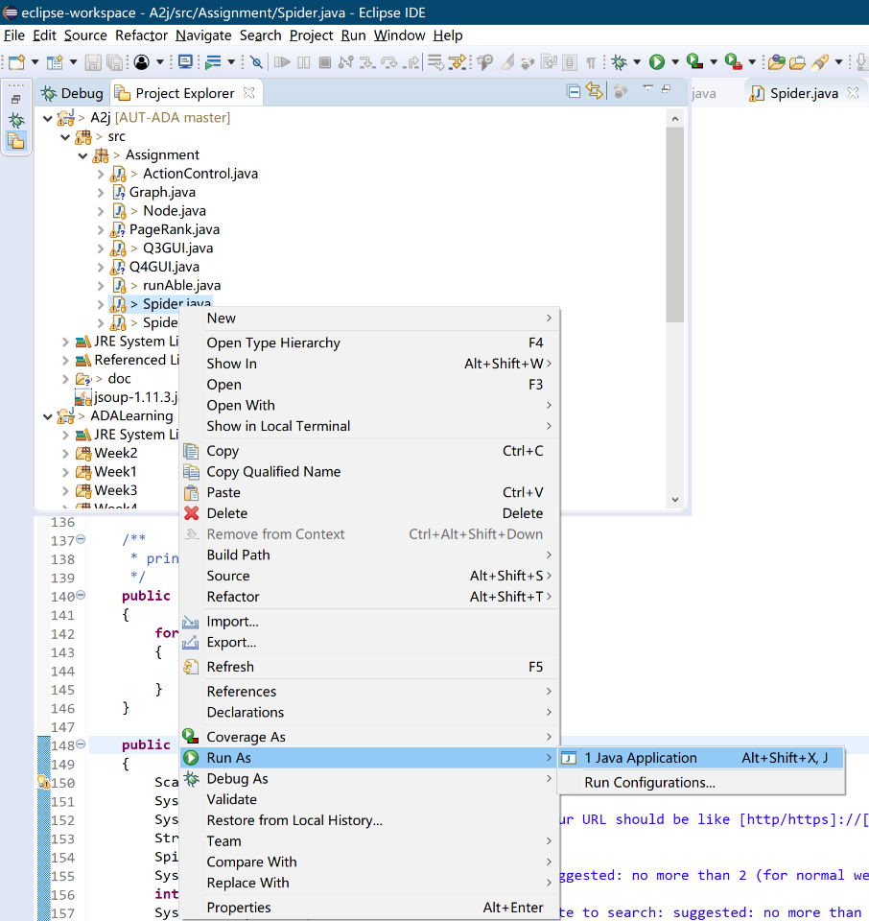

4. Following the console to test the BFS

4.1: recommended website: <https://ashuyun.tk/WP/>

Run BFS will easily to trigger robot test on other websites, my blog do not have robot test, so that it is safe to run

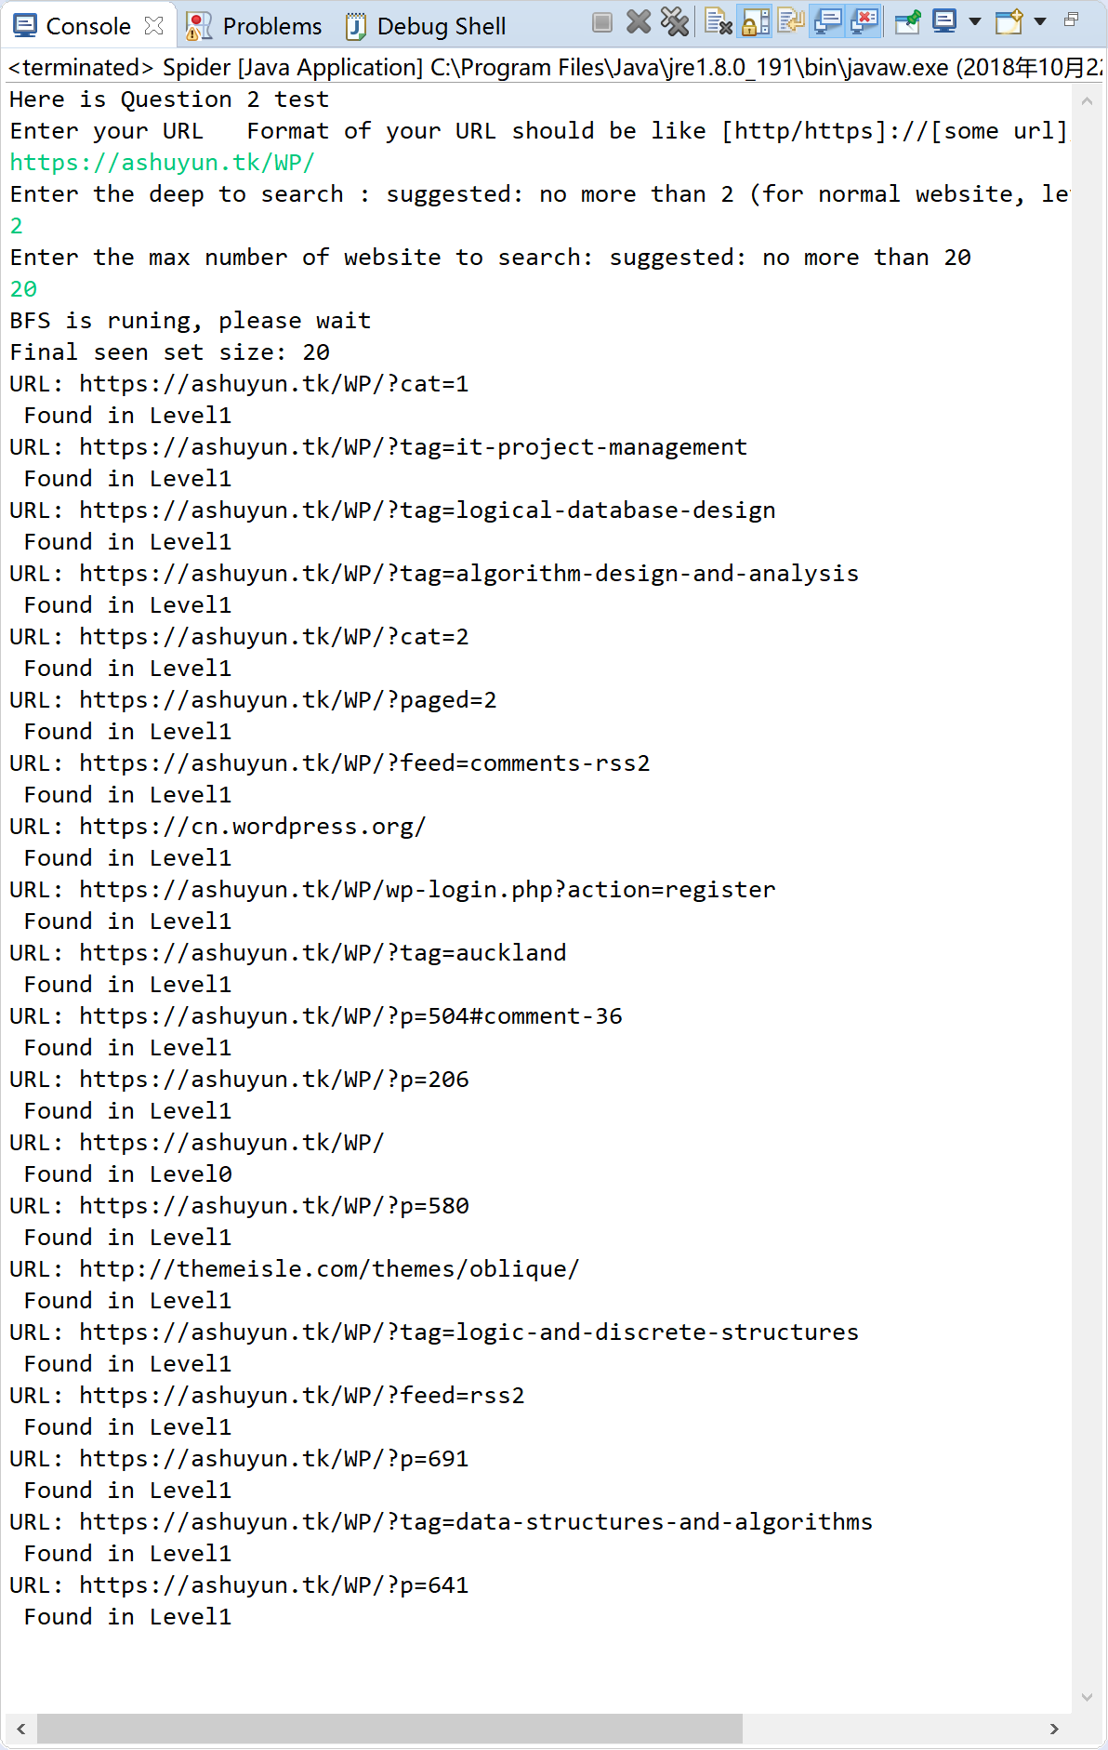

For question 2, Javadoc also available on: [https:ashuyun.tk/ADA/](https://ashuyun.tk/ADA/)

## Question 3

1: Import the project to your IED, the program is code in eclipse (version: photon), other IDEs may not work

2: Select ‘Q3Q4Runable.java’ in Project Explorer

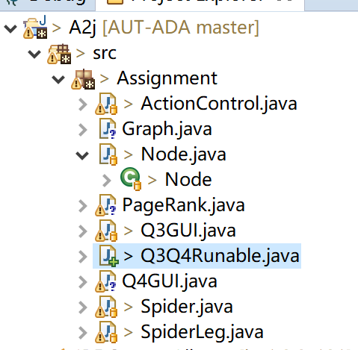

3: Run the ‘Q3Q4Runable.java’ as java application

`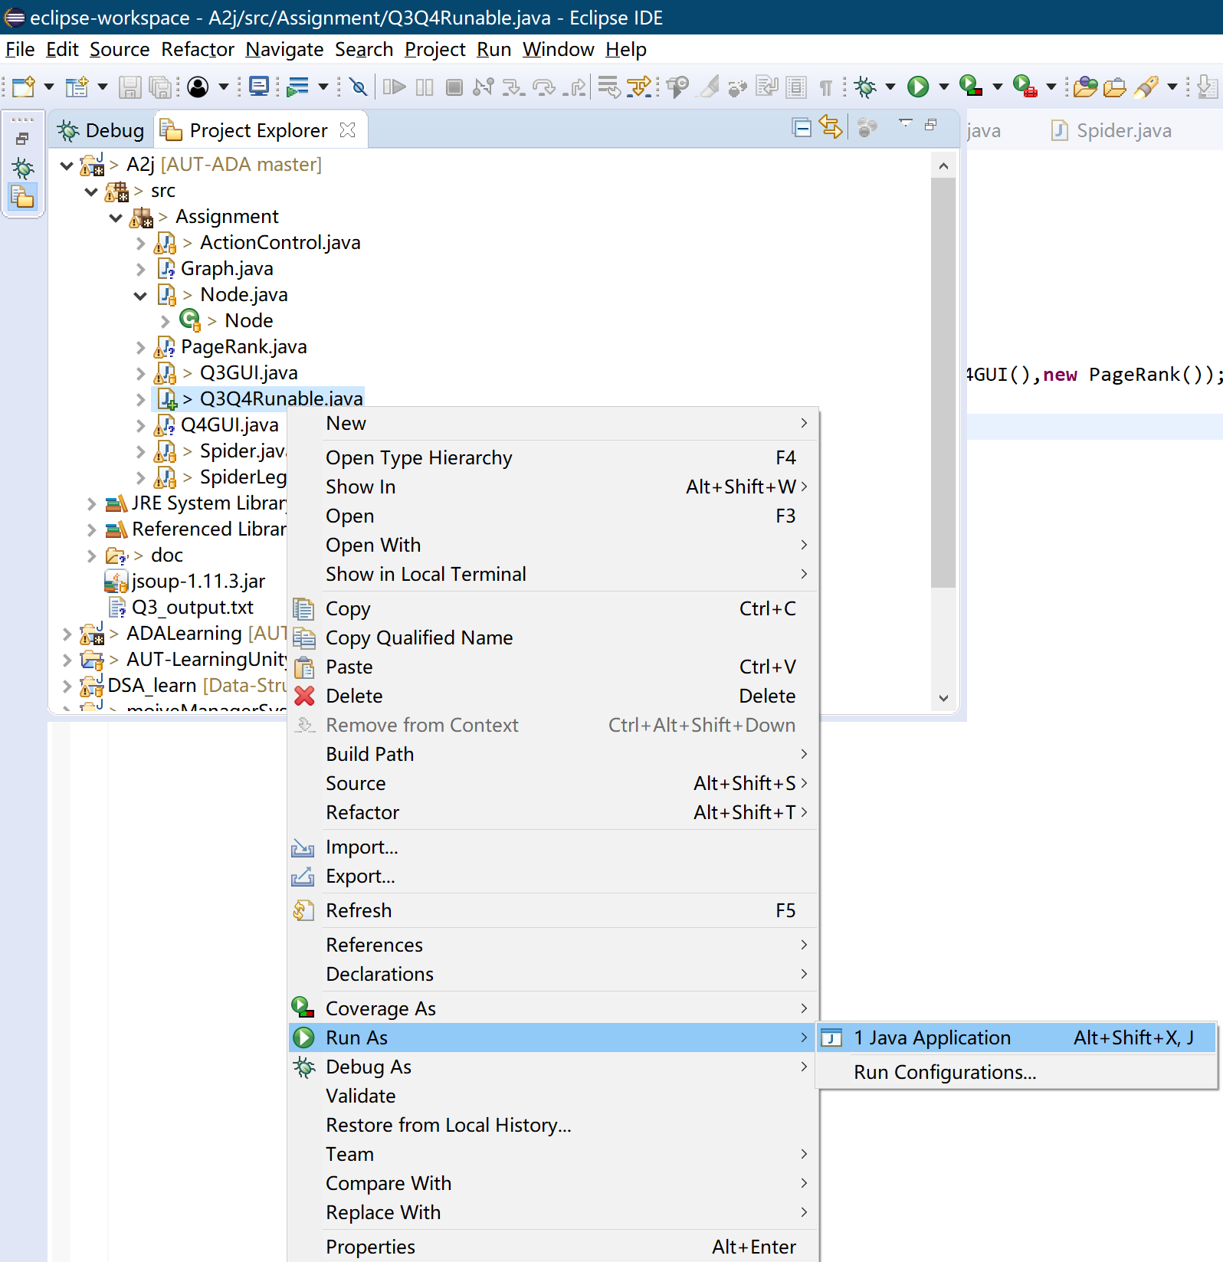

4. Following the console to choose Q3 is on testing

4.1 Input 1 to select Q3 for testing

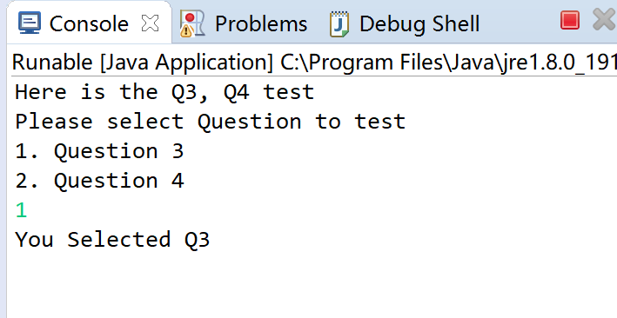

5. After you select 1, a window will pop up

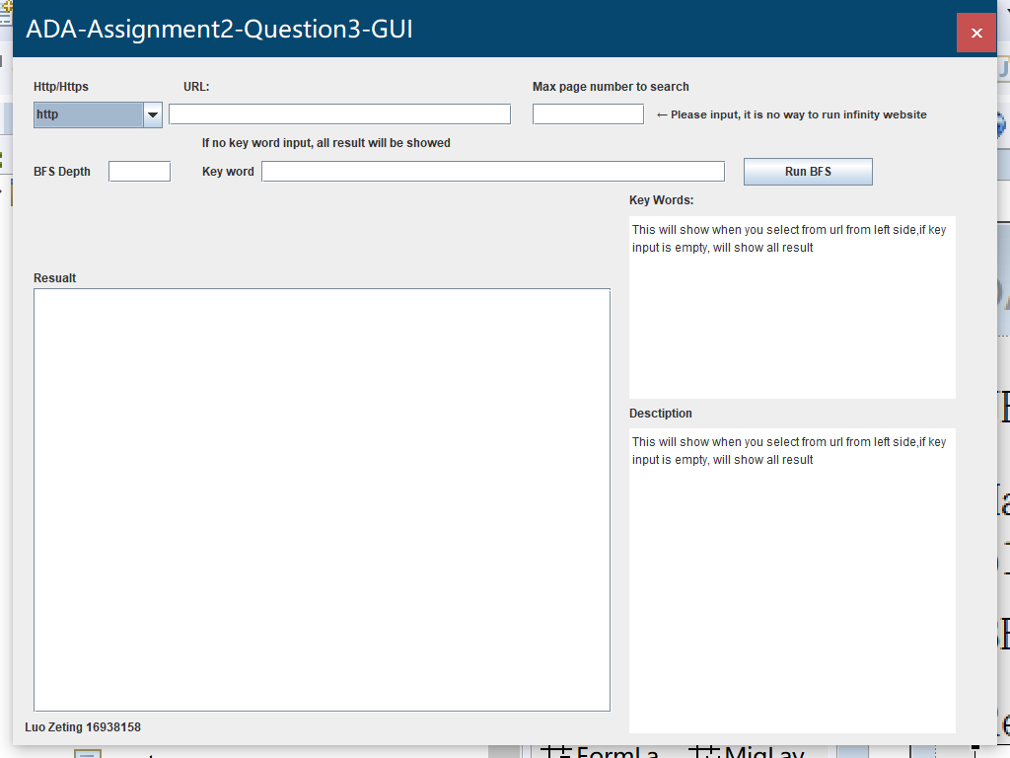

5.1 First select the URL you going to run is http website or https

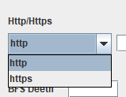

5.2 Input your URL

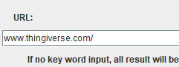

Your URL do not need http or https, but you should still to include / at the end of your URL.

5.3 Input the maximum number of websites going to be search

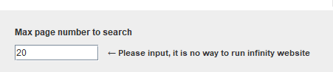

5.4 Input the maximum depth BFS going to search

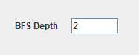

5.5.1 You can input your search keyword to the keyword input field

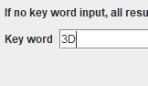

5.5.2 You can also leave this field empty



no key word entered, the result will output all website we get from BFS.

5.6 click the Run BFS button and wait

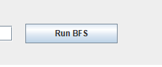

5.6.1 after you click the button you should able to see console pop up and show some run time message to you

Like this

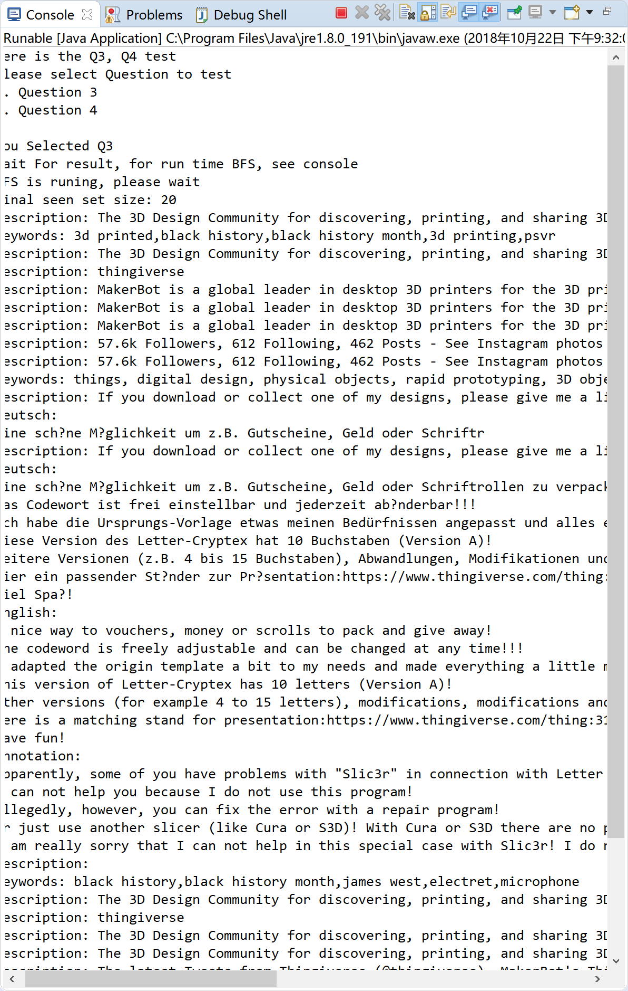

5.7 Once the BFS finished, result will show on the result list

If you entered key word, results URL is all have the key word you search

If no key word entered, all result will be showed

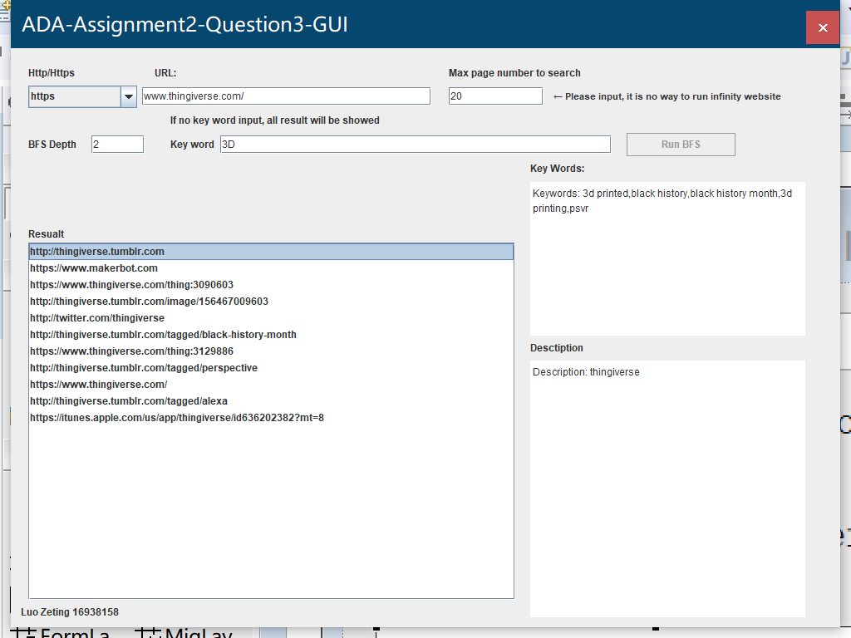

5.7.1 at the same time a txt file will be output to your project call output.txt

It will contain the information of the result; the txt file is located at the project folder call output.txt

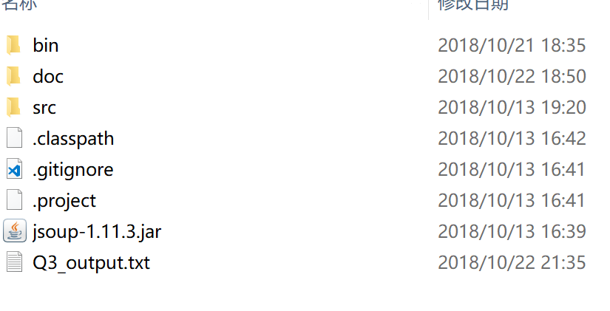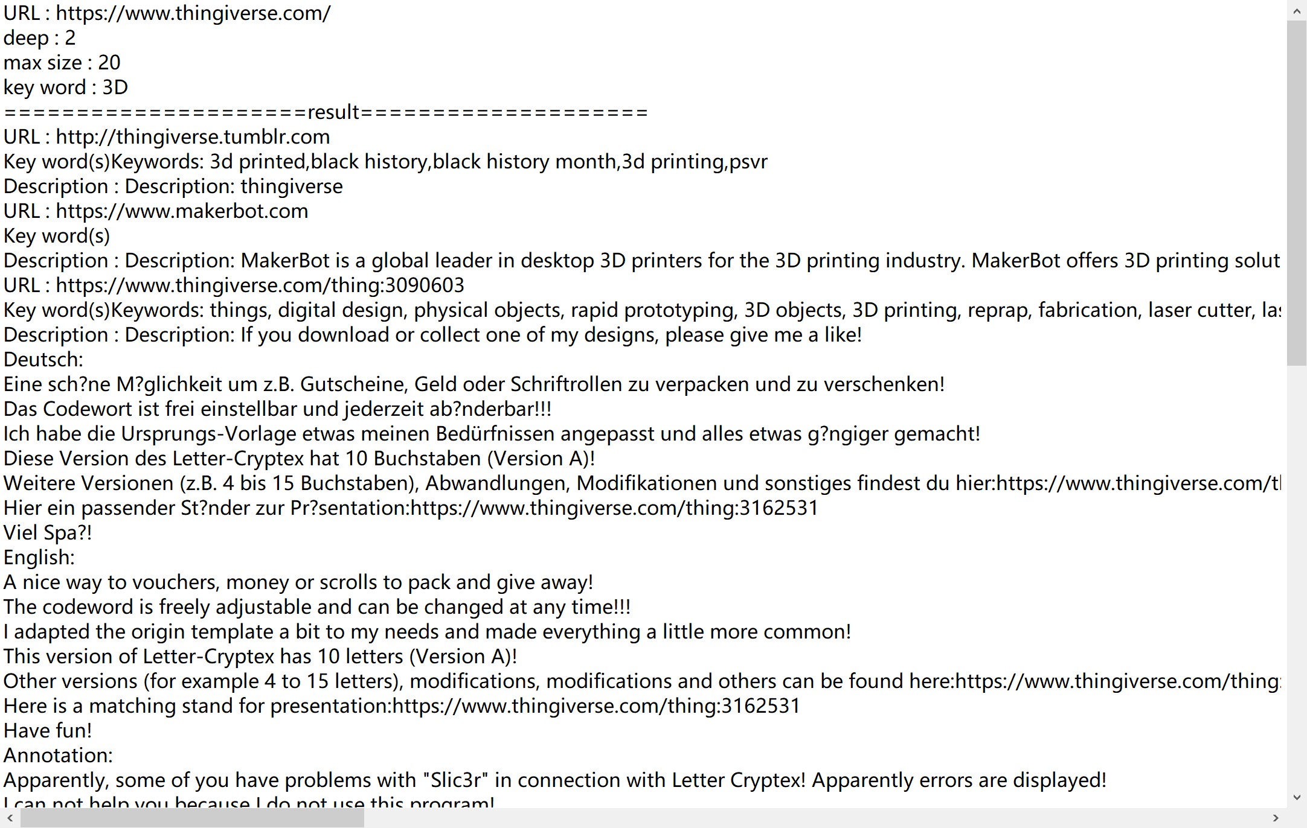

5.8 You can select result from left side list, and its keyword and description will show on right text blocks

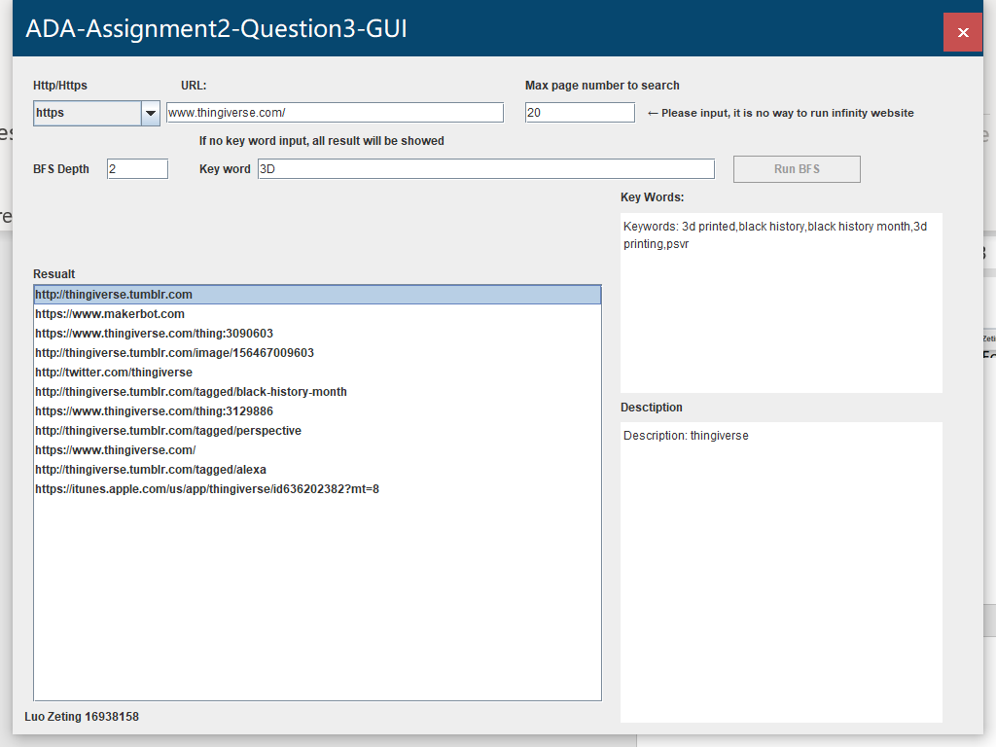

For question 4, Javadoc also available on: [https:ashuyun.tk/ADA/](https://ashuyun.tk/ADA/)

## Question 4

1: Import the project to your IED, the program is code in eclipse (version: photon), other IDEs may not work

2: Select ‘Q3Q4Runable.java’ in Project Explorer



3: Run the ‘Q3Q4Runable.java’ as java application

`

4. Following the console to choose Q4 is on testing

4.1 Input 2 to select Q4 for testing

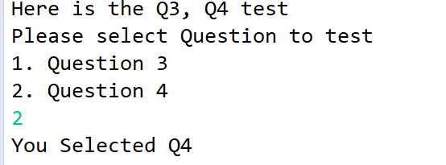

5. After you select 2, a window will pop up

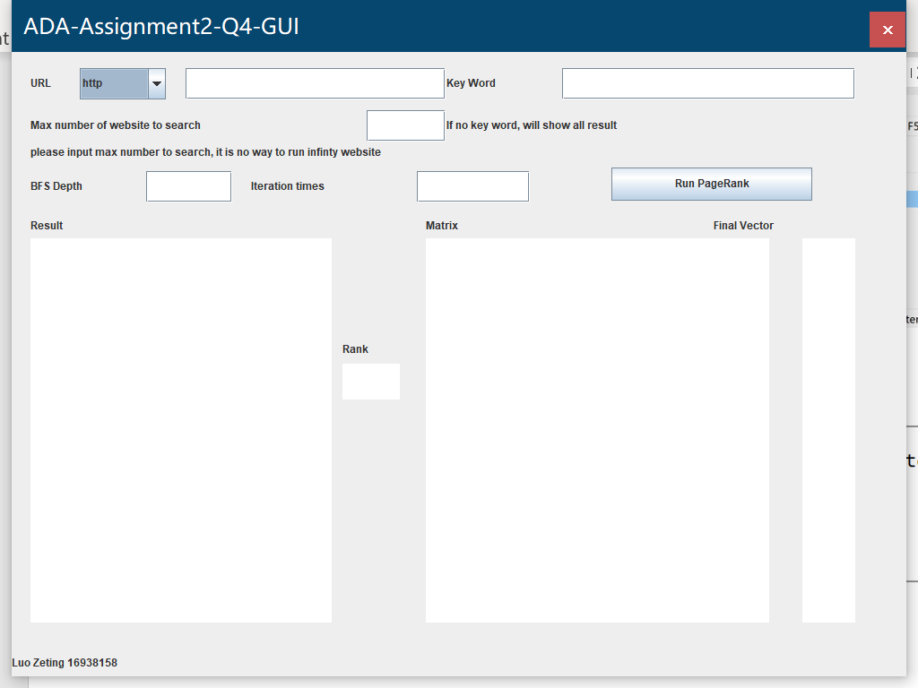

5.1 First select the URL you going to run is http website or https

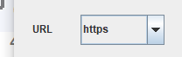

5.2 Input your URL

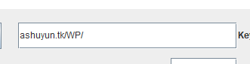

Your URL do not need http or https, but you should still to include / at the end of your URL.

5.3 Input the maximum number of websites going to be search



5.4 Input the maximum depth BFS going to search



5.5.1 You can input your search keyword to the keyword input field



5.5.2 You can also leave this field empty



no key word entered, the result will output all website we get from BFS.

If you enter keyword, it will only rank the website contains your key word

5.6 click the Run PageRank button and wait

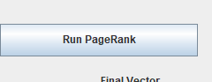

5.7 Once it finishes run the page rank, results, final vector, and matrix will show

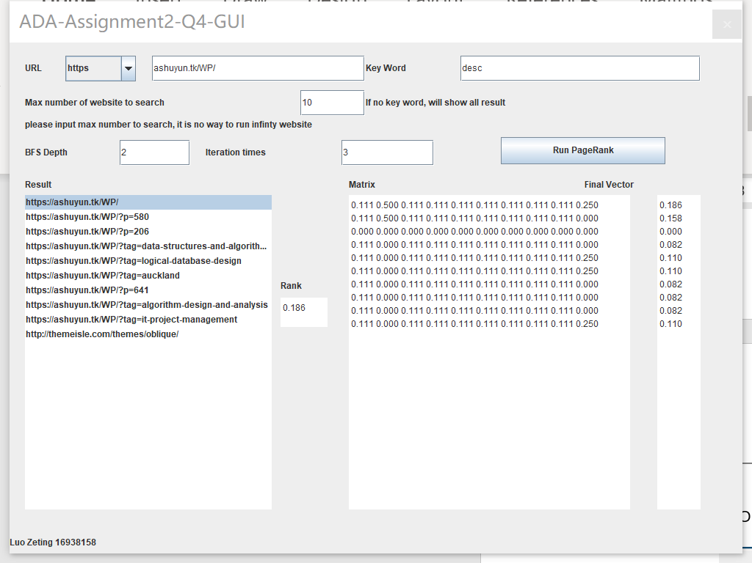

5.8 You can select the left side list, and the rank field in middle will show its rank.

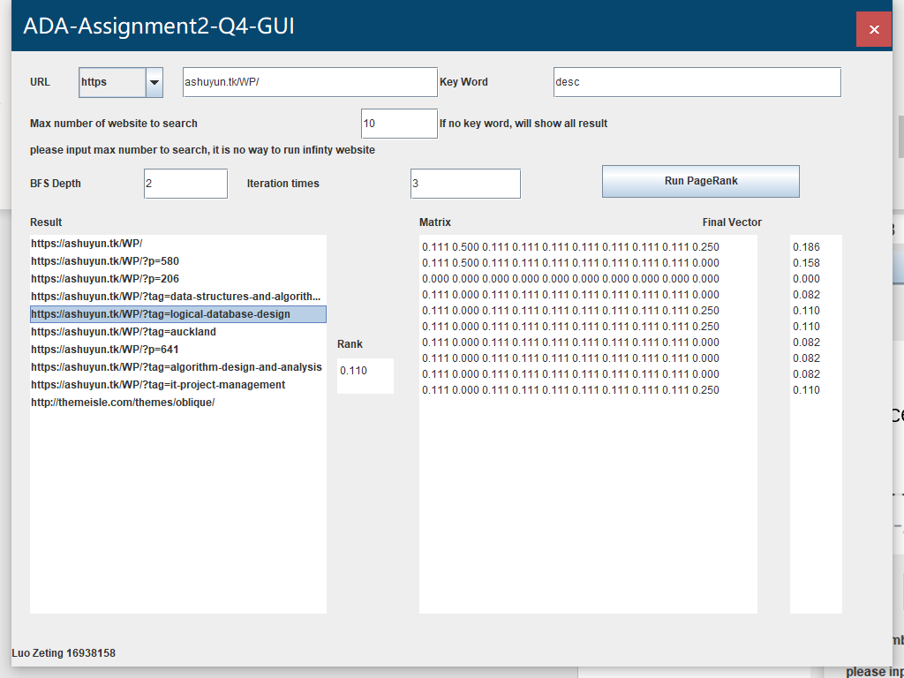

For question 4, Javadoc also available on: [https:ashuyun.tk/ADA/](https://ashuyun.tk/ADA/)