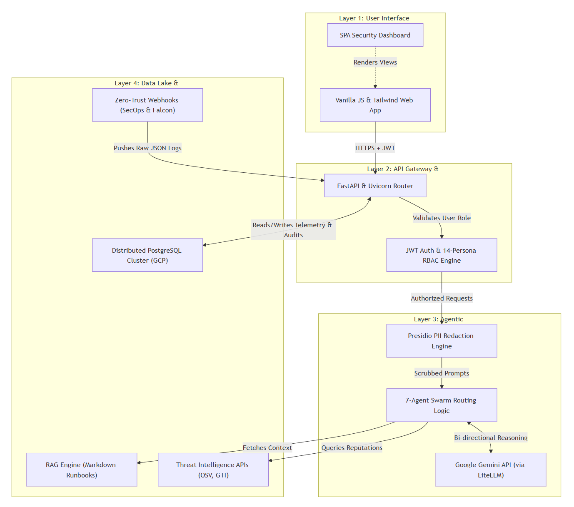
Fig 3.1 System Architecture
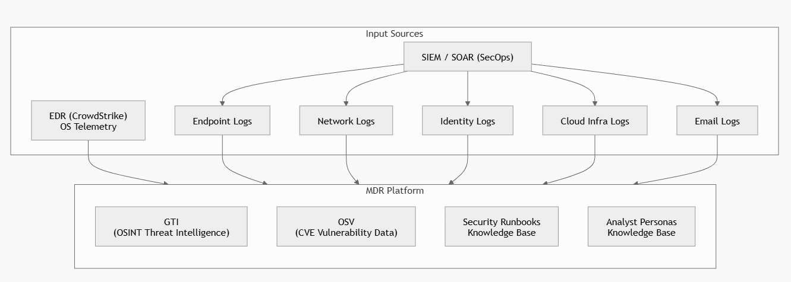
Fig 3.2 Data Ingestion and Intelligence Integration Architecture of the MDR System

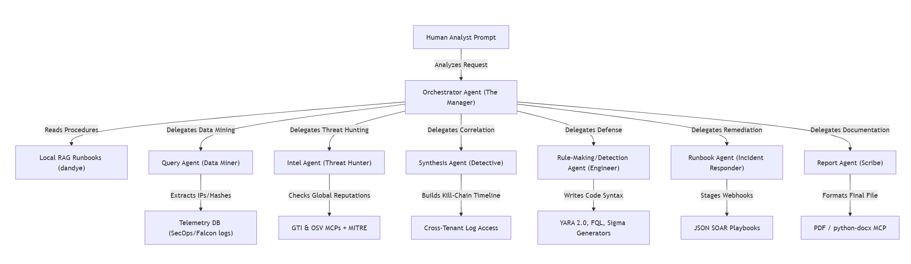
Fig 3.3 Workflow of the Multi-Agent MDR System
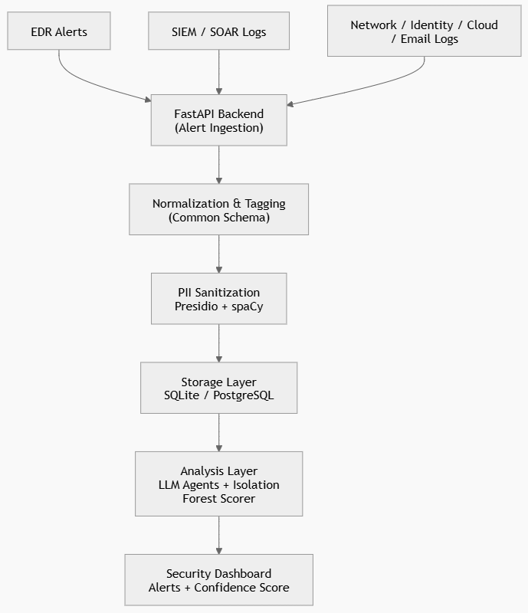
Fig 3.4 Flow of Alert Logs through the MDR Framework
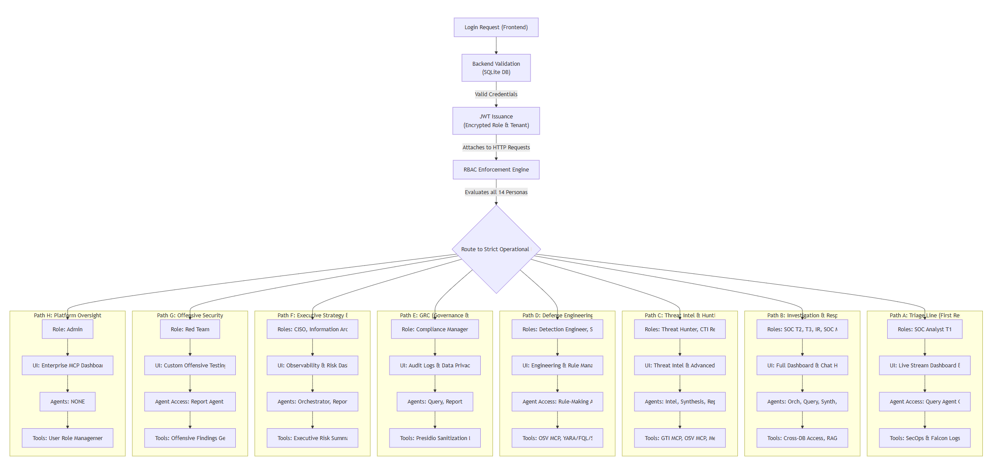
Fig 4.1 Authentication, RBAC Enforcement, and Persona-Specific Operational Paths in the MDR System

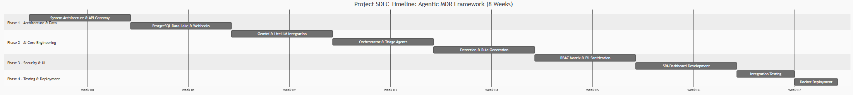
Fig 5.1 Project SDLC Timeline

