

**Department of Electrical & Computer Engineering**

**Second Semester (2022/2023)**

**ENCS3130 Linux Laboratory**

**Python Project – Library Management System**

**Prepared by:**

**Katya Kobari 1201478**

**Hidaya Mustafa 1201910**

**Instructor: Dr. Mohammad Jubran**

**Teaching Assistant: Eng. Ibrahim Injas**

**Date:8/7/2023**

**Section: 3**

# **Introduction:**

**The library management system (LMS) project aims to develop a comprehensive software solution for efficient management of library collections. The LMS will encompass key functionalities, including adding new books to the library collection, searching for books within the library, editing existing book information, archiving books, removing books from the LMS, generating reports about available books, and providing a smooth exit from the system. These features will empower librarians with enhanced control and organization of their collections, enabling streamlined operations and improved user experience.**

# **Procedure:**

1. **Main menu:**

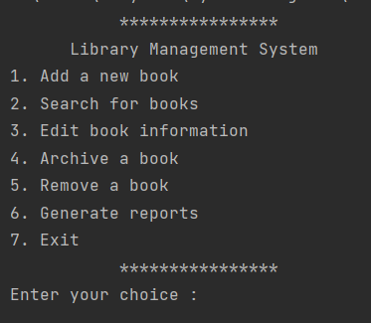

Figure 1:Main menu

1. **Adding New Books:**

The process of adding new books to the library collection in the LMS involves selecting the option, providing the name of the file containing the book information, verifying its availability, and loading the book details from the file. The LMS displays the book information on the screen, including the Title, Publisher, ISBN-10, ISBN-13, and some options. Each new book is assigned a default "number of copies" value of 1. If a book already exists in the LMS, the system prompts the user to replace the existing record or add an additional copy. This streamlined process ensures accurate cataloging and efficient management of the library's inventory.

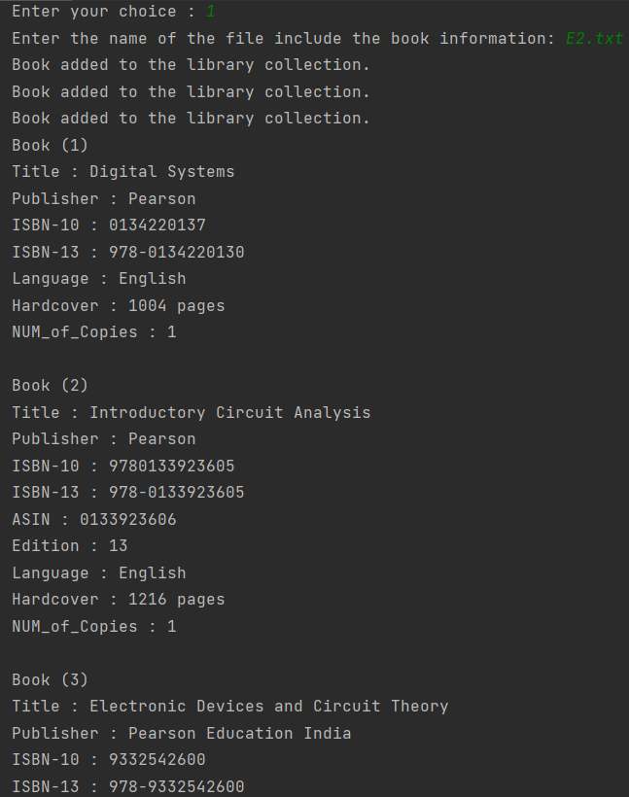

Figure 2: Add book

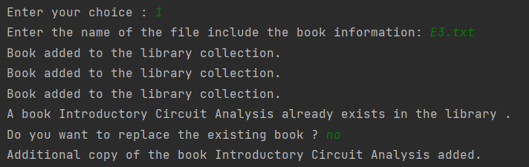

Figure 3: add additional copy

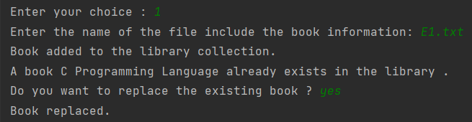

Figure 4:replace book

1. **Search Books:**

The LMS book search functionality allows users to find books in the library collection by using a variety of criteria. Users can search by title, ,ISBN, or any option . The search results are displayed in a clear and easy-to-read format, providing users with all the information they need to find the book they're looking for. Additionally, users can store the search results in a text file for future reference or analysis. This feature enhances the user experience and makes it easier to find information from the library's collection.

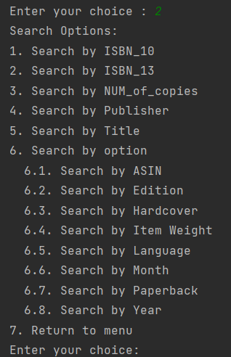

Figure 5: search menu

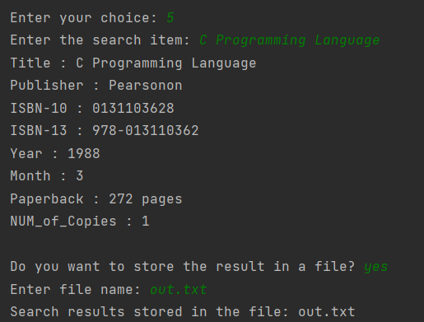

Figure 6: search by Title

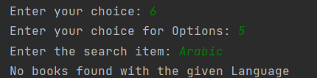

Figure 7:search by Language

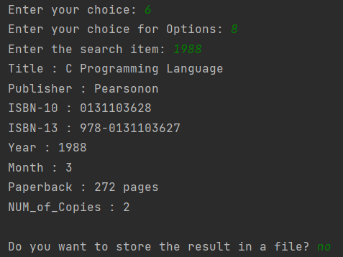

Figure 8:search by year

1. **Editing the information of existing books:**

The edit operation allows the user to modify a book's information. The user is prompted to choose between editing the book by ISBN number or by file name. If editing by ISBN number, the user is asked to enter the ISBN of the book they want to edit. If a matching book is found, its information is displayed, and the user is asked for confirmation to proceed with the edits. If confirmed, the user can enter new values for the book's attributes, such as the title, publisher, and number of copies. Additionally, the user can choose to edit other available options. After making the desired changes, the user is prompted to confirm if they want to update the book in the library, archived books, and LMS. If confirmed, the book is updated in all relevant lists. If the user decides to cancel the changes, they are given the option to revert all previous modifications.

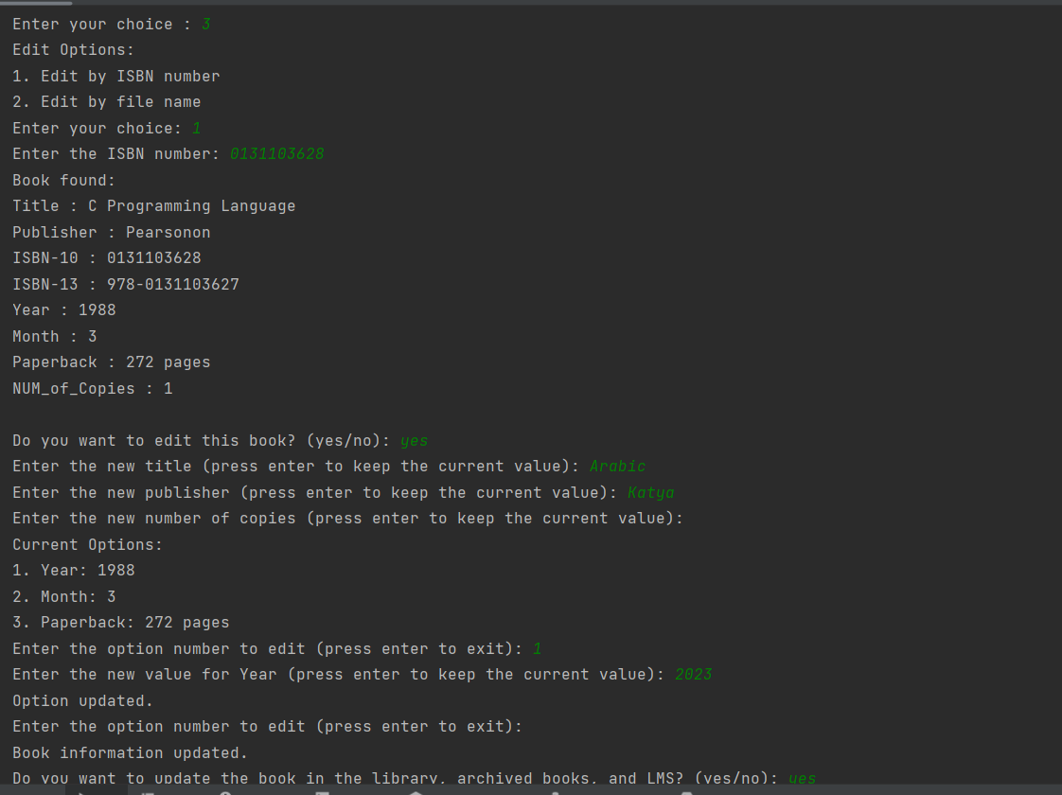

Figure 9. Edit ex1

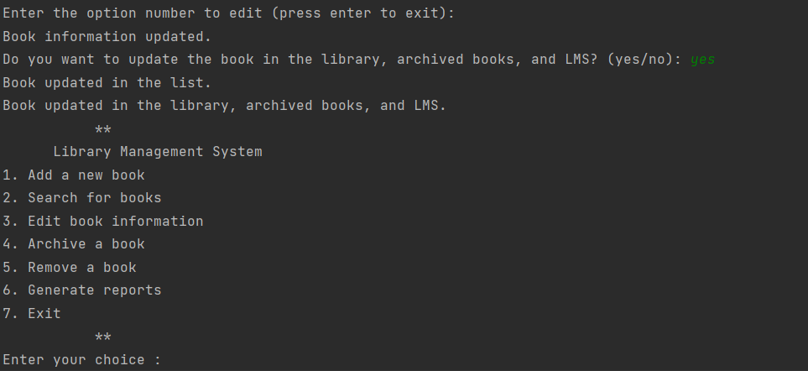

Figure 10. Edit ex1_2

1. **Archiving books:**

The archiving operation allows the user to archive a book in the system. The user is prompted to enter the ISBN of the book(s) they want to archive. If multiple ISBNs are entered, they should be separated by commas. The system checks if the book(s) exist in the library. If a book is found, the user is provided with the option to archive it. If there is only one copy of the book, the user is asked for confirmation before archiving. If confirmed, the book is removed from the library and added to the archived books list. If there are multiple copies, the user is prompted to enter the number of copies they want to archive. If the entered number is valid and within the available copies, the specified number of copies is archived, and the book's number of copies is updated accordingly. If the book has no copies remaining, it is fully archived by moving it from the library to the archived books list. After archiving the book(s), the system displays the list of archived books.

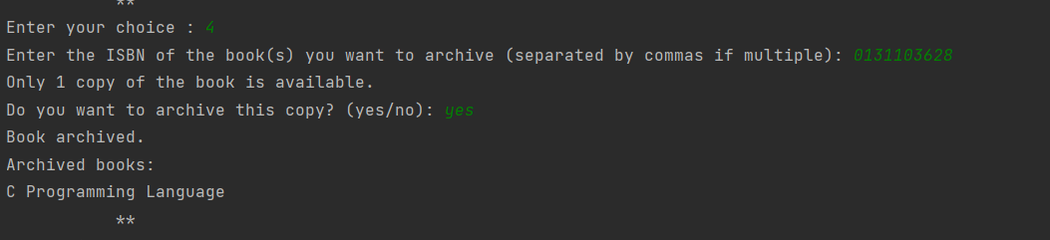

Figure 11. Archiving Example

1. **Removing books from the LMS:**

The remove book function allows users to remove a book from the Library Management System (LMS). Firstly, it verifies if there are any books in the LMS. Users are then prompted to enter the ISBN of the book they wish to remove. If the book is found in the archived books, its information is displayed, and users are asked to confirm the removal. Upon confirmation, the book is removed from both the archived books and the LMS. The function gracefully handles scenarios where the book is not found or if the removal operation is canceled, ensuring the LMS remains organized and up-to-date.

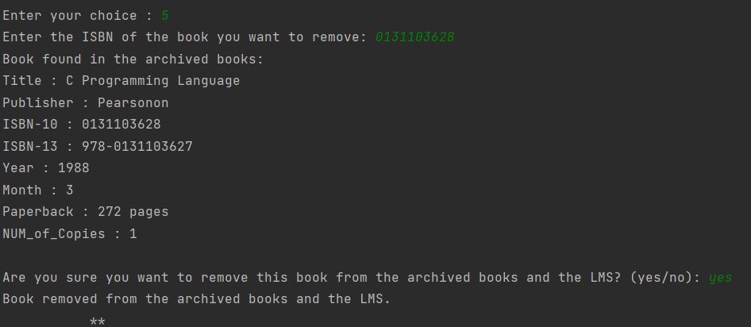

Figure 12. Remove Example

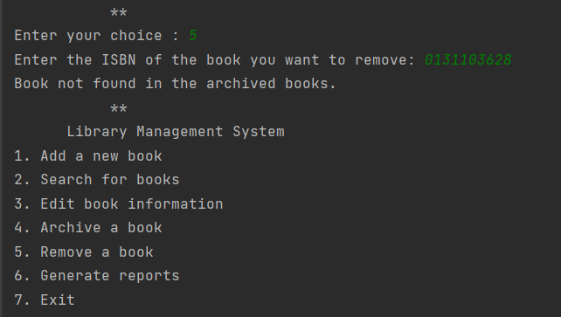

Figure 13. Remove example if the book not in the archive

1. **Generating reports:**

The LMS incorporates a robust reporting functionality that offers a comprehensive overview of the books within the library collection. By selecting this option, users can generate a detailed report on the screen, which includes key information such as the total number of books in the LMS, the count of unique books, the number of archived books, books newer than a specified year, book distribution by publisher, and book distribution by year. These reports provide with valuable insights into the library's inventory, helping them make informed decisions regarding book management, collection development.

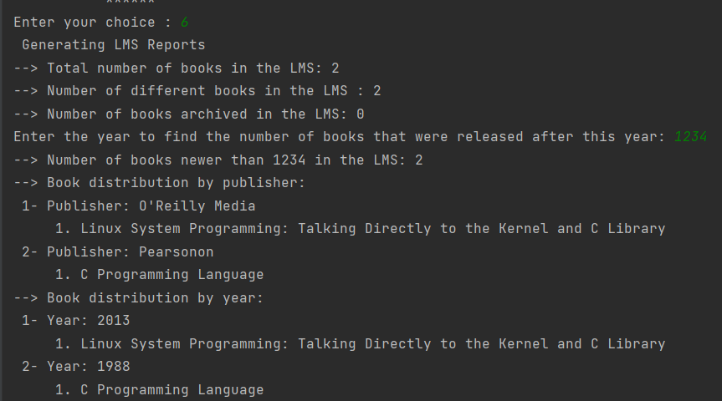

Figure 14: Genarate reports

1. **Exit:**

The "Exit" option serves to gracefully terminate the LMS. When selected, the system will save all the books' data to an LMS file, ensuring that no information is lost. This file will be loaded automatically the next time the LMS is launched, allowing for seamless continuation of library management activities. This feature guarantees data persistence and ensures that the LMS operates efficiently and reliably over multiple sessions.

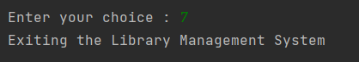

Figure 15:Exit