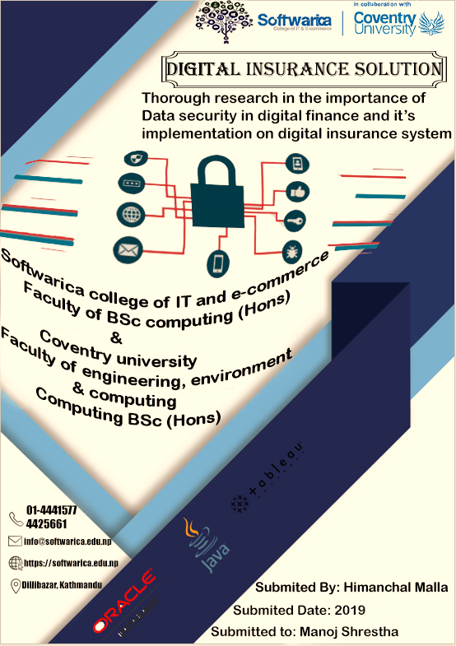

# **Abstract**

The dissertation mainly focuses on the data security issues in the digital insurance system. The use of internet has made the financial sector more cost effective with this there are many challenges with in the digital insurance system. Many issues of data breaches and data lost came into headlines. Data security issues in the digital insurance system has been the major concern. Data security has been the important to grow the business as it increases the costumer confidence towards the company.

Here, in the dissertation at first deep research related to the data security issues among the various financial sector as well as insurance sector is done. Various research related to the data security is studied to get the knowledge about the security issues in the financial sector. There are many works done for the data security but with this the challenges are also getting stronger every day. By studying various research paper, article and books we came in the result to use the oracle as the database which provide the various security features. There are many methods that are implemented for the data security which need to be upgrade with the time.

At last, the result is implemented by developing the digital insurance system and implementing all the results features. Different methods and techniques that are obtained from the result of the research in the data security is implemented in the system of the insurance.

# **Acknowledgement**

Above all else, my most earnest much gratitude goes to Prof. Manoj shrestha, who gave me a chance to work with his group, and furnished me with a noteworthy logical and moral bolster that most understudies envy. His thoughts, direction, and proposals constantly guided me to the correct heading, and her insight helped the dull corners of the course to under graduation. As the words miss the mark in offering my thanks, there is no uncertainty that without her valuable help it would not be conceivable to lead this examination. Besides, I would like to express gratitude toward Mr. Hira thapa who gives us backing and thoughts for the consummation of the venture. I likewise thank my kindred lab-mate, and dear companions, who has continuously been an extraordinary help at intense occasions. He persistently furnished me with headings to unravel hard question gives that I experienced over the span of this examination.

Additionally, I thank my companions One of my sincerest much gratitude goes to my family: my folks and to my sisters for supporting me profoundly all through composition this proposition and for an incredible duration as a rule.

# **Introduction**

The world is transforming from the mechanical to the general public of data innovation, by utilizing diverse inventive innovation individuals are getting more intelligent to take any choice in keen manner for their advantage. Each area from medical clinic, military, modern organization to little level business are utilizing data innovation for the better choice to upgrade the benefit of their business, following this none of organization can be separated from data innovation. Business organization with the utilization of various advances are developing in extraordinary pace with better choice and administration to their client. In the here and now these advances have been the key driver for changing the business and can possibly impact the estimation of business esteem. These organization gathers the gigantic measure of information from their client for the diverse reason for the business which they use for the better choice and increment the business estimation of the organization. At present time information turns into the existence line of the any business running organizations.

The organization holds distinctive secret information of the client where a portion of the organization like protection, clinic or bank holds the individual detail of the client. At present time each business estimation of the organization is the information they hold so with high estimation of information there is constantly a danger on the security of the information. Numerous organizations cost an immense measure of spending plan yet at the same time various cases for the information lost are went ahead news. In 6 September 2018 it was educated that British aviation routes needs to confront an information burglary where 380,000 exchange of client booking which incorporates bank number and expiry date. The monetary part are real unfortunate casualties and are on significant danger of information security. The loss of any sort of information may prompts disappointment of the organization as the organization may lose the trust from their client. There are numerous techniques that are being utilized for the better security of the information.

There are such a significant number of instruments and innovation created for the information security, numerous organizations are contributing millions to billions dollar for better security of the organization information. There are likewise various laws that are actualized for the information security like information insurance act executed in the UK. Information security risk can be limited by utilizing different safety effort like client verification, utilizing biometric secret key insurance and so on in the proposed research, various kinds of information security dangers will be examined and diverse significant that are existed at present will be contemplated and distinctive part of security real will be explored. The looked into will concentrate on the security major of the prophet database. The results of the exploration will be actualized in the model of protection framework where technique and innovation for the security of client information will be executed.

# **Oracle Virtual Box**

Oracle VM virtual box is the freely available open source software that provides a virtual environment to run the different operating system in a single machine at a time. The operating system that runs the virtual box called as host and the operating system which runs in the virtual box is called guest operating system. When designing a virtual machine, the client can determine what number of CPU centers, and the amount RAM and circle space ought to be given to the VM. At the point when the VM is running, it very well may be "delayed" (framework execution is solidified right then and there in time), and continued later when the client wishes to keep utilizing it.



# **Oracle Linux**

Linux is the open source operating system. Oracle Linux is an enterprise level of Linux which is supported by the oracle. The process of installation of the Linux is given below.

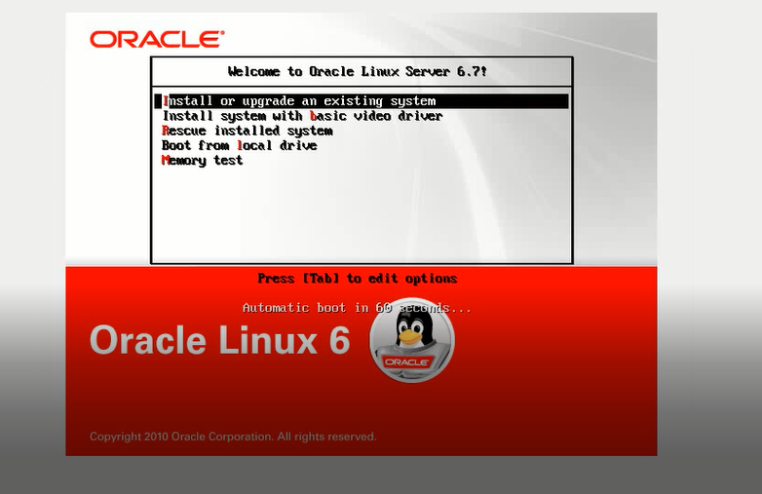

After running the Linux for the installation first this window appears which shows the different option just click the enter to install the Linux then the installation process will move forward. After that the screen will shows the installing of Linux and then next windows appears.

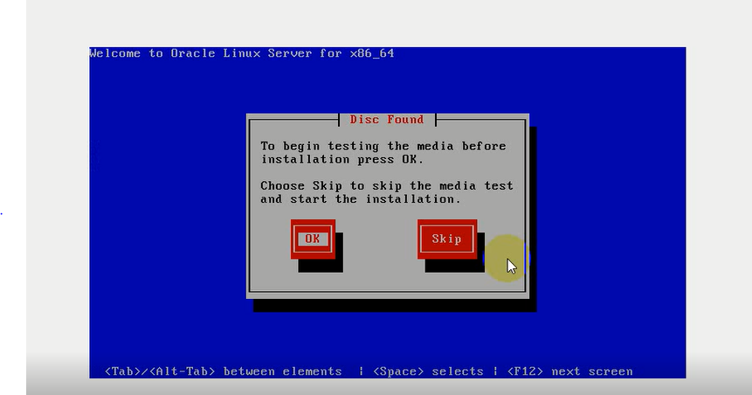

This window shows either to test the media or not just click the skip and continue the installation without media test. After skip the installation process will start again. Select the language option will come choose the language from there.

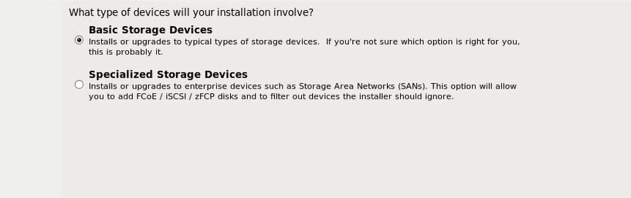

Here, Installation type is asked select the basic installation and click next to continue the installation.

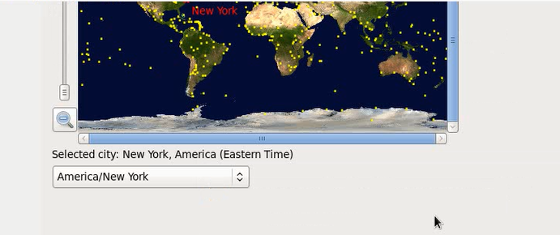

Here, selects the time zone of America as the time zone of Nepal isn’t supported by the oracle.

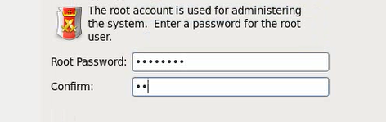

Provide the root password and confirm it. This is the password for the root user.

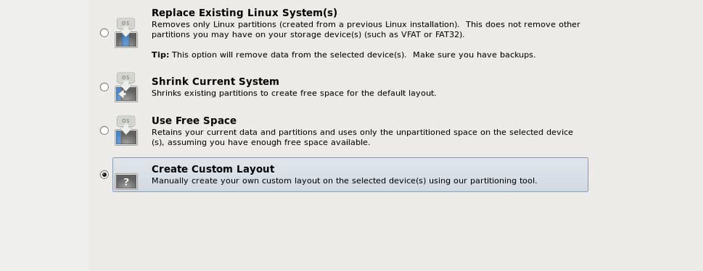

After that select the custom layout for the partition of the device storage.

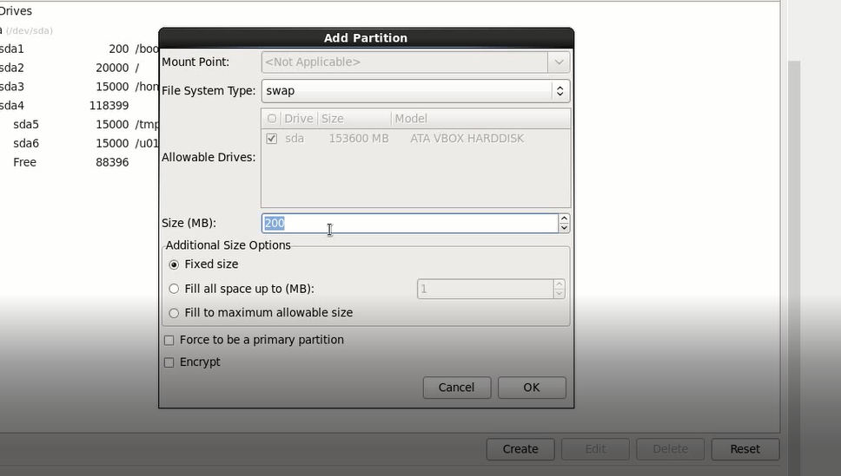

Here, the disk is partitioned into different part. Root, boot, home, temp and U01 and SWAP memory is also defined which is one third of the ram and then write the change on the disk and then click next.