# **Introduction**

Coursework and the dissertation are the part of the academic writing. In academic writing coursework is the work that is assigned to the student by the teacher according the course and the student has to perform and complete the work. Dissertation is the formal document and there are some rules how it must be presented. The dissertation contains different chapters which contain various topics like introduction, literature review etc. the dissertation is the research work document that is performed by the student in the relevant field. Both coursework and dissertation are equally important for the graduation.

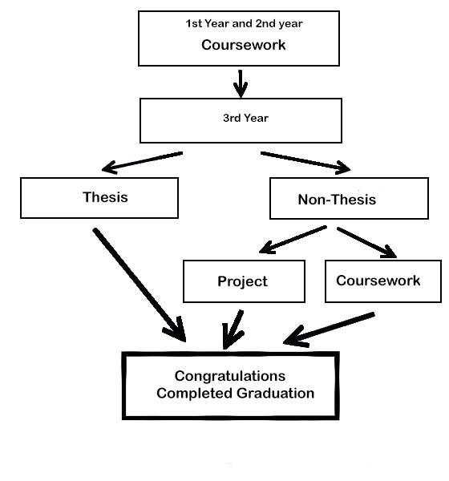

Coursework is done from very first phase of graduation till the completion of the graduation. Coursework work might be the written exam or the Assignment assigned by the teacher. Dissertation is done in final year of the graduation where the student does the research in the relevant field and write the document about the research and build the prototype. Dissertation is submitted at the last year of graduation and leads for the graduation.

# **Coursework**

Coursework is the academic part where the student is performing the task assigned by the teacher to complete the graduation. The coursework is assigned by the teacher as per the structure of the course. The student can perform the research in the given course work in the environment set by the teacher. The student can perform the research in the given course work in the environment set by the teacher. The teacher provides the research material to the student and the student has to complete the work within that environment. The coursework can be different according the discipline of the student and has to be done with in the certain given time. The major and the vital part of doing coursework is doing research. Coursework is used to grade the student for understanding of their related course.

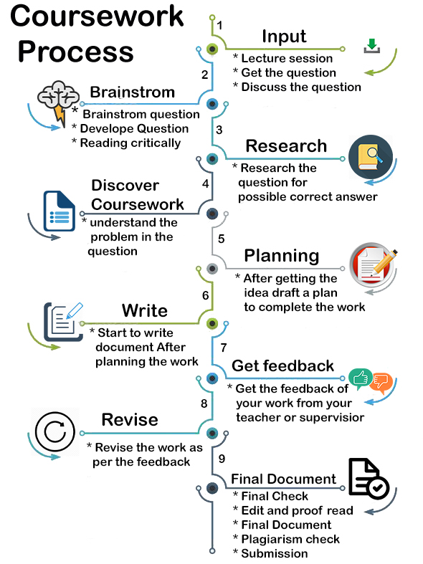

Above diagram shows the process of doing the coursework. At first the lecture session of course is done and during the lecture session question is received which is discussed from in the lecture session. After that question is analyzed critically and the question is developed for the best possible answer and then research is done to find the possible correct answer. After that the project draft plan is released to complete the work and then writing process for the coursework is started which is later on shown to the teacher for the feedback after getting the feedback the coursework is revised according to the given feedback and finally the finally document is prepared which is checked for plagiarism and finally submitted for the grading.

# **Dissertation**

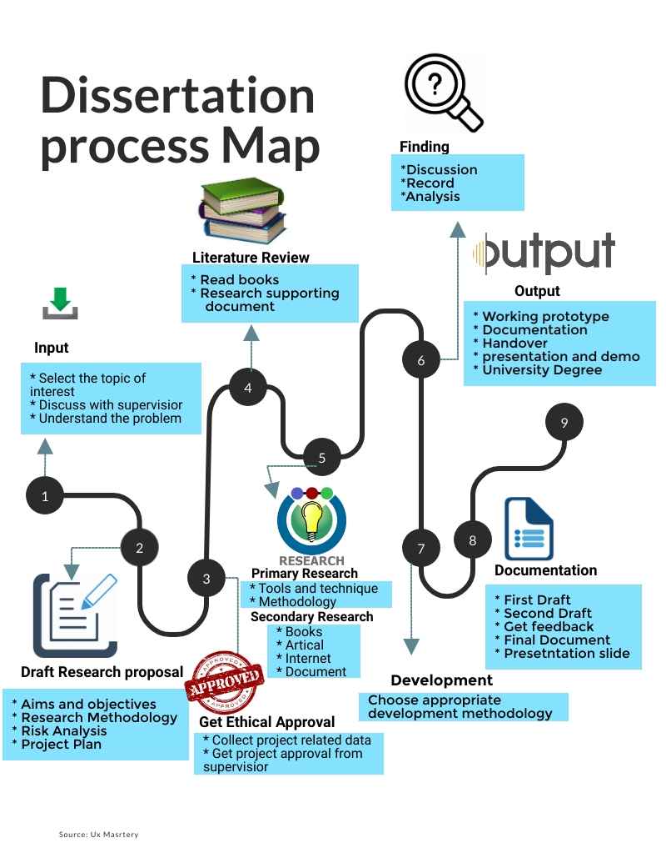Dissertation is the Research document where the student is free to do the research in the area of their interest according their discipline. The student is free to choose their topic and has to perform the research in the given topic. The document of the dissertation may larges from ten thousand words to twenty thousand words. The dissertation contains a literature review where the research works that are already done in the chosen topic is studied and have to perform the further research work.

Above figure shows the process of the dissertation at first in dissertation the topic is selected in the area of the interest and then topic is discussed with the supervisor to understand the problem. After that the draft proposal is released where aims and objectives, research methodology and risk are analyzed. After that get ethical report from the supervisor and then the literature review is written by doing the research in the relevant field. In literature review the research done in the past by the different student, teacher or expert are studied is written. After that the detail research is done for getting more information from books, articles, Different website etc. for more information. After the research the research finding are discussed with the supervisor and then analyzed the result after that the development process is started where the result of the research is implemented in the prototype by choosing the appropriate development methodology. After that the whole process is documented and release a different draft of document for the regular feedback from the supervisor and finally the actual final document is released which is then submitted in Turnitin for plagiarism and presentation slide is also prepared for the presentation and then finally the final document with working prototype is ready which later on submitted and then presentation and demo is also presented to the teacher and finally the university degree is received. The dissertation is the last stage of university under graduation where the student is given chance to show the skill and the knowledge, they achieved to do the research.

# **Similarities between Coursework and dissertation**

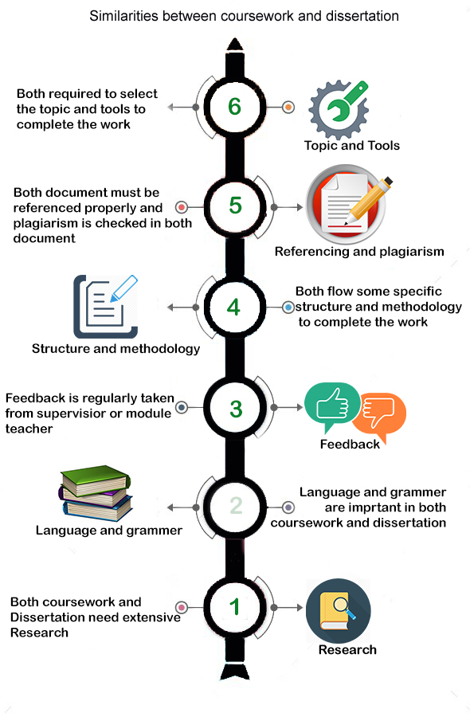

Coursework and the dissertation both are the important academic part of the graduation. Even though they have a different theme in the academic writing, there is also a lot of similarities between coursework and the dissertation. As shown in the above diagram both coursework and the dissertation need a research for the getting possible correct answer. Research is very important in both dissertation and coursework as the similar work done by other also need to studied to understand the problem. Language and grammar are checked in both coursework and the dissertation. Both coursework and the dissertation must have good language with active voice must be used. Both coursework and the dissertation need to have a regular feedback from the teacher or the supervisor to check if the work doing is on correct direction or not. Feedback requires both in coursework and dissertation to improve the work. Both coursework and the dissertation flow the specific structure and methodology to complete the work. Both in coursework and dissertation referencing is required properly and the plagiarism is checked in both coursework and the dissertation. Both coursework and dissertation require to choose the topic for the work and tools to complete the work.

# **Differences between Coursework and Dissertation**

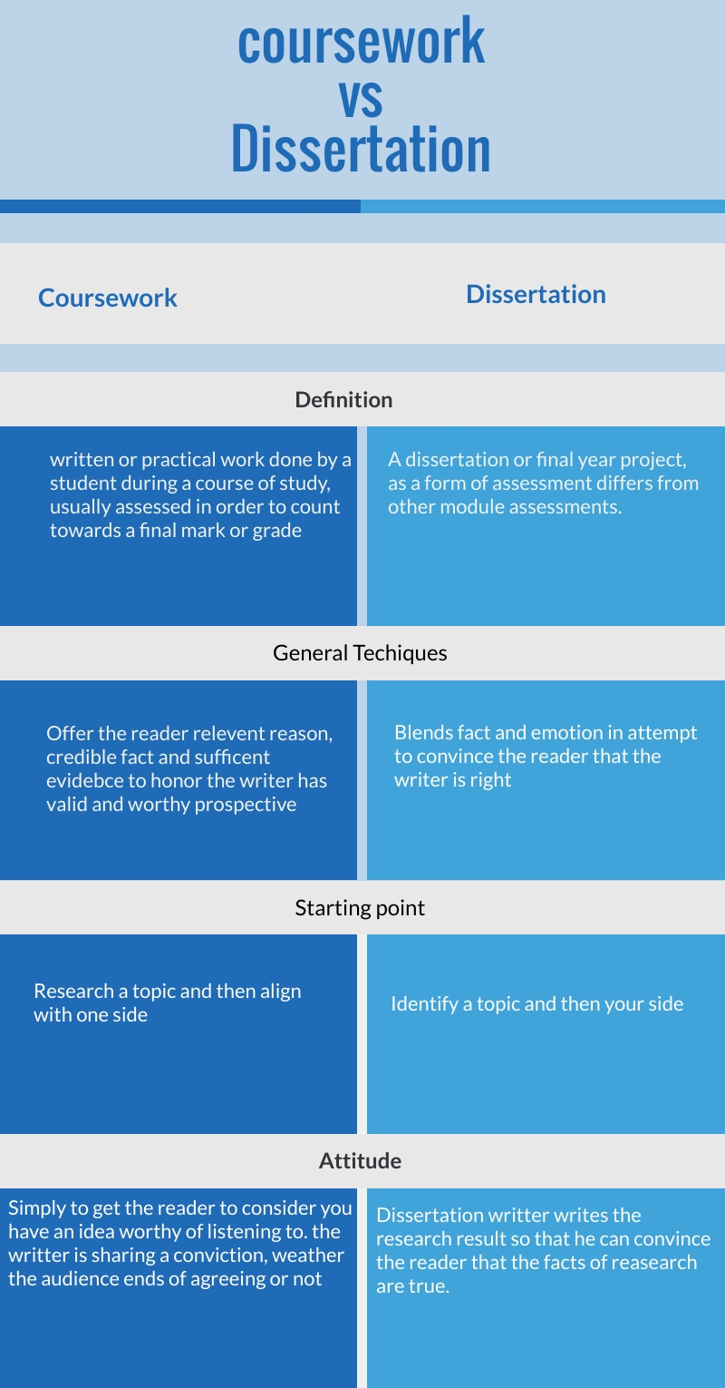

There is the various difference between the coursework and the dissertation. Although they both are the part of the academic writing, they have some differences. Coursework is either written or assignment based which is assigned to the student during the course period time which is later on graded by the teacher which leads to the graduation whereas the dissertation is done on last year and is research based where student has to research in the certain topic. Coursework is of short period of time generally limited within in course period of time whereas the dissertation is long which may continue for whole year. In coursework the answer is written as per the course requirement where as the dissertation is the research where answer is always a new finding or outcome of the research. Coursework is related to certain course and the attendance is require where as in dissertation student only visit the supervisor for the feedback. The dissertation has written document as well as the product to implement the research work but the coursework might only be written document or document with product to support the document. In dissertation the student has to manage the time whereas in the coursework the teacher has set the timeline for the student to do the task.

# **Benefits of coursework and Dissertation**

Coursework and dissertation both are important and beneficial for the student to enhance the knowledge in the relative field. Coursework has its own benefit to do. In coursework the topic may be given either by the teacher or the student may choose one specific topic. Research in the topic helps to enhance more knowledge in the related topic. Student are guided by the teacher to complete the work. The teacher provides the research material to the student and the student has to complete the work within environment set by the teacher and the dissertation has also its own benefit as the student can choose the topic of their own in the interested field. The student can present their own ideas for the work. Student has to perform the research in the dissertation which gives deep knowledge in the field. The work is supervised by the supervisor which provides regular feedback for the better work.

# **Challenge in Coursework and Dissertation**

Challenges are in every field of work, there are also challenges in the coursework and the dissertation. In coursework the students are bounded in the certain environment which is set by the teacher. Coursework only helps to gain the course knowledge and the student can’t present their ideas as they want. in coursework the student can’t perform their work as they want; they have to be strict with in the teacher’s requirement while in the dissertation, the main problem faced is choosing the appropriate topic. In dissertation the time management is the major challenge for the student.

# **Conclusion**

Dissertation and the coursework are the academic activities that are performed by the student. Coursework is guided by the teacher and set the requirement according to the course, in some way coursework is good as the student are guided by the teacher and give the task which the student has to do. In the dissertation the student can choose the research work as per their interest so that the student gets the chance to present their ideas and view among the people. In dissertation the student has to do lot of study for their research as in coursework the student has to do research with related to their coursework only. Both dissertation and the coursework have the challenges as well as the benefits as the coursework helps to improve the knowledge in the related course whereas the dissertation helps to improve the knowledge of the student in the specific are of the interest of the student. The coursework and the dissertation both have the important role in their way to improve the academic knowledge of the student.