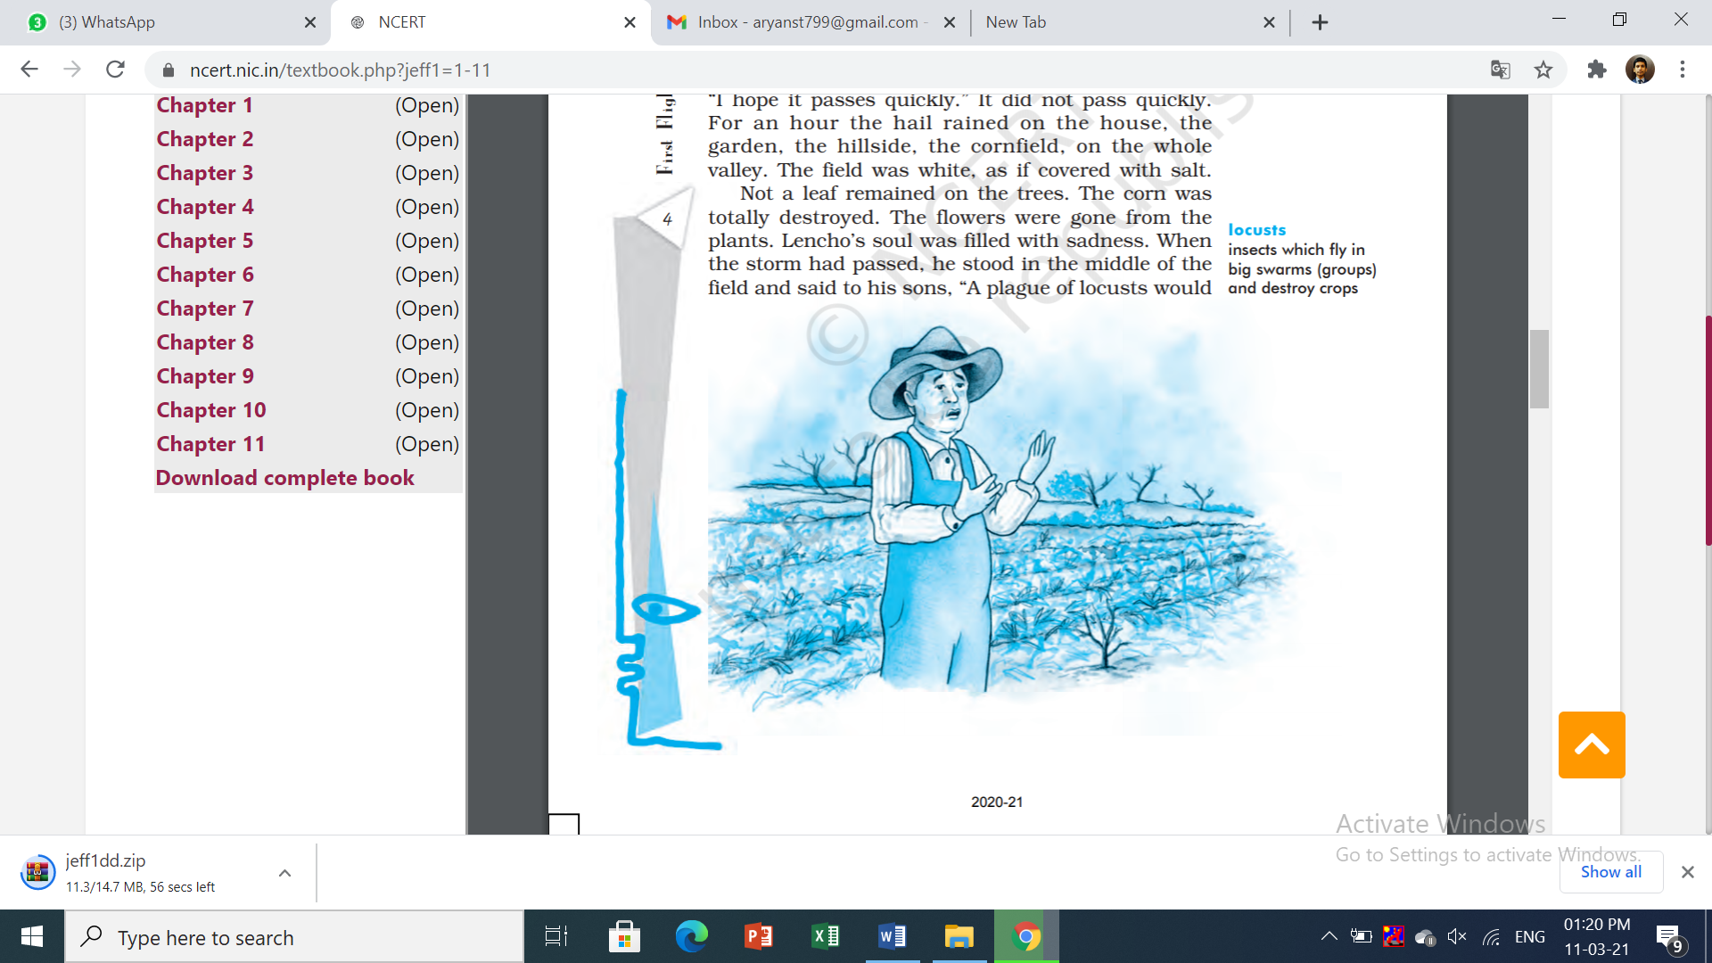**NCERT Flight Lesson 1: A Letter To God**

On MyLearning Locus we begin a new series of Class 10th Questions & Answers. We hope here you will find all the stuff that you need to learn for your exams and the academic year. So let’s begin:-

**Word Meanings:-**

1. Crest: top of a hill
2. Intimately: in a way that involves detailed knowledge
3. Draped: covered (with cloth)
4. Peso: currency of several Latin American countries
5. Conscience: an inner sense of right and wrong
6. Amiable : friendly and pleasant
7. Locusts: insects which fly in big swarms (groups) and destroy crops
8. Contentment: satisfaction

**Question & Answers:-**

**Oral Comprehension Check(Page No. 5)**1. What did Lencho hope for?

Answer:- Lencho hoped for a peaceful rain that would water his crops and he would get a good harvest this year. He hoped for rain because it would bring water and money as the ripened crops would get him some money after selling.

2. Why did Lencho say the raindrops were like ‘new coins’?

Answer:- Lencho said that the rain drops are like new coins because a good harvest is only possible with sufficient rain. Ultimately, good harvest would bring good income and money. As a farmer, who desperately waits for rain, Lencho too eagerly wait for rain and refer to raindrops as ‘new coins’ as they are the source for his income.

3. How did the rain change? What happened to Lencho’s fields?

Answer:- Light rain came from the north-east and Lencho regarded the field of ripe corns with its flowers as draped in a curtain of rain. But suddenly a strong wind began to blow and along with the rain very large hailstones began to fall which looked like silver coins and remained for an hour. Not a leaf remained on the trees. The corn was destroyed. The flowers were gone from the plants and Lencho’s was white as compared to salt.

4. What were Lencho’s feelings when the hail stopped?

Answer:- Lencho’s soul was filled with sadness as the hail stopped. He stood in the middle of the fields and claimed that plagues of locusts would have left more than this. The hail has left nothing and he lost all his hope and only had one hope that is the help from the God.

**Oral Comprehension Check(Page No. 6)**

1. Who or what did Lencho have faith in? What did he do?

Answer:- Lencho had utmost faith in god He had been instructed that God's eyes see everything, even what is deep in one's conscience. Therefore, he wrote a letter to God expressing his need for a hundred pesos so that he could sow his field again and live until the crop grew again.

2. Who read the letter?

Answer: The Postmaster at the Post Office read the letter.

3. What did the postmaster do then?

Answer:- At the very first sight of the letter the postmaster laughed but soon became serious as he read it. He was moved by the writer’s (Lencho’s) faith in God in order not to shake the writer’s faith in God, the postmaster came up with an idea that was to answer the letter. He along with other Post Office employees gathered the pesos and gave it to Lencho on the behalf of God.

**Oral Comprehension Check(Page No. 7)**

1. Was Lencho surprised to find a letter for him with money in it?

Answer:- No, Lencho was not at all surprised to see the letter from God with money inside it. His confidence and faith in God was such that he had expected that God would definitely send money and help him out of this situation.

2. What made him angry?

Answer:- When Lencho counted the money, he discovered that there were only seventy pesos in the envelope whereas he demanded hundred pesos. This difference in the amount he received made him angry and he suspected that the Post Office employees may have taken his money.

**Thinking About the text:-**

