Zoho Creator Exploration Report
Course: Low Code Development
Platform Explored: Zoho Creator
Objective: To explore the Zoho Creator interface, deployment options, dashboards, and application creation workflow.

Introduction
Zoho Creator is a low-code application development platform that enables users to rapidly build business applications with minimal coding. It provides visual form builders, workflow automation, dashboards, reports, integrations, deployment management, and analytics.

1. Environments
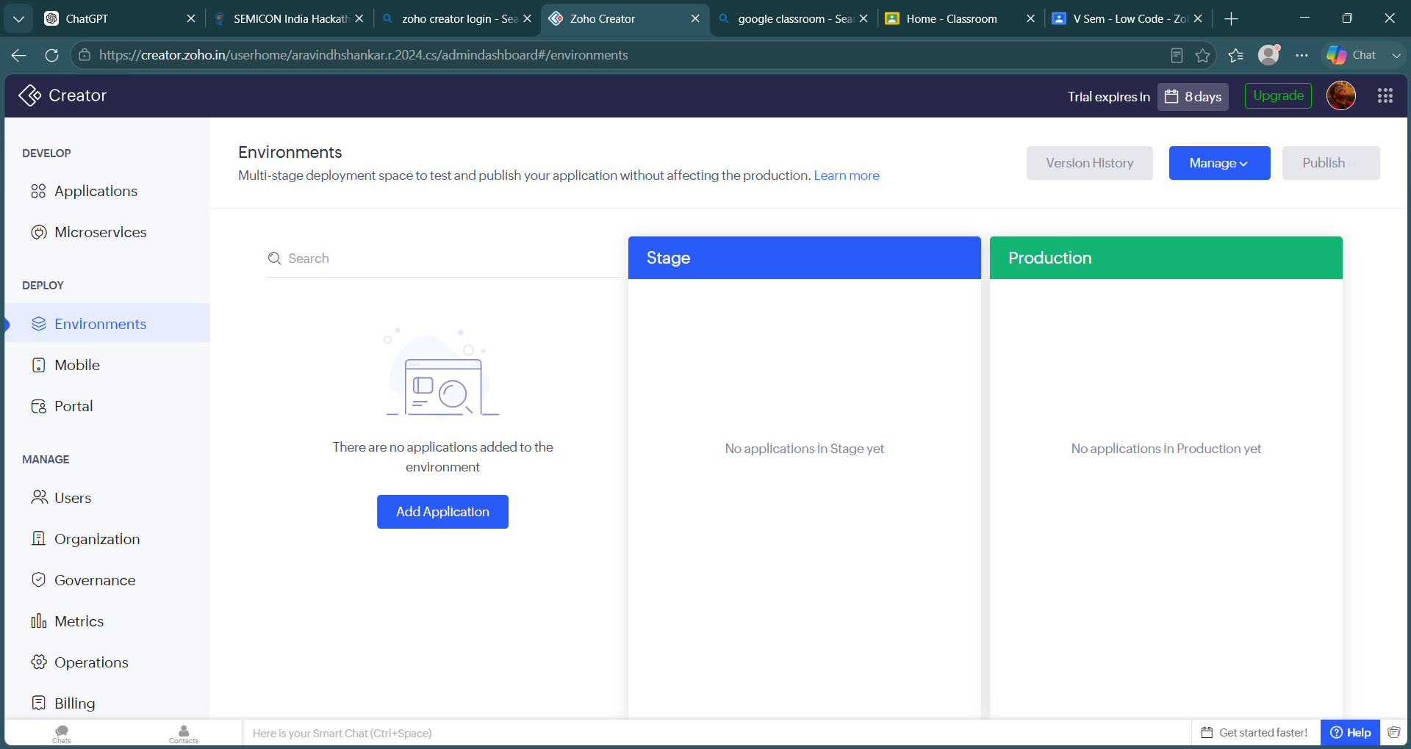
Figure: 1. Environments
Displays the deployment environments (Development, Stage and Production). It enables developers to safely test applications before publishing them to production. The page also provides version management and deployment controls.

2. Metrics Dashboard
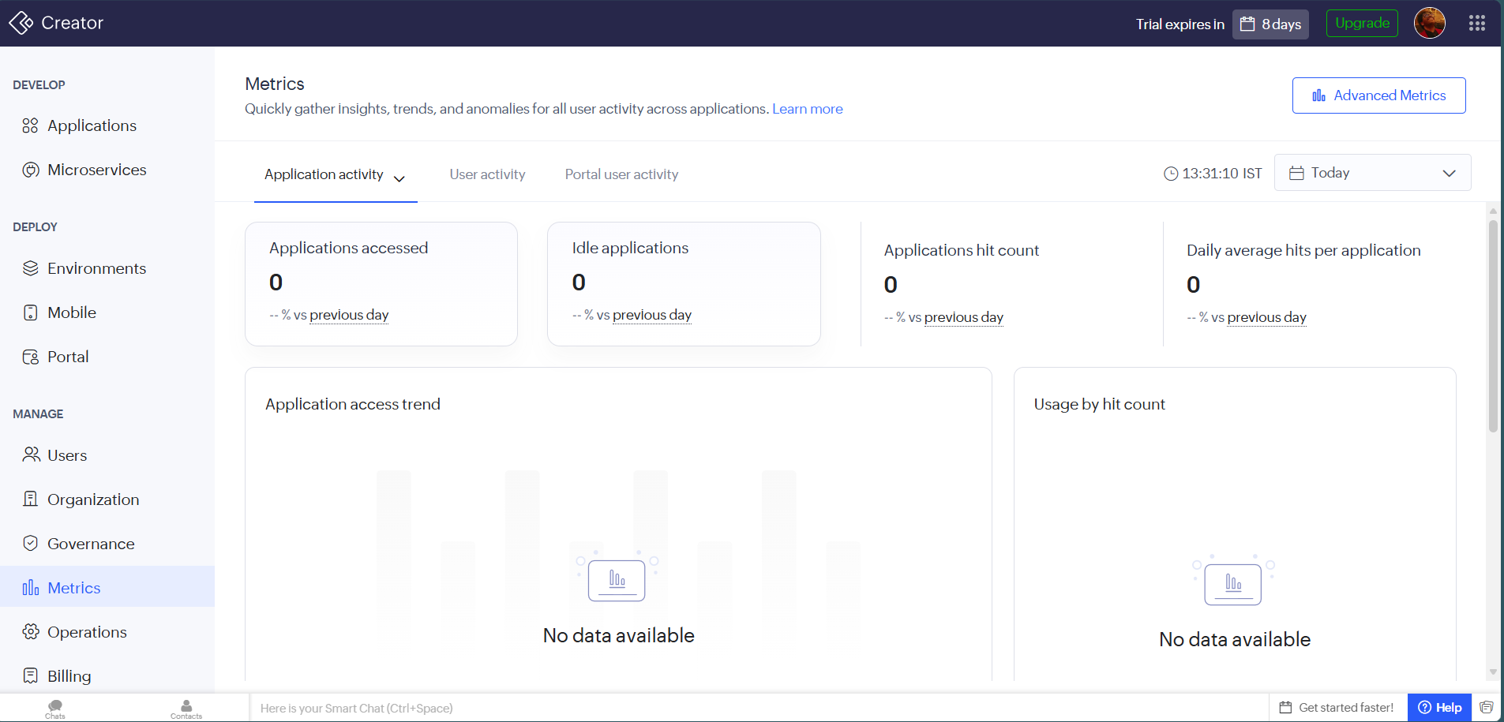
Figure: 2. Metrics Dashboard
Provides application analytics such as application access, hit count, user activity and usage trends. These metrics help administrators monitor application performance and user engagement.

3. Operations
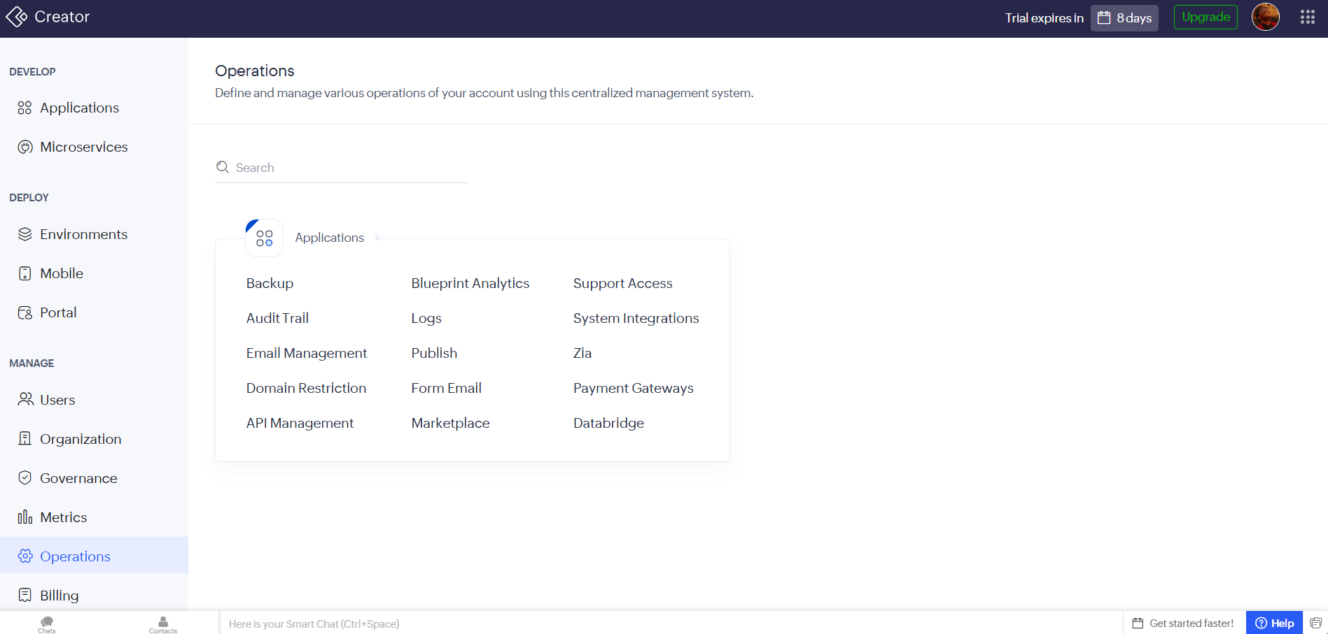
Figure: 3. Operations
Centralized administration section containing Backup, Audit Trail, Logs, API Management, Email Management, Payment Gateways, Marketplace integrations and other operational tools.

4. Sample Student Portal Dashboard
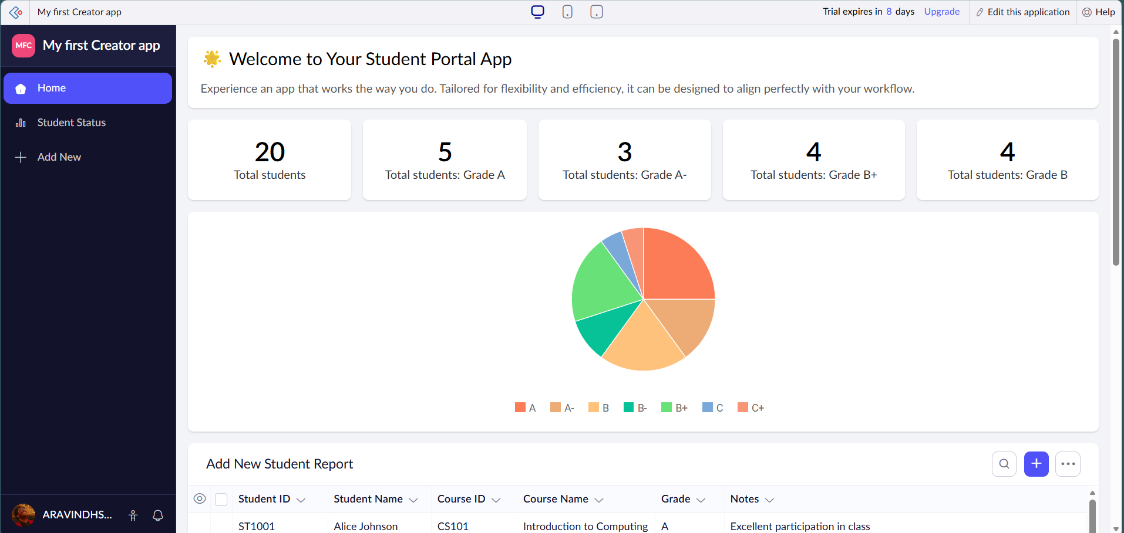
Figure: 4. Sample Student Portal Dashboard
A sample application demonstrating dashboards, KPI cards, charts, navigation menus and reports. This showcases how business applications can present information visually.

5. Student Report Table
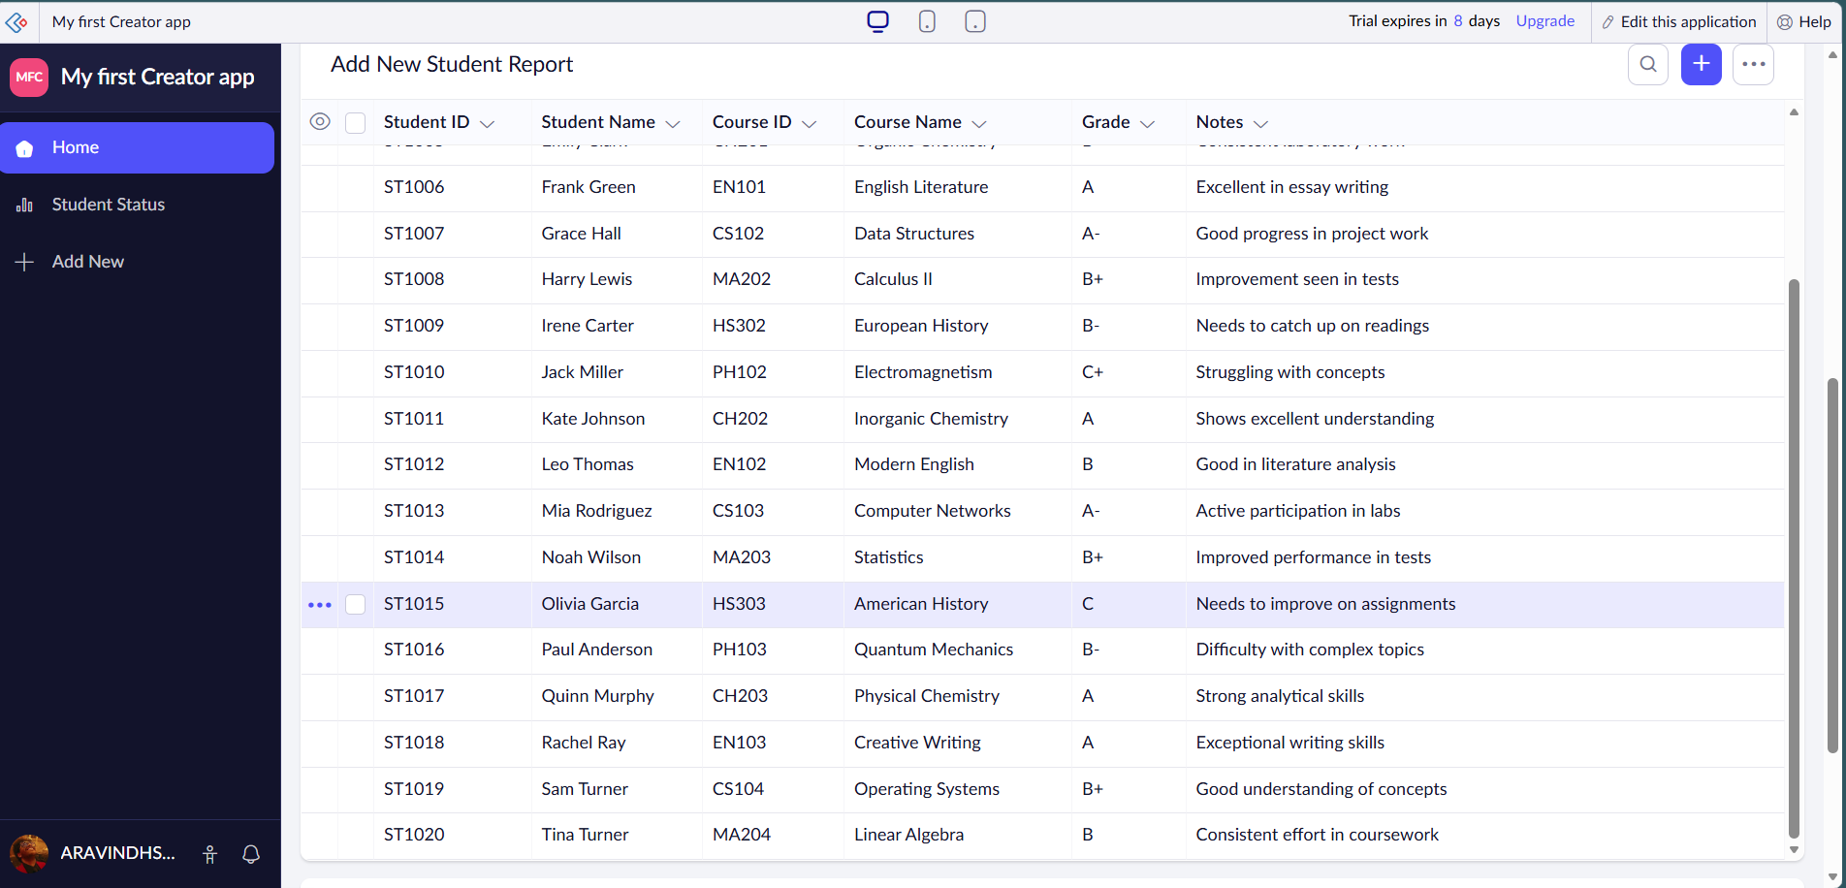
Figure: 5. Student Report Table
A tabular report displaying stored records with sorting, filtering and record management capabilities. Reports are automatically generated from form data.

6. Create New Application
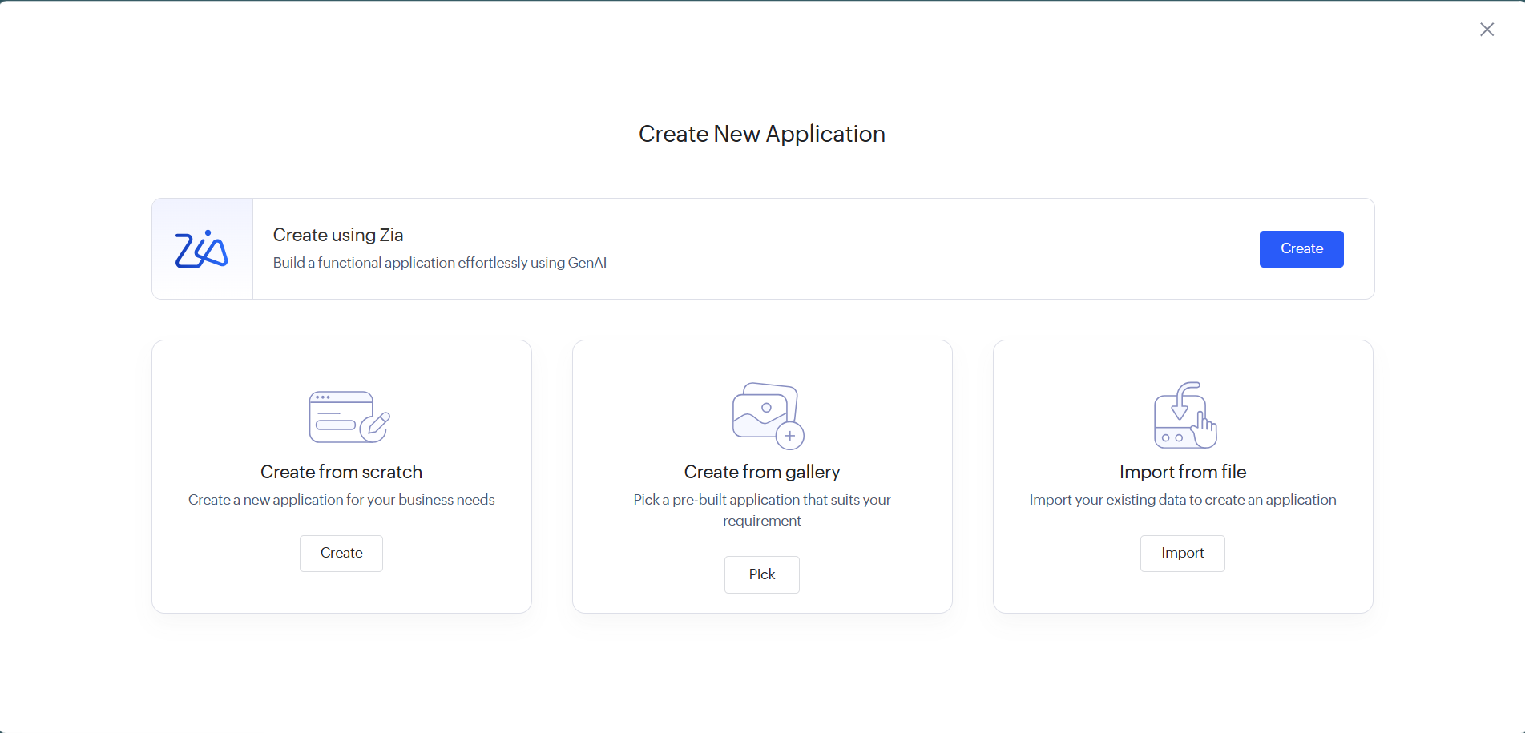
Figure: 6. Create New Application
Shows multiple ways to create an application: using Zia AI, from scratch, from gallery templates, or by importing existing data.

7. Create New Microservice
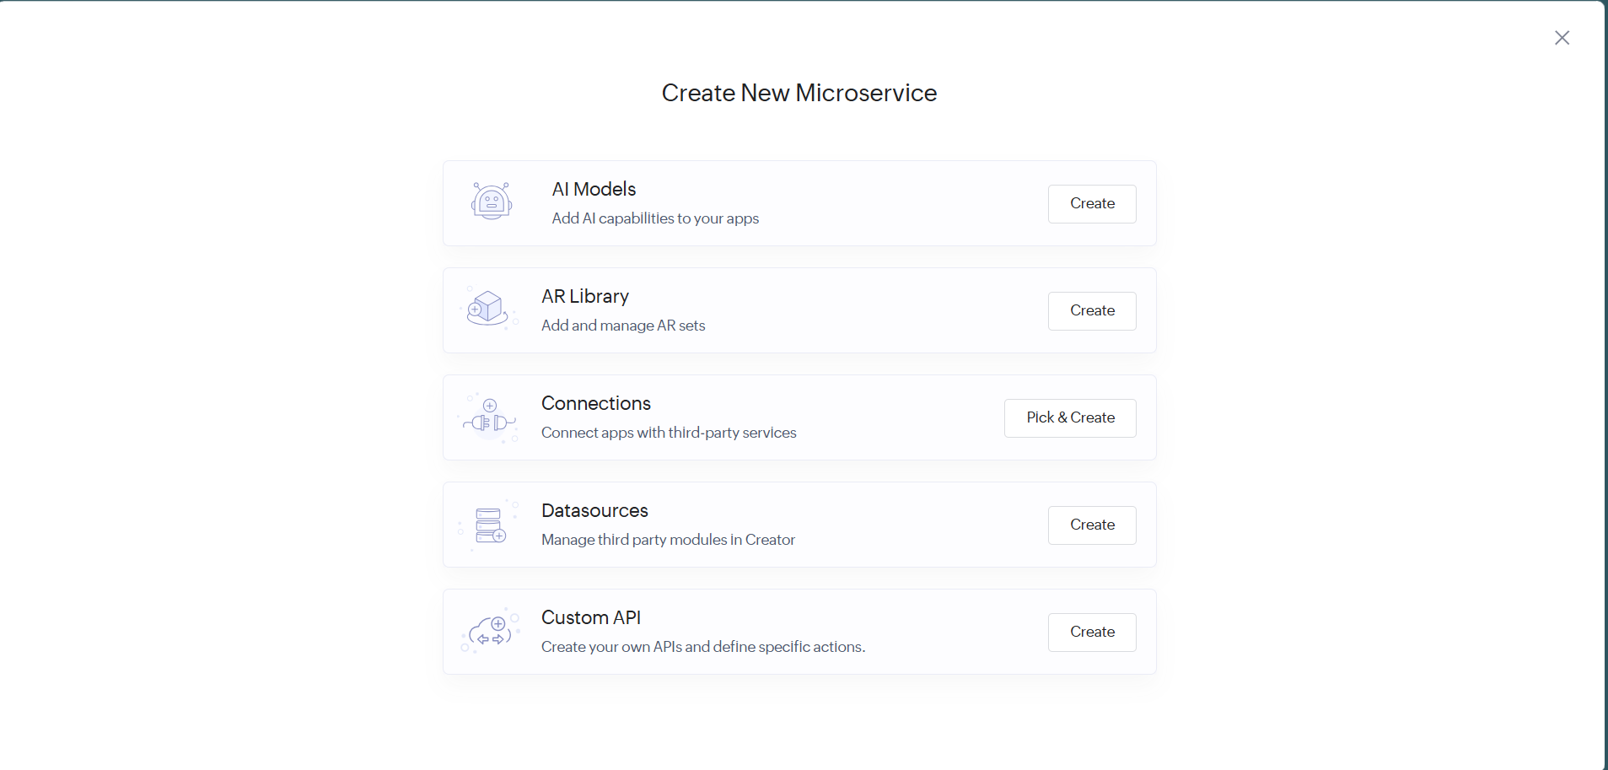
Figure: 7. Create New Microservice
Illustrates available microservices including AI Models, AR Library, Connections, Datasources and Custom APIs, allowing modular extension of applications.

8. Additional Environment View
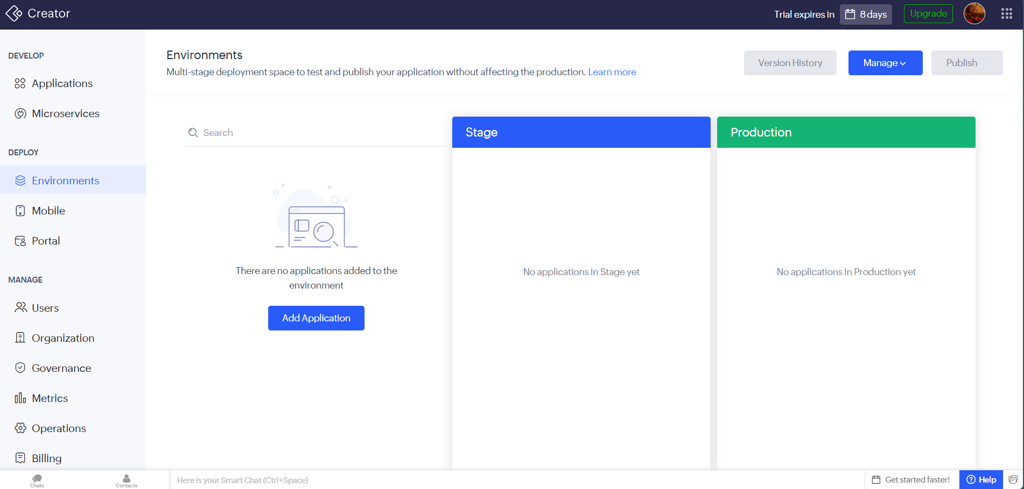
Figure: 8. Additional Environment View
Another view of the environment management screen showing deployment workflow and environment organization.

Key Features Observed
- Visual low-code application development
- Form and report generation
- Interactive dashboards with charts and KPI cards
- Environment-based deployment (Development, Stage, Production)
- Application monitoring through metrics
- Operational tools such as backups, logs and audit trails
- Support for AI, APIs and third-party integrations
- Responsive interface for desktop and mobile devices

Conclusion
Zoho Creator provides a comprehensive low-code environment suitable for rapidly building enterprise applications. During this exploration, the platform's interface, deployment workflow, monitoring capabilities, reporting tools and application creation options were examined. It is well suited for academic projects as well as real-world business process automation.

