
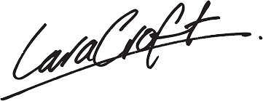
SAVANNA DR AUSTIN, TEXAS, 12345 | PH.: 234-234-2345 | INFO@ SOUTHERNLANDSCAPE.COM

Dear Mr. Smith,
This company's letterhead is visually complete only when it displays a typewritten letter. The format of the typewritten message and the quality of execution have a great effect on the attractiveness and impact of the finished letterhead.
This is the recommended letter format to complement this letterhead design. The letter is typed single-spaced in a left-block format with double spacing between paragraphs. The typeface we have used in Times New Roman and is set at 12 points. The right margin should not be justified and should not exceed the width of this facsimile letter, and the letter should be centered vertically on the page. In any typed correspondence, great care should be taken to insure that your company's logo is never obstructed in any way. A specific column has been set aside for the symbol which provides it with a presence that ensures that your company's image is consistent, clear and direct.
Your company's letterhead reflects your standard of quality. Thank you for taking care to produce an attractive and professional letter.

Sincerely,
John Doe,
Vice President
External Relations

March 1, 2001
Mr. John Smith
Fictional Company
Suite 12, 123 Main Street
Anytown, CA 90000

