1. Create a maven spring boot application as shown

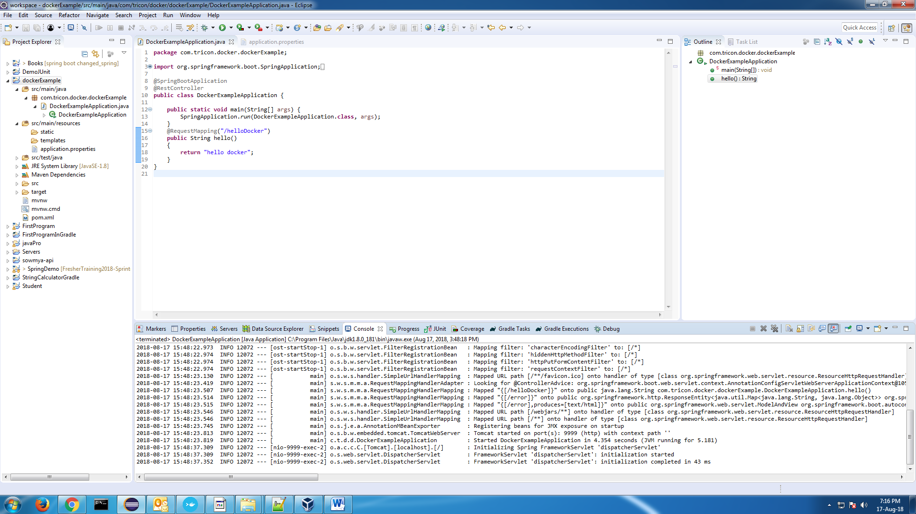

1. Create dockerfile with content as shown and place it in the pom.xml folder.

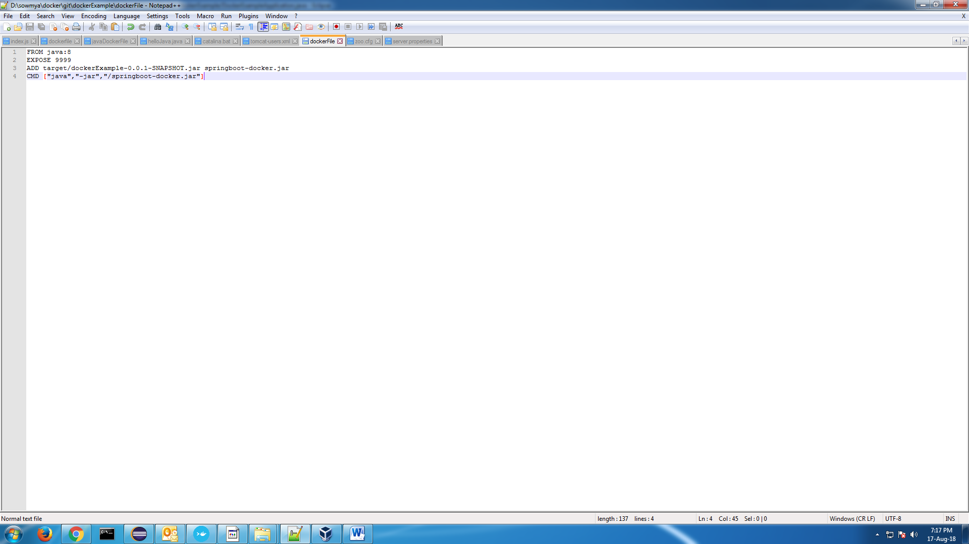

1. Start docker and build the dockerfile to create the image.

docker build –t sowmya_docker .

1. docker images
2. Then run the docker image

docker run –p 2222:9999 image_id

1. Then run in browser as localhost:2222/helloDocker

If it doesn’t show up then you need to do changes as

1. Open Oracle VM VirtualBox Manager
2. Select the VM used by Docker
3. Click Settings -> Network
4. Adapter 1 should (default?) be "Attached to: NAT"
5. Click Advanced -> Port Forwarding
6. Add rule: Protocol TCP, Host Port 2222, Guest Port 9999 (leave Host IP and Guest IP empty)
7. Guest is your docker container and Host is your machine

