**ITP**

2017

**Applicant Tracking Sytem Final Report**

**Fahad KALHORO (30323248)**

**Gyanendra POUDEL (30326808)**

**Hideaki KOBAYASHI (30324359)**

**Shankar PANDEY (30322313)**

**Salil KOIRALA (30326224)**

Contents

Introduction 5

Project Background 5

Detailed Analysis of client’s requirements 6

High level requirements 6

The First phase– Document management System 6

Functional requirements 6

Non-functional requirements 6

The second phase– Job advertising system 6

Functional requirements 6

Non-functional requirements 7

Low level requirements 7

The First phase 7

The second phase 7

Stakeholder Analysis (roles and responsibilities of each stakeholder) 8

Project Goals: 14

Specific: 14

Measureable: 15

Attainable: 15

Relevant: 15

Time Bound: 15

First Phase: 15

Summer Break: 16

Second Phase: 16

Time Breakdown Matrix: 16

Feasibility Report: 16

Technical Feasibility: 17

DOC toTXT: 17

Economical Feasibility: 18

Hardware Feasibility: 18

Software Feasibility: 18

Labour Feasibility: 18

Staff Feasibility: 19

Risk Feasibility: 19

Opportunities: 19

Threats: 19

Time Feasibility: 20

Phases: 20

Methodologies, Standards & Tools: 20

Methodology: 20

Agile Methodology: 20

Individual interactions over processes and tools: 21

Working software over comprehensive documentation: 21

Customer collaboration over contract negotiation: 21

Handling to change over following a plan: 21

Advantages: 22

Standards & Tools: 22

Application Development Tools: 22

For Database Management Tools: 23

Communication Management 23

Communication Matrix 23

Change Management 24

Risk Management 24

Risk Analysis Process 25

Risk Mitigation 25

Quality Assurance 25

Capability Maturity Model(CMMI) 26

Project Evaluation Plan 26

Project Planning 27

Work breakdown Structure (WBS) 27

Resource Allocation 27

Timeline and Gantt Chart 28

The first Phase 28

Middle break 28

The second Phase 28

Gantt Chart 29

Management of Critical activities 30

Task management 30

Coverage of the Tasks 30

Communication 30

Analysis of Client’s Requirement: 31

High Level Requirements: 31

First Phase-Documentation Management: 31

Functional Requirement: 31

Second Phase-Job Advertisement System: 32

Functional requirement: 32

Non-Functional requirement: 32

Low level requirement: 32

The First phase 32

Second Phase: 33

Analysis: 33

Goals of System: 33

Scope: 33

Constraint Related to the System: 34

Modelling: 34

Requirement Traceability: 36

Requirements Traceability Matrix detail 37

Retrospective Review of Project 38

Report Approval 39

References 40

Appendix 41

Diagram: Timeline 41

Diagram: GanttChart 42

List of Items with Deadline 43

Introduction

Application Tracking System(ATS) is the new technology for hiring environment. It automates the hiring process with own database and website. People who are seeking for the job can see the current available job in the website and those who can meet the job requirement can apply for job. Moreover, in administrator site all records store in database with necessary records and corresponding attributes. As result, strong and week point of candidate can be easily identified. Also, we can suggest possible position for those candidates who makes account in our website. This is an overall process for ATS. Through online conversation with MACS Technology and the development team, Applicant Tracking System (ATS) has potential to improve MACS Technology hiring environment. MACs Technology has some specific requirement that we are going applied in our implementation phase of project. This report contains the summary of client requirements and case studies for current application tracing system. The first section is summary of current project structures and requirements such as project background, requirement analysis, stake holder analysis and definition of project objectives and goals. In the second section, this report introduces some case studies and methodology for implementation of ATS. There are some case studies those are from current ATS and recruitment environment and findings. Those case studies are considered with actual implementation of ATS and how does the system make positive and negative effects to the companies.

Project Background

**Macs Technology** is an Australian based Company located in level 9, 84 Pitt Street, Sydney, NSW. It Consist of young, creative and bright people always striving to get success. It currently specializes in Mobile app development, Website development, Data Analytics, E-commerce, Cloud enablement, staffing solutions, digital transformation, business intelligence, infrastructure and security solution. Its partners are Amazon web services, Trend Micro, IBM Watson, Analytics, Microsoft and so on.

Currently, Macs technology is hiring a lot of Information Technology Staff due to work intensity. As a result, Macs is trying to implement the application tracking system to hire new IT staff which can digitally help in parsing thousands of resumes. It will save both time and cost of the company. The application Tracking System that we are going to develop will help MACS technology to further improve their IT staff recruitment policy.

The vision of MACS technology is to offer a unique integrated Digital Solutions that simply be embedded into the current ongoing process. And the Mission of MACS technology is to help business achieve their goals at affordable costs without affecting their Work Flow.

We have done the all documents require for this project. As we have done the vast research on this project we discovered the methodology which we are going to implement in next phase. That is agile software methodology. This is because we can implement easily if requirement is changing frequently.

Detailed Analysis of client’s requirements

In this section, what are the basic requirement for application tracking system is going to be explained detailly. There are two major requirements I.e. high-level requirement and low-level requirement. The high-level requirement contains two phases with functional requirement and non-functional requirement and explain in detail. Also, analysis of system service, system modelling, communicate requirements and requirement.

High level requirements

The first point is high level requirements. This section introduces functional and non-functional requirement for application tracking system. During online video meeting between clients and project team, client introduced two phases of the system functionality such as candidate collection and job introducing. In the first phase, collect resume and (CV) from candidate. Then in the second phase, open job opportunities to the candidates. From those requirements, this section introduces functional and non-functional requirements for those two phases in separately.

The First phase– Document management System

The first phase is document management system. Functional and non-functional requirement for this phase is listed as below.

Functional requirements

* direct input from users or retrieve document files
* store in the database with diving into relevant part
* make a list of all file that has stored in database
* Show the details of a record
* Edit the detail of a record
* Delete a record
* Export record(s) in certain format

Non-functional requirements

* document management system is working on the webserver
* operation is done with help of web browser
* website uploading link should be on website
* public can access resume uploading page only
* privilege can be set by username and password
* status of candidate can be identified by tracking indicator

The second phase– Job advertising system

The second phase is job advertising system. Functional and non-functional requirement for this phase is listed as below.

Functional requirements

* Once create Job position that is saved as a record in database
* Creation, view detail, edit of detail and deletion of job position record
* Manager can change status of job position record
* Public opening of position record

Non-functional requirements

* Access control is implemented for accessing these functions except public opening page
* Status of job record is Open, close, pending
* All of job advertising system is working on the web server
* Operations for this system is through by web browser

Low level requirements

The second point is low level requirement. For low level requirements, this section introduces each component which provides service for above high-levelrequirements. In this section also, separately introduces for the first phase and the second phase.

The First phase

* File upload function
  + File uploading User Interface
  + File validation
* Parse function
  + Open file function
  + Parse contents function
* Candidate view User Interface
  + Listing
  + Details
* Database function for candidate
  + Save record
  + Read record
  + Edit / update record
  + Delete record
* Exporting function
* User Authentication function

The second phase

* User Authentication function
* Database function for job positions
  + Save record
  + Read record
  + Edit / update record
  + Delete record
* Job position view user interface
  + Listing
  + Details
  + Public access page

Stakeholder Analysis (roles and responsibilities of each stakeholder)

According to the PMI (Project Management Institute), the project stakeholder meaning to an individuals, group, or organization, who may perceive itself to be affected by a decision, or affect by, activity or outcome of project. In this project, Paul Kanduim is our client. We project team member, our project supervisor, co-Ordinator, and our client are stakeholder. The roles and responsibilities of stakeholders and their influence, impact and contribution are explained below in table form.

|  |  |  |  |  |  |  |  |
| --- | --- | --- | --- | --- | --- | --- | --- |
| **Names** | **Contact Details** | **Organization** | **Influence** | **Impact** | **Roles & Responsibilities** | **Contributions Made** | **Approach Used for Engaging** |
|  |  |  |  |  |  |  |  |
| **Paul Kaduim** | Email – Paul.kaduium@gmail.com Number– '0431796476 | Macs Technology "Client" | High | High | The whole project requirements are given to us by Paul Kaduim | Macs Technology has provided us will all the basic requirements, what are they expecting from the project and the Goals | With the help of skype we will be engaging with the Client on weekly bases |
| **Ahmad Nadeem Saeed** |  | IIBIT "Project Supervisor" | High | Medium | Complete Supervision and Guidance throughout the life cycle of the project. | Giving us complete guidance and pointing us towards the right direction to achieve the project goal | Weekly discussion made during the class and tutorial time |
| **Cinthia Joy Godly** | Email - [C.godly@federation.edu](mailto:C.godly@federation.edu) | IIBIT“Project Coordinator” | Medium | Low | Licensing & Guidance | Has provided us with all the necessary software and hardware needed to complete the project | Monthly discussion made communication was also held through emails |
| **Fahad Kalhoro** | Email - Kalhorofahad@gmail.com Number - 0420699876 | IIBIT "Project Member" | High | High | Programing & Testing | Contribution made in programing for developing the software and the detailed testing will be done using different test cases | daily communication between the group members I.e. Face to face, WhatsApp Group made to effectively convey |
| **Hideaki Kobayashi** | Email - Bb.haruna@gmail.com Number - 0448 - 801 - 277 | IIBIT“Project Team Leader” | High | High | System design, core system programming, database design | Collaboration amongst the team members in terms of programing and all the essential background knowledge needed was collected, shared and discussed amongst the group members to achieve the project goals | Communication done on daily bases between the group members I.e. Face to face, WhatsApp GrSoup made to effectively convey the knowledge amongst all team members |
| **GyanendraPoudel** | Email - Gyanen56@gmail.com Number 0450344377 | IIBIT“Project Member” | High | High | User interface programming | Contribution made towards the programing side and step by step documentation done on daily bases on each and every aspect of the project | Communication done on daily bases between the group members I.e. Face to face, WhatsApp Group made to effectively convey the knowledge amongst all team members |
| **SalilKoirala** | Email Koirala.salu@gmail.com Number 0404490484 | IIBIT “Project Member” | High | High | Programing & sub System programming | Made contribution in programing and database creation connectivity with the application will be done | Communication done on daily bases between the group members I.e. Face to face, WhatsApp Group made to effectively convey the knowledge amongst all team members |
| **Shankar Pandey** | Email Shankarlamachaurko@gmail.com Number 0410 - 104 - 064 | IIBIT “Project sub leader” | High | High | Programing and GUI | Contribution made in Programing and Graphic User Interface GUI will be handled here to make it user friendly | Communication done on daily bases between the group members I.e. Face to face, WhatsApp Group made to effectively convey the knowledge amongst all team members |
| **Administrator** | 4 to 5 Administrator | Macs Technology | Low | Medium | Administrators &Maintenance | Administrator and Maintenance team to keep the operations running smoothly and handle expected and unexpected problems and provide solutions | Communication will be held throughout the life time of the project amongst all the stakeholders on regular bases. The medium of communication will be mostly face to face and completely documented. |
| **End Users** | Assumption = 1000 | Application User | High | High | End Users | Basic Rights to Upload and modify their resume | Communication will be mostly done through official Email account by the administrators and in special cases telephonic meeting will be conducted. |

# Project Goals:

The first and the primary goal is to implement an Application Tracking System “ATS”. Our Client “Max-Technologies” has recommendedthat the project should be SMART (Specific, Measureable, Attainable, Relevant, and Time Bound). We need our project goals to be SMART, therefor efficiency is attained andit also assists us in analysing diverse conditions, measurements and concerns at each stage of development cycle.

Figure 1 - Project Goals "SMART"

## Specific:

Our goal objectives were made transparent by our client, we have a clear understanding what the client Functional and Non-Functional requirements are. We need to develop and deploy:

* An Application Tracking System “ATS” to retrieve the document files online.
* For Job searching the end user does not need sign up to our website.
* If they wish to apply for a jobs listed on our website then user should be promoted to sign up.
* Any search inputs which are made by the end users after he has successfully signed up should be saved in the data base for future references.
* The Search history should be made visible to the end user.
* The end user should have full rights to update or delete their resumes from website.
* The administrator logins should not exceed 5 users
* Mac-Technology should have full rights to create new job positions and take off any job listing which is not effective anymore.

## Measureable:

Given below are the measurable components of the project:

* The number of users who will be able to upload there resume is taken as factor for measuring.
* It will also help us define the course of the project.
* Upload location, Minimum and Maximum file size file formats e.g. “Docs or PDF etc.” are also defined
* With assistance from our Project Supervisor and Coordinator we will be measuring the developing, implementation and success of the project.

## Attainable:

Given below are the attainable criteria which can be achieved:

* We will be using our client’s referrals to promote the website.
* We along with all the stakeholders of the project will be requested to share the website so that we can have more users for the website

## Relevant:

We will make sure that the product we are developing is simple and user friendly GUI so that the end users are able to easily navigate through our website.

## Time Bound:

We have been allocated a total duration of 4 months of time period. As advised by our client we have fragmented the assignment in to two major phases. Given below is a brief explanation of the time breakdown structure and the holiday period we have:

### First Phase:

In this phase we will be collecting the requirements, feasibility study and documentation phase. We have allocated 2 months for this phase.

### Summer Break:

2 Months holiday period.

### Second Phase:

In this phase we will be working together to develop and Implementthe project.

### Time Breakdown Matrix:

Given below is the Time breakdown Matrix:

|  |  |  |  |
| --- | --- | --- | --- |
| Phase: | Start Time: | Deadlines: | Task Performed: |
| Phase 1 | 17/07/2017 | 11/09/2017 | Project Charter, Project Process & Final Report |
| Summer Break | 12/09/2017 | 18/03/2018 | None |
| Phase 2 | 19/03/2017 | 31/05/2018 | Development & Implementation Phase |

Figure 2 - Time Breakdown Matrix

# Feasibility Report:

Feasibility study is done in order to analyse if the project is viable or not?

Feasibility report is divided into five major components, which are mentioned below:

Figure - Feasibility Report

## Technical Feasibility:

Given below are the components considered in the technical feasibility:

### DOC toTXT:

This is mainly done to save time and is achievable. For Doc2TXTwe need such extension on PHP programs because most of people have their resume on Microsoft Word. If we do not use DOC2TXT extension, Applicant Tracking system cannot check or go through content of the word document, which is uploaded by end user. For example:the staff needsto open word file for some inputs like comments etc. If we use DOC2TXT, this extension allows us to open word file and extract contents of word file to string or array format. So we write program of parsing, categorize and saving it to the database.Its an open source software s, there for no cost involved.

## Economical Feasibility:

Give below are the factors, which we need to keep under consideration while conducting economical feasibility:

### Hardware Feasibility:

Given below are the estimated hardware costs:

Members = 5

Cost per system = $ 0 as we will be using university resources to build the software

So Total Estimated Hardware Cost = 5 * 0 = $ 0

### Software Feasibility:

Given below is a list of software, which we will be using for the development purpose of the application phase.

For Application Development Purpose:

* PHP the fundamental language
* Html
* Java Scripts
* CSS
* DOC2TXT
* Cake PHP V-2.0

For Database Management:

* MYSQL

All the software used for development purposes are open source software, therefor no cost involved. This Project is software Feasible

### Labour Feasibility:

Estimated values are take form the Estimated Budget, estimated labour cost are given below:

Total Members = 5

Hours/Person= 381.81

Total Hours of 5 members = 1909.05

Rate per hour = $0

Total Labour Cost = Project Members * Total Hours of 5 Members * Rate Per Hour

Total Labour Cost of the project = $ 0

As there is no labour cost involved the project is labour feasible.

## Staff Feasibility:

Our team has a perfect blend of personals with sound theoretical and technical knowledge with tremendous contribution from all of our group members,furthermore, excellent supervision and guidance from our teacher MR. AHMED NADDEM SAEED to make this project a success, so far our team has gathered data from different sources and have made following reports:

* Requirement Analysis
* Feasibility Study
* Budget and Time Estimation
* Software Development
* Used Case Diagrams
* Final Report

As there is no cost involved the project is staff feasible.

## Risk Feasibility:

Given below are the opportunities and threats in our project:

### Opportunities:

As our Client is already in the market so we could use the royalty of the company to enter the online market and get our website known to the general public.

### Threats:

Given below are the threats in our project:

#### Competitors:

There are already few job-searching giants in the market like linkedin.com, seek.com etc.

#### Natural Calamities:

Nature’s fury is out of humans control but, to avoid such issue we have distributed the source code amongst all the members of the group.

## Time Feasibility:

Our team was assigned 4 mounts time period to complete the whole project; the task has been divided into two major sections with 2 months relaxation period. We are currently in the final stages of the first phase and have been given allocated enough time by our Client to prepare the final version

### Phases:

Phase 1:

(Semester 1) – (17/07/2017 – 11/09/2017) (Project Charter, Project Process & Final Report)

Summer Break:

(12/09/2017 – 18/03/2018) (Nothing)

Phase 2:

(Semester 2) – (19/03/2018 – 31/05/2018) – (Development & Implementation Phase)

# Methodologies, Standards & Tools:

## Methodology:

After having a thorough research and understanding our team has decided to use the Agile-methodology:

### Agile Methodology:

Application tracking system is an automate system that reduces all the human resources interaction and cost in the recruitment processes. A methodology named as "programming designing lite" which fuse the fundamental exercises correspondence, arranging, demonstrating, development and arrangement remained yet was a push the group toward development and conveyance sooner and less concentrate on documentation and administrating forms. The main truly essential work item is an operational "programming augmentation" or most recent form that is conveyed(IBM Security , 2010).

The standards of agile software development can be defined by the four values (Agile Methodologies, 2017). These are listed below:

### Individual interactions over processes and tools:

Esteeming individuals more exceptionally than procedures or apparatuses is straightforward because the general population react to business needs and drive the improvement procedure. On the off chance that the procedure or the instruments drive improvement, the group is less receptive to change and less inclined to address client issues. Correspondence is a case of the distinction between esteeming people versus process. Because people, correspondence is liquid and happens when a need emerges. Because process, correspondence is booked and requires substance (Agile Methodologies, 2017).

### Working software over comprehensive documentation:

Generally, colossal measures of time were spent on recording the item for advancement and extreme conveyance. Specialized details, specialized prerequisites, specialized outline, interface configuration archives, test designs, documentation designs, and endorsements required for each. The rundown was broad and was a reason for the long postponements being developed. Lithe does not kill documentation, but rather it streamlines it in a shape that gives the designer what is expected to take the necessary steps without getting hindered in detail. Dexterous archives prerequisites as client stories, which are adequate for a product engineer to start the assignment of building another capacity (Agile Methodologies, 2017).

### Customer collaboration over contract negotiation:

Arrangement is the period when the client and the item chief work out the subtle elements of a conveyance, with focuses route where the points of interest might be renegotiated. Joint effort is an alternate animal totally. With improvement models, for example, Waterfall, clients arrange the prerequisites for the item, frequently in incredible detail, preceding any work beginning (Agile Methodologies, 2017).

### Handling to change over following a plan:

Conventional programming improvement viewed change as a cost, so it was to be maintained a strategic distance from. The expectation was to create point by point, expand plans, with a characterized set of highlights and with everything, for the most part, having as high a need as everything else, and with a substantial number of numerous conditions on conveying in a specific request so the group can chip away at the following bit of the baffle.

With Agile, the shortness of a cycle implies needs can be moved from emphasis to cycle and new highlights can be included into the following cycle. Agile’s view is that progressions dependably enhance an undertaking; changes give extra esteem.(Comprehensive Guide to Agile, 2015)(Agile Methodologies, 2017).

It is goal driven methodology. At starting we need to spend more money and time after that the amount of money and time spent goes decreasing order which is shown below.

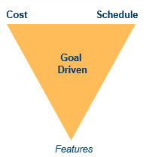

Figure - Agile Methodology – “Goal Driven”

### Advantages:

The advantages of agile software development are as follows:

* Flexible
* Adaptive
* Emergent roles
* Generative
* Minimal set of practices great communication as all stakeholder in regular meeting

## Standards & Tools:

Given below are the tools which are used for both development and debase management purpose:

### Application Development Tools:

* PHP fundamental language
* Html
* Java Scripts
* CSS
* DOC2TXT
* Cake PHP V-2.0

### For Database Management Tools:

* MYSQL

Communication Management

Communication Management is the effective management of communication in a project so that information can be transferred between the people in project effectively. It helps people involve in the project provide right information in a timely manner. It also ensures all the people involved in project are informed of the project status or project progress. There is always change in the need of stakeholders and dynamics of project communication. So, to deal with it, it is very important to understand the communication and its overall effect on the entire project.

Communication Matrix

Communication matrix is a table format document which helps to capture and communicate the results of the communication planning progress. It helps to demonstrates a table of responsibilities and can be simple or complex as needed. Below is shown the communication matrix for our project. We had four different types of Communication i.e. kickoff Meeting, Project Team Meetings, Software Design Meetings, Project Status Meetings, Project Status Reports. For the Kickoff Meeting, our medium was face to face and frequency was just once. The audience for this meeting was clients and project Team. Similarly, next Communication was Project Team Meetings. Audience involved was face to face and sometime Conference Call. Frequency of this meeting was weekly. Similarly there was other kind of communication like Software Design Meetings, Project Status Meetings and Project Status report.

|  |  |  |  |  |  |  |
| --- | --- | --- | --- | --- | --- | --- |
| **Communication Type** | **Objective of Communication** | **Medium** | **Frequency** | **Audience** | **Owner** | **Deliverable** |
| * Start off Meeting | * To Know about the project | * Face to Face | * Once | * clients * Project Team | * Project Manager | * Agenda * Meeting Minutes |
| * Project group Meetings with clients | * To know about the requirement for the project. | * Conference Call | * Once | * Project Team | * Project Manager | * Agenda * Meeting Minutes |
| * Project Progress report meeting | * To generate Project Progress Report | * Face to Face | * As Needed | * Project Team | * Project Manager | * Agenda * Meeting Minutes |
| * Project Presentation Meeting | * To discuss how the team will do the presentation | * Face to Face * Conference Call | * Once | * Project Team | * Project Manager | * Project Status Report |
| * Project final report meeting | * To discuss about the preparation for the final report. | * Email | * As needed | * Project Team * client | * Project Manager | * Project Status   Report |

Change Management

Change Management is the systematic way to dealing with change both from the perspective of an organization and the individual. It helps in achieving the desired behavioural outcomes and work toward achieving the common goal. Change management is very difficult to maintain. Change generally occurs in an organization for the following reason:

1. To remain competitive with the market
2. To improve the technology for the project
3. To improve the performance of the organization
4. To train the employee in an organization about new technology

There may be several resistances to the change in an organization. Like sometime people in an organization are afraid about change in an organization because of the fear of unknown. So proper change management process should be selected to manage change coming into an organization.

A change management process for out project looks like this:

1. Gain the information about the change
2. Assess the change like how much time is it needed to do the work going on
3. Prepare a recommendation about whether it is worth going ahead.
4. Then you get a decision from the project sponsor about whether you should incorporate the change or not.

Some method to effectively manage the change coming into an organization are:

1. Talk clearly about the change coming into organization
2. Share the Change Management Process
3. Make the process easy
4. Be there to help everybody involved in project.
5. Don’t be afraid to say no.

Risk Management

Risk Management is the process that includes risk assessment and a mitigation strategy for those risks. In risk assessment, it involves identifying potential risk and evaluation of the potential impact of the risk. Risk mitigation generally refers to the plan designed to eliminate or minimize the impact of the risk. There may be several risk involved in the project. So, analyzing all the possible risk in the beginning and testing the feasibility of the report would help us in managing risk.

Some of the important reason for risk management are:

1. Identify possible risk
2. Reduce or allocate risk
3. Provides a rational basis for better decision making in regards to all risk.
4. Plan

Risk Analysis Process

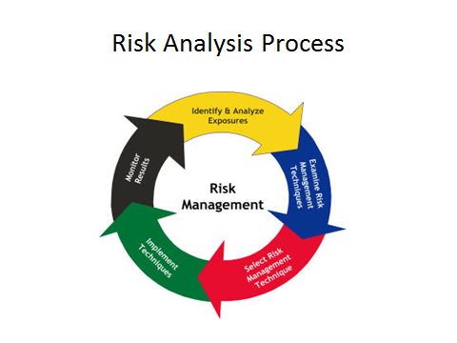

The above figure shows the Risk Analysis Process. First we, Identify and analyse the risk, then we examine the risk management technique for mitigating the risk. After examining the technique, we select the appropriate risk management technique and at last implement the technique. Then we monitor the result obtain from the process. This process goes on cycle and at every iteration we get the feedback from the process.

Risk Mitigation

Risk can be mitigated by the project in following ways:

1. Risk Avoidance
2. Risk Sharing
3. Risk Reduction
4. Risk Transfer

Quality Assurance

Quality Assurance is an activity and management processes that are done to ensure that the products and services the project delivers are at the required quality level.A quality assurance will be an document, constructed toward the one task team, intended to guarantee the last items are of the most extreme personal satisfaction. A quality assurance arrange holds an situated from claiming archived exercises intended to guarantee that clients are fulfilled by those merchandise or administrations an organization gives. There need aid four steps of the nature certification process: Plan, Do, Check, Furthermore act. The centering from claiming this article will be on the thing that things try under anquality assurance. Quality assurance document ought characterize objectives, parts Furthermore responsibilities, direction with different plans, and define assignments and the calendar.

The tools that we have used for quality assurance is CMMI Method.

Capability Maturity Model(CMMI)

It is a model developed by the software engineering institute, part of Carnegie, Mellon University in pittsburgh, USA. It can be used to guide process improvement across a project, a division or an entire organization.

It provides:

1. A standard for implementing Process
2. 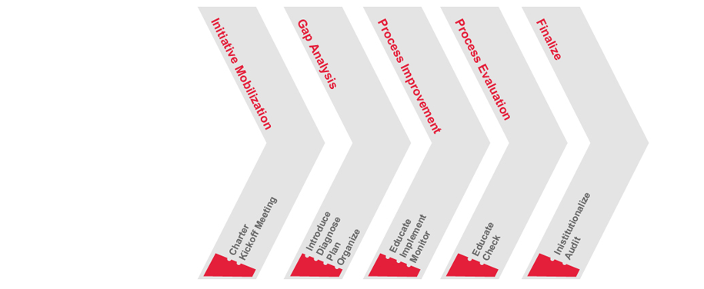An integrated approach to process improvement
3. A phases approach to introducing improvement

The above figure shows the CMMI Process diagram.

Project Evaluation Plan

Project Evaluation Plan is an document that adopts a systematic way for managing sequence of activities for analyzing and examining the project by certain education criteria. It aims to determine the project effectiveness and efficiency through tracking progress on each objective, completion of activites and dates of completion.

Guidelines for project Evaluation

1. Identify outcome and impact
2. Choose Evaluation Method
3. Report on the Evaluation

# Project Planning

This great section introduces project planning details such as Work Breakdown Structure (WBS), Resource Allocation, Time line, Gantt Chart and Management of Critical Activities. Work breakdown structure introduces hierarchy and relationship between MACS technology and Application Tracking System (ATS) project team. Resource Allocation introduces who are going to take responsibility for each team. Time line and Gantt Chart shows how project progresses in from start to end. In this report, mainly introduces implementation section of ATS. At the end, management of critical activities indicates how to manage activities during implementation. Implementation of ATS expects some technical difficulties while the project, therefore meaning of the section is significant.

# Work breakdown Structure (WBS)

This section introduces Work breakdown Structure (WBS) for ATS. Diagram of WBS is shown below.

Diagram: WBS for ATS Project

WBS and hierarchy for ATS is simple. On the top, MACS Technology is set as the client of this project. Then, Supervisor who is from the Federation University stays above of the project team member. The role of supervisor looking after project team and provides appropriate support for the management and running of the project. Therefore, supervisor is not positioned as direct manager of the project team. On the bottom, there are five project members of the ATS developing team. Hideaki Kobayashi is the team leader of this project. Then, Shankar is sub-leader of the team. This is because those two members have certain experience in the development of software in professional situation. Also, those experiences are fitted for most of requirements of the ATS. On the other hand, all the member of the project works as programmer and designer. Therefore, there is no hierarchy among the team. From this reason, WBS in the development team is flat and share same level of hierarchy.

# Resource Allocation

This section introduces Resource Allocation. Resource allocation for this project is simple. Main role of the team members are shown with below table.

|  |  |
| --- | --- |
| Name | Role |
| Hideaki | Team Leader  System design, Core system Programming, Database Design |
| Shankar | Sub Leader  System design, Core System programming, Database Design |
| Fahad | User Interface Programming, Sub system programming |
| Gyanendra | User Interface Programming, Sub system programming |
| Salil | User Interface Programming, Sub system programming |

For this project, most of team members have similar roles and responsibilities.

Hideaki and Shankar have experience in software development projects in their carrier. From this point, those two members take over the role of designing and planning of the ATS system such as screen transition, data flow and breakdown of requirements for individual modules and functions. Also they conduct core system programming and database design as well. The main programming language for those two members is PHP and MySQL.

Fahad, Gyanendra and Salil take responsibilities of user interface programming and sub system programming. Those three members conduct development of web page as user interface by coding combination of PHP, HTML and CSS. Also, they conduct some units and functions which is required in ATS core system as well such as data validation, access control and data processing.

# Timeline and Gantt Chart

This section introduces timeline and Gantt chart from start to end of the project. There are two individual chunks of tasks in all project time line. The first section is planning phase of the ATS, then the second section is developing phase of the ATS.

The first Phase

During the first phase, this is from July 2017 to October 2017. During this period, the project process planning of the ATS. There are three milestones and each milestone has certain artefacts. Project charter provides all consensus between not only team members but also the clients. About that time, the team had Skype meeting with the client. In this meeting, all team members understood the client situation and what is needed for the software. Reflect from the meeting, Project Progress report and Final report is issued. In the Project Progress report, some researchers are conducted by the develop team member which regards environment and implementation of Applicant Tracking System. Some of them mention about case study of system requirements. From those researches, the team has certain visual of the ATS for implementation. In the Final report, the team formalize timeline of development, role and critical activity of the development.

Middle break

For this project, there is middle break which is due to academic schedule. In this period, the development team members conduct studies and practice that relates to implementation of the ATS. In the detail, learning of Web Application Framework and combination of HTML, CSS and Javascript.

The second Phase

The second phase is implementation of ATS. It starts from March 2018 and will finish in end of May 2018. The 1st of June 2018, ATS will be released and demonstrated for the client and supervisor. During the development period, three reports will be issued from the development team. Those three reports are development progress report.

For list of items and artefacts, please refer appendix.

Gantt Chart

This section introduces Gantt Chart of the development phase of ATS. Especially this section steps into details of Phase2 of development.

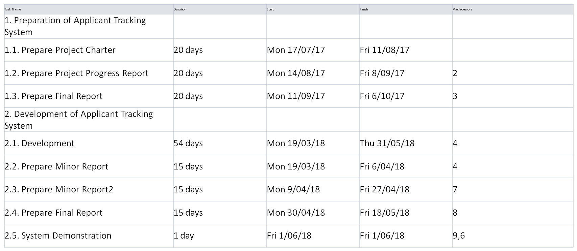

Diagram: Table of actions

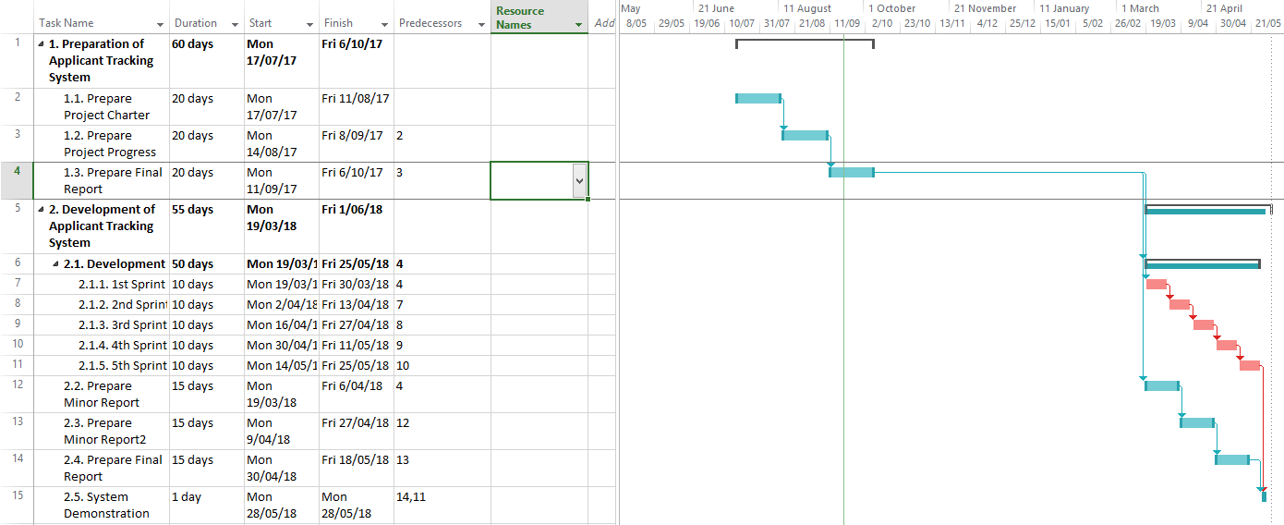

Diagram: Gantt Chart of Phase 1 to 2

For the second phase of ATS development, implementation of actual system will be held. All five members will stick to development environment. In this project, Agile methodology is adopted. Therefore, during the programming period, there are five sprint period is planned. In each development sprint, system implement and improving towards final grand image of the ATS. Also, in each development sprint, communication between client will become active for the client desired system. Those actions are core of Agile development methodology. Therefore, the client and the team should be well communicate each other. From those small and certain communication between the client and the development team, system gradually sophisticated and ready for release. This sprint development and preparation of three progress reports are done in parallel.

# Management of Critical activities

The last section of project planning is management of critical activities. Implementation of ATS is a kind of big project. Many modules and pages are corresponds each other. From those points, each development sprint during phase 2 is explicitly critical. Also, development phase continues around three months, therefore, certain strategies are required for smooth implementation and release. For such critical tasks three big strategies are prepared such as task management, coverage of task and communication.

Task management

The first point is task management. ATS is very big project, therefore so many tasks are hidden before each dead line of sprint. Therefore, if divide the task into very big chunk, project members might be lost their self in the middle of big task. The most expected question in such situation is "This task is what is for?". Therefore, team leader and sub leader divide chunk of big task into small and simple docket. From this action, all team members easy to take action and finish the task in quick. This affects motivation and implementation speed for next task more faster.

Coverage of the Tasks

The second point is coverage of the tasks. As mentioned at above, ATS is very big project, therefore, many modules should be implemented into the system. In other words, programmers should write so many source codes and files into. The development team consists from five member of software engineer students. Those five students have certain programming skills. Also, programming environment which will be used in this project is simple and easy to get used to. From these points, if someone has difficulty in implementation, other team members are easy to support task. Also, from above task management system, transfer of individual tasks are quite easy. Therefore, the development team can keep high developing speed in the Agile development.

Communication

The last point is communication. This is one of the fundamental of team management. In the phase 1, through strong communication tools, the team has enough level of amount and quality of communication. From this point, good communication has better consequence in team management. For phase 2, development of big software is challenge for all team members. Especially when team members encounter some problem or difficulties in the coding, level of stress might be very high. Therefore, all the team members need to share their status without hesitate or depression. In short, clear and assertive communication helps not only team members but also helps entire project as well.

# Analysis of Client’s Requirement:

In this section introduction and development of requirements for application tracking system is shown. The various requirements according to the clients are highlighted as follows:

* High Level Requirements
* Low Level Requirements
* Analysis of the system service
* System Modelling
* Requirement traceability

From above analysis we can get the real view of the application tracking system.

## High Level Requirements:

It will make the clear view of those functional and non-functional requirements of the application tracking system. When we interviewed with our client on video chatting in Skype, the client introduced us about two phases of the system functionality like candidate collection and introduction of job. For, the first phase we need to collect resumes from the candidates. In the second phase, we need to open various job opportunities for those candidates. According to those requirements in this section we will introduce functional and non-functional requirements for these two phases separately.

## First Phase-Documentation Management:

It is the first phase of Application Management System. Functional and Non-functional requirement for this phase can be highlighted as follows:

### Functional Requirement:

Those requirements which shows the functional behaviour of the system are functional requirements. (TutorialsPoint, 2017) Functional Requirement is the one which defines the functionality of a system or one of its subsystem. It may also be categorised as high-level or low-level. According to the client’s requirement we have collected some of the most important functional requirements which are enlisted as follows:

1. First and foremost, thing we need to retrieve the document files. Input from users should be directed.
2. The inputs given by the users should be pursued and saved into database as a record.
3. All those uploaded records must be listed.
4. Details of the record must be shown.
5. The details of a record must be shown and made editable.
6. There should be the provision to delete a record.

Non-Functional Requirement:

(Gilberte, 2011) Non-functional requirements help us to describe how the system works. As per the requirement of the client some of the non-functional requirements are highlighted as follows:

1. The first phase of the system which is document management system works on the webserver.
2. The uploading port to retrieve the document is on website.
3. Only public access for the applicant is granted only to upload resumes and search jobs which are enlisted.
4. For other part, access control is implemented by login ID and password for other least of pages.
5. To know the status of the applicant a tracking indicator is implemented.

## Second Phase-Job Advertisement System:

As per the client requirement he has requested it to be the second phase which is job advertisement. In this section the client wants to show the jobs that are available and allow the applicant to search for it and apply for the vacancies. For this phase also, we have got the functional and non-functional requirement which are enlisted as follows:

### Functional requirement:

Various functional requirement for this phase which will describe what the system must do can be highlighted as follows:

1. After the creation of job position, it must be saved as a record in database.
2. There should be the provision for creating, viewing detail, editing detail, and deleting of the job position record from the system.
3. The status of job position record can be done only by the manager.
4. Public opening of position record is allowed.

### Non-Functional requirement:

This part describes how the job advertisement system works. Those non-functional requirements are highlighted as follows:

1. Implementation of accessing the function is done by access control except for public opening page.
2. The status of job record must be shown as open, close, decision pending.
3. The job advertisement system is working on web server.
4. All the operations that are occurring for job advertisement is through the web server.

## Low level requirement:

For low level requirements, this part will look over each component which will provide service for high level requirement.

### The First phase

* File uploading Function:
  + It will deal with the file upload user interface.
  + It also deals with file validation components.
* Parsing Function
  + File opening function
  + Function for parsing the contents.
* User interface for viewing those applicants.
  + Listing- Those applicants who have applied for the job should be listed and recorded.
  + Details- Those applicants details such as their resumes, job specification should be recorded.
* Database function for candidate
  + Record should be saved.
  + Record is to be read.
  + There should be the provision for editing/updating a record.
  + There should be the facility for deleting.
* Functions are to be exported.
* Function for user authentication.

### Second Phase:

* Authenticating user function.
* Job functions for database.
  + Records should be saved.
  + Record should be saved.
  + Record should be edited/updated.
  + Deleting a record.
* View user interface for different job positions:
  + All the job positions should be listed.
  + Details of the job positions should be shown.
  + There should be public access to the page for the applicants for those applying job.

## Analysis:

In this section analysis above, high level and low-level requirements and clarify goal, scope and different constraints of application tracking system. In the previous section, functionality of application tracking system was discussed. It is all due to different functionality and requirements of the clients. After this section, the report will integrate both first phase and second phase. After integration this will both phases as automation job and lead to management system of candidate processing.

### Goals of System:

The goal of this system is automation of candidate process and job opportunity advertisements. Therefore, this system has two different functions such as candidate process management and management of advertising job.

### Scope:

In this section we will discuss in and out of scope of Application Tracking System. In scope section will deal about what system will provide whereas out scope will provide what system will not support.

#### In-Scope:

This section will improve applicant process. It will also improve the automation of the whole process and reduce the paper works. All these scopes are closely inter-related to each other.

After the implementation of Application Tracking System, all the information of applicants is summarized in system. These information about applicants is shared by the staffs of human resources and are communicated all over wherever required. When it comes to new applicant who is going to be registered in the system, the applicant is put on top of the list. This listing will help the client for not missing the new applicant. After staffing process is completed the system is automatically following the application process. With the help of these actions, the system will provide a notification to the related person for updating the information. It will help the staff to know about where the applicant is in and what is the progress for those applicants. This is automated process which will provide more effective and faster process of hiring.

Going on to the next, this system is designed to reduce the paper works in applicant hiring process. It will provide online information of applicant and update automatically. This will lead the team members not make a print out and make updates on applicants’ status time and again online. With the integration of this feature it will help to reduce the time and paper work of the clients.

#### Out-Scope:

While going through this section, opportunity for applicant and improvement for quality is noticed. The system provides the enhancement of ability while we consider about the basis of application tracking system. Moving on to the next, the system necessarily does not provide increasing job opportunity as it does not have automatic retrieving function from job opportunity site or user interface for posting the positioning of job. The guarantee to improve the quality of applicant is not done by the application tracking system. The system is not able to separate the level of applicant while parsing the resume uploaded by the applicant. So, all the input from inside and outside the MACS Technology should be approved and stored in the database.

### Constraint Related to the System:

It will introduce different constraint involved in Application Tracking System. Some of the constraints related to Application Tracking System are highlighted as follows:

The system works on the web server

* The system we are working on is based on web server.
* The programming language related to mail is PHP, MySQL, HTML,  
  JavaScript and CSS. PHP is used for backend of the system. MySQL is used for using the database whereas CSS works with the design layout of the system.
* The timeframe which we are allotted to finish the project is around three months.
* Open Source Software(OpenSource.com, 2017) is one of the software which can be easily inspected, modified, and enhanced whenever needed. And our system development is on Open Source Software or license free software.
* CakePHP one of the most import MVC (Model-View Controller) is supposed to be used for Web Application Framework for this project.

## Modelling:

In this section we will introduce about the modelling of Application Transition System with the help of Use Case Diagram, UML Diagram and DFD model.

Use Case Diagram:

(Rouse, 2015) The graphic representation of interaction between various actors and the system which get involved is known as Use Case Diagram. It can be also thought of as a methodology for analysing to identify, clarify and organising system requirements. For our case the system is “Application Tracking System”. They are one of the most important standard notation for modelling of real-world objects and systems. Use case diagram in our system will include resume uploading, recording into database, updating the jobs. Generally, use case diagram can contain four components which are highlighted as follows:

* Boundary: It defines the system of interest which is related to the world around it.
* Actors: Individuals who are involved with the system and are working accordingly.
* Use Cases: These represents the specific roles associated with the actors with in system and around the system.
* Relationship: It represents various relationships between actors and use cases associated with the system.

In Use Case Diagram, we should show two sides for the view. The first side will be used by applicant. From applicant side they will be only allowed to use the function to view different jobs, upload their resumes if possible can make their own account. For the second side it is for MACs Technology who will be using the Application Tracking System. They can use all the functions of Application Tracking System such as they can view, edit delete the applicant list.

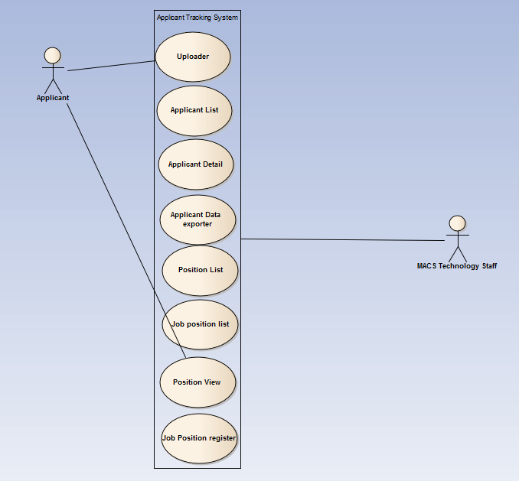

Figure: Use Case Diagram for Application Tracking System

UML(Unified Modelling Language):

(SmartDraw, 2017) It is one of the way to visualize the programs of a software. It uses various diagrams to do so. Modelling of the UML starts with showing the relationships between each of the functions. Looking to Application Tracking System, resume uploading function will use resume parsing function. All these things need to be stored in database with database driver. The applicant function will be there to provide list, view, edit and delete for users with database driver. Moving on to Job position information system which is independent from Application Tracking System, it provides information to expose to public. Following figure demonstrate the information to expose to public which is “open_JobPosition”.

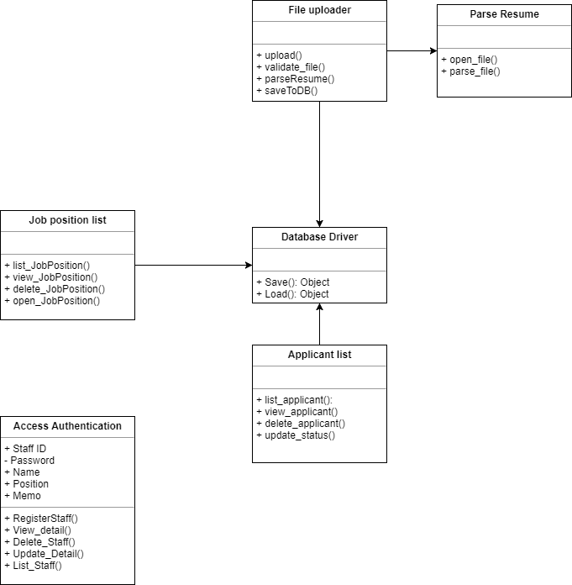

Figure: UML model for ATS (Application Tracking System)

## Requirement Traceability:

(Management.com, 2017) A tool which helps to ensure project’s scope, requirements and deliverables are found to be same as it must be after comparing to baseline can be termed as Requirement Traceability Matrix. It traces the deliverables by establishing a thread to each of individual requirement from the very beginning to implementation of the project. It can be used in all the phases of a project for tracking all requirements and to check whether they are fulfilled by the ongoing process and design. It also provides help in creating RFP, Project Plan Tasks, Deliverable Documents along with Test Scripts. It helps to ensure that all systems requirements are being met while we are verifying the product.

For our project, requirements of clients are at utmost priority. For implementing how to fulfil the requirement the excel format of requirement traceability is used. A part from this requirement traceability matrix is shown below:

## Requirements Traceability Matrix detail

|  |  |  |  |  |  |
| --- | --- | --- | --- | --- | --- |
| REQUIREMENTS TRACEABILITY MATRIX | | | | | |
| Project Name: Applicant Tracking System | | | | | |
| Business Requirements | | Functional Requirements | |  | Test Case Document |
| Business Requirement ID# | Name | Functional Requirement ID# | Name | Priority | Test Case ID# |
| BR_1 | Uploading Resume | FR_1 | Uploading User Interface | Medium | TC_1 |
|  |  | FR_2 | Validate Uploaded File | High | TC_2 |
|  |  | FR_3 | Parse Resume | High | TC_3 |
|  |  | FR_4 | Save to Database | High | TC_4 |
| BR_2 | Parse Resume | FR_5 | Receive File | High | TC_5 |
|  |  | FR_6 | Open File | High | TC_6 |
|  |  | FR_7 | Parse File | High | TC_7 |
| BR_3 | Applicant List | FR_8 | List all Applicant | High | TC_8 |
|  |  | FR_9 | View applicant detail | High | TC_9 |
|  |  | FR_10 | delete applicant | High | TC_10 |
|  |  | FR_11 | update status | High | TC_11 |
| BR_4 | Job position List | FR_12 | List all Job position | High | TC_12 |
|  |  | FR_13 | View job position detail | High | TC_13 |
|  |  | FR_14 | delete job position | High | TC_14 |
|  |  | FR_15 | public view of position | High | TC_15 |
| BR_5 | Authentication | FR_16 | Register Staff | High | TC_16 |
|  |  | FR_17 | Detail of Staff | High | TC_17 |
|  |  | FR_18 | Delete of Staff | High | TC_18 |
|  |  | FR_19 | Update of Staff Detail | High | TC_19 |
|  |  | FR_20 | List of Staff | High | TC_20 |

Data Flow Diagram(DFD):

(BusinessDictionary, 2017) Data Flow Diagram is a graphical representation which explains about the data processing and transferring within a system. It helps to define different source of data and its interaction with other required data to reach a desired output. To define the Data Flow diagram an individual should identify related external inputs and outputs. Also, one must be able to define the interrelationship between input and outputs. Data Flow Diagram can provide a guidance to business development and design team to visualize about processing data and identifying or improving certain aspects.

DFD (Data Flow Diagram) for our system has been draw below simply:

Applicant

Filters out the resumes

Searches for job

Applies uploading

Resumes

Profile created

Saves resumes Announces job vacancy

Database

Macs Technology

Figure: DFD of Application Tracking System

Retrospective Review of Project

In conclusion, there were a lot of benefits from doing the project. We had some difficulities in our way on doing the project as well.

Some of the things that went very well in our project are:

1. Group Coordination
2. Teamwork
3. Regular help by the project supervisor
4. Developing skills

Some of the challenges that we faced doing the project were:

1. Lack of resources for doing the project
2. Difficulty in finding out the project
3. Very few interaction with the client
4. Lack of communication

Similarly, we learn a lot of lesson from this project. First we learnt how to work in a team. We also learnt the practical implementation of Microsoft project for creating timeline and ganttchart.Similarly we also had some knowledge on use case diagram.At last, we learnt that communication is very important for effective project management.

# Report Approval

|  |  |  |
| --- | --- | --- |
| Name | Institute | Signiture |
| Paul Kaduim | MACS Technology Pty Ltd |  |
| Ahmad Nadeem Saeed | The Federation university |  |
| Fahad Kalhoro | The Federation university |  |
| Hideaki Kobayashi | The Federation university |  |
| Gyanendra Poudel | The Federation university |  |
| Salil Koirala | The Federation university |  |
| Shankar Pandey | The Federation university |  |

# References

change management. (2015, 04 05). Retrieved 09 26, 2017, from searchcio.techtarget.com: http://searchcio.techtarget.com/definition/change-management

Comprehensive Guide to Agile. (2015, 1 23). Retrieved from www.sartsheet.com: https://www.smartsheet.com/comprehensive-guide-values-principles-agile-manifesto

IBM Security . (2010, 11 12). Retrieved from www.ibm.com: https://www.ibm.com/security/announce/agile3/?S_PKG=-&cm_mmc=Search_Google-_-Security_Identify+and++protect+sensitive+data-_-WW_ANZ-_-+agile_Broad_-&cm_mmca1=000000MU&cm_mmca2=10006467&cm_mmca7=9071791&cm_mmca8=kwd-297273983021&cm_mmca9=2ef9e5c6-4a28-44bc

Martinez, M. (n.d.). what is quality assurance. Retrieved 09 26, 2017, from www.project-management-skills.com: http://www.project-management-skills.com/what-is-quality-assurance.html

Scheid, J. (2011, 02 13). Bright Hub Project Management . Retrieved from SMART GOALS in Project: www.brighthubpm.com/project-planning/26374-smart-goals-in-project-management/

Stanleigh, M. (n.d.). risk management the what why and how. Retrieved 09 26, 2017, from bia.ca: https://bia.ca/risk-management-the-what-why-and-how/

Poudel,Gyanendra.2017. Agile Methodologies. Unpublished menu script,Project1,IIBIT,Australia.

Appendix

Diagram: Timeline



Diagram: GanttChart



List of Items with Deadline

* The first Phase
  + 13/Aug: Project Charter
  + Skype Meeting
  + 10/Sep: Project Progress Report
  + 8/Oct: Final Report
* Summer break
  + Individual Studies
* The second phase
  + 19/Mar: Start development
  + 6/April: Minor Report 1
  + 27/April: Minor Report 2
  + 18/May: Report
  + 1/June: System demonstration