Briscola Online

**Briscola**

Tihana Britvić, Mia Filić, Valentin Hidasi, Leon Makorič

Ljubljana, 2. november 2016

Project summary

The main goal of the project is to get a functional website, which offers users an easy, simple and modern way to play traditional, regional oriented, card game Briscola. For this, a Web site will be implemented using web technologies through the front-end and back-end system, where users can play against one another or against an AI without registration or quickly and easily learn how to play.

The project is divided into 5 key points that will be distributed among the members of the development group. Development will be carried out simultaneously, always taking into account the work done by the others and a joint decision-making.

For all of this, we will use a platform of shared development GitHub and meet regularly, in addition to constant online communication.

Work will be divided into equal parts and assigned to the developers according to their skills and knowledge, always taking into account their objectives.

Content

Greška: Referentni izvor nije nađen

Greška: Referentni izvor nije nađen

Greška: Referentni izvor nije nađen

Problem description and the suggested solution Greška: Referentni izvor nije nađen

Project goals and expected results Greška: Referentni izvor nije nađen

Greška: Referentni izvor nije nađen

Greška: Referentni izvor nije nađen

Greška: Referentni izvor nije nađen

Greška: Referentni izvor nije nađen

Greška: Referentni izvor nije nađen

Greška: Referentni izvor nije nađen

Greška: Referentni izvor nije nađen

Greška: Referentni izvor nije nađen

Greška: Referentni izvor nije nađen

24

Greška: Referentni izvor nije nađen

Greška: Referentni izvor nije nađen

Greška: Referentni izvor nije nađen

30

Greška: Referentni izvor nije nađen

Motivation

There is no point in denying that the world we are living in has become digital. You can shop for clothes, furniture, order food. Books became ebooks, phones became smartphones. Practically everything has its online version. Including ourselvs. We make online profiles on social networks, we put pictures of our friends, families, activities etc. Everything is online and more important everybody. Since people nowadays spend a huge amount of time online socializing, studying, shopping, entertaining, we decided to make a contribution in this. Since we were children we loved to play Briscola. It is a card game that was traditionally passed on us buy our families and friends. To preserve this tradition we decided to make an online version of this wonderful game.

Problem description and the suggeted solution

We have divided into 5 small challenges:

1. we are implementing one player versus another (1v1)

2. we are implementing a player versus AI player

3. we are making ''Learn how to play Briscola'' video

4. implementing all together

Since the Briscola is a card game which all of us have played while we were young, we decided to create a fun version of the tutorial. There is no way to preserve this wonderful game with a boring tutorial. We will design a video in which we will explain every step of the decision making while playing Briscola.

Most of Briscolas online versions have one option: player versus AI. Searching a bit more you can come across multiplayer versions. The most of pages do not have integrated more than one Briscola playing version. That make us special. We will create something that is new and contains a lot of elements that are usually divided into several applications.

Also, our approach to ''Learning how to play Briscola'' is differrent in a way that makes it fun. Most of the other sumilar applications poorly explain the rules through lines and lines of text. We all know how that can be inefficient.

Next advantage we are going to have is a registration free website. Nowadays, almost every web- applications requires a registration, information which users are tired of giving. That is why we are creating this registration/login free website.

We are providing simple solutions to all of 5 problems in one.

With all of these advantages and modern and fresh approach we believe that more and more people are going to use our application. Also, since it is extremely simple and low key, it provides a really good background for turning it into desktop or mobile application someday.

One of the biggest risks of our project is the Schedule Risk. What happens if we do not address schedule properly? In other words, if we miscounted the time of work we need per product and therefore the time we need for the project in whole?

Then we are facing resources not tracked properly (staff, systems, skills of individuals etc). We decided to split work based on our skills. What if someone overestimated their skills? What if they need to use a software that is not inside the budget and do not know another way for finishing their part?

Also,what if we face a failure of not having enough investments? For example, one of our team members needs a software and another one needs a new computer to run their software. There is a big risk of not having investments and eventually money to buy it.

Another example of budget risk comes directly from this. Let say we buy a new software and a new computer but miscounted the rest of costs. We are left with empty budget and still have costs to cover.

The risk of having people sick or injured is a pretty big and real problem. In a case of this risk, our schedule changes, the working hours of other team members are being longer. We may even not finish the work until the deadline.

Finally, we are always facing Operational risks. This is what happens when if have no resource planning, not good communication in the team, failure to resolve our individual responsibilities, etc.

Our solution to all of these coming ahead risks is to be prepared for them. We are very careful with our costs, we have communication on daily, and video conference on weekly basis. We are divided into groups so that every team member has its backup. The rest of the team can handle the missing member duties.

Project goals and expected results

Goal description

The purpose of this project is to help preserve a traditional card game by digitalizing it. The goal is a funcitonal web application that enables anyone with a mobile device or computer and access to internet to play the traditional card game Briscola. This project should acheive more people playing Briscola as they do not have to buy a physical copy of the deck and do not need to find groups of people near them to play with. They are also able to play whenever they want with no planning ahead. In the case that person has only a few minutes of free time, he is not able to play a trick as he has, at first, to find people to play with. With our application, however, person simply has to click play.

Expected result

The concrete expected result is a functional web page/application.

It will containe a tutorial for teaching users how to play Briscola, a short version of the game's history, a play mode where the user will be able to select whether to play two-player game online, with another user who will be selected using FIFS matchmaking system, or against the AI opponent. The history part is for users that are interested in learning more about the game, and AI part is for the users who want to practice or chalenge themselfs at any time. It will also have an 'about us' page in case that the user wishes to contact us. The web application/page will be done using HTML5, CSS3, Javascript and PHP. It will use the standard frontend/backend approach. It will be useable by most, if not all, modern mobile phones and desktop computers with any OS as all that is required is a web browser that supports currently used technologies and an internet connection.

Project plan

Introduction/general description

The workplan consists of 3 phases each having many tasks in order to simplify developement.

Overlook of phases and activities

The first phase is precoding phase where is to decide on product specifications, project risk management, do the training in information design,do the tutorial developement and front end (webpage) design.

The second phase is coding phase where is to do the following: front-end coding (webpage), testing and bugfixing the front end code, developement of game 1v1 logic (two-players game logic), testing and bugfixing the game 1v1 logic, back-end coding (matchmaking system), testing and bugfixing the back-end code, developing AI for the game, testing and bugfixing the AI, general testing and bugfixing, integration of all elements (backend, frontend, logic), testing and bugfixing integration.

The third phase is the finish phase where we write the neccessary documentation, design the final presentation and practice presenting it.

Description of activities

|  |  |  |  |  |  |  |  |
| --- | --- | --- | --- | --- | --- | --- | --- |
| **Table of activities** | | | | | | | |
| **Activity mark:** | **A1** | **Beginning date** | **3.11.2016** | **End date** | **8.11.2016** | **Duration** | **6 days** |
| **Activity title:** | **Project specification** | | | | | **Activity scope** | **0,13 PM** |
| **Goals** | | | | | | | |
| * Concept of the final product * Create detailed project proposal * Definition of basic requirements | | | | | | | |
| **Activity description** | | | | | | | |
| Members of the group will specify the details of the project outcome. This phase will be followed by the process of defining the architectural needs of the product and lay down the primary foundation of such an architecture. It means declaring the used technologies, platforms also development tools and platforms. | | | | | | | |
| **Dependencies and limitations** | | | | | | | |
| Activity A1 is a first activity in the project and has no dependencies. This activity is on the critical path. | | | | | | | |
| **Results** | | | | | | | |
| Requirements specification, project proposal | | | | | | | |

|  |  |  |  |  |  |  |  |
| --- | --- | --- | --- | --- | --- | --- | --- |
| **Table of activities** | | | | | | | |
| **Activity mark:** | **A2** | **Beginning date** | **3.11.2016** | **End date** | **7.11.2016** | **Duration** | **5** |
| **Activity title:** | **Project management, risk management** | | | | | **Activity scope** | **0,1 PM** |
| **Goals** | | | | | | | |
| 1. Create project management plan 2. Create risk management plan | | | | | | | |
| **Activity description** | | | | | | | |
| Members of the group will discuss the methods to manage the proposed project effectively. The will develop startegies for communication, collaboration and means of shared work processes. Also these discussions will include a subprocess of collecting risks, afterwards these risks will be evaluated and analyzed by one of the group members. | | | | | | | |
| **Dependencies and limitations** | | | | | | | |
| Activity A2 has no dependencies. | | | | | | | |
| **Results** | | | | | | | |
| Part of project proposal, effective means of project management | | | | | | | |

|  |  |  |  |  |  |  |  |
| --- | --- | --- | --- | --- | --- | --- | --- |
| **Table of activities** | | | | | | | |
| **Activity mark:** | **A3** | **Beginning date** | **9.11.2016** | **End date** | **13.11.2016** | **Duration** | **5** |
| **Activity title:** | **Training in information design** | | | | | **Activity scope** | **0,1 PM** |
| **Goals** | | | | | | | |
| * Learn the fundamentals * Aquire sufficient knowledge to influence the product toward succession | | | | | | | |
| **Activity description** | | | | | | | |
| During the activity members will undergo a self-study induced training in the field of information design. One member need to get a general understanding on information design, futhermore get to know the aspect of the field that will be useful afterwards in the forthcoming phases of the project. | | | | | | | |
| **Dependencies and limitations** | | | | | | | |
| Activity A3 following directly the activities A1 and A2. This activity is on the critical path. | | | | | | | |
| **Results** | | | | | | | |
| Improved staff knowledge on information design. | | | | | | | |

|  |  |  |  |  |  |  |  |
| --- | --- | --- | --- | --- | --- | --- | --- |
| **Table of activities** | | | | | | | |
| **Activity mark:** | **A4** | **Beginning date** | **14.11.2016** | **End date** | **18.11.2016** | **Duration** | **5** |
| **Activity title:** | **Information design** | | | | | **Activity scope** | **0,1 PM** |
| **Goals** | | | | | | | |
| * Lay down global information design principles * Construct product's information design * Modify the list of used technologies and development tools | | | | | | | |
| **Activity description** | | | | | | | |
| Member of the project meet to create the foundation of the project's information design. The main problem to solve is how to design the product to attract more users, develop and choose proper methods to ensure user engagement with the final product. According to the previous subprocess create the information flow and expand the products toward the desired outcome. | | | | | | | |
| **Dependencies and limitations** | | | | | | | |
| Activity A4 following directly the activity A3. This activity is on the critical path. | | | | | | | |
| **Results** | | | | | | | |
| The information flow. | | | | | | | |

|  |  |  |  |  |  |  |  |  |  |  |  |  |  |  |  |  |
| --- | --- | --- | --- | --- | --- | --- | --- | --- | --- | --- | --- | --- | --- | --- | --- | --- |
| **Table of activities** | | | | | | | | | | | | | | | | |
| **Activity mark:** | **A5** | | **Beginning date** | | **9.11.2016** | | **End date** | | **13.11.2016** | | | | **Duration** | | | **5** |
| **Activity title:** | **Tutorial development** | | | | | | | | | | | | **Activity scope** | | | **0,1 PM** |
| **Goals** | | | | | | | | | | | | | | | | |
| * Make a detailed plan for the tutorial * Implement the defined introduction * Test the resulting subproduct * 'Learn to play should' be fun and detailed | | | | | | | | | | | | | | | | |
| **Activity description** | | | | | | | | | | | | | | | | |
| During plannig, implementation and testing the team focuses to make this process result comprehensive and informative. The actions taken are to choose a proper environment for the tutorial, determine it's depth, make a linear eventline in consideration of the essence of the subproduct purpose. Implementation and testing follows the design process. | | | | | | | | | | | | | | | | |
| **Dependencies and limitations** | | | | | | | | | | | | | | | | |
| Activity A5 following directly the activities A1 and A2. | | | | | | | | | | | | | | | | |
| **Results** | | | | | | | | | | | | | | | | |
| Tutorial | | | | | | | | | | | | | | | | |
| **Table of activities** | | | | | | | | | | | | | | | | |
| **Activity mark:** | | **A6** | | **Beginning date** | | **19.11.2016** | | **End date** | | **26.11.2016** | | **Duration** | | | **8 Days** | |
| **Activity title:** | | Front-end design | | | | | | | | | **Activity scope** | | | 0,17 **PM** | | |
| **Goals** | | | | | | | | | | | | | | | | |
| * Designing the webpage without functional game-logic | | | | | | | | | | | | | | | | |
| **Activity description** | | | | | | | | | | | | | | | | |
| Front-end design includes deciding which technologies to use (html5, css3, javascript) and which tools to use (software for coding etc.) in order to develop front-end. The most important part is to decide on the design of the pages in order to enhance the user experience and make them more likely to continue to use our application. Decision involves the decision on text font, text size, page background, menu, menu animations and so on – essentially everything visual that the user will see. | | | | | | | | | | | | | | | | |
| **Dependencies and limitations** | | | | | | | | | | | | | | | | |
| A6 depends on A4 and A5. | | | | | | | | | | | | | | | | |
| **Results** | | | | | | | | | | | | | | | | |
| Wireframes. | | | | | | | | | | | | | | | | |

|  |  |  |  |  |  |  |  |  |  |
| --- | --- | --- | --- | --- | --- | --- | --- | --- | --- |
| **Table of activities** | | | | | | | | | |
| **Activity mark:** | **A7** | **Beginning date** | **27.11.2016** | **End date** | **6.12.2016** | | **Duration** | | **10 Days** |
| **Activity title:** | Front-end deployment | | | | | **Activity scope** | | 0,21 **PM** | |
| **Goals** | | | | | | | | | |
| * Deploying the webpages | | | | | | | | | |
| **Activity description** | | | | | | | | | |
| Front-end deployment ,essentially ,delivers our product (in this case, a website) to the end user. It includes transfering the decided design, created in A6, into the the html5, css3, javascript code. | | | | | | | | | |
| **Dependencies and limitations** | | | | | | | | | |
| A7 is directly preceeded by A6. | | | | | | | | | |
| **Results** | | | | | | | | | |
| Webpages, front-end. | | | | | | | | | |

|  |  |  |  |  |  |  |  |  |  |
| --- | --- | --- | --- | --- | --- | --- | --- | --- | --- |
| **Table of activities** | | | | | | | | | |
| **Activity mark:** | **A8** | **Beginning date** | **7.12.2016** | **End date** | **11.12.2016** | | **Duration** | | **5 Days** |
| **Activity title:** | Testing, error handling and reparing | | | | | **Activity scope** | | 0,1 **PM** | |
| **Goals** | | | | | | | | | |
| * Determination of web pages errors and bugs * Handling predeterminated errors and bugs | | | | | | | | | |
| **Activity description** | | | | | | | | | |
| After we privately deploy our webpage we have to test it for errors. First, we will try normal usage cases and if those pass we will move onto edge usage cases. Of course, we will have to test it using different web browsers and operating systems to ensure it works as intended for all platforms. When we do find an error or a bug, we will have to handle it and then repeat the process. The repetition process stops when there are no errors or bugs found. With the end of repetition process, this action is concluded. | | | | | | | | | |
| **Dependencies and limitations** | | | | | | | | | |
| A8 is directly preceeded by A7. | | | | | | | | | |
| **Results** | | | | | | | | | |
| Removal of bugs and errors of deployed web pages. | | | | | | | | | |

|  |  |  |  |  |  |  |  |  |  |
| --- | --- | --- | --- | --- | --- | --- | --- | --- | --- |
| **Table of activities** | | | | | | | | | |
| **Activity mark:** | **A9** | **Beginning date** | **9.11.2016** | **End date** | **18.11.2016** | | **Duration** | | **10 Days** |
| Activity title: | Development of the game logic | | | | | **Activity scope** | | 0,21 **PM** | |
| **Goals** | | | | | | | | | |
| * Developement of two-players game logic * Developement of AI | | | | | | | | | |
| **Activity description** | | | | | | | | | |
| After building the skeleton of the game (including gui and so on) we will have to develop its logic. This is the game's actual functionality. It includes things like passing turns, playing a card, seeing if the card played wins or loses the round and so on. We will also have to develop an AI for the single player vs AI mode. As we do not wish to discourage players from the game the AI will not count cards, use heuristics or calculate odds in order to completely beat players into the ground. Most of the time that wouldn't be a fun experience. The player is likely to play single player vs AI mode to relax or learn the game. If he wishes to play a harder game, he can always play vs a real player online. | | | | | | | | | |
| **Dependencies and limitations** | | | | | | | | | |
| Activity A9 is dependant on A2,A1. A9 is preceeded by A1 and A2. | | | | | | | | | |
| **Results** | | | | | | | | | |
| Game logic design. | | | | | | | | | |

|  |  |  |  |  |  |  |  |  |  |
| --- | --- | --- | --- | --- | --- | --- | --- | --- | --- |
| **Table of activities** | | | | | | | | | |
| **Activity mark:** | **A10** | **Beginning date** | **27.11.2016** | **End date** | **10.12.2016** | | **Duration** | | **14 Days** |
| **Activity title:** | Deployment of game logic | | | | | **Activity scope** | | 0,29 **PM** | |
| **Goals** | | | | | | | | | |
| * Deployment of developed game logic. | | | | | | | | | |
| **Activity description** | | | | | | | | | |
| Deployment of developed game logic into JavaScript language.  First we deploy the 1v1, general, 2-player Briscola version, after which the AI mode is inserted.  The game is now playable, not yet integrated with the deployed front-end. | | | | | | | | | |
| **Dependencies and limitations** | | | | | | | | | |
| A10 is preceeded by A6 and A9. | | | | | | | | | |
| **Results** | | | | | | | | | |
| Game logic working. | | | | | | | | | |

|  |  |  |  |  |  |  |  |
| --- | --- | --- | --- | --- | --- | --- | --- |
| **Table of activities** | | | | | | | |
| **Activity mark:** | **A11** | **Beginning date** | **11.12.2016** | **End date** | **18.12.2016** | **Duration** | **8 days** |
| **Activity title:** | Testing of running code, error handling and reparing | | | | | **Activity scope** | **0,17 PM** |
| **Goals** | | | | | | | |
| * You must be able to play against the other players * You should be able to play against AI | | | | | | | |
| **Activity description** | | | | | | | |
| This activity is carried out by using chosen methods of testing and tests created by the developers themselves. A debate will be held whether the required level of quality has been obtained. | | | | | | | |
| **Dependencies and limitations** | | | | | | | |
| Activity A11 following directly the activities A10. This activity is on the critical path. | | | | | | | |
| **Results** | | | | | | | |
| The result running code which represents the game logic. It is organized in a structure that helps to develop the project in the desired way. | | | | | | | |

|  |  |  |  |  |  |  |  |
| --- | --- | --- | --- | --- | --- | --- | --- |
| **Table of activities** | | | | | | | |
| **Activity mark:** | **A12** | **Beginning date** | **09.11.2016** | **End date** | **24.11.2016** | **Duration** | **16 days** |
| **Activity title:** | Back-end coding | | | | | **Activity scope** | **0,33 PM** |
| **Goals** | | | | | | | |
| * Create a server architecture that fits for the project * The FIFS matchmaking should be logical | | | | | | | |
| **Activity description** | | | | | | | |
| Based on the designed serverside architecture the work of the back-end coding will be divided into tasks and assigned to fit for the different members skill. The goal of this activity to implement a FIFS (First In, First Served) queue for the application and will be done using websockets. | | | | | | | |
| **Dependencies and limitations** | | | | | | | |
| Activity A1 and A2 are it's predecessors. | | | | | | | |
| **Results** | | | | | | | |
| The back-end of the application | | | | | | | |

|  |  |  |  |  |  |  |  |  |  |
| --- | --- | --- | --- | --- | --- | --- | --- | --- | --- |
| **Table of activities** | | | | | | | | | |
| **Activity mark:** | **A13** | **Beginning date** | **25.11.2016** | **End date** | **4.12.2016** | **Duration** | | **10days** | |
| **Activity title:** | **Testing FCFS, fails handling and reparing** | | | | | | **Activity scope** | | **0,21 PM** |
| **Goals** | | | | | | | | | |
| * First Come First Served principle (FCFS) * Enable multiple users at same time * Make sure that nothing is collapsing | | | | | | | | | |
| **Activity description** | | | | | | | | | |
| While developing our solution one thing came up as a really big issue. How are we going to determine who will play with who. Which user will be served first. Having multiple users using our website at the same time, how to manage it. First, we have two game modes. User vs AI is not a problem.  User vs user mode is one to take care of. We came up with the First In First Served principle. Every user that decides to play will be put on a stack and grouped with first user that comes after him. | | | | | | | | | |
| **Dependencies and limitations** | | | | | | | | | |
| Predecessor is activity A12.  Limitaions are the differences in logic. Having trouble with multiple users. Crashing site. | | | | | | | | | |
| **Results** | | | | | | | | | |
| We are creating access for multiple users at the same time for each product of our website.  The untested back-end of the application | | | | | | | | | |

|  |  |  |  |  |  |  |  |  |  |
| --- | --- | --- | --- | --- | --- | --- | --- | --- | --- |
| **Table of activities** | | | | | | | | | |
| **Activity mark:** | **A14** | **Beginning date** | **19.12.2016** | **End date** | **30.12.2016** | **Duration** | | **12 days** | |
| **Activity title:** | **Integration** | | | | | | **Activity scope** | | **0,25 PM** |
| **Goals** | | | | | | | | | |
| * Integration of multiple products into one * Integration of Front-end and Back-end * Logic preservation | | | | | | | | | |
| **Activity description** | | | | | | | | | |
| In this activity, we need to be careful while integration our project into one unit. Since we have two groups and four people whit everybody doing their own code we have to make sure that everything functions as a unit. | | | | | | | | | |
| **Dependencies and limitations** | | | | | | | | | |
| Predecessors are activities A8, A11 and A13.  There are limitations are that all of us are individuals and everyone has its unique way of thinking and coding. What is logical to one, does not have to be same for others. | | | | | | | | | |
| **Results** | | | | | | | | | |
| Integration of every product into final project product which is a online game Briscola. | | | | | | | | | |

|  |  |  |  |  |  |  |  |  |  |
| --- | --- | --- | --- | --- | --- | --- | --- | --- | --- |
| **Table of activities** | | | | | | | | | |
| **Activity mark:** | **A15** | **Beginning date** | **31.12.2016** | **End date** | **04.01.2017** | **Duration** | | **5 days** | |
| **Activity title:** | **Testing integrated system** | | | | | | **Activity scope** | | **0,1 PM** |
| **Goals** | | | | | | | | | |
| * Going through the actual working application as a user * Correct the mistakes that are not to be seen without using the application | | | | | | | | | |
| **Activity description** | | | | | | | | | |
| Here we are having a roll of an actual user of our application. We put the data, we act as a player and test the application to see if everything works at it should. We are testing tutorial part, user vs user game, user vs AI game, a situation with multiple users trying to do overlapping actions with another user, etc. | | | | | | | | | |
| **Dependencies and limitations** | | | | | | | | | |
| Predecessor is activity A14.  We see a mistake and do not know how to fix it. The integration we did in the previous activity was not good. | | | | | | | | | |
| **Results** | | | | | | | | | |
| Integration of every product into final project product which is an online game Briscola. | | | | | | | | | |

|  |  |  |  |  |  |  |  |  |  |
| --- | --- | --- | --- | --- | --- | --- | --- | --- | --- |
| **Table of activities** | | | | | | | | | |
| **Activity mark:** | **A16** | **Beginning date** | **05.01.2017** | **End date** | **09.01.2017** | **Duration** | | **5 days** | |
| Activity title: | Documentation | | | | | | **Activity scope** | | **0,11 PM** |
| **Goals** | | | | | | | | | |
| * Collecting all the documentation that was crated during the project * Correct the mistakes if they were made * Write the report and the missing documentation * Make sure that the documentation is complete | | | | | | | | | |
| **Activity description** | | | | | | | | | |
| Documenting a project is really important when it comes to group projects. With proper documentation, we can see and have a better understanding of what other team members did and how.  It is also important for the scientific reasons. By proper documentation, we are creating a good base for other programmers that can use the code and maybe repeat the project or even turn our final product into even big one. | | | | | | | | | |
| **Dependencies and limitations** | | | | | | | | | |
| Predecessor is activity A15.  Not documenting on time makes the process of documentation almost impossible to finish at the end.  Another problem is having illegible descriptions and documentation. | | | | | | | | | |
| **Results** | | | | | | | | | |
| Clearly and fully written documentation that is crucial if the project is going to be worked on again. | | | | | | | | | |

|  |  |  |  |  |  |  |  |  |  |
| --- | --- | --- | --- | --- | --- | --- | --- | --- | --- |
| **Table of activities** | | | | | | | | | |
| **Activity mark:** | **A17** | **Beginning date** | **05.01.2017** | **End date** | **09.01.2017** | **Duration** | | **4 days** | |
| **Activity title:** | Prepare presentation | | | | | | **Activity scope** | | **0,13 PM** |
| **Goals** | | | | | | | | | |
| * Prepare fun and serious presentation at the same time * Make final product look good * Describe why is important * Why the project was good and worth investing into | | | | | | | | | |
| **Activity description** | | | | | | | | | |
| Preparing the presentation is really important part of the project. It must cover every angle of our work on the project, highlight the result and the advantages we have made. | | | | | | | | | |
| **Dependencies and limitations** | | | | | | | | | |
| Predecessor is activity A15.  The presentation must be fun, but not childish. If must be serious and entertaining at the same time.  What we present will result in a people to buy or product or not, investing in it or not.  People must be curious and intrigued by it. | | | | | | | | | |
| **Results** | | | | | | | | | |
| Making a presentation of a full product that can be leashed on a marked and worth of potential investment or even buying. | | | | | | | | | |

**List of products**

|  |  |  |  |
| --- | --- | --- | --- |
| **List of project products** | | | |
| **Product code** | **Name of the product** | **Release date** | **Product type** |
| PC 1.1 | Requirements specification | 5.11.2016 | PO |
| PC 1.2 | Project proposal | 8.11.2016 | PO |
| PC 5.1 | Tutorial  = what it will  be and what it will include. 13.11 | 13.11.2016 | PO |
| PC 6.1 | Wireframes and sitemaps | 26.11.2016 | PO |
| PC 8.1 | Frond-end | 11.12.2016 | DP |
| PC 11.1 | Running code representing the game logic | 4.12.2016 | DP |
| PC 13.1 | FIFS machmaking system | 4.12.2016 | DP |
| PC 15.1 | Final Application | 4.1.2017 | DP |
| PC 16.1 | Documentation | 9.1.2017 | PO |
| PC 17.1 | Final presentation | 9.1.2017 | PO |

**Timetable**

[Gantt chart](https://github.com/Hidevel/TaskForce-Briscola/blob/ProjectProposal%23Valentin/charts/TaskForce - Briskola - Gantt.pdf)

[COCOMOII estimation](https://github.com/Hidevel/TaskForce-Briscola/blob/ProjectProposal%23Valentin/charts/COCOMOII_estimation.png)

1[Gantt chart diagram](https://github.com/Hidevel/TaskForce-Briscola/blob/ProjectProposal%23Valentin/charts/TaskForce - Briskola - Gantt.pdf)

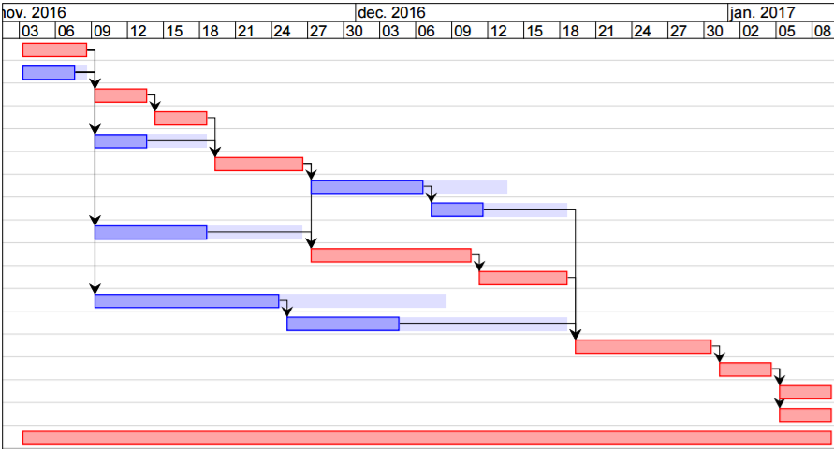

[COCOMOII estimation diagram](https://github.com/Hidevel/TaskForce-Briscola/blob/ProjectProposal%23Valentin/charts/COCOMOII_estimation.png)

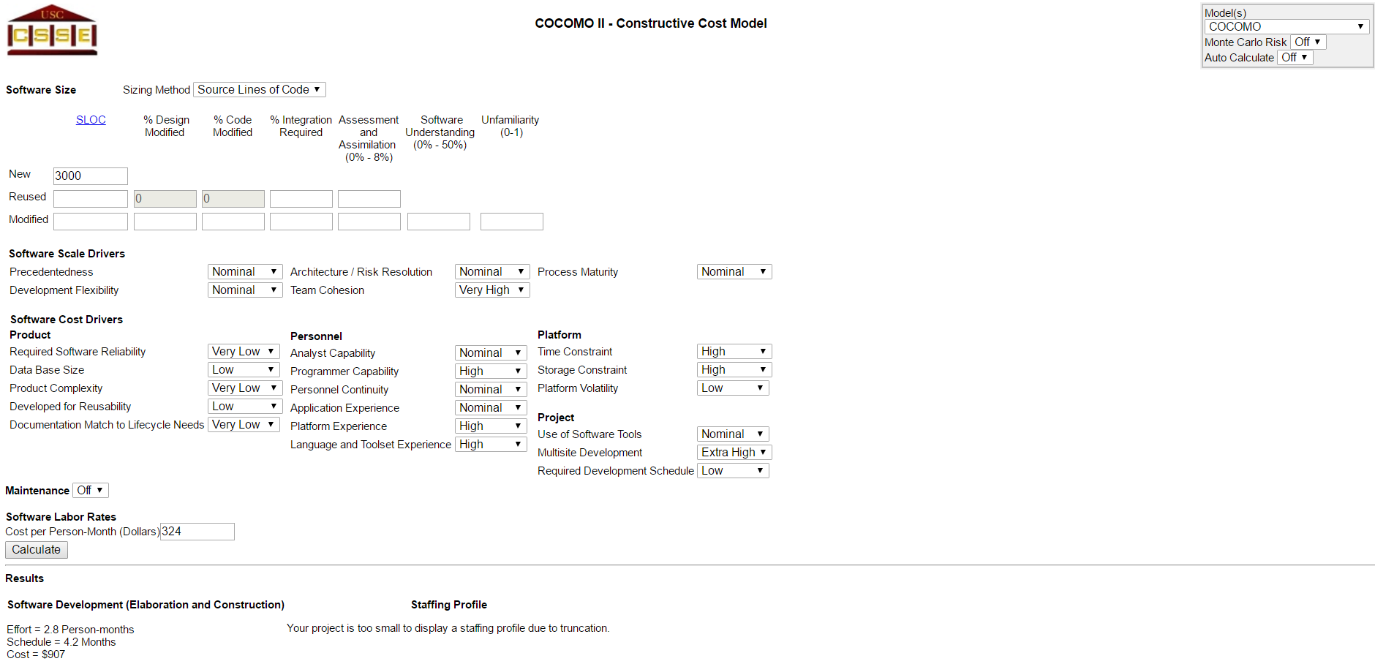

Dependencies

[Pert diagram](https://github.com/Hidevel/TaskForce-Briscola/blob/ProjectProposal%23Valentin/charts/TaskForce - Briskola - PERT.pdf)

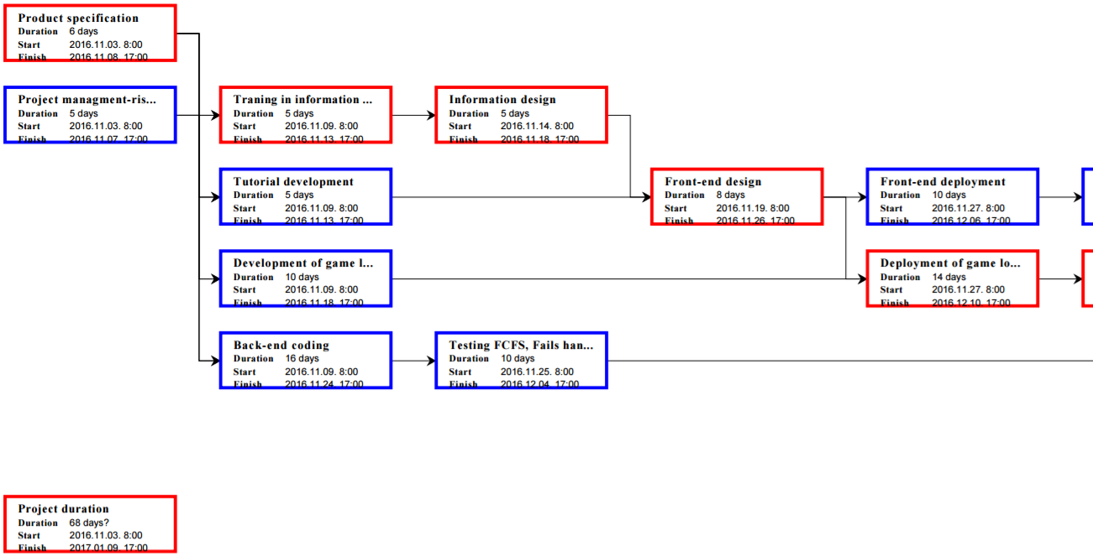

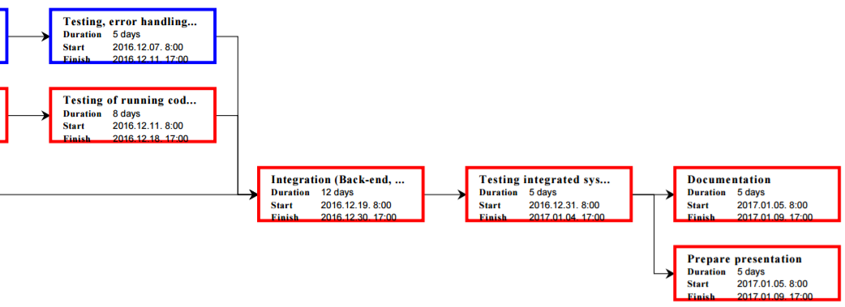

[Pert chart](https://github.com/Hidevel/TaskForce-Briscola/blob/ProjectProposal%23Valentin/charts/TaskForce - Briskola - PERT.pdf)

Analysis and Risk Management Plan

|  |  |  |  |  |  |
| --- | --- | --- | --- | --- | --- |
| **Risk** | **Risk type** | **Risk affects** | **Description** | **Probability** | **Impact** |
| Server unavailability | Tools / Organiza-tional | Project | A server-side architecture with the required performance for the determined budget won't be available. | High | Catastrophic |
| Product competition | Requirements | Business | The envisioned product is not competent enough due to a new software release in the field. | Low | Catastrophic |
| Technological advancement | Technology | Business | A used technology is replaced by a more advanced one. | Very low | Catastrophic |
| Time underestimate | Estimation | Project, product | The required time to develop the desired outcome is underestimated. | High | Serious |
| Team member unavailability | People | Project | Due to some reasons one or more teammember is unable to work on the project. | Moderate | Serious |
| Specification delays | Tools | Project,  Product | Crucial implementation specification will be delivered late. | Moderate | Serious |
| Client-side resource unavailability | Tools | Project | At some cases there won't be enough client side resource for the web application or won't supports well the browsers used by the target audience. | Low | Serious |
| Lack of knowledge | People | Project, product | The required knowledge to realize the project is unavailable. | Very low | Serious |
| Specification change | Requirements | Project, product | Due to unforeseen consequences the specification of the delivered software will be changed. | Low | Serious |
| Size underestimate | Estimation | Project | The scope of the application is larger than it was forecasted. | Moderate | Tolerable |
| Technology undeperformance | Technology | Product | One of chosen technologies cannot deliver the estimated performance. | Low | Insignificant |

|  |  |
| --- | --- |
| Legend for specific columns of the table above | |
| Column name | Possible values |
| Risk affection types | project, product, business |
| Risk type | technology, people, organizational, tools, requirements, estimation |
| Risk probabilities | very low (< 10%), low (10–25%), moderate (25–50%), high (50–75%), very high (> 75%) |
| Risk impacts type (with description) | catastrophic (threaten the survival of the project), serious (would cause major delays), tolerable (delays are within allowed contingency), insignificant |

**Risk planning**

|  |  |
| --- | --- |
| Risk | Strategy |
| Server unavailability | Indicate in requirement change that this project's outcome is a prototype which will run on localhost during the demostration, but won't be available for public use. |
| Product competition | Create a mayor change of features that overcomes on the new product if possible. Alternatively use the available marketing tools to gain increased market share over the competent software. |
| Technological advancement | Currently used technologies will still be able to deliver the proper outcome of the project, but the launch of a process thread which aims the replacement of the old technology in the near future is necessary. |
| Time underestimate | Investigate possible code reuse or integratation of already written components. Look for proven solutions, solid implementations of the emerging problems. Invest more working hours into the project to deliver the outcomes on time. |
| Teammember unavailability | Possibly assign multiple members to different development processes, raise the members overalll understanding of the project. Allocate the unavilable person's work in the given time period between other team members. |
| Specification delays | Look for another component that can be further pushed toward the final state, while the required specification arrives. If it isn't possible raise the number of persons working on the specification. |
| Client-side resource unavailability | Develop the application in a performance efficient way and try to minimize the use of client side resources. |
| Lack of knowledge | Add an other member with proper insight on the given topic to the people currently working on the problem, or reallocate work according to the emerged uncapabilities. |
| Specification change | Properly research and define both present and the most possible customer requirements. Prepare the project in a way that it's extension won't come at a high price. |
| Size underestimate | Create a detailed and well organized implementation plan and a proper project scope can be defined. |
| Technology undeperformance | Chose implementation methods, languages and tools with proper insight on their performance, integratibility and compatibility. |

2

Project management

We are using Github as a way of sharing and working together on the same project without overlapping mutual parts of coding. Each team member is having his own branch where they will be uploading their work. There will be two groups of work on our project: back-end and front-end.

Mia and Leon will mainly be doing back-end and Valentin and Tihana front-end.

We are also using Discord for video chats and having weekly online conversations.

Firstly we are doing the skeleton of over project. We are putting keynotes of what has to be done before something else. For example an implementation of 1 vs 1 and user vs AI versions. Since it will be coded and integrated by two different persons we need to establish who will be doing work first, and who will upgrade the first version. That is why we have our team leader Mia Filić and all of our product finishes go through her. She also makes sure that the work is split equally through all the team members and that everything is finishing on time.

**Description of the consortium**

Tihana Britvić, 23, is an Eramus student from Croatia. Finished Faculty of Science at the University of Zagreb in 2015. and applying for the master in Computer Science and Mathematics she came to the University of Ljubljana to finish her last year. She will be doing front-end with Valentin and the most of the project management on the project. She has knowledge of JavaScript, PHP, JQuery, Jason, HTML and CSS so for that reason she will be doing front-end.

Mia Filić, 23, is an Eramus student from Croatia. She is the leader of this team. Mia has finished her bachelor education in 2015. at Faculty of Science on University of Zagreb after which she applied for the master in Computer Science and Mathematics at the University of Ljubljana. She will be doing back-end with Leon, mostly concentrating on one player versus another player part. The reason why she is doing the mentioned part of work is her knowledge of Java, JavaScript, PHP, C, and C++.

Valentin Hidashi, 21, is also an Erasmus student. He is from Hungary. He is on a bachelor study at the University of Ljubljana. He used to work with HTML, CSS, JavaScript and SQL which he would like to perfect. For that reason, he is working on our front-end. He is really creative and wants to learn new technologies, which are prefect characteristics for our main front-end developer.

Leon Makorič, 21. He is the only non-Erasmus student in the group. He is studying for Bachelor at the University of Ljubljana at Faculty of Computer Science. He is most familiar with Java, Python and PHP and wants to learn how to implement an AI programme which is the main reason why he is doing the back-end part, with the accent on coding player versus AI part.

Juan Julián Cuéllar Abril, 24, is an Erasmus student from Spain. This is the last year of his Bachelor, and he is coming from Polytechnic University of Valencia. He has a knowledge about IA developments in Java and programing websites in CSS with HTML5 and JavaScript. Also has experience with graphic design. Therefore, he will do the front-end and help with the IA in the back-end.

Financial plan





We plan costs of indirect costs to be 20% of labor costs, which is considered a good planing.

In total, we have 2,8 PM(ČM) and 9100 euro of total costs, including direct and indirect costs. But to that costs, the budget should be increses by 15%, as the risk managment measure (in case of need of overtime working hours etc.).

Our total required budget is 10 465 euro.

References

[1] http://csse.usc.edu/tools/COCOMOII.php

[2] Ian Sommerville.2011.Software Engineering.9th edition.Pearson

Appendix 1

|  |  |  |  |  |  |
| --- | --- | --- | --- | --- | --- |
| **Task** | **Tihana Britvić** | **Mia Filić** | **Valentin Hidasi** | **Leon Makorič** | **Julian Cuellar** |
| Project summary |  |  |  |  | 100% |
| List of products |  | 100% |  |  |  |
| PERT chart |  |  | 100% |  |  |
| Gantt chart |  |  | 100% |  |  |
| Risk management | 50% |  | 50% |  |  |
| Motivation | 75% | 10% |  | 15% |  |
| Project plan |  | 40% |  | 60% |  |
| Timetable |  |  |  |  |  |
| Consortium description | 68% |  |  | 12% | 20% |
| Financial plan |  | 100% |  |  |  |
| Project goals and expected results | 40% |  |  | 60% |  |
| Problem description |  |  |  | 100% |  |