CT 2016 041

Mahesh M.G.H

C T E C 3 1 0 4 2

PYTHON ASSIGNMENT

**RUSH CAR LIMITED**

**INTRODUCTION**

This software product is developed for a small Car company called RUSH LTD. This company offers customized cars for sale. As it is mentioned in the Requirement Specifications, the whole company is controlled by two main types of users. The first type of users is responsible for managing the day to day activities of the company. These activities include, adding new models, manufacturers, upgrades and adding cars to the system. And the other type of users is responsible for selling the added cars to the customers with some customized upgrades. Those two types of users are named as “Staff Members” and “Sellers” accordingly.

In addition to the basic requirements for a Staff Member, there are some other functionalities which must be satisfied by the new system. One of them is that each of every Staff Member must be able to check out all the available cars in the system along with the sold cars. Each sold car contains the details of the seller, added upgrades and the timestamp which the car was sold.

In order to recognize the two types of users involved with the system, a login and a registration panels are added.

What you are going to see in the following sections is the way of which the given requirements are satisfied in the developed software product. And the technologies which have been used in this product.

**EXPECTED OUTCOMES**

The final product should be a standalone application. The same application must contains the ability to feature both the Staff Members and the Sellers in different ways.

There should be a login page to authenticate the users.

Every Staff Member has the ability to add new car models, manufacturers, upgrades, and cars. And also the ability to update and delete them.

An upgrade is made of with its own price along with the upgrade name.

Each and every car has a unique registration number, a name, price, and a colour with its own model and a manufacturer. These details must be added by a member when he/she adds a new car to the system.

Every Seller has the ability to look at the available models, manufacturers, upgrades and cars. But no any sellers are authorized to add or modify them. The only thing that they can do is to sell an available car. Once a car is sold, it should not be shown in the available car list. When a car gets selling, list of upgrades can be added by a seller according to the customer’s expectations. The final price with the added upgrades should be shown for the seller.

Both the Sellers and the Staff Members can search an available car by the model name or the manufacturer name.

**CLASS DIAGRAM**

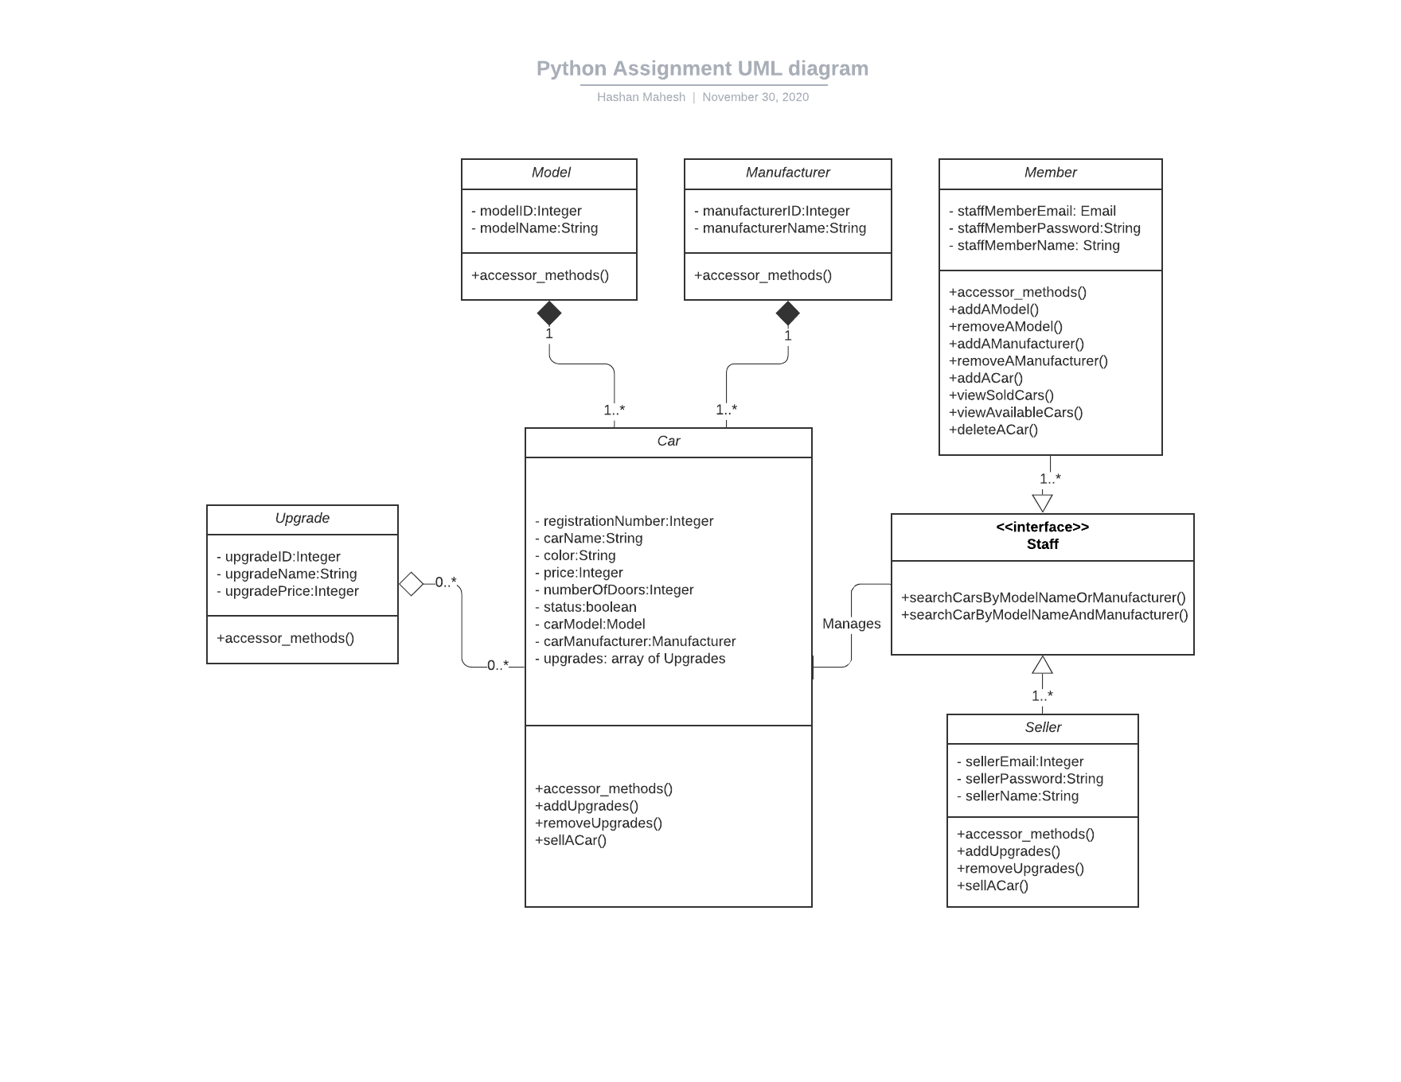

T

This is the planned class diagram for the project. In the class diagram, there is a s single interface which is implanted by the Seller and the Member class. In addition to that t to that, there are few other classes as well.

Although the project was intended to be developed according to the class diagram above above, some of the modifications were applied due to the MVC architecture which was fo was followed

MVC (Model View Controller) architecture is a famous software development architect architecture and it is used for properly packaging or modularising the source code. Thi This project is completely developed upon the MVC architecture.

**MODEL –** All thedomain classes are placed inside here. **VIEW -** Interface is defined here. **CONTROLLER -** The connection between the Model and The View is happened here.

**ER DIAGRAM**

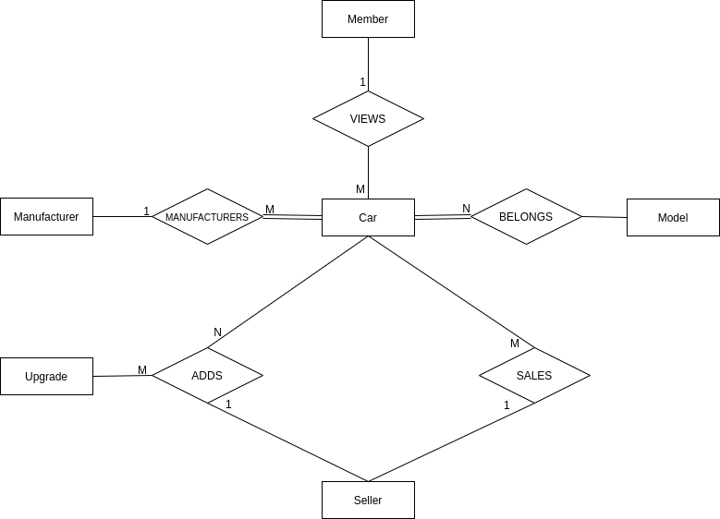

This is the intended database design which was drawn without the attributes for entities. By examining this diagram, it will be easy for anyone to determine the used relationships among different entities.

When this ER diagram is getting mapped with actual data tables, some more tables will be generated for the relationships as well. So, data table’s names which were c created for this project is listed down below.

* Cars
* Manufacturers
* Models
* Upgrades
* Orders
* Sellers
* Staff Members
* Sells

**TECHNOLOGY**

The whole software product is made by only using python programming language. In o And all the data for the system which are provided through the software are stored in inside a SQLITE3 database file.

The user interface for this software is developed with an additional python library cal called PyQt5. The advantage of using PyQt5 instead of default tkinter is that it has the ability to create good d the ability to create good looking software’s with its modern widgets. So, in order to run run the program, the PyQt5 library must be added to the project environment.

PyQt5 library can be added to the environment through the pip package manager u using the following command, on your terminal.

` **pip install pyqt5**

With PyQt5 we no need to create User Interfaces programmatically, instead we can use use a GUI Builder software called QT designer. All the interfaces which you see in this aaaaaaaaaaaaaa this software are designed with QT designer. In order to make it simple, no any advan advanced widgets or images have been used.

*“I used PyQt5 as an experiment and to learn something new, and honestly not just for expe for getting marks.”*

**HOW TO RUN**

With this document, I have attached a compressed folder called ‘Project’. What you have to have to do is Unzip it, and you will find two folders called **src** and **database.** The src f folder contains all the source codes where as the database folder contains the database database.db file.

In order to run the project either you can directly double click on the given .exe file or or create a new python project in Pycharm IDE and copy and paste two folders (src and (src and database) in the project. After you have added those two folders you need to s to install pyqt5 library to the venv (virtual environment), that can be installed through the pr the terminal. Once the pyqt5 library is added, expand the src folder and go to the View View directry and run the ViewHandler.py file.

THANK YOU