Data 03.12.2016 Name Vele Radu George Group 917

# Problem statement:

An application implement for:

* + arithmetic operations: addition, subtraction, multiplication and division by one digit, in a base p{2,3,...,9,10,16}
  + conversions of natural numbers between two bases p, q{2,3,...,9,10,16} using the substitution method or successive divisions and rapid conversions between two bases p, q{2, 4, 8, 16}.

# Calculator - Feature list

|  |
| --- |
| F1. **Add** two real numbers in a certain base |
| F2. **Subtract** two real numbers in a certain base |
| F3. **Multiply** a real number with a one digit number |
| F4. **Divide** a real number with a one digit number |
| F5. **Convert** a real number from base b into base h |

# Iteration plan

|  |  |
| --- | --- |
| Iteration | Planned features |
| I1 | F1. **Add** two real numbers in a certain base  F2. **Subtract** two real numbers in a certain base  F3. **Multiply** a real number with a one digit number  F4. **Divide** a real number with a one digit number |
| I2 | F5. **Convert** a real number from base b into base h  1. Substitution method  2. Successive divisions and multiplications  3. Rapid conversions |

**Iteration 1.**

1. **Addition.**

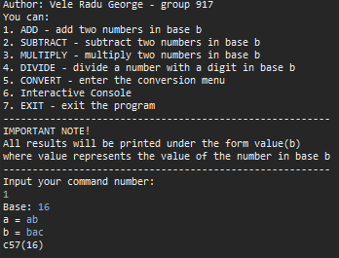

1. **Subtraction**

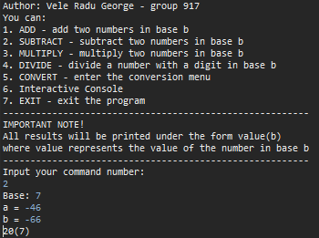

1. **Multiplication**

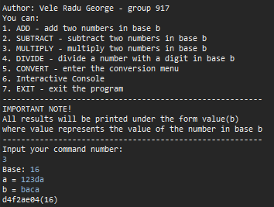

1. **Division**

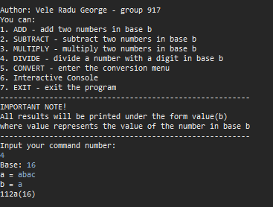

**Iteration 2**

1. **Smart conversion –** automatically chooses best conversion method

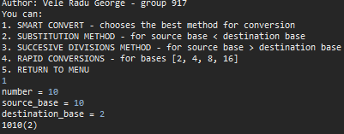

* **Substitution Method**

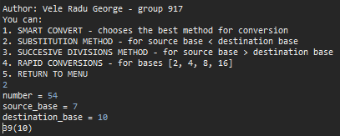

* **Successive division method**

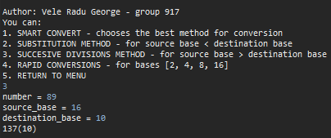

* **Rapid conversion**

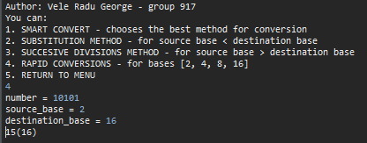

Work items/tasks

|  |  |
| --- | --- |
| T1 | Implement the arithmetic operation: addition, subtraction, multiplication, division |
| T2 | Implement conversion of any number in base 2 |
| T3 | Implement conversion of any number using following methods: substitution method or successive divisions or rapid conversions between two bases p, q{2, 4, 8, 16}. |