1b:

2. Answer Spring questions:

**What is Spring?**

Spring framework is an opensource and opinionated framework contains an ecosystem to develop Java-based Enterprise Application.

It is called opinionated framework because it offers strong conventions and best practices for developing application.

Spring framework follows IoC (inversion of Control) and Dependence Injection to achieve separation of concerns.

**What is Spring Boot?**

Spring Boot is used to simplify the development of Spring framework by providing auto config for Spring framework. It has main components includes starter project, auto configuration, properties file. It also has common features such as i18n, Swagger to document and test Rest APIs. It provides common non-functional features such as Embedded WebServer, Dependency management, Logging, Error Handling, profiles and Security.

Spring Boot can use spring web module which implements MVC architecture which belongs to layer architectures in which this layer has layer and tire mixed to hybrid architecture to apply for performance optimization, Security and Microservces.

**What is the relation between Spring platform and Spring Boot?**

Spring Boot is also the same with Spring which is an opinionated framework offering strong conventions and best practices for software development. Spring Boot provides auto config for Spring framework to make development easier, lessen time to config.

**What is Dependency Injection and how is it done in the Spring platform/framework?**

Dependency injection is an example of IoC, it is used to achieve separation of concern and loose coupling. In Spring framework, DI is done using Spring Config including XML config, Java config, multi config files and even mixed config between XML and Java config. These configs support for Constructor DI, Setter DI, Method parameter DI and Anotation DI.

**What is Inversion of Control (IoC) and how is it related to Spring?**

IoC follows Dependency Inversion Principle, it performs by Framework to control the flow of application. Instead of our source code (classes) instantiating their own dependencies, the framework manages these dependencies and injects them into the classes when needed.

Lab4:

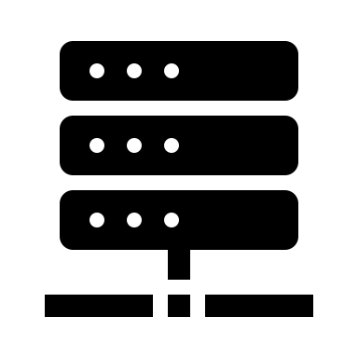

Enterprise Information Services

**Logical tiers and layers**

ESB

Legacy

Database

Application Server

Web Container

Json data

Raw response

DAO – Data Access Object Layer

POJO – Business Service Layer

Spring MVC web service layer

ReactJS

HTML React css

HTTP Request

Web Service

User Interface

URL

**Physical tiers**



Browser

Backend Server

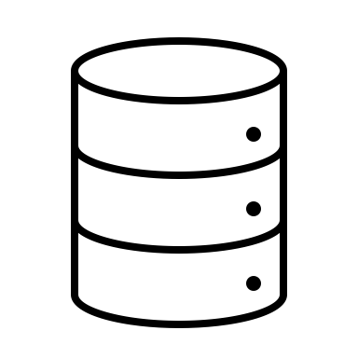

Database server