CUSTOMER SEGMENTATION APPLYING CUSTOMER 360, RFM MODEL AND BCG MATRIX

• INTRODUCTION Project Overview

Identifying customer segmentation is essential for creating targeted marketing strategies, improving customer satisfaction and retention, optimizing resources, enhancing product development, gaining competitive advantage, and ultimately increasing profitability. It enables businesses to understand their customers on a deeper level and deliver more personalized and effective solutions.

In this study, I apply the CUSTOMER 360 theory, RFM model, and BCG matrix synergistically to analyze the data, generate meaningful insights and ultimately classify customer segments.

This report also highlights the significance of each customer segment and provides strategic recommendations.

>> METHODOLOGY

**Implementation Process**

Connect Python with SQL Server using pyodbc to get data from Database

Query data from tables and compute Recency, Frequency, Monetary.

Use Python and some specialized packages such as Numpy, Pandas,… to compute and analyze data, generate “RFM” and “Segment” columns.

Use Matplotlib and Seaborn to plot some charts for visualization.

Then create a dashboard using Power BI tool.

Quartiles are a kind of quantile that divides the number of data points into four parts, or quarters.

* The **first quartile (Q1)** , is defined as the middle number between the smallest number and the median of the data set,
* The **second quartile (Q2)** is the [**median**](https://www.geeksforgeeks.org/median/)of the given data set.
* The**third quartile (Q3)** is the middle number between the median and the largest value of the data set.

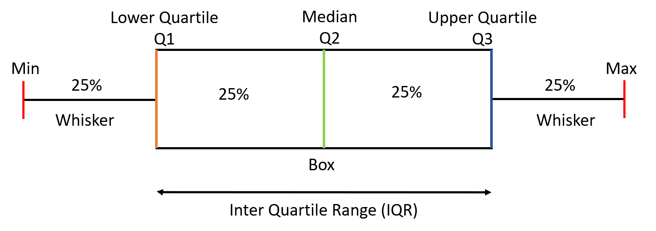

I propose grading scale for R, F, M based on quartiles.

RFM model assigns a score of 1 to 4 (from worst to best) for customers in each of the three categorie based on Quartiles method.

|  |  |  |  |
| --- | --- | --- | --- |
| **scale** | **R** | **F** | **M** |
| 1 | >= 92 | <  0.19 | < 15625 |
| 2 | 62 - <92 | 0.19 - <0.23 | 15625- <19175 |
| 3 | 31 - <62 | 0.23 - <0.26 | 19175- <23832 |
| 4 | < 31 | >= 0.26 | >= 23832 |

• **Stars**: High Recency, High Frequency, High Monetary Value.

• **Question Marks:** Low Recency and Frequency, High Monetary Value.

• **Cash Cows**: High Recency and High Frequency, Low Monetary Value.

• **Dogs**: Low Recency, Low Frequency, Low Monetary Value.

To classify elements (customers) into different segments (e.g., VIP, Potential, Regular) based on their RFM (Recency, Frequency, Monetary) values, we can define criteria similar to the Boston Matrix but tailored to customer segmentation. Here's an example of how you can classify customers into segments based on RFM values:

You want to classify customers into 4 groups based on the Boston Matrix model, where each group corresponds to one of the quadrants: Stars, Question Marks, Cash Cows, and Dogs. Here’s how you can classify customers into these groups based on their RFM values:

|  |  |  |
| --- | --- | --- |
| **BCG Elements** | **Segment** | **RFM** |
| Stars | VIP | 333, 334, 343, 344, 433, 434, 443, 444 |
| Question Marks | Potential Customers | 113 114 123 124 133 134 143 144 213 214 223 224 233 234 243 244 313 314 323 324 413 414 423 424 |
| Cash Cows | Loyal Customers | 131 132 141 142 231 232 241 242 311 312 321 322 331 332 341 342 411 412 421 422 431 432 441 442 |
| Dogs | Walk-in customers | 111, 112, 121, 122, 211, 212, 221, 222 |

DATA

Definitions

1.Customer 360

*Customer 360 (or* 360-degree customer) *is a framework that consolidates all existing customer insights from various tables and models within your data warehouse to create a single, unified, and actionable profile of each customer.*

**Customer 360** is a shared, single view of your customer across an organization. It includes not only who the customer is but also their relationships (e.g., households or business affiliations), their activities (i.e., transactions and interactions) and inferred attributes (e.g., sentiment, anniversary dates and lifecycle stages).

The ultimate goal of customer 360 is to eliminate fragmented and siloed data and create a single customer data hub so you can build personalized customer experiences and optimize business processes.

360-degree customer rotates around 4 key fields: demographic, transaction, behavioral, and  interaction data.

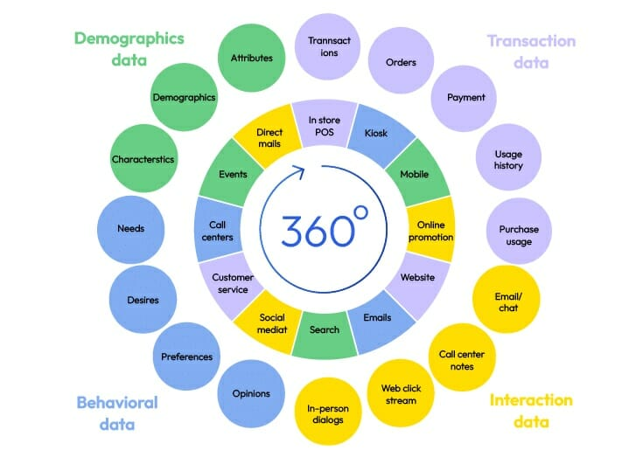

1. BCG Matrix

BCG Matrix (or Boston Consulting Group Matrix), is a strategic management tool that helps companies analyze their product portfolios or customer segmentation.

The matrix categorizes a company’s products or services into four categories: Stars, Cash Cows, Question Marks, and Dogs. Each category represents a different level of market share and growth potential.

Businesses can use the BCG Matrix to make strategic product portfolio decisions or marketing campaigns. It can help them allocate resources, prioritize investment, and decide which segment to invest in and which to divest.

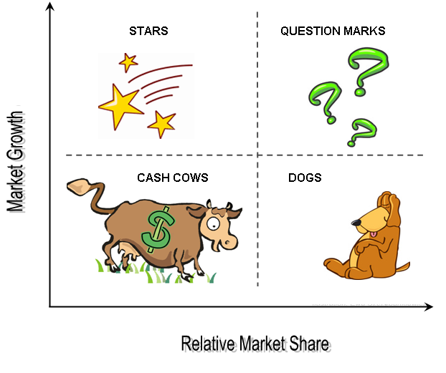

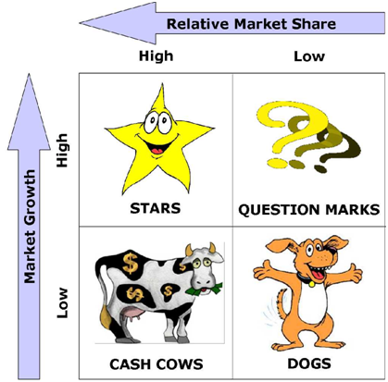

1. RFM (what is R, F, M?)

**What Is Recency, Frequency, Monetary Value (RFM)?**

**RFM is a model applied for analysing transaction data from Customer 360. It enables transforming transaction data into analytical data for multiple purposes.**

An RFM analysis evaluates clients and customers by scoring them in three categories:

1. **Recency**: How recently a customer has made a purchase
2. **Frequency**: How often a customer makes a purchase
3. **Monetary value**: How much money a customer spends on purchases

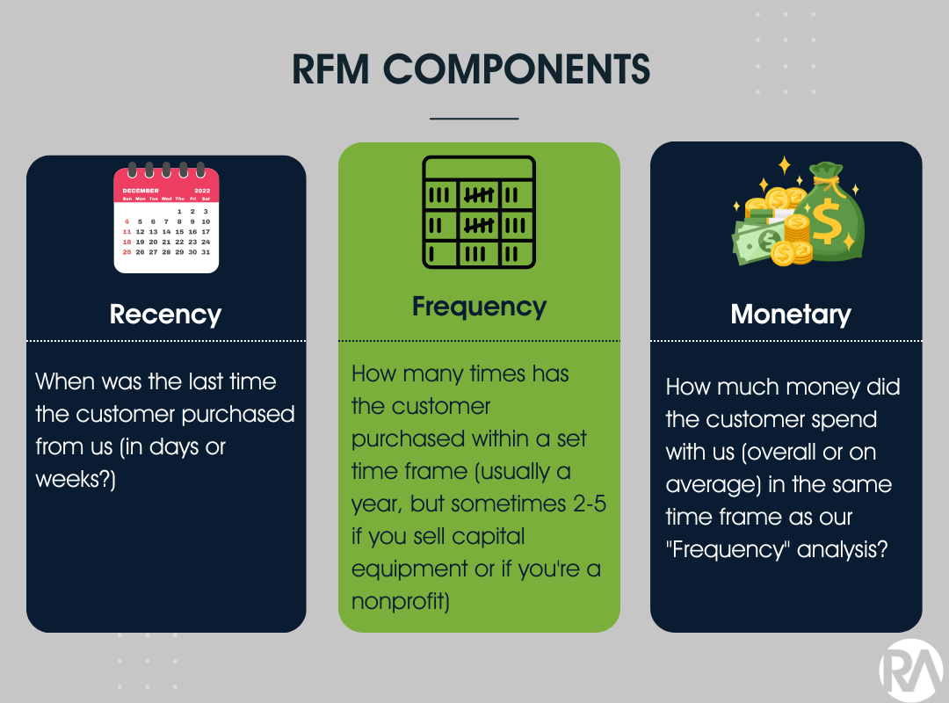

RFM analysis numerically ranks a customer in each of these three categories, generally on a scale of 1 to 4 (the higher the number, the better the result). The “best” customer would receive a top score in every category.

RFM is then used to identify a company’s or an organization’s best [customers](https://www.investopedia.com/terms/c/customer.asp) by measuring and analyzing spending habits to improve low-scoring customers and maintain high-scoring ones.

[What Is Recency, Frequency, Monetary Value (RFM) in Marketing? (investopedia.com)](https://www.investopedia.com/terms/r/rfm-recency-frequency-monetary-value.asp)

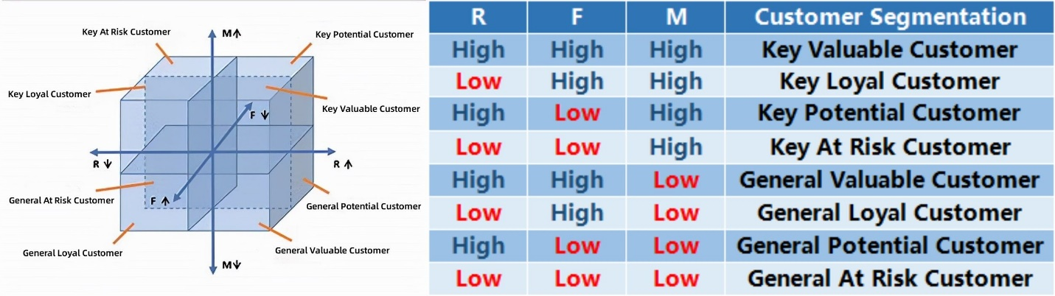

1. Dashboard

1. Marketing Strategies