**MISSON**

*Find the hidden link*

Who are you? (click on the image) (Ctrl + Click on image to open the page)

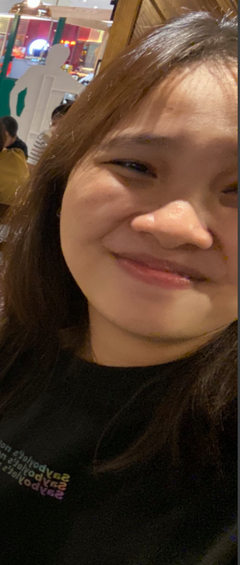[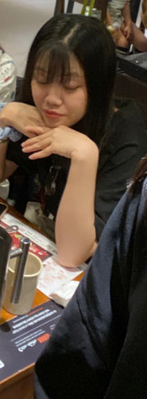](https://hiennguyen-git.github.io/guess-me/)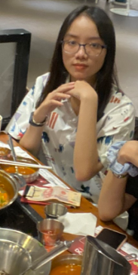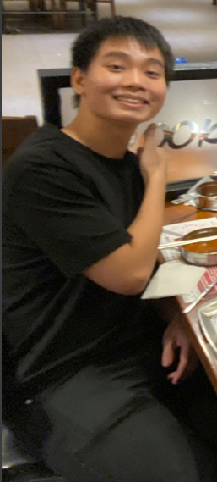

Cre: Daddy0102