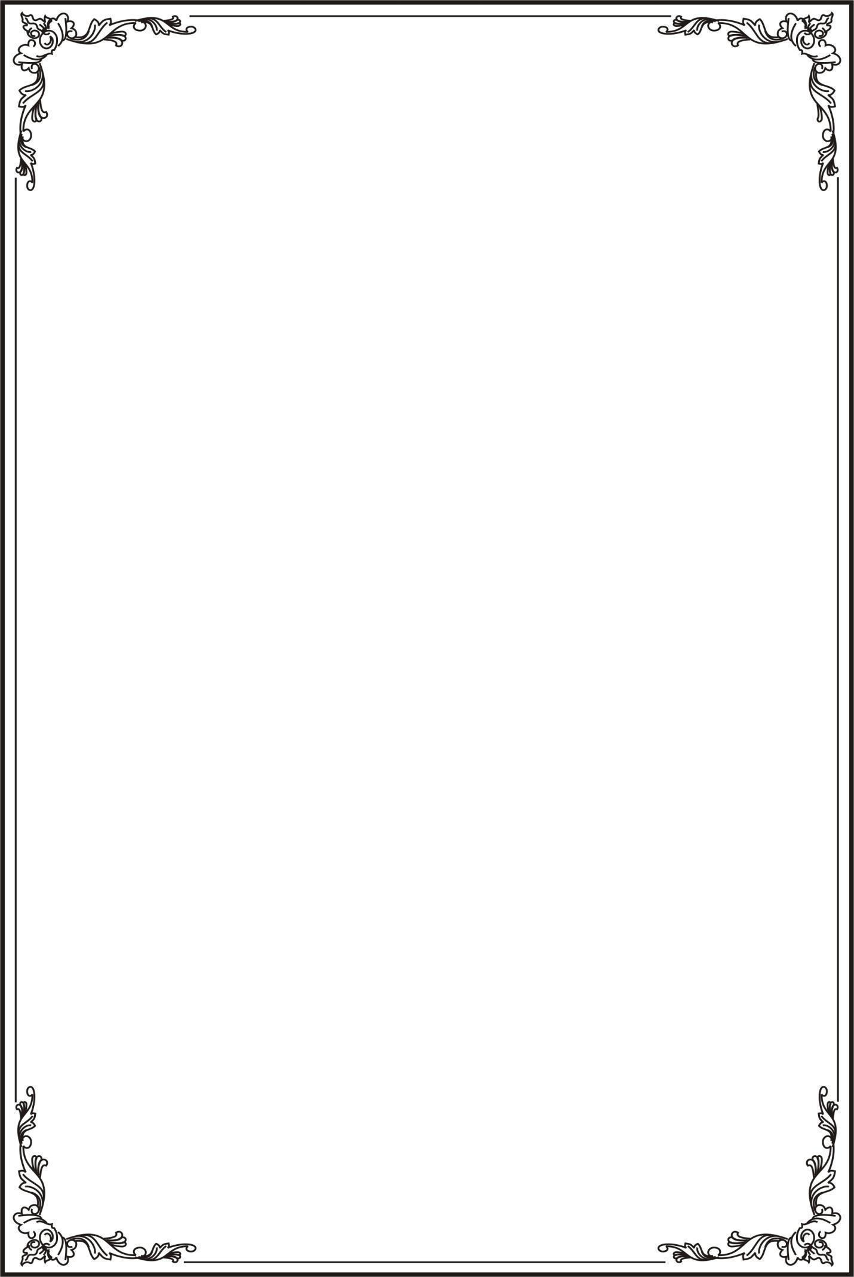
This text should be ON TOP of the image!

