**UNIVERSITY OF SCIENCE AND TECHNOLOGY OF HANOI**



**NETWORK SIMULATION**

*Lecturer: Mrs. Nguyen Minh Huong*

CSMA/CA Protocol Without RTS/CTS in

Ad-hoc WLAN Network

*Members:*

Phạm Tuấn Hiệp

Đỗ Quang Anh

Nguyễn Viết Minh Đức

Nguyễn Qúy Đức

Ngô Hải Anh

Phạm Quang Dương

Lã Duy Anh

22BI13158

22BI13013

22BI13095

22BI13094

22BI13019

22BI13116

22BI130161

*March 13, 2025*

Contents

1. INTRODUCTION 3

RESEARCH AND REVIEW 4

**CSMA/CA** 4

**RTS/CTS** 4

**Ad-hoc Mode** 4

2. SET UP APPLICATION 5

**Design** 5

**Implement** 5

3. COLLECT AND ANALYZE DATA 8

**Collected Data** 8

**Analyze Data** 8

4. CONCLUSION 9

5. References: 10

# 1. INTRODUCTION

In 1974, the term “Internet” first appeared, but at that time people still used the word ARPANET. It was not until the 1995s that the Internet gradually became more familiar when the ARPANET network was no longer effective. The first Internet inventor was Paul Baran with two other colleagues, Donald Davies and Leonard Kleinrock. He formed the first network of links, which are Stanford Research Institute, the University of California, Los Angeles, the University of Utah, and the University of California, Santa Barbara of the US, allowing the exchange of data belonging to these regions.

After a long time of research and development, Vietnam’s Internet history recorded November 19, 1997 as the day when the S-shaped country connected to the world’s information highway. During the past 20 years. The Internet has had a direct impact, changing many conceptions and lifestyles of Vietnamese people.

In recent years, wireless network technology has developed rapidly and covered almost all countries in the world, however, the increase in the number of such network devices has raised many problems related to the optimization of the transmission line and causing collisions.

In fact, CSMA/CA (Carrier sense multiple access/collision avoidance) has been applied in basic 802.11 networks. Thanks to RTS/CTS (request to send/ clear to send), some problems can be resolved such as devices in a wireless network may appear to be concealed from one another, making it more difficult for individual devices to determine when to broadcast.

In this research, we will use NS-3.34 to simulate an ad-hoc wireless network utilizing the CSMA/CA protocol without RTS/CTS to determine the efficiency of RTS/CTS.)

Wireless networks have become ubiquitous in our daily lives and are an essential means of communication. One of the most commonly used wireless networking protocols is CSMA/CA, which is used in Wi-fi networks operating in Ad-hoc Mode.

# RESEARCH AND REVIEW

## **CSMA/CA**

Carrier sense multiple access/collision avoidance (CSMA/CA) is a [protocol](https://www.techtarget.com/searchnetworking/definition/protocol) for carrier transmission in [802.11](https://www.techtarget.com/searchmobilecomputing/definition/80211) networks. It was developed to minimize the potential of a [collision](https://www.techtarget.com/searchnetworking/definition/collision) occurring when two or more stations send their signals over a data link layer.

## **RTS/CTS**

The RTS/CTS (Request to Send / Clear to Send) mechanism used in **Wi-Fi networks** (and other wireless communication protocols) to reduce the chances of data collisions when multiple devices are trying to communicate over the same channel.

## **Ad-hoc Mode**

Ad-hoc mode is a decentralized network setup where devices communicate directly with each other, ideal for scenarios where no centralized infrastructure exists. In NS-3 simulation, we are using this mode by setting the MAC layer to AdhocWifiMac, which allows all nodes to communicate without the need for an access point.

# 2. SET UP APPLICATION

## **Design**

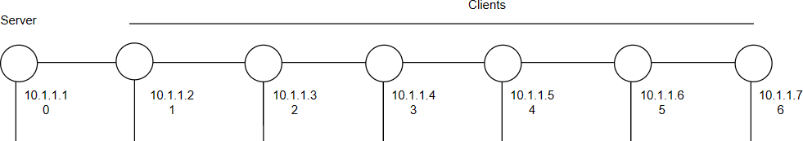

*Figure 1. An example of a design with 7 nodes*

* + - 1 node is a server (default is the 1st node).
    - The rest are clients.
    - All clients will simultaneously send packets to the server.

## **Implement**

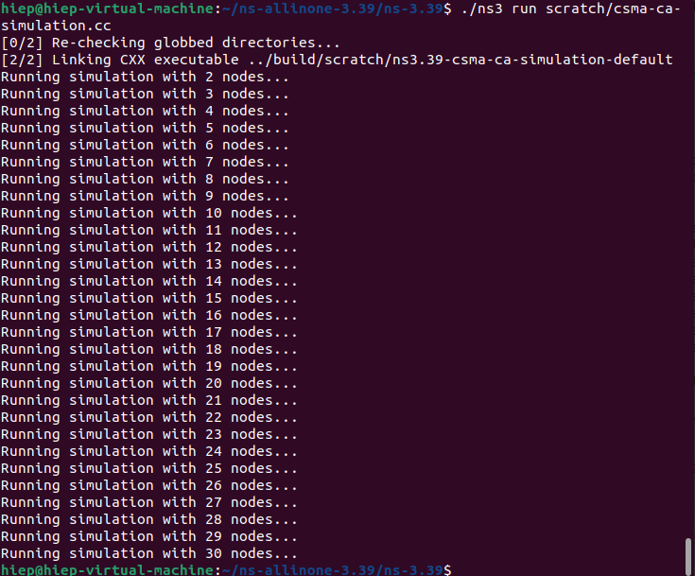

*Figure 2. Running the simulation with 2-30 nodes*

**

*Figure 3. Disable RTS/CTS by setting the threshold*

*Configuration of* UdpEchoServer:

* Firstly, we create a UdpEchoServerHelper and provide the server port number.
* Secondly, instantiate the server on the chosen server node.

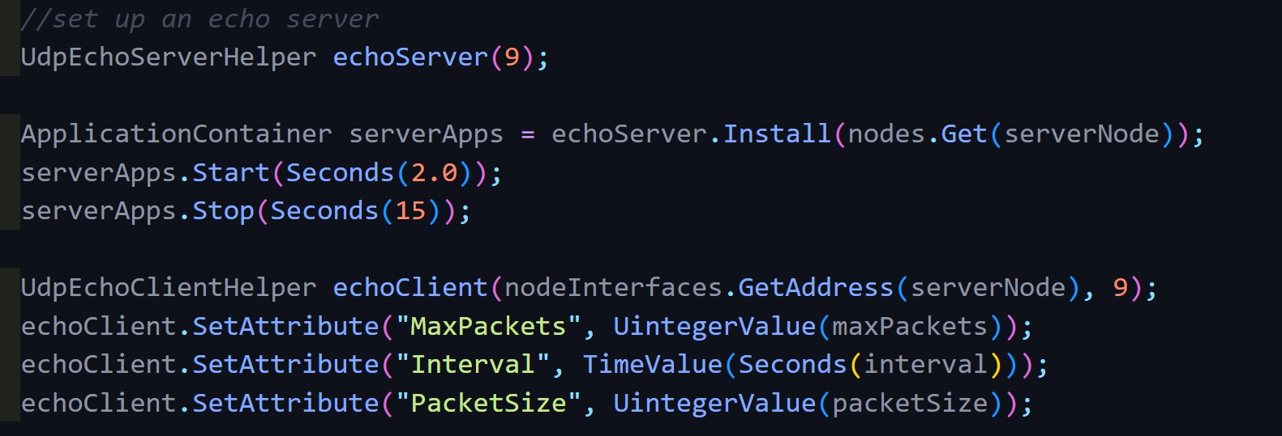

*Figure 4. Set up an echo server*

* *Configuration of* UdpEchoClient:
* Create a UdpEchoClientHelper and provide the remote address and port.
* After, we install the client on every other node except the serverNode.

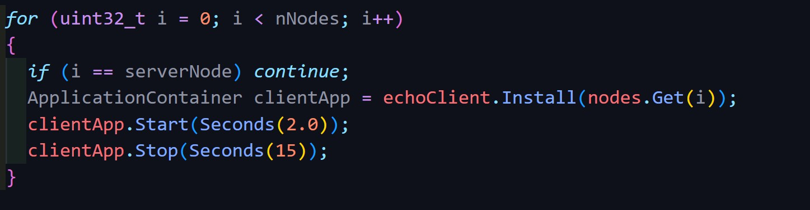

*Figure 5. Setup the Running time*

# 3. Data Collection and Analyzation

## **Collected Data**

- We use a flow monitor as the main method to collect data.

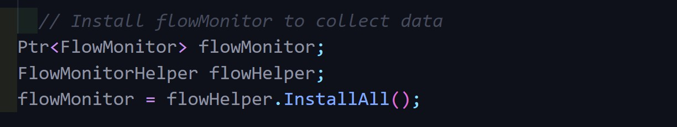

*Figure 6. Install flowMonitor to collect data*

## **Analyze Data**

* + *Data from Flow Monitor*: Data is stored in flows that contain all data about packets sent by a particular host to another.
  + *Data from the flows contains a lot of information,* including:
    - The time the first and the last packet is transmitted and received.
    - The total delay.
    - The total bytes and packets transmitted and received.
    - Number of lost packets.

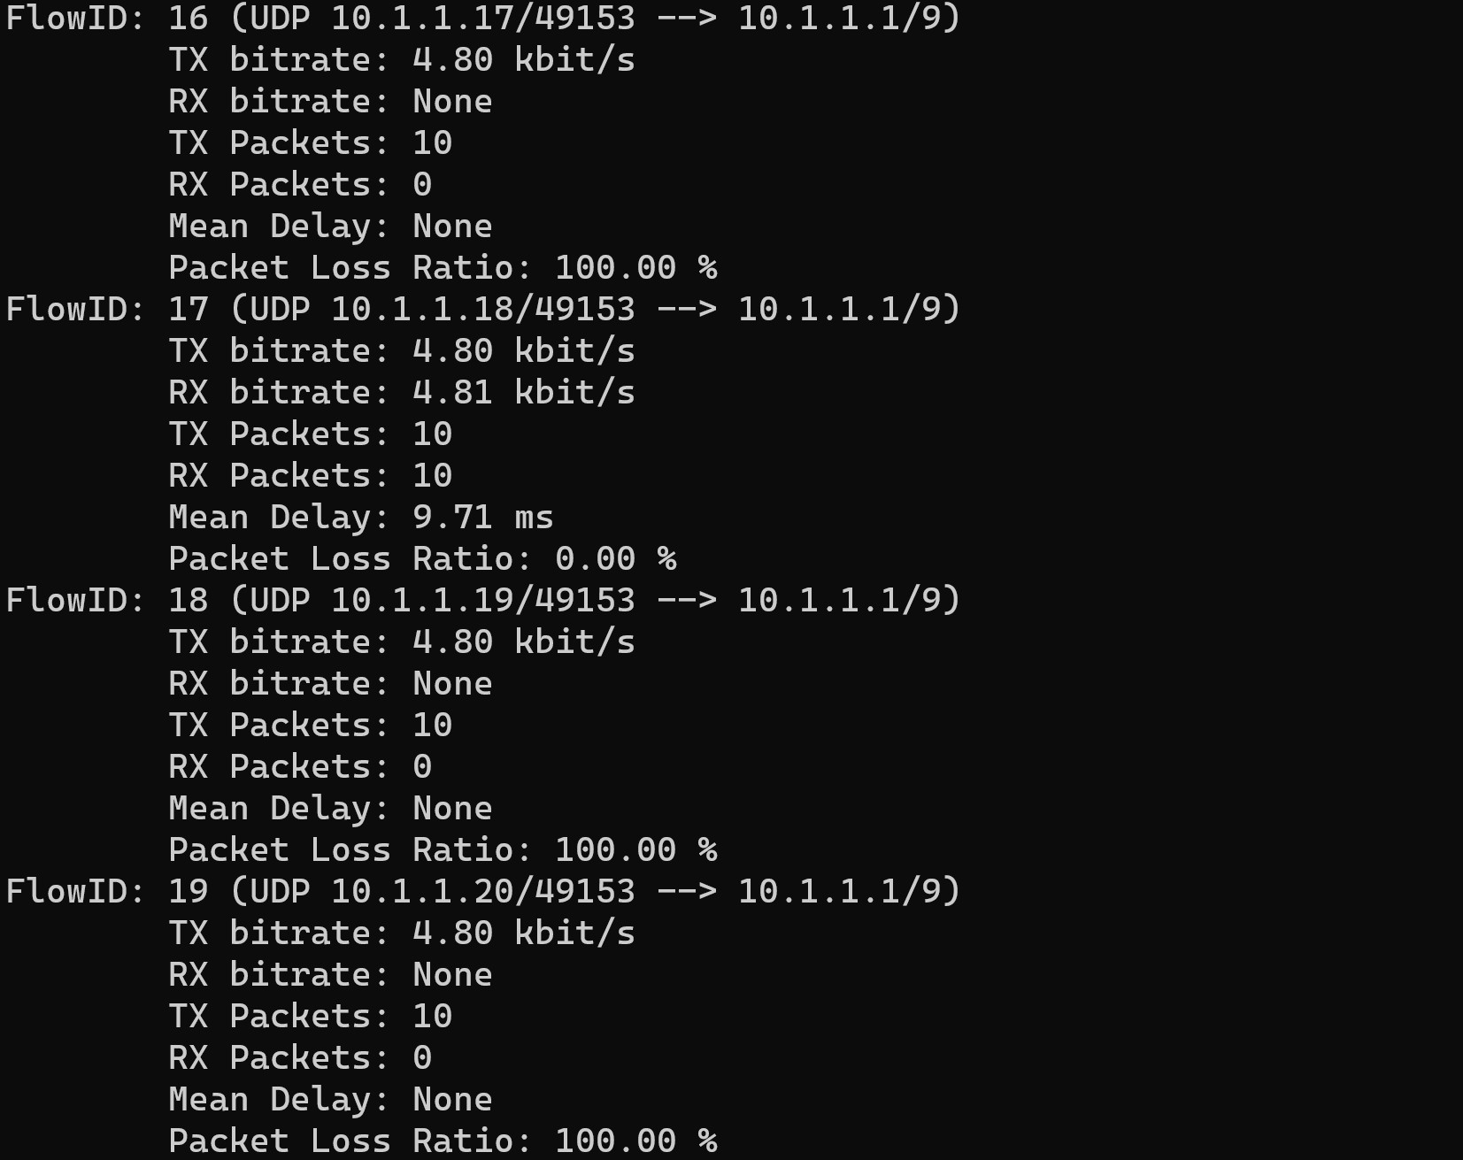

*Figure 7. An example of data with 4 nodes*

#### => All packets sent by some clients are completely lost.



*Figure 8. The ratio of lost clients when the total of nodes ranges from 2 to 30*

The CSMA/CA protocol is used in an ad-hoc Wi-Fi network to prevent collisions between nodes that are trying to transmit data simultaneously. Nonetheless, collisions are still possible without the RTS/CTS mechanism, which can reduce network performance, particularly as the number of nodes within a communication range grows.

# 4. Conclusion

*Explain the results:* Data collision is more likely to occur in ad-hoc wireless networks if all devices are linked to one another if RTS/CTS is disabled. In light of this, as the number of nodes rises, so do the number of clients and the volume of packets being sent. More collisions occur, and more packets are lost as a result.

# 5. References:

[*https://www.techtarget.com/searchnetworking/definition/CSMA-CA#:~:text=Carrier%20sense%20multiple%20access%2Fcollision%20avoidance%20(CSMA%2FCA),over%20a%20data%20link%20layer*](https://www.techtarget.com/searchnetworking/definition/CSMA-CA#:~:text=Carrier%20sense%20multiple%20access%2Fcollision%20avoidance%20(CSMA%2FCA),over%20a%20data%20link%20layer)*.*

1. “Comparative Analysis of Infrastructure and Ad-Hoc Wireless Networks.” *ITM Web of Conferences*,

<https://www.itm-conferences.org/articles/itmconf/pdf/2019/02/itmconf_icicci2018_01009.pdf>.

“CSMA/CD and CSMA/CA Explained.” *Computer Networking Notes*, 9 April 2022, [https://www.computernetworkingnotes.com/networking-tutorials/csma-cd-and-csma-ca-explained](https://www.computernetworkingnotes.com/networking-tutorials/csma-cd-and-csma-ca-explained.html)

[.html](https://www.computernetworkingnotes.com/networking-tutorials/csma-cd-and-csma-ca-explained.html).

1. “Flow Monitor — Model Library.” *NS-3*, 21 March 2023, <https://www.nsnam.org/docs/models/html/flow-monitor.html>.
2. “Enable RTS/CTS?” *Google*, <https://groups.google.com/g/ns-3-users/c/18BuTqRWBTs?pli=1>.
3. “wifi-adhoc.cc” *NS-3*,

<https://www.nsnam.org/docs/release/3.19/doxygen/wifi-adhoc_8cc_source.html>.

1. “Flying Adhoc Network using NS3” *LinkedIn*,

<https://www.linkedin.com/pulse/flying-adhoc-network-using-ns3-phd-srmieee-acmdsp/>.

1. “csma-ca-simulation” *Github*, <https://github.com/mindt102/csma-ca-simulation>.