MD OT Security v4.0.0 — Insight Report
Source: https://opswat.atlassian.net/wiki/spaces/NAC3/pages/5180621046/Test+Report+v4.0.0
Generated from Jira project OTSECURITY, fix version “MD OT Security 4.0.0”. Summaries matching “[Cancel]” were excluded where applicable. Several sections combine Jira fields with description-based inference (keyword scoring over summary + description + acceptance criteria when present).

1. Key stories (from ticket content)
Stories and epics ranked by story points, then by description length. The “Narrative (from description)” column is the first sentence (or lead fragment) of plain-text description.
Key | Type | Summary | Story pts | Narrative (from description)
OTSECURITY-10470 | Story | [BE] Visualize Links and Sessions on the network map in asset detail view depending on selection | 18 | (No description — see summary.)
OTSECURITY-10025 | Story | [DevOps] Setup HA cluster Patroni | 14 | https://opswat.atlassian.net/wiki/spaces/NAC3/pages/4908744705/Postgres+High+Availability+Cluster+with+Patroni+v2
OTSECURITY-8434 | Story | [DevOps] Upgrade zeek to version LTS 8.0 | 5 | # Zeek 6.0 → 8.0 LTS Upgrade: Plugin Compatibility Fixes Zeek 8.0 ships Spicy 1.14, which enforces stricter validation than Spicy 1.8 (Zeek 6.0).
OTSECURITY-10399 | Story | [FE] Close out and manage vulnerabilities — UI delivery | 3.5 | ## Epic context (OTSECURITY-10347) Users need to manage asset vulnerabilities: status workflow (Open, False Detection, Patched, Mitigated), visibility of vulnerability information, and handling false detections with option to re-open.
OTSECURITY-10474 | Story | [DevOps] Enhance debianize network sensor build | 1.1 | (No description — see summary.)
OTSECURITY-10475 | Story | [DevOps] Increase space disk CI Site build debian | 1.1 | (No description — see summary.)
OTSECURITY-10682 | Story | [DevOps] Optimize zip step to reduce time CI Build Upgrade | 1.1 | (No description — see summary.)
OTSECURITY-10641 | Story | [BE] Update OUI Collection | 1 | ### User story * As a network administrator, when I update the OUI collection, I want to ensure that all relevant OUI entries are included so that the network devices can be accurately identified.
OTSECURITY-10647 | Story | [BE] Normalize some manufacturer name | 1 | ### User story * As a product manager, when reviewing manufacturer names, I want to normalize the names so that they are consistent across our database.
OTSECURITY-10652 | Story | [FE] Enhance UX for Download/Delete support package | 0.25 | * Add loading for each row when downloading/deleting * Set timeout is infinity for download package * Prioritize lightweight
OTSECURITY-10614 | Epic | Add Suricata rule for ZionSiphon Malware detection | 0 | Add these rules in Suricata: alert tcp any any -> any 502 ( msg:"MALWARE ZionSiphon Modbus Read Holding Registers Probe"; flow:established,to_server; content:"|01 03 00 00 00 0A|"; offset:6; depth:12; classtype:trojan-activity; sid:9000047; rev:1; metadata:affected_product Modbus_ICS, attack_target…
OTSECURITY-9274 | Epic | Import & ingest SCD file for sub-station use case (Power sector) | 0 | ## Ingest SCD to support asset enrichment : What is an SCD File? An SCD file, based on the IEC 61850 standard, is a comprehensive substation configuration file that describes all IEDs in a substation, including their communication parameters, logical connections, datasets, and GOOSE/SV configurations.
OTSECURITY-10593 | Epic | Support Schneider ME Discovery protocol | 0 | Support Schneider Electric EcoStruxure Machine Expert discovery protocol.
OTSECURITY-10538 | Epic | Support CDP protocol | 0 | Cisco Discovery Protocol (CDP) is a proprietary Layer 2 network protocol developed by Cisco Systems.

2. Features (Epic / story scope)
Feature / scope | Story pts (Jira Σ) | Dev estimate (Σ) | QA estimate (Σ) | Review estimate (Σ) | Total est. (Σ) | Driver | Priority
Standardize OUI information | 39.0 | 39.0 | 4.7 | 4.4 | 48.1 | Market Gap | Minor
Migrate passive discovery implementation in Sensor To Rust | 15.0 | 15.0 | 3.0 | 3.0 | 21.0 |  | Minor
Fix bugs and enhancements 4.0.0 | 60.7 | 60.8 | 11.6 | 10.76 | 83.16 |  | Minor
Close out vulnerabiities | 24.5 | 24.5 | 3.6 | 3.2 | 31.3 | Opportunity - Dealbreaker | Blocker
CSV Import to Provide Data Enrichment | 16.0 | 16.0 | 3.4 | 3.2 | 22.6 | Opportunity - Dealbreaker | Blocker
Visualise Links and Sessions on the network map in asset detail view dpeending on selection | 36.0 | 36.0 | 5.4 | 6.2 | 47.6 | Opportunity - Dealbreaker | Blocker
Devices with Multiple Nics are not combined | 26.0 | 26.0 | 5.2 | 5.2 | 36.4 |  | Blocker
Generate Support Package option from GUI | 5.2 | 5.2 | 1.7 | 0.2 | 7.1 | Internal | Major
Support CDP protocol | 4.0 | 4.0 | 0.4 |  | 4.4 | Opportunity - Dealbreaker | Minor
Support Schneider ME Discovery protocol | 2.5 | 2.5 | 0.5 | 0.3 | 3.3 | Market Gap | Minor
Add Suricata rule for ZionSiphon Malware detection | 2.0 | 2.0 | 0.4 | 0.4 | 2.8 | Market Leadership | Minor
Fix bugs and enhancements 4.1.0 | 0.3 | 0.3 | 0.1 | 0.06 | 0.46 |  | Minor
Optimize processing performance 4.0.0 | 45.0 | 45.0 | 7.1 | 6.3 | 58.4 | Engineering | Major
Optimize zeek | 5.0 | 4.0 | 1.0 | 1.0 | 6.0 |  | Minor
Enhance Automation Framework |  | 20.0 | 2.0 | 2.0 | 24.0 |  | Minor
Bulk Approval for Smart Profiling Changes | 28.0 | 28.0 | 3.0 | 3.8 | 34.8 | Market Gap | Major
Import & ingest SCD file for sub-station use case (Power sector) | 16.5 | 14.0 | 3.1 | 2.7 | 19.8 | Market Gap | IFFEasy
Detect and merge assets automatically based on CDP | 4.0 | 4.0 | 0.8 | 0.8 | 5.6 | Customer Request - Specific | Minor
Parser SCD file |  |  |  |  |  | Market Leadership | Minor
MD OTS Distro: New OS, ISO and AWS AMI support + optimisations for OT sensor on IFW | 76.9 | 67.0 | 14.5 | 10.2 | 91.7 | Engineering | Major
Root-level items (no parent in Jira) | 165.4 | 136.5 | 26.1 | 27.0 | 189.6

3. Member effort and contributions
Story points sum the Jira “Story point estimate” on assigned issues. Percentages use team totals in this export. Role / primary focus use [FE]/[BE]/[DevOps] and issue-type mix.
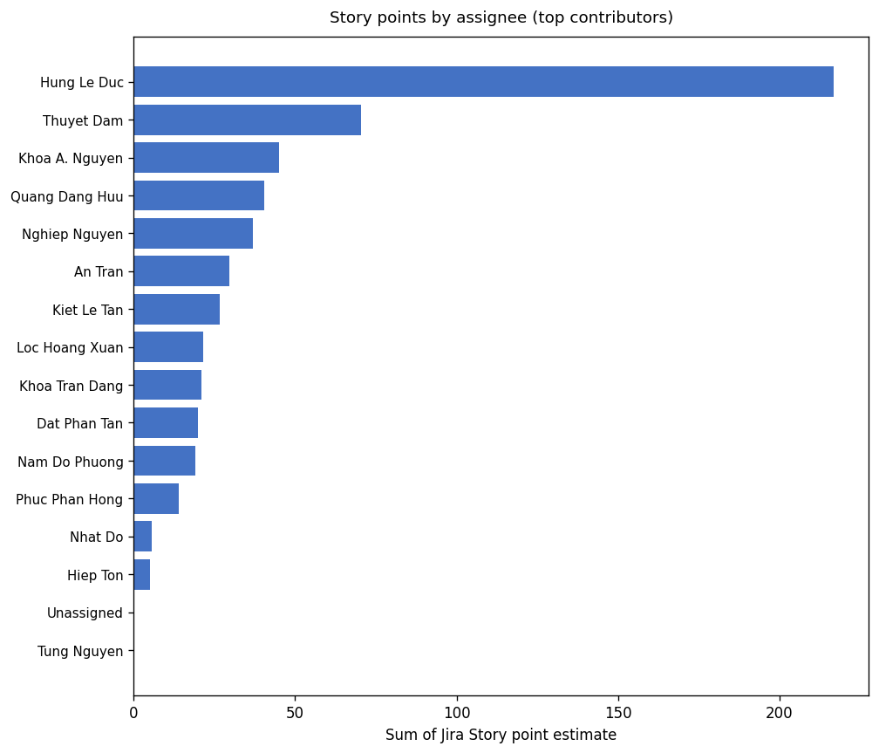
Figure 1 — Story point concentration helps spot single points of failure in planning.
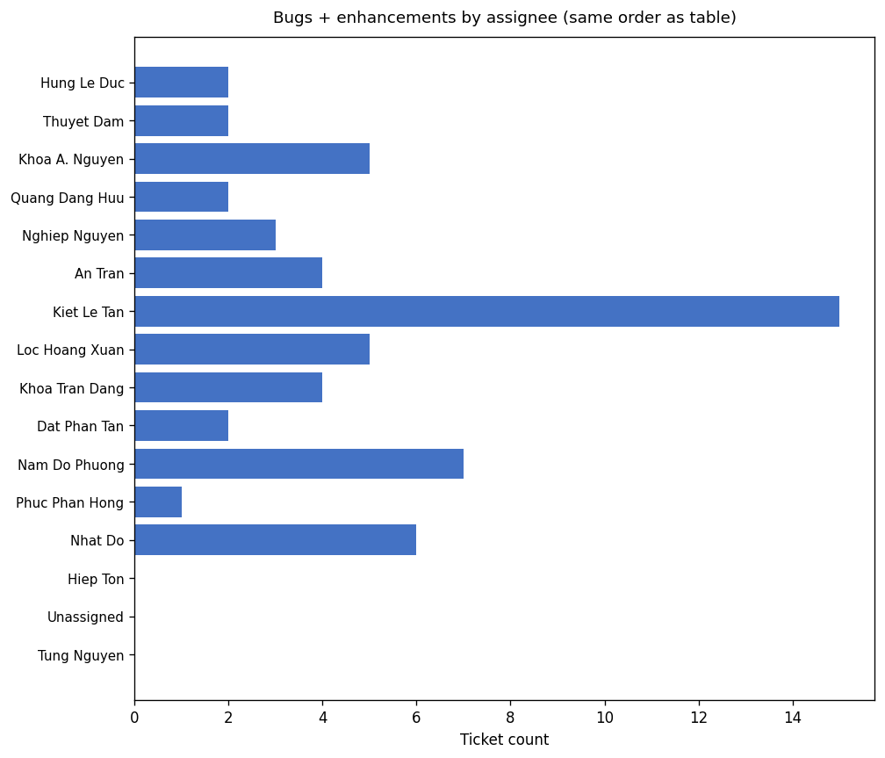
Figure 2 — Bug + enhancement counts by assignee (same top slice as the chart above).
Member | Story points (Σ) | % of team SP | Role | Primary focus | Tasks | Subtasks | Stories | Bugs + Enh. | Total issues | % of issues
Hung Le Duc | 216.8 | 37.9% | DevOps | DevOps: features & tasks | 5 | 27 | 6 | 2 | 40 | 18.2%
Thuyet Dam | 70.3 | 12.3% | Backend | Backend: bugs & fixes | 8 | 3 | 1 | 2 | 18 | 8.2%
Khoa A. Nguyen | 45.1 | 7.9% | Backend | Backend: bugs & fixes | 3 | 0 | 2 | 5 | 11 | 5.0%
Quang Dang Huu | 40.4 | 7.1% | Backend | Backend: bugs & fixes | 4 | 0 | 1 | 2 | 7 | 3.2%
Nghiep Nguyen | 37.0 | 6.5% | Backend | Backend: bugs & fixes | 12 | 0 | 0 | 3 | 16 | 7.3%
An Tran | 29.6 | 5.2% | Frontend | Frontend: features & tasks | 3 | 9 | 6 | 4 | 25 | 11.4%
Kiet Le Tan | 26.7 | 4.7% | Frontend | Frontend: bugs & fixes | 1 | 13 | 0 | 15 | 29 | 13.2%
Loc Hoang Xuan | 21.6 | 3.8% | Backend | Backend: bugs & fixes | 6 | 6 | 0 | 5 | 17 | 7.7%
Khoa Tran Dang | 21.0 | 3.7% | Engineering | Engineering: bugs & fixes | 5 | 1 | 0 | 4 | 10 | 4.5%
Dat Phan Tan | 20.0 | 3.5% | Engineering | Engineering: bugs & fixes | 3 | 1 | 1 | 2 | 7 | 3.2%
Nam Do Phuong | 19.0 | 3.3% | Frontend | Frontend: bugs & fixes | 0 | 12 | 2 | 7 | 21 | 9.5%
Phuc Phan Hong | 14.0 | 2.4% | Engineering | Engineering: features & tasks | 1 | 0 | 0 | 1 | 2 | 0.9%
Nhat Do | 5.5 | 1.0% | DevOps | DevOps: bugs & fixes | 0 | 1 | 0 | 6 | 7 | 3.2%
Hiep Ton | 5.0 | 0.9% | DevOps | DevOps: features & tasks | 0 | 0 | 1 | 0 | 2 | 0.9%
Unassigned |  | 0.0% | Engineering | Engineering | 0 | 0 | 0 | 0 | 7 | 3.2%
Tung Nguyen |  | 0.0% | Engineering | Engineering: features & tasks | 1 | 0 | 0 | 0 | 1 | 0.5%

4. Bug breakdown by area
Two views: Jira Bug Category (when set) vs. description-driven buckets from keyword scoring over summary + description.

4a — Jira Bug Category
Bug category (Jira) | Count
(Uncategorized in Jira) | 58

4b — Inferred from ticket text
Inferred area (text) | Count
Import / CSV / SCD / assets | 44
DevOps / install / upgrade / CI | 3
Dashboard / UI / filters | 3
Connection / Network / Policy | 3
Reporting / PDF / support package | 2
Device / detection / classification | 1
Patching / Suricata / services | 1
Alerts / notifications | 1

5. Issues by component
Jira component field (tickets may list multiple components). Text-inferred slice uses [FE]/[BE]/[DevOps] tags when present, else keyword rules on description.

5a — Jira components
Component (Jira) | Row count
(No Jira component) | 220

5b — Text-inferred component
Inferred component (text) | Issue count
Frontend (from [FE] tag) | 70
Backend (from [BE] tag) | 67
DevOps (from [DevOps] tag) | 47
Frontend (text) | 10
General / mixed (text) | 10
Backend (text) | 7
AI (text) | 5
DevOps (text) | 4

6. Major bugs (Major / Critical / Blocker)
Key | Summary | Status | Priority | Assignee
OTSECURITY-10571 | [BE] Can not import csv/scd file | Done | Blocker | Loc Hoang Xuan
OTSECURITY-10600 | [FE] Error when fixing data when importing | Done | Blocker | Kiet Le Tan
OTSECURITY-6779 | [BE] Connection Allow Policy Setting not working | Done | Major | Khoa A. Nguyen

7. Resolution time analysis (Bugs + Enhancements)
Count: 58 | Mean: 26.6 d | Median: 5.0 d | P90: 33.0 d

8. Workload distribution — bugs + enhancements by assignee
Assignee | Count
Kiet Le Tan | 15
Nam Do Phuong | 7
Nhat Do | 6
Khoa A. Nguyen | 5
Loc Hoang Xuan | 5
Khoa Tran Dang | 4
An Tran | 4
Nghiep Nguyen | 3
Quang Dang Huu | 2
Hung Le Duc | 2
Thuyet Dam | 2
Dat Phan Tan | 2
Phuc Phan Hong | 1

9. Frontend bug detail ([FE])
- 27 bug-like tickets; dominant priority: Minor (25 tickets); most common status: Done.
- Description-inferred hotspots: Import / CSV / SCD / assets (25), Dashboard / UI / filters (1), Reporting / PDF / support package (1).
- Recurring language around “media” (37 mentions) — review tests and docs in that subsystem.
- Recurring language around “staging” (37 mentions) — review tests and docs in that subsystem.
- Recurring language around “atl-paas” (37 mentions) — review tests and docs in that subsystem.
- Recurring language around “collection” (37 mentions) — review tests and docs in that subsystem.
- Recurring language around “occurrencekey” (37 mentions) — review tests and docs in that subsystem.
- 1 ticket(s) are Major or above; ensure targeted regression and sign-off evidence before release.
Key | Summary | Status | Priority | Assignee
OTSECURITY-10367 | [FE] Display "-" for Fields Transferred Packets/Received Packets when BE response is null | Done | Minor | Kiet Le Tan
OTSECURITY-10396 | [FE] Connection List - can not be filtered with the previous search list after clicking to view asset detail | Done | Minor | Kiet Le Tan
OTSECURITY-10455 | [FE] Destination is not displayed information | Done | Minor | Kiet Le Tan
OTSECURITY-10456 | [FE] Add require field for Escalate Incident and Tooltips for user | Done | Minor | Nam Do Phuong
OTSECURITY-10460 | [FE] App link navigation is not working | Done | Minor | Kiet Le Tan
OTSECURITY-10496 | [FE] Mismatch number of devices between Dashboard of Site and Assets | Done | Minor | Kiet Le Tan
OTSECURITY-10497 | [FE] Can not Filter Acknowledge Alert time | Done | Minor | Nam Do Phuong
OTSECURITY-10504 | [FE] Error filter purdue model on Asset Alerts page | Done | Minor | An Tran
OTSECURITY-10506 | [FE] Missing Network & Discovery setting of Network Sensor | Done | Minor | Kiet Le Tan
OTSECURITY-10507 | [FE] Missing setting default some value for SNMPv3 profile | Done | Minor | Nghiep Nguyen
OTSECURITY-10510 | [FE] Enhancement related to re-render about Manufacturer after update OUI list | Done | Minor | Nam Do Phuong
OTSECURITY-10511 | [FE] Infinite loading on Site Manager dashboard | Done | Minor | Nam Do Phuong
OTSECURITY-10512 | [FE] Generate a support package for the incorrect component | Done | Minor | Nam Do Phuong
OTSECURITY-10524 | [FE] The result after filtering the Create/Edit Role table lacks a checked checkbox | Done | Minor | Nam Do Phuong
OTSECURITY-10535 | [FE] Asset Type Settings - Configure selected but apply for scope Enterprise | Done | Minor | Kiet Le Tan
OTSECURITY-10553 | [FE] Can not create Sub-type | Done | Minor | Kiet Le Tan
OTSECURITY-10555 | [FE] Missing a lot of data like Origin of NIC, Vendor, Purdue Level... when importing assets | Done | Minor | Kiet Le Tan
OTSECURITY-10559 | [FE] Can not edit device that having many IP in import devices | Done | Minor | Kiet Le Tan
OTSECURITY-10570 | [FE] Duplicate API request when create new Type | Done | Minor | Kiet Le Tan
OTSECURITY-10579 | [FE] Inconsistence hard disk of Site | Done | Minor | Kiet Le Tan
OTSECURITY-10585 | [FE] Save Report Vulnerabilities Page successful but not displayed records on Saved Report page | Done | Minor | Nam Do Phuong
OTSECURITY-10600 | [FE] Error when fixing data when importing | Done | Blocker | Kiet Le Tan
OTSECURITY-10601 | [FE] Connection is disappeared when user check both then uncheck inactive assets | Done | Minor | An Tran
OTSECURITY-10602 | [FE] Missing Origin of NIC and user can not scroll to right to see properties in Batch Edit of Import Asset Features | Done | Minor | Kiet Le Tan
OTSECURITY-10611 | [FE] Missing MAC column when user import SCD | Done | Minor | Kiet Le Tan
OTSECURITY-8944 | [FE] Order Site and Sensor alphabetically | Done | Minor | An Tran
OTSECURITY-9366 | [FE] Update Filters to make them consistent with table header | Done | IFFEasy | An Tran

10. Backend bug detail ([BE])
- 22 bug-like tickets; dominant priority: Minor (20 tickets); most common status: Done.
- Description-inferred hotspots: Import / CSV / SCD / assets (15), Connection / Network / Policy (3), Device / detection / classification (1), Dashboard / UI / filters (1).
- Recurring language around “media” (23 mentions) — review tests and docs in that subsystem.
- Recurring language around “staging” (23 mentions) — review tests and docs in that subsystem.
- Recurring language around “atl-paas” (23 mentions) — review tests and docs in that subsystem.
- Recurring language around “collection” (23 mentions) — review tests and docs in that subsystem.
- Recurring language around “occurrencekey” (23 mentions) — review tests and docs in that subsystem.
- 2 ticket(s) are Major or above; ensure targeted regression and sign-off evidence before release.
Key | Summary | Status | Priority | Assignee
OTSECURITY-10461 | [BE] Should delete connection in Network Map when connections are deleted | Done | Minor | Quang Dang Huu
OTSECURITY-10495 | [BE] Wrong detection Type of device | Done | Minor | Khoa Tran Dang
OTSECURITY-10540 | [BE] Wrong action when importing assets | Done | Minor | Loc Hoang Xuan
OTSECURITY-10541 | [BE] Sub-type is not a required field, so when user import assets, they can make it blank | Done | Minor | Loc Hoang Xuan
OTSECURITY-10546 | [BE] Wrong status of CVEs after updating firmware | Done | Minor | Nghiep Nguyen
OTSECURITY-10547 | [BE] Error when viewing pdf | Done | Minor | Nhat Do
OTSECURITY-10560 | [BE] Missing devices after importing | Done | Minor | Loc Hoang Xuan
OTSECURITY-10571 | [BE] Can not import csv/scd file | Done | Blocker | Loc Hoang Xuan
OTSECURITY-10583 | [BE] The sub-type is updated to Switch but the Type still is Generic | Done | Minor | Khoa Tran Dang
OTSECURITY-10584 | [BE] The data CVE list on the Site Manager does not sync with the Network Sensor | Done | Minor | Nghiep Nguyen
OTSECURITY-10603 | [BE] Expose Score of Switch is wrong | Done | Minor | Khoa A. Nguyen
OTSECURITY-10604 | [BE] CDP protocol create 1 more device, It should be merged to existing device | Done | Minor | Khoa Tran Dang
OTSECURITY-10610 | [BE] Missing validate IP when importing SCD | Done | Minor | Loc Hoang Xuan
OTSECURITY-10660 | [BE] Brand names duplicated / inconsistent (e.g. with or without "Inc.") | Done | Minor | Khoa A. Nguyen
OTSECURITY-10663 | [BE][Connection Dashboard] No data displayed | Done | Minor | Thuyet Dam
OTSECURITY-10664 | [BE] Toggle on/off does not apply Patching/Suricata correctly | Done | Minor | Quang Dang Huu
OTSECURITY-10665 | [BE][AIO / Site Bundle] No data after handshake completes | Done | Minor | Dat Phan Tan
OTSECURITY-10666 | [BE][Handshake] Sensor ↔ Site handshake unstable (sometimes requires second attempt) | Done | Minor | Thuyet Dam
OTSECURITY-10668 | [BE] Primary MAC of the network device should be the chassis MAC | Done | Minor | Khoa Tran Dang
OTSECURITY-10671 | [BE] Wrong staus of Patching | Done | Minor | Dat Phan Tan
OTSECURITY-6779 | [BE] Connection Allow Policy Setting not working | Done | Major | Khoa A. Nguyen
OTSECURITY-9977 | [BE] The Built-in sensor is removed when user remove stand alone sensor | Done | Minor | Khoa A. Nguyen

11. DevOps bug detail ([DevOps])
- 7 bug-like tickets; dominant priority: Minor (7 tickets); most common status: Done.
- Description-inferred hotspots: DevOps / install / upgrade / CI (3), Import / CSV / SCD / assets (3), Reporting / PDF / support package (1).
- Recurring language around “initramfs” (12 mentions) — review tests and docs in that subsystem.
- Recurring language around “build” (8 mentions) — review tests and docs in that subsystem.
- Recurring language around “site” (8 mentions) — review tests and docs in that subsystem.
- Recurring language around “devops” (7 mentions) — review tests and docs in that subsystem.
- Recurring language around “modules” (7 mentions) — review tests and docs in that subsystem.
Key | Summary | Status | Priority | Assignee
OTSECURITY-10446 | [DevOps] Nginx configure timeout issue - 3.7.0 | Done | Minor | Nhat Do
OTSECURITY-10608 | [DevOps] Prod | Can not generate Support Package | Done | Minor | Nhat Do
OTSECURITY-10618 | [DevOps] Can not enable AI service on production build | Done | Minor | Hung Le Duc
OTSECURITY-10634 | [DevOps] 1U Hardware have problem when upgrade to 4.0.0 | Done | Minor | Hung Le Duc
OTSECURITY-10656 | [DevOps] Update path does not update all components | Done | Minor | Nhat Do
OTSECURITY-10657 | [DevOps] Fresh install fails for AIO, Site and Site Bundle | Done | Minor | Nhat Do
OTSECURITY-10659 | [DevOps][Support package] Issue pending verification after fix | Done | Minor | Nhat Do

12. Recommendations
- Link root-level stories and tasks to epics in Jira so release reporting rolls up drivers and priorities consistently.
- Keep Black Duck high-severity items on a versioned remediation plan (per release test report) instead of open-ended acknowledgement.
- Back UI and asset-scanning themes called out in sign-off with targeted regression automation for the next train.
- Enrich descriptions and Bug Category at filing time — text-inferred buckets are useful but should converge with structured fields.

13. Insights and key takeaways for the next release
- Scope after exclusions: 220 issues; subtasks are a large share (73), so epic/story health metrics should stay visible to leadership.
- Bugs plus enhancements in this fix version: 58; severity Major or above: 3.
- Compare mean versus median resolution time — a wide gap usually indicates a few long-tail defects that needed escalation or environment access.
- If bug workload is concentrated on a small set of assignees, plan load-balancing and earlier DevOps involvement for pipeline-impacting defects.
- Align security scanning sign-off with release criteria early to avoid late-cycle risk acceptance carrying into the next version.
- Compare Jira Bug Category vs. text-inferred areas: large gaps highlight tickets missing triage metadata.

Generated automatically. Issue snapshot: 220 items.

