HANOI UNIVERSITY OF SCIENCE AND TECHNOLOGY

School of Information and communications technology

Novel Reading Project

Subject: Software engineering

Group 17

*Hanoi,* *04, 2024*

Table of contents

Table of contents 1

1 Introduction 2

1.1 Objective 2

1.2 Scope 2

1.3 Glossary 2

1.4 References 3

2 Overall Description 4

2.1 Survey 4

2.2 Overall requirements 4

2.3 Business process 4

3 Detailed Requirements 5

3.1 Use case 1 6

3.2 Use case 2 7

4 Supplementary specification 8

4.1 Functionality 8

4.2 Usability 8

4.3 Reliability 8

4.4 Performance 8

4.5 Supportability 8

4.6 Other requirements 8

# Introduction

## Objective

## Scope

## Glossary

## References

# Overall Description

## Survey

*The Project involves three main actors interacting with the system:*

1. User: User are people who are interested in using the website to read their novels online. They can do many things on the website such as add new novels to their favorite list, search for a particular novel, read the novel, rate a novel or comment on a novel.
2. VNPAY system: It plays a critical role in executing transactions between user and the Novel website. Whenever a user want to upgrade to VIP membership, they are asked to perform a transaction on VNPAY.
3. Administrator: Admins are responsible for managing users, items in the database.

## Overall requirements

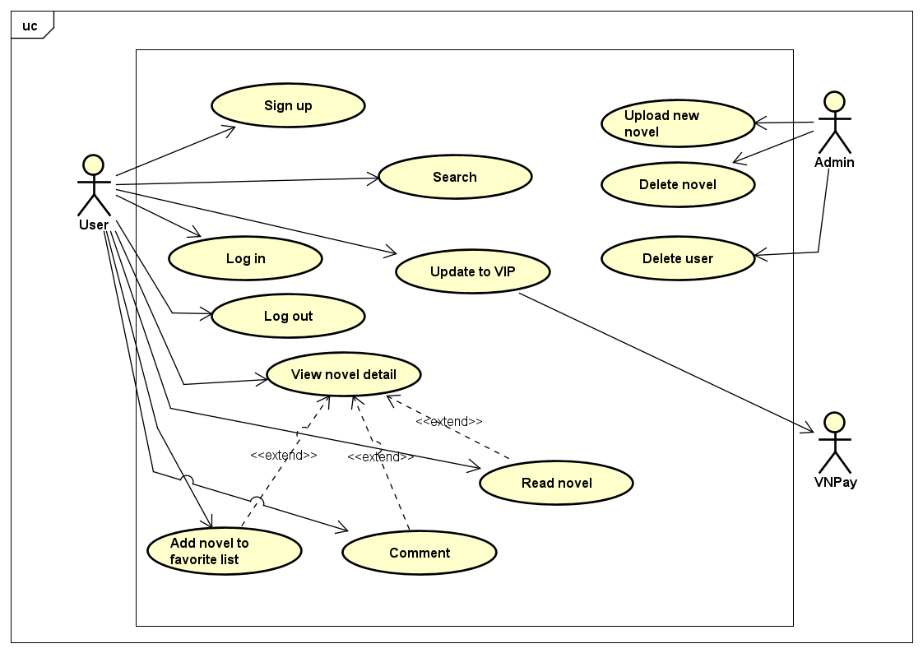

## Business process

### **The overall process**

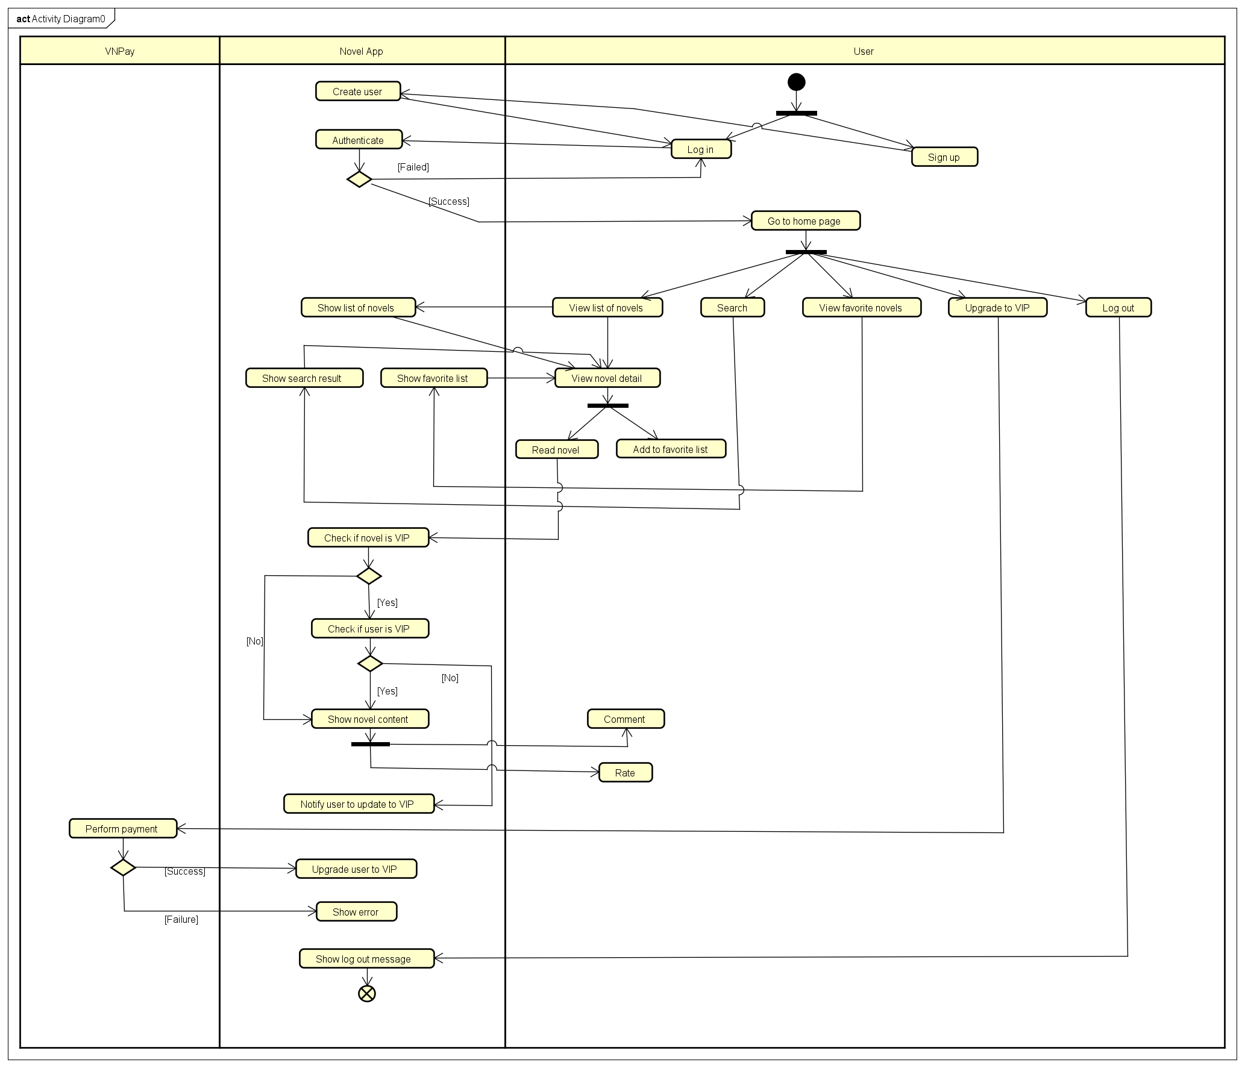

# Detailed Requirements

## Use case 1

|  |  |  |  |  |  |  |  |  |  |  |  |  |  |  |  |
| --- | --- | --- | --- | --- | --- | --- | --- | --- | --- | --- | --- | --- | --- | --- | --- |
| **Use Case “Read Novel”**   1. **Use case code**   UC001   1. **Brief Description**   This use case describes the interaction between User and Novel website when user wish(es) to read a novel.   1. **Actors**    1. **User** 2. **Preconditions** 3. **Basic Flow of Events** 4. User select a novel card 5. The web then show detail of the novel to the user 6. User choose option Read to read the novel 7. The web then check if the novel is a VIP item or not 8. The web then check if the user is a VIP member or not 9. The web then show the novel’s content for user to read 10. **Alternative flows**   Table 1-Alternative flows of events for UC “Read Novel”   |  |  |  |  |  | | --- | --- | --- | --- | --- | | **No** | **Location** | **Condition** | **Action** | **Resume location** | |  | At Step 4 | If the novel is a VIP item | * The web continue to check if the user is a VIP member or not | Resumes at Step 5 | |  | At Step 5 | If the user is not a VIP member | * The web asks the user to upgrade to VIP member to read this novel | Resumes at Step 2 |  1. **Input data** 2. **Postconditions** |

## Use case 2

|  |  |  |  |  |  |  |  |  |  |  |
| --- | --- | --- | --- | --- | --- | --- | --- | --- | --- | --- |
| **Use Case “Upgrade to VIP”**   1. **Use case code**   UC002   1. **Brief Description**   This use case describes the interaction between Novel website, user and VNPay system when the user wants to upgrade to VIP membership.   1. **Actors**    1. **Customer**    2. **VNPay** 2. **Preconditions** 3. **Basic Flow of Events** 4. The website displays the invoice (see Table A) 5. User asks to pay the invoice 6. AIMS software redirects to VNPay with payment information 7. VNPay notifies the transaction result 8. The website saves the payment transaction 9. The website upgrade user to VIP membership 10. **Alternative flows**   Table 1-Alternative flows of events for UC “Upgrade to VIP”   |  |  |  |  |  | | --- | --- | --- | --- | --- | | **No** | **Location** | **Condition** | **Action** | **Resume location** | |  | At Step 4 | If the user cancels the transaction | * The transaction is canceled | Resumes at Step 1 |  1. **Input data** 2. **Output data** 3. **Postconditions** |

# Supplementary information

## Functionality

- User: Read novel, search novel, rate novel, comment on novel, add novel to favorite list, upgrade to VIP membership.

- Administrator: manage user, manage novels

## Usability

- Operates 24/7, allowing new users to easily familiarize themselves.

## Reliability

- The software can resume normal operation within a maximum of 1 hour after anincident

## Performance

- Can serve up to 1,000 customers simultaneously without significantly reducing performance and can operate continuously for 300 hours without failure.

- The maximum response time of the software is 2 seconds under normal conditions or 5seconds during peak hours

## Supportability