
Student Grading Management Sub-System
Nguyễn Hoàng Hiếu
HE163283 – DBI202 Slot 3
LECTURER: NGÔ TÙNG SƠN

1) DESCRIPTION OF THE DATABASE
- One student can join many groups and one group can have many students
- A subject can have many groups but a group can only participate in one subject
- A subject will have many assessments and each assessment can only be used for one subject
- A student studying only one major, one major will have many students
- Each student will be allowed to take up to 2 times the final exam and the 2nd test score (if any) will be counted as the final score.

Things that can be done with this database:

2) ENTITY RELATIONSHIP DIAGRAM
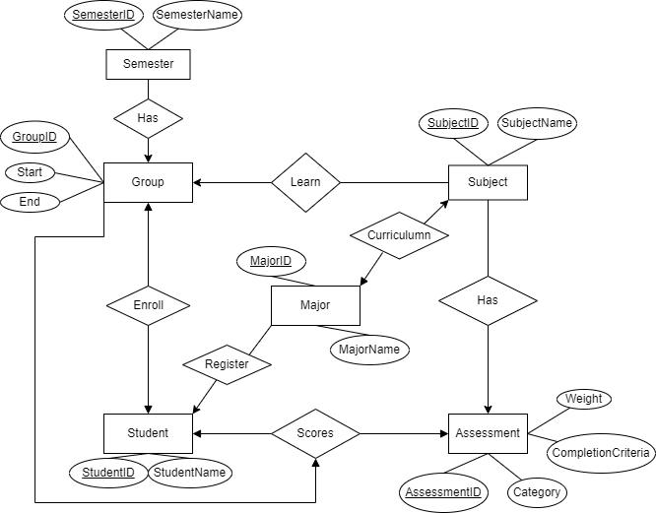

3) RELATIONAL SCHEMA
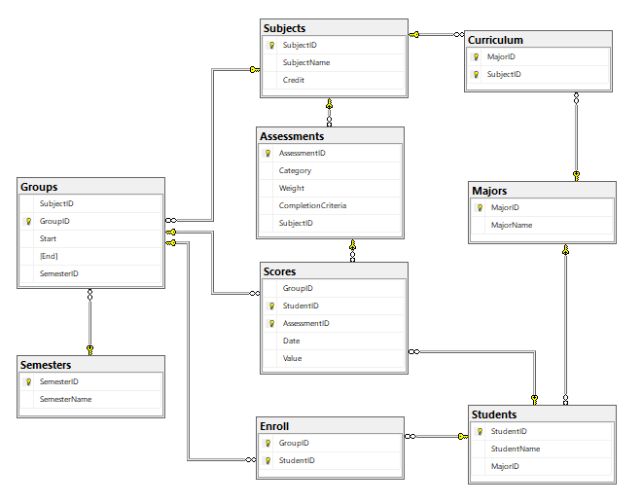

4) THE SET OF DATABASE STATEMENTS USED TO CREATE THE TABLES
Create table Subjects(
SubjectID nchar(6) PRIMARY KEY,
SubjectName nvarchar(50) not null,
Credit int
)

Create table Semesters(
SemesterID nvarchar(10) not null PRIMARY KEY,
SemesterName nvarchar(20) not null
)

Create table Majors(
MajorID nvarchar(5) primary key,
MajorName nvarchar (20) not null
)

Create table Students(
StudentID int not null PRIMARY KEY,
StudentName nvarchar(50) not null,
MajorID nvarchar(5) FOREIGN KEY REFERENCES [Majors](MajorID)
)

Create table Curriculum(
MajorID nvarchar(5) not null FOREIGN KEY REFERENCES [Majors](MajorID),
SubjectID nchar(6) not null FOREIGN KEY REFERENCES [Subjects](SubjectID),
CONSTRAINT pk_Curriculum PRIMARY KEY ([MajorID],[SubjectID])
)

Create table Assessments(
AssessmentID int not null PRIMARY KEY,
Category nvarchar(50) not null ,
[Type] nvarchar(50) not null CHECK ([type] in ('quiz','on-going','pratical exam','final exam')),
[Weight] float not null,
CompletionCriteria nvarchar,
SubjectID nchar(6) not null FOREIGN KEY REFERENCES [Subjects](SubjectID)
)

Create Table Scores(
StudentID int not null FOREIGN KEY REFERENCES [Students](StudentID),
AssessmentID int not null FOREIGN KEY REFERENCES [Assessments](AssessmentID),
[Date] date not null,
[Value] float,
CONSTRAINT pk_Scores PRIMARY KEY ([AssessmentID],[StudentID])
)

Create table Groups(
SubjectID nchar(6) not null FOREIGN KEY REFERENCES [Subjects](SubjectID),
GroupID nvarchar(20) not null PRIMARY KEY,
[Start] date not null,
[End] date not null,
SemesterID nvarchar(10) not null FOREIGN KEY REFERENCES [Semesters](SemesterID)
)

Create table Enroll(
GroupID nvarchar(20) not null FOREIGN KEY REFERENCES [Groups](GroupID),
StudentID int not null FOREIGN KEY REFERENCES [Students](StudentID),
CONSTRAINT pk_Group_Student PRIMARY KEY ([GroupID],[StudentID])
)

5) QUERY
-- Display test scores in ascending order of a class
-- Example: FE of SE1647_DBI202
Select s.StudentName,g.GroupID,a.Category,sc.Value
From Scores sc INNER JOIN Groups g ON sc.GroupID=g.GroupID
INNER JOIN Students s ON s.StudentID=sc.StudentID
INNER JOIN Assessments a ON a.AssessmentID=sc.AssessmentID
WHERE g.GroupID='SE1647_PRO192' and a.Category='FE'
Order by sc.Value

--Function calculate AVG of students
Create function Average
( @studentID int,
@groupID nvarchar(20)
)
Returns float
as
BEGIN
Declare @FE float
Declare @FEresist float
Declare @removedFE float
Set @removedFE=0
Declare @AVG float
Select @FEresist=sc.Value*a.Weight
From Scores sc INNER JOIN Groups g ON sc.GroupID=g.GroupID
INNER JOIN Students s ON s.StudentID=sc.StudentID
INNER JOIN Assessments a ON a.AssessmentID=sc.AssessmentID
WHere g.GroupID=@groupID and s.StudentID=@studentID and a.Category='FE(Resist)'

Select @FE=sc.Value*a.Weight
From Scores sc INNER JOIN Groups g ON sc.GroupID=g.GroupID
INNER JOIN Students s ON s.StudentID=sc.StudentID
INNER JOIN Assessments a ON a.AssessmentID=sc.AssessmentID
WHere g.GroupID=@groupID and s.StudentID=@studentID and a.Category='FE'

if @FEresist is not null
SET @removedFE=@FE

Select @AVG=SUM(Isnull(sc.Value,0)*a.[Weight])-@removedFE
From Scores sc INNER JOIN Groups g ON sc.GroupID=g.GroupID
INNER JOIN Students s ON s.StudentID=sc.StudentID
INNER JOIN Assessments a ON a.AssessmentID=sc.AssessmentID
WHERE g.GroupID=@groupID and s.StudentID=@studentID
Group by s.StudentName,g.GroupID

Return @AVG
END
-- Calculate AVG score of a class
Select s.StudentName,g.GroupID,
[dbo].Average(s.StudentID,g.GroupID) as AVG
From Groups g INNER JOIN Enroll e ON e.GroupID=g.GroupID
INNER JOIN Students s ON s.StudentID=e.StudentID
Where g.GroupID='SE1647_DBI202'

-- Students can check their details scores of each subject
Select s.StudentName, g.GroupID, g.SubjectID,a.Category,sc.Value
From Scores sc INNER JOIN Groups g ON sc.GroupID=g.GroupID
INNER JOIN Students s ON s.StudentID=sc.StudentID
INNER JOIN Assessments a ON a.AssessmentID=sc.AssessmentID
Where g.GroupID='SE1647_CSD201' and s.StudentID=1

--Display student not enroll any class
Select s.StudentName
From Students s LEFT JOIN Enroll e ON e.StudentID=s.StudentID
Where e.GroupID is null

--Check student pass or not pass
Create function CheckStatus
(
@ID int,
@groupID nvarchar(20)
)
Returns nvarchar(20)
AS
BEGIN
DECLARE @Status nvarchar(20)
DECLARE @AVG FLOAT;
DECLARE @FE FLOAT;
DECLARE @FEresist FLOAT;
DECLARE @Min FLOAT;
SET @Status = 'PASS';

Set @AVG=[dbo].Average(@ID,@groupID)
if @AVG<5
Set @Status = 'NOT PASS'

Select @FEresist=isnull(sc.Value,0)
From Scores sc INNER JOIN Groups g ON sc.GroupID=g.GroupID
INNER JOIN Students s ON s.StudentID=sc.StudentID
INNER JOIN Assessments a ON a.AssessmentID=sc.AssessmentID
WHere g.GroupID=@groupID and s.StudentID=@ID and a.Category='FE(Resist)'

Select @FE=isnull(sc.Value,0)
From Scores sc INNER JOIN Groups g ON sc.GroupID=g.GroupID
INNER JOIN Students s ON s.StudentID=sc.StudentID
INNER JOIN Assessments a ON a.AssessmentID=sc.AssessmentID
WHere g.GroupID=@groupID and s.StudentID=@ID and a.Category='FE'

if @FEresist <> 0
if @FEresist < 4 SET @Status='NOT PASS'

if @FE <4 or @FE=0
if @FEresist<4 or @FEresist =0
SET @Status='NOT PASS'

Select @MIN=MIN(isnull(sc.Value,0))
FROM Scores sc INNER JOIN Assessments a ON sc.AssessmentID=a.AssessmentID
WHERE GroupID=@groupID and StudentID=@ID and a.Category<>'FE' and a.Category<>'FE(Resist)'
IF @MIN=0
SET @Status='NOT PASS'

return @Status
END

--Calculate GPA of a student in one semester
--Example: studentID = 1 and SemesterID = Su2022
Select s.StudentName, SUM([dbo].Average(s.StudentID,g.GroupID))/10*4 as GPA
From Groups g INNER JOIN Enroll e ON e.GroupID=g.GroupID
INNER JOIN Subjects su ON su.SubjectID=g.SubjectID
INNER JOIN Students s ON s.StudentID=e.StudentID
INNER JOIN Semesters se ON g.SemesterID=se.SemesterID
Where s.StudentID = 1 AND g.SemesterID='Su2022'
Group by s.StudentName

--Find student has highest GPA of a major in 1 semester (coc vang)
--Example: SE, Summer 2022
Select top 1 s.MajorID,s.StudentName, AVG([dbo].Average(s.StudentID,g.GroupID))/10*4 as GPA
From Groups g INNER JOIN Enroll e ON e.GroupID=g.GroupID
INNER JOIN Subjects su ON su.SubjectID=g.SubjectID
INNER JOIN Students s ON s.StudentID=e.StudentID
INNER JOIN Semesters se ON g.SemesterID=se.SemesterID
INNER JOIN Majors m ON s.MajorID=m.MajorID
Where s.MajorID='SE' and g.SemesterID='Su2022'
Group by s.StudentName,s.MajorID
Order by GPA DESC
6) TRIGGER, PROCEDURE, VIEW
a, Trigger
--This trigger is used to prevent insert false weight of assesment, total weight of a subject = 1
Create Trigger Trigger_Weight ON Assessments
After INSERT,UPDATE
AS
DECLARE @Total float
Declare @Subject nchar(8)
Select @Subject= SubjectID from inserted
Select @Total=Sum(Weight) From Assessments Where SubjectID=@Subject
If @Total<>1
BEGin
print 'Total weight of subject must equal 1'
Rollback tran
END

b, Procedure
--PROCEDURE total GPA of a Student
Alter Procedure caculateGPA
@ID int
AS
BEGIN
Declare @totalCredit int
Declare @Major nvarchar(5)

Select @Major=MajorID from Students Where StudentID=@ID

Select @totalCredit=SUM(su.Credit)
FROM Majors m INNER JOIN Curriculum c ON m.MajorID=c.MajorID
INNER JOIN Subjects su ON su.SubjectID=c.SubjectID
Where c.MajorID=@Major

Select s.StudentID,s.StudentName, SUM(isnull([dbo].Average(s.StudentID,g.GroupID),0)*su.Credit)/@totalCredit*4/10 as GPA
From Groups g INNER JOIN Enroll e ON e.GroupID=g.GroupID
INNER JOIN Subjects su ON su.SubjectID=g.SubjectID
INNER JOIN Students s ON s.StudentID=e.StudentID
INNER JOIN Semesters se ON g.SemesterID=se.SemesterID
Where s.StudentID=@ID
Group by s.StudentID,s.StudentName
RETURN 0;
END

