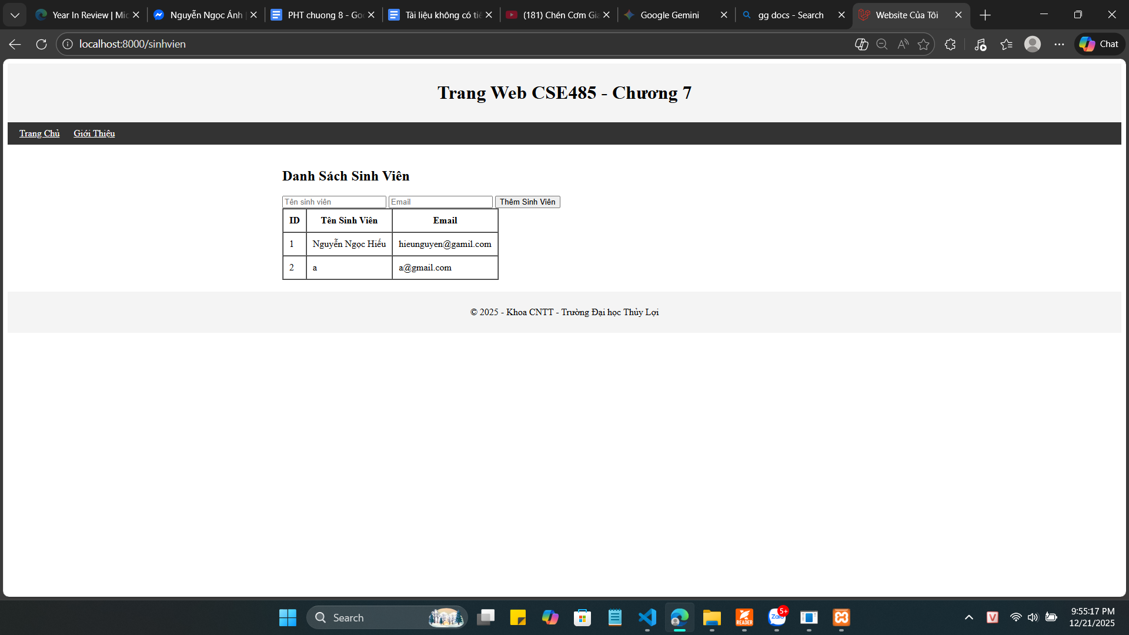

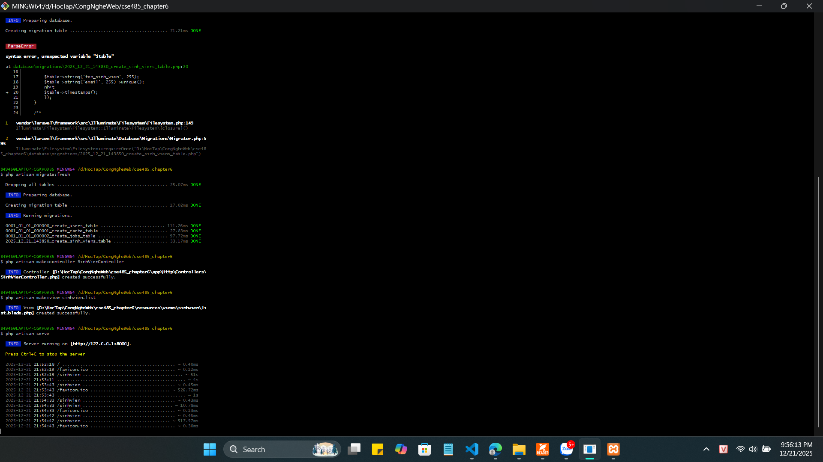

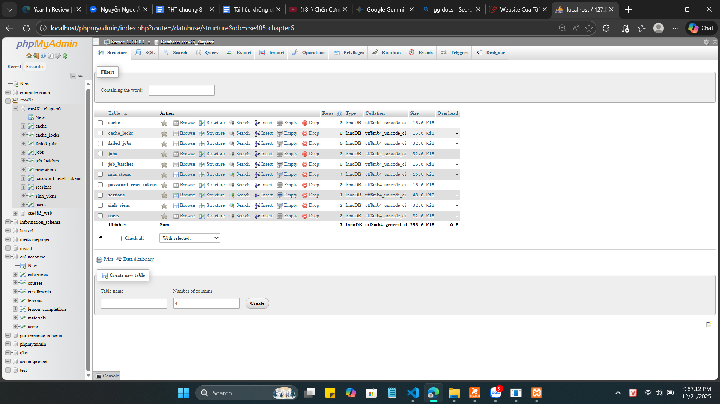

1. Hàm up() trong file Migration
public function up(): void
{
Schema::create('sinh_viens', function (Blueprint $table) {
$table->id();
$table->string('ten_sinh_vien', 255);
$table->string('email', 255)->unique();
$table->timestamps();
});
}

2. file app/Models/SinhVien.php
<?php

namespace App\Models;

use Illuminate\Database\Eloquent\Model;
use Illuminate\Database\Eloquent\Factories\HasFactory;

class SinhVien extends Model
{
use HasFactory;

protected $fillable = [
'ten_sinh_vien',
'email',
];
}
3. file app/Http/Controllers/SinhVienController.php
<?php

namespace App\Http\Controllers;

use Illuminate\Http\Request;
use App\Models\SinhVien;

class SinhVienController extends Controller
{
public function index()
{
$danhSachSV = SinhVien::all();

return view('sinhvien.list', compact('danhSachSV'));
}
public function store(Request $request)

{
$data = $request->all();

SinhVien::create($data);

return redirect()->route('sinhvien.index');
}

}

4.routes/web.php

<?php
use App\Http\Controllers\SinhVienController;

use Illuminate\Support\Facades\Route;

Route::get('/sinhvien', [SinhVienController::class, 'index'])->name('sinhvien.index');
Route::post('/sinhvien', [SinhVienController::class, 'store'])->name('sinhvien.store');

Câu hỏi:
Tại sao Laravel bắt buộc phải khai báo $fillable khi sử dụng hàm ::create($request->all())?

