

PROJECT REPORT

EMPLOYEE PAYROLL MANAGEMENT SYSTEM

SUBJECT: LAB211

INSTRUCTOR: NGUYEN TAN PHUC

Student Name: Nguyễn Trung Hiếu

Student Code: SE203599

Class: SE2025

Mục lục
1. Introduction 3
2. Requirement Analysis 3
2.1. Functional Requirements Matrix 3
F01: Load Employee Data from File 3
F02: Add a New Employee 3
F03: Update Employee Information 4
F04: Remove an Employee 4
F05: Search Employees by Attribute 4
F06: Calculate Monthly Payroll 4
F07: Display Employee List 4
F08: Save Data to File 5
F09: Quit Program 5
2.2. Data Validation Rules and Integrity Constraints 5
3. Applying Computational Thinking 6
3.1. Decomposition 6
3.2. Pattern Recognition 6
3.3. Abstraction 7
3.4. Algorithm Design 7
Algorithm 1: Safe Record Insertion (Add Employee) 7
Algorithm 2: Automated Monthly Payroll Computation 8
4. System Design (Architecture & Class Structure) 8
4.1. Layered MVC + Service Architecture 8
4.2. Class Responsibilities and Interdependencies 8
5. Implementation & Testing 9
5.1. Key Implementation Details 9
5.2. Test Cases 10
6. Experimental Results 11
6.1. Main Menu 12
6.2. Load Employee Data from File 12
6.3. Add a New Employee 12
6.4. Update Employee Information 13
6.5. Remove an Employee 13
6.6. Search Employees by Attribute 14
6.7. Calculate Monthly Payroll 14
6.8. Save Data to File 15
7. Appendix 16
7.1. Source Files Registry 16
7.2. Flat-File Database Layout (employees.txt) 17

1. Introduction
In contemporary enterprise environments, human resource management and payroll administration constitute critical operational backbones. Manual execution of payroll computations is inherently susceptible to human error, procedural delays, and data inconsistencies. To address these operational challenges, this technical report documents the development of the Employee Payroll Management System, a robust, high-performance console application engineered using the Java programming language. The primary objective of this system is to streamline the administration of corporate employee records, fully automate monthly salary calculations, enforce strict input validation boundaries, and ensure reliable long-term data persistence using a local flat-file storage strategy.
The engineering process behind this system explicitly adheres to the core paradigms of Object-Oriented Programming (OOP) and integrates Computational Thinking (CT) methodologies to break down, model, and resolve complex structural demands. By utilizing encapsulation, inheritance, polymorphism, and abstraction, the application achieves a highly modular, maintainable, and scalable architecture. This application provides human resource operators with an interactive console interface capable of executing safe Create, Read, Update, and Delete (CRUD) pipelines, conducting advanced partial-match queries, and conducting instant monthly payroll generation based on dynamic parameters.
Furthermore, the architecture employs a layered variant of the Model-View-Controller (MVC) design pattern combined with a dedicated Service layer to guarantee a strict separation of concerns. The interface is optimized for rapid human-machine interaction through the command-line console, incorporating customized validation routines that capture runtime exceptions, boundary violations, and format anomalies prior to data commitment. This ensures that the underlying database remains structurally pristine and completely reliable throughout the lifecycle of the business application.

2. Requirement Analysis

2.1. Functional Requirements Matrix

F01: Load Employee Data from File
- Input Parameters: None (Target file path is hardcoded or resolved contextually).
- Core Processing Logic: Opens target storage file; reads content sequentially line-by-line; splits comma-separated string variables; validates and parses data types; instantiates model objects; populates the runtime in-memory list infrastructure.
- Expected System Output: Displays a success console message indicating the exact number of employee objects safely recovered from the file.

F02: Add a New Employee
- Input Parameters: ID, Name, Role, Base Salary, Working Days, Bonus, Status.
- Core Processing Logic: Prompts the operator sequentially; validates ID format against regex and ensures absolute runtime uniqueness; verifies range bounds for salary and working days; constructs a new instance and injects it into memory.
- Expected System Output: Prints a real-time console notification confirming successful registration of the unique record.

F03: Update Employee Information
- Input Parameters: Target Employee ID, Target Field Choice, New Field Value.
- Core Processing Logic: Locates the specific target record; presents a specialized loop sub-menu for individual property selection; updates the single field dynamically while preserving all other properties intact.
- Expected System Output: Displays current property metrics pre-edit, performs dynamic type casting, and emits an "Update Successful" status flag.

F04: Remove an Employee
- Input Parameters: Target Employee ID, Deletion Confirmation (Y/N).
- Core Processing Logic: Queries the list for the specified unique ID; isolates the object; displays full contextual details to prevent erroneous removal; enforces an explicit console confirmation check; purges the object from the list.
- Expected System Output: Displays a localized "Deleted successfully" affirmation message or aborts the structural state shift if rejected.

F05: Search Employees by Attribute
- Input Parameters: Search Criterion (ID / Name / Role / Status), Search Keyword String.
- Core Processing Logic: Prompts choice selection; evaluates target fields; implements case-insensitive partial string matching across the collection using string filtering pipelines; handles zero-result exceptions gracefully.
- Expected System Output: Renders a cleanly structured, formatted grid table displaying all records containing matching text fragments.

F06: Calculate Monthly Payroll
- Input Parameters: None.
- Core Processing Logic: Iterates through the active runtime list; triggers internal math formulas on each object; maps calculated totals to transient memory fields; transfers compiled data structures to the view layout engine.
- Expected System Output: Generates a comprehensive corporate payroll matrix grid containing full computations, base metrics, and individual total compensation figures.

F07: Display Employee List
- Input Parameters: None.
- Core Processing Logic: Inspects list state; loops over active items; maps enum references to friendly string representations; evaluates internal collection sizing metrics.
- Expected System Output: Renders a comprehensive multi-column text table displaying all registered employees with standard alignments.

F08: Save Data to File
- Input Parameters: None.
- Core Processing Logic: Opens file writers; iterates over collection; converts object domains to structured CSV formatted string buffers; writes buffers to file; flushes stream resources; updates system state flags to clean.
- Expected System Output: Outputs a confirmation message stating data has been safely written to the storage system.

F09: Quit Program
- Input Parameters: Unsaved Change Prompt Choice (Y/N) if dirty flag active.
- Core Processing Logic: Evaluates state dirty flags; triggers safe exit prompts if changes remain uncommitted; closes scanning wrappers; terminates the current Java Virtual Machine process stack gracefully.
- Expected System Output: Closes the physical terminal application safely or falls back to execution loops if cancelled.

2.2. Data Validation Rules and Integrity Constraints
To protect the system against data corruption and logic errors, the application implements an extensive validation layer. This layer validates all interactive data entries prior to updating memory states. The validation parameters are formally structured as follows:
- Employee Identifier (ID): Must strictly comply with the regular expression pattern ^E\d{3}$ (e.g., E001, E102). Any string falling outside this standard format or conflicting with an existing identifier already present in the memory repository is rejected immediately.
- Employee Full Name: Must be a non-empty, non-null text string. It must contain alphabet characters and reasonable spacing, filtering out purely numeric or specialized symbol payloads.
- Corporate Role: Restricted exclusively to a pre-defined set of enterprise enumeration configurations: DEVELOPER, TESTER, MANAGER, or HR. Input choices are mapped via numerical menu boundaries (1 through 4) to eliminate typing bugs.
- Base Salary & Bonus: Must be declared as positive double-precision floating-point numbers. Negative inputs are intercepted by the validation engine, requiring re-entry.
- Working Days: Must be a precise integer value restricted strictly to the operational calendar range of 0 to 26 days inclusive.
- Operational Status: Bound tightly to the enumeration options ACTIVE or INACTIVE, preventing arbitrary state strings from corrupting the analytical modules.

3. Applying Computational Thinking

3.1. Decomposition
Decomposition involves breaking down a large, complex software application into distinct, self-contained packages and classes that communicate through clean application programming interfaces. The Employee Payroll Management System is decomposed into the following operational components:
- Model Component (Employee.java): Acts as the blueprint for employee data. It encapsulates individual attributes, maintains getter and setter methods, and exposes the mathematical calculation engine that computes employee compensation.
- Service Component (EmployeeService.java): Manages the central runtime in-memory database. It hosts the primary collection array list, coordinates Create, Read, Update, and Delete operations, and interfaces directly with the storage subsystem.
- Data Access Layer (IFileReadWrite.java, EmployeeFile.java): Separates the application logic from physical file storage. It handles disk input/output operations, manages reader/writer streams, and parses characters to and from data models.
- Controller Component (Controller.java): Functions as the operations hub of the system. It handles the application's flow of control by validating data structures, calling business logic methods within the service layer, and routing results to the user interface.
- View Infrastructure (View.java, Menu.java): Manages the console presentation layer. It displays formatted data grids and handles terminal input scanning.
- Utility Framework (Inputer.java, Validator.java, EmployeeRole.java): Provides reusable utility methods, such as regular expression matchers, boundary-checked numerical scanners, and enterprise enumeration utilities.

3.2. Pattern Recognition
By identifying patterns across various functional components, the system implements uniform, reusable solutions for recurring challenges. The following major design and structural patterns are applied throughout the software architecture:
- The Centralized Validation Pattern: Every data collection routine follows an identical validation lifecycle: loop indefinitely → prompt user input → execute verification matching → catch exceptions → break loop only upon receipt of pristine data.
- The Uniqueness Verification Pattern: Prior to adding or modifying records, the controller executes an iterative search pattern across the active collection to confirm that the proposed ID does not conflict with any existing records.
- The Linear Collection Filtering Pattern: Search operations across various attributes (such as ID, Name, Role, or Status) use a consistent matching pattern: loop over the entire collection, cast properties to lowercase, perform string comparison matches, and append positive matches to a temporary results list.

3.3. Abstraction

Essential data and behaviour are captured while implementation details are hidden safely across the system components:

Employee Class: Encapsulates only the specific attributes strictly required for processing corporate payroll (such as id, name, role, baseSalary, workingDays, bonus, status, and the dynamically computed salary). It hides internal data representations and restricts direct modification, exposing access only via managed public methods.

IFileReadWrite<T> Interface: Abstracts complex file input and output operations into two primary contract methods: loadFromFile() and saveToFile(List<T>). This structural abstraction allows the EmployeeService to remain entirely independent of the underlying flat-file format, CSV parsing logic, or specific stream management implementations.

EmployeeRole.Role (Enum): Abstracts the fixed domain of valid corporate positions within the organization. It eliminates the risks of arbitrary text inputs and encapsulates localized helper utilities for robust string-to-object conversions and smooth console menu selection.

Inputer Class: Abstracts all interactive console scanning, type-parsing, and validation routines. By handling formatting exceptions, regular expression checks, and error loop cycles internally, it allows the Controller layer to acquire clean, pre-validated data structures through simple method calls without dealing with raw UI validation states.

3.4. Algorithm Design
The application's business logic is driven by precise, step-by-step processing algorithms. Two core system operations are detailed below:

Algorithm 1: Safe Record Insertion (Add Employee)
- Step 1: Request a new identification string from the console interface.
- Step 2: Pass the string to the regular expression validation engine to check compliance with the ^E\d{3}$ pattern. If invalid, display an error and return to Step 1.
- Step 3: Query the data service layer to ensure the ID does not already exist in the system. If a duplicate is found, display an error and return to Step 1.
- Step 4: Request the employee name string. Validate that it contains appropriate alphabetical characters and is not empty.
- Step 5: Render the job role sub-menu. Scan the user's numeric choice (1-4) and map it to the corresponding Role enum value.
- Step 6: Request the numerical Base Salary and Bonus amounts. Intercept any negative values and require re-entry.
- Step 7: Prompt for Working Days. Ensure the value is an integer within the valid range of 0 to 26 inclusive.
- Step 8: Instantiate a new Employee object with the validated fields and add it to the in-memory array list.
- Step 9: Toggle the system dirty state flag to true and display a success confirmation message.

Algorithm 2: Automated Monthly Payroll Computation
- Step 1: Retrieve the complete list of employee records from the active data service.
- Step 2: Check if the list is empty. If no records are found, send an empty status alert to the presentation layer and terminate the routine.
- Step 3: Loop through each Employee object in the collection.
- Step 4: Extract the baseSalary, workingDays, and bonus variables from the current object.
- Step 5: Apply the system payroll formula: Total Salary = (Base Salary * Working Days) + Bonus.
- Step 6: Assign the calculated total to the object's transient salary field.
- Step 7: Pass the fully updated collection to the tabular rendering engine to display the compiled payroll matrix.

4. System Design (Architecture & Class Structure)

4.1. Layered MVC + Service Architecture
The application follows a structured Model-View-Controller (MVC) design pattern combined with a dedicated Service layer. This separation of concerns ensures that the user interface, data validation, business logic, and file storage components remain isolated from one another.
Under this architecture, the View layer focuses entirely on rendering menu structures and scanning raw input strings from the terminal. The Controller layer coordinates operations by capturing input from the view, passing it to utility classes for validation, routing clean parameters to the Service layer, and returning the results back to the view for formatting. The Service layer manages the application state and business logic, while the File Data Access layer handles reading from and writing to the physical disk. This decoupled design makes it easy to swap out components, such as replacing the console interface with a graphical UI or migration from flat files to a relational SQL database, without rewriting the core application logic.

4.2. Class Responsibilities and Interdependencies
The system is organized into decoupled packages that separate responsibilities across distinct operational boundaries:
Package | Class / Interface | Responsibility
controller | Main.java | Entry point: wires Scanner, View, Controller, Menu together
 | Controller.java | Business logic coordinator: calls Service and View for each operation
view | Menu.java | Main menu loop: dispatches to Controller based on user choice
 | View.java | All console I/O: displaying menus, tables, prompts, reading input
model | Employee.java | Data model: all fields + getters/setters + calSalary()
service | EmployeeService.java | In-memory list management: add, find, delete, getAll, save, load
files | IFileReadWrite<T> | Generic interface: loadFromFile() and saveToFile(List<T>)
 | EmployeeFile.java | CSV-based file handler: implements IFileReadWrite<Employee>
utils | Inputer.java | Validated input prompts for all Employee fields
 | Validator.java | Static regex validators: validEmpId(), validString()
 | EmployeeRole.java | Enum Role + helper methods for conversion and menu display
Key design decisions:
- Controller accepts View via constructor injection, enabling separation between UI and logic.
- EmployeeService accepts IFileReadWrite<Employee> via constructor injection, making the file layer swappable.
- Inputer is instantiated inside Controller with a reference to both View and EmployeeService, allowing it to validate uniqueness during input.
- Menu holds references to both View and Controller; the main loop sits in displayMenu() and dispatches all 9 operations.

5. Implementation & Testing

5.1. Key Implementation Details
The application is built on several key implementation patterns that ensure stability and data integrity:
- Stream-Based File I/O: File operations use BufferedReader and BufferedWriter wrapped inside FileReader and FileWriter blocks. This approach processes data line-by-line using structured string splitting, and ensures file handles are safely closed even if a runtime exception occurs.
- Defensive Validation Infrastructure: Input routines use loop structures that intercept invalid data at the boundary. If validation fails, the system catches the error, displays a clear message, and prompts for re-entry without crashing the application.
- Dynamic Entity Modification: The update subsystem allows modifying individual fields without re-entering the entire record. It reads current values from memory, presents an update menu, modifies only the selected attribute, and leaves all other properties unchanged.

5.2. Test Cases
TCs ID | Test Functionality | Input / Action | Expected Output
TC01 | Add a valid new employee (Positive) | ID=E123, Name=Nguyen Trung Hieu, Role=1 (DEVELOPER), Base Salary=5000, Working Days=26, Bonus=1000, Status=1 (ACTIVE) | The system successfully accepts data, instantiates the record in memory, and displays: >> Add Employee successful!
TC02 | Add an employee with a duplicate ID (Negative) | Enter ID=E123 (which already exists in the system from TC01) | The validation engine detects the duplicate identifier, blocks data commitment, and outputs: Error: ID already exists (prompts for re-entry).
TC03 | Add an employee with an invalid ID format (Negative/Regex) | Enter ID=EMP01 or e123 (violating the ^E\d{3}$ pattern) | The system rejects the payload and prompts: Error: Invalid ID format (E001) (requires uppercase 'E' followed by exactly 3 digits).
TC04 | Add an employee with an empty name string (Negative) | Leave Name completely blank (press Enter) or enter invalid symbols | The validation layer intercepts the empty input, blocks progress, and prompts the user for a valid alphabetical string.
TC05 | Input working days out of boundary limits (Boundary Value) | Enter Working Days = 27 or -1 (outside the logical range of 0 to 26 days) | The input handler intercepts the range violation and throws a localized error: Error: Number must be Range: 0–26
TC06 | Input negative financial metrics (Negative) | Enter Base Salary = -2000 or Bonus = -500 | The validation wrapper captures the negative floating-point numbers and requires the entry of positive real numbers.
TC07 | Update employee information successfully (Positive) | Query ID=E123, select field choice 1 (Name), and input: Nguyen Trung Hieu V2 | The system dynamically mutates the targeted property, leaves other attributes unchanged, and prints: >> Update Name success!!! followed by the new state grid.
TC08 | Remove an existing employee with confirmation (Positive) | Enter ID=E123, then input deletion confirmation flag = y or Y | The object is purged from the core ArrayList, and the system confirms: >> Deleted successfully!
TC09 | Remove a non-existent employee ID (Negative) | Enter ID=E999 (an ID that does not exist within the collection) | The query handler fails to locate the record and gracefully outputs: Error: Employee has not registered yet
TC10 | Perform a partial-match employee search (Positive) | Select search by Name, and enter the sub-string keyword: emma | The filtering pipeline executes a case-insensitive match and renders a grid containing both Emma Stone and Emma Wilson.
TC11 | Automated monthly payroll generation (Positive/Formula) | Select main menu Option 6 (Calculate monthly payroll) | The logic loops over the collection and accurately executes:  $$TotalSalary=BaseSalary×WorkingDays+Bonus$$  The view layouts render a clean, aligned table displaying the compiled matrix.

6. Experimental Results
The application was tested manually via the NetBeans IDE console. All 9 menu options executed correctly under both normal and boundary-case inputs. The screenshots below demonstrate the successful execution of key operations.

6.1. Main Menu
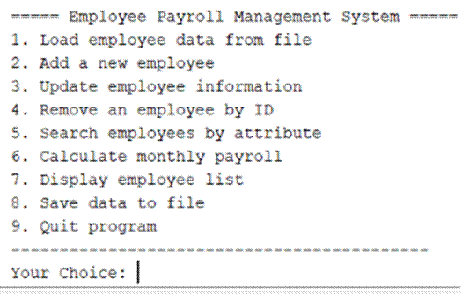
Figure 1: Main menu on startup

6.2. Load Employee Data from File
Selecting option 1 loads all employee records from employees.txt into memory. The system confirms how many employees were loaded.
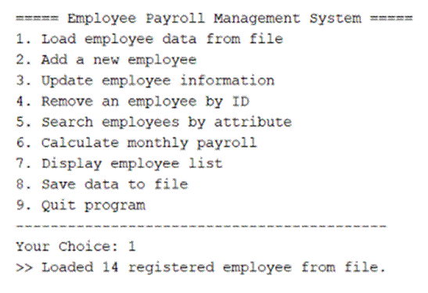
Figure 2: Load 14 employees from file

6.3. Add a New Employee
The system prompts for all required fields sequentially. Each input is validated before proceeding to the next field. Upon completion, a success message is displayed.
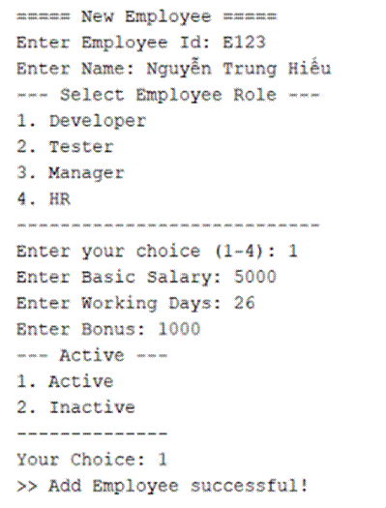
Figure 3: Add employee E123 – Nguyen Trung Hieu (DEVELOPER)

6.4. Update Employee Information
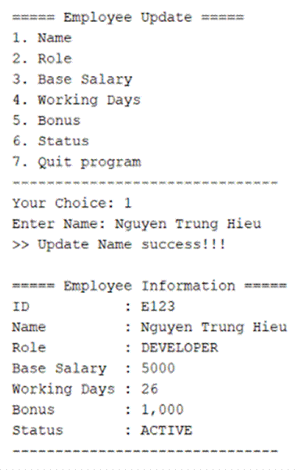

The update sub-menu displays current employee information before each edit. Fields can be updated individually without affecting the others.
Figure 4: Update name of employee E123

6.5. Remove an Employee
The system displays full employee information and requires Y/N confirmation before deletion, preventing accidental data loss.
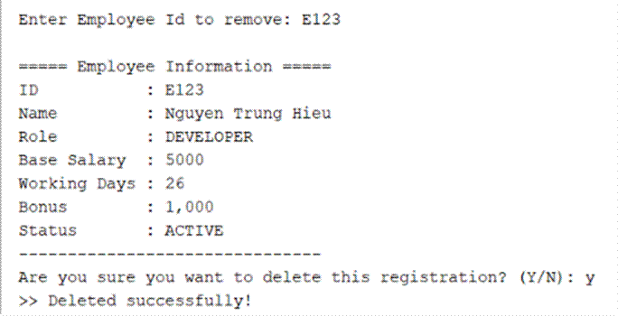
Figure 5: Remove employee E123 with confirmation

6.6. Search Employees by Attribute
Case-insensitive partial matching is applied for Name and ID searches. Searching for 'emma' returns both Emma Stone (E004) and Emma Wilson (E005).
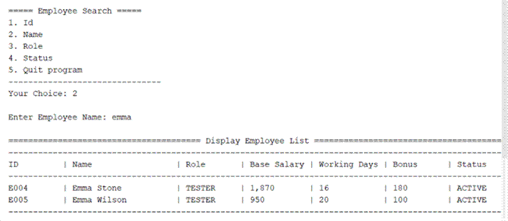
Figure 6: Search by name 'emma' – 2 results found

6.7. Calculate Monthly Payroll
Option 6 calculates and displays the total salary for every employee. The formula applied is: Total Salary = Base Salary × Working Days + Bonus.
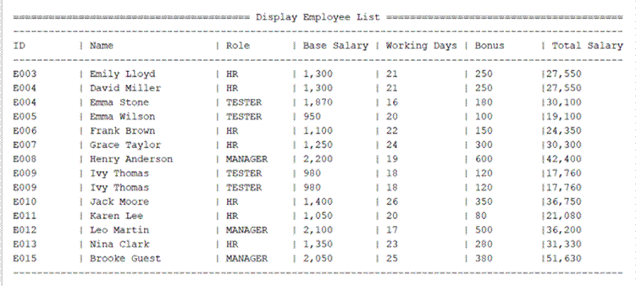
Figure 7: Monthly payroll calculation for all employees

6.8. Save Data to File
Option 8 persists the current in-memory employee list to employees.txt. A confirmation message is displayed upon successful save.
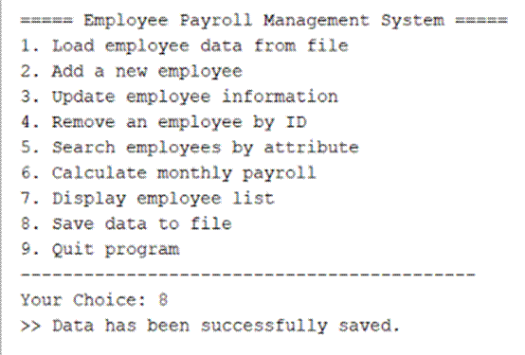
Figure 8: Data saved successfully to file

7. Appendix

7.1. Source Files Registry
The application codebase is organized into modular source files across packages. This structure separates core data models, business logic, file storage handlers, and interface views.
Package Location | Java Source File | Core Functional Summary Description
controller | Main.java | Contains the entry point method. It initializes the application, links dependency references, and loads the interface loop.
controller | Controller.java | Coordinates system workflows. It translates menu selections into actions and directs data between services and views.
view | Menu.java | Manages the command-line menu loop, displaying option catalogs and reading user choices.
view | View.java | Renders user interface layouts, formatting text tables, alignment grids, and data visualizations.
model | Employee.java | Defines the core data model entity. Encapsulates properties, provides getters/setters, and contains payroll calculation formulas.
service | EmployeeService.java | Provides runtime data operations for the employee list, managing record additions, edits, and removals.
files | IFileReadWrite.java | Declares the generic data access contract interface, defining standard load and save operations.
files | EmployeeFile.java | Implements flat-file storage logic, parsing data records to and from disk files.
utils | Inputer.java | Provides validated input scanning utilities, wrapping standard console inputs with exception-safe loop checks.
utils | Validator.java | Houses validation functions, verifying data criteria such as identification codes and regular expression matches.
utils | EmployeeRole.java | Maintains employment role enumerations and provides helper utilities for choice mappings.

7.2. Flat-File Database Layout (employees.txt)
The application uses a plain text file for data persistence. Records are saved sequentially using comma-separated values (CSV) matching the following layout:
E001,Emily Lloyd,HR,1300.00,21,250.00,ACTIVE
E002,David Miller,HR,1300.00,21,250.00,ACTIVE
E003,Emma Stone,TESTER,1870.00,16,180.00,ACTIVE
E004,Emma Wilson,TESTER,950.00,20,100.00,ACTIVE
E005,Frank Brown,HR,1100.00,22,150.00,ACTIVE
E006,Grace Taylor,HR,1250.00,24,300.00,ACTIVE
E007,Henry Anderson,MANAGER,2200.00,19,600.00,ACTIVE
E008,Ivy Thomas,TESTER,980.00,18,120.00,ACTIVE
E009,Jack Moore,HR,1400.00,26,350.00,ACTIVE
E010,Karen Lee,HR,1050.00,20,80.00,ACTIVE
E011,Leo Martin,MANAGER,2100.00,17,500.00,INACTIVE

