HO CHI MINH UNIVERSITY OF TECHNOLOGY

Faculty of Computer Science and Engineering

------------------------



Logic Design With Verilog

PROJECT REPORT

CAR ARLARM

Lê Nguyễn Anh Tú – 1751110

Nguyễn Hữu Anh Hiếu - 1652741

Ho Chi Minh, 3 Dec 2019

**CONTENTS**

# :

# Introduction…….……………….……………………….2

# :

# Design and Implementation…………………………….3

# :

# Testing…………………………………………………….4

# :

# Conclusion……………………………………………….5

**Chapter 1: Introduction**

*According to the FBI, a motor vehicle is stolen and/or broken into every* ***44 seconds*** *in the United States. Recent reports show that* ***over $4.3 billion*** *is lost every year due to vehicle theft, which is why more than ever, drivers need to make sure their vehicles are secured with a car alarm.*

**Raymond Ware**

* **How does a Car Alarm work?**

This security system will provide the owner with a range of notifications regarding their vehicle. The system will know when someone has started the vehicle’s engine without you in the car and provide an alert. The system can also provide alerts for unusual vibrations, such as when someone is trying to break into the vehicle. It will send an alert if the device has been disconnected and if the vehicle is being moved. It can also provide real-time tracking. The system keeps you fully updated about everything that’s happening with the vehicle, so you can alert the authorities if it is stolen



* **Devices and Tools:**

1. 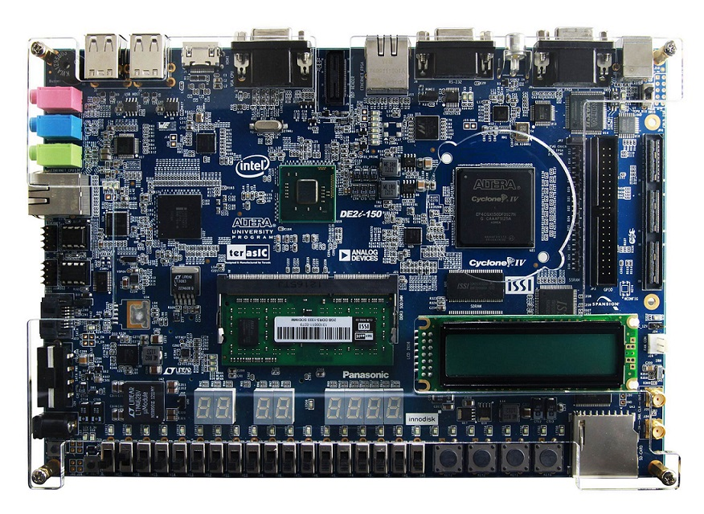DE2i-150 FPGA Development Kit and Remote

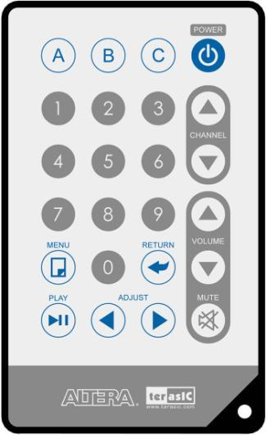

1. Quartus Prime Lite and ModelSim software

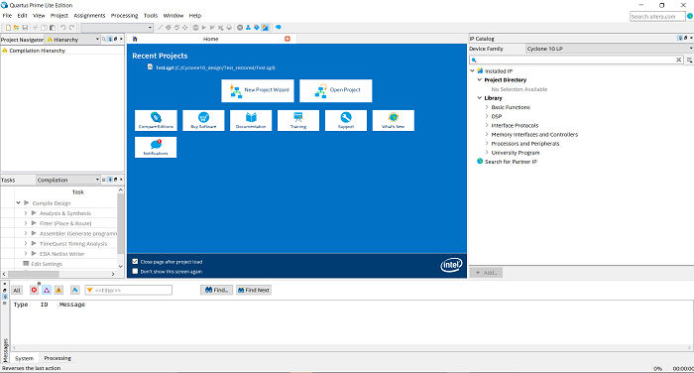

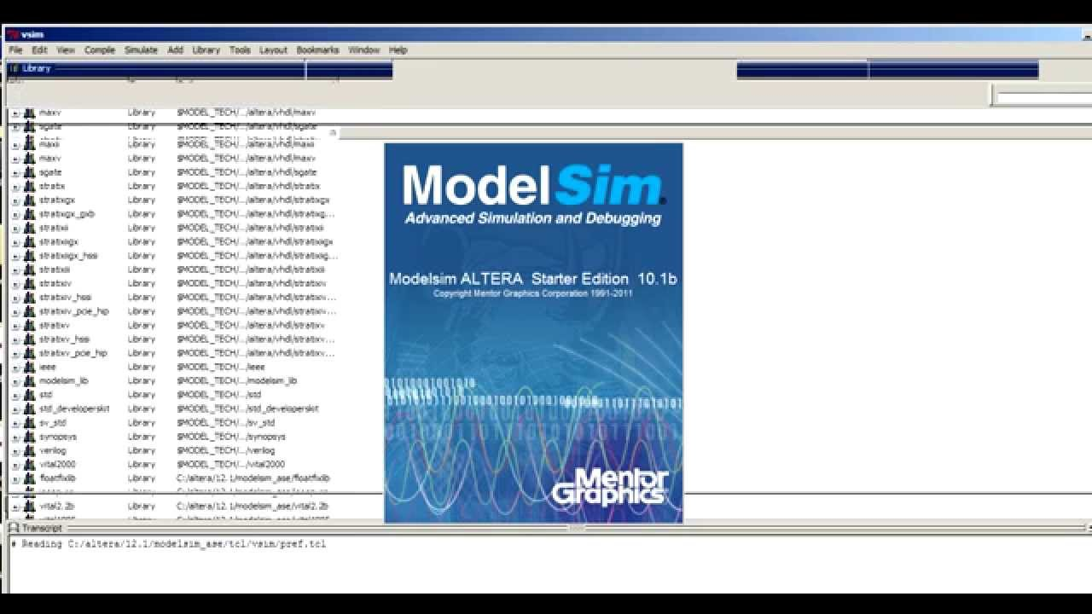

**Chapter 2: Design and Implementation**

* **Block-diagram**

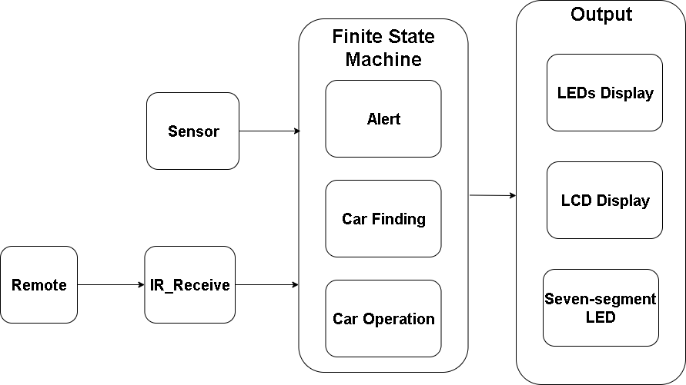

1. 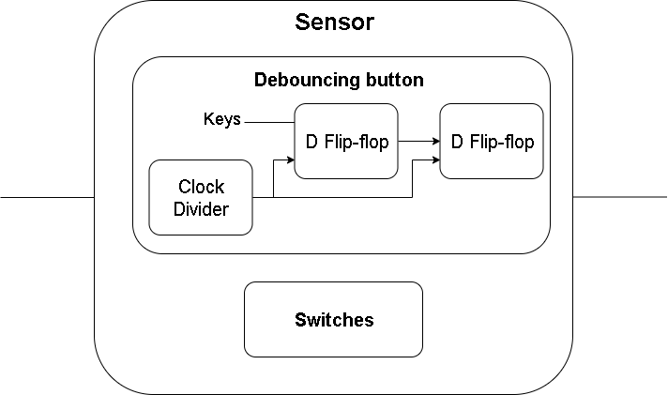Sensor

1. IR_Receive

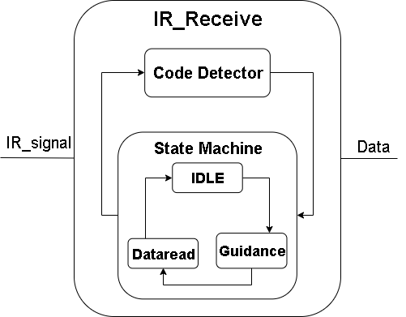

1. Finite State Machine

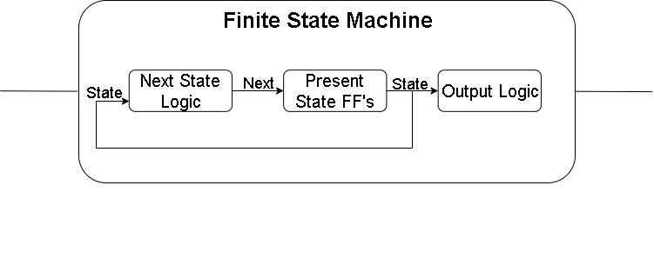

1. Output

* LEDs Display

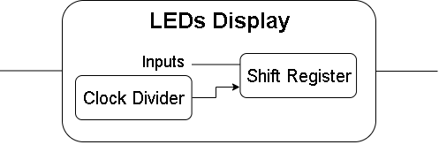

* Seven-segment LEDs

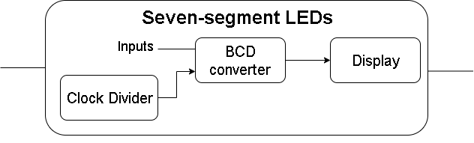

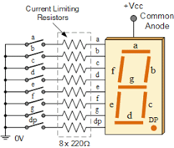

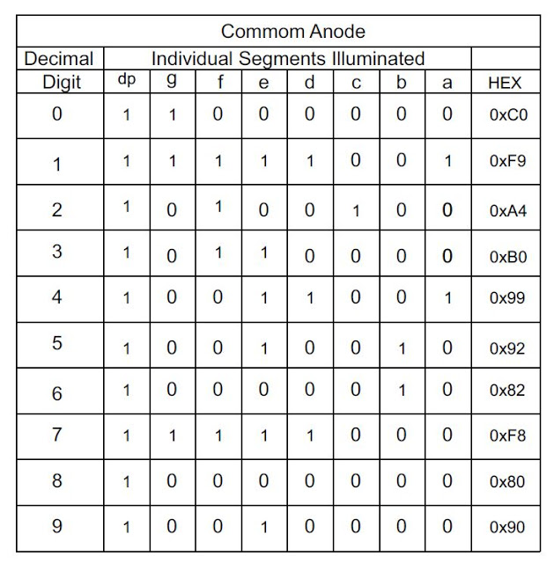

* LCD Display

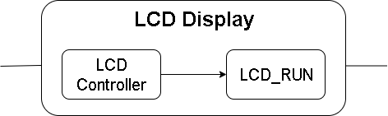

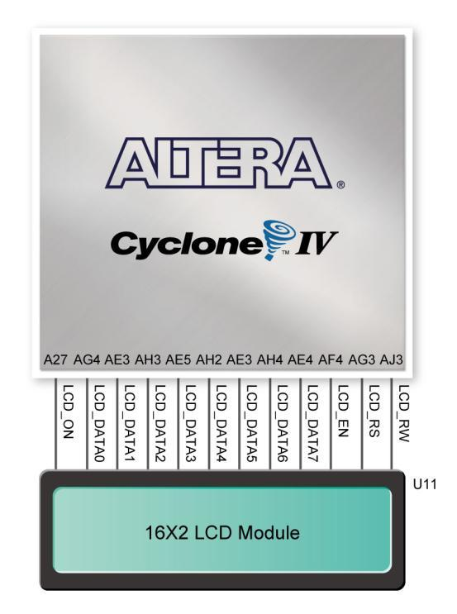



* **Interface of Car Alarm (main module)**

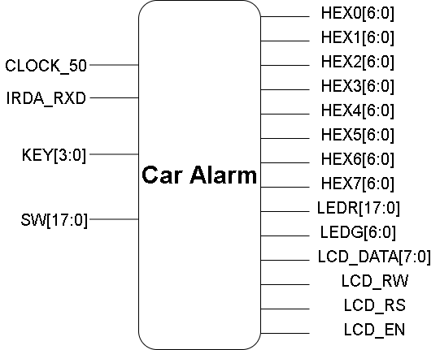

**Chapter 3: Testing**

* 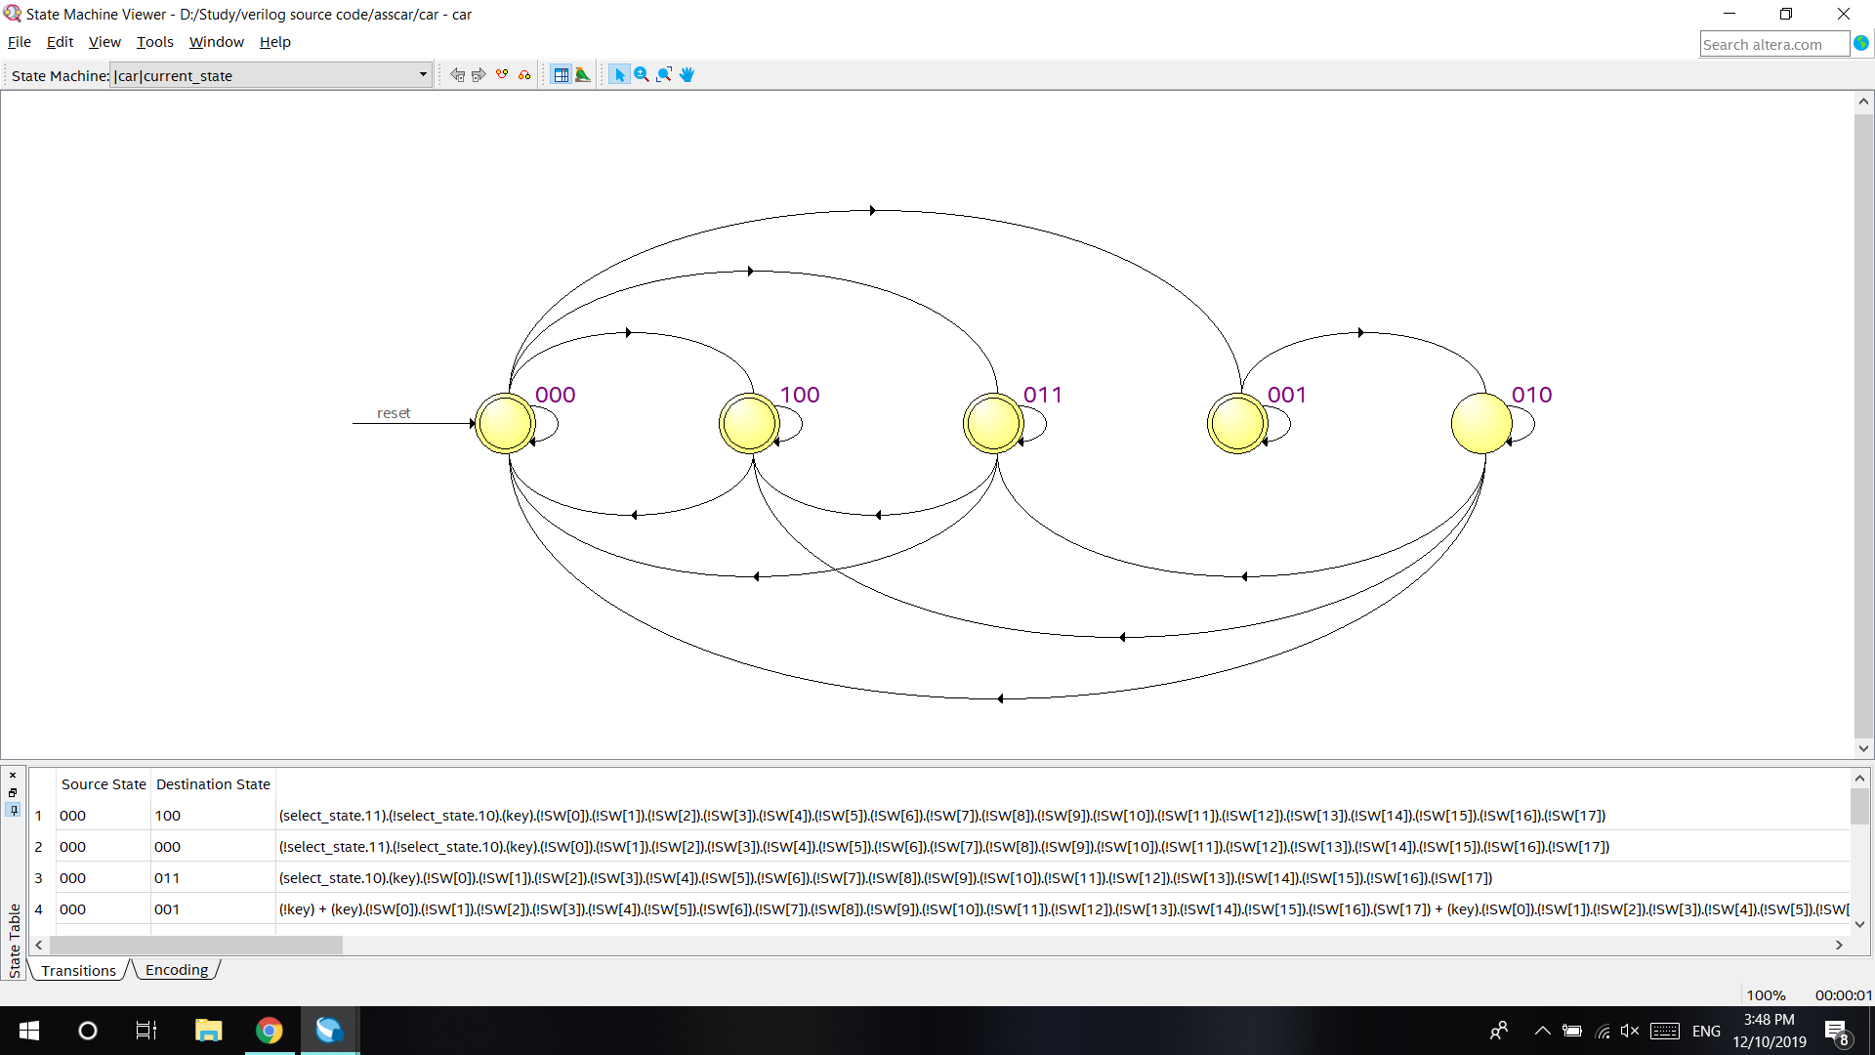**Test Case:**
* **Simulation results on DE2i-150 board**
* 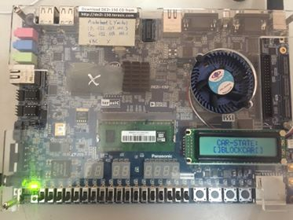State 000: Car Blocking

* State 001: Alert on

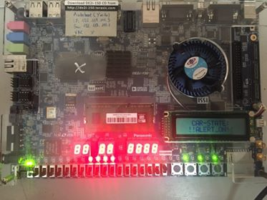

* State 010: Alert off

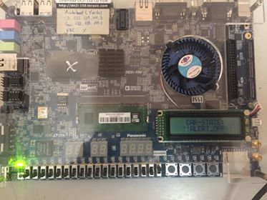

* State 011: Car Finding

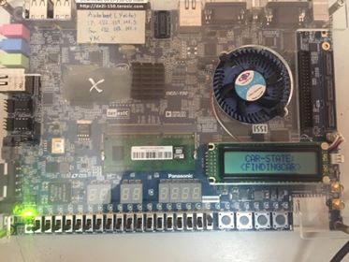

* State 100: Password Verification

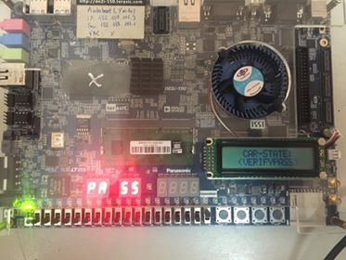

* Full simulation link:

<https://www.youtube.com/watch?v=CYgWz0DFw2g>

* **Chapter 4: Conclusion**
* **Functionalities**

There are **three** mains functionalities:

1.**Alert mode**: using remote => Press A to activate, press A again to inactivate

When car in alert mode => press any key, switch to active sensors => system is put into intrusion and the siren operating with running leds, LCD displays

2. **Finding car mode**: using remote => Press B to activate, press A again to inactivate

When car in finding car mode, siren operating with leds, LCD displays

3. **Car operation (Verify password) mode**: using remote => Press C to activate, press C again to inactivate

When car in car operation mode => press from 0 to 9 to set available password (4 numbers) => press up button to show password on LCD => press down button to check password

If password is right (2541) => show “right” signals on LCD and led running

If not => show “wrong” signals on LCD and ask to set password again

* Advantages / Disadvantages
* **Advantages:**

1. Completed all requirements of the project.
2. Using infrared remote (IR) to control system.
3. Display result on all LEDs and LCD.

* **Disadvantages**

1. Can’t apply real sensor and siren on board.
2. Don’t allow to set password.

**Table of task:**

|  |  |
| --- | --- |
| Members | Task |
| Nguyễn Hữu Anh Hiếu | Car Operation (Verify password) |
| Đào Hoành Đạt | Alert state |
| Lê Nguyễn Anh Tú | Alert state |
| Đỗ Nguyễn Đạt | Car finding |