# ĐẠI HỌC QUỐC GIA THÀNH PHỐ HỒ CHÍ MINH TRƯỜNG ĐẠI HỌC KHOA HỌC TỰ NHIÊN

**KHOA CÔNG NGHỆ THÔNG TIN**



# ĐỒ HỌA MÁY TÍNH

# COMPUTER GRAPHIC

# Lab03

**Giảng viên lý thuyết: Lý Quốc Ngọc**

**Giảng viên hướng dẫn: Nguyễn Mạnh Hùng**

**Sinh viên thực hiện:**

**Họ và tên: Nguyễn Văn Hiếu MSSV: 20127498**

**Lớp học phần: 20TGMT1**

**TP.HCM, ngày 6 tháng 12 năm 2022**

**I. Self-assessment Table**

|  |  |  |  |
| --- | --- | --- | --- |
| **No** | **Requirements** | **Grade** | **% Completed** |
| **1** | Implement an 2D affine transformation class on basis objects |  |  |
| a | Line segment, circle, ellipse, rectangle, polygon | 1 | 100% |
| b | Equilateral triangle, equilateral pentagon, equilateral hexagon | 1 | 100% |
| **2** | Manipulate on 2D objects |  |  |
| a | Move shapes by dragging mouse | 2 | 100% |
| b | Rotate shapes by dragging mouse on control points | 2 | 100% |
| c | Zoom shapes by dragging mouse on control points | 2 | 100% |
| **3** | Friendly interface, easy to use (refer to Paint or other popular graphic software) | 1 | 100% |
| **4** | Using OOP | 1 | 100% |

**II. Instruction**

**1. User interface**

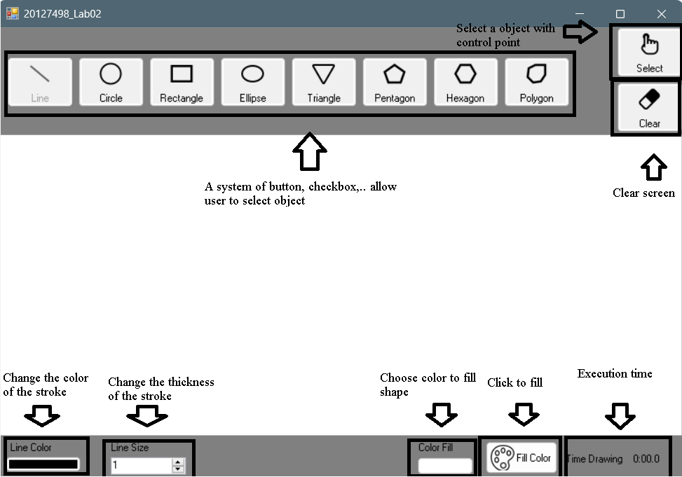

**2. Move shape**

- First, user need to select the shape they want to move. Select the shape by clicking the Select button and selecting the shape.

- Then, dragging the mouse in the shape to move it.

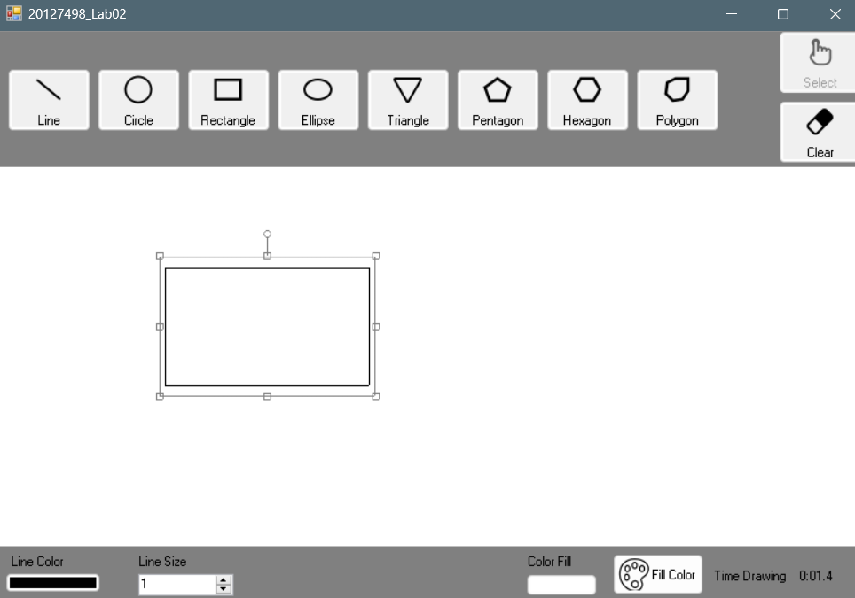

**3. Rotate shape**

- After selecting the shape, you need to click in the control point in the top of the shape and drag the mouse to rotate it.

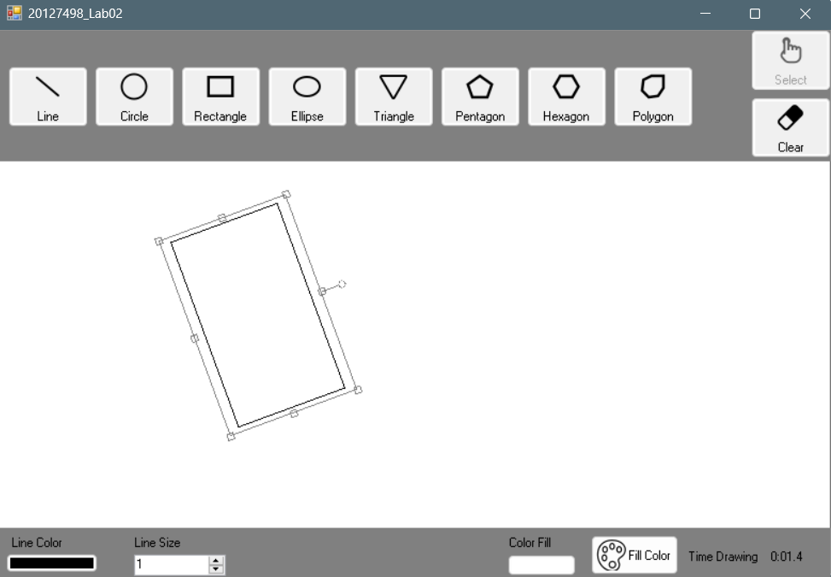

**4. Zoom shape**

- After selecting the shape, you need to click in the control point around the shape and drag the mouse to zoom it.

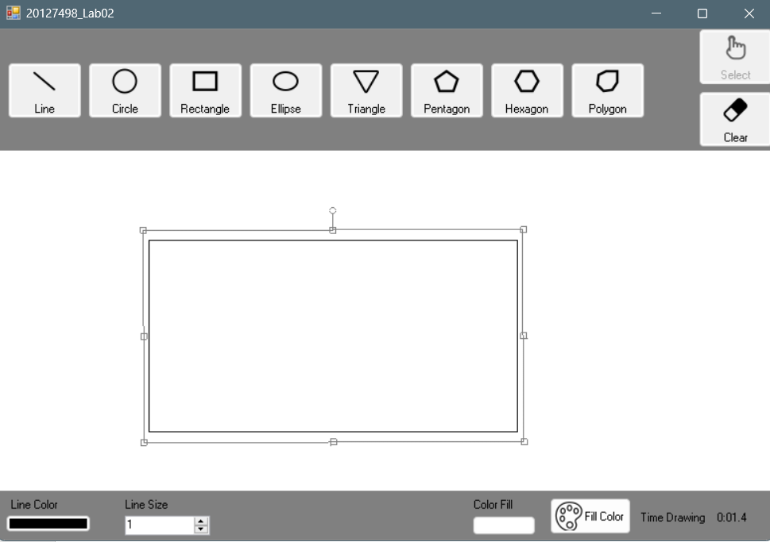

**III. Link video demo**

- Youtube: https://www.youtube.com/watch?v=RONKUUOiBtk