**HIỂN THỊ DANH SÁCH COURSE INSTRUCTOR:**

**Sequence diagram:**

**GUI:**

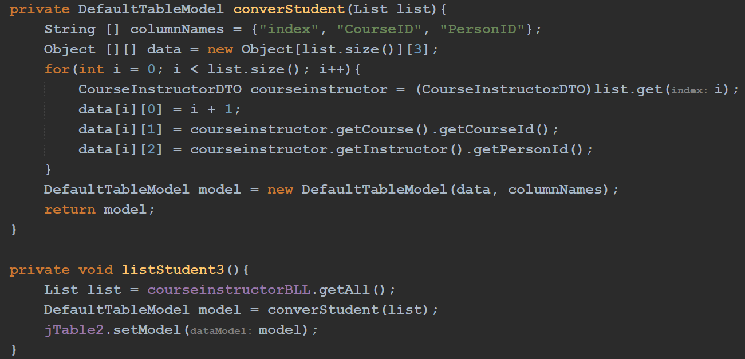

**BLL:**

**DAO:**

**HIỂN THỊ CHI TIẾT 1 CourseInstructor:**

**Sequence diagram:**

**GUI:**

**BLL:**

**DAO:**

**THÊM MỘT COURSEINSTRUCTOR:**

**Sequence diagram:**