**Lab 1: Guide to Using JSX and ES6**

1. **Building a React Project Using Webpack and Babel**
   1. **Directory Structure**

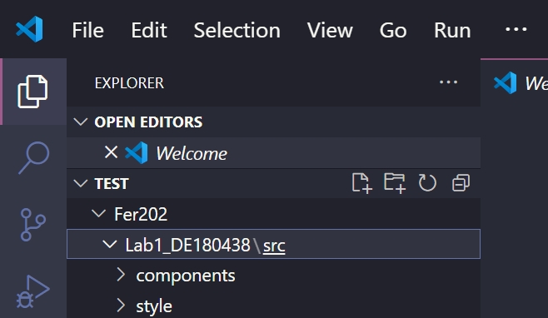

* 1. **Initializing the Project**

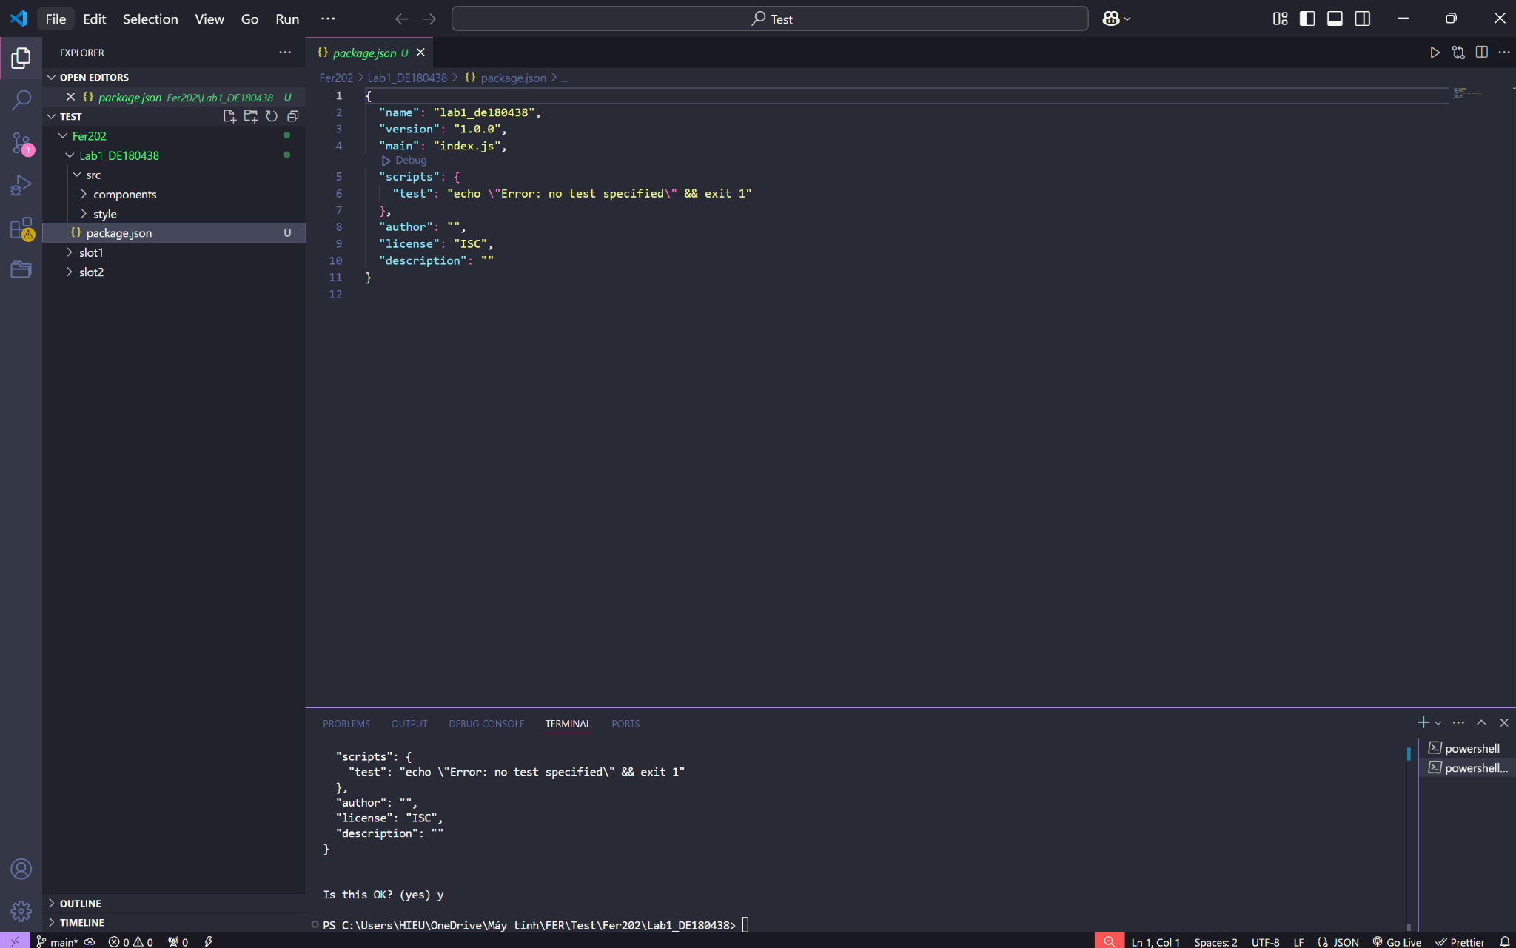

* 1. **Installing Webpack**

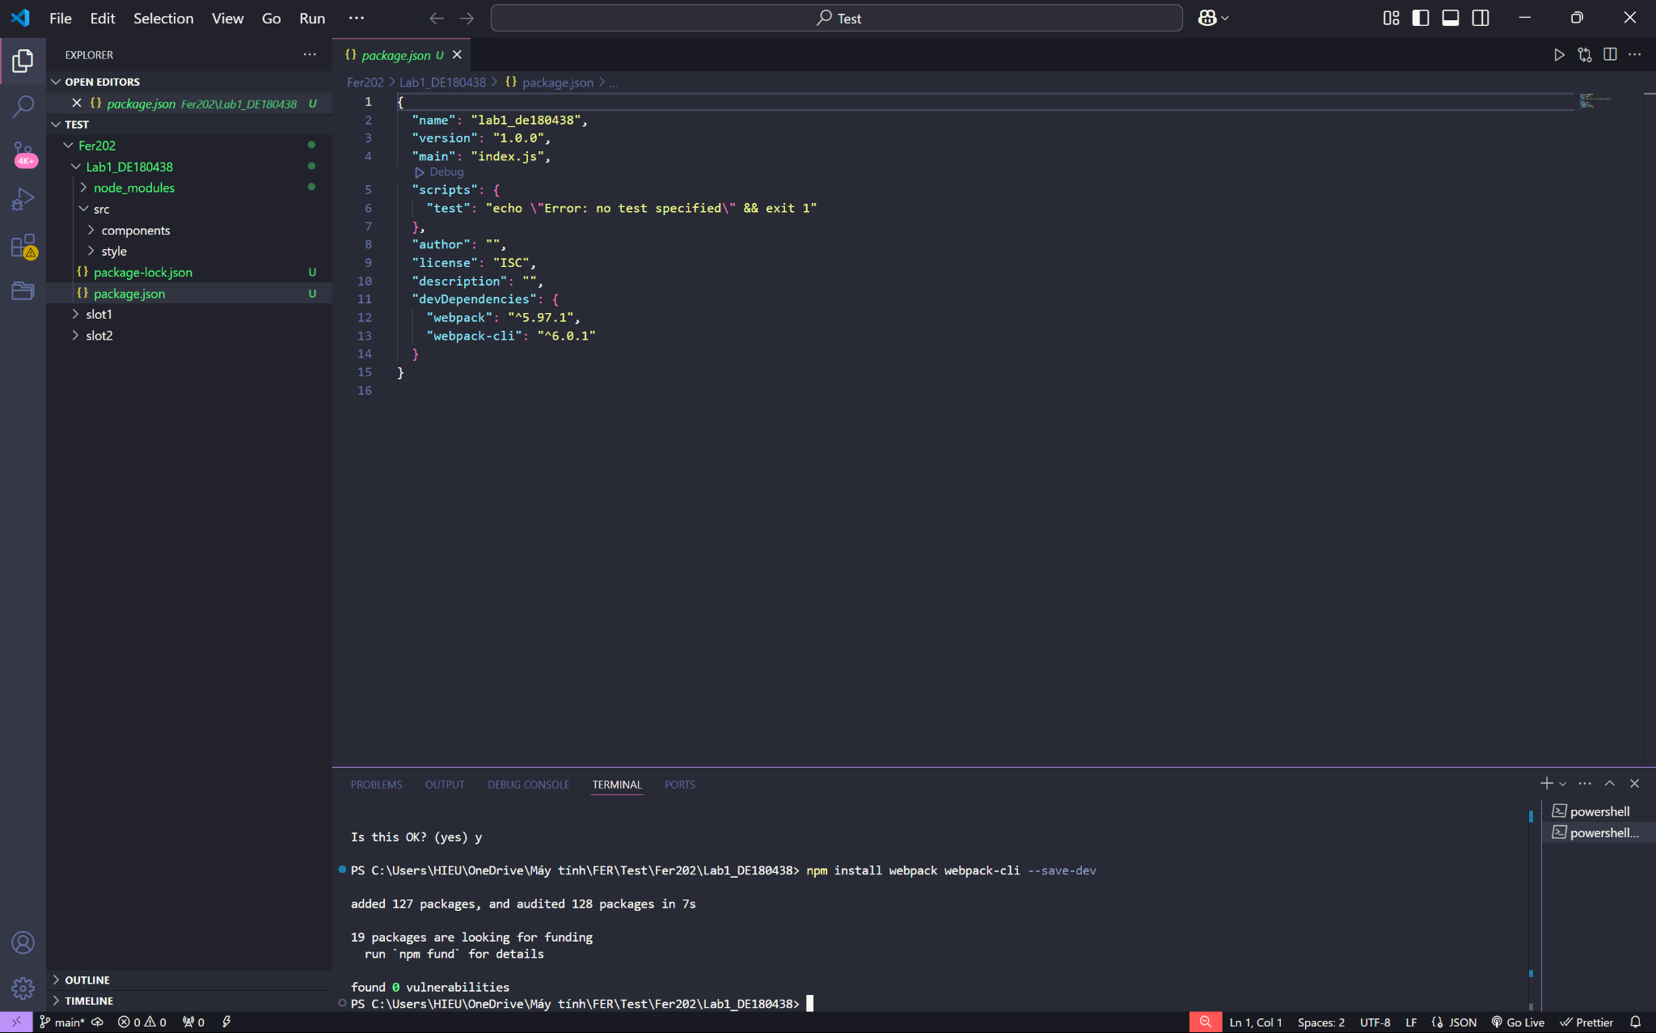

* 1. **Installing React**

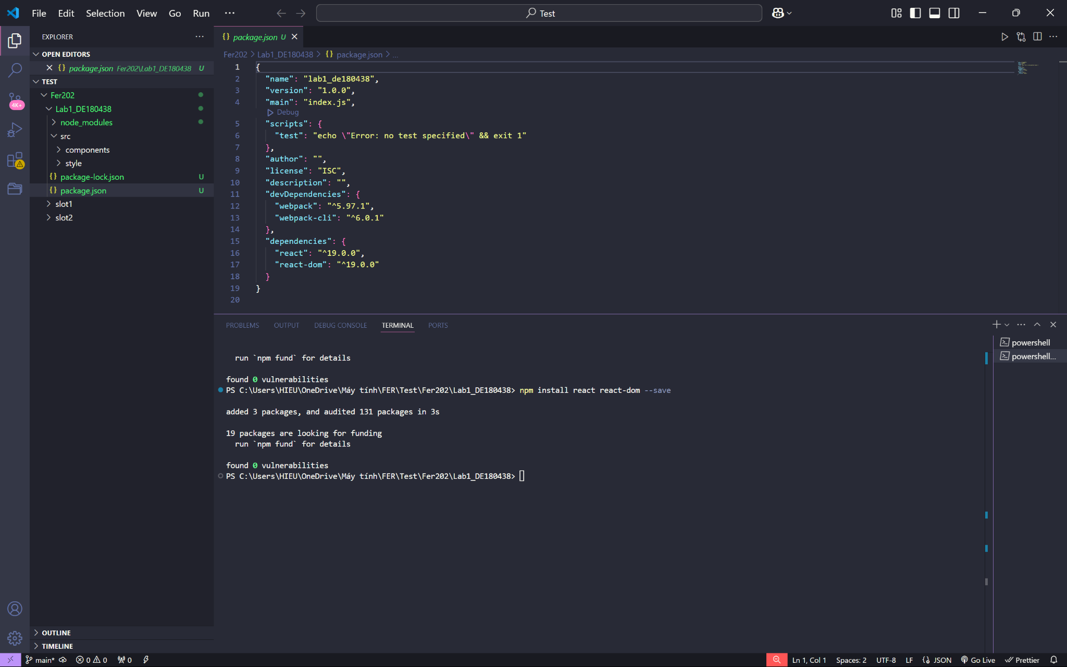

* 1. **Installing Babel**

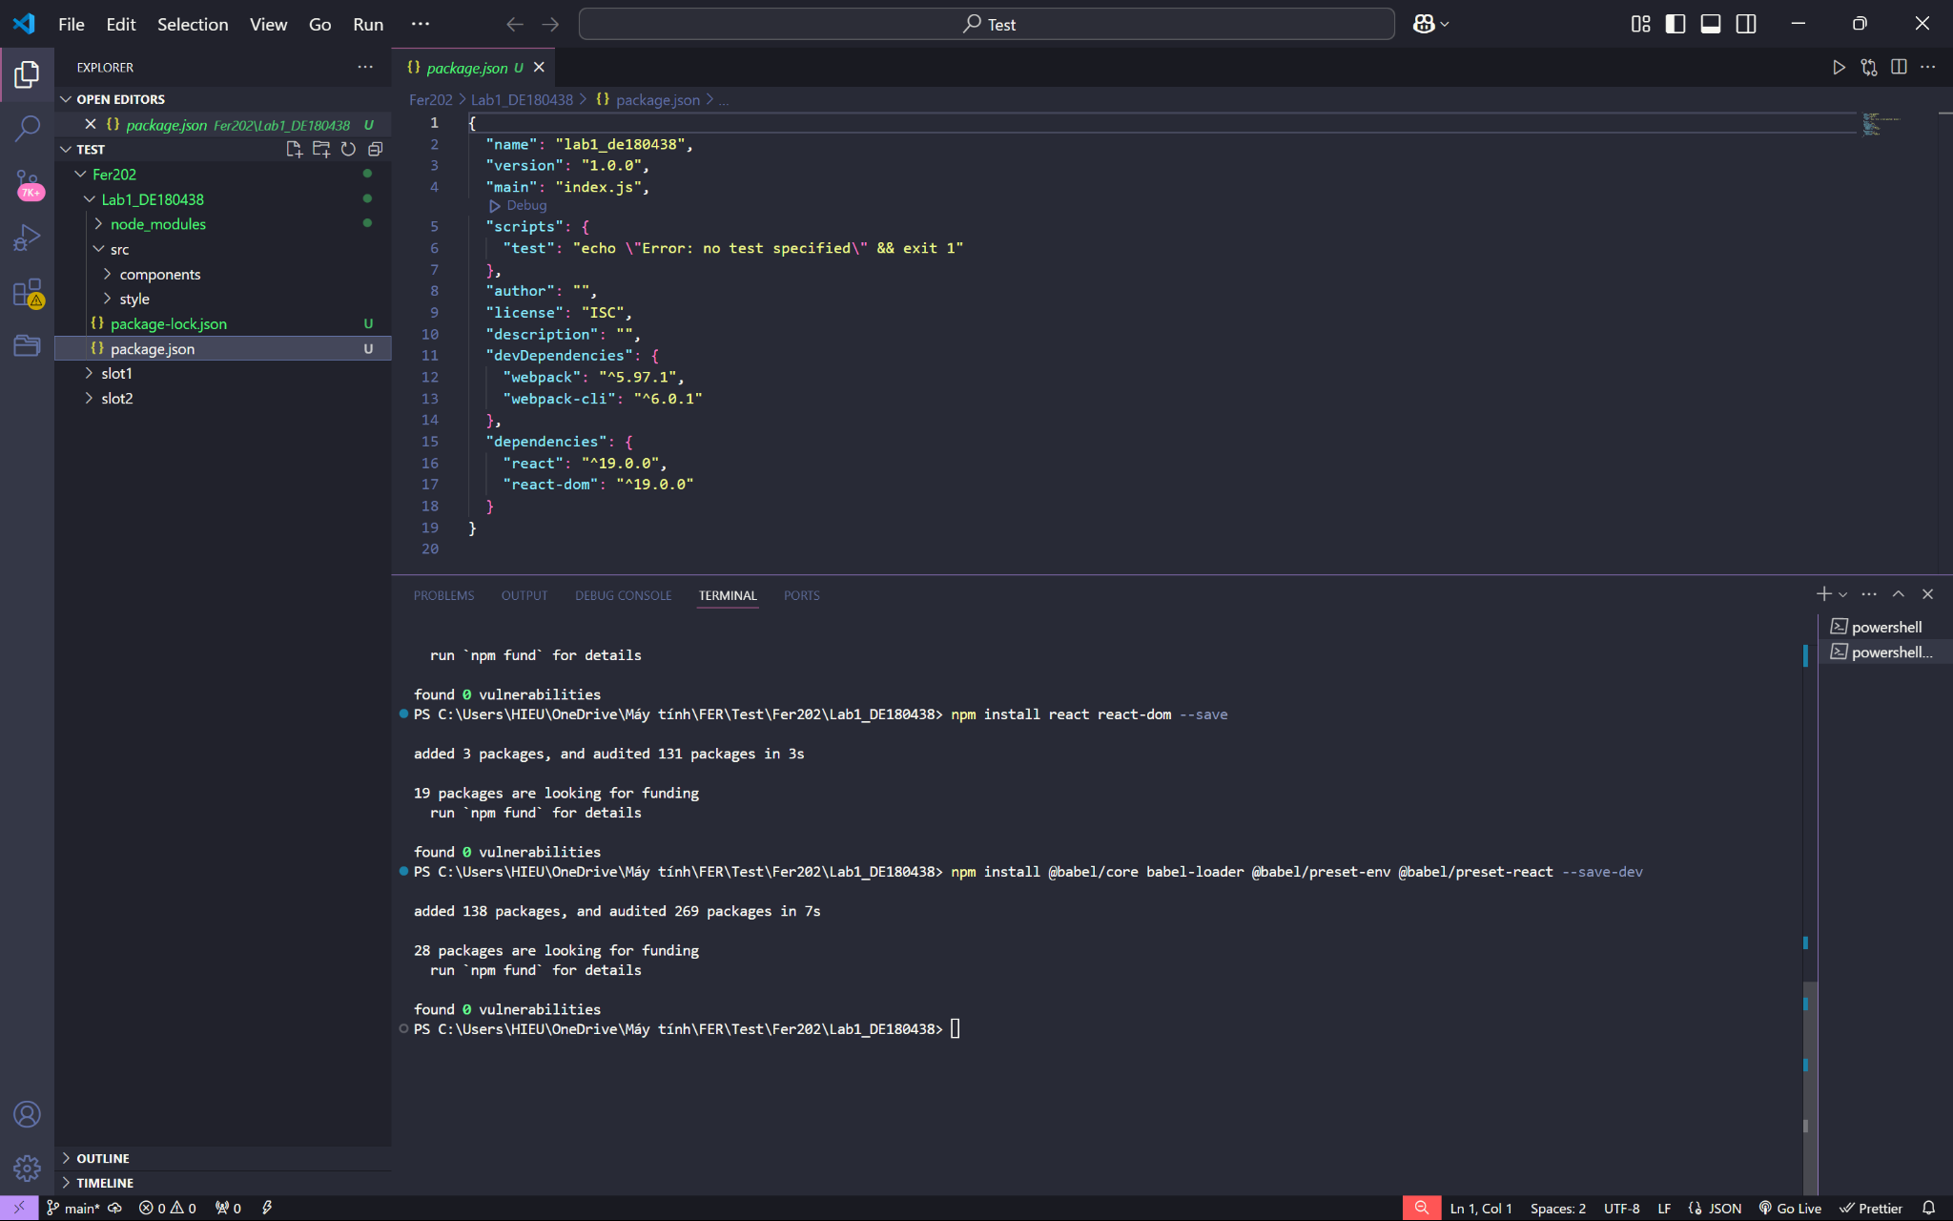

* 1. **Creating the index file**

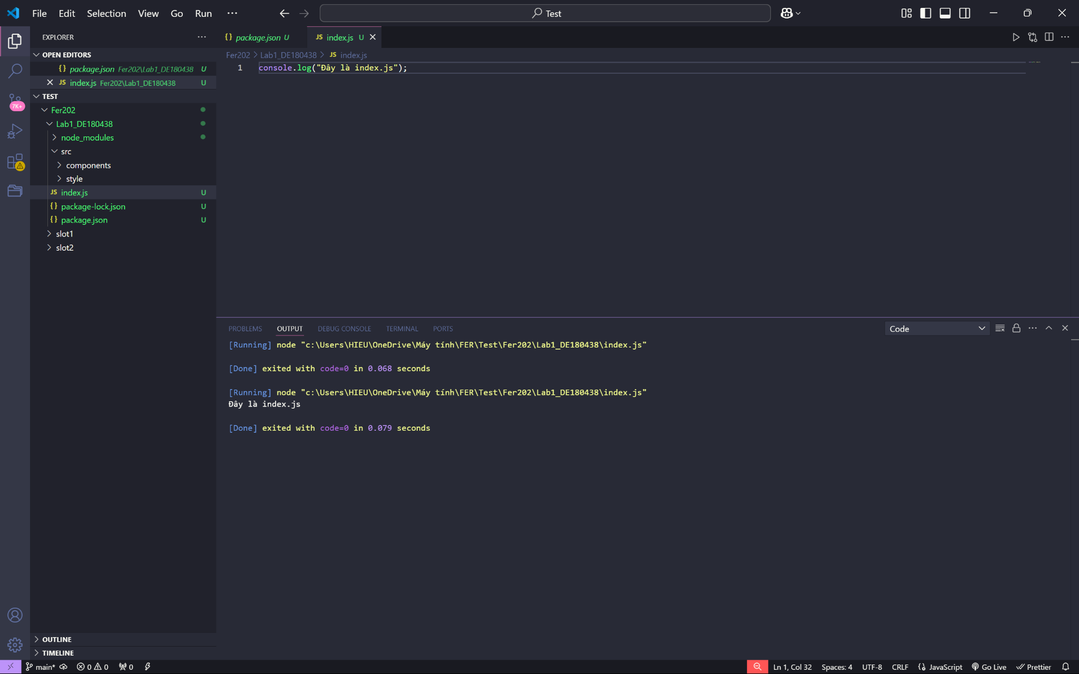

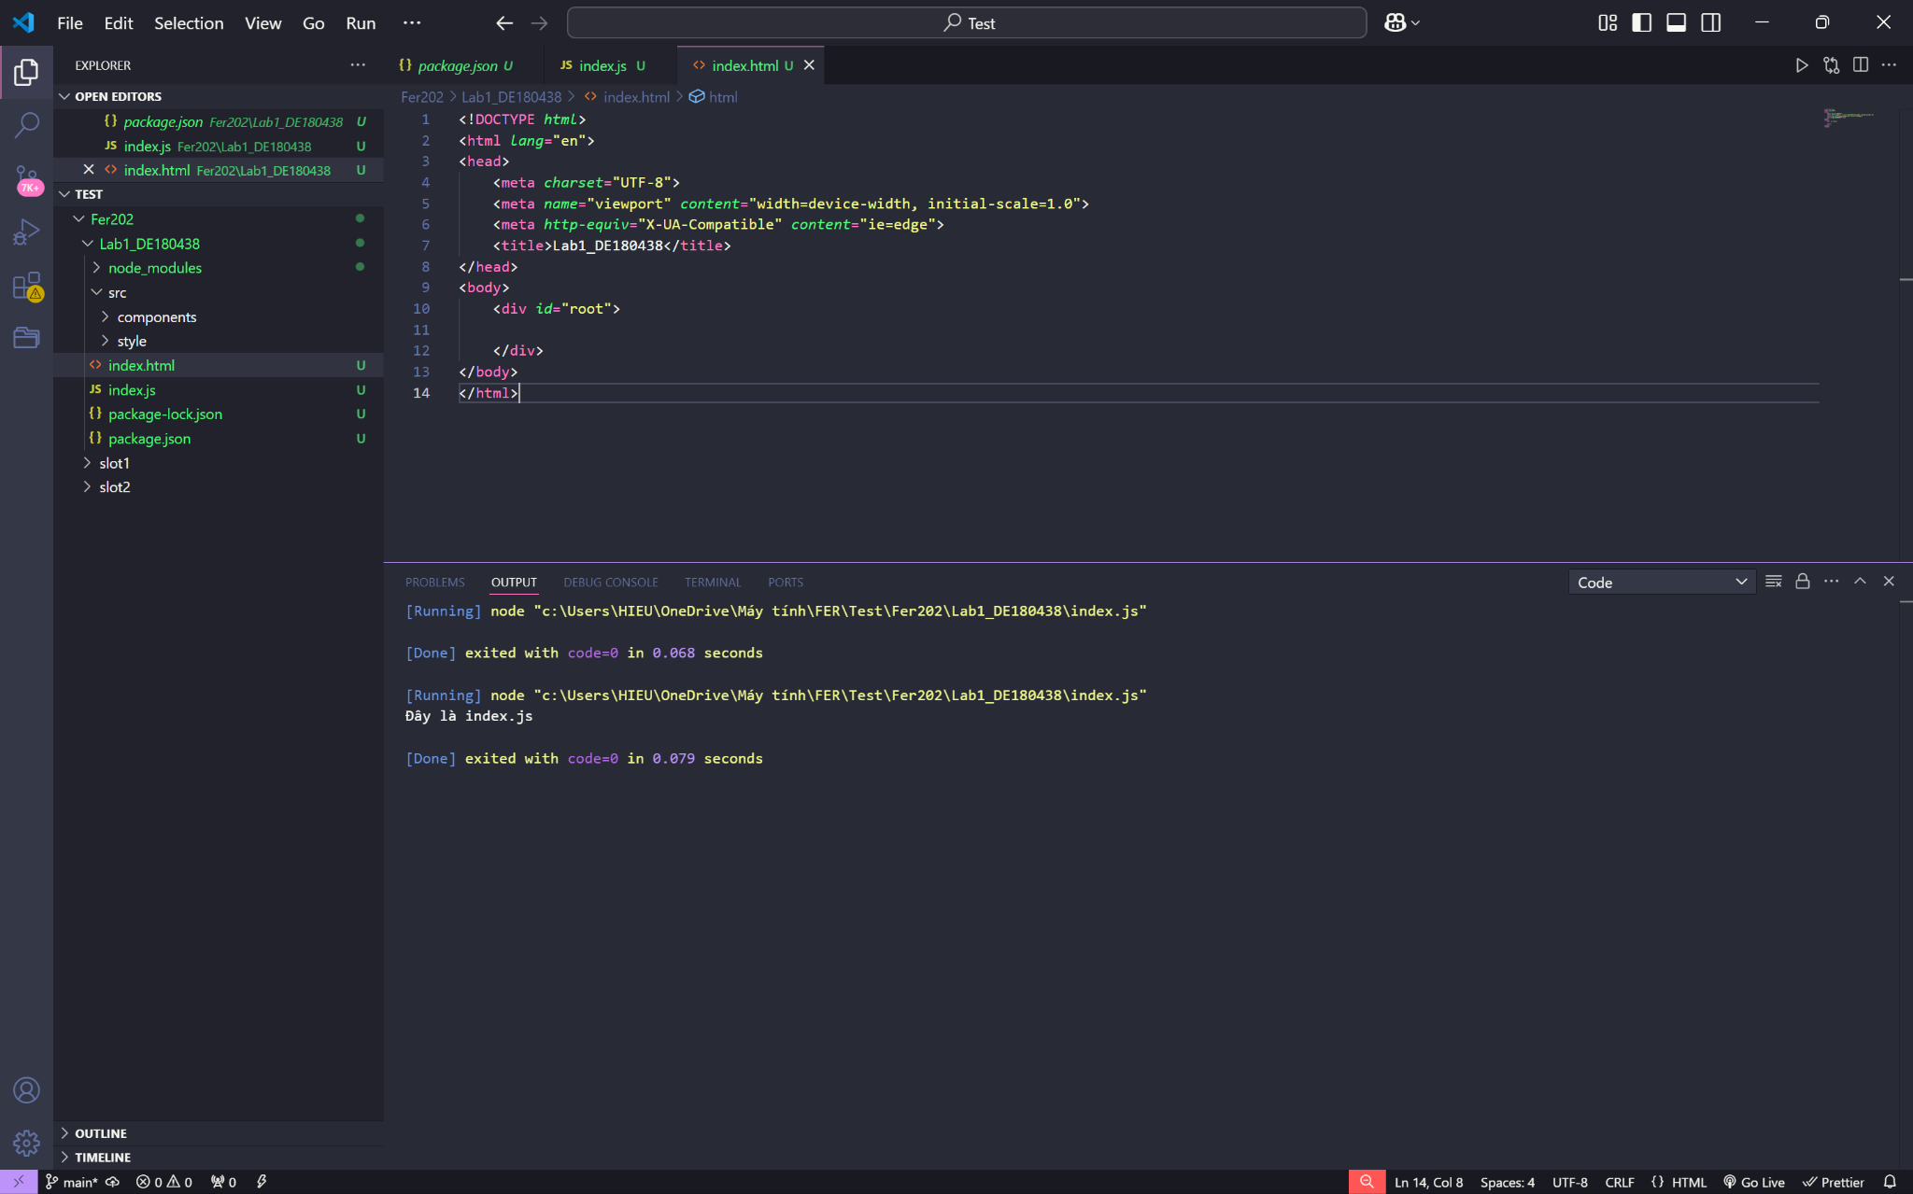

* 1. **Entry and output files**

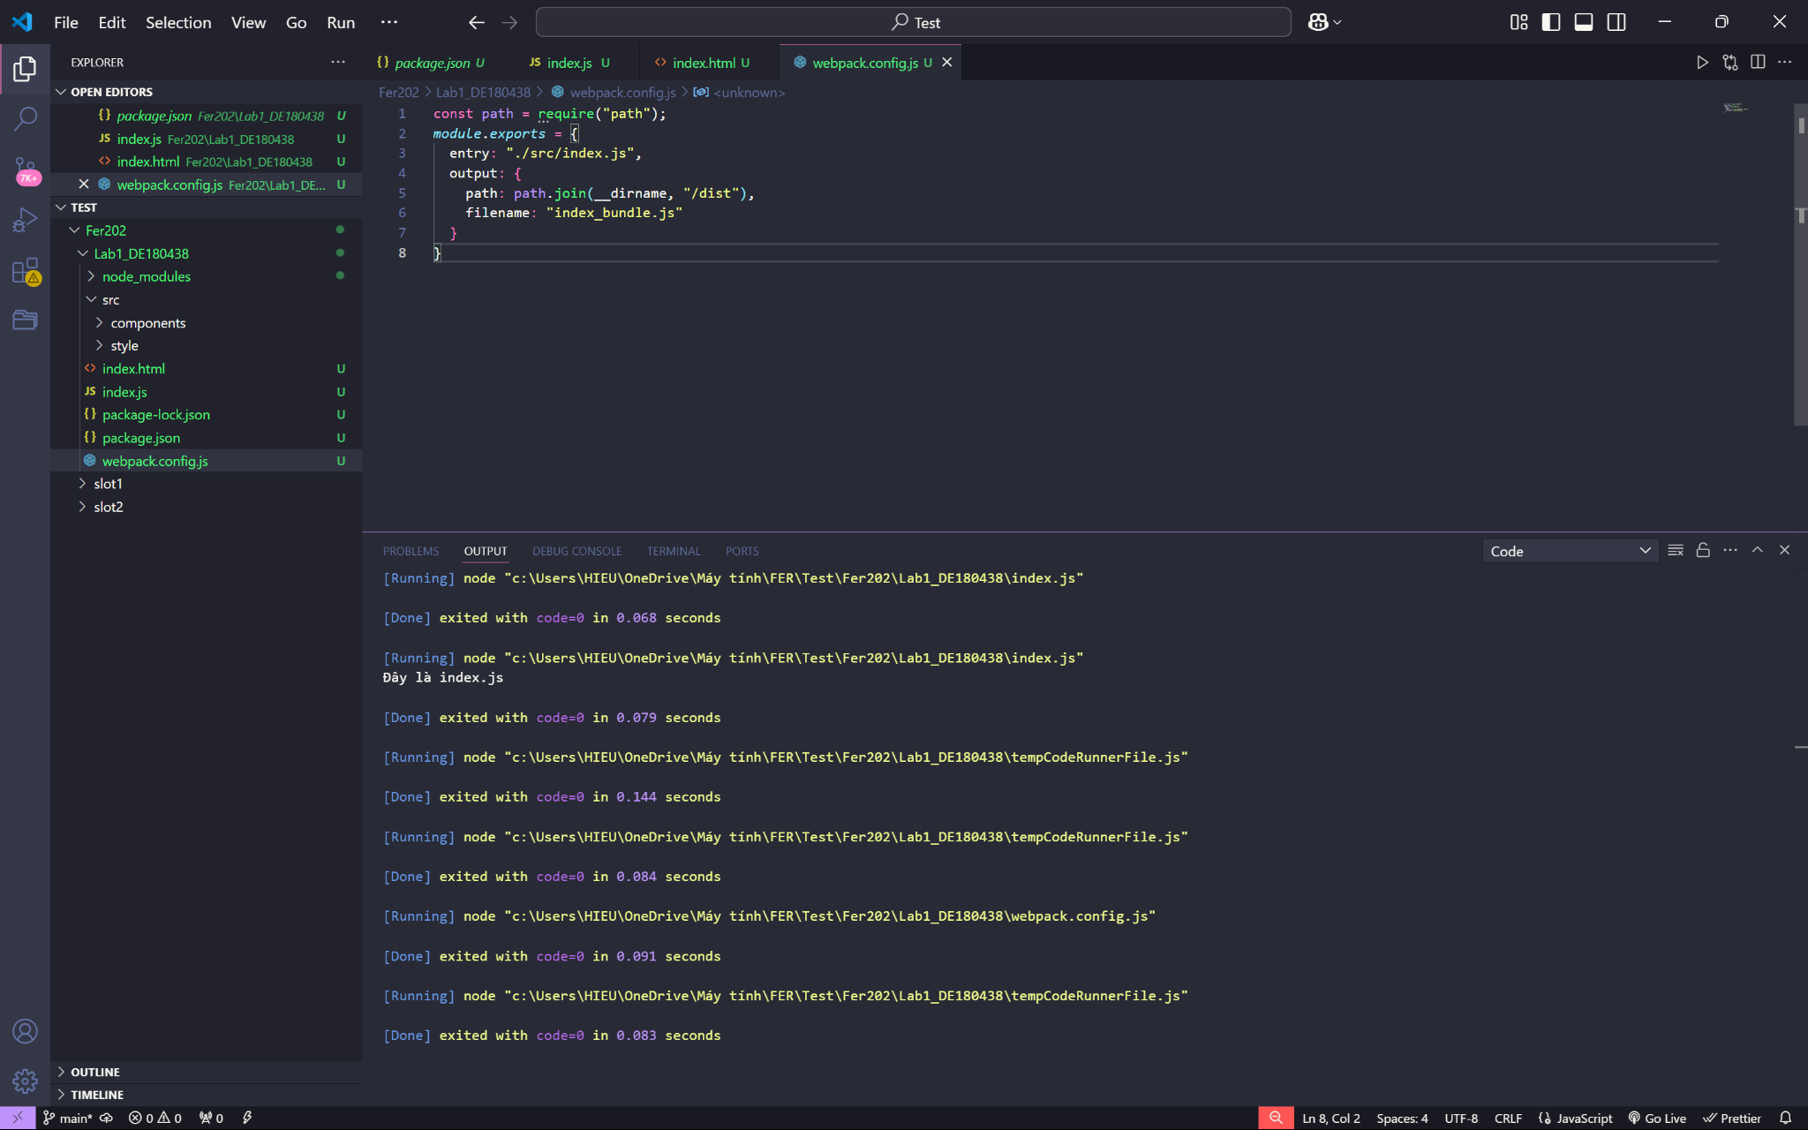

* 1. **Webpack Loaders**

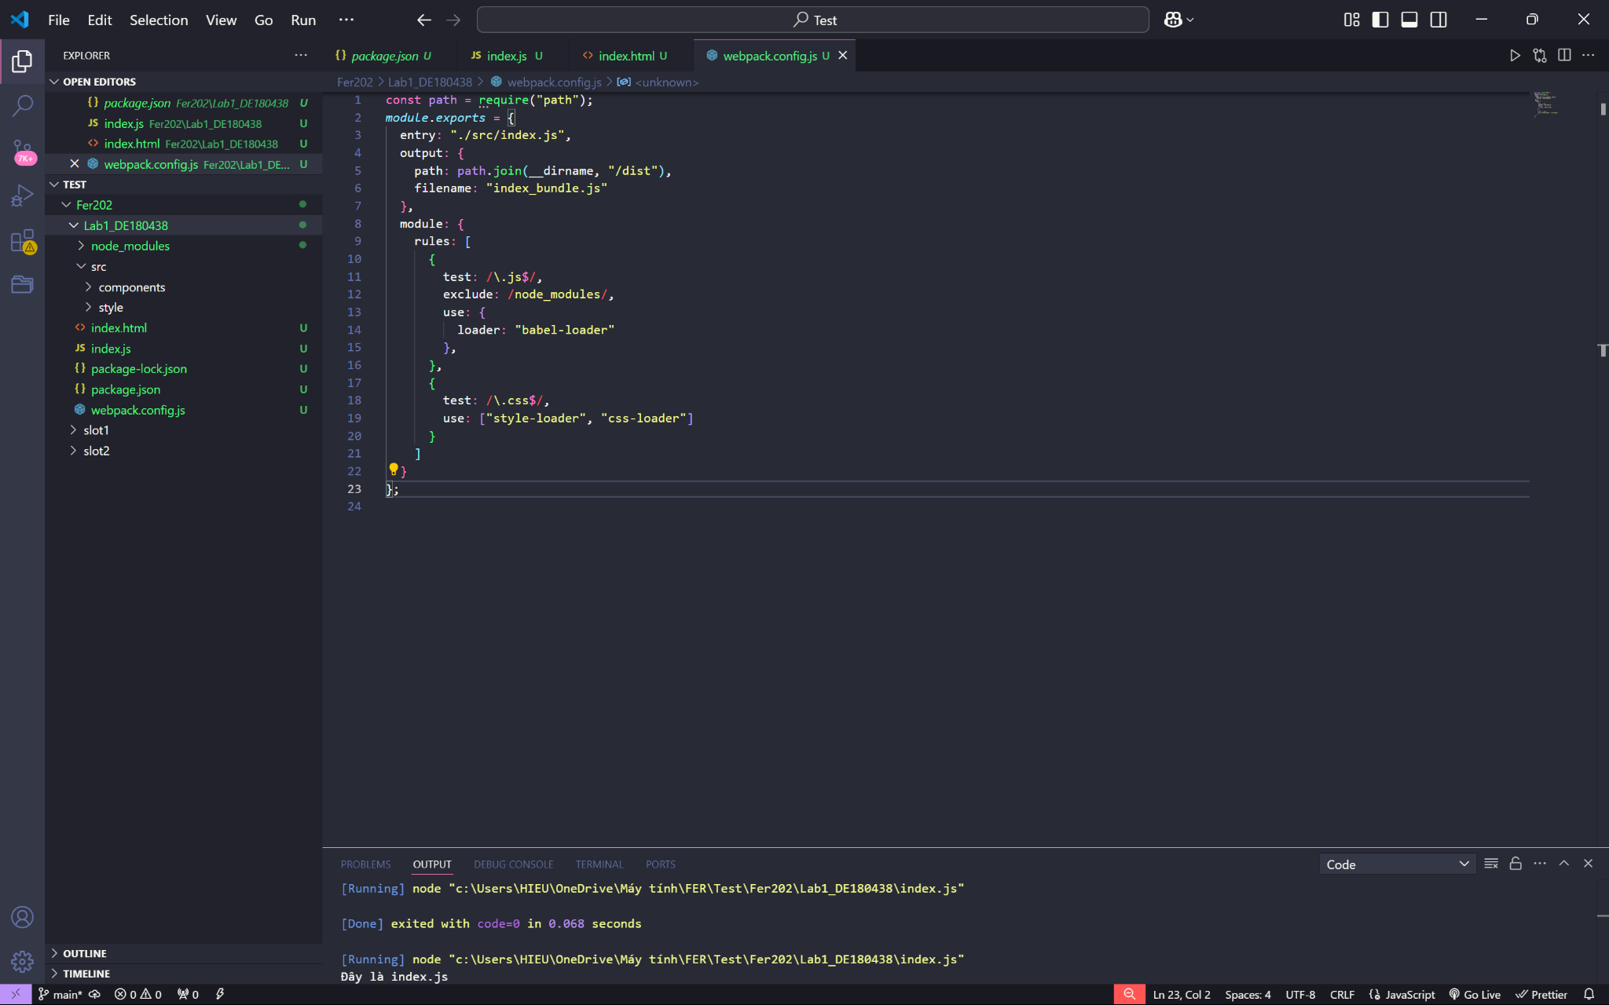

* 1. **.babelrc**

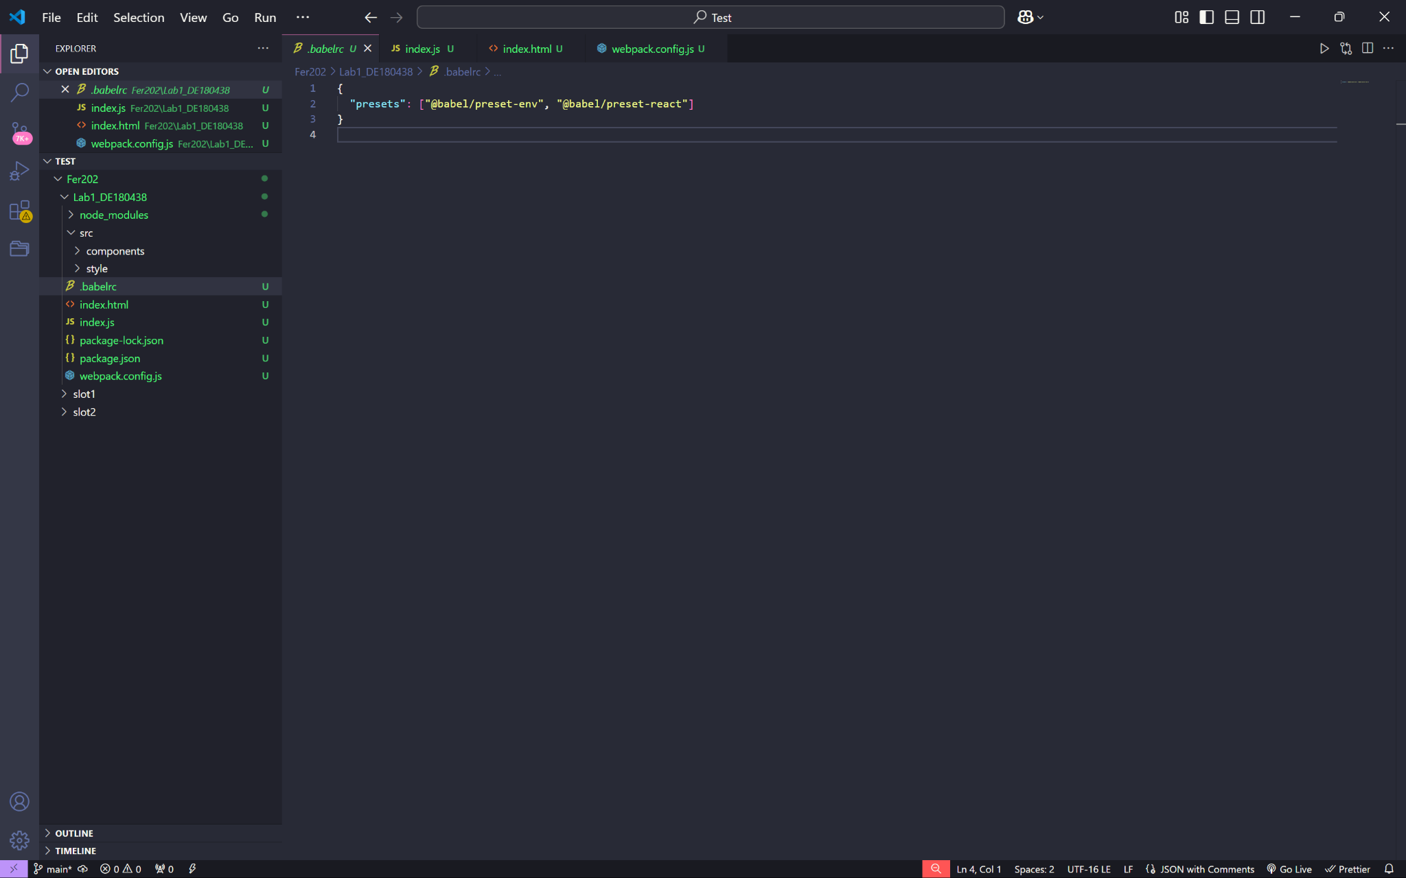

* 1. **Compiling the files using Webpack**

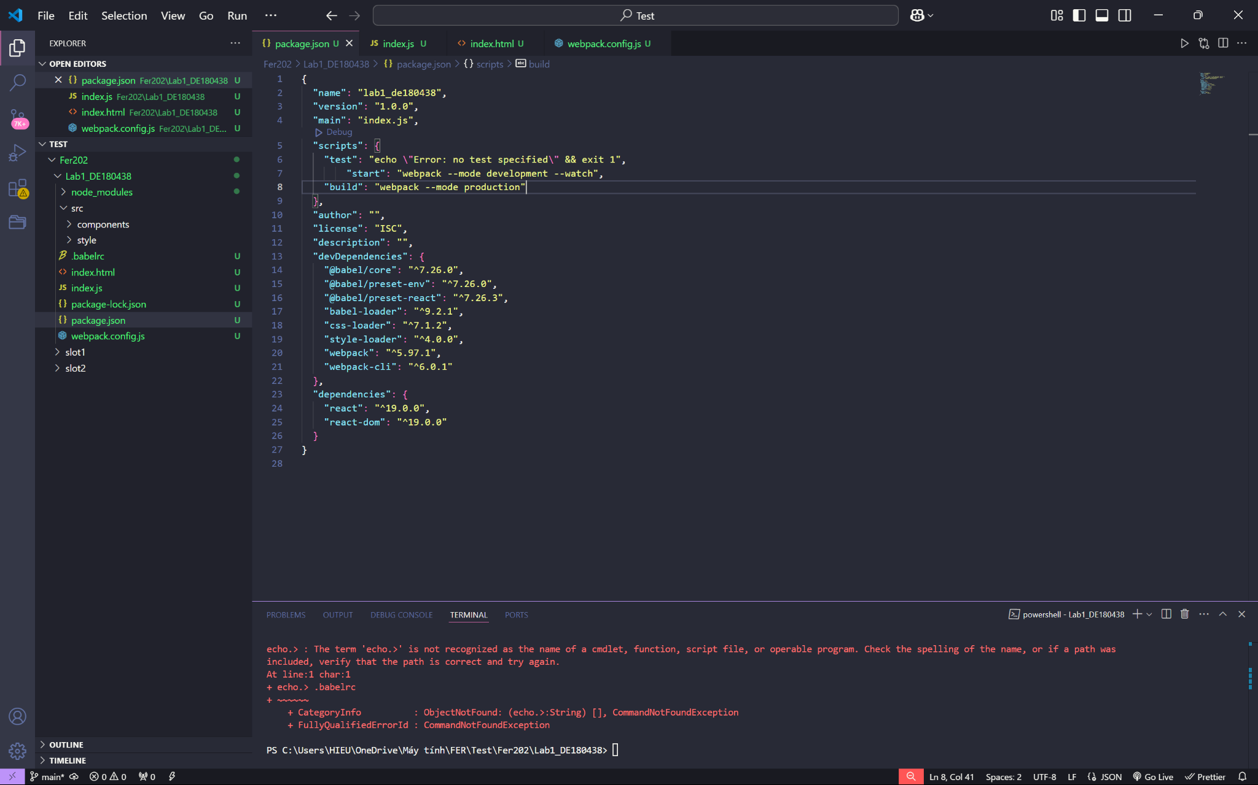

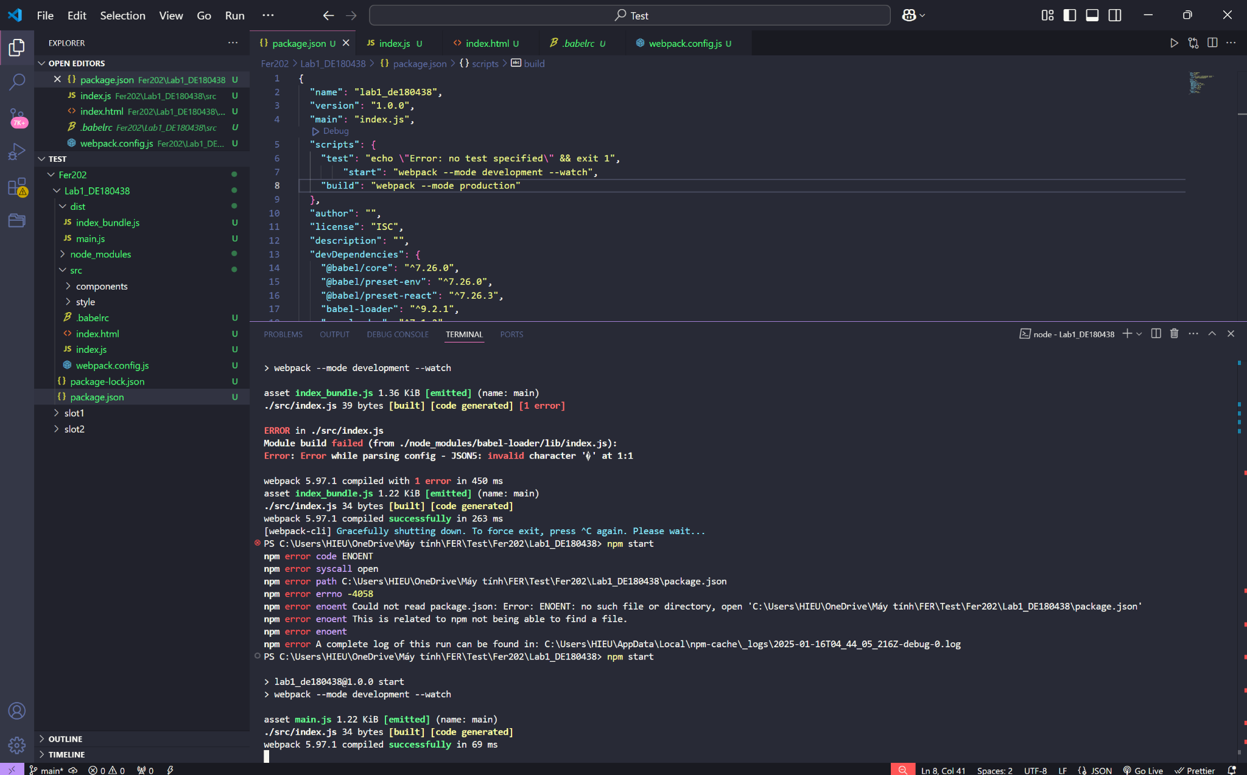

* 1. **App.js and App.css**

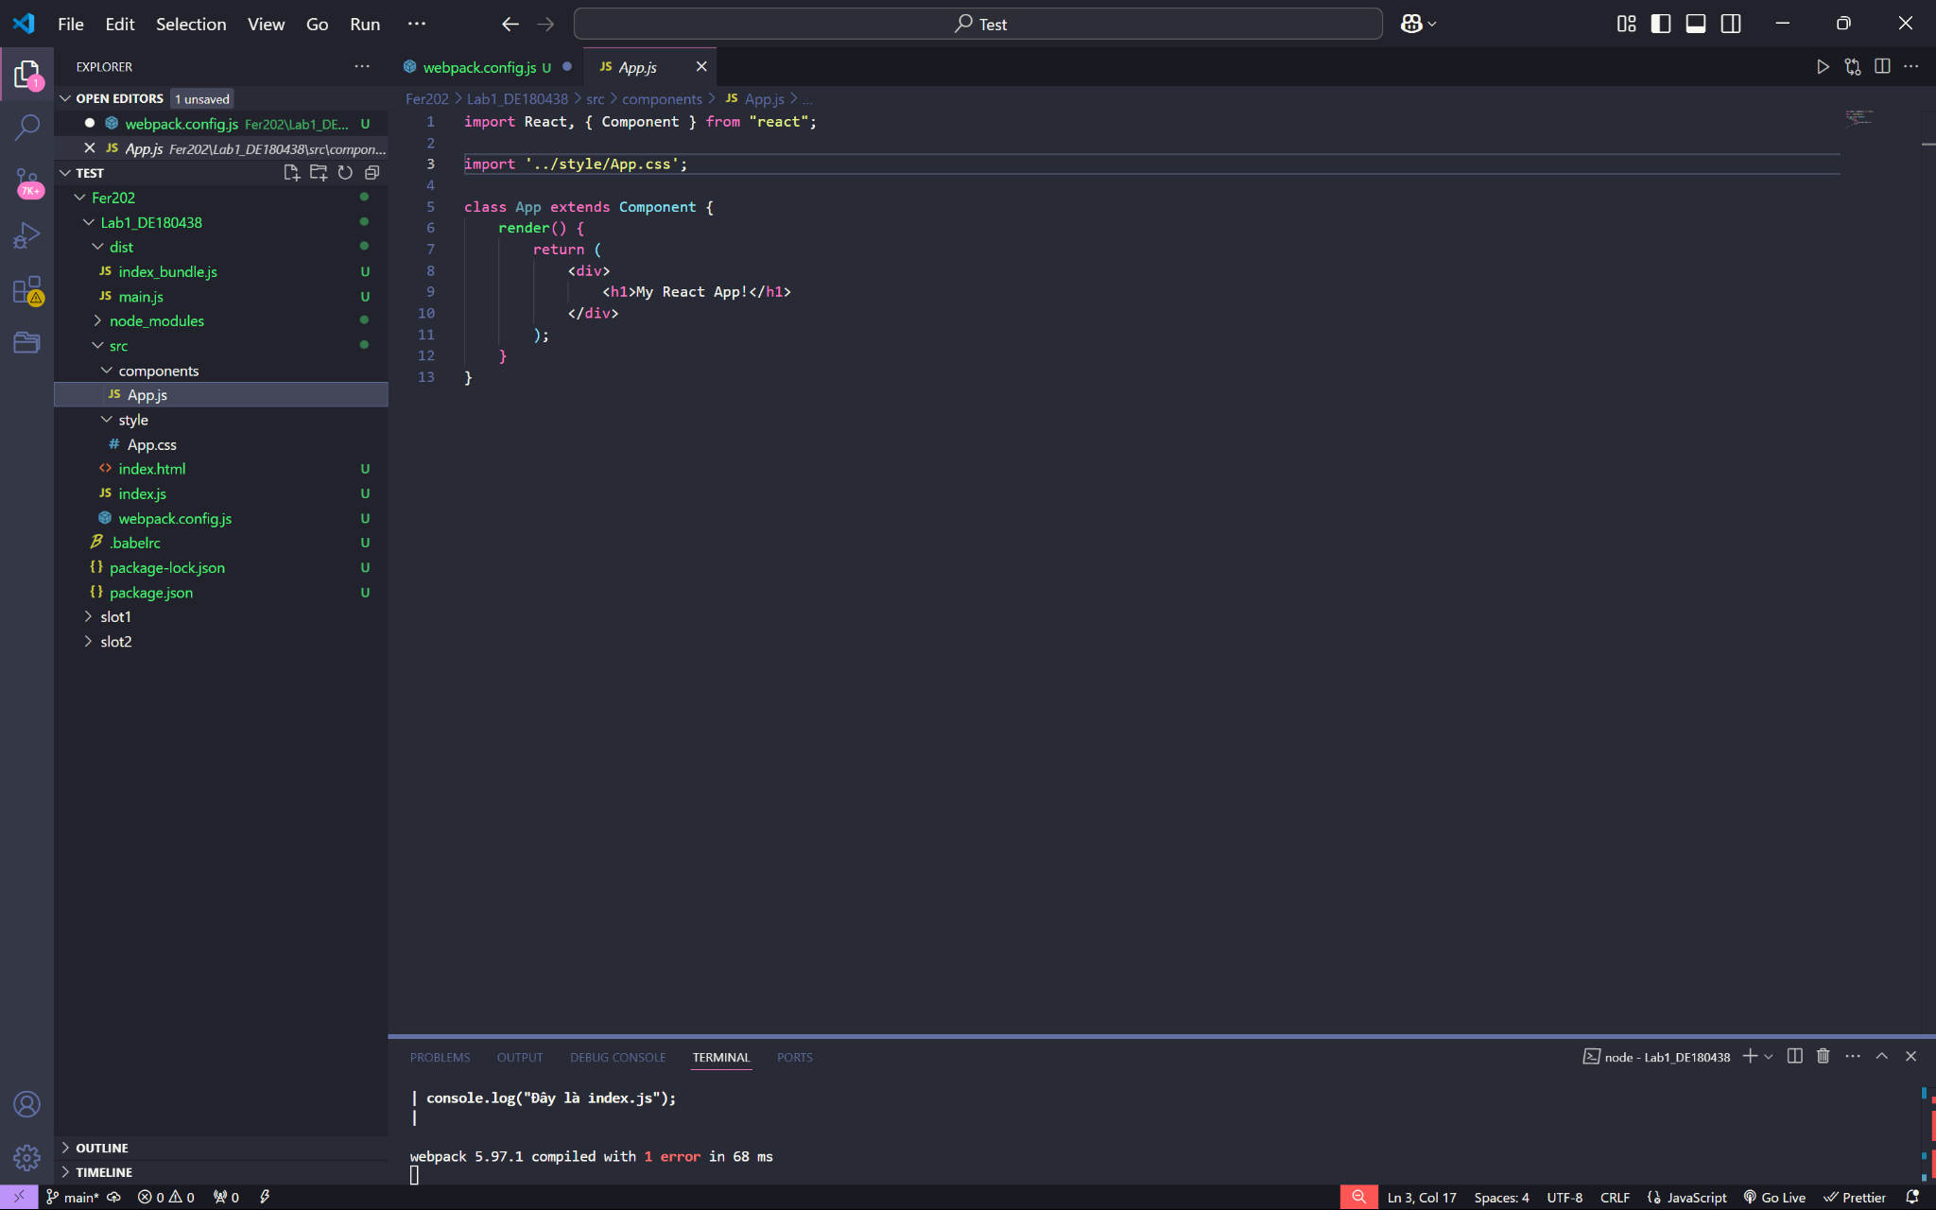

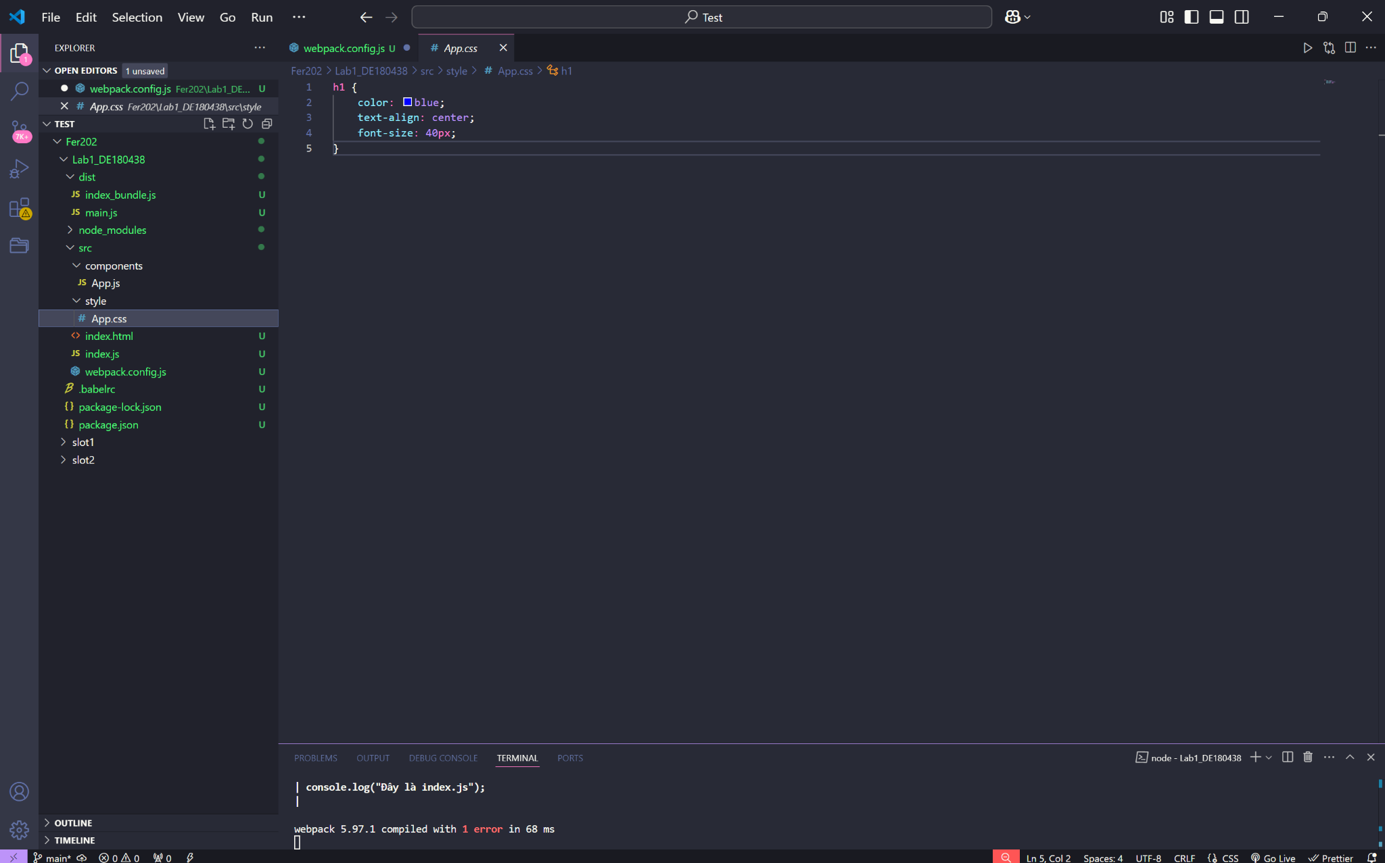

* 1. **Installing Html-webpack-plugin**

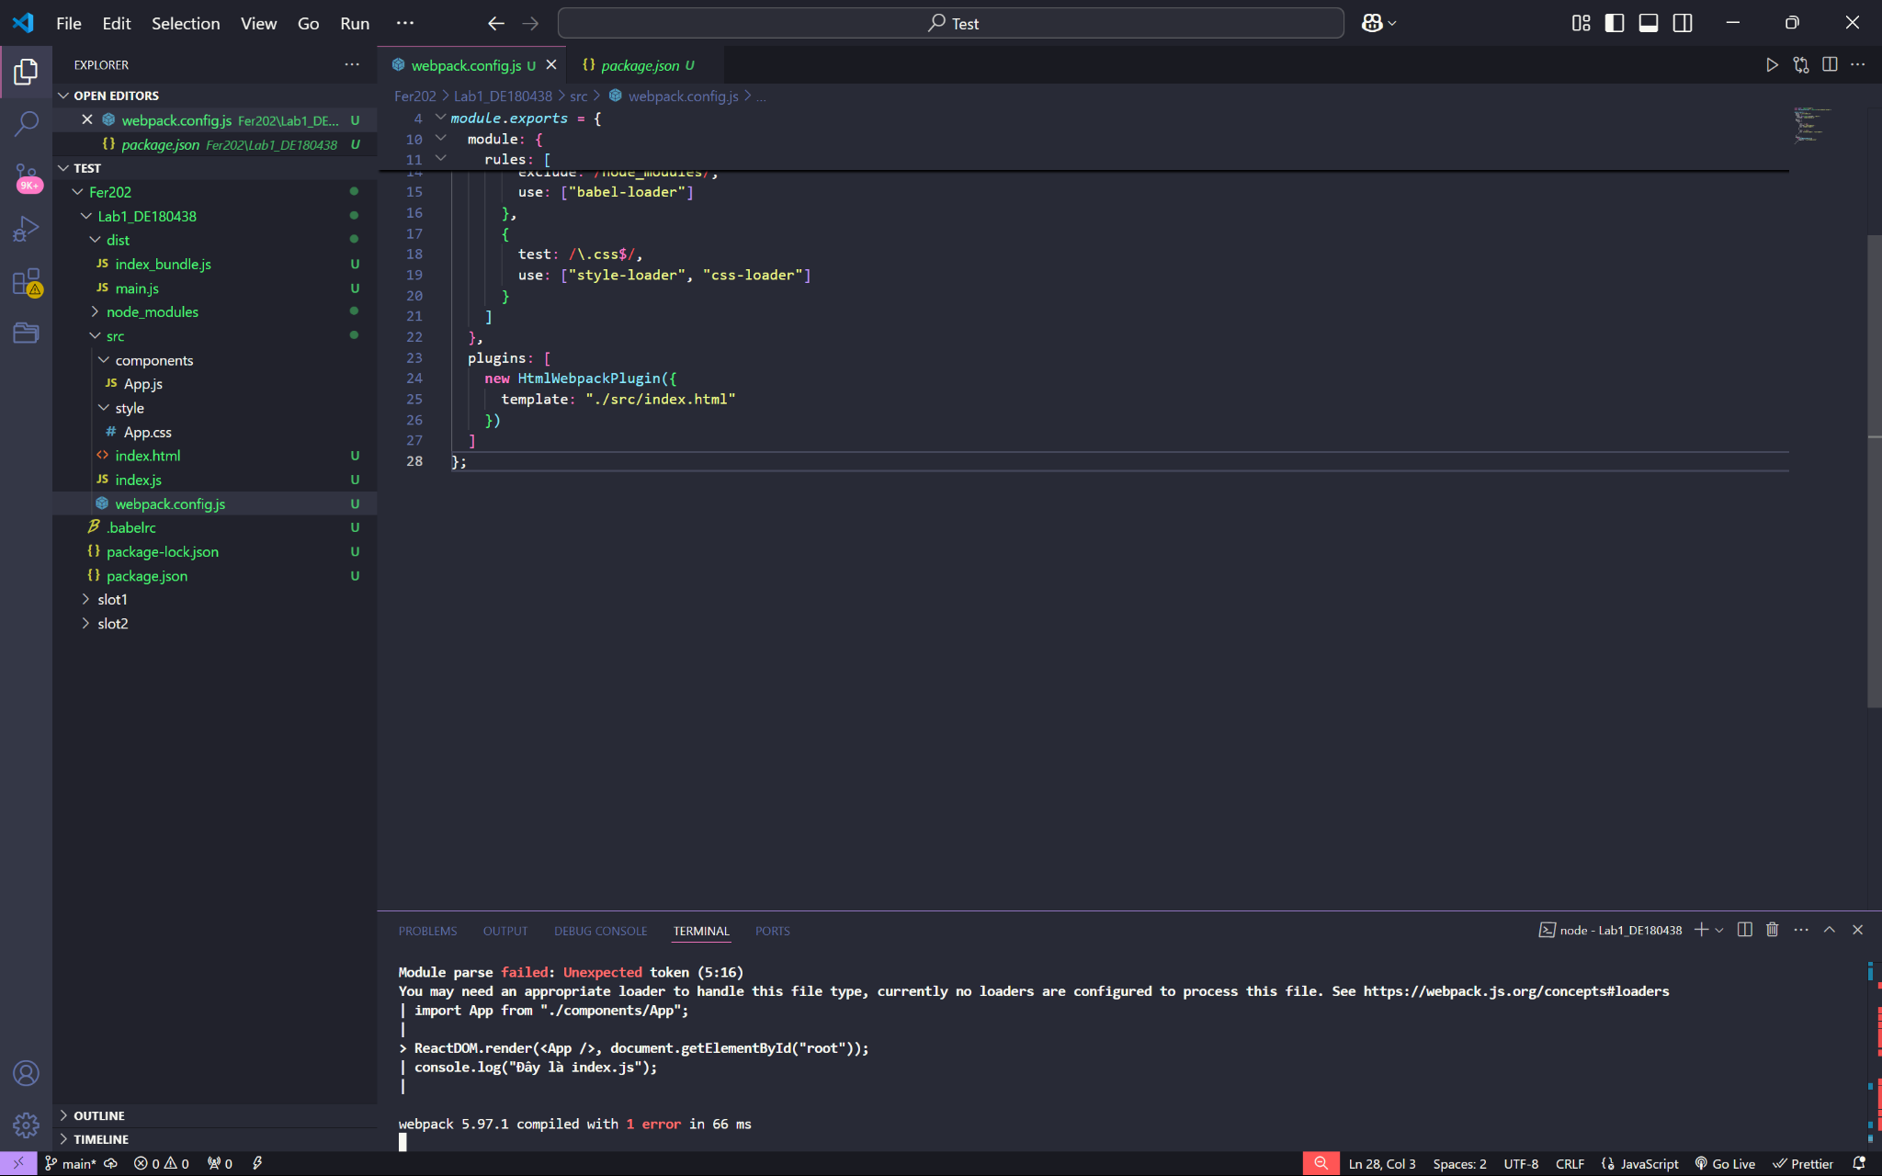

* 1. **Installing Webpack-dev-server**

1. **Write JSX and ES6 code**

