**Project descriptions**

* Chicken-to-Table egg delivery – web project, webcam, label printer
  + Web based sales site for high end all natural chicken eggs. The site will allow you access to web cams that show the inside of the henhouse and the pen that the chickens are housed in. You can watch them roam around, eat, and lay eggs. When the eggs are collected they are immediately labeled as to the time and location/henhouse where they came from. The customer can then order those specific eggs to be delivered overnight to their home.
  + There will be the options of selecting and viewing different chicken farms that you can shop from for your eggs.
* High Density Car valet parking system – computer simulation, pc, mobile app
  + System for parking cars that consists of large car sized motorized platforms that are controlled by a program for doing valet parking.
* Home Automation – webcam, RFID card reader, mobile app (optional)
  + Pretty much what you would expect from a home automation system.
* Spoken Language IDE – microphone (internal/ bluetooth) – HARD
  + Make a java IDE that uses voice input instead of keyboard.
* Card swipe attendance system – mag card reader, Raspberry Pi
  + System for taking attendance in very large classes.
* ACR-122U RFID interface – written in java
  + Make an interface program to read and write to the ACR-122U RFID reader/writer. Program should be able to communicate with all the NFC tags that the hardware is compatible with.

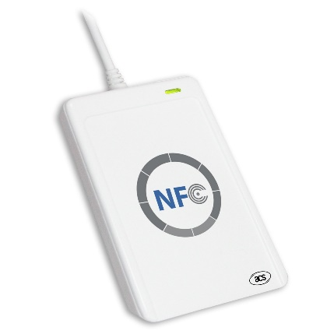

* Video remote and chill
  + System to allow easily sharing a video stream where each person at either end of the link can watch the same stream in sync and both can control the playback (pause/repay/jump forward/backwards, etc).
* Coffee shop intranet (CoffeeNet) – raspberry Pi, wifi router
  + Private isolated miniature internet that is accessed by connection through it by wifi. It exists only within the range of that wifi, such as at a coffee shop or at a party or rave. The website will have a public chat room as well as providing the ability to create local websites and blogs. There will be a local search engine (Gaggle?) to be able to find information on this intranet.
* Robotic Luggage – path finding skills, simulation
  + Autonomous robot that follows you through the use of camera based face and body movement recognition. Can also communicate with your phone through Bluetooth to check if you are near. If lost it will communicate through cell phone connection to query you for your gps coordinates and head to you based on that. It can also communicate like a dog or R2D2 by making various noises to call for your attention.