Review SRS_PRSver1.1
Date Review 17/10/2025
Member Chung Anh Hiệu

- Overview of SRS_PRSver1.1

Document SRS_PRS_VER1.1 describes the Product Retail System (PRS) - retail management software built by PLT Solutions.
The system's goal is to automate business processes at the store: from product management, staff, suppliers, to warehousing, sales and revenue reporting.
The written document has three main parts:
- Part 1 – Introduction: describes the scope, target users and usage environment.
- Part 2 – System Analysis: details the 13 core functions of the system.
- Part 3 – System requirements: states functional, non-functional requirements, and technical constraints.
The system users include: Admin, Store Manager, Warehouse Staff, Sales Staff, Suppliers and Customers.
This document acts as a bridge between the development team (Dev/BA) and the testing team (QA/Test Team) during the system development process.
- Review SRS_PRSver1.1
From the perspective of QA/Test Lead, the purpose of reviewing this SRS document is:
- Check the clarity, completeness and consistency of functional requirements.
- Evaluate the feasibility and testability of each section of the SRS.
- Identify potential risks in requirements that may cause errors during development or testing.
- Make suggestions for improvements to help the SRS document reach “Ready for Test” standards.

- Content
Product Type Management
Evaluation:
This is a basic function that helps classify product groups by category, serving filtering, searching and reporting. The description in SRS is quite complete about the uses, user groups, constraints, and operating procedures.
Strengths:
- Detailed description of CRUD (Create – Read – Update – Delete) operations.
- Clearly state data constraints: “Type names cannot be duplicated”, “Type codes must be unique”, “Do not delete if there are associated products”.
- Describe the flow of activities in a clear order (login → select store → access module → add/edit/delete type).
Weaknesses:
- Missing specific Input/Output section (no format, character length specified).
- There is no rule for setting product type code (auto-gen or manual entry).
- No description of Import/Export data (Excel/CSV) – often a practical requirement.
- Missing system error handling (network fail, duplicate name).
Personnel management
Evaluation:
This function plays the role of internal user administration. The level of detail in the SRS is quite high, with descriptions of user roles, operation procedures, and reasonable data constraints.
Strengths:
- Be clear about user roles.
- There are specific rules about data: “Email is not duplicated”, “Valid phone number”, “Role required when saving new employees”.
- The flow of activities is specific and easy to understand.
Weaknesses:
- Lack of security information: password policy is not clearly stated (minimum length, special characters, etc.).
- There is no session timeout or automatic logout mechanism.
- Missing Audit Log description (history of employee changes, roles).
Supplier Management
Evaluation:
The function represents the process of managing partners and serving import goods. The SRS describes quite detailedly the functions, users, and constraints. However, the data part is still simple compared to the actual business.
Strengths:
- There are constraints: “Supplier code is unique”, “Do not delete if there is a related receipt”.
- Has a clear, easy to test CRUD process.
- There is an “Active/Inactive” status section to preserve historical data.
Weaknesses:
- Missing payment information, debt limit, tax code.
- There are no detailed rules for entering address, email, phone number.
- There is no description of the relationship with the “Purchase Order” table.
- Missing error scenario description when entering wrong data or duplicate name.
Product Management
Evaluation:
This is a central function, linking many other modules (Product Type, Warehouse, POS, Supplier). The description in SRS is quite good but lacks technical part related to product identification and detailed business rules.
Strengths:
- Has basic field structure: code, name, price, product type, status.
- Logical association with Category and Supplier.
- There is a constraint that the product code is unique.
Weaknesses:
- Missing description of unit, import price, selling price, discount, tax.
- There are no rules for rounding, or conversion units (pcs, box…).
- No mention of multi-branch inventory sync.
- There is no description of the product image upload section (if any).
Warehouse Management
Evaluation:
This is the most important module in the PRS system. The description in the current SRS is only at an overview level, not detailed enough to design test cases or test complex operations.
Strengths:
- Specify the import - export - inventory functions.
- Linked to “Product” and “Purchase Order” modules.
- Highly realistic, accurately reflects store operations.
Weaknesses:
- Lack of specific import/export rules: no approval, confirmation, or ticket status procedures are specified.
- There is no description of FIFO/LIFO, expiration date of goods, or lot.
- Lack of handling of negative inventory errors, out of stock products.
- There is no Input/Output description table for import and export vouchers.
- Detailed review
Strengths
• Logical document structure: clear division, reasonable sequence between modules.
• Practical business content: functions such as Product Management, Suppliers, Employees, Warehouse, Invoices reflect the correct retail process.
• Has data constraints: many functions have descriptive constraints (e.g. product code, employee code, type code are unique).
• Easy to understand for testers: describe user operation flow clearly (add, edit, delete, search).
• Have main flow and alternate flow: helps QA to easily identify valid test cases and exceptions.
Points for improvement
• Missing link between requirement and test case: no requirement ID to trace defect/test result.
• No RTM (Requirements Traceability Matrix): QA cannot determine test coverage.
• Lack of specific input/output information: many functions do not clearly state input, output, and format data.
• The non-functional requirements part is still vague: there are no performance metrics (response time, capacity, security).
• The names are not consistent: between parts, English and Vietnamese are used alternately (for example, “Product Category” / “Product Type”).
• Lack of error description and error handling: no error code, no statement of how the system responds when an error occurs.
• Some modules with brief descriptions: POS, Reports, Invoices do not have enough details on the activity flow and output data.
Evaluate each functional group
• Category Management Group: detailed and logical description, but needs to add duplicate check constraint and data import/export description.
• Operational Management Group: reflects real business processes but lacks error flows (error warehousing, canceled invoices, out-of-stock orders).
• User Groups and Permissions: clear about roles but no authentication description (token, password, session time).
• Reporting & Analysis Group: no specific output metrics or reporting examples yet.
- Problem
STT | Problem detection | Impact / Risk | Proposed solution
1 | Missing request code (FR ID) | Difficult to trace test cases and defects | Assign code FR-001, FR-002,… to each function
2 | Lack of RTM | Test coverage not guaranteed | QA creates RTM mapping table SRS → Test Case
3 | Missing Input/Output information | Test case without clear data | Add I/O table for each function
4 | The NFR (non-functional) part lacks an index. | Unable to test performance | Add index: response time ≤ 3s, backup 1 time/day…
5 | Inconsistent function names and terminology | Confusion between BA, Dev, QA | Standardize terminology in the Glossary
6 | Lack of error handling | QA cannot test error scenarios | Additional error codes & standard messages
7 | Some modules (POS, Report) are still sketchy | Missing test scenarios | Add details of process, status & expected results

- Conclude
After a detailed review of 5 typical functions in the Software System Analysis section of the SRS_PRS_VER1.1 document, it can be affirmed that this document is built with a relatively complete structure, has a clear orientation and accurately reflects the actual operation of a modern retail system.
Overall, the document has met the goals of a business-level SRS, demonstrating good modeling and functional separation. The modules in part 2 demonstrate the core business flow of the system, including product catalog management, human resources, suppliers, warehouses, sales, and reporting. However, when evaluated from the perspective of QA/Test Lead, there are still many points that need to be improved to ensure testability, scalability, and consistency throughout the document.
1. In terms of structure and content
The document structure follows the IEEE SRS standard framework with sections: Introduction, System Analysis, System Requirements, helping readers easily grasp the relationship between sections.
The functions all have a similar layout: Function – User Group – Relationship – Constraint – How it works, this makes it easy to define the Scope of Test.
However, some modules are inconsistent in the level of detail. For example, the Employee and Supplier functions are described quite thoroughly, while the Warehouse or POS are sketchy, lacking in operational details and input/output data.
Documentation should be standardized so that each function has the same level of detail, making it easier for the testing team to build Test Cases, Test Scenarios, and Traceability Matrix (RTM).
2. About Testability
The functional descriptions are mainly business-oriented, with little technical information, so they are not enough for QA to write complete test cases.
Most functions lack Input/Output tables, detailed data binding, and error handling.
Some processes do not have a description of Error Flow or Exception Handling — this is a very important part for early defect detection.
There is no requirement code (FR ID), making traceability between requirements and test cases difficult.
To ensure high testability, the BA or QA team should add:
Identifier for each functional requirement (FR_001, FR_002…).
RTM table to link requirements – test cases – test results.
Non-functional metrics (NFR): response speed, stability, security, system availability.
3. About business and system logic
The functions described in the document are relatively close to the actual business processes of a retail store. The connection between Products – Suppliers – Warehouse – Sales – Reports is clearly shown, showing that the person who compiled the document has a good understanding of the business process.
However, the new document stops at the static module description level, not clearly showing the dynamic flow between modules. For example:
When importing goods, how are products and inventory updated?
When deleting a product type, how are associated products handled?
When an employee is disabled, is their invoice data still visible?
These details need to be added to fully model the interactions in the system and help QA design more accurate cross-module test cases.
4. About the quality of expression and consistency
Some parts of the document use English and Vietnamese interchangeably (“Product Category”, “Product Type”, “Employee Management”), making it difficult to integrate the system or write automated test cases.
There should be a unified glossary that clearly states the English and Vietnamese names of each module and business term.
In addition, many user action descriptions are in bullet form without images or flowcharts or activity diagrams. Adding illustrations will help QA and Dev better understand the workflow, input/output conditions and system status.
5. About deployment and expansion capabilities
The current SRS document is good enough to initiate the initial development phase or write manual test cases. However, if we aim for actual implementation, the following elements need to be improved:
Identify Non-functional Requirements (performance, security, backup, recovery).
Clearly describe integration points (e.g. POS connection, cloud data sync).
Add Data Model (ERD) and Use Case Diagram sections to help QA easily determine the scope of system testing (System Test Scope).
6. General conclusion
The SRS_PRS_VER1.1 document is a well-founded specification that clearly shows the objectives, scope, and business processes of the retail management system. The team has invested in describing the business flow, user authorization, and basic data constraints. However, to meet the standards of an SRS “Ready for Testing and Development”, the document needs to .
- Propose
1 Product Management – Improved interface and product import process
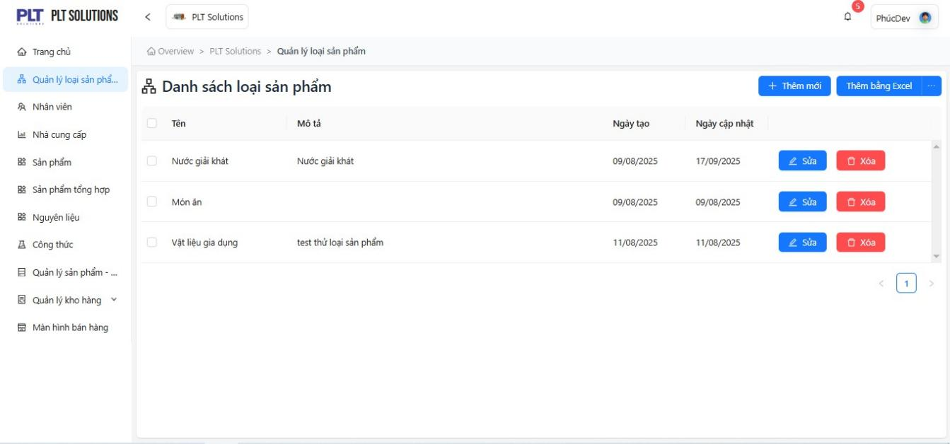
• The product input interface includes many fields (name, code, price, type, supplier) → prone to manual input errors.
• No auto-generated code or duplicate checking.
• No product image preview or barcode.
Category | Specific proposals | Practical benefits
Automatic code generation | When adding a product, the system automatically generates a code in the form SP-yyyyMM-xxx | Reduce duplicate errors, data consistency
Automatically suggest product types | When the user enters a name, the system suggests an existing type. | Speed up operations, avoid duplicate creation
Upload & Preview images | Allow uploading product photos and previewing | Support quick product identification
Barcode scanning integration | Allows quick entry using barcode scanner | Increase efficiency when importing or selling goods
Automatically calculate selling price based on import price + % profit | Reduce manual operations, ensure price consistency

2 Supplier Management – Smart supplier management proposal
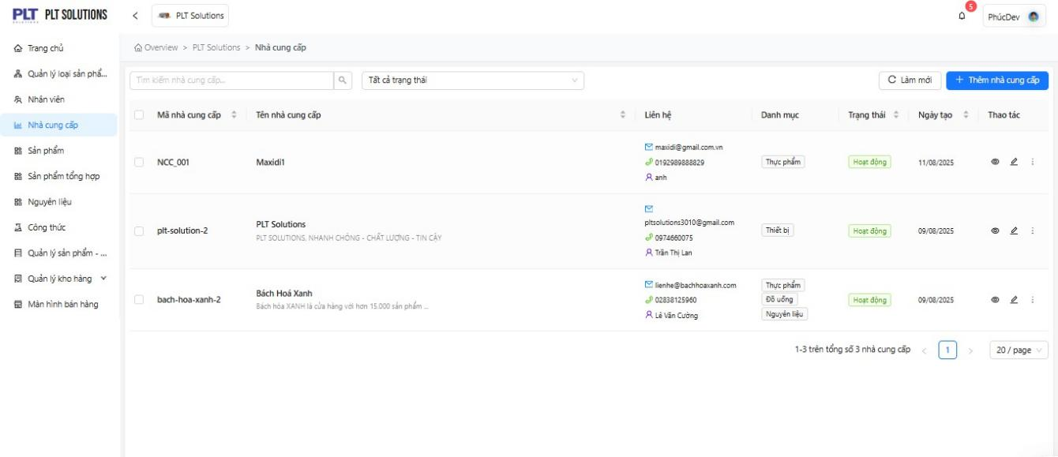
• The provider only stores basic information (name, code, email, phone number).
• No debt tracking or transaction history features.
Category | Specific proposals | Practical benefits
Credit Management | Add fields “Amount owed”, “Payment due date”, “Total transaction value” | Helps accountants and managers track cash flow
Transaction history | Display a list of import vouchers related to each supplier | Easy to check source and quality
Supplier Classification | Tags “Priority”, “Stop cooperation”, “New” | Help make quick decisions when importing goods
Supplier Performance Report | Summary of on-time delivery %, defective product rate | Evaluate suppliers more objectively

3 Employee Management – Improve employee management experience
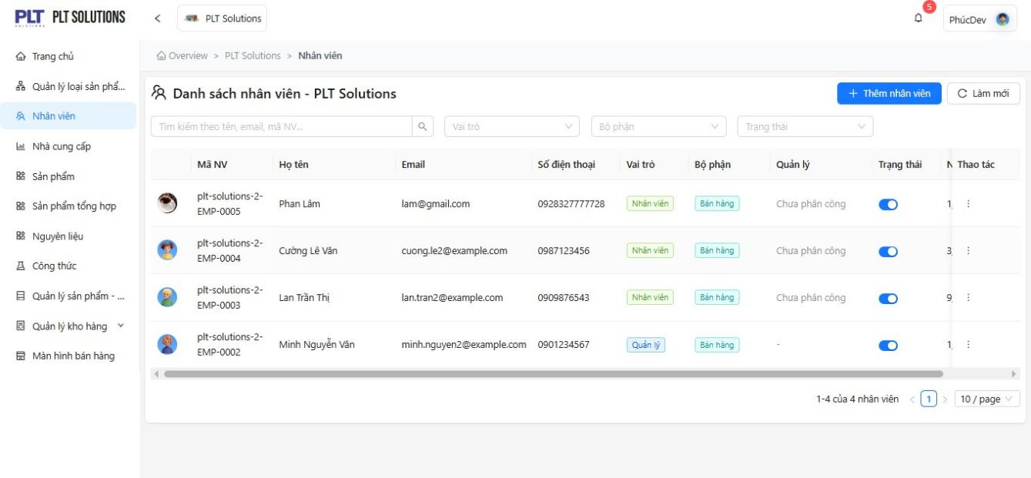
• Decentralization is simple, not intuitive.
• No performance statistics or shift tracking.
• Does not show login history or activity log.
Category | Specific proposals | Practical benefits
Employee Performance Dashboard | Display revenue/day, number of orders processed | Helps manage performance reviews quickly
Login history | Record employee login/logout time | Security check and attendance support
Shift management | Allows assigning shifts to employees and tracking status | Reduce duplicate shifts and shortages
Quick password reset | Admin can reset password via confirmation email | Increased security and convenience
Drag & drop permissions interface | More intuitive, easier to set permissions

4 Warehouse Management – Propose more intuitive and accurate warehouse management
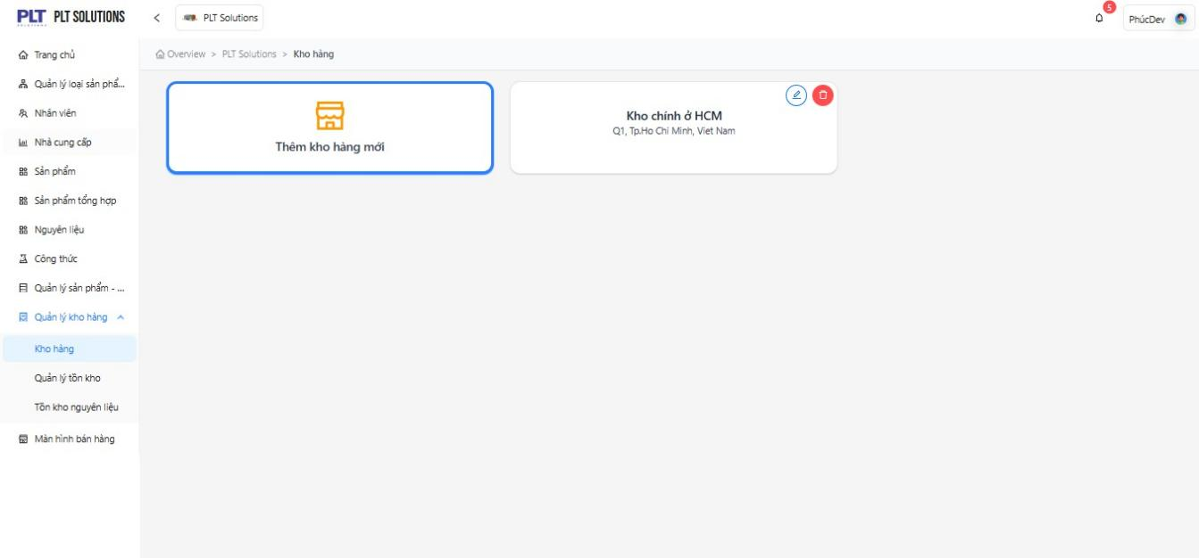
• There is no import/export voucher status (Draft, Approved, Completed).
• Cannot control negative inventory or expired goods.
• Lack of automatic inventory feature.
Category | Specific proposals | Practical benefits
Add ticket status (Draft → Approved → Completed) | Follow a clear approval process | Reduce inventory errors
Automatic low inventory alerts | When quantity < minimum level | Help store owners place orders on time
Tracking product expiration dates | Warning when about to expire | Reduce defective goods and waste
Mobile Inventory Integration | Scan product code for quick comparison | Reduce errors in manual inventory
Inventory chart over time | Track import and export trends | Inventory forecasting support

5 POS (Point of Sale) – User-friendly sales interface and optimized operations
• The POS interface in the SRS document is only described simply, without any features to support quick sales or fix payment errors.
• No offline mode when network is lost.
Category | Specific proposals | Practical benefits
Large touch interface (Touchscreen UI) | Optimized for POS devices or tablets | Easy to operate, reduce accidental presses
Search for products by voice | For busy staff | Fast, convenient and friendly
Offline sales mode | Allows temporary saving of orders when network is lost | Ensure uninterrupted flow
Support multi-method payment | Cash, QR, card, e-wallet | Flexible and practical
Fast invoice printing (auto-print) | Automatically print upon payment completion | Reduce customer service time

