The AWS Command Line Interface (AWS CLI) is an open source tool that enables you to interact with AWS services using commands in your command-line shell. With minimal configuration, the AWS CLI enables you to start running commands that implement functionality equivalent to that provided by the browser-based AWS Management Console from the command prompt in your terminal program.

**About AWS CLI version 2:**

The AWS CLI version 2 is the most recent major version of the AWS CLI and supports all of the latest features. Some features introduced in version 2 are not backported to version 1 and you must upgrade to access those features. There are some "breaking" changes from version 1 that might require you to change your scripts.

**Install and update requirements:**

+ Support the AWS CLI on Microsoft-supported versions of 64-bit Windows.

+ Admin rights to install software

**Install or update the AWS CLI:** Details in the link below

<https://docs.aws.amazon.com/cli/latest/userguide/getting-started-install.html>

After install AWS CLI, configure the access key:

+ In the AWS Management Console, select “Security credentials”:

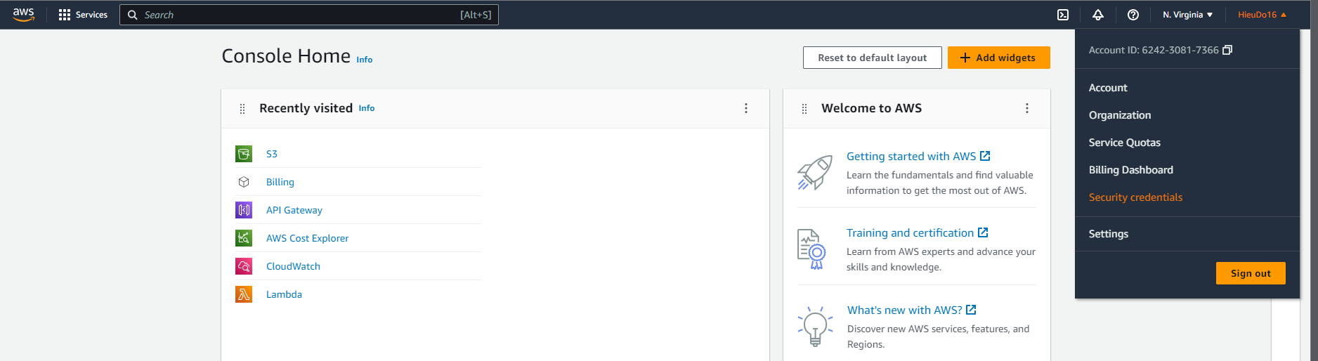

+ Scroll down and create Access Key

+ Then open cmd, type “aws configure”, type ID, access key, default region (in my case is “ap-southeast-1”), default output (**I have no idea about this part**, I type “json”).

+ To check if it works, simply run this code in the python IDE (I used SublimeText):

import boto3

# Let's use Amazon S3

s3 = boto3.resource('s3')

# Print out bucket names

for bucket in s3.buckets.all():

print(bucket.name)

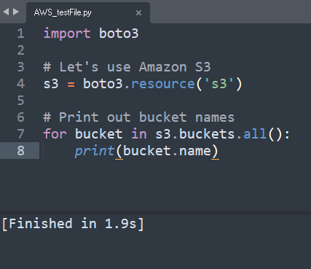

*(Note: I haven’t create any bucket yet, hence it shows nothing)*