**Question 1: What software development methodology would you suggest for this situation and why?**

Software development methodology I would suggest for this situation is Agile due to the following reasons:

1. In term of requirements characteristic :

* Reliability :

+ The project requirements are clear and achievable, making it both effective and practical.

+ The requirements are defined quite clearly but they are not enough and still have some missing points that need to discover later in the development process.

+ It can operate immediately upon completion of the project.

* The project is eagerly anticipated with high reliability .
* Types and number of requirement :

+In the project, there are both functional requirements and non-functional requirements.

+ There are a lot of requirements in the project.

* Types and number of requirements defined this project is very complex and many functions.
* Frequency of requests may change :

+ “The FU-NextExam is a new development system”

+ “There may be many changes during the development process”

+ According to the information, there can be a lot of adjustments made during the development phase

* The project is a new system and can be changes during the development process.
* Determination of requirements at an early stage

+ The requirements are clearly defined at an early stage. However, they can easily change during development.

* The project is well-defined but not enough so agile methodology is suitable.

1. In term of development team :

* Team size : 4-5

+ “The development team participating in the project will include 4-5 extensive and skill developers”

=> Agile works best in a cross-functional team of 4 to 9 developers working on a medium to large-scale project

* Level of understanding of user requirements by the developers :

+ The project is undertaken by FU’s IT department and other departments commit to sending employees to join the project team to support

* The size of team and the skill, experience and understanding of the team is suitable for AGILE

1. In term of user involvement:

+ “The FU’s leaders intend that the project will be undertaken by the IT department”

+ “Managers of other departments commit to sending employees to join the project team”

* Our team is supported by others a lot => Agile
  + Time constraints : “put into use within 3 months and the project needs to be completely completed within 8 months” => quite long time and many phases => AGILE has many phases to release products

CONCLUSION :In conclusion, based on the characteristics mentioned in the context of the software development project, the software development method I recommend for this situation is Agile. This was a complex project so our team needed to design the project into smaller parts to make it easier. Additionally, this project can easily be changed due to new systems and changes to accommodate user requirements. The size of team and the skill, experience and understanding of the team is suitable for Agile. Our team is supported FU’ss members who can support our team to provide additional resources when needed. It can support customers in early product deployment and collect reviews and feedback from users to better improve the product.

**Question 2: Levels of tests I suggest the team use are:**

- Unit testing (performed by the developers): Because the project is complex, and have a lot of function so that when applying Agile, each developer will take some tasks, they need to use Unit test to ensure that individual components is good. Unit testing is a process ensures that the individual components of a piece of software function and react as expected.

- System Testing (performed by testers): Because the project have a lot of requirements so that the project need system testing to ensure that the application meets all of its requirements and that it is stable and reliable.

- Security Testing: FU-NextExam will contain many information of students, lecturers so it needs involves identify vulnerabilities and ensure that confidential data, integrity, and functionality are protected from unauthorized access, attacks, or any form of security risks.

- Compatibility Testing: Because students, lecturers may use different device so that the project need to be verified that a software application functions correctly across different environments, devices, browsers, and operating systems. It ensures that the application delivers a consistent and reliable user experience across various platforms.

=> I believe that the combination of testing, which are mentioned above will offer the team extensive and meticulous testing coverage for the project, ensuring proper testing of the application and early detection and resolution of any bugs during development. This approach will guarantee that the application is of high quality, reliability, and security.

**Question 3:**

1. 4 functional requirements:
   * Lecturers can import student lists from the FAP system or from Excel files.
   * Lecturers can create an examination, start, stop an exam and change test time.
   * Students can view a list of exam and join the exam.
   * The student also can view test result after he/she finished the test.
2. 2 non-functional requirements:
   * The system needs to ensure information security.
   * The system needs to ensure high performance and reliability, require little training time to use.

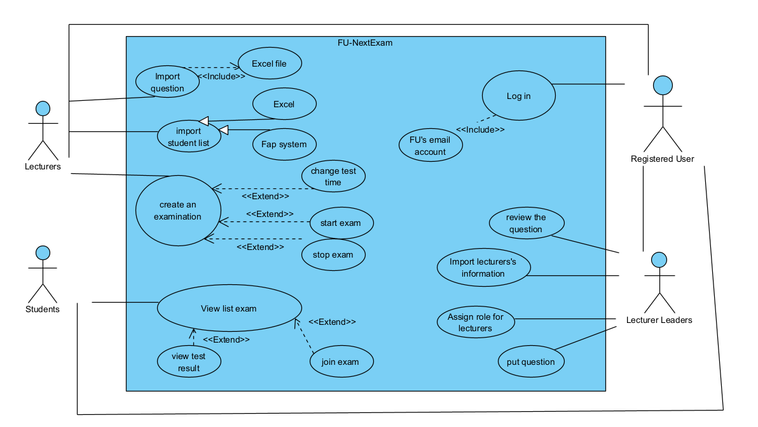**Question 4: Draw use case diagram:**

**Question 5: 4 functional test case**

Test case 1 :Test if someone does not login by FPT mail successfully or not?

+ Description: The test case to test the users login by FPT mail or not

+ Objective: Ensuring the log in is ok.

+ Test steps:

* Login to the app/web by FU’ account on the gmail platform

+ Expected result:

* User can log in to web succesfully

Test case 2 : Test if lecturers import student list successfully .

+ Description: The test case to test the functions import student lists of lecturer is successfully or not

+ Objective: Ensuring the function import is fine.

+ Test steps:

* Login to the app/web by lecturer account
* Click to import button
* Choose import from FAP or excel
* Choose a file to import
* Save to import.

+ Expected result:

* Lecturer can import student lists from the FAP system
* Lecturer can import student lists from the excel file.
* The file to import not exceed 10MB
* Time to import not exceed 5s.

Test case 3 : Test if lecturers can create exam or not.

+ Description: The test case to test the create exam of lectures

+ Objective: Ensuring the function create exam is good.

+ Test steps:

* Login to the app/web by lecturer account
* Click to create exam
* Set time of exam
* Set class in exam

+ Expected result:

* Lecturer can create exam
* The exam will begin in on time

Test case 4 : Test if lecturers leader can assign role for lecturers or not.

+ Description: The test case to test the assign role function .

+ Objective: Ensuring the function assign role is good.

+ Test steps:

* Login to the app/web by lecturer account
* Click to assign role
* Choose lecturer will be assigned
* Choose class for assign

+ Expected result:

* Lecturer leader can assign role for others lecturer successfully.

**Question 6: Write user story**

- As a lecture, I want to import student lists so that I can manage the class, create homework and grade marks for students.

- As a student, I want to view a list of exam so that I can prepare for next exam better.

**Question 7: Create story map**

|  |  |  |  |  |
| --- | --- | --- | --- | --- |
| **User Goals, User Activities, Epics, Journeys** | Import Question list |  | Create a New Exam |  |
| **User Steps (Activities), Narative Flow, Backbone** | Login to the web | Import question list | Create new exam | Review Exam |
| **Release #1** | Login by FU’s account | Import question list from Excel file | Create new exam with time, start/stop exam | Show marks of students |
| **Release #2** | Remember password | Import from word | Create check-log for exam. | Show students have highest or lowest mark. |
| **Release #3** | Notify for school if forgetting password | Using AI to import words in image | Show student face by live camera in exam | Analyse mark of student for after exam |