https://github.com/Hieuthao63d/CSE441_Mobile/tree/main/Lab3_PhanDinhHieuThao_2131200020

Q1

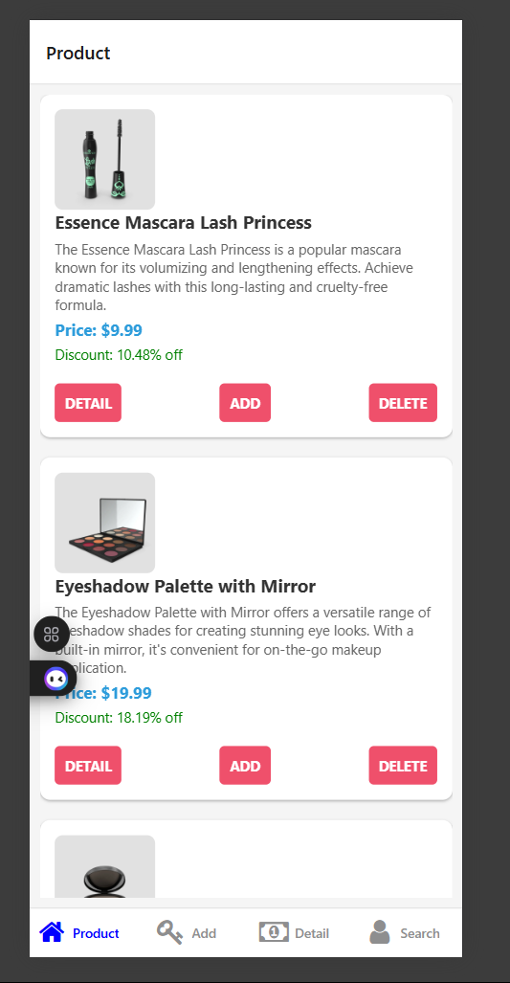

Q2

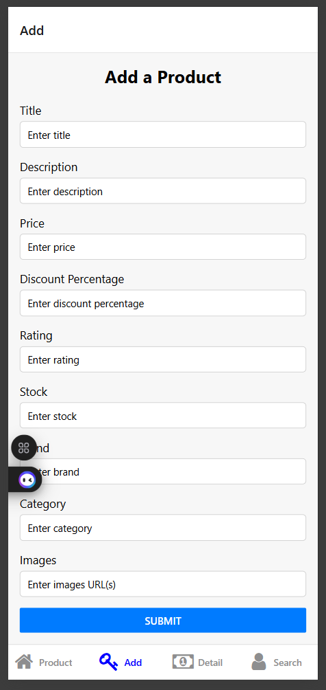

Q3

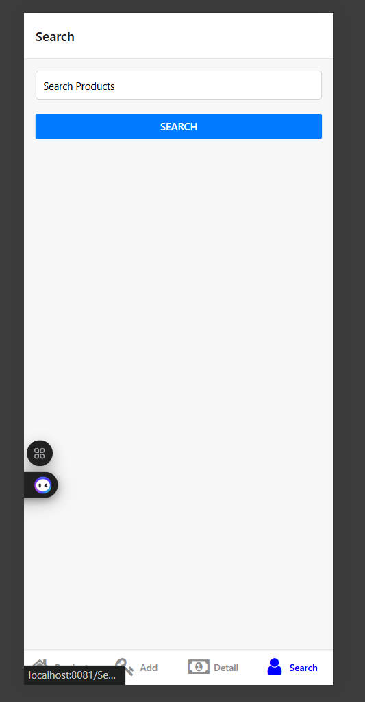

Q4

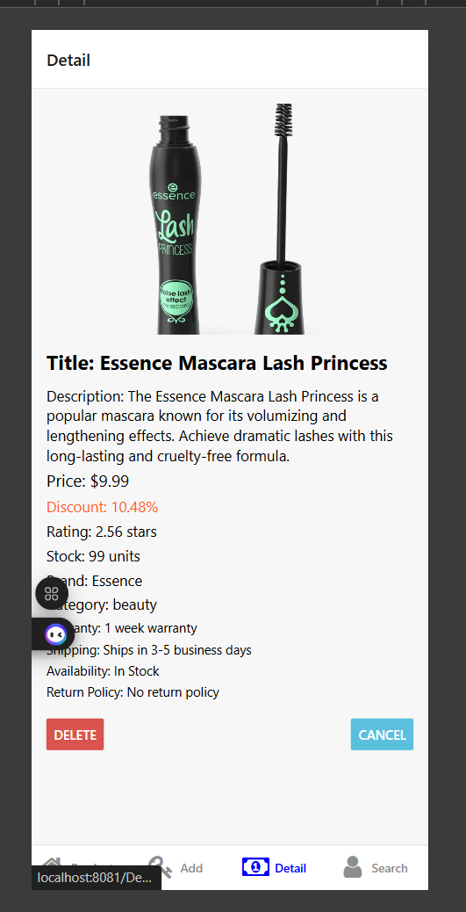

Q5

