Velkomin. Welcome.

**Vertu vegan**

**Stuðlaðu að friði**



Loving Hut Reykjavík

Laugavegur 164

105 Reykjavík, Iceland

# FORRÉTTIR

## 01. Avocado Vorúllur 4,90,-/2 Stk

Avókadó, gúrka, gulrót, sojaspírur, salat, borið fram með majónesi og sojasósu- (E,F,N.)

*Avocado, Cucumber, Carrot, Soysprouts, Salad, served with Majonaise & Soy Sauce- (E,F,N.)*

## 10. Summer Vorúllur 4,90,-/2 Stk

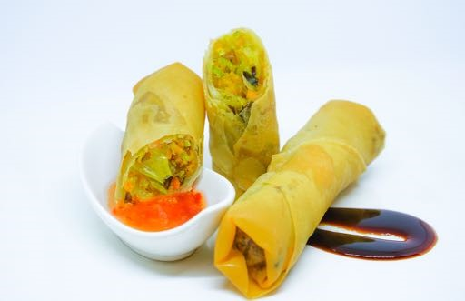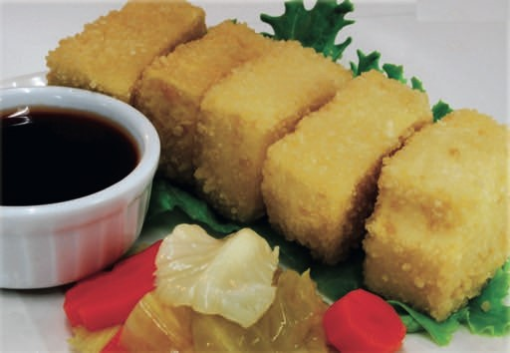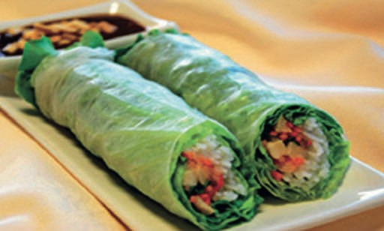

Hrísgrjónanúðlur, Sojaskinka, Tofu, gulrót, Sojaspírur, Salat, borið fram með hnetusósu - (E, F, N)

*Rice Noodle, Soy Ham, Tofu, Carrot, Soysprouts, Salad, served with Peanut Sauce - (E,F,N)*

## 11. Spring Vorúllur 4,50,-/ 2 Stk

Steiktar vorrúllur, gulrót, hvítkál, Júdaseyru sveppir, tofu, glernúðlur – (A, F, N)

*Crunchy fried Rolls, Carrot, Cabbage, Wood Ear Mushroom, Tofu, Glassnoodles - (A, F, N)*

**12. Golden Tofu 4,90,- / 5 Stk**

Steikt Tofu, með sætri Chili sósu og sojasósu – (A, F, N)

*Crunchy fried Tofu, served with sweet Chili Sauce and Soy Sauce - (A, F, N)*

## 18. Korean Dumpling 4,90,- / 8 Stk

Gufusoðin grænmetis dumplings, með sveppasósu og sætri chilisósu – (A)

*steamed Vegetable Dumplings, served with Mushroomsauce & Sweet Chili Sauce - (A)*

**14. Spicy Cha Cha 4,90,- / 6 Stk**

Steikt seitan, borið fram með Vegan majónesi – A, F

*Crunchy Fried Seitan, served with Vegan Mayonnaise - A, F*

**09. Laukhringir 4,90,- / 7 Stk**

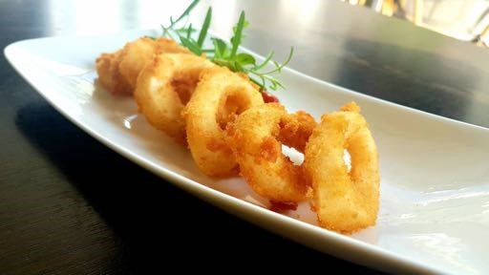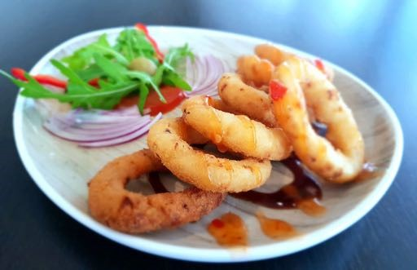

Stökkir laukhringir, bornir fram með tómatsósu – (A)

*Crunchy breaded onion ring served with ketchup - (A)*

**15. Vegan Calamari 5,50,- / 7 Stk**

Steikt seitan, borið fram með Vegan majónesi – (A, F)

*Crunchy Fried Seitan, served with Vegan Mayonnaise - (A, F)*

## 21. Avocado-Salat 8,50,-

Klettasalat með avókadó, tómötum, ólífum, agúrku sólblómafræm, sesamfræm, kasjúhnetum og heimagerðri sósu (N)

*Arugula (or Rocket) salad with avocado, tomatoes, Olive, cucumber sunflower seeds, sesame seeds, cashews and home made sauce (N)*

## NÚÐLU

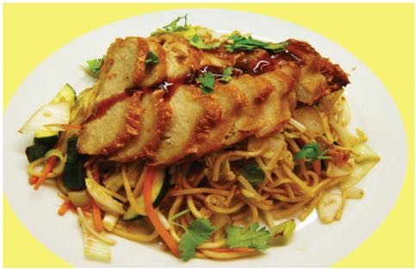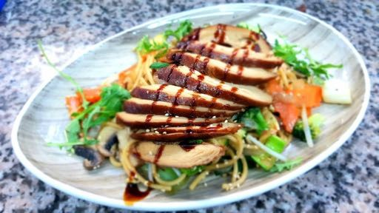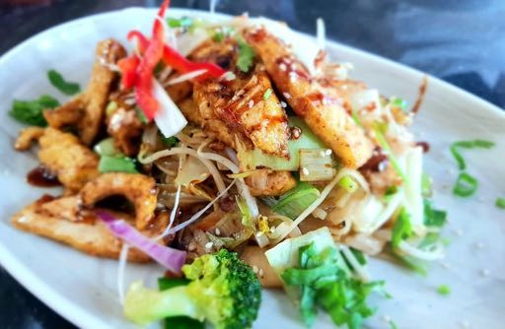

1. **Chow-Mien 8,50,-**

Steiktar núðlur með grænmeti og tofu – A, F, N

*Fried Noodles with Vegetables and Tofu - A, F, N*

1. **Golden Núðlur 9,90,-**

Steiktar núðlur með grænmeti og léttu sojapróteini (án kjúklings) – A, F, N  
*Fried Noodles with Vegetables and light Soy Protein (Chickless) - A, F, N*

1. **Himneskar Núðlur 9,90,-**Steiktar núðlur með grænmeti og Seitan-próteini (án andar)

*Fried Noodles with Vegetables and Seitan Protein (Duckless) - A,F, N*

1. **Ocean Núðlur 9,90,-**Steiktar núðlur með grænmeti og Seitanpróteini (án rækju) – A, F, N

*Fried Noodles with Vegetables and Seitan Protein (Shrimpless) - A, F, N*

1. 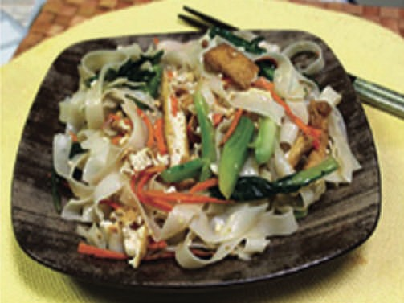**PHO Xao 8,90,-**Steiktar hrísgrjónanúðlur með grænmeti og Tófú

*Fried Rice noodles with Vegetables and Tofu - F, N*

1. **Saigon Núðlur 9,90,-**Steiktar hrísgrjónanúðlur með grænmeti og sojapróteini (án kjúklings)

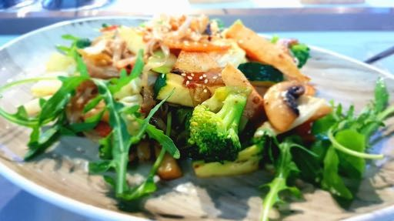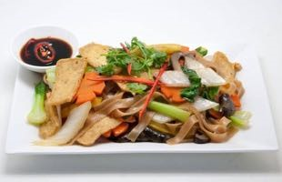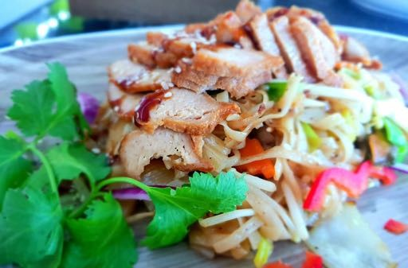

*Fried Rice noodles with Vegetables and Soy Protein (Chickless) - F, N*

1. **Aulac Núðlur 9,90,-**Steiktar hrísgrjónanúðlur með grænmeti og Seitan próteini (Duckless)

*Fried Rice noodles with Vegetables and Seitan Protein (Duckless) - A,F,N*

1. **Meer Núðlur 9,90,-**Steiktar hrísgrjónanúðlur með grænmeti og Seitan próteini (án rækju) – A, F, N

*Fried Rice noodles with Vegetables and Seitan Protein (Shrimpless) - A, F, N*

### 33. PHO Hanoi 9,90,- Hrísgrjónanúðlusúpa með sojapróteini (án kjúklings), lauk, kóríander, myntu, chili, pipar, lime og sojasósu – (F)

*Soup with Rice noodles, Soy Protein (Chickless), Onion,*

*Coriander, Mint, Chilli, Pepper, Lime,and Soy Sauce - (F)*

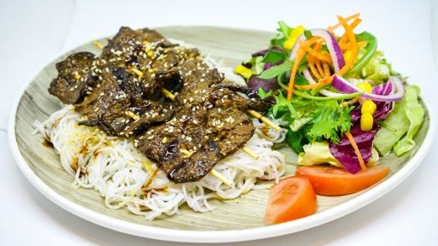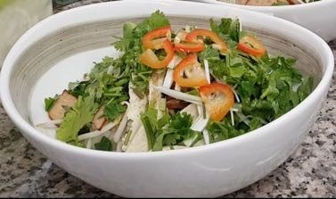

### 34. PHO Saigon 9,90,- Hrísgrjónanúðlusúpa með sojapróteini (án kjöts), lauk, kóríander, myntu, chili, pipar, lime og sojasósu – (F)

*Soup with Rice noodles, Soy Protein (beefless), Onion, Coriander, Mint, Chili, Pepper, Lime, Soy Sauce - (F)*

### 35. Bun Thit Nuong 10,90,- Steikt Vermicelli (þunnar hrísgrjónanúðlur), sojaprótein (án kjöts), lítið salat og salatdressing

*Fried Vermicelli (thin Rice noodles), Soy Protein (beefless), small Salad and Dressing - E, F, N*

### 36. Combo Núðlur 12,90,- Vermicelli (þunnur hrísgrjónanúðlur), sojaprótein (án kjöts), seitanprótein (án rækju) vorrúllur, með salati og dressing

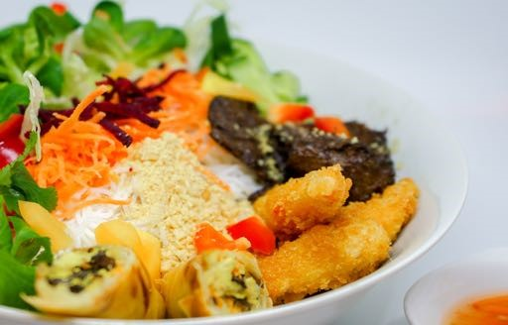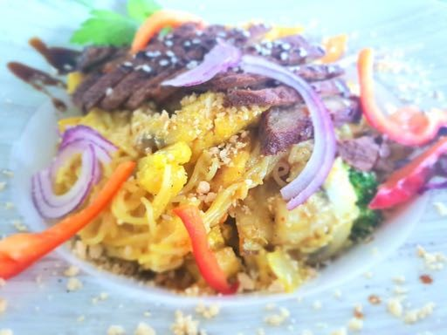

*Vermicelli (thin Ricenoodles), Soy Protein (Beefless), Seitanprotein (Shrimpless) Spring Rolls, served with Salad and Dressing - E,F,N,A*

### 39. Bun xao Curry 10,90,- Steiktar núðlur með grænmeti, Tofu, Sojaplöttum, Jarðhnetum, Kókoshnetumjólk og Karrý

*Fried Noodles with Vegetables, Tofu, Soy Patties, Peanuts, Coconutmilk and Curry - E, F, N*

### AÐALRÉTTIR

#### 23. Banh Xeo (Hrísgrjónapönnukökur) 12,90,- Hrísgrjónapönnukökur - fylltar með vegan sjávarfæði og baunaspírum, ásamt salati með sætri og kryddaðri sósu (A,F,N)

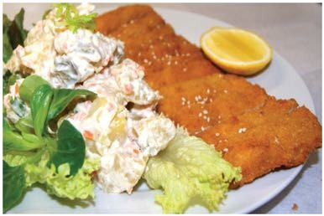*rice pancakes - stuffed with vegan seafood, Bean sprouts, salad with sweet and spicy sauce (A,F,N)*

**41. Wiener 10,90,-**Schnitzel í raspi ásamt kartöflusalati

*Breaded Wheatschnitzel with Potato Salad - F, N, A*

#### 47. Guru Hrísgrjón 10,90,- Steikt hrísgrjón með sojapróteini (án kjúklings), grænmeti, karrý, hnetum og kókoshnetumjólk

*Fried Rice with Soy Protein (Chickless), Vegetables, Curry, Peanut and Coconutmilk - E, F, N*

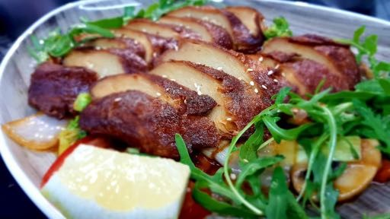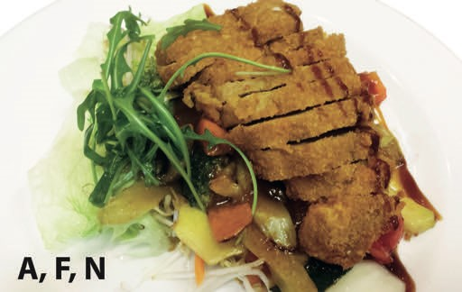

1. **Canton Spezial 12,90,-**Steikt sojasneiðar (án kjúklings), kantóna sósa með grænmeti og hrísgrjónum

*Fried Soy Slices (Chickless), cantonese Sauce with Vegetables and Rice - A, F, N*

1. **Pecking Spezial 12,90,-**Steikt seitan prótein (án andar), pekingsósa með grænmeti og hrísgrjónum - A, N

*Fried Seitan Protein (Duckless), Peking Sauce with Vegetables and Rice - A, N*

1. 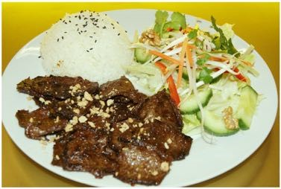**BBQ Beefless 10,90,-**Sojaprótein (án nautakjöts) með BBQ sósu, litlu salati, hnetum og hrísgrjónum

*Soy Protein (Beefless) with BBQ Sauce ,small Salad, Peanut and Rice - E, F, N*

1. **Thai Curry 9,90,-**Grænmeti, Tofu, kókosmjólk, karrý, hneta og hrísgrjón

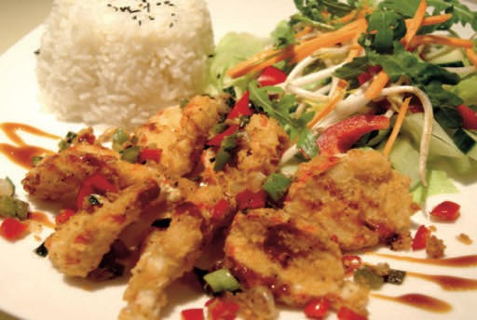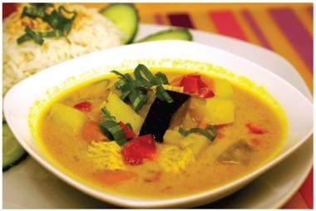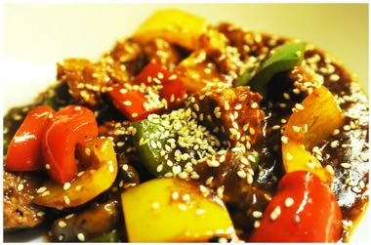

*Vegetables, Tofu, Coconutmilk, Curry , Peanut and Rice - E, F*

#### 60. Szechuan Stripes 11,50,- Soja nugget, papriku, laukur, sveppir, spergilkál með Szechuan sósu og hrísgrjónum

*Soy Nuggets, Bellpepper, Onion, Mushrooms, Broccoli with Szechuan Sauce and Rice - F, N*

#### 61. Combo Spicy Cha Cha 11,90,- Steikt Seitan prótein (án rækju), krydd, laukur, hvítlaukur, engifer, chili, með chili og með salati og hrísgrjónum

*Fried Seitan Protein (Schrimpsless), Spices, Onion, Garlic, Ginger, Chili, served with Chili served with Salad and Rice - A, N*

**62. Teriyaki Kungpao 11,50,-**Loving Hut Teriyaki, Kung Pao sósan og hrísgrjón

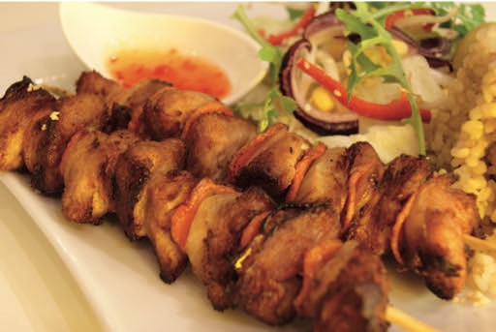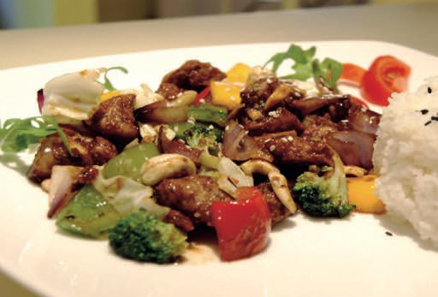

*Loving Hut Teriyaki, Kungpao Sauce and Rice - H, F, N*

**68. Happy Summer 10,90,-**Steiktur spýta með salöt og hrísgrjón

*Fried Skewers with Salad and Rice - F, N*

#### Meðlætir

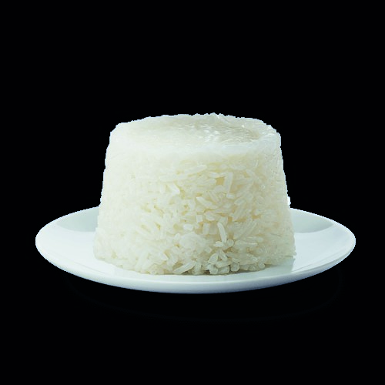

**90. Franskar kartöflur / Fries 2,50 ,-**

**91. Jasmin hrísgrjón / Rice (N) 2,50 ,-**

**92. Smá Salat / Small Salad (N) 2,50 ,-   
  
93. Kartöflu Salat / Potato Salad (F) 2,50 ,-**

#### Eftirréttur

##### 205. Bananensplit/ Banana Split 4,90,-

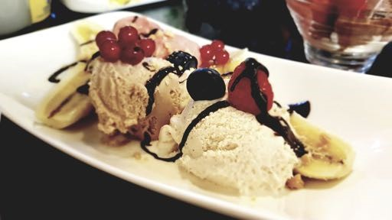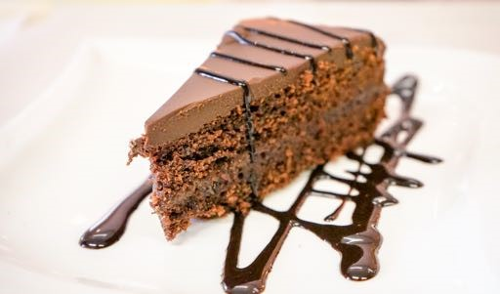

3 Kugeln Sojaeis mit Bananen - E, F

**206. Sojaeis /** soy ice cream **3,90,-**

3 Kugeln - E, F

##### 207. Veganer Kuchen 3,90,-

Vegan Cake A,H,E,F

**Við óskum þér „góðrar lyst“**

***All dishes are without animal ingredients. No glutamate, no milk, no eggs.***

* ***Allergen information according to Codex recommendation:***

*gluten-containing cereals: A / Peanuts: E / Soy: F / Mustard: M / Sulfites: O / Lupins: P / Sesame: N / Nuts: H / Celery: L*

##### Fast Food Menu

###### 1. Jackfruit Burger 6,90,- BBQ Jackfruit með salati, gulrót coleslaw á hamborgarabita toppað með vegan majónesi, BBQ sósu og tómatsósu.

BBQ Jackfruit served with lettuce, carrot coleslaw on a burger bun topped with vegan mayonnaise, BBQ sauce and ketchup.

2. Save the Ocean Burger 9,50,-

Two No-fish fillets served with lettuce, tomato, cucumber, gherkins, onions on a burger bun topped with vegan mayonnaise, tartar sauce and mustard.

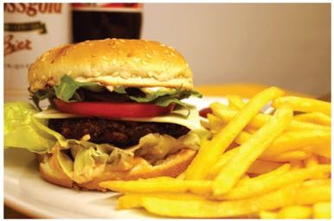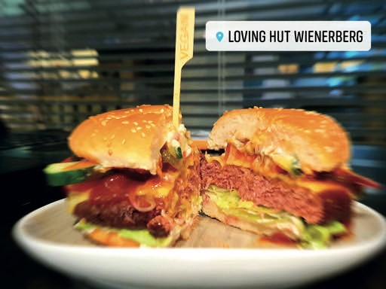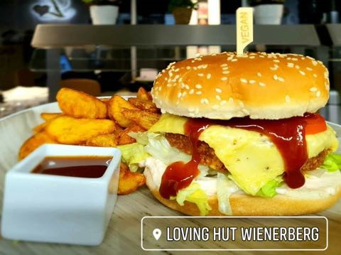

3. Loving Burger 10,90,-

Loving Hut burger patty, made in house, served with lettuce, tomato, gherkins and vegan cheese on a burger bun topped with vegan mayonnaise, BBQ sauce and ketchup.

4a. Beyond Burger 8,90,-

Beyond burger patty served with lettuce, gherkins on a burger bun topped with vegan mayonnaise, BBQ sauce and ketchup.

**4b. Beyond Burger with 10,90,-**

Spiced potato wedges

Beyond burger patty served with lettuce, gherkins on a burger bun topped, vegan mayonnaise, BBQ sauce, Spiced potato wedges and ketchup.

4c. Avocado Beyond Burger 11,90,-

Beyond burger patty served with lettuce, gherkins on a burger bun topped, vegan mayonnaise, BBQ sauce, mix Salad & dressing and ketchup.

