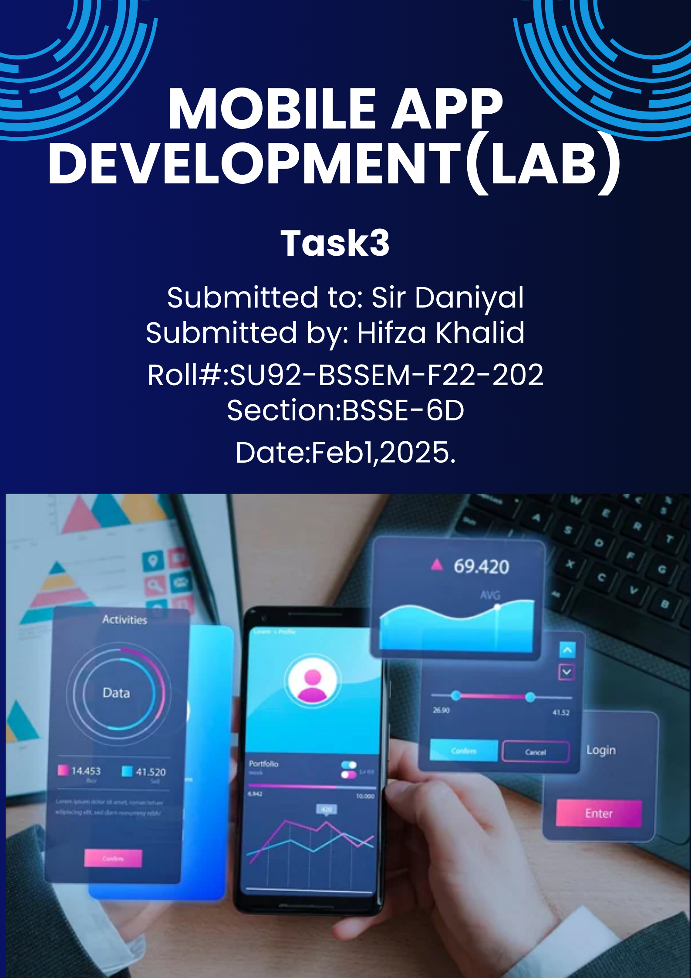

|  |
| --- |
| **Task: Create a Login Screen in Flutter**  **Task Description:**  Create a **Flutter** application that includes a **login screen** with the following features:  **Requirements:**   1. **UI Components:**    * A centered login form with:   Email input field.  Password input field.  Login button.  "Forgot Password?" clickable text.  "Don't have an account? Sign Up" clickable text.     1. **Validations:**    * + The email field should check for a valid email format.      + The password field should ensure the input is at least **6 characters** long.      + Display an error message, if user enters wrong details. 2. **Interactivity:**    * When the login button is pressed:   Check if the email and password fields are not empty.  If valid, display a success message (mock authentication). If invalid, show an error message.   * + Clicking on **"Forgot Password?"** should navigate to a placeholder screen.   + Clicking on **"Sign Up"** should navigate to a **registration screen** (can be an empty screen for now).      1. **Additional Features:** o Add a **loading indicator** when the login button is pressed.   o Implement a **password visibility toggle**.   * + Use a clean **UI design** with Flutter's ElevatedButton, TextField, and TextFormField. |