Smartly Hire

Final Year Project

Session 2022-2026

A project submitted in partial fulfillment of the degree of

BS in Software Engineering


Department of Software Engineering
Faculty of Computer Science & Information Technology
The Superior University, Lahore

Fall 2025

Type (Nature of project) |  |  | [] Development [ ] Research [ ] R&D
Area of specialization
FYP ID |  |  | BSSE-FYP-F25-059
Project Group Members
Sr.# | Reg. # | Student Name |  | Email ID | *Signature
(i) | SU92-BSSEM-F22-202 | Hifza Khalid |  | su92-bssem-f22-202@superior.edu.pk | 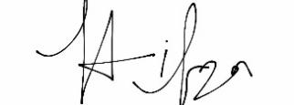
(ii) | SU92-BSSEM-F22-201 | Baqir Sultan |  | su92-bssem-f22-201@superior.edu.pk | 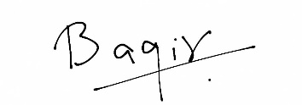
(iii) | SU92-BSSEM-F22-196 | Muhammad Zubair |  | su92-bssem-f22-196@superior.edu.pk | 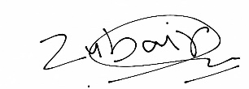

*The candidates confirm that the work submitted is their own and appropriate credit has been given where reference has been made to work of others

Plagiarism Free Certificate
This is to certify that, I Hifza Khalid S/D of Khalid Nawaz, group leader of FYP under registration no BSSE-FYP-F25-059 at Software Engineering Department, The Superior University, Lahore. I declare that my FYP report is checked by my supervisor.

Date: Nov 24, 2025. Name of Group Leader: Hifza Khalid Signature:_________
Name of Supervisor: Mr. Sohail Irshad
Designation: Lecturer
Signature: ________________

HoD: Dr. Tehreem Masood
Signature: _______________
Smartly Hire

Change Record
Author(s) | Version | Date | Notes | Supervisor’s Signature
Hifza Khalid  Baqir Sultan  Zubair Iftikhar | 1.0 | 12 Sep, 2025 | Initial draft including problem statement, project motivation, and literature survey
Hifza Khalid  Baqir Sultan  Zubair Iftikhar | 1.1 | 26 Sep , 2025 | Revised requirements and introduction based on supervisor feedback
Hifza Khalid  Baqir Sultan  Zubair Iftikhar | 1.2 | 31 Sep, 2025 | Updated document after faculty evaluation feedback; improved clarity and scope
Hifza Khalid  Baqir Sultan  Zubair Iftikhar | 1.3 | 3 Oct, 2025 | Added detailed project plan, WBS, Gantt chart, and responsibility matrix
Hifza Khalid  Baqir Sultan  Muhammad Zubair | 1.4 | 10 Oct, 2025 | Included system use case model, process workflows, and interview flow definition
Hifza Khalid  Baqir Sultan  Muhammad Zubair | 1.5 | 17 Oct, 2025 | Added system design models (UML diagrams, database ERD, component layout)
Hifza Khalid  Baqir Sultan  Muhammad Zubair | 1.6 | 31 Oct, 2025 | Document updated to include implementation details and deployed environment
Hifza Khalid  Baqir Sultan  Muhammad Zubair | 1.7 | 16 Nov, 2025 | Final optimized report version including evaluation, results, and conclusion

APPROVAL
Project Supervisor
Comments: ___________________________________________________________________
_____________________________________________________________________________
Name:______________________________
Date:_______________________________ | Signature:__________________________

Project Manager
Comments: ___________________________________________________________________
_____________________________________________________________________________
Date:_______________________________ | Signature:__________________________

Head of the Department
Comments: ___________________________________________________________________
_____________________________________________________________________________
Date:_______________________________ | Signature:__________________________

Dedication

I dedicate this work to all academic community, industry professionals, and mentors visionaries and innovators who believe in the power of technology to transform how we communicate and connect.

Acknowledgements

We are thankful to our supervisor Mr. Sohail who has guided us throughout this journey with immense patience and dedication. His expertise, constructive criticism, and continuous support have been instrumental in shaping not just this project, but our approach to innovation and problem-solving. The countless hours spent in discussion, brainstorming, and refinement have proven invaluable to the development of Smartly Hire.

Executive Summary
Smartly Hire is an AI-powered online interview platform designed to make recruitment secure, efficient, and automated. It provides real-time monitoring of candidates using face detection, emotion recognition, head-pose tracking, and behavioral analysis to ensure fair and proctored interviews. Candidates can apply, attend interviews, and receive instant reports, while recruiters manage jobs, monitor live sessions, and generate detailed performance insights.

Built with a microservices architecture with React and Tailwind for frontend, Node.js and Express for backend, MongoDB for database, and Python-based AI services, Smartly Hire ensures scalability, security, and reliability. The system reduces reliance on human proctors, prevents cheating, and delivers consistent, actionable insights, making remote hiring smarter, faster, and more transparent.

Table of Contents

Dedication v
Acknowledgements vi
Executive Summary vii
List of Figures xi
List of Tables xii
Chapter 1 13
Introduction 13
1.1. Background 2
1.2. Motivations and Challenges 2
1.3. Goals and Objectives 3
1.4. Literature Review/Existing Solutions 4
1.5. Gap Analysis 4
1.6. Proposed Solution 5
1.7. Project Plan 6
1.7.1. Work Breakdown Structure 6
1.7.2. Roles & Responsibility Matrix 12
1.7.3. Gantt Chart 13
1.8. Report Outline 14
1.9. Empathy Map 15
1.9.1 Empathy Map (For Recruiter / Admin User) 15
1.9.2. Empathy Map (Candidate User) 16
Chapter 2 17
Software Requirement Specifications 17
2.1. Introduction 18
2.1.1. Purpose 18
2.1.2. Document Conventions 18
2.1.3. Intended Audience and Reading Suggestions 19
2.1.4. Product Scope 19
2.1.5. References 19
2.2. Overall Description 20
2.2.1. Product Perspective 20
2.2.2. Product Functions: 20
2.2.3. User Classes and Characteristics 20
2.2.4. Operating Environment 21
2.2.5. Design and Implementation Constraints 21
2.2.6. User Documentation 21
2.2.7. Assumptions and Dependencies 22
2.3. External Interface Requirements 22
2.3.1. User Interfaces 22
2.3.2. Hardware Interfaces 23
2.3.3. Software Interfaces 23
2.3.4. Communications Interfaces 23
2.4. System Features 24
2.4.1. User Authentication & Management 24
2.4.1.1. Description and Priority 24
2.4.1.2. Stimulus/Response Sequences 24
2.4.1.3. Functional Requirements Table 24
2.4.2. Admin Functional Features 25
2.4.2.1. Description and Priority 25
2.4.2.2. Stimulus/Response Sequences 25
2.4.2.3. Functional Requirements 25
2.4.3. Candidate Functional Features 26
2.4.4. Browser Permission & Video Access 26
2.4.5. Interview Question Handling 27
2.4.6 AI Proctoring & Monitoring 27
2.4.7 Auto-Submission & Notifications 28
2.4.8 Report Generation 29
2.4.9 System & Data Management 30
2.4.10 External Services 30
2.5. Nonfunctional Requirements 31
2.5.1. Performance Requirements 31
2.5.2. Safety Requirements 32
2.5.3. Security Requirements 32
2.5.4. Usability Requirements 32
2.5.5. Reliability Requirements 33
2.5.6. Maintainability/Supportability Requirements 33
2.5.7. Portability Requirements 34
2.5.8. Efficiency Requirements 34
2.6. Domain Requirements 34
Chapter 3 36
Use Case Analysis 36
3.1. Use Case Model 37
3.2. Use Cases Description 39
Chapter 4 48
System Design 48
4.1. Architecture Diagram 49
4.2. Domain Model 50
4.1. Entity Relationship Diagram with data dictionary 52
4.2. Class Diagram 61
4.3. Sequence Diagram 63
4.4. Operation contracts 65
4.5. Activity Diagram 70
4.6. State Transition Diagram 71
4.7. Component Diagram 73
4.8. Deployment Diagram 75
4.9. Data Flow diagram 76
Chapter 5 78
Implementation 78
5.1. Important Flow Control/Pseudo codes 79
5.2. Components, Libraries, Web Services and stubs 81
5.3. Deployment Environment 82
5.4. Tools and Techniques 83
5.5. Best Practices / Coding Standards 83
5.6. Version Control 84
Appendices 86
Appendix A: Information / Promotional Material 87
A.1. Broacher 87
A.2. Flyer 89
A.3. Standee 89
A.5.1.1. Logo Usage 91
Appendix B: Sample Screenshots 91
B.2. Candidate Interface Screenshots 94

List of Figures
Figure 1 Gantt Chart 13
Figure 2 Empathy Map 15
Figure 3 Use Case (Smartly Hire) 39
Figure 4 Architecture diagram 51
Figure 5 Domain Model Diagram 53
Figure 6 Entity Relationship Diagram 54
Figure 7 Class Diagram 63
Figure 8 Sequence Diagram 65
Figure 9 Activity Diagram 72
Figure 10 State Transition Diagram 73
Figure 11 Component Diagram 75
Figure 12 Deployment Diagram 76
Figure 13 Level 0 DFD 77
Figure 14 Level 1 DFD 78
Figure 15 Admin Login Flow 80
Figure 16 Job Creation Flow 81
Figure 17 Candidate Application Flow 81
Figure 18 Proctoring Event Flow 82
Figure 19 Brochure Front side 90
Figure 20 Brochure inside 90
Figure 21 Flyer 91
Figure 22 Standee 92
Figure 23 Landing page 94
Figure 24 Admin Dashboard 95
Figure 25 Available Jobs 96
Figure 26 Candidate Interviews list 96
Figure 27 Interview Submitted Page 97
Figure 28 login page 97

List of Tables

Table 1 Gap Analysis 5
Table 2 Work Breakdown Structure 12
Table 3 Roles & Responsibility Matrix 13
Table 4 User Classes and Characteristics 21
Table 5 User Interfaces 23
Table 6 Hardware Interfaces 23
Table 7 Functional Requirements 25
Table 8 Admin Functional Features 25
Table 9 Candidate Functional Features 26
Table 10 Browser Permission & Video Access (Functional Requirements) 27
Table 11 Interview Question Handling (Functional Requirements) 27
Table 12 AI Proctoring & Monitoring (Functional Requirements) 28
Table 13 Auto-Submission & Notifications (Functional Requirements) 29
Table 14 Report Generation (Functional Requirements) 29
Table 15 System & Data Management (Functional Requirements) 30
Table 16 External Services (Functional Requirements) 31
Table 17 Entity: users 53
Table 18 Entity: Jobs 54
Table 19 Entity: Applications 55
Table 20 Entity: Interview Sessions 56
Table 21 Entity: Questions 57
Table 22 Entity: Answers 58
Table 23 Entity: Violations 59
Table 24 Entity: Reports 60
Table 25 Relationships (Data Dictionary Linkage) 61
Table 26 User Operations 65
Table 27 Job Operations (User Authentication) 66
Table 28 Job Operations (Admin) 67
Table 29 Application Operations 67
Table 30 InterviewSession Operations 68
Table 31 Question & Answer Operations 69
Table 32 Violation Operations 69
Table 33 Report Operations 70

Chapter 1

Introduction

Chapter 1: Introduction
This chapter provides an overview of Smartly Hire, a web-based AI-assisted recruitment platform, outlining the background of the problem, motivation for developing an automated recruitment solution, and the modern challenges associated with remote hiring environments. It reviews existing tools, identifies gaps in traditional recruitment workflows, and presents the proposed solution. The chapter concludes with the project plan, including the WBS structure, roles and responsibility matrix, Gantt chart outline, and empathy map, which collectively define the operational framework for the system’s development.

Background
With the rapid digital transformation of organizational processes, recruitment has shifted from traditional in-person interviews to remote, technology-driven hiring models. While online interviews reduce administrative overhead, expand candidate reach, and accelerate hiring cycles, they introduce challenges such as:
- Impersonation or proxy interviews
- Use of unauthorized devices (mobile phones, books, or notes)
- External assistance
- Lack of reliable candidate behavior analysis
- Manual, biased, or inconsistent evaluation
To address these challenges, organizations are adopting AI-driven solutions for live proctoring and automated assessment. Smartly Hire is designed to provide a secure, AI-enabled recruitment platform capable of real-time monitoring, automated analysis, and fair evaluation, thereby improving integrity and reliability in remote hiring.

Motivations and Challenges
Motivations:
- Growing demand for scalable remote hiring tools
- Need for automated evaluation to reduce human bias
- Requirement for secure online interview environments
- Rising impersonation and cheating attempts during remote interviews
- Recruitment teams require faster, data-driven decision-making
Challenges:
Developing such a system involves:
- Real-time AI detection of candidate presence, attention, and prohibited objects
- Processing large volumes of live video and behavioral data with minimal latency
- Designing a clean, intuitive interface for both candidates and recruiters
- Ensuring cybersecurity, data privacy, and seamless cloud deployment
- Maintaining accuracy and generalization across different devices and environments

Goals and Objectives
Main Goal:
To develop Smartly Hire, an AI-assisted recruitment platform that automates hiring, enhances security, and ensures fair evaluation in remote interview environments.
Specific Objectives:
- Build a fully responsive frontend for both Admin (Recruiter/HR) and Candidate
- Implement secure authentication with role-based access
- Provide tools for job posting, application management, and interview scheduling
- Integrate ML services for live proctoring:
- Face detection and tracking
- Multiple face detection
- Head pose analysis
- Suspicious object detection (cell phone, book, paper)
- Automatically detect:
- Candidate leaving camera view
- Multiple faces
- Unauthorized devices
- Looking away or distraction events
- Generate structured interview reports with integrity scores, analytics, and optional AI evaluation
- Ensure system scalability through modern cloud deployment

Literature Review/Existing Solutions
Current platforms such as HireVue, Mettl, TestGorilla, and HackerRank offer automated scoring, basic proctoring, or skill testing. However:
- Real-time cheating detection is limited
- Most systems focus on a single capability (e.g., coding tests or MCQs) rather than full interviews
- Emotion and behavioral analytics are often restricted or expensive
- Systems lack transparency, customization, and multi-modal monitoring
- Costs remain prohibitive for universities and startups
These limitations justify the development of a fully integrated, cost-effective platform like Smartly Hire.

Gap Analysis
Area | Existing Systems | Identified Gap
Proctoring Depth | Limited monitoring | No unified real-time multi-modal AI
AI Models | Either object detection OR emotion | Lack of combined face, emotion, head-pose, device detection
Reporting | Basic Scoring | Need for analytics, charts, PDF reports
Customization | Restricted thresholds | No flexible rules/weights per organization
Cost | High subscription plans | Not feasible for small institutions
Scalability | Manual supervision still required | Need for fully automated pipeline

Table 1 Gap Analysis

These gaps reinforce the need for a unified, AI-assisted online recruitment platform.

Proposed Solution
Smartly Hire is a cloud-based, AI-assisted recruitment platform designed to ensure fairness, security, and transparency in online assessments. The system integrates secure authentication, job management, automated interview workflows, and real-time AI-assisted proctoring using lightweight ML models.
The platform captures candidate webcam frames and behavioral cues for integrity evaluation. Instead of heavy models, it leverages MediaPipe + COCO-SSD + TensorFlow.js for efficient live monitoring, enabling real-time analysis even on standard devices.
AI/ML Components Used:
- Face Detection & Tracking: MediaPipe FaceMesh (468 points)
- Object Detection: COCO-SSD (cell phone, book, paper)
- Integrity Score Computation: Weighted deduction system from 100
- Optional Backend Evaluation: LLM (Ollama Llama3) for scoring and feedback
Key Features:
- Secure authentication for Admin and Candidate
- Automated job posting, application tracking, and interview scheduling
- Real-time proctoring with alerts for:
- Candidate absence
- Multiple faces
- Unauthorized objects
- Distraction events
- Automatic violation logging and integrity score calculation
- Structured recruiter reports with charts, risk scores, and timelines
- Scalable, cloud-ready architecture

Project Plan
The project follows a structured development approach: requirements gathering, system design, frontend/backend development, ML microservices integration, testing, and deployment. Each phase has defined tasks, timelines, and responsibilities.

Work Breakdown Structure

WBS # | WBS Item | Deliverable | Activity # | Activity to Complete the Deliverable | Duration (Days) | Responsible Team Member(s) & Role(s)
1 | Requirements & Analysis | Requirements Specification | 1.1 | Collect functional requirements (admin, candidate, proctoring) | 7 | Baqir (Lead), Hifza & Zubair (Support)
 |  |  | 1.2 | Collect non-functional requirements (security, performance, usability) | 5 | Baqir (Lead)
 |  |  | 1.3 | Prepare Software Requirements Specification (SRS) | 10 | Baqir (Lead), Hifza & Zubair (Support)
 |  |  | 1.4 | Prepare use cases & initial UML diagrams | 6 | Baqir (Lead), Hifza & Zubair (Support)
2 | System Design | Architecture & Database | 2.1 | Define overall architecture (frontend, backend, ML microservices) | 7 | Baqir (Lead)
 |  |  | 2.2 | Design database schema (ERD, collections, relations) | 6 | Zubair (Lead), Hifza & Baqir (Support)
 |  |  | 2.3 | Design module-level components (auth, jobs, interviews, reports) | 8 | Baqir (Lead)
 |  |  | 2.4 | Prepare all design diagrams (Architecture, Domain Model, ERD, Class, Sequence, Activity) | 12 | Shared (All)
3 | Frontend Development | Fully Functional UI | 3.1 | Setup Smartly Hire React Project | 4 | Hifza (Lead), Baqir & Zubair (Support)
 |  |  | 3.2 | Implement authentication pages (login/signup for Admin & Candidate) | 6 | Hifza (Lead)
 |  |  | 3.3 | Admin dashboard UI | 8 | Hifza (Lead)
 |  |  | 3.4 | Job management screens | 7 | Hifza (Lead)
 |  |  | 3.5 | Candidate job listings & applications | 8 | Hifza (Lead)
 |  |  | 3.6 | Proctored interview screen (questions, timer, editor, webcam capture) | 14 | Hifza (Lead)
 |  |  | 3.7 | Integrate charts (Chart.js) for reports | 5 | Hifza (Lead)
4 | Backend Development (Node.js + MongoDB) | Fully Functional APIs | 4.1 | Setup Express server & MongoDB connection | 4 | Hifza (Lead)
 |  |  | 4.2 | Implement authentication module (JWT + roles) | 6 | Hifza (Lead)
 |  |  | 4.3 | Job management APIs | 6 | Hifza (Lead)
 |  |  | 4.4 | Applications & interview scheduling APIs | 6 | Hifza (Lead)
 |  |  | 4.5 | Interview session & answer storage APIs | 7 | Hifza (Lead)
 |  |  | 4.6 | Proctoring event logging APIs | 6 | Hifza (Lead)
 |  |  | 4.7 | Report generation APIs (JSON + PDF export) | 8 | Hifza (Lead)
5 | ML & Proctoring Services | Teal-time Proctoring & Evaluation | 5.1 | Integrate MediaPipe Face Detection in frontend | 6 | Hifza (Lead), Baqir (Support)
 |  |  | 5.2 | Integrate MediaPipe FaceMesh for 468-point tracking | 10 | Hifza (Lead), Baqir & Zubair (Support)
 |  |  | 5.3 | Integrate TensorFlow.js COCO-SSD for object detection | 6 | Hifza (Lead)
 |  |  | 5.4 | Implement Head Pose Estimation (SolvePnP using mesh points) | 12 | Hifza (Lead)
 |  |  | 5.5 | Implement MAR-based mouth movement detection | 6 | Hifza (Lead)
 |  |  | 5.6 | Violation Engine – combine ML outputs into integrity scoring | 7 | Baqir (Lead), Hifza (Support)
6 | Integration, Testing & Deployment | Fully Working System | 6.1 | Integrate frontend with baxckend APIs | 7 | Shared (All)
 |  |  | 6.2 | Functional testing of all flows | 10 | Shared (All)
 |  |  | 6.3 | Performance & reliability testing | 7 | Shared (All)
 |  |  | 6.4 | Deploy frontend (Vercel/Netlify) | 3 | Baqir (Lead), Hifza & Zubair (Support)
 |  |  | 6.5 | Deploy backend (Render/Railway) | 3 | Baqir (Lead), Hifza & Zubair (Support)
 |  |  | 6.6 | Deploy ML services (cloud VM / containers) | 5 | Baqir (Lead), Hifza & Zubair (Support)
7 | Documentation & Presentation | Final Project Deliverables | 7.1 | Final SRS & design chapters | 7 | Shared (All)
 |  |  | 7.2 | User manuals (admin + candidate) | 6 | Shared (All)
 |  |  | 7.3 | Final report with results, charts, screenshots | 10 | Shared (All)
 |  |  | 7.4 | Presentation slides & demo script | 5 | Zubair (Lead), Hifza & Baqir (Support)

Table 2 Work Breakdown Structure

Roles & Responsibility Matrix
Role / Task | Hifza Khalid  (Team Lead) | Baqir Sultan | Zubair Iftikhar
Requirements & SRS | Support | Lead | Support
Frontend Development | Lead | Support | Support
Backend Development | Lead | Support | Support
ML Microservices Face Detection, FaceMesh, Object Detection, Head Pose, EAR, MAR) | Lead | Support | Support
Database Design & Integration | Support | Support | Lead
Testing & Integration | Shared | Shared | Shared
Deployment (Cloud / Hosting) | Support | Lead | Support
Documentation | Shared | Shared | Shared
Presentation & Reporting | Support | Support | Lead

Table 3 Roles & Responsibility Matrix

Gantt Chart
The 24-week project is structured into clear phases, covering requirements, design, development, ML integration, testing, deployment, and documentation.
• Requirements & Analysis (Weeks 1–3)
- Gather requirements
- Prepare SRS
- Create UML/use-case diagrams
• System Design (Weeks 3–5)
- Define architecture
- Create database schema
- Design modules and system diagrams
• Frontend Development (Weeks 6–10)
- Setup React project
- Build authentication, dashboard, and job management UI
- Develop candidate job flow & proctoring screens
• Backend Development (Weeks 7–12)
- Implement authentication & job management APIs
- Add scheduling, interview logging, and reporting APIs
• ML & Proctoring Module (Weeks 10–15)
- Integrate Face Detection, FaceMesh, and COCO-SSD
- Implement head pose and mouth-movement detection
- Build violation & integrity scoring engine
• Integration & Testing (Weeks 15–18)
- Connect frontend, backend, and ML modules
- Functional, performance, and reliability testing
• Deployment (Weeks 18–20)
- Deploy frontend, backend, and ML services
• Documentation & Finalization (Weeks 20–24)
- Prepare user manual, final report, and presentation

Figure 1 Gantt Chart

Report Outline
The final year project report for Smartly Hire is structured into five major chapters that collectively describe the complete system, its problem domain, design, implementation, evaluation, and outcomes.
• Chapter 1 (Introduction): Presents recruitment challenges in remote hiring, motivation for Secure and scalable automated interviews, gap analysis in current hiring tools, and overview of the Smartly Hire platform with its two core actors: Admin and Candidate. It also outlines the project planning artifacts including WBS and responsibility mapping.
• Chapter 2 (Software Requirement Specifications): Defines detailed functional, non-functional, security and domain-specific requirements of Smartly Hire. It describes system constraints, interfaces, performance benchmarks, user behavior assumptions, and AI-enabled services used for interview monitoring and evaluation.
• Chapter 3 (Use Case Analysis): Models interaction scenarios between hiring Admins and Candidates in Smartly Hire using structured use cases. It covers user authentication, job selection, interview flow, proctoring triggers, data storage, and report generation, ensuring traceability across system requirements.
• Chapter 4 (System Design): Describes the architectural blueprints of Smartly Hire, including UML and system modeling diagrams. This involves high-level architecture components, domain structure, database entities, behavioral interaction sequences, component integration layouts, cloud execution environment, module contracts, and system states.
• Chapter 5 (Implementation & Results): Demonstrates actual development of Smartly Hire using its complete tech stack. It covers frontend and backend API integration, AI Proctoring module execution inside the browser, LLM-based question generation and answer evaluation, database persistence, development tools, coding standards, and deployment. This chapter also presents integrity scoring, interview attempt records, reports, analytics, system outputs, and future enhancement recommendations.
Primary report modules communicate securely through REST and internal microservice stubs to enable real-time candidate monitoring and AI-based evaluation.
This report format ensures traceable requirements, modular design clarity, expert-level implementation, and recruiter-ready documented outputs with integrity-focused evaluation support.

Empathy Map
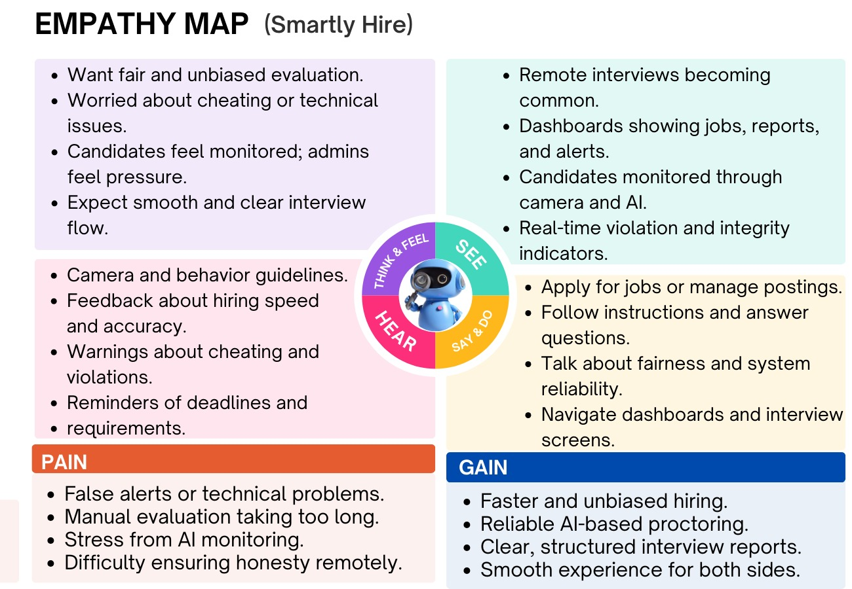
Figure 2 Empathy Map

Chapter 2

Software Requirement Specifications

Chapter 2: Software Requirement Specifications

Introduction

Purpose
The purpose of this Software Requirement Specification (SRS) is to define the functional and non-functional requirements for Smartly Hire (Version 1.0). This software system provides a web-based platform for conducting secure, AI-driven proctored interviews for recruitment purposes.
The system integrates:
- Real-time facial and behavior analysis using MediaPipe Face Detection and FaceMesh (eye blink, mouth movement, head pose),
- Emotion detection using Mini-Xception CNN,
- Automated proctoring violation detection based on real-time candidate activity (e.g., absence, multiple screens, talking),
- Online candidate management and reporting modules.
This SRS covers all software components, including frontend, backend, AI microservices, database, and reporting systems. Hardware-specific constraints (webcam, system requirements) are included as required.

Document Conventions
Fonts & Styles: Headings use bold and numbered styles; requirement statements use numbered tags (e.g., REQ-SF1-1).
Requirement Priorities:
- Must: Essential for correct system operation
- Should: Highly desirable, not critical
- May: Optional or enhancement features
Traceability: Every requirement is uniquely tagged for traceability.
Terminology:
- “Candidate” refers to the person taking the interview.
- “Admin/Recruiter” refers to the hiring manager or HR user.

Intended Audience and Reading Suggestions
- Developers: For implementing frontend, backend, and AI services.
- Project Managers: To track requirement coverage and timelines.
- Testers: To validate functionality, UI, AI proctoring accuracy, and reporting.
- Documentation Writers: To prepare user manuals and guides.
- End Users: Admins and candidates to understand system functionalities.
Reading Sequence:
- Overview & system context (Sections 2.2 & 2.3)
- Functional requirements (Section 2.4)
- Non-functional and domain requirements (Sections 2.5 & 2.6)

Product Scope
Smartly Hire is a cloud-based platform enabling secure, monitored online interviews.
Key objectives:
- Real-time AI monitoring of candidate behavior (face, emotions, attention, multiple screens).
- Automated recording and reporting of candidate performance and violations.
- Streamlined job and interview management for recruiters.
- Supports multiple question formats: MCQ, coding, and short questions.
Benefits:
- Reduces human proctor dependency.
- Ensures fairness and compliance in remote interviews.
- Provides actionable insights to recruiters via reports and dashboards.

References
- MediaPipe Documentation: https://developers.google.com/mediapipe
- Mini-Xception Emotion Detection Paper: https://arxiv.org/abs/1710.07557
- FastAPI Documentation: https://fastapi.tiangolo.com/
- MongoDB Atlas Documentation: https://www.mongodb.com/cloud/atlas
- React Vite & Tailwind CSS Documentation: https://vitejs.dev, https://tailwindcss.com

Overall Description

Product Perspective
Smartly Hire is a self-contained platform for secure remote interviews, built using a microservices architecture:
- Frontend: React Vite + Tailwind (UI/UX, dashboards, forms)
- Backend: Node.js + Express (API layer, authentication, job/interview management)
- Database: MongoDB Atlas (users, jobs, interviews, violations, reports)
- AI Services: Python + FastAPI microservices (Face Detection, FaceMesh, Emotion, Head Pose, EAR/MAR)

Product Functions:
Key functions include:
- Candidate registration, job application, and interview scheduling.
- Live AI proctoring (emotion, head-pose, cheating detection).
- Real-time alerts for violations.
- Performance analytics and PDF reports.
- Admin dashboards with charts and insights.

User Classes and Characteristics
User Class | Description | Frequency | Tech Skill
Admin/Recruiter | Manages jobs, reviews candidates, monitors interview reports | Frequent | Moderate
Candidate | Attends interviews, answers questions, consents to AI proctoring | Occasional | Basic
System/AI | Automated proctoring agent, evaluates candidate behavior | Continuous | N/A

Table 4 User Classes and Characteristics

Operating Environment
- Candidate/Recruiter Device: Windows/Mac/Linux, modern browser (Chrome, Firefox, Edge).
- AI Services: Cloud VM or container (Python 3.8+, FastAPI, TensorFlow, OpenCV, MediaPipe).
- Database: MongoDB Atlas, accessible via backend API.
- Network: Stable internet (≥5 Mbps recommended).

Design and Implementation Constraints
- Microservices architecture requires internal HTTP communication.
- Candidate devices must have webcam; multiple screens trigger violations.
- AI services must process frames in near real-time (3–5s frequency).
- Database operations must be secure; no direct frontend access.

User Documentation
Documentation provides guidance for all system users:
- Candidates: Registration, login, dashboard, job listings, interview participation, timers, proctoring alerts, device setup, viewing reports.
- Admins: Dashboard navigation, job management, AI-based interview report interpretation, violation monitoring, audit trails.
- Developers: Frontend, backend, database, ML microservices integration, REST API references, deployment instructions, monitoring/maintenance.

Assumptions and Dependencies
- Candidates consent to webcam access.
- Internet connection is stable for streaming webcam frames.
- Third-party libraries (MediaPipe, TensorFlow, FastAPI, React) remain compatible.
- MongoDB Atlas and cloud deployment platforms are available.

External Interface Requirements

User Interfaces
User Type | UI Component | Description / Features
Candidate | Interview Screen | Displays question area, timer, answer field (MCQ, coding, short), webcam preview, and live proctoring alerts.
Admin/Recruiter | Dashboard | Overview cards, charts, violation reports, candidate details, job management.
All Users | Standard Components | Navbar, breadcrumbs, standard buttons, error messages, validation feedback.

Table 5 User Interfaces

- Responsive design optimized for desktop, laptop, and tablet.
- Consistent layout using React + Tailwind.

Hardware Interfaces
User Type | Hardware Requirement | Description
Candidate | Laptop/Desktop | Webcam (≥720p), multi-screen triggers violation.
Admin | Laptop/Desktop | Modern browser (Chrome, Firefox, Edge) with internet access. No special hardware required.

Table 6 Hardware Interfaces

Software Interfaces
- Frontend: React + Vite + Tailwind, WebRTC, Web Speech API.
- Backend: Node.js + Express REST APIs (auth, job/interview management, logging).
- Database: MongoDB Atlas (users, jobs, sessions, violations, reports).
- ML Microservices: Python + FastAPI (face detection, head-pose, emotion, EAR/MAR, violation detection).

Communications Interfaces
- Frontend ↔ Backend: HTTPS REST APIs (JSON data).
- Real-time notifications: WebSockets or long-polling.
- Backend ↔ AI Microservices: Secure internal HTTP/HTTPS calls.
- Port assignments: Frontend/Backend: 443 (prod), 5173/5000 (dev); AI services: 8001–8003.

System Features

User Authentication & Management

Description and Priority

Manages user registration, login, session, and password security. Priority: High (core functionality).

Stimulus/Response Sequences
- Candidate/Admin opens registration page → enters details → account created.
- Candidate/Admin logs in → system authenticates → grants access to dashboard.
- Inactive users → session auto-logout.

Functional Requirements Table
Req ID | Req Definition | Want | Stakeholder
REQ-AUTH-1 | System shall allow Candidate/Admin to create an account with name, email, password | Must | Candidate, Admin
REQ-AUTH-2 | System shall authenticate users via email/password | Must | Candidate, Admin
REQ-AUTH-3 | System shall enforce strong password rules and hash passwords | Must | Admin, Security
REQ-AUTH-4 | System shall ensure unique email addresses | Must | Admin, Candidate
REQ-AUTH-5 | System shall maintain active sessions and auto-logout inactive users | Must | Candidate, Admin

Table 7 Functional Requirements

Admin Functional Features

Description and Priority

Allows Admins to manage jobs, candidates, interviews, and view reports. Priority: High

Stimulus/Response Sequences
- Admin logs in → navigates to dashboard → views summary.
- Admin selects job → create/edit/delete → job data updated.
- Admin views candidate list → reviews interview reports/violations.

Functional Requirements
Req ID | Req Definition | Want | Stakeholder
REQ-ADMIN-1 | View admin dashboard summarizing jobs, candidates, interview statuses | Must | Admin
REQ-ADMIN-2 | Create job posting with job details | Must | Admin
REQ-ADMIN-3 | Edit existing job posting | Must | Admin
REQ-ADMIN-4 | Delete a job posting | Must | Admin
REQ-ADMIN-5 | Generate AI-based job description | Want | Admin
REQ-ADMIN-6 | View candidate list per job | Must | Admin
REQ-ADMIN-7 | View AI-generated interview reports | Must | Admin
REQ-ADMIN-8 | View violations detected during interviews | Must | Admin

Table 8 Admin Functional Features

Candidate Functional Features
2.4.3.1 Description and Priority:
Supports candidate dashboard, job application, interview participation. Priority: High
2.4.3.2 Stimulus/Response Sequences:
- Candidate logs in → sees dashboard → selects job → applies.
- Candidate uploads resume → starts interview → answers questions → submits.
2.4.3.3 Functional Requirements:
Req ID | Req Definition | Wish/Want | Stakeholder
REQ-CAND-1 | Display available job postings | Must | Candidate
REQ-CAND-2 | Apply for a selected job | Must | Candidate
REQ-CAND-3 | Upload resume as part of application | Must | Candidate
REQ-CAND-4 | Start assigned interview | Must | Candidate
REQ-CAND-5 | Answer text/video questions | Must | Candidate
REQ-CAND-6 | Manually submit interview | Must | Candidate

Table 9 Candidate Functional Features

Browser Permission & Video Access
2.4.4.1 Description and Priority:
Ensures proper browser permissions for camera. Priority: High
2.4.4.2 Stimulus/Response Sequences:
- Candidate opens interview page → system checks camera → alerts if denied.
2.4.4.3 Functional Requirements:
Req ID | Req Definition | Wish/Want | Stakeholder
REQ-BROWSER-1 | Check camera permission | Must | Candidate
REQ-BROWSER-2 | Alert candidate if permission denied | Must | Candidate

Table 10 Browser Permission & Video Access (Functional Requirements)

Interview Question Handling
2.4.5.1 Description and Priority:
Handles loading, presenting, and recording interview questions. Priority: High
2.4.5.2 Stimulus/Response Sequences:
- Interview starts → questions loaded → system reads aloud if enabled → candidate responds → data stored.
2.4.5.3 Functional Requirements:
Req ID | Req Definition | Wish/Want | Stakeholder
REQ-Q-1 | Load job-specific interview questions before start | Must | Candidate, Admin
REQ-Q-2 | Optional text-to-speech reading of questions | Want | Candidate
REQ-Q-3 | Record video/text responses | Must | Candidate, Admin

Table 11 Interview Question Handling (Functional Requirements)

2.4.6 AI Proctoring & Monitoring
2.4.6.1 Description and Priority:
Real-time candidate monitoring for cheating detection and behavior analysis. Priority: High
2.4.6.2 Stimulus/Response Sequences:
- Candidate starts interview → webcam active → system monitors → violations logged → threshold triggers alerts/auto-submit.
2.4.6.3 Functional Requirements:

Req ID | Req Definition | Wish/Want | Stakeholder
REQ-PROCTOR-1 | Continuous monitoring via webcam | Must | Admin, Candidate
REQ-PROCTOR-2 | Face detection using MediaPipe | Must | System
REQ-PROCTOR-3 | Extract 468 facial landmarks | Must | System
REQ-PROCTOR-4 | Detect candidate emotions via Mini-Xception | Must | Admin
REQ-PROCTOR-5 | Head pose estimation | Must | Admin
REQ-PROCTOR-6 | Eye blink detection | Must | Admin
REQ-PROCTOR-7 | Mouth movement detection | Must | Admin
REQ-PROCTOR-8 | Detect anomalies (phone, extra screen/person, face missing) | Must | Admin
REQ-PROCTOR-9 | Log detected violations | Must | Admin
REQ-PROCTOR-10 | Threshold-based auto-actions | Must | Admin, Candidate

Table 12 AI Proctoring & Monitoring (Functional Requirements)

2.4.7 Auto-Submission & Notifications
2.4.7.1 Description and Priority:
Automatically submits interview if violations occur or inactivity is detected. Priority: High
2.4.7.2 Stimulus/Response Sequences:
- Candidate exceeds violation threshold → interview auto-submitted → candidate notified.
2.4.7.3 Functional Requirements:

Req ID | Req Definition | Wish/Want | Stakeholder
REQ-AUTO-1 | Auto-submit interview on violation threshold | Must | Candidate, Admin
REQ-AUTO-2 | Auto-submit if candidate disappears from webcam | Must | Candidate, Admin
REQ-AUTO-3 | Auto-submit on repeated tab/browser switches | Must | Candidate, Admin
REQ-AUTO-4 | Notify candidate after auto-submission | Must | Candidate

Table 13 Auto-Submission & Notifications (Functional Requirements)

2.4.8 Report Generation
2.4.8.1 Description and Priority:
Generates AI-based final interview reports for admin/candidate review. Priority: High
2.4.8.2 Stimulus/Response Sequences:
- Interview completed → system computes score → report generated → stored for viewing.
2.4.8.3 Functional Requirements:

Req ID | Req Definition | Wish/Want | Stakeholder
REQ-REPORT-1 | Generate final AI-based report | Must | Admin, Candidate
REQ-REPORT-2 | Compute overall score (emotion, head pose, answers, violations) | Must | Admin
REQ-REPORT-3 | Store report for review | Must | Admin, Candidate
REQ-REPORT-4 | Allow Admin to view all reports | Must | Admin
REQ-REPORT-5 | Allow Candidate to view own report | Must | Candidate

Table 14 Report Generation (Functional Requirements)

2.4.9 System & Data Management
2.4.9.1 Description and Priority:
Ensures secure storage, backup, and encryption of candidate/interview data.
Priority: High
2.4.9.2 Stimulus/Response Sequences:
- Candidate responses recorded → system saves in DB → backups maintained → data encrypted.

Req ID | Req Definition | Wish/Want | Stakeholder
REQ-DATA-1 | Save interview video/text responses | Must | Admin, Candidate
REQ-DATA-2 | Save job applications and resumes | Must | Admin, Candidate
REQ-DATA-3 | Encrypt sensitive data | Must | Security, Admin
REQ-DATA-4 | Maintain secure backups of data | Must | Admin

Table 15 System & Data Management (Functional Requirements)

2.4.10 External Services
2.4.10.1 Description and Priority:
Integrate browser APIs and AI/ML services for proctoring and speech functionality.
Priority: High
2.4.10.2 Stimulus/Response Sequences:
- Candidate starts interview → browser APIs accessed → ML services invoked for monitoring → responses processed.
2.4.10.3 Functional Requirements:

Req ID | Req Definition | Wish/Want | Stakeholder
REQ-EXT-1 | Integrate browser camera APIs | Must | Candidate, System
REQ-EXT-2 | Use Web Speech API for speech synthesis/recognition | Want | Candidate
REQ-EXT-3 | Utilize MediaPipe Face Detection | Must | System
REQ-EXT-4 | Utilize MediaPipe FaceMesh | Must | System
REQ-EXT-5 | Run Mini-Xception CNN for emotion classification | Must | Admin, System

Table 16 External Services (Functional Requirements)

Nonfunctional Requirements

Performance Requirements
      - ML Frame Processing: MediaPipe + Mini-Xception must process webcam frames within 3–5 seconds to ensure accurate cheating detection, emotion recognition, and head-pose analysis.
      - Frontend Responsiveness: All frontend actions including login, navigating jobs, starting interviews, and moving to the next question must respond within 2 seconds under normal load.
      - Concurrent Interview Support: The system must handle at least 50 simultaneous interviews without any performance degradation.
      - Report & Analytics Load: Candidate answers, reports, and analytics should load within 3 seconds.
      - Caching: Frequently accessed data such as interview questions and job listings must be cached to reduce database queries and ensure retrieval within 2 seconds.
      - Scalability: The system architecture must support horizontal scaling to accommodate increased candidate loads and concurrent interview sessions.

Safety Requirements
      - Device Safety: Candidate device such as webcams must operate within standard voltage limits, and the system must not issue any commands that could damage them.
      - Obstruction Alerts: The system must notify candidates if their webcam is obstructed to prevent false proctoring violations.
      - Auto-Save: All interview data, including answers and monitoring logs, must be automatically saved and securely stored to prevent data loss.
      - Fairness Logging: Proctoring violations should be logged and reviewed to ensure fairness and transparency in assessment.
      - Duplicate Submission Prevention: The system must prevent accidental multiple submissions or overlapping interview sessions to avoid conflicts or data loss.

Security Requirements
      - Role-Based Access Control: Only registered candidates can access interviews using JWT-based authentication. Admins and recruiters have distinct access privileges.
      - Encrypted Communication: All communication between frontend, backend, and ML microservices must use HTTPS to prevent eavesdropping.
      - Data Encryption: Sensitive candidate information, including interview responses and results, must be encrypted in MongoDB.
      - Session Expiry: Interview sessions must automatically expire after completion or periods of inactivity to prevent unauthorized access.
      - Tamper-Proof Logs: The system must maintain immutable logs of all user actions and system events for compliance and auditing purposes.

Usability Requirements
      - Dashboard Navigation: Candidate and admin dashboards must be easy to navigate, requiring minimal training for first-time users.
      - Responsive Design: The interface must support standard desktop resolutions and adapt for tablets where necessary.
      - Proctoring Indicators: Candidates must clearly see the interview timer, current question number, and live proctoring alerts.
      - Error Messages: All errors must be human-readable with clear instructions for corrective action.
      - Admin Configuration: Admins must easily configure violation thresholds, question sets, and reporting options.
      - Accessibility: The system should support keyboard navigation and screen readers where feasible.
      - Ease of Use: The system should prioritize simplicity over complex configuration to enable rapid adoption.

Reliability Requirements
      - Durable Storage: All candidate answers, proctoring logs, and reports must be reliably stored in MongoDB.
      - Retry Mechanism: The system must retry failed ML requests and queue events to prevent data loss.
      - Session Resumption: In case of network or system failure, ongoing sessions must resume without data loss.
      - Accurate Reports: All reports and analytics must accurately reflect real-time candidate activity.
      - Continuous Logging: Backend and ML microservices must continuously log events to detect anomalies and failures promptly.

Maintainability/Supportability Requirements
      - MVC Architecture: The backend must follow the MVC pattern, while ML services are deployed separately for independent updates.
      - Documentation: Comprehensive developer and admin manuals must be available for troubleshooting and system understanding.
      - Event Logging: All system events and errors must be logged for debugging and performance analysis.
      - Microservices Updates: The architecture must allow patching or replacement of components without system downtime.
      - Monitoring Integration: System health dashboards must monitor CPU/memory usage and ML service status in real time.

Portability Requirements
      - Browser Compatibility: Frontend must work on Chrome, Firefox, and Edge without requiring installation.
      - Cloud Deployment: Backend and ML microservices must be deployable on AWS, Render, Railway, or similar platforms.
      - Dockerized Deployment: All components must support Docker for consistent deployment across environments.
      - OS Support: Backend services must run on Linux or Windows servers.

Efficiency Requirements
      - Resource Management: ML services and backend must efficiently manage CPU and memory to handle multiple concurrent interviews.
      - Proctoring Updates: Proctoring alerts and UI updates must appear within 1–2 seconds of detection.
      - Optimized Database Queries: Database queries must be indexed and optimized to prevent performance bottlenecks.
      - Webcam Frame Capture: Candidate webcam frames should be captured every 3–5 seconds for balanced accuracy and performance.
      - Frontend Memory Usage: The frontend must maintain memory usage below 200MB on standard devices.

Domain Requirements
    - Candidate Authentication & Access Control: Only candidates who have successfully applied for a job and received a scheduled interview link may access the proctored session. Multi-factor authentication (e.g., email verification, OTP) ensures authorized access.
    - Proctoring & Monitoring: The system requires active webcam during interviews. It detects multiple screens, phones, or extra persons, triggering configurable violation events (e.g., max tab switches, face not visible count).
    - Interview Configuration: Organizations can define various question types, including MCQs, coding, and short questions. Each session enforces strict time limits per question or overall interview.
    - Audit & Reporting: Every interview maintains a detailed audit trail with timestamps, candidate actions, violations, and final decisions. Reports include visual summaries such as emotion curves, head-pose deviation, and overall score for recruiters.
    - Data Storage & Security: All candidate responses, proctoring logs, and reports are stored securely in MongoDB. Access is role-based, restricting sensitive data to Admin/Recruiter accounts.
    - Reuse & Extensibility: MediaPipe + Mini-Xception microservices are modular for future upgrades or reuse. The system allows new question types or proctoring rules to be added without major changes.
    - Legal & Compliance: Candidates must be informed about webcam and screen monitoring. The system complies with applicable data privacy regulations, such as GDPR for EU candidates.

Chapter 3

Use Case Analysis

Chapter 3: Use Case Analysis

This chapter delivers a detailed analysis of the functional behavior of the Smartly Hire recruitment system. It demonstrates how system users and internal services interact to accomplish key recruitment operations such as hiring automation, candidate screening, interview monitoring, violation tracking, and AI-powered report generation. The chapter establishes the functional scope, defines actor goals, maps relationship boundaries, and documents complete workflows via structured use case scenarios. This analysis ensures a shared understanding among developers, designers, testers, and stakeholders prior to entering system design and implementation phases.

3.1. Use Case Model
The use case model outlines the functional limits and interaction scope for the Smartly Hire system. The primary actors include:
- Recruitment Administrator / HR Recruiter: Responsible for job publishing, candidate management, interview reviews, violation oversight, and hiring decisions.
- Job Candidate: Interacts with the platform to register, explore opportunities, apply for roles, upload resumes, attend interviews, and access personal interview evaluations.
Supporting and interfacing secondary actors include:
- Browser Permission Manager: Handles secure access to device peripherals such as camera and screen validation.
- AI Recruitment Engine: Performs real-time monitoring, emotion recognition, head-pose evaluation, anomaly detection, violation classification, and automated scoring.
This model is represented through a structured use case diagram, ensuring coverage of actor intentions, system duties, interaction sequences, and service interdependencies for functional achievement.
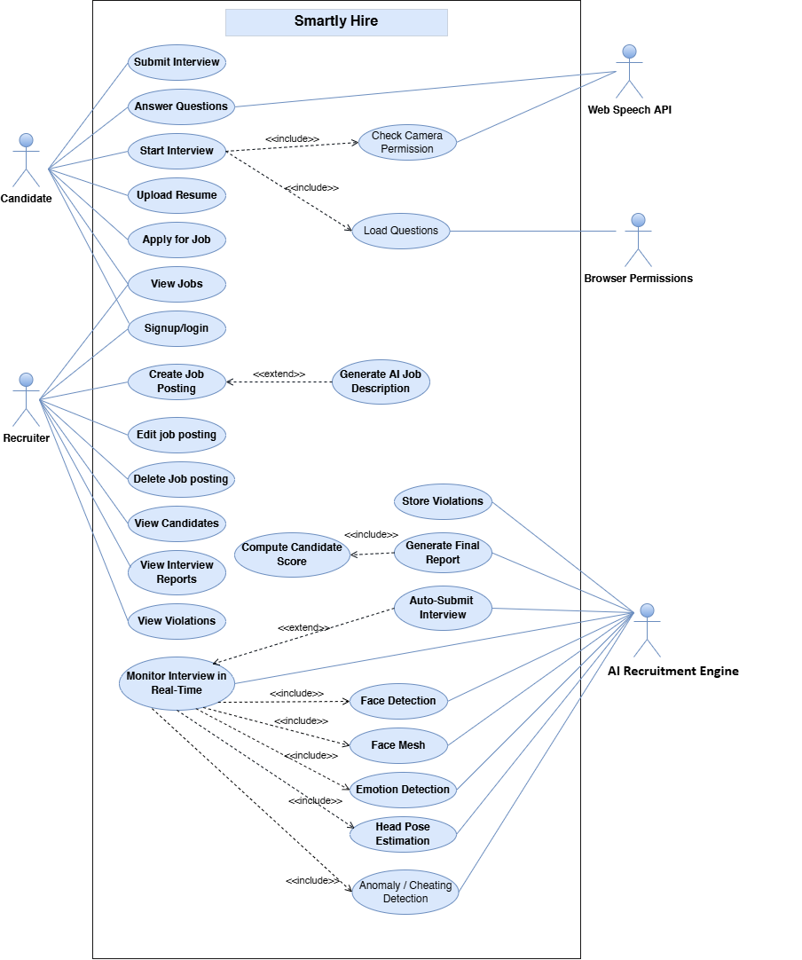
Figure 3 Use Case (Smartly Hire)

3.2. Use Cases Description
- Admin / Recruiter Use Cases

UC1 – Signup/Login
Actor: Admin
Preconditions:
- For Login: Admin already has an existing registered account.
- For Signup: Admin is not yet registered in the system.
Postconditions:
- Admin is successfully authenticated.
- Admin is redirected to the system dashboard.
Main Flow (Login Scenario):
- Admin enters email and password.
- System verifies if credentials match an existing record.
- If valid, system logs in the admin.
- Admin is granted access to the dashboard.

Alternate Flow (Incorrect Login Credentials):
- Admin enters invalid credentials.
- System displays an “Invalid email or password” error.
- Admin is prompted to try again.

Main Flow (Signup Scenario):
- Admin selects “Create Account / Signup” option.
- Admin enters required information (name, email, password).
- System checks if email already exists.
- System creates a new admin account.
- Admin receives confirmation and is redirected to login.

Alternate Flow (Signup Email Already Exists):
- Admin enters an email that is already registered.
- System displays “Email already exists” message.
- Admin must choose a different email or proceed to login.

Business Rules:
- Password must meet security requirements.
- Email must be unique for each admin account.

UC2 (Manage Jobs)
Actor: Admin
Purpose: To view and access all job postings.
Preconditions: Admin is logged in.
Postconditions: Job list is displayed with actions.
Main Flow:
- Admin navigates to job management.
- System displays all available job postings.

UC3 (Create Job Posting)
Actor: Admin
Preconditions: Admin is logged in.
Postconditions: New job posting is created.
Main Flow:
- Admin enters job details.
- Admin optionally triggers AI job description generation (extends UC6).
- System saves the job.
Extension:
UC6 Generate AI Description extends this use case.

UC4: Edit Job Posting
Actor: Admin
Preconditions: Job must exist.
Postconditions: Updated job details saved.
Main Flow:
- Admin selects existing job.
- Admin updates fields.
- System saves changes.

UC5: Delete Job Posting
Actor: Admin
Preconditions: Job must exist.
Postconditions: Job is removed.
Main Flow:
- Admin selects job.
- Admin confirms deletion.
- System deletes job.

UC6: Generate AI Job Description (Extend)
Actor: Admin
Preconditions: Admin is creating/editing a job posting.
Postconditions: AI-generated job description shown.
Main Flow:
- Admin clicks “Generate Description”.
- System creates AI-based job description.
- Admin accepts or edits it.

UC7: View Candidates
Actor: Admin
Purpose: To see list of applicants for a job.
Preconditions: Candidates must have applied.
Postconditions: Candidate list displayed.

UC8: View Interview Reports
Actor: Admin
Purpose: To analyze AI-generated reports.
Preconditions: Candidate must have completed an interview.
Postconditions: Report shown.

UC9: View Violations
Actor: Admin
Purpose: To review cheating/violation logs.
Preconditions: System recorded violations.
Postconditions: Violation details displayed.

- Candidate Use Cases

UC10: login/Signup
Primary Actor: Candidate
Preconditions:
- For Signup: Candidate does not have an existing registered account.
- For Login: Candidate must already be registered.

Postconditions:
- Candidate is authenticated successfully.
- Candidate is redirected to the job dashboard or homepage.

Main Flow (Signup Scenario):
- Candidate selects “Signup / Create Account.”
- Candidate enters required details (name, email, password).
- System checks if email is already registered.
- If not registered, system creates a new candidate account.
- Candidate receives confirmation and is redirected to login.

Alternate Flow (Signup -> Email Already Exists):
- Candidate enters an email that already exists in the system.
- System displays message: “Account already exists.”
- Candidate is prompted to log in instead.

Main Flow (Login Scenario):
- Candidate enters email and password.
- System validates credentials.
- If valid, system logs in the candidate.
- Candidate is redirected to the job dashboard.

Alternate Flow (Invalid Credentials):
- Candidate enters incorrect email or password.
- System displays: “Invalid credentials. Please try again.”
- Candidate retries login.

Business Rules:
- Email must be unique for each candidate.
- Password must meet security requirements.

UC11: View Jobs
Actor: Candidate
Main Flow: System displays available jobs.

UC12: Apply for Job
Actor: Candidate
Preconditions: Candidate is logged in.
Postconditions: Application submitted.

UC13: Upload Resume
Actor: Candidate
Preconditions: Candidate is applying for a job.
Postconditions: Resume uploaded.

UC14: Start Interview
Actor: Candidate
Preconditions: Candidate applied and has permission.
Postconditions: Interview begins.
Includes: UC15, UC16, UC17
Main Flow:
- Candidate clicks “Start Interview”.
- System checks permissions (camera).
- System loads questions.
- Interview session starts.

UC15: Check Camera Permission (Include)
Actor: Browser Permissions
Purpose: Ensure camera access.
Main Flow: Browser prompts user to allow camera.
UC16: Load Questions (Include)
Actor: Web Speech API (partial) / System
Purpose: Load question list and prepare text-to-speech.

UC18: Answer Questions
Actor: Candidate
Secondary Actors: Web Speech API
Postconditions: Responses stored.

UC19: Submit Interview
Actor: Candidate
Purpose: End interview session.
Postconditions: Submission stored.

- AI Recruitment & Monitoring Use Cases

UC20: Monitor Interview in Real-Time
Actor: AI Recruitment Engine
Purpose: Continuous monitoring of candidate behavior in real time.
Includes: UC21, UC22, UC23
Postconditions: Monitoring data generated and streamed for analysis.

UC21: Detect Candidate Emotion (Include)
Actor: AI Recruitment Engine
Model: Mini-Xception CNN
Purpose: Categorize emotional state for interview insights
Postconditions: Emotion state logged.

UC22: Head Pose & Attention Tracking (Include)
Actor: AI Recruitment Engine
Model: MediaPipe + SolvePnP
Purpose: Assess candidate attention and head movement.

UC23: Anomaly & Cheating Detection (Include)
Actor: AI Recruitment Engine
Checks: Phone detection, additional person, face not visible, multi-screen usage
Purpose: Flag behavioral anomalies and recruitment violations.

UC24: Record Violations
Actor: AI Recruitment Engine
Purpose: Store violation logs securely.
Postconditions: Violations stored for admin review.

UC25: Auto-Submit Interview (Extend)
Actor: AI Recruitment Engine
Triggered When: Predefined violation limits exceeded
Extends: UC20 Live Monitoring
Postconditions: Interview auto-submitted with candidate notification.

UC26: Create Interview Evaluation Report
Actor: AI Recruitment Engine
Purpose: Generate final interview analysis document.
Includes: UC27

UC27: Compute Candidate Hiring Score (Include)
Actor: AI Recruitment Engine
Purpose: Calculate cumulative performance score considering responses, emotions, attention, and violations.

Chapter 4

System Design

Chapter 4: System Design
This chapter presents the detailed system design of the Smartly Hire platform by modeling both structural and behavioral components of the recruitment system. It explains the overall architecture, data entities, object relationships, process interactions, system behavior, security-aware module boundaries, and cloud execution strategy used to conduct AI-driven and integrity-focused interviews. Through UML design diagrams, this chapter illustrates how information flows from candidate input to recruiter evaluation while integrating AI proctoring and LLM scoring services. It provides a blueprint for developers, ensuring that all modules frontend, backend, database, and AI services are structured, synchronized, and deployable in a scalable environment. The chapter ensures a complete design view before moving into implementation and evaluation stages.

Architecture Diagram
The architecture diagram presents the system design and service interaction for Smartly Hire, an AI-powered recruitment and interview platform. It highlights secure user access, scalable frontend hosting, API integration, and real-time AI proctoring workflows. Interview data, integrity events, and evaluation reports are stored in structured databases and object storage. AI question generation and answer assessment are orchestrated through LLM inference services, supported by monitoring and CI/CD pipelines.

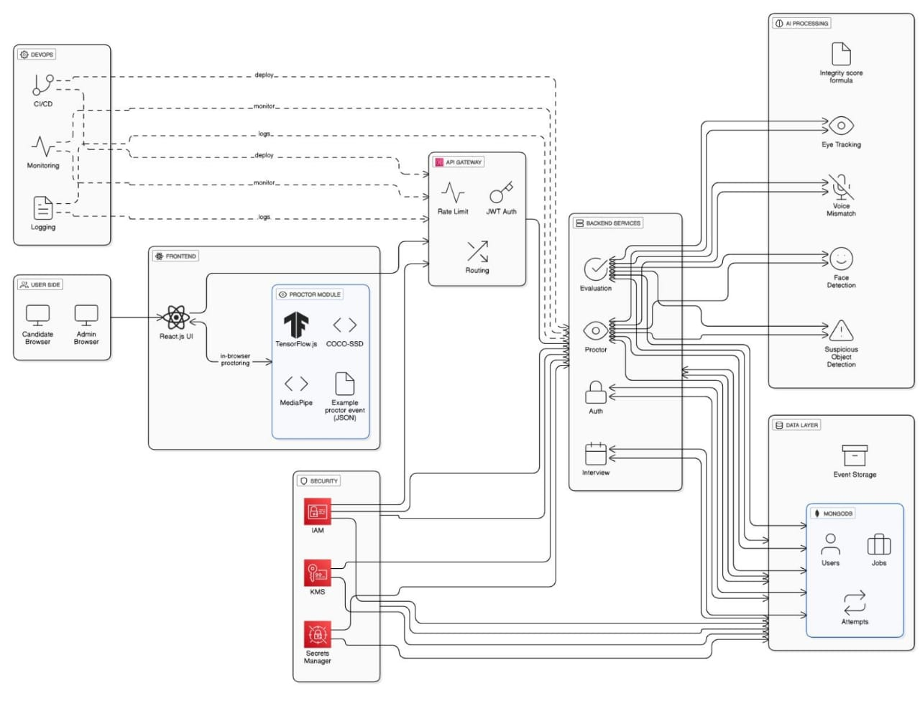
Figure 4 Architecture diagram

Domain Model
The domain model of Smartly Hire illustrates the conceptual entities and their relationships within the recruitment system.
It focuses on the real-world objects such as users, jobs, applications, interviews, and reports.
Only business-relevant attributes and high-level behaviors are included to show system understanding.
The model provides a clear, abstract view of the problem domain, serving as a blueprint for design and communication.
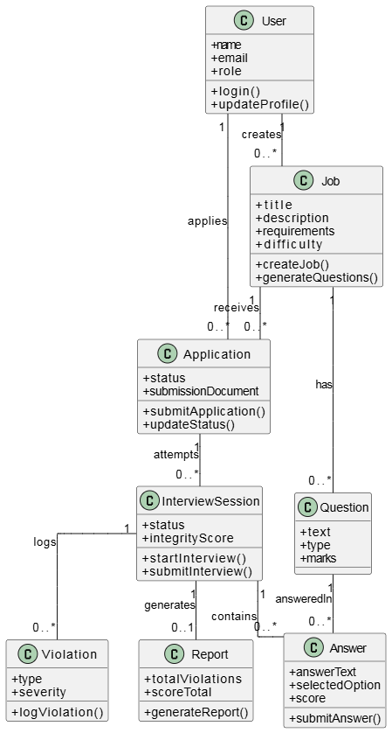
Figure 5 Domain Model Diagram

Entity Relationship Diagram with data dictionary
The ER diagram for Smartly Hire visualizes the complete recruitment and interview integrity data model.
It maps key entities and relationships to ensure seamless storage of job posts, interview responses, and real-time proctoring violations.
The ERD establishes cardinality (1:M, 1:1), foreign key linkage, and data flow dependencies critical for system consistency.
This structured representation serves as the foundation for database design, evaluation scoring, and integrity monitoring across interviews.

Figure 6 Entity Relationship Diagram

Data Dictionary:
Entity: users
Attribute | Type | Size | Key | Constraints | Description
user_id | ObjectId | 24 | PK | Not Null, Unique | Unique identifier for each user in the system
Name | String | 100 |  | Not Null | Full name of the Admin or Candidate
Email | String | 255 |  | Not Null, Unique | Email used for login and communication
password_hash | String | 255 |  | Not Null | Secure hashed password for authentication
Role | String | 20 |  | Enum(admin, candidate) | Defines system access level
created_at | DateTime |  |  | Auto Generated | Timestamp when account was created
updated_at | DateTime |  |  | Auto Generated | Timestamp of last update to the user

Table 17 Entity: users

Entity: Jobs
Attribute | Type | Size | Key | Constraints | Description
job_id | ObjectId | 24 | PK | Not Null, Unique | Unique identifier for each job posting
title | String | 150 |  | Not Null | Job position title
description | Text |  |  | Not Null | Full job details and expectations
requirements | Array<String> |  |  |  | List of required skills/qualifications
difficulty | String | 20 |  | Enum(easy, medium, hard) | Difficulty level for interview questions
number_of_questions | Integer |  |  |  | Total questions generated for interview
application_deadline | DateTime |  |  |  | Last date/time to apply for job
created_by | ObjectId | 24 | FK | Not Null | References the admin user who created the job
created_at | DateTime |  |  | Auto Generated | Job creation timestamp
updated_at | DateTime |  |  | Auto Generated | Job last modified timestamp

Table 18 Entity: Jobs

Entity: Applications
Attribute | Type | Size | Key | Constraints | Description
application_id | ObjectId | 24 | PK | Not Null, Unique | Unique  identifier for job application
candidate_id | ObjectId | 24 | FK | Not Null | References candidate user who applied
job_id | ObjectId | 24 | FK | Not Null | References job being applied for
resume_path | String | 255 |  |  | File path or storage reference to uploaded resume
status | String | 20 |  | Enum (applied, invited, completed) | Current application stage
applied_at | DateTime |  |  | Auto Generated | Time when candidate applied for job

Table 19 Entity: Applications

Entity: Interview Sessions:
Attribute | Type | Size | Key | Constraints | Description
interview_id | ObjectId | 24 | PK | Not Null, Unique | Unique interview attempt/session id
application_id | ObjectId | 24 | FK | Not Null | References linked application
candidate_id | ObjectId | 24 | FK | Not Null | Interview attempting candidate
job_id | ObjectId | 24 | FK | Not Null | References job being interviewed for
start_time | DateTime |  |  | Not Null | Interview start time
end_time | DateTime |  |  | Not Null | Interview end time
status | String | 20 |  | Enum(started, submitted, evaluated) | Interview progress state
integrity_score | Integer |  |  | Min 0, Max 100 | Final computed integrity score from proctoring
created_at | DateTime |  |  | Auto Generated | Session creation timestamp

Table 20 Entity: Interview Sessions

Entity: Questions:
Attribute | Type | Size | Key | Constraints | Description
question_id | ObjectId | 24 | PK | Not Null, Unique | Unique question identifier
job_id | ObjectId | 24 | FK | Not Null | References parent job
type | String | 20 |  | Enum(mcq, short, long, coding) | Type of interview question
text | Text | Not Null |  | Not Null | Actual question prompt text
options_json | JSON |  |  |  | MCQ options (only if type=mcq)
correct_answer | String |  |  |  | Optional golden answer for auto-eval
marks | Integer |  |  | Not Null | Maximum score for this question
created_at | DateTime |  |  | Auto Generated | Question creation time

Table 21 Entity: Questions

Entity: Answers:
Attribute | Type | Size | Key | Constraints | Description
answer_id | ObjectId | 24 | PK | Not Null, Unique | Unique identifier for submitted answer
interview_id | ObjectId | 24 | FK | Not Null | References interview session
question_id | ObjectId | 24 | FK | Not Null | References answered question
candidate_id | ObjectId | 24 | FK | Not Null | Candidate who gave answer
answer_text | Text |  |  |  | Textual/coding answer if applicable
selected_option | String |  |  |  | Option chosen for MCQ questions
score_obtained | Integer |  |  |  | Score given after evaluation
evaluated_by | String | 10 |  | Enum(ai, manual, null) | Evaluation source
evaluated_at | DateTime |  |  |  | Evaluation timestamp

Table 22 Entity: Answers

Entity: Violations:
Attribute | Type | Size | Key | Constraints | Description
violation_id | ObjectId | 24 | PK | Not Null, Unique | Unique violation identifier
interview_id | ObjectId | 24 | FK | Not Null | References interview session
type | String | 30 |  | Enum(no_face, multiple_faces, looking_away, phone, book, paper, other) | Category of integrity violation
severity | String | 10 |  | Enum(low, medium, high) | Severity level of the violation
detected_at | DateTime |  |  | Auto Generated | Time when incident was detected
frame_reference | String | 255 |  |  | Video frame/snapshot path stored externally
metadata | JSON |  |  |  | Additional details like bounding box, confidence

Table 23 Entity: Violations

Entity: Reports:
Attribute | Type | Size | Key | Constraints | Description
report_id | ObjectId | 24 | PK | Not Null, Unique | Unique interview report identifier
interview_id | ObjectId | 24 | FK | Not Null, Unique (1:1) | Links to evaluated interview session
total_violations | Integer |  |  | Not Null | Count of integrity violations in session
score_total | Integer |  |  |  | Final interview evaluation score
report_json_path | String | 255 |  |  | Path to stored JSON evaluation result
report_pdf_path | String | 255 |  |  | Optional path to generated PDF report
created_at | DateTime |  |  | Auto Generated | When report was created

Table 24 Entity: Reports

Relationships (Data Dictionary Linkage):
From | To | Cardinality | Description
Users.user_id | Jobs.created_by | 1:M | One admin can create many jobs
Users.user_id | Applications.candidate_id | 1:M | One candidate can apply to many jobs
Jobs.job_id | Applications.job_id | 1:M | One job can receive many applications
Applications.application_id | InterviewSessions.application_id | 1:M | One application may allow multiple interview attempts (default supports retries)
InterviewSessions.interview_id | Answers.interview_id | 1:M | One interview session has many answers
Questions.question_id | Answers.question_id | 1:M | One question can be answered in many interview sessions
InterviewSessions.interview_id | Violations.interview_id | 1:M | One interview may log many violation events
InterviewSessions.interview_id | Reports.interview_id | 1:1 (0/1 initially, then 1) | One interview has one report after evaluation

Table 25 Relationships (Data Dictionary Linkage)

Class Diagram
The class diagram of Smartly Hire represents the implementation-level structure of the system.
It includes detailed attributes, methods, and visibility for each class, reflecting how the system will be built.
Relationships between classes, along with multiplicities and ownership types, are clearly defined.
This diagram serves as a technical blueprint for developers and guides the actual software implementation.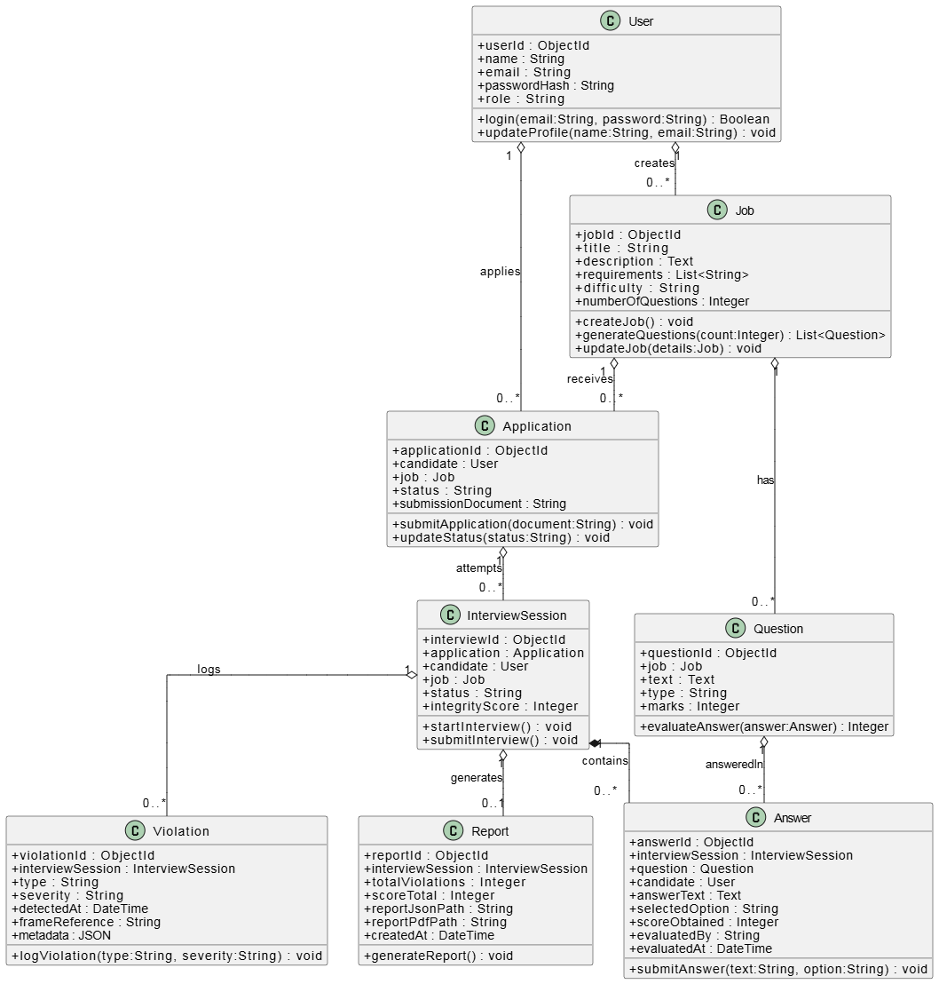
Figure 7 Class Diagram

Sequence Diagram
The Sequence Diagram illustrates the dynamic interactions between users and system components in Smartly Hire. It shows the chronological flow of messages between actors, the frontend, backend controllers, database, and AI/ML services. The diagram captures both candidate interview workflows, including live proctoring and answer evaluation, and admin job creation processes. By visualizing these interactions, it provides a clear understanding of the system’s runtime behavior and message sequence.

Figure 8 Sequence Diagram

Operation contracts
Operation Contracts illustrate the detailed specifications of system operations in Smartly Hire.
They describe the preconditions, postconditions, inputs, outputs, and responsibilities of each major function.
These contracts provide a clear understanding of how each operation affects the system state and interacts with other entities.
They serve as a bridge between use case analysis and class design, ensuring consistent and precise implementation.
User Operations:
Operation Name | User.login(email, password)
Cross-Reference | User Authentication Use Case
Precondition | User exists in the system
Postcondition | User session initiated if credentials are valid
Inputs | email : String, password : String
Outputs | success : Boolean
Responsibility | Authenticates a user and starts a session
Operation Name | User.updateProfile(name, email)
Cross-Reference | Update Profile Use Case
Precondition | User is logged in
Postcondition | User’s name and email updated in the system
Inputs | name : String, email : String
Outputs | updated : Boolean
Responsibility | Updates user profile information

Table 26 User Operations

Job Operations:
Operation Name | Job.createJob()
Cross-Reference | User Authentication Use Case
Precondition | User exists in the system
Postcondition | User session initiated if credentials are valid
Inputs | email : String, password : String
Outputs | success : Boolean
Responsibility | Authenticates a user and starts a session
Operation Name | User.updateProfile(name, email)
Cross-Reference | Update Profile Use Case
Precondition | User is logged in
Postcondition | User’s name and email updated in the system
Inputs | name : String, email : String
Outputs | updated : Boolean
Responsibility | Updates user profile information

Table 27 Job Operations (User Authentication)
Job Operations:
Operation Name | Job.createJob()
Cross-Reference | Admin creates job Use Case
Precondition | User role = "admin"
Postcondition | Job saved in system, available for candidates
Inputs | title : String, description : String, requirements : List<String>, difficulty : String
Outputs | jobId : ObjectId
Responsibility | Creates a new job posting
Operation Name | Job.generateQuestions(count)
Cross-Reference | Question Generation Use Case
Precondition | Job exists
Postcondition | List of interview questions generated and returned
Inputs | count : Integer
Outputs | questions : List<Question>
Responsibility | Generates interview questions using AI or template

Table 28 Job Operations (Admin)
Application Operations:
Operation Name | Application.updateStatus(status)
Cross-Reference | Application Status Update
Precondition | Application exists
Postcondition | Application.status updated
Inputs | status : String (applied/invited/completed)
Outputs | updated : Boolean
Responsibility | Updates the status of an application
Operation Name | Application.submitApplication(submissionDocument)
Cross-Reference | Candidate applies for Job Use Case
Precondition | User role = "candidate", Job deadline not passed
Postcondition | Application linked to user and job, status = "submitted"
Inputs | submissionDocument : String
Outputs | confirmation : Boolean
Responsibility | Submits a job application along with document

Table 29 Application Operations

InterviewSession Operations:
Operation Name | InterviewSession.startInterview()
Cross-Reference | Start Interview Use Case
Precondition | Candidate has submitted application
Postcondition | Interview status = "started", timer begins, proctoring activated
Inputs | None
Outputs | sessionActive : Boolean
Responsibility | Begins the interview session
Operation Name | InterviewSession.submitInterview()
Cross-Reference | Submit Interview Use Case
Precondition | Interview in progress
Postcondition | Interview status = "submitted", answers stored, integrity score logged
Inputs | None
Outputs | submissionConfirmed : Boolean
Responsibility | Submits the completed interview for evaluation

Table 30 InterviewSession Operations
Question & Answer Operations:
Operation Name | Answer.submitAnswer(answerText, selectedOption)
Cross-Reference | Candidate Answers Question
Precondition | Interview in progress
Postcondition | Answer stored and linked to interview and question
Inputs | answerText : String, selectedOption : String
Outputs | submitted : Boolean
Responsibility | Records candidate’s answer to a question
Operation Name | Question.evaluateAnswer(answer)
Cross-Reference | AI/Manual Evaluation Use Case
Precondition | Answer exists
Postcondition | Score calculated and returned
Inputs | answer : Answer
Outputs | score : Integer
Responsibility | Evaluates an answer and returns the score

Table 31 Question & Answer Operations
Violation Operations:
Operation Name | Violation.logViolation(type, severity)
Cross-Reference | Proctoring Detection Use Case
Precondition | Interview is active, candidate under observation
Postcondition | Violation logged with timestamp and type
Inputs | type : String (no_face, phone, book, etc), severity : String (low/medium/high)
Outputs | violationLogged : Boolean
Responsibility | Logs a proctoring violation during the interview

Table 32 Violation Operations

Report Operations:
Operation Name | Report.generateReport()
Cross-Reference | Evaluation & Reporting Use Case
Precondition | Interview submitted and evaluated
Postcondition | Report generated with total score, violations, and optional PDF/JSON
Inputs | None
Outputs | reportPath : String
Responsibility | Produces final interview report including scores and proctoring summary

Table 33 Report Operations

Activity Diagram
The activity diagram illustrates the end-to-end workflows of the Smartly Hire platform, highlighting the interactions between Admin, Candidate, and AI/Proctoring modules. It captures key activities such as login, job creation, interview initiation, live proctoring, question answering, and optional AI evaluation. Decision points, loops, and concurrent processes, like camera permission checks and question loading, are clearly represented to show dynamic control flow. Swimlanes are used to group activities by actor, providing clarity on role-specific responsibilities. Overall, the diagram visually communicates the sequence, conditions, and concurrency of tasks within the recruitment system.
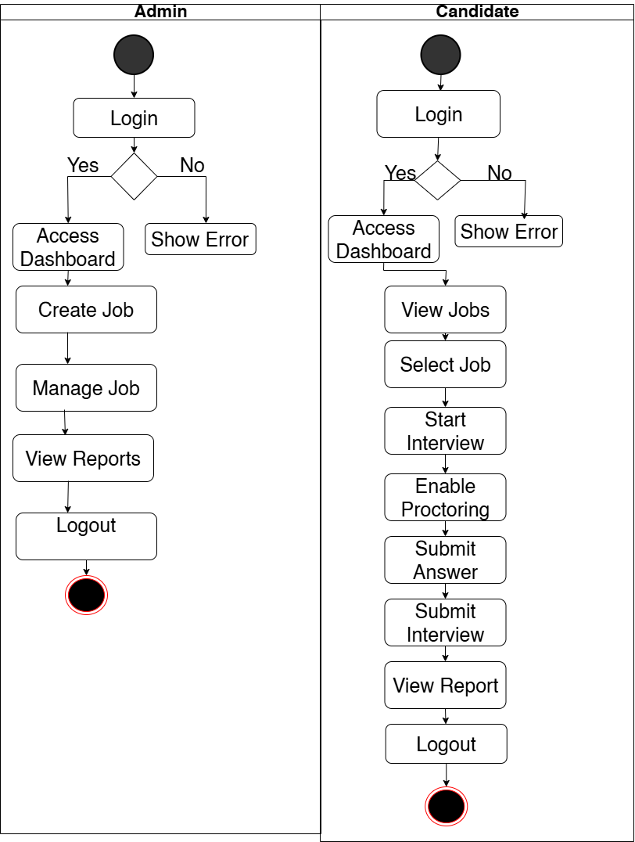

Figure 9 Activity Diagram

State Transition Diagram
The State Transition Diagram illustrates the dynamic behavior of the Smartly Hire system, capturing the various states a user can pass through during job application and interview processes. It highlights both candidate and admin workflows, including login, job browsing, application submission, interview taking, proctoring, evaluation, and report generation. The diagram also models continuous proctoring events and a dynamic loop for answering any number of questions, ensuring system integrity. This visual representation provides a clear and structured overview of the system’s runtime behavior and interactions.
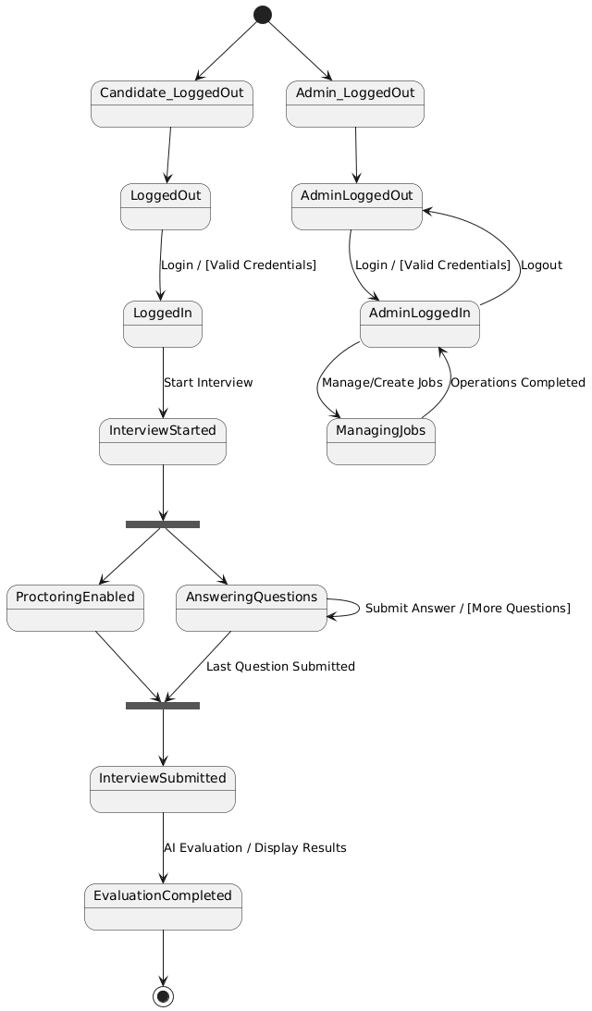
Figure 10 State Transition Diagram

Component Diagram
The Component Diagram illustrates the high-level architecture of the Smartly Hire system, showing how the system is modularized into distinct components. It highlights the separation between frontend, backend, database, and AI/ML services, along with the interfaces and dependencies between them. The diagram emphasizes the modularity, reusability, and communication paths among components, ensuring clarity in system design. This visual representation provides a structured overview of the system’s architecture for both development and documentation purposes.
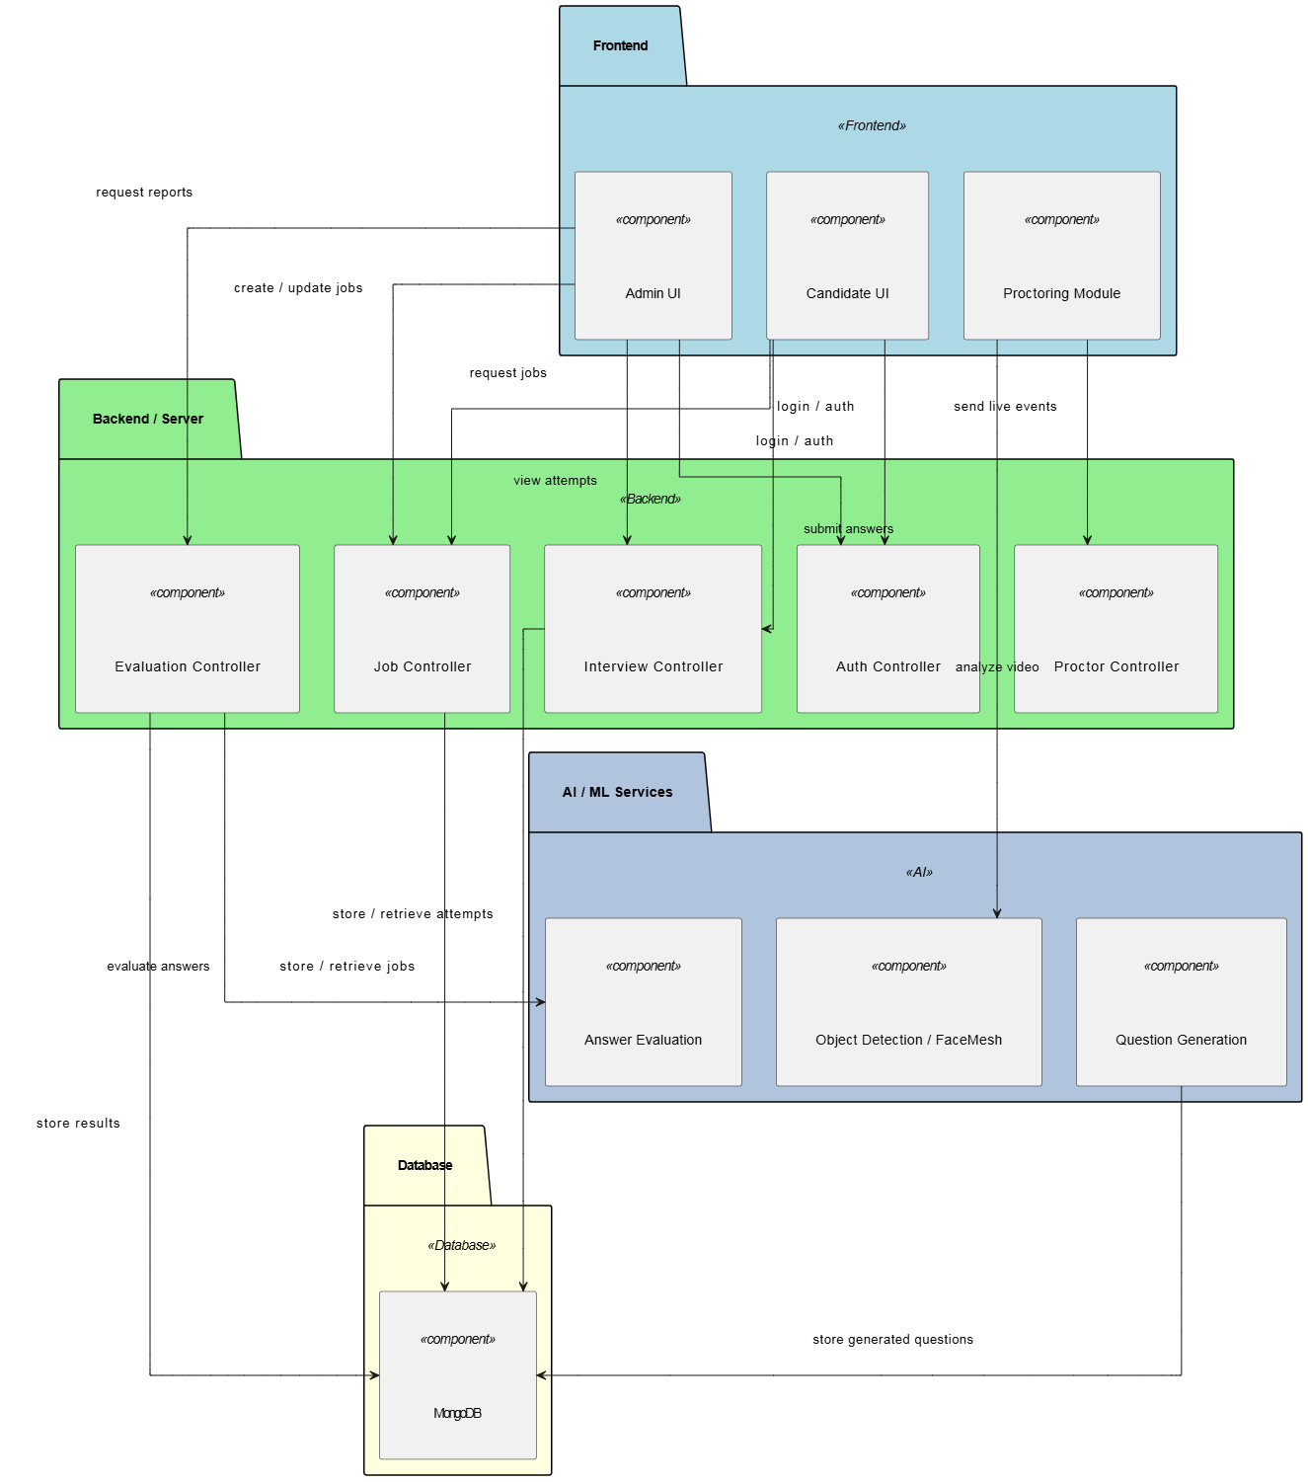
Figure 11 Component Diagram

Deployment Diagram
The Deployment Diagram illustrates the physical architecture of the Smartly Hire system, showing how software components are deployed on hardware nodes. It highlights the mapping of the frontend, backend, database, and AI/ML services to specific servers and devices. The diagram emphasizes communication paths, protocols, and dependencies between nodes, ensuring clarity in system deployment. This visual representation provides a clear overview of the system’s infrastructure for development, testing, and production environments.

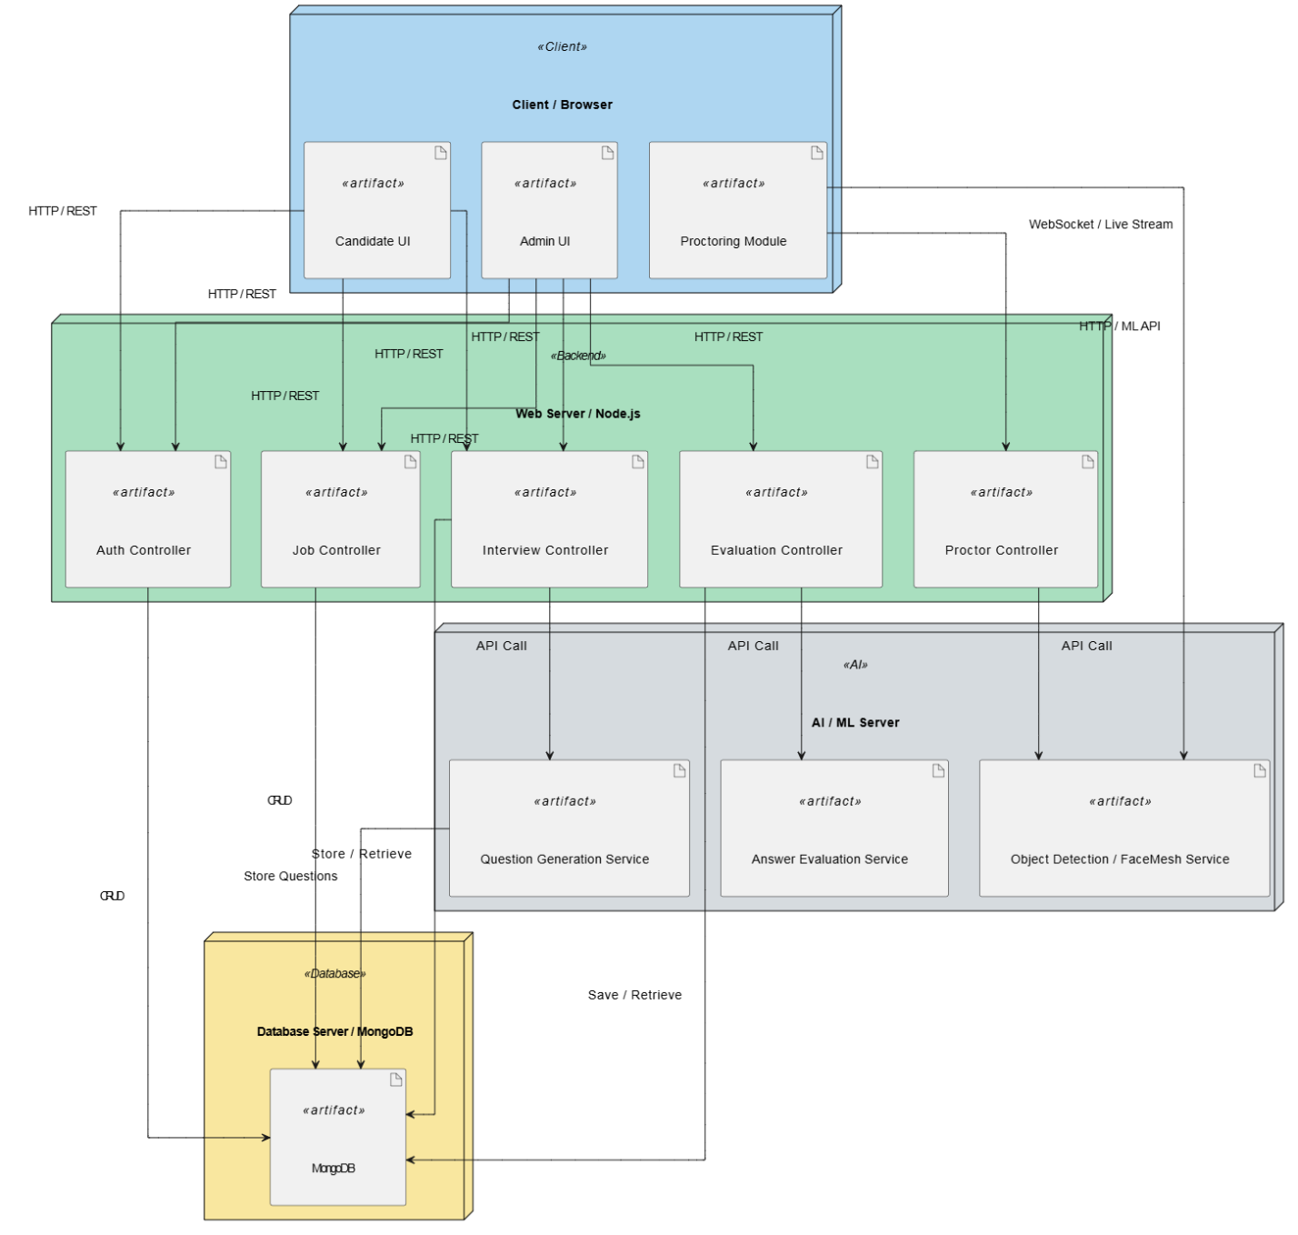
Figure 12 Deployment Diagram

Data Flow diagram
The Data Flow Diagram (DFD) illustrates how data moves through the Smartly Hire system, showing processes, data stores, and interactions with external entities. It provides a clear visual representation of system functionality, supporting analysis of data flow and integration of AI-based evaluation and proctoring. These diagrams help stakeholders understand the flow of information and the key operations performed by the system. Overall, DFDs enhance system clarity and support efficient system design and communication.
Level 0 DFD:
Level 0 provides a high-level view of the system as a single process interacting with external entities like Admin, Candidate, and AI Services, showing the main inputs and outputs.

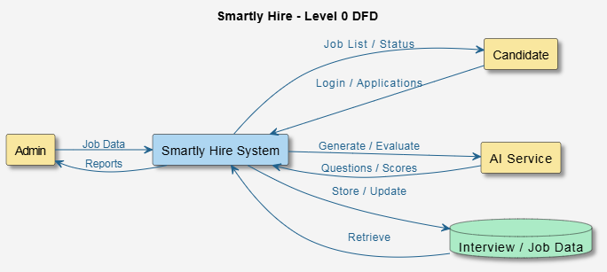
Figure 13 Level 0 DFD
Level 1 DFD:
Level 1 decomposes the main process into sub-processes including Job Management, Interview Handling, Proctoring & Monitoring, and Evaluation & Reporting, showing detailed data flows and storage interactions.

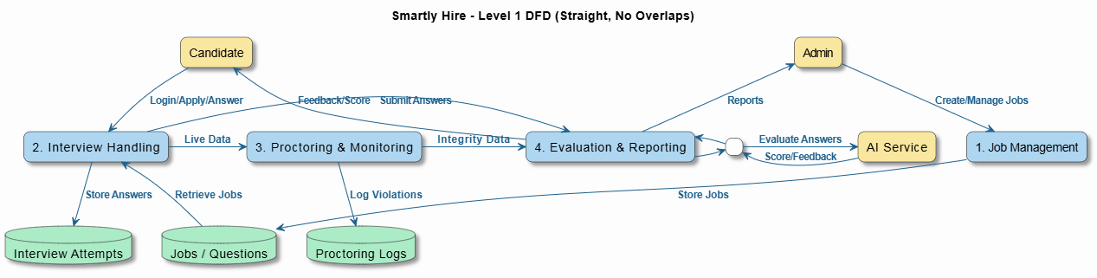
Figure 14 Level 1 DFD

Chapter 5

Implementation

Chapter 5: Implementation
This chapter outlines the technical realization of the Smartly Hire recruitment platform. It covers system workflow, module integration, core components, libraries, security implementation, deployment pipelines, tool usage, coding standards, and version control practices followed throughout development. The implementation demonstrates how AI-driven monitoring, automated screening, job processing, and interview assessment are unified to create an intelligent digital hiring ecosystem.

Important Flow Control/Pseudo codes
The following pseudocode reflects the primary control logic implemented within the system, spanning administrator authentication, job publishing, candidate application processing, and AI-based interview monitoring and evaluation.

Admin Login Flow (Pseudocode):
This flow verifies the credentials of the admin and ensures that only authorized users can access the admin dashboard. It generates a JWT token upon successful authentication for secure session management.

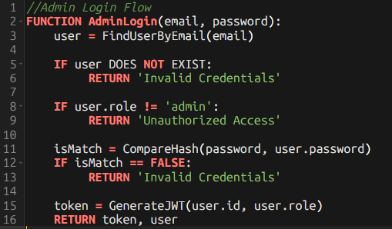
Figure 15 Admin Login Flow

Job Creation Flow (Pseudocode):
This flow allows an authenticated admin to create a new job posting in the database. It ensures that only users with admin privileges can add jobs.

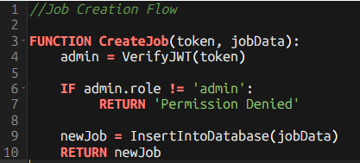
Figure 16 Job Creation Flow

Candidate Application Flow (Pseudocode):
This flow handles job applications submitted by candidates and records them securely in the database. It verifies the candidate’s identity before storing application details.

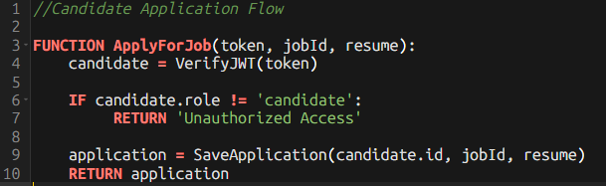
Figure 17 Candidate Application Flow

Proctoring Event Flow (Pseudocode):
This flow captures webcam frames during the interview and analyzes them for facial landmarks, emotion, head pose, eye blinks, and mouth movements. It logs any detected violations for maintaining interview integrity.
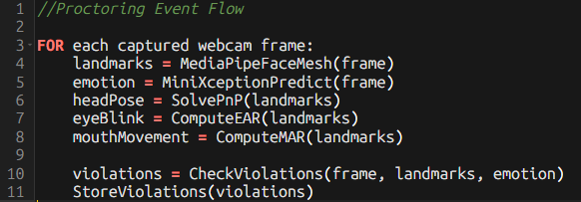
Figure 18 Proctoring Event Flow

Components, Libraries, Web Services and stubs
The system integrates multiple components across the backend, frontend, and AI services:
• Backend: The server-side logic is implemented in Node.js using Express.js for API layer development. Database operations are handled via Mongoose ODM. Authentication is secured through JSON Web Token, while password hashing and verification use bcrypt and bcrypt.compare. File handling for resumes uses multer middleware, and cross-origin access is managed using secured CORS configuration. Environment variables are loaded using dotenv.
• Frontend: The user interface is developed using the React component-based framework, bundled with Vite for optimized development and fast hot module reloading, and styled using Tailwind CSS utility-first design. Routing and interview flow navigation are managed using React Router.
• AI/ML Services: Real-time interview integrity monitoring is powered by modular microservices built in Python using FastAPI. These services integrate MediaPipe models (BlazeFace for face detection, FaceMesh for landmark extraction), OpenCV for frame processing, and Mini-Xception CNN for emotion classification. Model format conversion and inference deployment use TensorFlow.js and ONNX runtime for browser-compatible ML execution.
• Database: All system data including user profiles, job postings, applications, interview sessions, violation logs, and structured recruitment reports are cloud-hosted in a scalable and encrypted cluster using MongoDB Atlas.
• Web Services: Secure HTTPS REST APIs handle authentication, job postings, candidate applications, interview scheduling, session recordings, violation logging, and final report generation. Real-time proctoring stubs and AI inference are accessed through FastAPI microservice endpoints instead of direct model execution inside the frontend.

Deployment Environment
The deployment environment ensures modularity and scalability:
• Backend: The Node.js server runs on managed cloud platforms such as Render and Railway for fail-safe API hosting.
• Database: The MongoDB Atlas cloud database cluster securely stores all recruitment and interview process collections with encrypted access.
• Frontend: The React application is deployed on global frontend hosting platforms including Vercel and Netlify for scalable UI delivery and fast CDN-based load distribution.
• ML Microservices: AI monitoring services built on FastAPI are containerized using Docker for isolated scaling and deployed on cloud VM/container runtimes. The services are exposed on secure internal ports (8001–8003) to process candidate interview frames and behavior signals through encrypted HTTP communication.
This deployment enables independent horizontal scaling of AI services, secure API-to-ML service communication, geographical accessibility, and high availability for concurrent interview sessions without performance compromise.

Tools and Techniques
The development process employed the following tools and techniques:
• Development Tools: Visual Studio Code for source development, Thunder Client for REST API testing, MongoDB Compass for local database inspection, GitHub for repository hosting, and Docker Desktop for AI microservice container testing and pipeline validation.
5.4.1. Techniques:
• Modular MVC architecture for backend organization, separating controllers, routes, models, and middleware for maintainability.
• REST API construction with structured JSON request-response layers.
• JWT-based authentication enforcing strict role-based access control for Admin/Recruiter and candidates.
• WebRTC webcam streaming integration for interview capture and monitoring.
• Asynchronous processing for minimal API latency and high parallel execution.
• Containerized ML microservices supporting isolated inference execution and independent scaling for recruitment monitoring AI.

Best Practices / Coding Standards
The implementation follows professional coding and security standards:
• Code Organization: Backend folders are structured into controllers, models, routes, middleware, and services, ensuring clear segregation between core recruitment logic and AI-monitoring microservices.
• JavaScript Standards: Development uses ES6+ conventions, reusable modules, async/await syntax for non-blocking execution, descriptive method naming, and structured response models for interview data handling.
Security Measures:
Passwords are hashed using bcrypt before storage.
Access control is enforced using JWT tokens with role payloads.
CORS settings restrict unauthorized origins.
All sensitive credentials and secrets are managed securely using environment variables via dotenv (.env).
No direct database access is allowed from the client/frontend.
• Maintainability: The platform supports independent updates for backend APIs and AI services without requiring full system redeployment.
• Documentation: Inline comments, modular function explanations, request-response descriptions, microservice stub contracts, and structured code significantly enhance readability for future development and recruiter process auditing.

Version Control
Version control is managed using Git and GitHub:
• Branching Strategy: The repository follows industry-standard branch segmentation including main (stable), development (integration), and separate feature branches for modules such as job publishing, interview session control, violation monitoring, and report generation.
• Commit Practices: All commits follow structured and meaningful messages for auditability and requirement traceability.
• Collaboration: Pull requests, peer code reviews, module approvals, and controlled merging ensure reliability and safety in feature integration.
• Backup and Tracking: GitHub cloud repository hosting provides persistent version history, deviation tracking, and secure rollback capability for both core recruitment and AI-monitoring development changes.

Appendices

Appendix A: Information / Promotional Material
This appendix presents the promotional and informational material developed for the AI Proctor Interview System. It demonstrates the branding, marketing, and awareness content prepared to communicate the system’s features, capabilities, and benefits. The material includes brochures, flyers, standees, and banners, designed for both digital and physical distribution. These resources support user onboarding, recruitment campaigns, and organizational presentations, ensuring clear communication of the system’s functionality to administrators, recruiters, and candidates. This appendix also includes guidelines for consistent use of colors, logos, and branding elements across all marketing and user-facing materials.

  - Broacher
The brochure provides a detailed overview of the AI Proctor Interview System. It highlights the system’s core features, underlying technology stack, and key benefits for both administrators and candidates. The brochure is intended for distribution to organizations, educational institutions, and recruitment agencies. It visually summarizes the workflow of proctored interviews, AI-powered monitoring processes, and automated reporting capabilities, making it easy for stakeholders to understand the system at a glance.
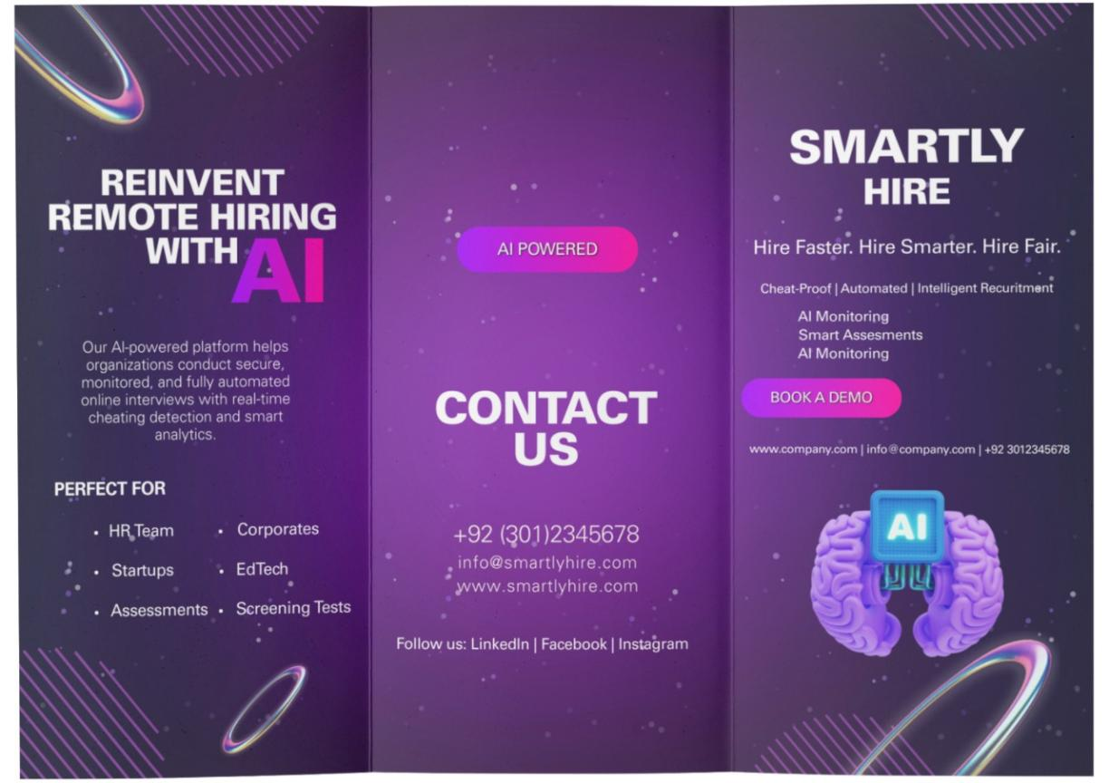
Figure 19 Brochure Front side
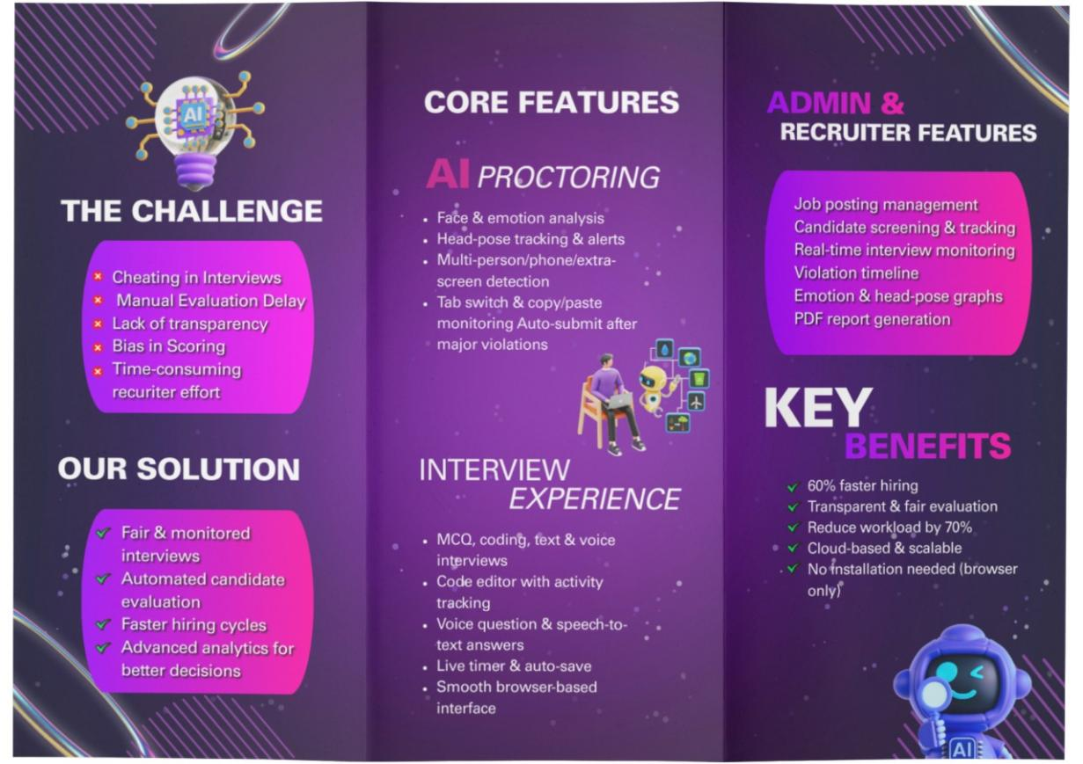
Figure 20 Brochure inside

A.2. Flyer

The flyer is a one-page promotional document designed to attract both candidates and recruiters. It visually communicates the system’s primary advantages, including secure interviews, real-time AI proctoring, and automated performance reporting. The flyer uses concise messaging and illustrative graphics to convey key features quickly. It is optimized for both digital distribution (emails, social media) and physical printing for events or notice boards.
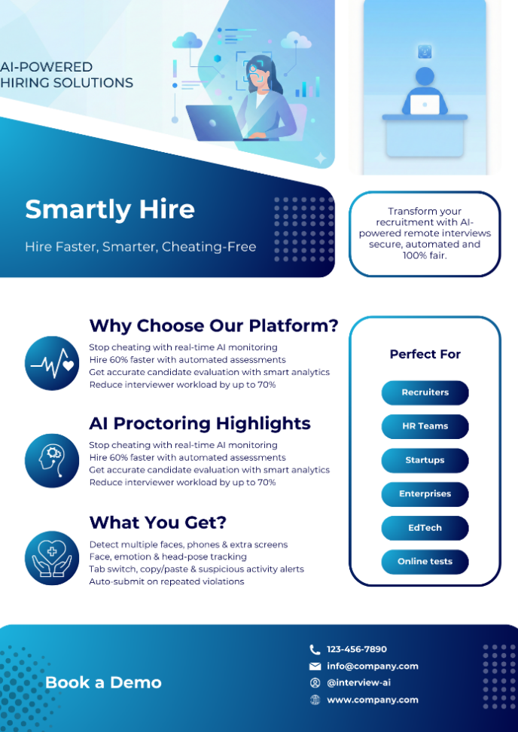
Figure 21 Flyer

A.3. Standee
The standee is designed for display at events such as recruitment fairs, workshops, or conferences. It provides a visual summary of the system’s capabilities, including candidate dashboards, AI monitoring interfaces, and real-time violation alerts. The standee uses diagrams and infographics to demonstrate the interview workflow, capturing attention and conveying professionalism to stakeholders.
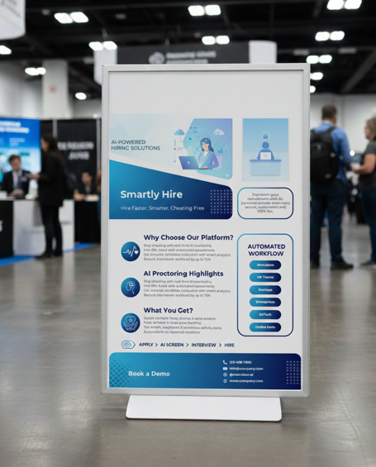
Figure 22 Standee
A.5. Branding Guidelines
This section outlines the visual identity and branding principles for the AI Proctor Interview System. It ensures consistency across all promotional material and user interfaces, enhancing brand recognition and professional presentation.
A.5.1. Color Scheme
The platform uses a sleek, modern color palette designed to communicate trust, sophistication, and advanced AI-driven technology.

Primary Colors
- Deep Navy: Establishes reliability, professionalism, and a stable visual foundation.
- Purple–Blue Gradient: Conveys innovation, intelligence, and a futuristic feel throughout the interface.
- Soft White: Ensures high readability and maintains a clean, minimalist aesthetic.

Accent Colors
Bright pink-purple neon accents are applied strategically to highlight key actions—such as primary buttons, navigation states, and important interactive elements. These accents provide contrast, guide user focus, and enhance the overall modern UI experience.

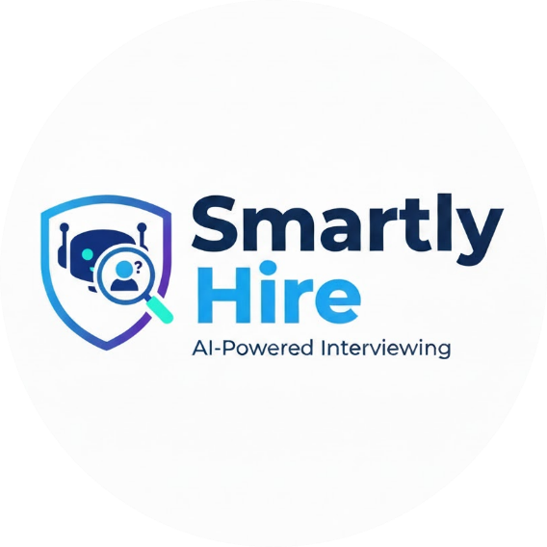

A.5.1.1. Logo Usage
The system logo is designed for versatility across digital and print media. Key guidelines include:
- Maintain clear spacing around the logo to avoid visual clutter
- Use consistent colors as defined in the color palette
- Preserve proportional scaling to avoid distortion

- Use the full-color version for digital applications and the monochrome version for printing purposes
- Do not alter or rotate the logo in any promotional or official materials

Appendix B: Sample Screenshots
This appendix contains representative screenshots of the AI Proctor Interview System in operation. It demonstrates the user interface, administrative dashboards, candidate workflows, and AI-proctoring outputs. The appendix provides stakeholders with a clear understanding of the system’s functionality, layout, and reporting capabilities. It also serves as evidence of the implemented features and system usability during interviews.
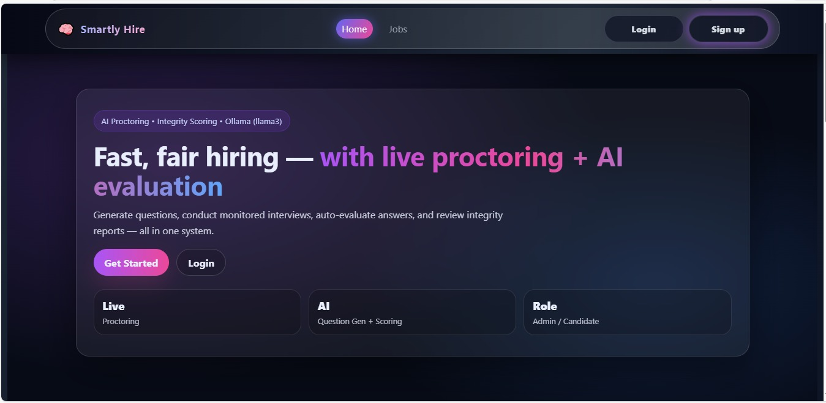
Figure 23 Landing page
B.1. Admin Dashboard Screenshots
The admin dashboard displays an overview of all job postings, candidate applications, and active interview sessions. It includes visual elements such as charts, cards, and tables that summarize key statistics, including total jobs, candidate counts, ongoing interviews, and violation metrics. These screenshots demonstrate the real-time monitoring and management capabilities available to administrators.
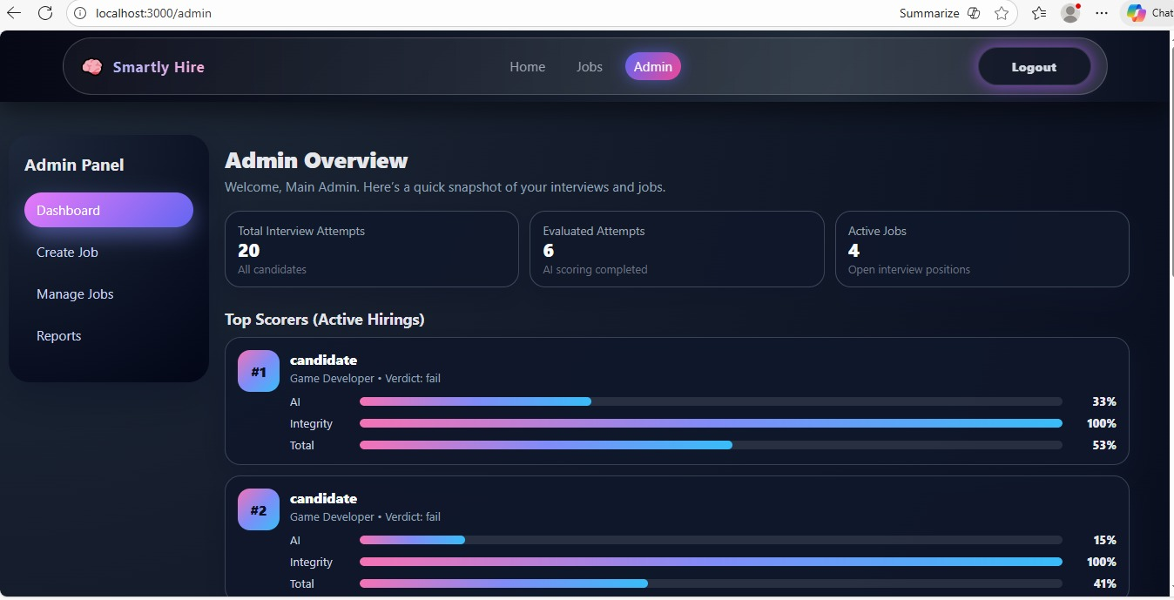
Figure 24 Admin Dashboard
B.1.1. Job Management Screens
This section shows screenshots of the job management interface, where administrators can create, edit, and delete job postings. Each job includes fields such as title, description, number of questions, and application deadlines. The interface provides filtering and search options for efficient job tracking and management.
B.1.1.1. Job Creation Form
The job creation form allows administrators to input job details and generate AI-assisted job descriptions. It ensures that all necessary information is captured before posting the job, maintaining consistency and reducing manual effort.
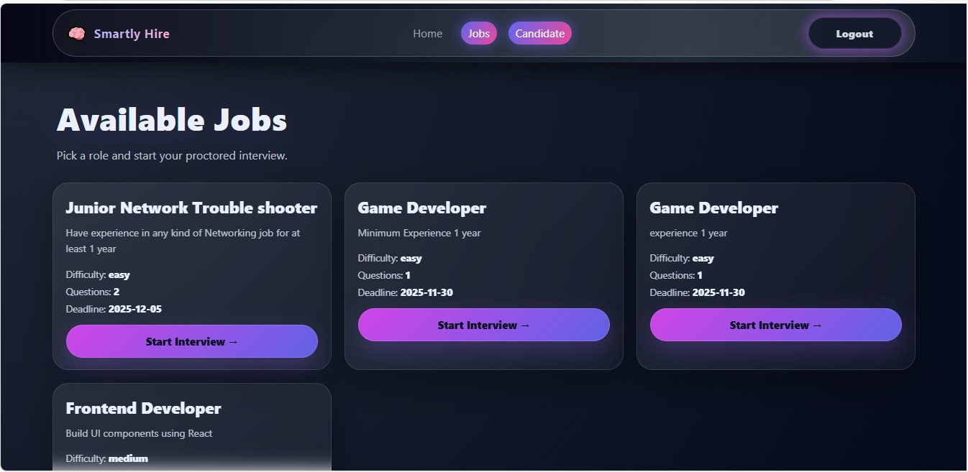Figure 25 Available Jobs

B.2. Candidate Interface Screenshots
The candidate dashboard displays available job listings, applied positions, and scheduled interviews. It also shows the interview interface with questions, timers, and real-time proctoring alerts. These screenshots illustrate the candidate experience and interaction with the system.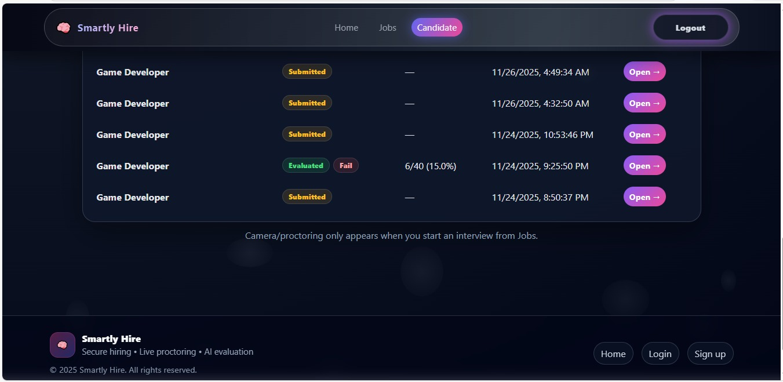Figure 26 Candidate Interviews list

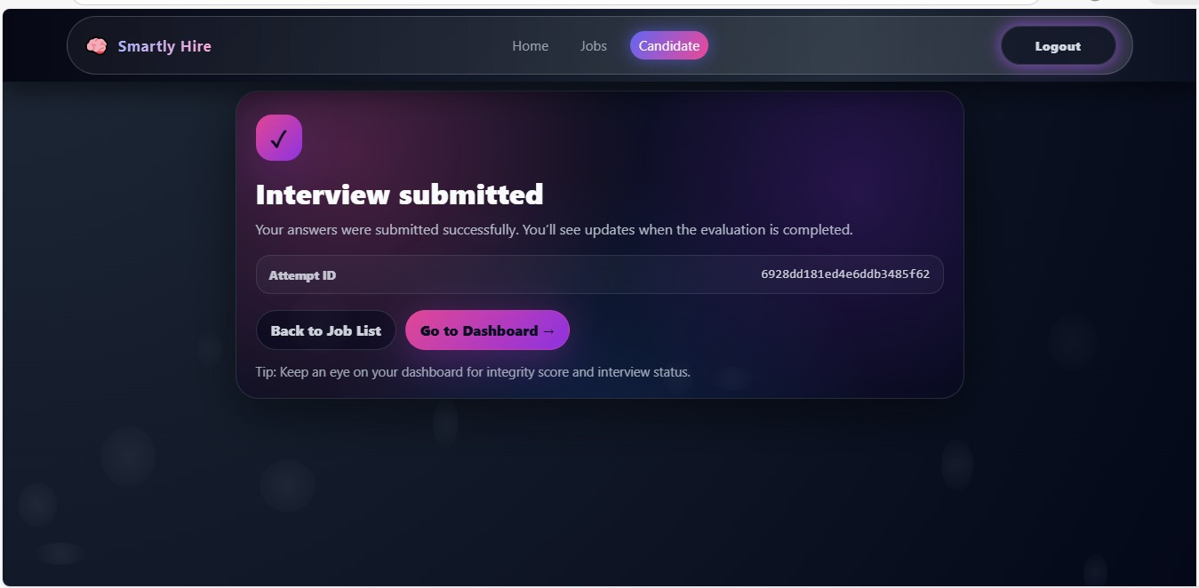
Figure 27 Interview Submitted Page
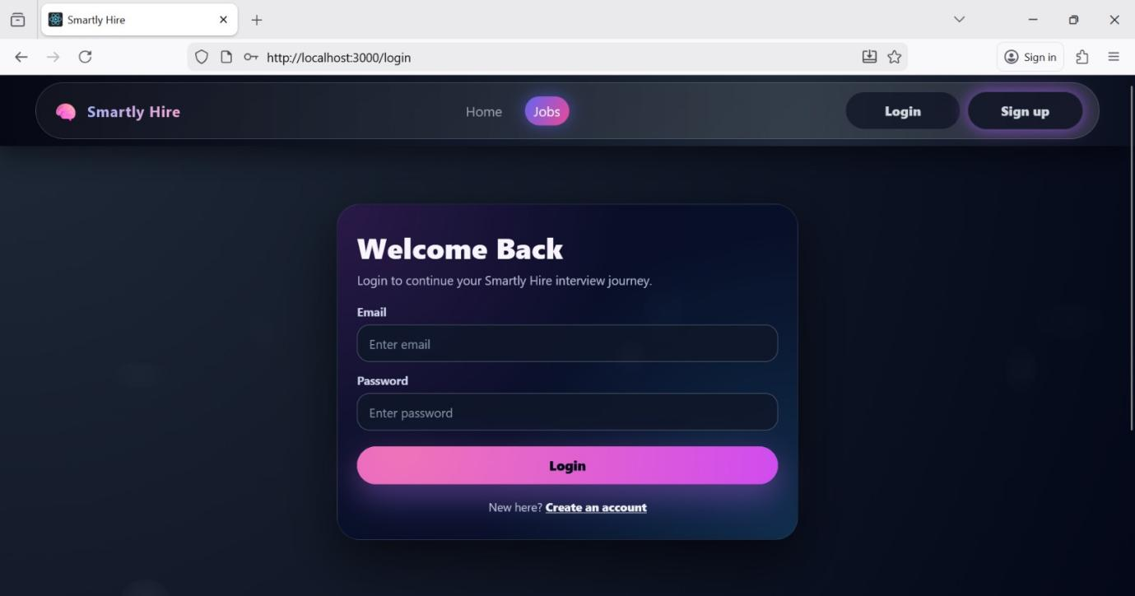
Figure 28 login page

