**Assignment # 3 (Kubernetes)**

**Group members:**

19P-1652 Hifza Majeed

19P-1664 Noman

19P-1672 Ahmad

**Step 1:**

1. **install the docker desktop**

1. **install kubectl**

1. **install minikube**

**Step 2:**

After the docker assignment 2, we start further work to continue in Kubernetes

For Kubernetes, we create a deployment.yaml file

These files create two potions one is services and the other is the deployment

**Code of all files:**

**Dockerfile**

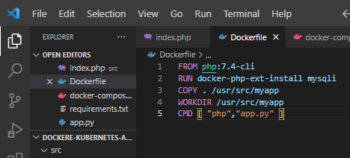

**Index.php**

**requirements.txt**

**deployment.yaml**

**app.py**

