**Electric Power Consumption and CO2 Emission**

Electricity is the main factor for a country that help run all the system there. Electricity is used in different industries such as power plants, goods production plants etc. The produced goods are consumed by the customer that is the people in the countries. In most cases, CO2 is produced at the time of producing and consuming it. CO2 is mainly produced at the time of burning materials like coal, and petroleum products that are utilized to produce energy and electricity. So, there are some impacts on the CO2 emission for the value of electricity consumed by the countries. To realise the relationship between electricity consumption and the emissions of CO2, the data has been taken from the world bank and the following countries and indicators have been selected:

* Electric power consumption
* CO2 emissions (kt)
* China
* France
* Germany
* India
* Iraq
* World

In this context, two data have been created from the collected data. The first data contains all the years in the column positions and the countries along with the values are in the rows. On the other hand, the second data contausn the names of the countries and inductors at the columns positions and the values relevant to the years (19609 to 2022) in the rows. After formatting the data, the data analysis has been done. In this context, the mean or average values of the electricity consumtion and CO2 emission have been computed and stored in the data set. The outcomes are shown below:

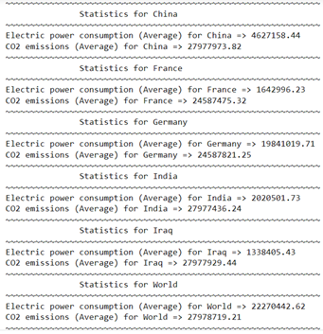 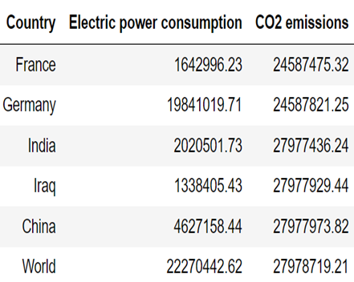

In the data frame, the values of average electric consumption and CO2 Emissions are shown. To understand the statistics more clearly, the visualization has been done using line chart. The line chart has been chosen because it can show the progression of values of both two variables on the graph. Additionally, the marker has been used to point to the specific value for the countries. The line chart for the consumption of electricity and CO2 emissions is shown below:

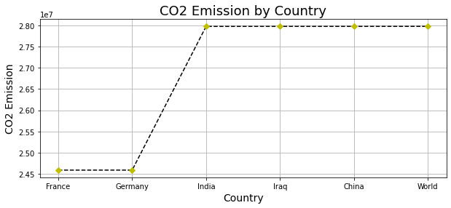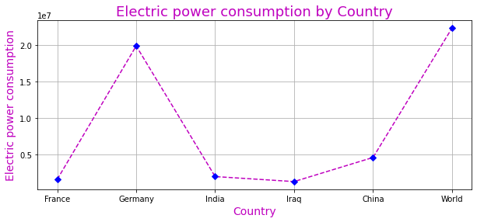

From the visualization, it can be seen that consumption of electric powr is higher for Germany as a country but the average CO2 emission is less got Germany as well. The average emission of CO2 is highest for India, Iraq and China. Next, the correlation has been applied to the features of the data as shown above to determine the relationship between the electricity comsumption to CO2 emission. Correlation helps to identify the influence of one features to another. The visualization has been done using heatmap as it facilitates graphically understanding the correlation opf features as follows:

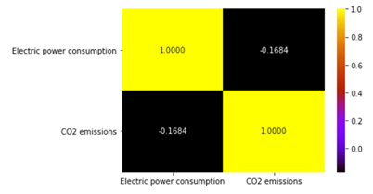

From the correlation plot, it can be understood that the features are negatively correlated. To understand the statistics better, the correlation has been applied to all countries and shown below:

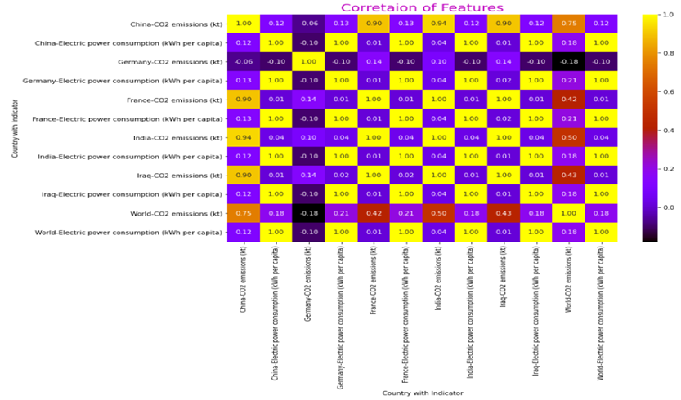

From the correlation of all countries, it can be seen that the value of correlation for China is 0.12, for Germany it is 0.12, for France, it is 0.01 etc. So, the relationship between electricity consumption and CO2 emissions is not the same or similar for all countries.