DATABASE SYSTEMS (IT301L)

JOB PORTAL & RECRUITMENT
DATABASE MANAGEMENT SYSTEM
ER Model to Relational Model Conversion
and Database Normalization

Oracle Database | Relational Design | 1NF • 2NF • 3NF

1. Introduction
The Job Portal and Recruitment Database Management System is designed to organize information about companies, job vacancies, job seekers, skills, applications and interviews. The database provides a structured way to represent recruitment activities and the relationships among the participants in the recruitment process.
This document presents the conversion of the Entity-Relationship (ER) model into a relational schema and explains normalization through First Normal Form (1NF), Second Normal Form (2NF) and Third Normal Form (3NF). The target implementation platform is Oracle Database.

2. Project Objectives
- Design a relational database for managing job seekers, employers, vacancies and recruitment applications.
- Represent entities, attributes, primary keys, foreign keys and relationship cardinalities.
- Resolve many-to-many relationships through associative (junction) relations.
- Convert the ER model into a set of relational tables with integrity constraints.
- Apply normalization to reduce redundancy and prevent insertion, update and deletion anomalies.

3. ER Model
The ER model contains eight entities: COMPANY, JOB, JOB_SEEKER, SKILL, SEEKER_SKILL, JOB_SKILL, APPLICATION and INTERVIEW. The two many-to-many relationships—between job seekers and skills, and between jobs and skills—are resolved using SEEKER_SKILL and JOB_SKILL.
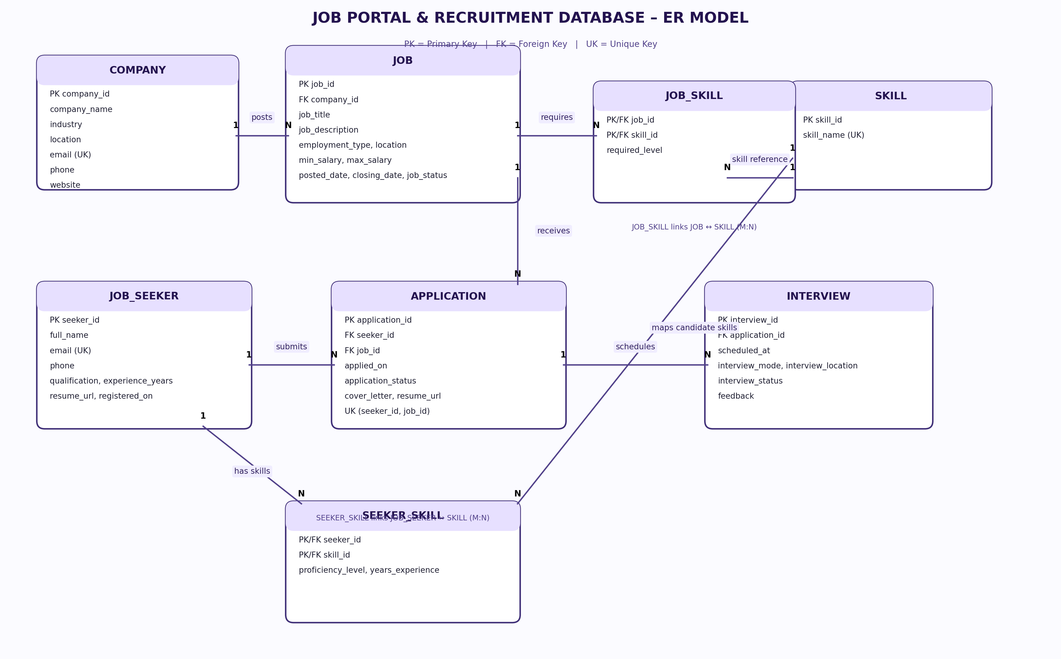
Figure 1. Job Portal and Recruitment Database ER model.

3.1 Entities and their purpose
Entity | Purpose
COMPANY | Stores employer details such as company name, industry, location and contact information.
JOB | Stores vacancies posted by companies, including title, description, employment type, location and salary range.
JOB_SEEKER | Stores candidate profile information, qualification, experience and resume reference.
SKILL | Maintains a master list of technical and professional skills.
SEEKER_SKILL | Associates job seekers with skills and records candidate-specific proficiency and experience.
JOB_SKILL | Associates jobs with required skills and records the required proficiency level.
APPLICATION | Records a candidate's application for a job, including date, status and application documents.
INTERVIEW | Stores interview rounds, scheduling details, mode, status and feedback for an application.

3.2 Relationship cardinalities
Relationship | Cardinality | Explanation
COMPANY — JOB | 1 : N | A company can post many jobs; each job belongs to one company.
JOB_SEEKER — APPLICATION | 1 : N | A job seeker can submit multiple applications; each application belongs to one seeker.
JOB — APPLICATION | 1 : N | A job can receive multiple applications; each application refers to one job.
JOB_SEEKER — SEEKER_SKILL | 1 : N | A seeker can have multiple skill records.
SKILL — SEEKER_SKILL | 1 : N | A skill can be associated with multiple seekers.
JOB — JOB_SKILL | 1 : N | A job can have multiple required-skill records.
SKILL — JOB_SKILL | 1 : N | A skill can be required by multiple jobs.
APPLICATION — INTERVIEW | 1 : N | An application can have multiple interview rounds.

The JOB_SEEKER–SKILL and JOB–SKILL relationships are conceptually many-to-many (M:N). Each is implemented as two one-to-many relationships through its associative table.

4. ER Model to Relational Model Conversion
The ER-to-relational conversion follows standard mapping rules: each strong entity becomes a relation; simple attributes become columns; the entity key becomes the primary key; a 1:N relationship is implemented by placing the primary key of the one-side as a foreign key on the many-side; and an M:N relationship is represented by a separate associative relation.
Relation | Relational schema (underlined attributes are represented by PK notation)
COMPANY | company_id (PK), company_name, industry, location, email (UK), phone, website
JOB | job_id (PK), company_id (FK), job_title, job_description, employment_type, location, min_salary, max_salary, posted_date, closing_date, job_status
JOB_SEEKER | seeker_id (PK), full_name, email (UK), phone, qualification, experience_years, resume_url, registered_on
SKILL | skill_id (PK), skill_name (UK)
SEEKER_SKILL | (seeker_id (PK, FK), skill_id (PK, FK)), proficiency_level, years_experience
JOB_SKILL | (job_id (PK, FK), skill_id (PK, FK)), required_level
APPLICATION | application_id (PK), seeker_id (FK), job_id (FK), applied_on, application_status, cover_letter, resume_url
INTERVIEW | interview_id (PK), application_id (FK), scheduled_at, interview_mode, interview_location, interview_status, feedback

4.1 Detailed relation attributes and constraints

COMPANY
Attribute | Oracle data type | Key / constraint
company_id | NUMBER | Primary key
company_name | VARCHAR2(100) | NOT NULL
industry | VARCHAR2(100) | Optional
location | VARCHAR2(150) | Optional
email | VARCHAR2(100) | UNIQUE; nullable unless declared NOT NULL
phone | VARCHAR2(15) | Optional
website | VARCHAR2(150) | Optional

JOB
Attribute | Oracle data type | Key / constraint
job_id | NUMBER | Primary key
company_id | NUMBER | Foreign key → COMPANY(company_id); NOT NULL
job_title | VARCHAR2(100) | NOT NULL
job_description | CLOB | Optional
employment_type | VARCHAR2(50) | Optional
location | VARCHAR2(150) | Optional
min_salary | NUMBER(10,2) | CHECK (min_salary >= 0), if supplied
max_salary | NUMBER(10,2) | CHECK (max_salary >= min_salary), if both supplied
posted_date | DATE | Optional; may have DEFAULT SYSDATE
closing_date | DATE | Optional
job_status | VARCHAR2(20) | Optional; recommended CHECK constraint

JOB_SEEKER
Attribute | Oracle data type | Key / constraint
seeker_id | NUMBER | Primary key
full_name | VARCHAR2(100) | NOT NULL
email | VARCHAR2(100) | UNIQUE; nullable unless declared NOT NULL
phone | VARCHAR2(15) | Optional
qualification | VARCHAR2(100) | Optional
experience_years | NUMBER(3) | CHECK (experience_years >= 0), if supplied
resume_url | VARCHAR2(255) | Optional
registered_on | DATE | Optional; may have DEFAULT SYSDATE

SKILL
Attribute | Oracle data type | Key / constraint
skill_id | NUMBER | Primary key
skill_name | VARCHAR2(100) | UNIQUE and NOT NULL

SEEKER_SKILL
Attribute | Oracle data type | Key / constraint
seeker_id | NUMBER | Composite PK; FK → JOB_SEEKER(seeker_id)
skill_id | NUMBER | Composite PK; FK → SKILL(skill_id)
proficiency_level | VARCHAR2(20) | Optional; recommended CHECK constraint
years_experience | NUMBER(3) | CHECK (years_experience >= 0), if supplied

JOB_SKILL
Attribute | Oracle data type | Key / constraint
job_id | NUMBER | Composite PK; FK → JOB(job_id)
skill_id | NUMBER | Composite PK; FK → SKILL(skill_id)
required_level | VARCHAR2(20) | Optional; recommended CHECK constraint

APPLICATION
Attribute | Oracle data type | Key / constraint
application_id | NUMBER | Primary key
seeker_id | NUMBER | FK → JOB_SEEKER(seeker_id); NOT NULL
job_id | NUMBER | FK → JOB(job_id); NOT NULL
applied_on | DATE | May have DEFAULT SYSDATE
application_status | VARCHAR2(20) | May have DEFAULT 'Pending'; recommended CHECK constraint
cover_letter | CLOB | Optional
resume_url | VARCHAR2(255) | Optional

INTERVIEW
Attribute | Oracle data type | Key / constraint
interview_id | NUMBER | Primary key
application_id | NUMBER | FK → APPLICATION(application_id); NOT NULL
scheduled_at | DATE | Oracle DATE stores date and time
interview_mode | VARCHAR2(20) | Optional; recommended CHECK constraint
interview_location | VARCHAR2(150) | Optional
interview_status | VARCHAR2(20) | Optional; recommended CHECK constraint
feedback | CLOB | Optional

4.2 Key integrity constraints
- Entity integrity: every relation has a primary key; primary-key values are unique and cannot be NULL.
- Referential integrity: foreign-key values must reference existing parent rows, unless the foreign key is nullable.
- Uniqueness: COMPANY.email, JOB_SEEKER.email and SKILL.skill_name are intended to be unique when supplied.
- Duplicate application prevention: UNIQUE (seeker_id, job_id) prevents the same seeker from applying to the same job more than once.
- Composite keys: SEEKER_SKILL uses (seeker_id, skill_id); JOB_SKILL uses (job_id, skill_id).
- Domain checks: salary and experience values must not be negative; max_salary must not be less than min_salary when both are supplied.

5. Database Normalization
Normalization is the process of organizing relations to reduce unnecessary duplication and avoid insertion, update and deletion anomalies. The design is evaluated against 1NF, 2NF and 3NF.

5.1 First Normal Form (1NF)
A relation is in 1NF when each attribute contains a single, atomic value and there are no repeating groups or multivalued fields.
Illustration of a non-1NF design:
seeker_id | full_name | skills
101 | Candidate A | Java, SQL, Python
102 | Candidate B | Python, HTML

The skills field contains multiple values in one cell. This is not atomic and makes searching, updating and maintaining skills difficult.
1NF solution:
seeker_id | skill
101 | Java
101 | SQL
101 | Python
102 | Python
102 | HTML

In the final design, skills are maintained in SKILL and linked to candidates through SEEKER_SKILL. Job requirements are similarly maintained through JOB_SKILL. Each stored attribute value is atomic.

5.2 Second Normal Form (2NF)
A relation is in 2NF when it is in 1NF and every non-prime attribute is fully functionally dependent on the whole of every candidate key. In particular, there must be no partial dependency on only part of a composite candidate key.
Illustrative relation with a composite key:
seeker_id (PK part) | skill_id (PK part) | seeker_name | skill_name | proficiency
101 | 1 | Candidate A | Java | Advanced
101 | 2 | Candidate A | SQL | Intermediate
102 | 1 | Candidate B | Java | Intermediate

Assume the composite key is (seeker_id, skill_id). The dependencies seeker_id → seeker_name and skill_id → skill_name depend on only part of the composite key. These are partial dependencies. The proficiency value depends on the complete pair (seeker_id, skill_id).
Decomposition:
Relation | Attributes
JOB_SEEKER | seeker_id (PK), full_name, ...
SKILL | skill_id (PK), skill_name
SEEKER_SKILL | seeker_id (PK, FK), skill_id (PK, FK), proficiency_level, years_experience

Candidate details and skill descriptions are stored in their own relations. The associative relation stores only attributes that depend on the complete seeker-skill key. JOB_SKILL follows the same principle.

5.3 Third Normal Form (3NF)
A relation is in 3NF when it is in 2NF and no non-key attribute is transitively dependent on a candidate key through another non-key attribute. Formally, for every non-trivial functional dependency X → A, either X is a superkey or A is a prime attribute.
Illustrative design containing a transitive dependency:
job_id (PK) | company_id | company_name | job_title
301 | 201 | ABC Technologies | Java Developer
302 | 201 | ABC Technologies | Database Analyst

The dependencies are job_id → company_id and company_id → company_name. Therefore, job_id → company_name is transitive through company_id. Repeating company_name in JOB can cause update anomalies.
3NF decomposition:
Relation | Attributes
COMPANY | company_id (PK), company_name, industry, location, email, phone, website
JOB | job_id (PK), company_id (FK), job_title, job_description, employment_type, location, salary fields, dates, status

Company details are stored once in COMPANY. JOB references COMPANY through company_id. Changing a company name therefore requires one update in COMPANY rather than updates to every job row.

6. Functional Dependencies in the Final Schema
Relation | Functional dependencies
COMPANY | company_id → company_name, industry, location, email, phone, website
JOB | job_id → company_id, job_title, job_description, employment_type, location, min_salary, max_salary, posted_date, closing_date, job_status
JOB_SEEKER | seeker_id → full_name, email, phone, qualification, experience_years, resume_url, registered_on
SKILL | skill_id → skill_name; skill_name is also a candidate key if UNIQUE and NOT NULL
SEEKER_SKILL | (seeker_id, skill_id) → proficiency_level, years_experience
JOB_SKILL | (job_id, skill_id) → required_level
APPLICATION | application_id → seeker_id, job_id, applied_on, application_status, cover_letter, resume_url
INTERVIEW | interview_id → application_id, scheduled_at, interview_mode, interview_location, interview_status, feedback

Because APPLICATION has UNIQUE(seeker_id, job_id), the pair (seeker_id, job_id) is also a candidate key and functionally determines the remaining application attributes. Similarly, the unique email constraints make each non-NULL email a candidate key in its respective table.

7. Normalization Summary
Normal form | Requirement | How the design addresses it
1NF | Atomic attribute values; no repeating groups. | Skills and job requirements are represented through separate relations rather than comma-separated lists.
2NF | No partial dependency on part of a composite candidate key. | SEEKER_SKILL and JOB_SKILL keep descriptive entity attributes in their own parent relations.
3NF | No transitive dependency of non-key attributes on a candidate key. | Company details are stored in COMPANY and referenced by JOB using company_id.

8. Conclusion
The Job Portal and Recruitment Database Management System ER model has been mapped into eight relations. Primary keys, foreign keys, composite keys and uniqueness constraints define the relationships and support entity and referential integrity. The many-to-many relationships are resolved through SEEKER_SKILL and JOB_SKILL.
The design addresses 1NF by using atomic values and separate relations for multivalued skill associations, 2NF by removing partial dependencies from composite-key relations, and 3NF by separating company information from job records to avoid transitive dependencies. This normalized schema provides the foundation for implementation and testing in Oracle SQL.

9. Implementation Notes
- Oracle identity columns may be used to generate surrogate primary-key values.
- Use VARCHAR2 for variable-length character fields, NUMBER for numeric values, DATE for date/time values, and CLOB for long text.
- Oracle DATE stores both date and time; TIMESTAMP may be used if fractional seconds are required.
- The final SQL implementation should define all primary keys, foreign keys, unique constraints and check constraints described in this document.
- The design assumes each job belongs to one company, each application refers to one job seeker and one job, and each interview belongs to one application.

